# Docx guidelines

## Styles



Figure . Example caption.

Cross-ref:

* Entire caption: Figure 1. Example caption.
* Only label and number: Figure 1
* Only caption text: Example caption.
* Above/below: above
* Page number: 1

MS Word styles are your friend. There are a way for the platform to recognize whether you intend a body of text to be a heading or a paragraph. For a human, it may seem like an easy task in distinguishing a paragraph from a quotation or a chapter title from a section header, but that’s because a typical human have seen lots and lots of text and developed an intuition in this regard. For instructions run by a computer, this task is not so simple.

This is why you must use MS Word styles in order for the computer to transform your manuscript into a book.

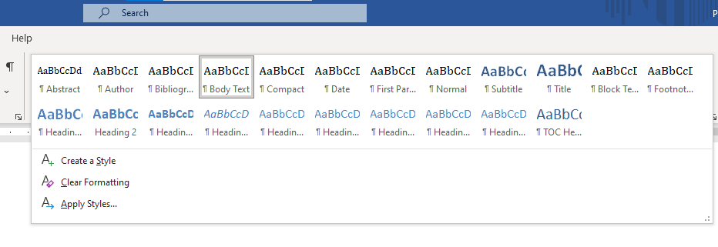

|  |  |
| --- | --- |
| #Id | docx-styles |
| #File | ./images/docx-styles.png |
| #Align | center |
| #Caption | You can find a selection of MS Word styles in the “Home” > “Styles” bar at the top of your MS Word window. |

## Headers

Use the following MS Word styles for headings in your work (e.g. for chapter titles, section headings, subsection heading, etc.):

# Heading 1 title[1]

## Heading 2

### Heading 3

#### Heading 4

##### Heading 5

Note that there is no heading 6.

## Styling body of text

### Paragraphs

First paragraph of each section should be styled with the “First Paragraph” style.

Every other paragraph should be styled as the “Body Text”.

### Typography

Currently, we support the following font formatting:

*Italics.*

**Bolded text.**

Subscript (e.g. H2O).

Superscript (e.g. 11th of November).

Note that some of the common text formatting options, like underlining, ~~strikethrough~~ and highlighting are not supported and might not work.

## Quotes

In our platform, we use the “Quote” MS Word style to format a quotation:

Sometimes you have to put a lot of manual work to automate something.

- Unknown Author

## Horizontal Rule

To indicate section breaks in your work, you can use the horizontal rule.

## Lists



|  |  |
| --- | --- |
| #Id | lists-icons |
| #File | ./images/lists-icons.png |

### Bullet lists

We support non-ordered bullet points…

* First point
* Second point
* Third point

### Ordered lists (numbering)

…as well as numbered lists.

1. First item.
2. Second item.
3. Third item.

### Multilevel lists

Multilevel lists are also supported.

1. Item 1
   1. Item 1.1
      1. Item 1.1.1
         1. Item 1.1.1.1
2. Item 2

### Other lists

You can also create nested unordered lists by indenting bullet points.

* point 1.
  + point 1.2.
    - point 1.3.
      * point 1.4.
* point 2.

## Multimedia

### Images

You can embed an image by linking to an image file. You can add a caption “Insert Caption”.

Note that this will only work with tables and figures, which have titles or captions created with the MS Word’s caption tool.

Table . A sample title

|  |  |
| --- | --- |
| Header 1 | Header 2 |
| Row 1, Column 1 | Row 1, Column 2 |
| Row 2, Column 1 | Row 2, Column 2 |

And now an image.



Figure . Example caption.

Write a paragraph on how to create a cross-reference. Cross-ref:

* Entire caption: Figure 2. Example caption.
* Only label and number: Figure 2
* Only caption text: Example caption.
* Above/below: above
* Page number: 6

The same but for table:

* Entire caption: Table 1. A sample title
* Only label and number: Table 1
* Only caption text: A sample title
* Above/below: above
* Page number: 6

## Tables

There are no explicit rules for formatting a table. As long as you will insert a proper MS Word table, the platform should be able to recognize it and its contents and render it.

|  |  |
| --- | --- |
| **Header 1** | **Header 2** |
| Row 1, Column 1 | Row 1, Column 2 |
| Row 2, Column 1 | Row 2, Column 2 |

Note that the styling of a table does not influence how the platform will render it. The general rules of styling are applied, though (see for example the bolded table headers).

|  |  |
| --- | --- |
| **Header 1** | **Header 2** |
| Row 1, Column 1 | Row 1, Column 2 |
| Row 2, Column 1 | Row 2, Column 2 |

## Directives

Directives are multi-line containers that allow you to place a complex element that will be interpreted by the platform. As a general rule, each directive consists of an opening colon fence (`:::`), name of a directive enclosed in braces (`{directive-name}`), content, and closing colon fence. Directives have to be continues text without blank lines. A syntax of a directive is presented below. Later in this chapter you will find examples of many different directives.

```

:::{some-directive-name}

Content.

:::

```

:::{important}  
Remember, directives must be a continues text undivided by blank lines. To avoid common problems with directives that span multiple lines, you might need to use the “Shift + Enter” instead of splitting lines with “Enter” to format your equation.  
:::

### Cards

You can group related information in a container box that will adjust to the width of the page.

:::{card} Card title  
Card content  
:::

### Admonitions

Admonitions highlight a particular block of text that exists slightly apart from the narrative of your page, such as a note or a warning.

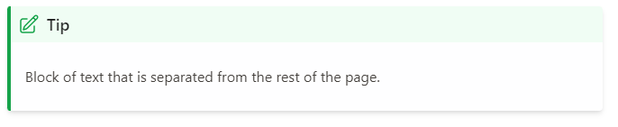

To achieve that, you have to use the following syntax:

:::{tip}  
Block of text that is separated from the rest of the page.  
:::

You can use different admonition types, which will be render using a color and an icon specific to that type. An icon might change in the future, but the general principle stays the same. Currently, the supported admonition types are as follows:

:::{attention}  
…  
:::

:::{caution}  
…  
:::

:::{warning}  
…  
:::

:::{danger}  
…  
:::

:::{error}  
…  
:::

:::{tip}  
…  
:::

:::{hint}  
…  
:::

:::{seealso}  
…  
:::

:::{important}  
…  
:::

:::{note}  
…  
:::

### Interactive elements

#### Dropdowns

:::{dropdown} Dropdown Title

Dropdown content

:::

#### Admonition Dropdowns

:::{note}  
:class: dropdown  
You can combine an admonition with a dropdown to create an interactive element in your book.  
:::

#### Tabs

::::{tab-set}  
:::{tab-item} Tab 1  
:sync: tab1  
Content of tab one  
:::  
:::{tab-item} Tab 2  
:sync: tab2  
Content of tab two  
:::  
::::

### Math

Unfortunately, we don’t support MS Word equations.

$$a^{2}+b^{2}=c^{2}$$

Instead, we do support a special `{math}` directive, which allows the platform to render equations written in LaTeX syntax.

:::{math}

e^{i\pi}+1 =0

:::

Constructing math equations in LaTeX syntax may seem daunting, but thankfully there are multiple tools to help you with that task. Look in your favorite web search engine (e.g. google) for “*online latex equation editor*” to find a few.

Another way of formulating an equation is by wrapping it between `$$` characters.

$$ Ax=b $$

This might be especially useful when constructing equations that span over multiple lines.

$$  
\label{maxwell}  
\begin{aligned}  
\nabla \times \vec{e}+\frac{\partial \vec{b}}{\partial t}&=0 \\  
\nabla \times \vec{h}-\vec{j}&=\vec{s}\_{e}  
\end{aligned}  
$$

### Diagrams (mystmd feature)

:::{note}  
Note that the platform does not allow to use standard MS Word charts. It is advised to write chapters with charts, diagrams and other data visualization in a separate Jupyter Notebook (.ipynb) files.  
:::

Mystmd supports mermaid diagrams. Please see [the documentation](https://mermaid.js.org/) on how to create graphs for your work. Few implementation examples are presented below.

#### Flowchart

:::{mermaid}  
flowchart LR  
 A[Hard edge] -->|Link text| B(Round edge)  
 B --> C{Decision}  
 C -->|One| D[Result one]  
 C -->|Two| E[Result two]  
:::

#### Sequence diagrams

:::{mermaid}  
sequenceDiagram  
 participant Alice  
 participant John  
 link Alice: Dashboard @ <https://dashboard.contoso.com/alice>  
 link Alice: Wiki @ <https://wiki.contoso.com/alice>  
 link John: Dashboard @ <https://dashboard.contoso.com/john>  
 link John: Wiki @ <https://wiki.contoso.com/john>  
 Alice->>John: Hello John, how are you?  
 John-->>Alice: Great!  
 Alice-)John: See you later!  
:::

#### Gantt diagram

:::{mermaid}  
gantt  
 title A Gantt Diagram  
 dateFormat YYYY-MM-DD  
 section Section  
 A task :a1, 2014-01-01, 30d  
 Another task :after a1, 20d  
 section Another  
 Task in Another :2014-01-12, 12d  
 another task :24d  
:::

#### Pie chart

:::{mermaid}  
pie showData  
 title Key elements in Product X  
 "Calcium" : 42.96  
 "Potassium" : 50.05  
 "Magnesium" : 10.01  
 "Iron" : 5  
:::

:::{warning}  
Please be aware that the diagram implementation is not stable and you can experience graph syntax error warnings.  
:::

### Glossaries (mystmd feature)

Sometimes a body of literary work can benefit from a glossary of terms, which are used later in the book or an article.

:::{glossary}  
Term1  
: some term that need to be defined.  
:::  
:::{glossary}  
Term2  
: another definition.  
:::

A use of glossaries enables us to reference certain terms in our books/articles, for example, we can now reference {term}`Term1`.

## Footnotes

We support footnotes out of the box. Just insert a footnote[2] and the platform will handle it further.

## Cross-references

### MS Word cross-reference

xxx

## Links to websites

## Links to other files

## Citations

### MS Word

Here we make a simple quotation (Holliday 2007). And here is an example of more complex quotation (Holliday 2007, Perneger and Hudelson 2004).

### Zotero

Here we make a simple quotation (Frisch 1990). And here is an example of more complex quotation (see Hall 2013, 11 for notes; Frisch 1990).

### Manual

Here we make a simple quotation [@graves_researcher_1984]. And here is an example of more complex quotation [e.g. @holliday_doing_2007, p. 100; @perneger_writing_2004].

Guidelines on:

* installation of Zotero …
* installation of Zotero Word Plugin <https://www.zotero.org/support/word_processor_plugin_usage>
* how to “Add/Edit Citation” with Zotero Word Plugin

@holliday_doing_2007

[@holliday_doing_2007]

[@holliday_doing_2007; @perneger_writing_2004]

[@holliday_doing_2007, p. 100]

[@holliday_doing_2007, chap. 2]

[e.g. @holliday_doing_2007, p. 100; @perneger_writing_2004]

{cite}`{see}holliday_doing_2007{fig 12}`

(Jerome, n.d.)

~~For bibliography, go to “References” > “Bibliography” > “Insert Bibliography”~~

# Bibliography

Holliday, Adrian. 2007. *Doing and Writing Qualitative Research.* SAGE Publications Ltd.

Perneger, Thomas V., and Patricia M. Hudelson. 2004. "Writing a research article: advice to beginners." *International Journal for Quality in Health Care* 191-192.

Maybe as a “**Built-in**”. What’s the difference?

# Bibliography

Holliday, Adrian. 2007. *Doing and Writing Qualitative Research.* SAGE Publications Ltd.

Perneger, Thomas V., and Patricia M. Hudelson. 2004. "Writing a research article: advice to beginners." *International Journal for Quality in Health Care* 191-192.

Or maybe there is no need for inserting a bibliography? The platform can insert one by itself.

1. Every main part of a book should open with “Heading 1”. There shouldn’t be more than one Heading 1 per docx file.
2. To insert a footnote in MS Word, you may click the “Insert Footnote” button or use the “Alt + Ctrl + F” key combination.