

**COMSATS University Islamabad, Attock Campus Department of Computer Science**

**Mobile Application Development Midterm Exam**

**Program: BSCS-6 Time: 90 Minutes Total Marks: 25**

**Question 1: (CLO-1)** **(2+2)**

1. Object Destructing is an important concept in JavaScript. Explain the concept of object destructuring.
2. Explain the concept of "learn once, write anywhere" in the context of React Native?

**Question 2: (CLO-2) (5, 4)**

1. Complete the code below using spread operator and reduce method.

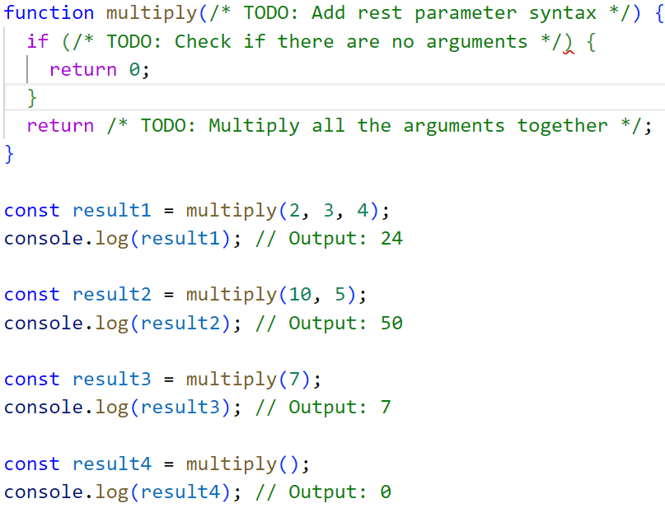

1. Complete the code below using **startswith** and **endswith** methods of strings.
2. 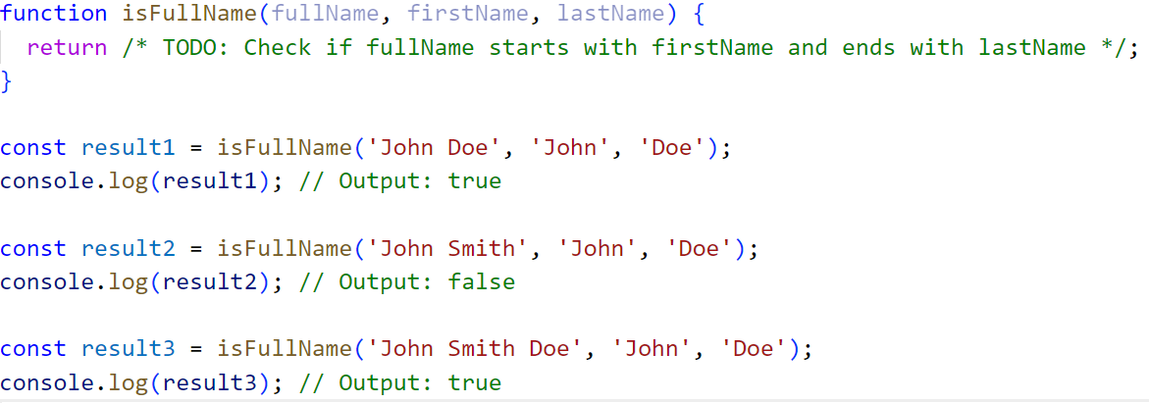

**Question 4: (CLO-3) (2, 6,4)**

1. How does Flexbox in React Native differ from Flexbox in CSS?
2. Write a React Native component called **List** that receives an array of items as a prop. The component should store the items in its ‘**state**’ and render them in a list view. Each item should be displayed as a separate **Text** element. (Build the list using ‘Text’ and ‘View’ Components).
3. Extend the List component to allow the user to filter the list Items.   
   Add a Text Input where user can enter the term to filter the results from list.