

**COMSATS University Islamabad, Attock Campus Department of Computer Science**

**Mobile Application Development Mid Term Exam**

**Program: BS(SE-6) Time: 90 Minutes Total Marks: 25**

**Question 1:** Answers the following short questions. (CLO-1) **(4, 4, 2)**

1. Write an example to explain the concept of **method over riding** in Javascript classes.
2. Write a template function that allows you to create multiple instances of Students with properties name, registration number and session.
3. Let names= {a: “apple”, b: “ball”, c:”cat”}

Assign the properties to individual variables using Destructuring.

**Question2:** (CLO-2) (4, 2, 4)

1. Create a Counter component that has a Text component to display the counter.   
   An increment button and a decrement button.
2. List mandatory props of List component.
3. List the limitation of Button Component in React Native. and explain solution for these limitation using an example

**Question3:** (CLO-3) (5)

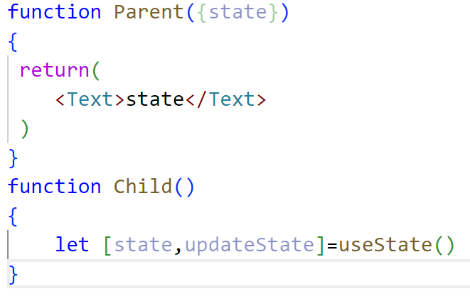

In above code we are trying to pass the state from child component to parent component. Does React Native allow this? Justify your opinion. In addition, if it is not allowed than what is the solution for this problem?