Virtual School Device Management Platform
SaaS-Based MDM, Kiosk, and Learning Device Control System
Detailed Business and Technical Proposal
Prepared for: Prospective Schools, Virtual Academies, EdTech Companies, and Device Partners
Prepared by: [Your Company Name]
Document version: 1.0
Date: May 16, 2026
Confidential - for evaluation and partnership discussions

Contents
- 1. Executive Summary
- 2. Business Opportunity and Problem Statement
- 3. Proposed Solution
- 4. Product Vision and Strategic Positioning
- 5. Target Customers and Use Cases
- 6. Functional Scope and Feature Catalogue
- 7. User Roles and Permission Model
- 8. Learning Modes and Policy Templates
- 9. Technical Architecture
- 10. Device Enrollment and Operations
- 11. Security, Privacy, and Compliance Design
- 12. Integrations and Ecosystem Strategy
- 13. Analytics, Reporting, and Success Metrics
- 14. Implementation Roadmap and Delivery Plan
- 15. Deployment Options and Commercial Model
- 16. Pilot Plan and Acceptance Criteria
- 17. Risks, Dependencies, and Mitigation
- 18. Responsibilities and Governance
- 19. Appendices and References
Document purpose
This proposal is written as a company-facing document. It can be shared with schools, online academies, device vendors, telecom partners, EdTech companies, investors, and enterprise buyers. Items in square brackets are placeholders that can be customized before sending to a specific prospect.

1. Executive Summary
Virtual schools need a reliable way to make student devices behave like controlled learning devices rather than general-purpose entertainment devices. The proposed system is a SaaS-based virtual school device management platform that combines mobile device management, kiosk lockdown, approved app access, web filtering, scheduled learning modes, teacher controls, parent visibility, and enterprise reporting.
The recommended first product is Android-first and school-owned-device-first. This approach provides the strongest technical control, the clearest privacy boundary, and the fastest route to a commercially viable pilot. The system should not depend on a normal mobile app alone; it should enforce controls through managed-device enrollment and policy-based MDM capabilities, supported by a branded student launcher and optional secure browser.
The platform will allow schools to define exactly what a student can access during class, exams, homework, break time, and after-school periods. The student sees a simple learning interface. The school gets centralized administration. Teachers get real-time classroom controls. Parents get appropriate transparency without invasive surveillance. The company gets a recurring SaaS product with optional device-bundle and white-label revenue streams.
Core recommendation
Build a SaaS control platform with MDM/kiosk enforcement under the hood. Position it as a distraction-free learning device platform for virtual schools, not as a generic enterprise MDM product.

Proposal Area | Recommended Direction
Primary market | Virtual schools, online academies, tutoring networks, remote-learning programs, and school-device providers.
First platform | Android tablets managed through Android Enterprise / Android Management API style device management.
Initial device type | School-owned or institution-leased devices, not fully controlled personal phones.
Core product | SaaS admin portal, teacher console, student kiosk launcher, policy engine, device inventory, app and web allowlisting, scheduled modes, exam mode, reports.
Differentiation | Education-specific workflow, timetable-based learning modes, simple templates, parent visibility, and integrations with LMS/SIS/video-class systems.
Commercial model | Per-device or per-student SaaS subscription, implementation fee, support package, optional preconfigured device bundle, and white-label licensing.

2. Business Opportunity and Problem Statement
Virtual learning has created a new device-management problem. A student may attend class from home, but the school still needs the digital environment to be safe, focused, and academically controlled. Without device-level control, students can switch to games, messaging, social media, unapproved websites, VPNs, alternative browsers, app stores, or entertainment platforms during learning time.
Generic MDM tools exist, but many schools and virtual academies do not have the IT capacity to configure complex device management systems. They need a purpose-built education layer that translates academic requirements into simple device policies: Class Mode, Exam Mode, Homework Mode, Parent Mode, Lost Device Mode, and School Day Mode.
The proposed platform solves this problem by connecting school schedules, teacher controls, student identity, device inventory, approved applications, web access rules, parent visibility, and remote support into one managed service.

2.1 Key Pain Points
- Students can access distracting or unsafe content during scheduled learning time.
- Schools cannot consistently enforce which apps and websites are permitted on home-based devices.
- Teachers have limited control once the student is outside the physical classroom.
- Parents may want oversight but do not want the school to control the family device indefinitely.
- Existing MDM tools are often too technical for smaller schools, online academies, and tuition networks.
- Exam integrity is difficult when students can open other apps, browsers, notes, or messaging tools.
- Device loss, misuse, app drift, and support issues increase operational costs.
- Schools need evidence of compliance, auditability, and responsible handling of student data.

2.2 Market Opportunity
- Virtual schools and hybrid schools need a controlled digital classroom environment.
- Education companies can bundle managed devices with their learning services.
- Telecom and device distributors can offer school-ready tablets as a managed subscription.
- Online tuition centers and coaching institutes can differentiate through a distraction-free study device.
- Governments and non-profits can use preconfigured devices for remote education programs.
- Schools can reduce IT burden by adopting prebuilt education policy templates rather than configuring generic MDM from scratch.

3. Proposed Solution
The proposed solution is a cloud-based platform that allows schools to manage student learning devices centrally. The system provides the administrative controls of MDM, the student simplicity of a kiosk launcher, and the academic logic of a virtual school timetable.
The system is designed around school-owned or institution-controlled devices. The student device is enrolled into managed mode, receives school policies from the cloud, and displays only the apps, websites, lessons, and actions permitted by the school policy at that time.
For schools using personal devices, the platform can offer a lighter BYOD edition, but the strongest lockdown experience should be reserved for school-owned devices because they can be managed, supported, and governed without crossing family privacy boundaries.
Layer | Description | Primary Users
SaaS Admin Portal | Central dashboard for schools, device inventory, policies, apps, web rules, students, roles, reports, billing, and integrations. | School owner, IT admin, academic admin
Teacher Console | Class-level controls to start class mode, launch exam mode, push approved links, view readiness, and request support. | Teachers, coordinators
Student Kiosk Launcher | Device home screen that exposes only permitted learning actions and hides normal device complexity. | Students
Parent View | Transparent view of school schedules, after-school permissions, support requests, and device status where allowed. | Parents/guardians
MDM/Kiosk Enforcement Layer | OS-level policy enforcement for app restrictions, device settings, remote commands, and lockdown behavior. | Platform backend and managed devices
Secure Browser/Web Filter | Approved web access, domain allowlists, category blocks, exam browser controls, and logging of policy events. | Students, teachers, admins

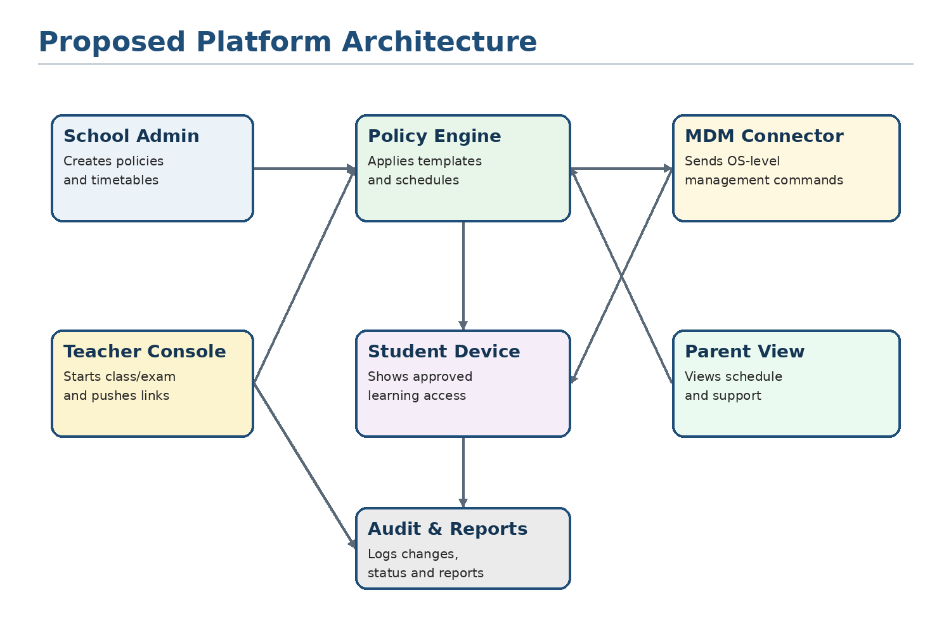
Figure 1. High-level platform architecture showing school controls, policy engine, MDM connector, student device, teacher console, parent view, and reporting.

4. Product Vision and Strategic Positioning
The product should be positioned as a learning-device operating layer for virtual schools. Its purpose is not merely to block apps; its purpose is to turn a general-purpose tablet into a school-approved learning environment that changes automatically based on the student timetable and learning context.
The strongest market positioning is simple: "Turn any school tablet into a controlled online classroom." This message is easier for schools to understand than a technical MDM pitch.

4.1 Product Vision
Vision statement
Every virtual school should be able to provide students with a safe, focused, managed learning device that automatically supports class, homework, exams, and parent-supervised learning without requiring a large IT department.

4.2 Strategic Positioning
Do Not Position As | Position As Instead
Another generic MDM tool | Education-specific learning device control platform
A parental control app | School-approved managed learning environment
A surveillance product | Privacy-respecting distraction-free learning system
A simple app blocker | Policy-driven classroom, exam, and homework mode system
A hardware-only tablet package | Complete device + SaaS + support operating model

4.3 Differentiators
- Timetable-based policy switching that aligns device access with school schedules.
- Teacher-led class controls without requiring teachers to understand MDM settings.
- Built-in policy templates for grade levels, subjects, exams, homework, and after-school use.
- Student-first launcher that makes the device feel like a learning portal, not a locked enterprise phone.
- Privacy-by-design model that avoids invasive monitoring and focuses on policy enforcement.
- Optional device-bundle model for schools that want a turnkey virtual-school device program.
- Multi-platform future roadmap while remaining Android-first for MVP speed and cost efficiency.

5. Target Customers and Use Cases
Customer Segment | Need | Recommended Offer
Virtual schools / online academies | Control student learning environment at home. | Full SaaS + managed Android tablet program.
Hybrid K-12 schools | Extend classroom device control beyond campus. | School-owned device management with teacher console.
Tuition centers / coaching institutes | Offer premium controlled study devices. | White-label student launcher and app/web allowlists.
EdTech/LMS companies | Bundle secure learning device access with their platform. | API integration and co-branded managed-device program.
Telecom/device distributors | Sell school-ready tablets with recurring SaaS. | Hardware + subscription bundle with support workflows.
Government/non-profit programs | Distribute safe learning devices at scale. | Bulk device enrollment, regional hosting, and policy templates.

5.1 Primary Use Cases
- A grade 5 student logs in at 8:00 AM and sees only today's classes, the school LMS, video class app, notes app, and approved learning resources.
- A teacher starts Exam Mode for a class and each assigned device is restricted to the exam app or exam website only.
- The school admin pushes a new reading app to grade 3 devices and automatically removes a deprecated app.
- A parent views the student's school schedule and understands why the device is locked during class hours.
- A lost device is remotely locked, marked as lost, and displays a recovery message.
- A school launches a new term by assigning policy templates to classes instead of configuring each student device manually.
- An online academy offers a branded device bundle to parents as part of its enrollment package.

5.2 Device Ownership Model
Model | Recommended Control Level | Notes
School-owned device | Strong lockdown | Best fit for kiosk mode, managed apps, remote lock/wipe, and exam controls.
Leased/subsidized school device | Strong lockdown with contract terms | Good for device bundles where parent pays monthly but school controls academic use.
Student-owned/family device | Limited session-based controls | Use secure browser, class mode prompts, and parent consent. Avoid full-device takeover.
Shared family tablet | Limited and transparent controls | Create a student learning profile where technically possible; do not control non-student family activity.

6. Functional Scope and Feature Catalogue
This section defines the detailed product capabilities. For planning purposes, features are grouped by module and classified as MVP, Phase 2, or Phase 3. MVP should focus on the smallest set required to deliver a strong school-owned Android tablet pilot.

6.1 School Administration Portal
ID | Feature | Description | Phase
ADM-01 | Multi-tenant school setup | Create and manage schools, campuses, branches, programs, and administrative hierarchy. | MVP
ADM-02 | Class and section management | Create grades, classes, sections, subjects, cohorts, academic years, and student groups. | MVP
ADM-03 | User management | Add students, teachers, parents, school admins, IT support users, and external partners. | MVP
ADM-04 | Role-based access control | Assign fine-grained permissions by role and school scope. | MVP
ADM-05 | Bulk import/export | CSV import for students, classes, parents, and device assignment; export reports. | MVP
ADM-06 | Academic calendar | Configure school year, holidays, exam periods, breaks, and timetable exceptions. | Phase 2
ADM-07 | Branch-level policy inheritance | Apply policy templates at organization, campus, grade, class, or student level. | Phase 2

6.2 Device Inventory and Lifecycle
ID | Feature | Description | Phase
DEV-01 | Device registry | Maintain device ID, serial number, model, OS version, enrollment status, assigned student, warranty, and owner. | MVP
DEV-02 | Enrollment workflow | Enroll Android devices through QR/setup process or pre-staged device vendor workflow. | MVP
DEV-03 | Device assignment | Assign or reassign a device to a student, class, parent, or program. | MVP
DEV-04 | Remote lock and unlock | Lock a device during policy violations, loss, or administrative action. | MVP
DEV-05 | Remote wipe / retire | Wipe or retire school-owned devices at end-of-life or after loss according to policy. | MVP
DEV-06 | Lost device mode | Display recovery message and restrict device access until recovered. | Phase 2
DEV-07 | Device health monitoring | Battery status, connectivity, last check-in, OS version, app status, and compliance state. | Phase 2
DEV-08 | Repair and replacement workflow | Track support tickets, device swaps, returns, and RMA status. | Phase 3

6.3 Policy Engine and Learning Modes
ID | Feature | Description | Phase
POL-01 | Policy templates | Reusable templates for grade bands, class mode, homework, exam, break, parent mode, and lost mode. | MVP
POL-02 | App allowlist | Permit only approved apps for a class, grade, subject, or mode. | MVP
POL-03 | Web allowlist/blocklist | Control allowed domains and blocked domains by school policy. | MVP
POL-04 | Timetable-based switching | Automatically activate different policies based on class schedule and school calendar. | MVP
POL-05 | Teacher-triggered temporary allow | Teacher can temporarily allow a website or app for the current class. | Phase 2
POL-06 | Policy precedence rules | Resolve conflicts between organization, grade, class, student, emergency, and exam policies. | Phase 2
POL-07 | Offline policy persistence | Device continues enforcing last known policy when internet is unavailable. | Phase 2
POL-08 | Policy simulation | Admin can preview what a student will see before publishing a policy. | Phase 3

6.4 Student Kiosk Launcher
ID | Feature | Description | Phase
LCH-01 | Controlled home screen | Show only approved learning apps, websites, assignments, class links, and support actions. | MVP
LCH-02 | Today view | Display today's classes, next live session, pending homework, and exam alerts. | MVP
LCH-03 | Single-app and multi-app kiosk states | Support both single-purpose lockdown and small allowlisted app sets. | MVP
LCH-04 | School branding | Logo, school colors, welcome message, help contact, and optional white-label identity. | MVP
LCH-05 | Emergency support button | Allow student/parent to request device support without leaving kiosk mode. | Phase 2
LCH-06 | Offline learning resources | Display cached lessons, PDFs, e-books, and offline assignments. | Phase 3

6.5 App Management
ID | Feature | Description | Phase
APP-01 | Approved app catalog | School-approved apps categorized by grade, subject, provider, and use case. | MVP
APP-02 | Managed installation | Install approved apps on assigned devices through device-management policy. | MVP
APP-03 | Blocked app handling | Prevent use of unapproved apps and hide or disable irrelevant apps where possible. | MVP
APP-04 | App update policy | Control automatic app updates and staged release by pilot group. | Phase 2
APP-05 | App compliance reports | Show missing apps, outdated apps, failed installs, and policy conflicts. | Phase 2
APP-06 | Vendor app approval workflow | Review, approve, reject, and document third-party educational apps. | Phase 3

6.6 Secure Browser and Web Filtering
ID | Feature | Description | Phase
WEB-01 | School-approved browser mode | Provide browser access only to approved domains, LMS links, e-books, and exam sites. | MVP
WEB-02 | Domain allowlist/blocklist | Configure allowed and blocked websites by mode, grade, class, and subject. | MVP
WEB-03 | Safe search and content categories | Apply safer web search settings and block inappropriate categories where supported. | Phase 2
WEB-04 | Teacher-approved links | Teacher can send links to students that open inside controlled browser context. | Phase 2
WEB-05 | Anti-bypass controls | Block unapproved browsers, VPN/proxy apps, and known circumvention websites where technically supported. | Phase 2
WEB-06 | Exam browser restrictions | Restrict navigation, tabs, printing, screenshots, copy/paste, and external links where technically possible. | Phase 3

6.7 Teacher Console
ID | Feature | Description | Phase
TCH-01 | Class dashboard | View assigned classes, student list, device readiness, and class policy state. | MVP
TCH-02 | Start class mode | Activate or confirm class mode for assigned students. | MVP
TCH-03 | Push link or resource | Send a lesson link, LMS page, PDF, quiz, or video class link to students. | MVP
TCH-04 | Start exam mode | Launch restricted test mode for class, group, or individual student. | MVP
TCH-05 | Temporary exceptions | Temporarily allow a resource with expiry and audit trail. | Phase 2
TCH-06 | Class activity summary | View policy compliance, attendance signals, app readiness, and support issues. | Phase 2

6.8 Parent View
ID | Feature | Description | Phase
PAR-01 | Parent account | Parent can view assigned student, school device, basic schedule, and support channels. | MVP
PAR-02 | After-school rules | Optional parent-controlled access only within school-approved boundaries. | Phase 2
PAR-03 | Lost device reporting | Parent can report lost device and trigger school support workflow. | Phase 2
PAR-04 | Transparency dashboard | Show what the school controls and what data is collected. | MVP
PAR-05 | Consent and policy acknowledgement | Collect parent acknowledgement for device program and acceptable-use policy. | Phase 2

6.9 Reporting and Audit
ID | Feature | Description | Phase
RPT-01 | Device compliance report | Shows enrolled, online, offline, non-compliant, missing app, and outdated devices. | MVP
RPT-02 | Policy audit log | Record who changed what policy, when, and which students/devices were affected. | MVP
RPT-03 | Class readiness report | Teacher/admin can see whether students are ready before live class or exam. | Phase 2
RPT-04 | Usage summary | High-level educational usage by approved app/site without invasive content monitoring. | Phase 2
RPT-05 | SLA/support dashboard | Track open tickets, response time, device replacements, and recurring issues. | Phase 3

6.10 Platform Administration and Billing
ID | Feature | Description | Phase
BIL-01 | Subscription management | Manage school plan, device count, student count, renewal dates, and add-ons. | Phase 2
BIL-02 | White-label configuration | Branding, custom domain, custom launcher theme, email templates, and partner identity. | Phase 2
BIL-03 | Support tiers | Configure support SLA, ticket priority, and escalation rules. | Phase 3
BIL-04 | Partner portal | Allow device vendors, telecoms, or implementation partners to manage assigned customers. | Phase 3

7. User Roles and Permission Model
The system must use a strict role-based access control model. Schools should be able to delegate operational work without giving every staff member full administrative access.
Role | Main Capabilities | Restricted From
Platform Super Admin | Manage tenants, subscriptions, global settings, support tools, partner accounts, system audit. | Student private content and unnecessary personal details unless support-authorized.
School Owner / Principal | View school-wide dashboards, approve policies, assign admins, view reports, manage billing. | Low-level platform configuration and other school tenants.
School IT Admin | Enroll devices, assign devices, manage apps, publish policies, lock/wipe devices, view device logs. | Billing changes unless granted; academic grading data unless integrated by role.
Academic Admin | Manage classes, timetables, teachers, learning mode templates, exam schedules, and approved resources. | Device wipe/retire unless separately granted.
Teacher | Start class/exam mode for assigned classes, push resources, view class readiness, request support. | Global policy changes, device wipe, other teacher classes unless assigned.
Parent/Guardian | View child's device schedule, acknowledge policy, report device lost, view allowed after-school rules. | Changing school-time restrictions or seeing unrelated students.
Student | Use approved apps, websites, lessons, assignments, support button, and permitted offline resources. | Changing device policy, installing apps, opening blocked apps/sites.
Support Agent | View support tickets, device status, remote assistance tools, and audit logs relevant to the case. | Academic reports and broad student personal data unless necessary.

8. Learning Modes and Policy Templates
Learning modes are the main user-friendly concept that differentiates this platform from generic MDM. Instead of asking school staff to configure technical restrictions, the system provides ready-made templates that can be assigned to grades, classes, subjects, or timetables.
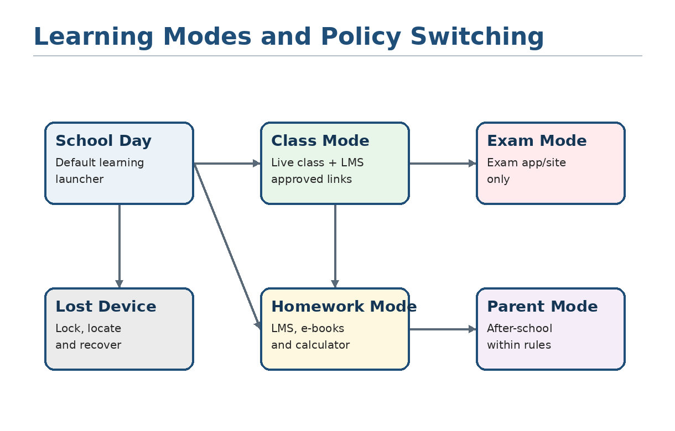
Figure 2. Learning modes are policy states that change the allowed apps, websites, device settings, and launcher experience.
Mode | Purpose | Typical Access | Typical Restrictions
School Day Mode | Default learning state during official school hours. | Today view, LMS, class schedule, approved school apps. | No app store, social apps, games, unapproved browsers, or device settings.
Class Mode | Live class or subject-specific learning session. | Video class app, LMS page, notes app, teacher-pushed links. | Only subject-approved apps/sites; no unrelated apps.
Exam Mode | High-control assessment environment. | Single exam app/site, calculator if allowed, timer/instructions. | No multitasking, no external browsing, no messaging, no app switching where technically enforceable.
Homework Mode | After-class study period. | LMS, assignment apps, e-books, PDF reader, calculator, approved research domains. | Blocks entertainment and non-learning apps.
Break Mode | Optional limited break access. | Optional school-approved break content or wellness apps. | Still blocks unsafe or non-approved categories.
Parent Mode | After-school use under parent/school boundaries. | Parent-approved apps within the school-approved list. | Prevents changing device management and unsafe access.
Lost Device Mode | Security mode for lost, stolen, or unreturned device. | Recovery message and support contact. | Locks normal use; optional locate/wipe workflow.
Offline Mode | Continuity when internet is unstable. | Cached content, offline lessons, approved local apps. | Enforces last-known policy and limits bypass opportunities.

9. Technical Architecture
The architecture should separate academic workflow from enforcement. The SaaS platform owns schools, users, timetables, policies, approvals, integrations, reports, and support workflows. Device enforcement is delegated to OS-level management capabilities and a controlled launcher/secure browser installed on student devices.

9.1 Architecture Components
Component | Description | Notes
Web Admin Frontend | Browser-based interface for school admins, teachers, support agents, and partners. | Responsive design; admin and teacher portals may share base UI.
Backend API | Core REST/GraphQL APIs for tenants, users, classes, policies, devices, reports, and billing. | Should be versioned and support external integrations.
Policy Engine | Resolves policy templates, timetable rules, exceptions, and role permissions into device-ready rules. | Critical core module; must handle conflicts predictably.
MDM Connector | Communicates with Android Management API initially and future MDM/OS integrations later. | Keep abstraction layer to avoid Android-only technical lock-in.
Command Queue | Handles remote lock, wipe, policy update, app install, status refresh, and retry logic. | Useful for offline devices and retryable commands.
Student Launcher | Managed app that presents the controlled student experience. | Should be lightweight, branded, reliable, and hard to exit under managed mode.
Secure Browser | Controlled browser experience for approved sites and exam workflows. | Can be native app, webview-based app, or integrated with policy-managed browser.
Data Store | Tenant configuration, users, classes, devices, policies, logs, reports, and subscriptions. | Use encryption at rest and strong tenant isolation.
Audit Log Store | Immutable or tamper-resistant audit events for policy changes, remote commands, and access. | Important for enterprise trust and compliance reviews.
Integration Layer | Connectors for LMS, SIS, SSO, video platforms, identity providers, and support tools. | Start with API/webhook design; add direct connectors in phases.

9.2 Recommended Technology Principles
- Use policy-as-configuration: school rules should be stored as structured policies, not hardcoded logic.
- Create an MDM abstraction layer so that Android can be MVP while ChromeOS, iOS/iPadOS, and Windows can be added later.
- Keep privacy-sensitive data minimal and purpose-bound. The platform should not collect unnecessary student behavior data.
- Make every policy change auditable with user, timestamp, affected scope, previous value, new value, and reason.
- Ensure device commands are idempotent and retryable because student devices may be offline or on poor networks.
- Design multi-tenant isolation from the beginning because the SaaS will serve multiple schools and partners.
- Prefer configuration templates and guided workflows over complex technical forms for school staff.

9.3 Suggested Data Model
Entity | Purpose | Important Fields
Tenant/School | Represents a customer school or organization. | Name, domain, plan, region, branding, policies, billing status.
Campus/Branch | Optional sub-organization under a school. | Name, location, admins, classes, policy inheritance.
Academic Term | Defines year, term, holiday, and schedule boundaries. | Start/end dates, holidays, assessment windows.
Class/Section | Groups students and teachers. | Grade, section, subjects, timetable, assigned policy.
User | Represents admins, teachers, parents, students, support users. | Role, school, class, contact, authentication method.
Student Profile | Academic identity of a student. | Class, guardian link, assigned device, policy group.
Device | Managed physical device. | Serial, model, OS, status, assigned student, last check-in.
Policy Template | Reusable device rule set. | Allowed apps, allowed domains, restrictions, priority, mode.
Learning Mode | Named state applied to device access. | Mode type, schedule, allowed resources, exception rules.
Remote Command | Action sent to device. | Command type, status, retries, initiated by, timestamp.
Audit Event | Tamper-resistant record of sensitive actions. | Actor, action, target, old/new values, timestamp, IP/context.
Integration | External system connection. | Provider, credentials reference, sync status, mapping rules.

10. Device Enrollment and Operations
Device enrollment is the operational heart of the system. The goal is to make device onboarding simple enough for non-technical schools while maintaining strong device control and auditability.
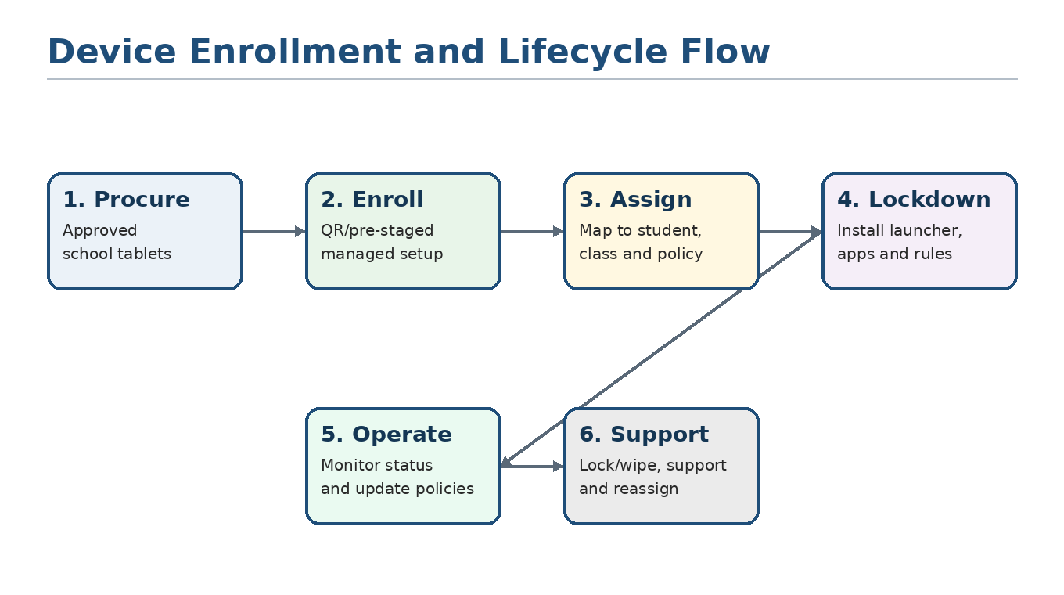
Figure 3. Recommended device lifecycle from procurement through enrollment, assignment, lockdown, operation, and support.

10.1 Recommended Android-First Enrollment Flow
- School purchases or receives approved Android tablets from the company, a device vendor, or a telecom/device partner.
- Devices are enrolled into managed mode during initial setup using QR-based or pre-staged enrollment workflow.
- The device receives the baseline school policy and installs the student launcher, secure browser, and approved core apps.
- The school admin assigns the device to a student, class, grade, and policy template from the SaaS portal.
- The policy engine applies the correct learning mode based on school timetable and current context.
- Teachers can trigger class or exam controls for assigned students.
- The platform receives device status and policy event logs for reporting and support.
- At year-end or transfer, the device can be reassigned, wiped, retired, or converted to another program policy.

10.2 Operational Workflows
Workflow | Steps | Expected Outcome
New school setup | Create tenant, configure branding, import users/classes, create policies, enroll pilot devices. | School can run a controlled pilot.
New term setup | Update academic calendar, import roster, assign policy templates, validate class schedules. | Devices switch modes according to new timetable.
New app approval | School requests app, admin reviews purpose/privacy, app is added to catalog, pilot group tests, broader rollout follows. | Only approved apps are installed.
Exam session | Academic admin schedules exam, teacher starts exam mode, device locks to exam app/site, report generated afterward. | Reduced distraction and stronger exam integrity.
Lost device | Parent/school marks lost, device is locked, recovery message appears, locate/wipe workflow follows policy. | Device and data risk is reduced.
Device replacement | Support marks old device lost/retired, assigns new device, policy and user mapping transferred. | Student continues learning with minimal disruption.
Policy exception | Teacher/admin grants temporary resource access with expiry and audit reason. | Flexibility without uncontrolled access.

11. Security, Privacy, and Compliance Design
Because the platform is designed for children and schools, privacy, security, and transparency are not optional features. They are core product requirements. The platform should avoid invasive surveillance and should only collect data needed to manage the learning device and support the educational service.

11.1 Privacy-by-Design Principles
- Collect the minimum data required to provide device management, learning access, support, and reporting.
- Make school and parent-facing explanations clear: what the device controls, what is logged, and what is not monitored.
- Avoid keystroke logging, secret screenshots, continuous webcam recording, private message reading, or always-on home surveillance.
- Use role-based access so teachers, support agents, and partners only see information necessary for their role.
- Provide data retention settings and deletion workflows for student records, device logs, and support history.
- Maintain audit logs for policy changes, remote commands, admin access, and sensitive data actions.
- Use consent and acknowledgement workflows for device program terms, acceptable use, and parent/guardian communication.

11.2 Security Controls
Control Area | Requirement
Authentication | Admin MFA, strong password policy, optional SSO/SAML/OIDC for enterprise schools, session timeout, device trust checks for admins.
Authorization | Role-based access control, least privilege, school/tenant boundaries, scoped support access, approval workflows for destructive commands.
Encryption | TLS for data in transit, encryption at rest for databases and backups, secure secret storage for integration credentials.
Tenant isolation | Every API, database query, report, and support view must enforce tenant scoping.
Auditability | Log policy changes, remote commands, admin logins, exports, failed access attempts, device reassignment, and wipe actions.
Device command safety | Confirm and audit remote wipe, retire, and destructive commands; apply maker/checker approval for high-risk actions in enterprise plans.
Secure development | Code review, dependency scanning, vulnerability scanning, penetration testing before enterprise rollout.
Incident response | Documented incident workflow, contact escalation, breach assessment, customer notification process, and post-incident review.
Data retention | Configurable retention windows for logs and reports; deletion process for former students and retired devices.
Backups and recovery | Encrypted backups, regular restore tests, recovery point objectives and recovery time objectives appropriate to plan tier.

11.3 Compliance Considerations
The platform should be designed to support the compliance obligations of schools and EdTech customers in their applicable jurisdictions. The following are planning considerations and should be validated by legal counsel for each target market.
Framework / Area | Relevance to the Platform | Product Implication
FERPA / student education records | Relevant for U.S. schools and service providers handling education records. | Written agreements, purpose limitation, access controls, audit logs, data deletion, and school control over records.
COPPA / children under 13 | Relevant to online services collecting personal information from children under 13 in U.S. contexts. | Parent/school consent workflows, notices, limited data collection, no behavioral advertising, clear retention limits.
GDPR / UK GDPR | Relevant where EU/UK student data is processed. | Data processing agreements, lawful basis, rights workflows, data minimization, DPIA support, breach notification.
ICO Children's Code / age-appropriate design | Relevant to children's online services and EdTech in the UK. | High privacy defaults, transparency, minimal profiling, child-centered design, no unnecessary nudging.
Local data protection laws | Relevant in every deployment country. | Regional hosting, data residency, DPA templates, local legal review, customer-specific controls.
School safeguarding policies | Operational requirement for safe student access. | Web filtering, age-appropriate resources, parent transparency, escalation workflows.

Important compliance note
This proposal is not legal advice. The final product should include jurisdiction-specific legal review, data processing agreements, privacy notices, subprocessor lists, and school-approved acceptable-use policies.

12. Integrations and Ecosystem Strategy
The platform becomes more valuable when it connects device control to the systems schools already use. Integration should be phased: begin with simple CSV import/export and APIs, then add direct connectors for high-demand platforms.
Integration Category | Examples | Use Cases | Phase
LMS | Moodle, Canvas, Google Classroom, proprietary LMS | Import classes, launch lessons, restrict device to LMS resources, push assignments. | Phase 2
Video class systems | Zoom, Google Meet, Microsoft Teams | Display live class links, open approved session, block unrelated apps during class. | MVP/Phase 2
SIS/ERP | School management systems, student information systems | Roster sync, class mapping, parent contacts, academic term data. | Phase 2
Identity/SSO | Google Workspace, Microsoft Entra ID, SAML/OIDC | Admin/teacher login, user provisioning, class/group mapping. | Phase 2
Exam platforms | Online testing systems, quiz engines | Exam mode, approved exam app/site, reporting, session control. | Phase 2/3
Support tools | Helpdesk/ticketing, chat, remote assistance | Parent/student support requests, device issues, escalation tracking. | Phase 3
Partner systems | Device vendors, telecom billing, logistics | Device bundle activation, subscription status, warranty/repair workflow. | Phase 3

12.1 API Strategy
- Provide a secure partner API for roster import, policy assignment, device status, command status, and reports.
- Use webhooks for device status changes, policy violations, support tickets, and exam mode events.
- Maintain API versioning, rate limits, audit logging, and scoped API keys per tenant or partner.
- Offer integration templates for common LMS/SIS data formats before building full native integrations.
- Keep the policy engine API-independent so it can support Android, ChromeOS, iOS/iPadOS, and Windows backends later.

13. Analytics, Reporting, and Success Metrics
Reports should help schools operate devices and evaluate learning readiness without becoming a surveillance system. The product should report device compliance, access availability, support issues, and high-level use of approved learning resources.
Report | Audience | Purpose
Device compliance dashboard | IT admin, school owner | Shows online/offline devices, policy status, missing apps, OS/app versions, last check-in.
Class readiness dashboard | Teacher, academic admin | Shows whether students assigned to a class are online, enrolled, and ready for live session or exam.
Policy change audit | School admin, compliance reviewer | Shows who changed policy settings and what scope was affected.
Remote command log | IT admin, support | Tracks lock, wipe, policy update, app install, and device reassignment commands.
App deployment report | IT admin | Shows app installation success/failure by class, grade, device model, and OS version.
Learning resource summary | Teacher/admin | Shows usage of approved resources at a high level without exposing private content unnecessarily.
Support report | Support manager, partner | Shows tickets, recurring issues, device replacements, and SLA performance.
Subscription report | Platform admin, partner | Shows active devices, billable seats, plan usage, renewals, and partner/customer status.

13.1 Success Metrics for Pilot and Scale
Metric | Target Direction | Reason
Enrollment success rate | High and improving | Shows onboarding workflow is reliable and scalable.
Policy application time | Low delay | Important for class and exam switching.
Device compliance rate | High | Shows students are using managed environment correctly.
Class readiness before session | High | Indicates fewer live-class interruptions.
Support tickets per 100 devices | Lower over time | Measures operational quality and user training.
Teacher adoption | Increasing | Shows teachers trust the class/exam controls.
Parent acknowledgement rate | High | Supports transparency and program acceptance.
App install failure rate | Low | Indicates device/app management reliability.
Renewal/expansion rate | High | Commercial proof of value.

14. Implementation Roadmap and Delivery Plan
A phased roadmap reduces risk and helps the company reach market with a focused MVP. The recommended plan is to build Android-first for school-owned devices, then add deeper integrations and additional platforms after successful pilots.
Phase | Duration | Major Deliverables | Outcome
Phase 0 - Discovery and Solution Design | 2-3 weeks | Requirements workshops, target buyer profile, technical validation, product specification, pilot success criteria. | Validated MVP scope and pilot plan.
Phase 1 - MVP Build | 12-16 weeks | Admin portal, device enrollment, student launcher, app/web allowlists, policy templates, class mode, exam mode, teacher console basics, device reports. | Pilot-ready Android device management platform.
Phase 2 - Controlled Pilot | 4-8 weeks | Pilot school onboarding, 50-300 devices, feedback cycles, support workflows, reporting improvements, policy tuning. | Evidence of product-market fit and deployment readiness.
Phase 3 - Commercial Launch | 8-12 weeks | Billing/subscription, partner onboarding, white-label assets, enhanced reports, helpdesk, documentation, support SLAs. | Sellable SaaS product for multiple schools.
Phase 4 - Expansion | Ongoing | LMS/SIS integrations, parent mode, ChromeOS/iPad/Windows strategy, advanced analytics, partner portal. | Broader market coverage and higher enterprise value.

14.1 MVP Scope
MVP Area | Included
Admin Portal | School setup, classes, users, device inventory, policy templates, app catalog, web allowlists, audit logs.
Device Management | Android enrollment, student-device assignment, remote lock/wipe/retire, policy updates, app deployment status.
Student Experience | Branded kiosk launcher, Today view, approved apps, approved websites, support contact.
Learning Modes | School Day, Class Mode, Exam Mode, Homework Mode, Lost Device Mode.
Teacher Console | Assigned classes, start class mode, start exam mode, push approved link/resource, class readiness status.
Parent View | Basic schedule, device program transparency, policy acknowledgement, support contact.
Reports | Device compliance, policy audit log, app deployment status, class readiness summary.
Security | RBAC, MFA for admins, encryption, audit logs, tenant isolation, privacy notices.

14.2 Out of Scope for MVP
- Full control of unmanaged student-owned personal phones.
- Always-on webcam monitoring, secret screenshots, keystroke logging, or invasive surveillance.
- Advanced AI proctoring or biometric identity checks.
- Full native support for iOS/iPadOS, ChromeOS, and Windows in the first release.
- Complex multi-country legal automation without jurisdiction-specific legal review.
- Deep LMS/SIS integrations beyond basic CSV/API import in the first pilot unless a pilot partner requires it.

15. Deployment Options and Commercial Model
The platform can be sold as software-only, device bundle, or white-label managed service. The best model depends on the buyer. Smaller virtual schools may prefer a complete device bundle, while larger schools may already own devices and only need SaaS control.
Offer | Description | Best For
Software-only SaaS | School brings compatible devices; platform provides admin portal, policy engine, MDM enrollment, launcher, reports, and support. | Schools with existing devices and IT support.
Device + SaaS bundle | Company or partner provides preconfigured tablets with subscription, support, warranty, and replacement options. | Virtual schools without IT teams; device distributors; telecom partners.
White-label platform | Custom branding, domain, launcher theme, partner portal, and school/customer segmentation. | EdTech companies, online academies, telecom/device partners.
Enterprise/private deployment | Dedicated cloud environment, custom data residency, custom integrations, advanced security review. | Government programs, large school networks, enterprise buyers.
BYOD learning-session edition | Limited secure browser/class mode for personal devices, without full device takeover. | Schools that cannot issue managed devices but still want some structure.

15.1 Pricing Structure Options
The following pricing structure is illustrative and should be adjusted by target market, device cost, support obligations, hosting region, and sales channel.
Pricing Component | Description
SaaS subscription | Per active device/month or per student/month. Tiered by feature set and support SLA.
Implementation fee | One-time setup for tenant configuration, policies, branding, training, and pilot support.
Device bundle margin | Optional hardware resale/lease margin for preconfigured tablets.
White-label fee | Monthly platform fee or annual license for branded partner deployments.
Support package | Standard, priority, or enterprise support based on SLA, response time, and device replacement process.
Integration services | Paid professional services for LMS/SIS/SSO/custom APIs.
Regional hosting/private cloud | Premium fee for dedicated infrastructure or data residency.

15.2 Suggested Packaging
Package | Included | Ideal Customer
Starter | Admin portal, Android enrollment, app/web allowlists, launcher, basic reports, email support. | Small virtual schools and pilot programs.
School Plus | Teacher console, scheduled modes, exam mode, parent view, advanced reports, priority support. | Growing online academies and hybrid schools.
Enterprise | SSO, advanced RBAC, audit exports, dedicated support, private deployment options, custom integrations. | Large school networks, government/non-profit programs.
White Label Partner | Custom branding, partner dashboard, customer segmentation, API access, device-bundle workflows. | EdTech, telecom, device distribution, franchise education brands.

16. Pilot Plan and Acceptance Criteria
A structured pilot should prove technical feasibility, school value, teacher usability, parent transparency, and operational support. The pilot should be small enough to manage closely but large enough to expose real device and user behavior.
Pilot Item | Recommended Detail
Pilot size | 50-300 school-owned Android tablets across 2-5 classes or one virtual-school program.
Pilot duration | 4-8 weeks after device enrollment and staff training.
Participants | School admin, IT/admin staff, teachers, students, parents, support team, product team.
Core scenarios | Daily class mode, homework mode, app/web allowlists, exam mode, remote lock, lost-device drill, app update.
Training | Admin training, teacher quick-start, parent/student onboarding, support escalation process.
Data collection | Device compliance, class readiness, support tickets, teacher feedback, parent acceptance, feature issues.
Success review | Pilot report, gaps, roadmap changes, commercial rollout recommendation.

16.1 Acceptance Criteria
Category | Acceptance Criteria
Enrollment | Devices can be enrolled reliably and assigned to students/classes without manual technical intervention for each policy.
Lockdown | Students can only access approved apps and websites during managed learning modes.
Mode switching | Device access changes correctly based on timetable, teacher action, and exam mode.
Teacher usability | Teachers can start class/exam mode and push resources with minimal training.
Reporting | Admins can identify non-compliant/offline devices and see policy/app deployment status.
Parent transparency | Parents can understand the device program and know how to request help or report loss.
Security | Admin actions are authenticated, authorized, and logged. Destructive actions require safeguards.
Reliability | Device policy remains enforced during reasonable connectivity interruptions using last-known state.
Supportability | Support team can diagnose common issues and resolve or escalate them through documented workflow.

17. Risks, Dependencies, and Mitigation
Risk / Dependency | Impact | Mitigation
Device compatibility variation | Some tablets may not support expected management behavior consistently. | Define approved device list; test models before sale; maintain compatibility matrix.
MDM API limitations | Certain restrictions may not be enforceable on every OS/device version. | Document enforceable controls; use OS-level APIs; avoid overpromising; maintain platform notes.
BYOD privacy concerns | Parents may resist full control of personal devices. | Keep strong lockdown for school-owned devices; provide lighter BYOD edition with clear consent.
Student bypass attempts | Students may try VPNs, alternative browsers, safe mode, factory reset, or app stores. | Use managed enrollment, restrict app install/settings, block known bypass routes, monitor compliance, educate schools.
Poor internet connectivity | Policies, class links, and remote commands may be delayed. | Offline policy persistence, command retry queue, cached resources, clear status indicators.
Teacher adoption risk | Teachers may not use console if it feels complex. | Design simple teacher workflows; provide templates, training, and minimal-click class actions.
Legal/regulatory variation | Privacy obligations vary by jurisdiction. | Privacy-by-design baseline, legal review by market, DPA templates, configurable retention and data residency.
Hardware logistics | Device replacement, warranty, and support can become operationally heavy. | Offer partner-led device bundle; define support tiers and repair/replacement workflow.
Competition from large MDM vendors | Schools may compare with generic MDM products. | Differentiate on virtual-school workflows, learning modes, simplicity, parent view, and bundled support.
Scope creep | Multi-platform ambitions may slow MVP. | Android-first MVP; platform abstraction for future; pilot before expansion.

18. Responsibilities and Governance
Successful deployment requires clear responsibility between the platform provider, school, teachers, parents, students, and device partners.
Party | Responsibilities
Platform Provider | Build and operate SaaS, provide device management workflows, maintain security, provide support tools, document controls, manage updates, protect data.
School / Academy | Approve policies, define allowed apps/sites, manage rosters, inform parents, train staff, operate acceptable-use policy, respond to incidents.
Teachers | Use teacher console appropriately, start class/exam modes, approve temporary learning resources, report device issues.
Parents / Guardians | Acknowledge device program, support safe device use at home, report lost or damaged devices, respect school policy boundaries.
Students | Use device for approved learning purposes, follow school acceptable-use policy, report issues, avoid bypass attempts.
Device Partner / Vendor | Supply approved devices, support warranty/replacement, optionally pre-enroll or stage devices, maintain device compatibility records.
Legal/Compliance Advisors | Review privacy notices, contracts, data protection terms, jurisdiction-specific compliance, and consent mechanisms.

18.1 Governance Cadence
Meeting / Review | Frequency | Purpose
Pilot standup | Weekly during pilot | Review enrollment, device issues, teacher feedback, feature defects, and policy tuning.
Security/privacy review | Before pilot and before launch | Review data flows, access controls, retention, agreements, and incident workflows.
Product steering committee | Monthly | Prioritize roadmap, integrations, partner needs, and commercial readiness.
Customer success review | Monthly or quarterly | Review usage, support, renewal risks, expansion opportunities, and training needs.
Incident review | As needed | Analyze security/support incidents and define corrective actions.

19. Appendices and References

Appendix A - Feature Phase Summary
Phase | Focus | Included Highlights
MVP | Prove core lockdown and school workflow. | Android enrollment, admin portal, launcher, app/web allowlists, class mode, exam mode, teacher console basics, reports.
Phase 2 | Operational maturity and customer usability. | Parent mode, timetable exceptions, LMS/SIS/SSO connectors, advanced reports, compliance workflows, white label.
Phase 3 | Enterprise scale and ecosystem expansion. | Partner portal, support SLA dashboard, app review workflow, ChromeOS/iPad/Windows strategy, advanced analytics.

Appendix B - Sample Policy Templates
Template | Allowed | Blocked / Restricted
Grade 1-3 Default | LMS, live class app, e-books, drawing/notes app, school messages. | App store, settings, browsers except secure browser, games, social media, unknown apps.
Grade 4-8 Default | LMS, live class app, approved browser, notes, calculator, library resources. | Unapproved apps, social media, games, VPN/proxies, app stores.
Exam Mode | Exam app/site, calculator if allowed, instructions, support contact. | All other apps/sites, multitasking, non-exam browsing, messaging, app install.
Homework Mode | LMS, assignments, PDF reader, e-books, calculator, approved research sites. | Entertainment, social media, games, unapproved video, app store.
Parent Mode | Parent-approved apps selected from school-approved list. | Device management changes, unsafe content, unapproved installs.
Lost Device Mode | Recovery message and support contact only. | All normal device access.

Appendix C - Example SaaS Modules
- Admin Portal: tenants, schools, users, classes, policies, devices, apps, websites, reports, billing, integrations.
- Teacher Console: class list, current mode, start exam, push link, class readiness, support request.
- Student Launcher: today view, allowed apps, allowed websites, assignments, messages, help button.
- Parent View: transparency, schedule, support, lost-device reporting, after-school rules if enabled.
- MDM Connector: device enrollment, policy publish, app install, remote lock/wipe, status collection.
- Secure Browser: web allowlist, exam restrictions, approved links, category controls where available.
- Reporting Layer: compliance, audit, support, class readiness, app deployment, subscription usage.
- Integration Layer: LMS, SIS, SSO, video platforms, support systems, partner/device systems.

Appendix D - Reference Standards and Platform Documentation
The following official resources were used to inform the technical and compliance direction of this proposal. Final implementation details should be validated against the current platform documentation during development.
- Android Management API - Overview: https://developers.google.com/android/management
- Android Management API - Dedicated devices: https://developers.google.com/android/management/policies/dedicated-devices
- Android Enterprise - Dedicated devices overview: https://developer.android.com/work/dpc/dedicated-devices
- Android Open Source Project - Device management overview: https://source.android.com/docs/devices/admin
- Google ChromeOS - Managing ChromeOS devices: https://support.google.com/chrome/a/answer/1289314
- Google ChromeOS - Kiosk apps on ChromeOS: https://developers.google.com/chromeos/app-development/learn/kiosk
- Apple School Manager - Introduction: https://support.apple.com/guide/apple-school-manager/intro-to-apple-school-manager-axm7909096bf/web
- Apple Education - Deploy and manage: https://www.apple.com/education/k12/deploy-and-manage/
- Apple Platform Deployment - Choose an MDM solution: https://support.apple.com/guide/deployment-education/edu1c1be3511/web
- Microsoft Intune - What is Intune: https://learn.microsoft.com/en-us/intune/fundamentals/what-is-intune
- U.S. Department of Education - Student Privacy FERPA resources: https://studentprivacy.ed.gov/ferpa
- FTC - Children's Online Privacy Protection Rule: https://www.ftc.gov/legal-library/browse/rules/childrens-online-privacy-protection-rule-coppa
- ICO - Children's Code and education technologies: https://ico.org.uk/for-organisations/uk-gdpr-guidance-and-resources/childrens-information/childrens-code-guidance-and-resources/the-children-s-code-and-education-technologies-edtech/

Appendix E - Customization Checklist Before Sharing
Item | Action
Company name and logo | Replace [Your Company Name] and add branding.
Target market | Adjust terminology for schools, academies, government, telecom, or EdTech prospects.
Pricing | Insert market-specific pricing if the document is being used as a commercial offer.
Legal terms | Add customer-specific privacy, DPA, service agreement, and acceptable-use language.
Platform scope | Confirm whether the prospect expects Android-only, ChromeOS, iPad, Windows, or BYOD.
Implementation dates | Replace generic durations with actual project timeline and milestones.
Support model | Define support hours, SLA, escalation, warranty, and replacement responsibilities.
Pilot success criteria | Align acceptance criteria with the prospective customer's decision process.

Conclusion
The proposed Virtual School Device Management Platform addresses a clear need: virtual schools require safe, focused, school-controlled learning devices without the complexity of enterprise MDM administration. The strongest strategy is to launch with Android school-owned devices, deliver learning-mode based policy control, and expand through integrations, partner bundles, white-label offerings, and additional platforms after market validation.
This proposal provides a complete foundation for product design, partner discussions, enterprise sales conversations, pilot planning, and technical implementation. The next step is to customize the document with company branding, prospect-specific commercial terms, and a pilot deployment plan for the first target customer.
Recommended first commercial offer
Android school-owned managed tablet program for virtual schools: SaaS admin portal + student kiosk launcher + MDM enforcement + teacher console + app/web allowlisting + exam mode + parent transparency + support workflow.

