Databases Laboratory Work Nr 1

By Piciriga Bogdan FAF-192

Title: Instalarea si configurarea SQL Server 2017

Prerequisites: PC w/ Windows 10 and net connection

Objectives: To install and configure SQL Server 2017

Tasks:

1. To install SQL Server 2017

2. Register the server on the available computer, choosing the type of SQL authentication.

3. Create three user logins that have SQL Authentication.

Implementation:

After installation:

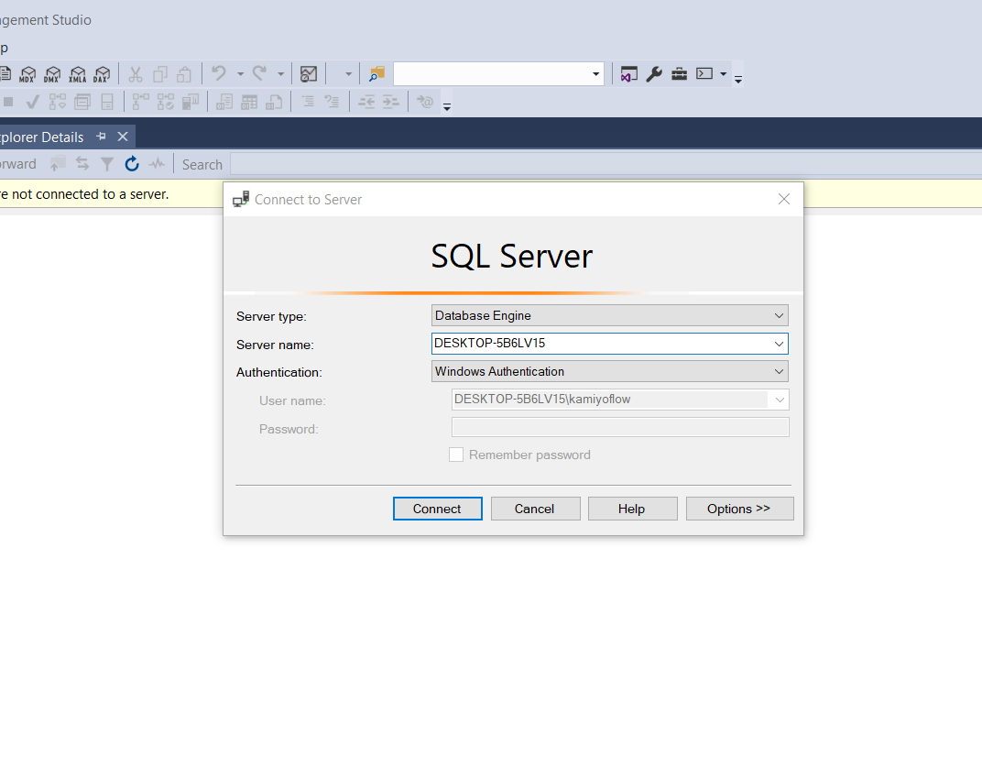

After SQL Authentification:

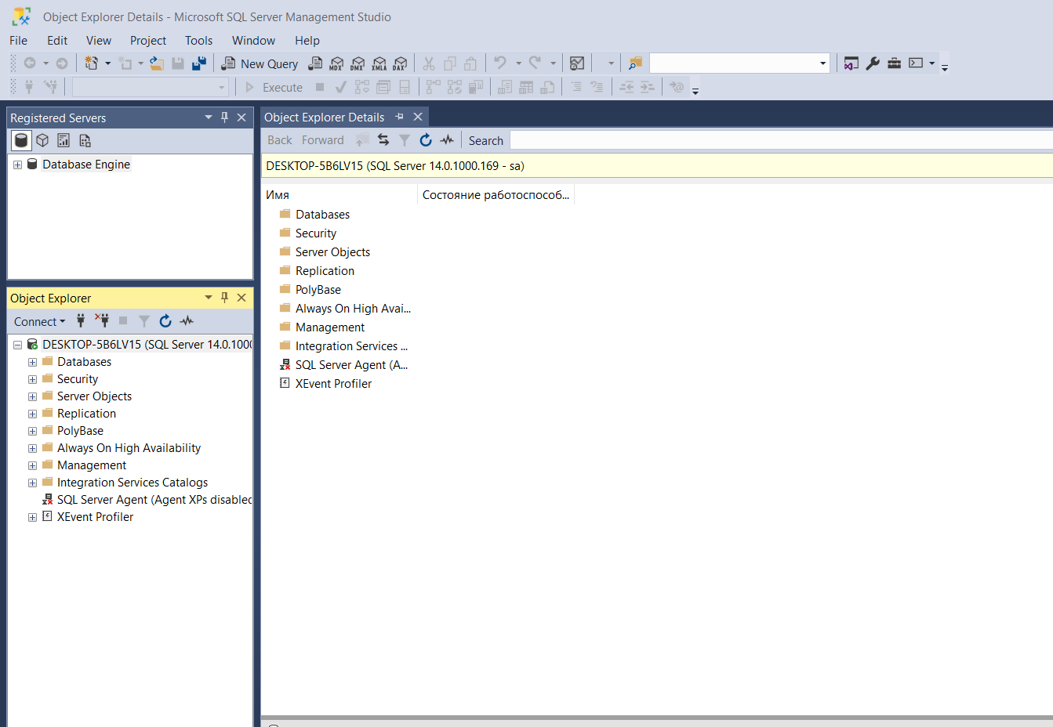

Database restore: (in screenshot I installed AdventureWorksLT2017,but I fixed later)

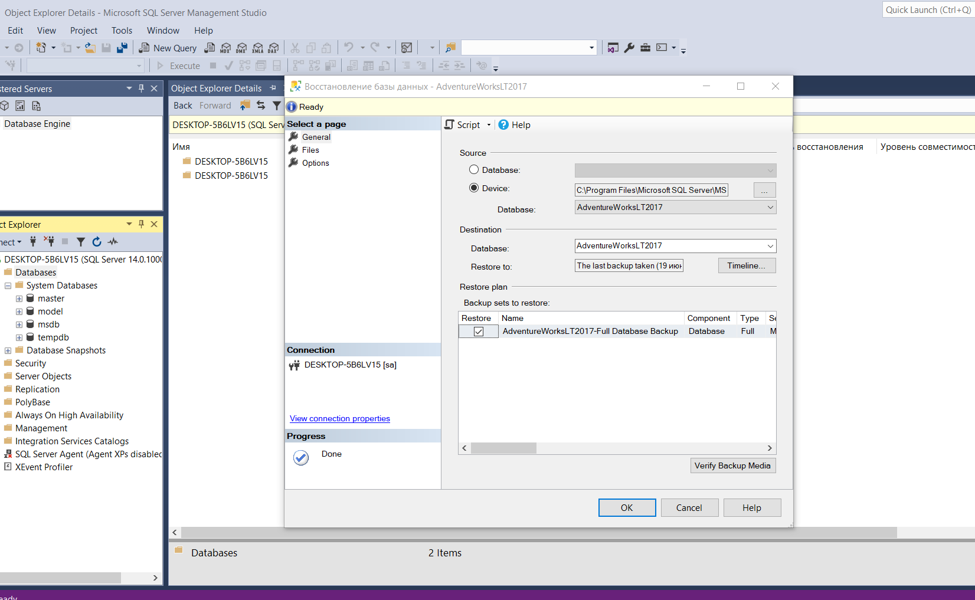

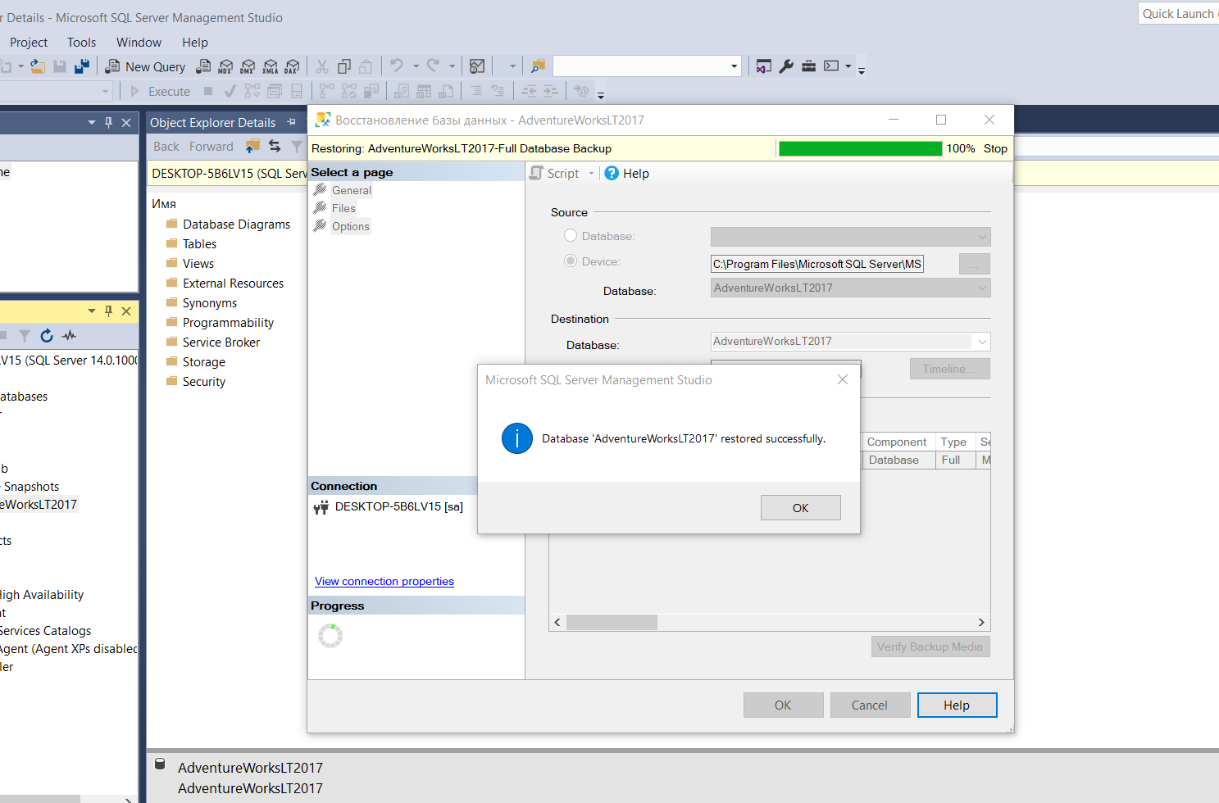

Giving to first user MYSON1 access to Human Resources scheme from AdventureWorks2017 database

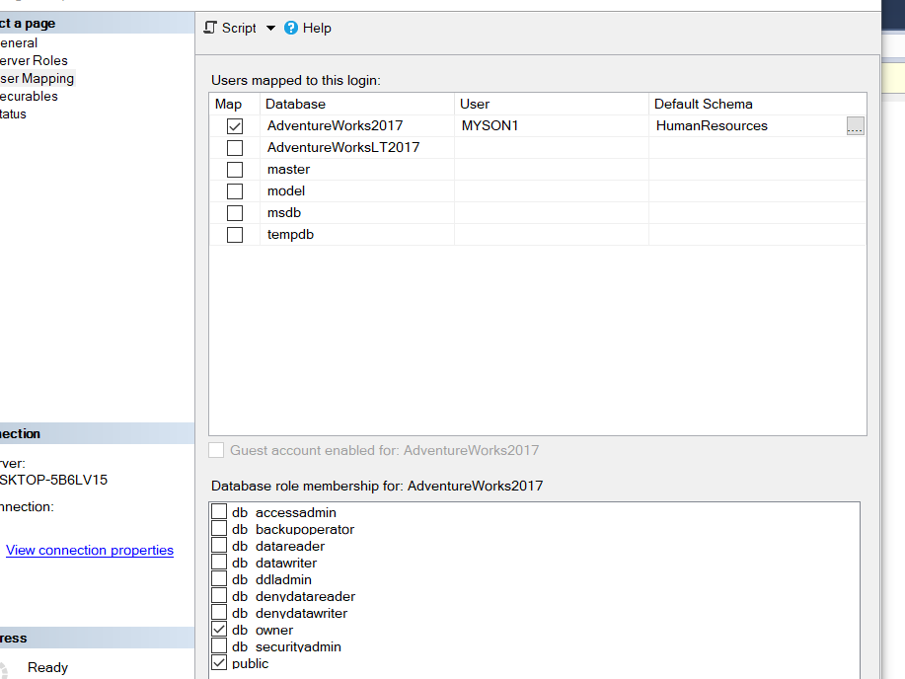

Giving to second user MYSON2 access to Sales scheme from AdventureWorks2017 database as a reader

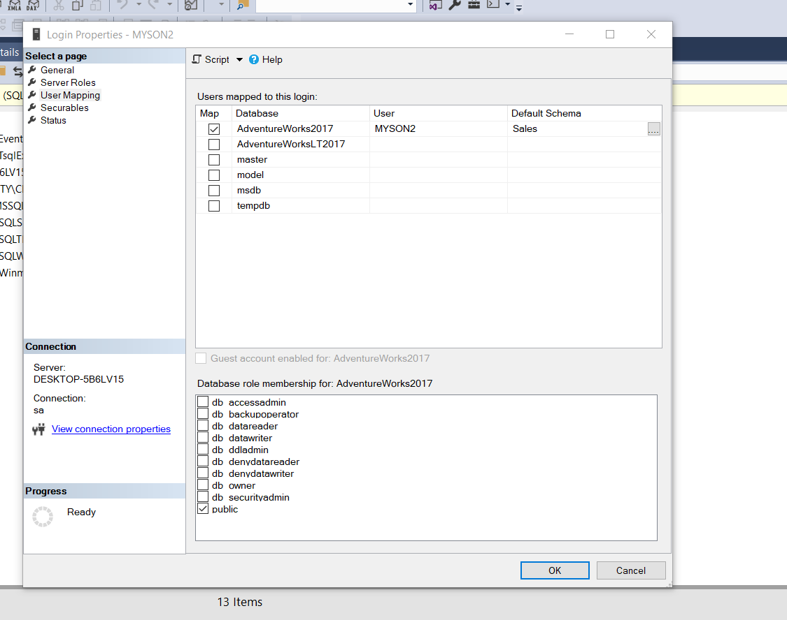

Giving to third user possibility to crate databases

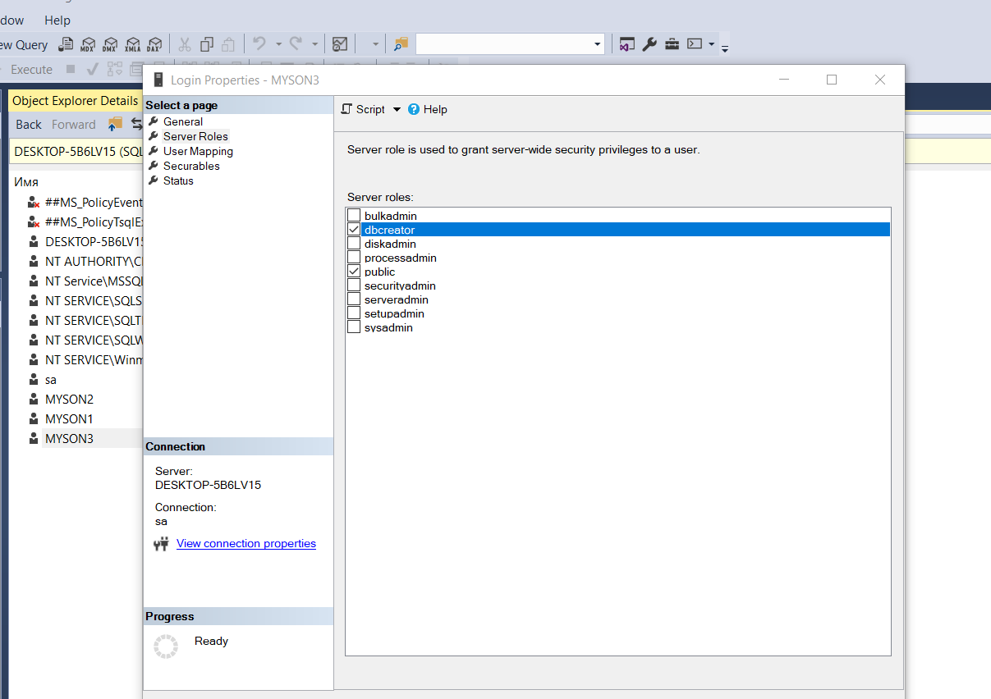

Conclusion: So,we installed SQL Server and logged in with SQL Authentifiocation. Also we gave some roles to users in different schemes and databases.

