**a. Visualize Gujarat state’s population:**

*#importing libraries*

import folium

import pandas as pd

import numpy as np

*#reading the csv files which contains the population data of India*

district_wise_census = pd.read_csv("/content/district wise population and centroids.csv")

district_wise_census.head()

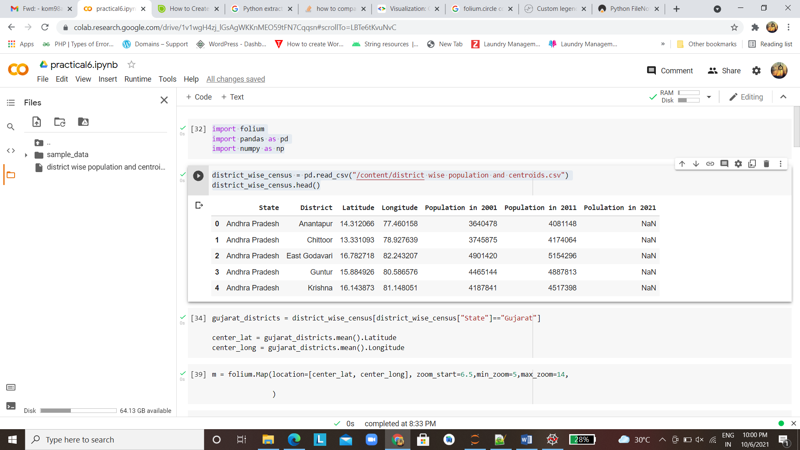

*#select the state as Gujarat and their Latitude and Longitude*

gujarat_districts = district_wise_census[district_wise_census["State"]=="Gujarat"]

center_lat = gujarat_districts.mean().Latitude

center_long = gujarat_districts.mean().Longitude

*#plotting the map*

m = folium.Map(location=[center_lat, center_long], zoom_start=6.5)

m

for district in gujarat_districts["District"].unique():

  district_census = gujarat_districts[gujarat_districts["District"]==district]

*#adding the circle according to population of city in Gujarat state*

  folium.Circle(

    location=[district_census.Latitude.values[0], district_census.Longitude.values[0]],

    radius = float(district_census["Population in 2011"].values[0]/100),

    color="yellow" if(district_census["Population in 2011"].values<2000000) else"blue",

    fill_color="yellow"if(district_census["Population in 2011"].values<2000000)else"blue",

    popup="Population 2011 : %s"%district_census["Population in 2011"].values[0],

    tooltip = district_census.District.values[0],

    ).add_to(m)

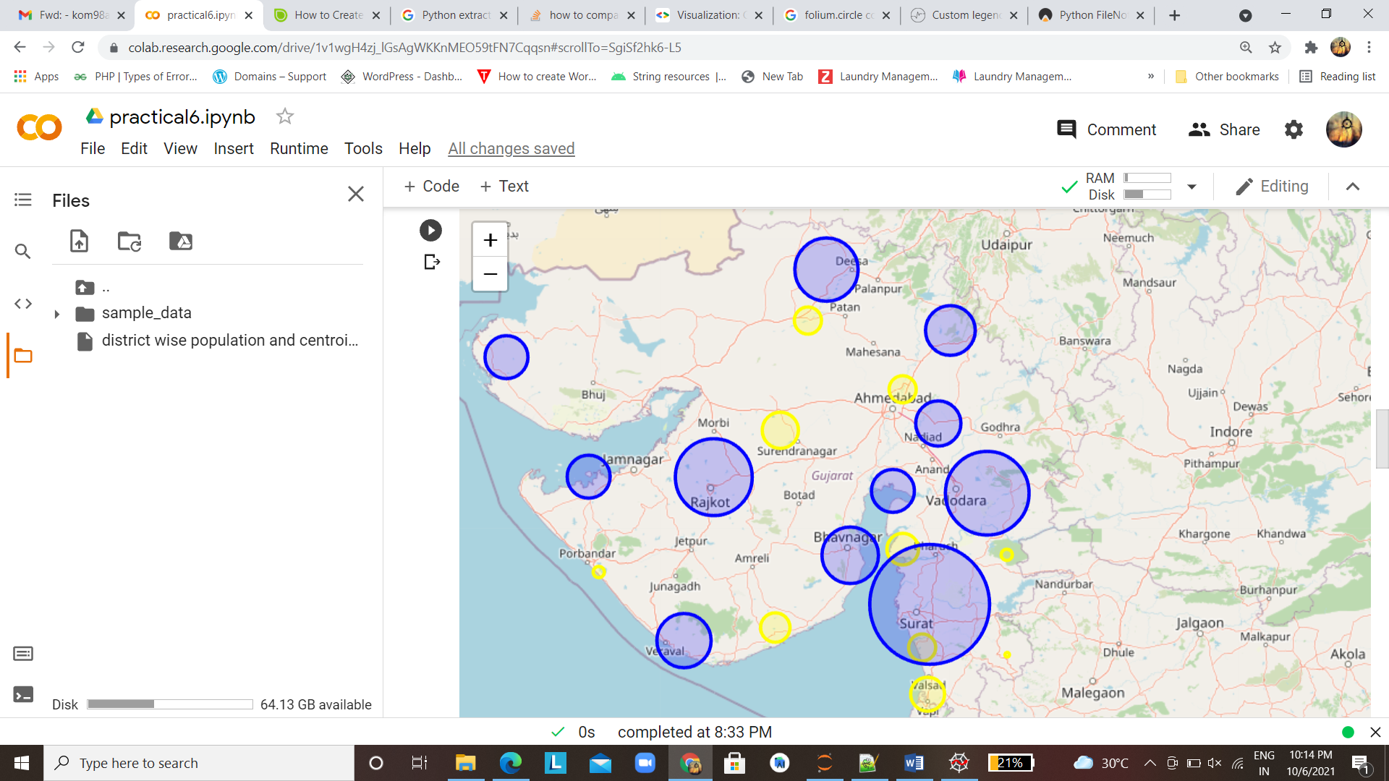

**b. State wise literacy rate of India:**

*#importing libraries*

import json

import numpy as np

import pandas as pd

import plotly.express as px

*#reading the Geojson file*

india_states = json.load(open("C:\\Users\\Admin\\Downloads\\states_india.geojson", "r"))

india_states

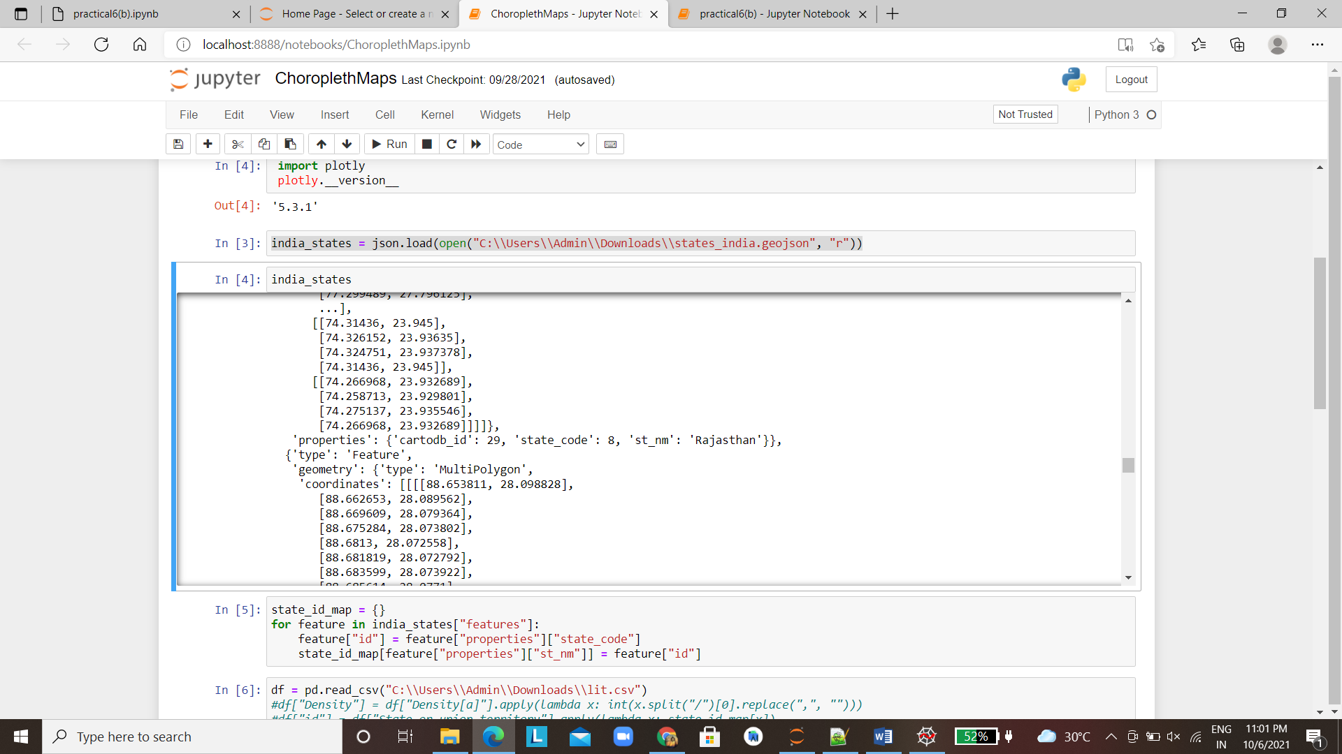

*#from the geojson file making the feature is of state*

state_id_map = {}

for feature in india_states["features"]:

feature["id"] = feature["properties"]["state_code"]

state_id_map[feature["properties"]["st_nm"]] = feature["id"]

*#reading the csv file having literacy data of india*

df = pd.read_csv("C:\\Users\\Admin\\Downloads\\lit.csv")

*#mapping the states of geojson file and csv file*

df["id"] = df["States"].apply(lambda x: state_id_map[x])

df.head()

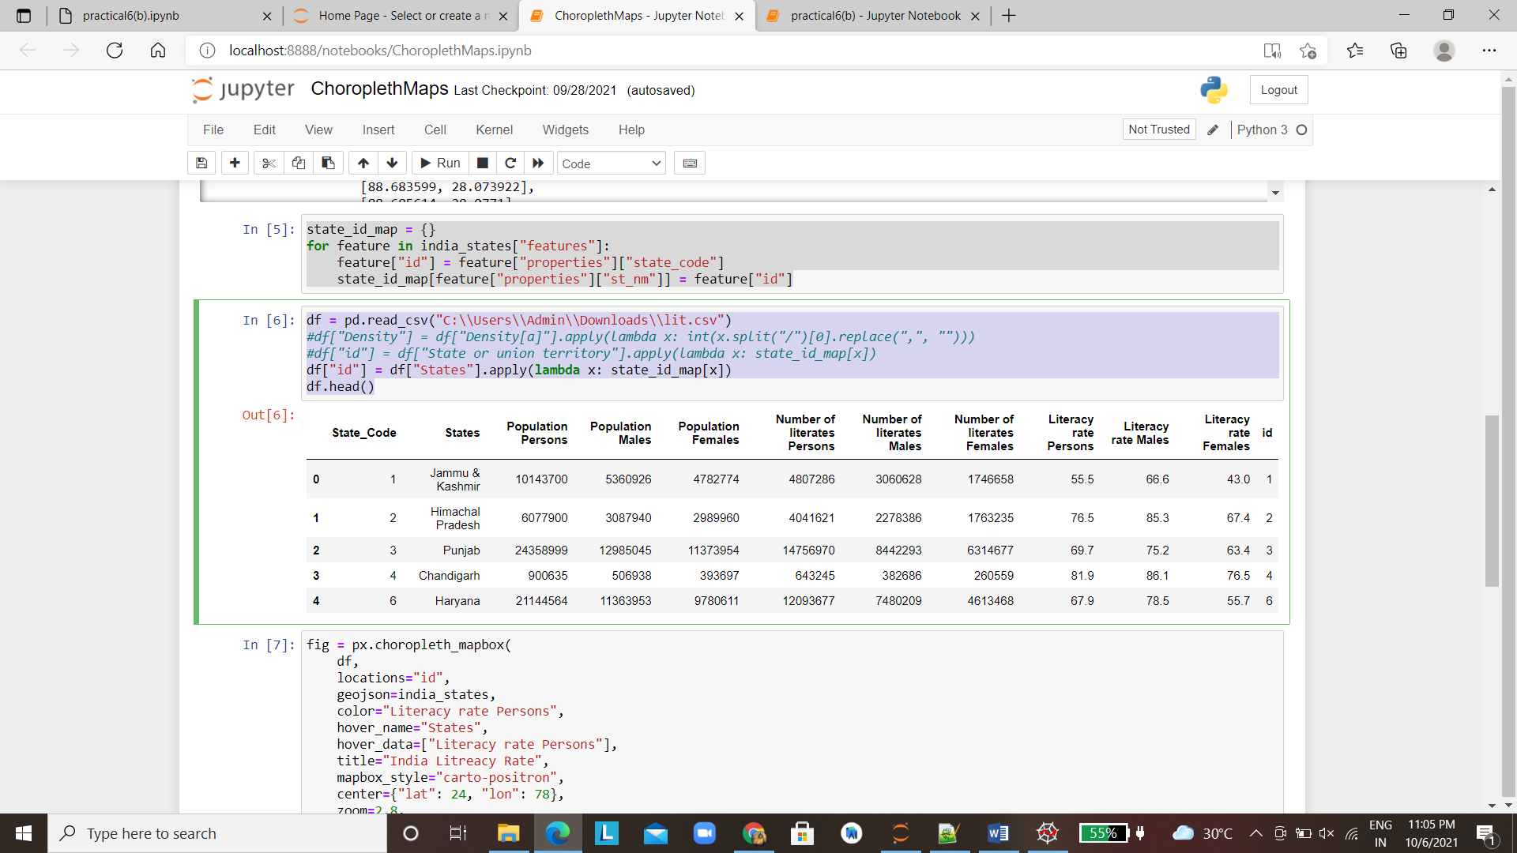

*#plotting the map*

fig = px.choropleth_mapbox(

df,

locations="id",

geojson=india_states,

color="Literacy rate Persons",

hover_name="States",

hover_data=["Literacy rate Persons"],

title="India Litreacy Rate",

mapbox_style="carto-positron",

center={"lat": 24, "lon": 78},

zoom=2.8,

)

fig.show()

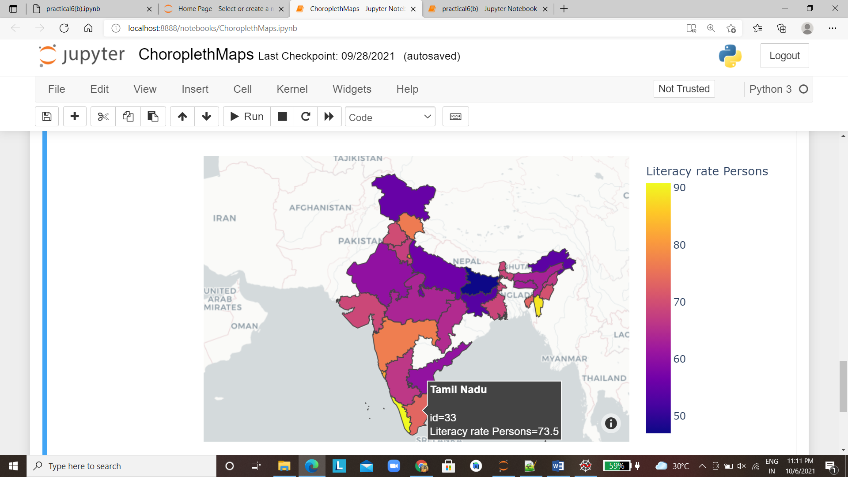

**c.** **Railway lines in Gujarat**

#reading the csv file

import pandas as pd

df = pd.read_csv("/content/Indian_railway1.csv",encoding="latin1",nrows=50)

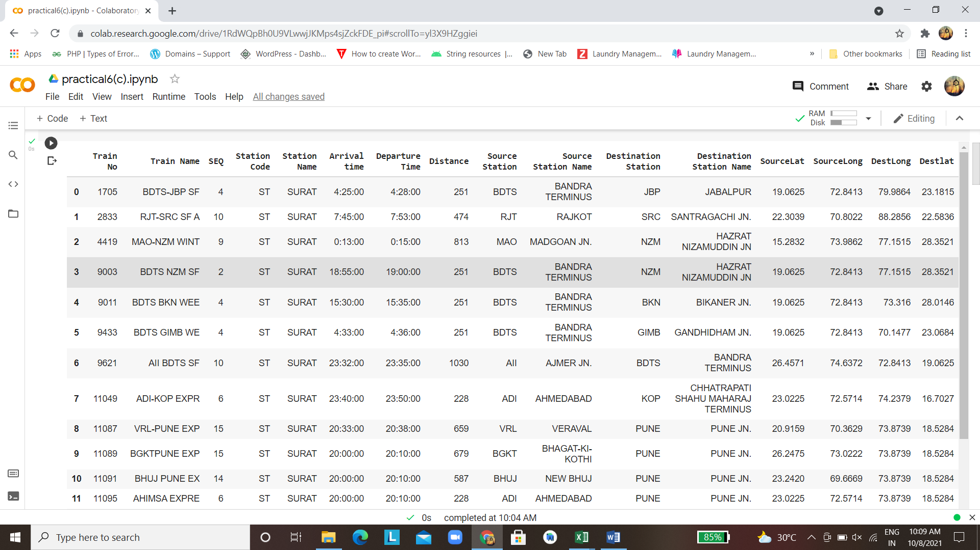

#importing libraries

import pandas as pd

import geopandas as gpd

import matplotlib.pyplot as plt

import plotly.graph_objects as go

fig=go.Figure()

source_to_dest = zip(df["SourceLat"], df["Destlat"],

                     df["SourceLong"], df["DestLong"],

                     df["Distance"])

*# Loop thorugh each station entry to add line between source and destination*

for slat,dlat, slon, dlon, distance in source_to_dest:

    fig.add_trace(go.Scattergeo(

                      lat = [slat,dlat],

                      lon = [slon, dlon],

                      mode = 'lines',

                      line = dict(color='#111021', width=1,dash='dash')

                        ))

*# Logic to create labels of source and destination cities of stations*

cities =df["Source Station Name"].values.tolist()+df["Destination Station Name"].values.tolist()

scatter_hover_data = [city for city in cities]

*#Loop thorugh each station entry to plot source and destination as points.*

fig.add_trace(

    go.Scattergeo(

                lon = df["SourceLong"].values.tolist()+df["DestLong"].values.tolist(),

                lat = df["SourceLat"].values.tolist()+df["Destlat"].values.tolist(),

                text = scatter_hover_data,

                textposition='top right',

                textfont=dict(color='#f0251a'),

                mode = 'markers+text',

                marker = dict(size = 10, color = 'green', opacity=0.1,))

    )

*# Update graph layout to improve graph styling.*

fig.update_layout(

    height=500, width=800, margin={"t":0,"b":0,"l":0, "r":0, "pad":0},

    showlegend=False,

    ,

    geo = dict(projection_type = 'natural earth',scope = 'asia'),

                )

fig.show()

