Using Maple to find a power series solution of a differential equation.
As you have seen, solving a differential equation using power series can be tedious. Now when the purpose is to solve a problem and a suitable device is available, it is often useful to know how to use the device.

You can do your own searches, if and when you have time, here are a few examples to get you started.
To solve 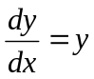 say, using power series you punch in the following commands:

> with(powseries):
> a:=powsolve(diff(y(x),x)=y(x)):
tpsform(a, x,8);

On hitting enter you would get:
Here C0 is a constant and the above line means that the solution is
(Here 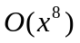means that after 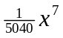there are terms that involve power 8 or higher of x.
If you do not give any number you would get the series truncated at the fifth power. Here is the example:
> a:=powsolve(diff(y(x),x)=y(x)):
tpsform(a, x);
Before I let you play with it, I ask you to remember one thing. The software will not give you a general term of the power series. For example the power series solution given above does not give you the information that the solution of is your usual 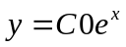.
Now here is a somewhat nontrivial example: (Recall that if you already have >with(powseries): on your screen you need not repeat it.)

> a:=powsolve(diff(y(x),x$2)-y(x)=0):
> tpsform(a,x,8);
Here there are two constants involved that means that there are tow linearly independent solutions. Once you sift though you would find that the solutions are:
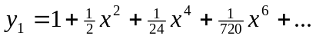 and 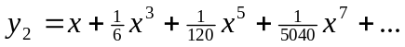

Now the question is when you are faced with a situation like:
Find a series solution of 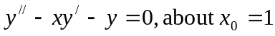.. In such a case you can use the z-substitution: Put z=x-1. This gives you x=z+1. You can change the equation to
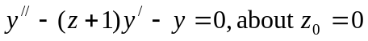,
> a:=powsolve(diff(y(z),z$2)-(z+1)*diff(y(z),z)-y(z)=0):
> tpsform(a,z,8);
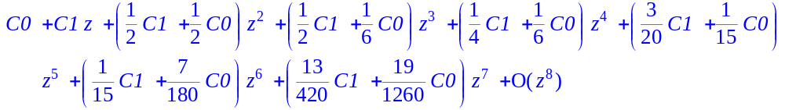
Now sift through and rewrite the two solution by substituting z=x-1.
There is the last job of taking care of problems like
For such problems the command is:
> a:=powsolve(diff(y(x),x$2)-x*diff(y(x),x)-y(x)=0,y(0)=2,D(y)(0)=1):
> tpsform(a,x,8);
