Using Euler’s tangent line method to approximate solutions
The idea is: If you are given an initial value problem such as 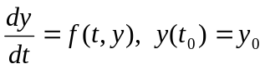, and if both 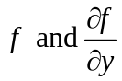 are continuous in some rectangle about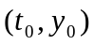, i.e. you know that there is a possible solution 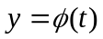, then note that 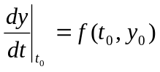 is the slope of the tangent to the graph of at the point . Let us write the equation of the tangent to at . The equation of the tangent is 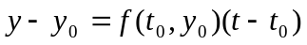. This equation can be written as: 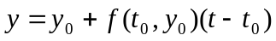………(1).
In the absence of a clear-cut analytic formula for we can say that all right passes through so if there is a point very close to on the t-axis then let us use the equation (1) of the tangent at to approximate the value of 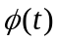 at . (After all, a tangent touches the curve and so must be very close to it near the point of tangency!) So we say that 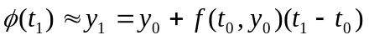.
Let us take an example for clarity so that we can make appropriate pictures. I choose the example given in your book (on page 98): 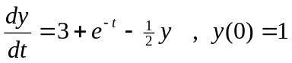. The equation of the tangent at the point (0,1) is 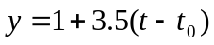. I like this example because the authors have appropriately taken a differential equation whose analytic solution 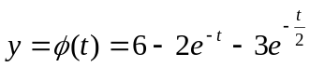 can be easily found. The graphs of the exact solutions and the tangent are given below: The red line is and the green one is the tangent at (0,1).

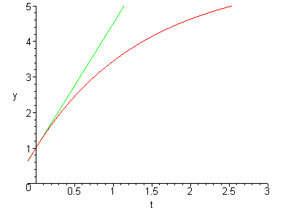
You may note that at t=0.1 the graph of the curve is almost indistinguishable from that of the tangent, while at t=0.3 the difference between y(.3) (on the tangent) and 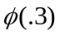 (on the curve) is appreciable. But we are dealing with lines here, which have no thickness, so rest assured that there is indeed some difference between y(.1) (on the tangent) and 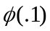. To make a clearer picture we take =.3. We note that on the tangent y(.3)=2.05 which is clearly greater than 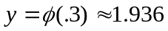. Now if we approximate by y(.3)=2.05 then we are on the solution of the initial value problem: 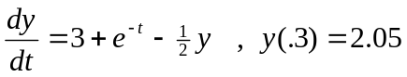. Now we have the following picture, including the necessary Maple computations and plot commands:
> dsolve({diff(y(t),t)=3+exp(-t)-.5*y(t),y(.3)=2.05},y(t));
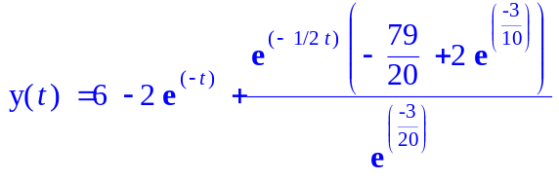

> evalf(%);
>
> plot({6-2*exp(-t)-2.87*exp(-t/2),6-2*exp(-t)-3*exp(-t/2),1+(3.5)*t},t=-.1..3,y=0..5);
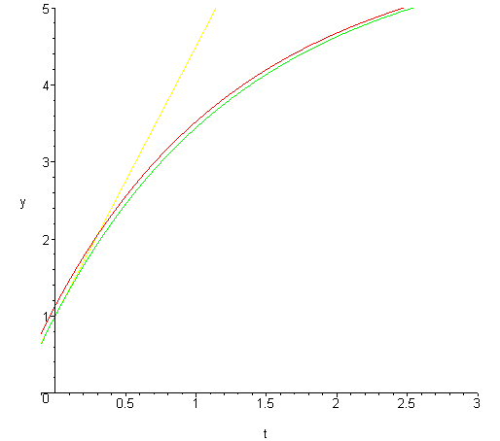
Here the green line is the solution to the original initial value problem red line is the solution to the IV problem and the tangent at (0,1) to the actual solution to the original solution is sort of yellow. But have you noticed? We set out to find the solution of , used the tangent method to approximate the solution at t=.3 and now we are stuck with the initial value problem . We can use the tangent at (0.3, 2.05) to approximate the value of the solution to this new IV problem at t=.6 and take it as an approximate value for 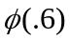 and repeating the whole procedure over and over again we can make a sequence of approximations for 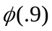, 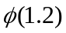, etc. With the choice of the step size = .3 we may wander away from the exact solution but we know that had we taken step size = 0.1, we would not be too far from the actual value. Let us then go back to the generalities to fix the method.
We had the initial value problem: .
We used the tangent at to approximate 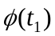 as 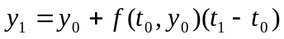. We got stuck at the initial value problem 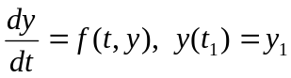 so we decided to use the tangent method all over again and the equation of the tangent at 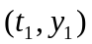 is 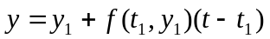. Now we can use this tangent to approximate 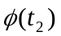 as 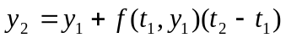. We can proceed similarly and have a whole sequence of approximations:
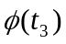 as 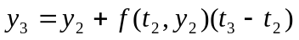
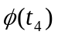as 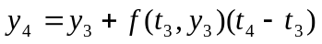 and generally
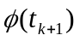as 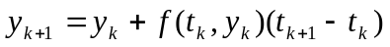 where we assume that 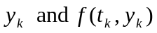have been computed before. Life will be easier if we assume that 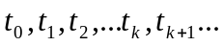 is an increasing sequence of numbers and that 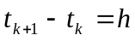 a constant. Then we can approximate as 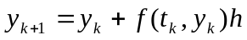
This gives us the following tabular procedure (let’s say for our favorite initial value problem with h=0.1):
t | y(t) | f(t, y(t))= 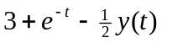
=0 | 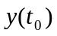=1 | 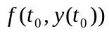=3.5
=0.1 | 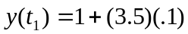=1.35 | 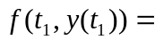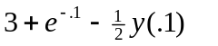=3.2298
=.2 | - - -- | --- ---
Proceeding in this fashion making new approximations using previous approximations we produce a whole sequence of approximate points for the graph of which can be plotted to get an idea of the solution. Excel is very well suited for this kind of computations. The attached Excel file would give you the idea of how to do those approximations quickly and efficiently. In Excel only two columns are necessary thanks to the facility of writing formulas. I have used the third column to give the corresponding values of the exact solution.

