MATH 160 Test 03 (Pract.), Spring 2002
Name:
- Find the indefinite integrals.
(i)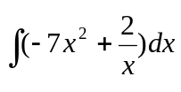

(ii) 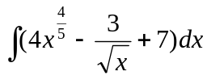

(iii) 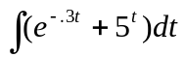

- Given that f(x) is a function such that f(0)=7 and 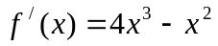. Find f(x).

- A car starts moving at time t = 0 and goes faster and faster. Its velocity is shown in the following table. Estimate how far the car travels during the first 12 seconds
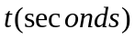 | 0 | 3 | 6 | 9 | 12
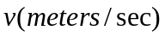 | 0 | 10 | 12 | 45 | 75

- You are moving with velocity 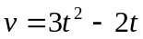, meters/sec, and want to calculate the distance traveled between t = 0 and t = 5.
(i). Graph the velocity function and show on the graph left and right hand estimates of the distance traveled, with n = 5.

(ii). Calculate, using your calculator, or otherwise, the net distance traveled between t = 0 and t = 5.

5. Assume that a function f(x) is differentiable everywhere and has just one critical point at x=4. If 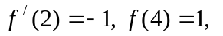 and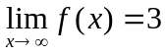, decide if x = 4 is a local max, local min or neither. Also sketch the graph of the function.

- Find the local maxima and local minima of the function 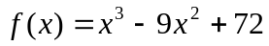. Use this information and your calculator to sketch a graph of the function.

7. The attached figure shows cost and revenue functions for a product. For approximately what production level is the profit function positive? Negative? Estimate the production level at which the profit is maximized.
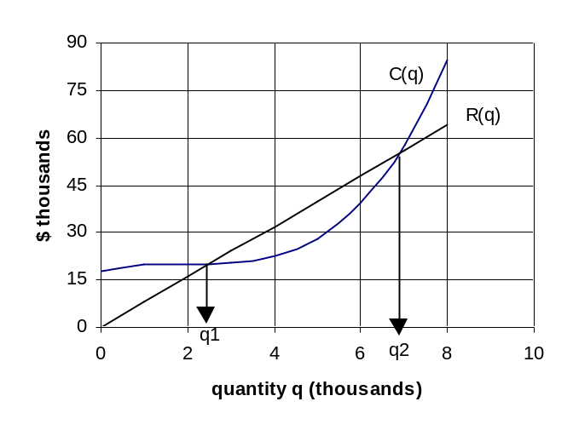

- Attached is the graph of a function f(x).
(a). Indicate on the graph of f(x), approximately where the critical points are and where the points of inflection are.
(b). Sketch the graph of 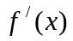.
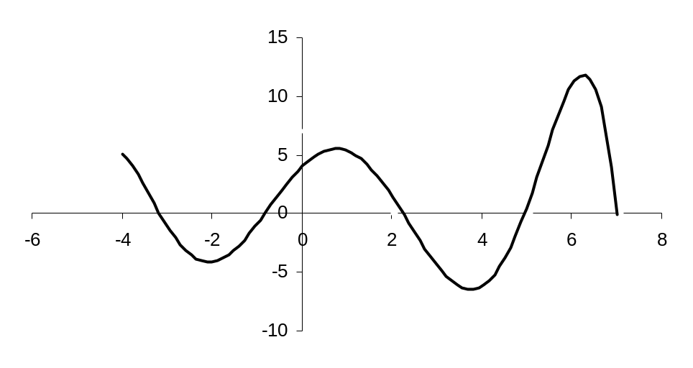

9. The attached figure shows the response curves of drugs A and B. Which of these drugs has the larger range of safe and effective dosage?
