MATH 160 TH Quiz 4, Spring 2002
Name:

5. Use the rules of differentiation to find the derivatives of the following functions:
(a). 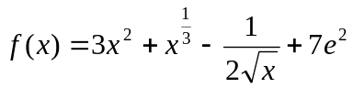

(b). 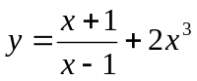

(c). 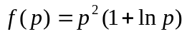

(d). 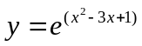

6. (a). If 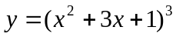 find 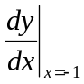

6. (b). Find the equation of the line tangent to the graph of 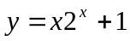 at x = 0.

7. The population of a country after t years since 1990 is approximated by 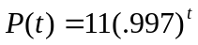 million.
- What was the population of that country in 1990?
- What was the rate of change of the population at the end of the year 2000? What is the sign of the rate of change that you have computed? How do you interpret it?

8. Let 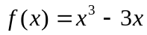.
(a). Find 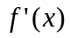 and use it to determine the intervals over which f(x) is decreasing. (exact numbers required.)
(b). Find 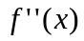and use it to determine the intervals over which f(x) concave down.

9. The cost (in dollars) of producing q items is given by 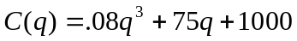.
- Find the marginal cost function.
- Find 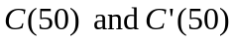. Give units with your answers.

