Statistics Notes
Given below are some questions. I give hints when I think that you may need help.

- I need a sample of 20 students from a list of 805. Label those students from 1 to 805 and give me one sample of 20 using random sampling (using a table or a calculator and indicating how you did it). Also, give me a sample of 20, using systematic random sampling, indicating the procedure. (page 18).
- Suppose that 100 of the 805 students of problem 1 are graduating seniors and that I want them well represented. What kind of sampling would you use? Approximately how many graduating seniors will be in a sample of 20? (page 22).
- What is the difference between an observational study and a designed experiment? Look up at least one example of each.
- Label the following variables qualitative or quantitative as appropriate:
Height,
Weight
Place of birth
Color of hair
High school class rank
Amount of water in a beaker
Telephone number of a person
Number of courses
- Given the data respond to the requests that follow: 83, 58, 77, 57, 87, 93, 70, 85, 92, 92, 79, 68, 82, 72, 68, 76, 88, 90, 81, 76, 77, 55, 74, 73, 82, 86, 92, 84, 89, 64, 35, 73.
(i). Prepare a stem and leaf diagram of the data and comment on the shape of the distribution.
(ii). Complete the following frequency and relative frequency table.
Class | Tally | Frequency | Relative Frequency
30-39
40-49
50-59
60-69
70-79
80-89
90-99

(iii). Use the above table to construct a frequency histogram of the data.
(iv). Give the “five number summary” and construct the box plot of the data. Decide if the data contains any outliers
- Given the data: 5,14, 7, 10, 6, 8, 12, 9, 10, 9, 7, 11.
- Find the mean________ , median ________, and mode ________, of the data.
- Test the data for normality using the normal probability plot. (You are supposed to use Table III for the z-scores.)
- Find the variance of the data using the fact that 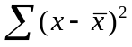=74 and assuming that the above data is a sample.
- Find the standard deviation of the above data assuming that it is the data of a population.

- The following table provides 8 observations of y against x.
Observation | 1 | 2 | 3 | 4 | 5 | 6 | 7 | 8
x | 2.4 | 3.4 | 4.6 | 3.7 | 2.2 | 3.3 | 4 | 2.1
y | 1.33 | 2.12 | 1.80 | 1.65 | 2.00 | 1.76 | 2.11 | 1.63

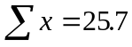, 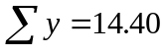, 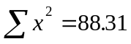, 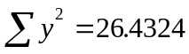 and 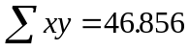,
- Using your calculator, or the information above, find the (linear) coefficient of determination of the data and comment on the strength of relationship between the x’s and the y’s.

- Using your calculator, or the information above, find the slope and the intercept 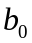 of the line of regression taking x as predictor and y as response.
- The following table provides observations of y against x.
x | 6 | 6 | 2 | 5 | 4 | 5 | 1 | 4
y | 205 | 195 | 299 | 230 | 270 | 243 | 340 | 240

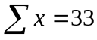, 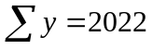, 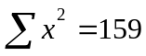, 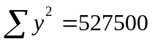 and 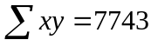,
- Using your calculator, or the information above, find the liner correlation coefficient of the data and comment on the strength of relationship between the x’s and the y’s.

- In general what can you tell about the slope from the linear correlation coefficient?

- Using your calculator, or the information above, find the slope and the intercept of the line of regression taking x as predictor and y as response.

- Write the regression equation 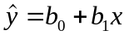 and use it to predict the value of y for x=3.

- The following table provides the frequency distribution for the number of rooms in US housing units. The frequencies are in thousands.
Rooms | 1 | 2 | 3 | 4 | 5 | 6 | 7 | 8+
Freq. | 471 | 1,470 | 11,715 | 23,468 | 24,476 | 21,327 | 13,782 | 15,647
Total number of housing units: 112,356
For a US housing unit selected at random, let
A = event the unit has at most 4 rooms.
B = event the unit has at least 2 rooms.
C = event the unit has between 5 and 7 rooms inclusive.
D = event the unit has more than 7 rooms
- Describe each of the above events (e.g. A = {1,2,3,4}= the unit has 1 rm or 2 rms or 3 rms, or 4 rms.).
- Find P(A), P(B) and P(C). (e.g. 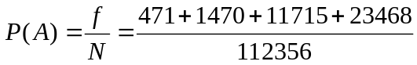)
- Describe each of the events and find their probabilities: (not A), (A &B), (C or D).

- In Problem 9 above, X= “number of rooms” is a random variable. Using this notion the event A can be written as A =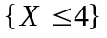. Rewrite the events B, C and D using the random variable notation.
- The following table displays a frequency distribution for the number of crew- members on each shuttle mission from April 1981 to July 2000.
Crew Size | 2 | 3 | 4 | 5 | 6 | 7 | 8
Frequency | 2 | 1 | 2 | 36 | 18 | 33 | 2
Let X denote the crew size of the randomly selected shuttle mission between April 1981 and July 2000.
- What are the possible values of the random variable X? (Ans. X=2,3,4,5,6,7,8)
- Use random variable notation to represent the event that the space shuttle mission obtained has a crew of size 6. (Ans. {X=6})
- Find P(X=6). (Ans. 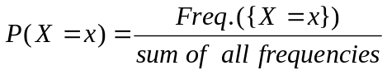=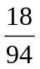).
- Find P(X=4) and interpret it in terms of percentages.
- Obtain the probability distribution of X, by writing the value of P(X) under each possible value of X in the following table
X | 2 | 3 | 4 | 5 | 6 | 7 | 8
P(X) |  |  |  |  | .1915

12. Given in the table below are two investment options.
Option A |  |  | Option B
Profit =x | P(X =x) | 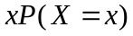 | Profit = x | P(X =x)
-2000 | .2 | -400 | -3000 | .2
100 | .1 | 10 | -1000 | .1
1000 | .3 | 300 | 2000 | .2
2000 | .3 | 600 | 3000 | .3
4000 | .1 | 400 | 4000 | .2
 |  | 910
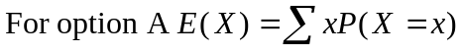=910

For the given probability distribution of the random variable of option A, the expected value (or the mean ) =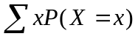= 910. Find the expected value of profit in option B and decide which gives higher expected value. (Note. The negative profit is loss, as you already know.)
- A fair die is rolled. Count “six showing up” as success denoted as s.
- Find P(s) = (probability of success). (Ans. P(s) = 1/6 why?)
- Denote failure by f, indicate what you mean by it in this context, and find P(f).
- Give all the necessary reasons to establish that: Rolling a (fair) die looking for six is a Bernoulli trial.
- Suppose that a fair die is rolled 4 times and let X denote the number of times six shows up. What are the possible values of X? (Ans. X = 0,1,2,3,4)
- Use the binomial probability formula to find P(X =2). (Note: Here n = the number of trials =4, the probability p of success is 1/6 and the formula is: 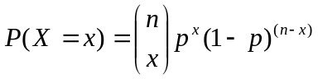.
- Use the formula in part (v) to verify the following table and use the following table to compute the expected value of X.
X | 0 | 1 | 2 | 3 | 4
P(X) | .48225 | .3858 | .11574 | .01543 | .00077

  - Find the expected value of X.
  - Assess the normality of the distribution of P(X).
  - Find P(X<2) from the above table.

More to come in the next instalment.

