Smart Tender & Auction Portal
(STAP)

Project Review Document

A Role-Based Platform for Digital Tendering and Auctioning

Submitted By

Name | Division | Roll No
Nem Shah | G | C54
Priyansh Shah | G | E41
Kamlesh Prajapati | G | E54

Guidance By
Jahanvi Shukla

Index
Sr. No. | Section Title
1. | Introduction
2. | Existing System
3. | Need for the New System
4. | Objective of the New System
5. | Problem Definition
6. | Scope of the Project & Core Components
7. | Project Profile
8. | Assumptions and Constraints
9. | Advantages and Limitations of the Proposed System
10. | Requirement Determination & Analysis
10.1 | Requirement Determination
10.2 | Targeted Users
11. | Use Case Diagram
12. | Class Diagram
13. | Interaction Diagram (Sequence Diagram)
14. | Activity Diagram

1. Introduction
The Smart Tender & Auction Portal (STAP) is a role-based web application designed to digitise the processes of tendering and auctioning. Traditional tendering and auction processes in government and corporate procurement are burdened by manual paperwork, lack of transparency, susceptibility to collusion, and delayed result declaration. STAP addresses these problems by providing a unified platform where Government agencies, Companies, and general Users can create, manage, and participate in tenders and auctions through clearly separated role-based dashboards.
The system is built on a Spring Boot 3.2 back end with a Thymeleaf-rendered front end, PostgreSQL persistence, WebSocket-driven live bid updates, scheduled automatic deadline enforcement, email notifications via Gmail SMTP, and a rule-based chatbot for user assistance. Security is enforced through Spring Security with BCrypt password hashing, CSRF protection, session fixation guards, rate limiting, and audit logging.
This review document analyses the project's design, architecture, and implementation status. All assertions in this document are grounded in the actual codebase of the STAP repository.

2. Existing System
Existing tender and auction systems, particularly those used by government procurement bodies, typically suffer from one or more of the following problems:
- Paper-based or semi-manual processes: Tender notices are published in newspapers or bulletin boards. Bid submissions arrive as sealed physical envelopes. Evaluation is manual, error-prone, and slow.
- Fragmented digital solutions: Some organisations use email or basic web forms to collect bids, but these lack structured workflows, role separation, and real-time status tracking.
- No real-time bidding: Auctions, where present, run offline or through phone-based bidding with no live transparency for participants.
- Delayed result declaration: Winners are announced days or weeks after the deadline, with no automated mechanism to enforce timely closure.
- Weak security and auditability: Bid tampering, favouritism, and lack of immutable audit trails are well-documented problems in manual procurement.
- No integrated notification system: Participants must manually check for updates; there is no automated email or in-app notification to inform stakeholders of deadline changes, bid receipt, or winner announcements.

3. Need for the New System
Given the limitations of the existing system, there is a clear need for a purpose-built digital platform that:
- Centralises tender and auction management under a single web application, eliminating the need for separate systems or manual processes.
- Enforces role-based access control (RBAC) so that Admins, Government users, Companies, and general Users each see only the functionality and data relevant to their role. The STAP codebase defines four roles in the UserRole enum: ADMIN, GOVERNMENT, COMPANY, and USER, each mapped to a dedicated controller and dashboard.
- Provides real-time bid updates via WebSocket (STOMP over SockJS), so that all participants in an auction see bids as they arrive, promoting transparency.
- Automates deadline enforcement through server-side scheduled tasks. The AuctionScheduler runs at configurable intervals (default: every 60 seconds for auctions, every 5 minutes for tenders) to close expired items and declare winners.
- Delivers email notifications for critical events — OTP-based password reset, bid confirmation, winner announcements, and loser notifications — using an idempotent, retry-capable email pipeline.
- Maintains an immutable audit trail (AuditRecord entity) that logs every security-sensitive action with actor, IP address, action type, entity reference, and timestamp.

4. Objective of the New System
The primary objectives of the Smart Tender & Auction Portal are:
- To provide a transparent, tamper-resistant platform for creating, managing, and participating in tenders and auctions.
- To enforce server-side business rules — such as minimum tender duration of 3 days (BusinessRuleValidator.MIN_TENDER_DAYS), minimum auction duration of 30 minutes (BusinessRuleValidator.MIN_AUCTION_MINUTES), edit-lock windows (24 hours before tender start, 1 hour before auction start), and prohibition of self-bidding — ensuring fair play regardless of client-side behaviour.
- To declare winners automatically: the lowest bidder wins a tender, and the highest bidder wins an auction, with results published immediately after the deadline through the ClosureService.
- To support Earnest Money Deposit (EMD) payments through a pluggable PaymentGateway interface, currently backed by MockPaymentGatewayImpl for development and testing.
- To provide a rule-based chatbot (ChatbotService) that answers frequently asked questions about platform usage, tender processes, and auction rules.
- To ensure security through BCrypt password hashing, CSRF token validation, session fixation protection, account lockout after five failed login attempts (configurable via app.security.login.max-attempts), rate limiting, and restrictive HTTP security headers.

5. Problem Definition
The problem can be stated as follows: Design and implement a web-based role-separated platform that allows government bodies and companies to publish tenders and auctions, allows registered companies and users to submit bids or proposals, enforces configurable business rules on duration, timing, and participation eligibility, automatically closes expired items and declares winners based on deterministic criteria (lowest bid for tenders, highest bid for auctions), provides real-time bid visibility through WebSocket connections, sends email notifications at critical lifecycle points, records an immutable audit trail of all significant actions, and exposes administrative controls including user management, data export (CSV), and platform-wide dashboards.

6. Scope of the Project & Core Components
The scope of the STAP project encompasses the following core components:

6.1 Authentication & Authorisation Module
Handles user registration (signup), login with BCrypt password verification, session management with Spring Security, OTP-based forgot-password flow (generate → verify → reset), account lockout after repeated failed attempts, and role-based redirection to the appropriate dashboard. Implemented in AuthController and AuthService.

6.2 Tender Management Module
Allows Government and Company users to create, edit, and delete tenders. Tenders have a title, description, category (Infrastructure, Technology, Supply Chain), start date, end date, and estimated budget. Business rules enforce a minimum 3-day duration and a 24-hour pre-start edit lock. Company users submit proposals with a bid amount, textual proposal, and optional document upload. The winner is the company with the lowest bid amount, declared automatically by ClosureService. Government users can also upload supplementary tender documents (TenderDocument entity). Implemented in GovernmentController, CompanyController, TenderService, and ClosureService.

6.3 Auction Management Module
Supports time-bounded auctions with a specific date, time, and duration in minutes (minimum 30). Auctions progress through lifecycle states: UPCOMING → LIVE → CLOSED (or CANCELLED), computed in real time by AuctionLifecycle. Bidding is allowed only during the LIVE window. Each participant may place exactly one bid per auction (enforced by a unique constraint on auction_id + bidder_id). The highest bidder wins, declared by ClosureService. Implemented in AuctionService, CompanyController, UserController, and AuctionScheduler.

6.4 Real-Time Bid Broadcasting Module
Uses Spring WebSocket with STOMP protocol over SockJS. The WebSocketConfig registers a STOMP endpoint at /ws with a simple broker on /topic. BidBroadcastService pushes BidMessage DTOs containing bid amount, bidder name, rank, participant count, and auction status to /topic/auction/{id} or /topic/tender/{id}. The WebSocket interceptor enforces authentication, role-based subscription (COMPANY and USER for auctions; COMPANY for tenders), and prevents owners from bidding on their own items.

6.5 Email Notification Module
EmailService composes and sends emails for events including OTP delivery, bid confirmation, winner announcement, loser notification, and creator result summary. EmailNotification entities provide idempotency (unique idempotency_key) and retry tracking (attempts, lastError). EmailNotificationListener processes EmailNotificationRequested domain events asynchronously. Delivery is handled by EmailDeliveryService using Spring Mail with Gmail SMTP.

6.6 Scheduled Closure & Winner Declaration Module
AuctionScheduler runs two fixed-delay scheduled tasks: closeExpiredAuctions (every 60 seconds by default) and closeExpiredTenders (every 5 minutes by default). Each task acquires a distributed SchedulerLock to prevent duplicate execution in multi-instance deployments. ClosureService processes each expired item in its own transaction (REQUIRES_NEW propagation for auctions) and records WinnerDeclaration entries with a unique constraint on (entityType, entityId).

6.7 Administration Module
The Admin dashboard provides platform-wide statistics (total users by role, total/open/closed tenders and auctions), user management (activate/deactivate), full CRUD on all tenders and auctions (with admin bypass of edit-lock rules), and CSV export endpoints for tenders, auctions, and users (AdminService).

6.8 Payment Module
PaymentService manages Earnest Money Deposit (EMD) payments for both tenders and auctions. Payments are recorded in the EmdPayment entity, which enforces a mutual exclusivity constraint — each payment targets either a tender or an auction, but not both. The PaymentGateway interface is currently backed by MockPaymentGatewayImpl for development.

6.9 Chatbot Module
ChatbotController exposes a REST API at /api/chatbot. ChatbotService implements a rule-based response engine that matches user queries against predefined keyword patterns and returns structured ChatResponse DTOs.

6.10 Monitoring & Observability
Spring Boot Actuator exposes health, info, and metrics endpoints. ReliabilityHealthIndicator provides custom health checks. WebSocketMetrics tracks WebSocket connection counts. Micrometer counters in AuctionScheduler and BidBroadcastService record scheduler runs, closures, skips, and WebSocket broadcast events.

7. Project Profile
Parameter | Details
Project Title | Smart Tender & Auction Portal (STAP)
Front-End | Thymeleaf 3.x templates, HTML5, CSS3, JavaScript, SockJS client
Back-End | Java 17, Spring Boot 3.2.5, Spring MVC, Spring Security, Spring WebSocket (STOMP), Spring Data JPA, Spring Mail, Spring Retry, Spring Cache (Caffeine), Lombok
Database | PostgreSQL (runtime), H2 (in-memory, for automated tests); schema managed by Flyway migrations
Tools Used | Maven 3.x (build), JaCoCo (code coverage), Spring Boot DevTools (hot reload), Spring Boot Actuator + Micrometer (monitoring), Logback (logging), Git (version control)
Team Size | 3

Team Members
Name | Division | Roll No
Nem Shah | G | C54
Priyansh Shah | G | E41
Kamlesh Prajapati | G | E54

8. Assumptions and Constraints

8.1 Assumptions
- The Admin account is seeded via environment variables (ADMIN_USERNAME, ADMIN_PASSWORD as a BCrypt hash) and cannot be created through the signup flow; the application assumes these variables are correctly set before first launch.
- SMTP credentials (SMTP_USERNAME, SMTP_PASSWORD) are expected to be valid Gmail App Password credentials. If they are absent or invalid, the email pipeline will log errors but the application will continue to function; email delivery degrades gracefully.
- The PaymentGateway interface is implemented by MockPaymentGatewayImpl, which always returns a success response. The system assumes that a real payment gateway will be integrated before production deployment.
- The database password (DB_PASSWORD) is supplied via an environment variable with no default value; the application will fail to start if it is unset.

8.2 Constraints
- Monetary values are stored as Java Double and rounded to two decimal places via MonetaryDoubleConverter. This introduces potential floating-point precision issues for very large amounts; a production system should migrate to BigDecimal or a monetary library.
- File uploads (auction images, tender documents, bid proposals) are stored in a configurable local directory (app.upload.dir, defaulting to ${user.home}/smartportal-uploads/). No cloud object storage or malware scanning is integrated; the README explicitly notes this limitation.
- The maximum file upload size is hardcoded to 10 MB in application.properties (spring.servlet.multipart.max-file-size=10MB).
- The WebSocket message broker is the Spring built-in SimpleBroker (in-memory). This does not support horizontal scaling across multiple application instances; a production deployment requiring multiple nodes would need an external broker such as RabbitMQ or Redis.
- Session concurrency is limited to one session per user (maximumSessions(1) in SecurityConfig); any second login invalidates the first session.
- Account lockout duration is hardcoded to 15 minutes (app.security.login.lock-duration=PT15M) after 5 failed attempts (app.security.login.max-attempts=5).
- The mobile number validation regex enforces exactly 10 digits with no country code prefix, limiting the system to Indian mobile numbers by default.
- Tender categories (Infrastructure, Technology, Supply Chain) are stored as free-text strings in the Tender entity rather than as a constrained enum, allowing arbitrary values to be entered.
- Caffeine cache (maximumSize=1000, expireAfterWrite=60s) is used for in-process caching. In a multi-instance deployment, caches will not be synchronised.

9. Advantages and Limitations of the Proposed System

9.1 Advantages
- Server-enforced business rules: All bidding constraints (minimum durations, edit-lock windows, self-bid prohibition, one-bid-per-participant uniqueness) are enforced on the server side in BusinessRuleValidator, AuctionService, and TenderService, making them immune to client-side bypass.
- Automatic winner declaration: The scheduler-based ClosureService eliminates human delay in result announcement. Winners are determined deterministically (lowest bid for tenders, highest bid for auctions) and persisted in a WinnerDeclaration table with a unique constraint.
- Real-time transparency: WebSocket-based live bid broadcasting allows all auction participants to see bids as they are placed, including rank and participant count.
- Idempotent email notifications: The EmailNotification entity uses a unique idempotency_key to prevent duplicate emails. The pipeline supports retries with configurable backoff.
- Comprehensive audit trail: Every security-sensitive action (login, bid, closure, winner declaration, errors) is recorded in AuditRecord with actor, IP address, and metadata.
- Role-separated dashboards: Each of the four roles (ADMIN, GOVERNMENT, COMPANY, USER) has a dedicated controller, template directory, and dashboard, ensuring clean separation of concerns.
- Optimistic concurrency control: Both Tender and Auction entities use JPA @Version fields, preventing lost-update problems when concurrent edits or bids target the same record.

9.2 Limitations
- No production-grade payment integration: The PaymentGateway is backed by a mock implementation that always succeeds.
- Local file storage only: Uploaded files reside on the local filesystem with no CDN, cloud storage, or virus scanning.
- No internationalisation or multi-currency support: All amounts are treated as a single currency with no locale-aware formatting.
- In-memory WebSocket broker limits horizontal scalability.
- The chatbot is rule-based (keyword matching) rather than NLP-driven, limiting its ability to handle novel user queries.
- OPEN-IN-VIEW is disabled (spring.jpa.open-in-view=false), which is the correct architecture, but it means any lazy-loaded association accessed outside a transactional context will throw a LazyInitializationException if not explicitly fetched.

10. Requirement Determination & Analysis

10.1 Requirement Determination

10.1.1 Functional Requirements
- Registration & Authentication: Users can sign up with name, email, 10-digit mobile, password (min 10 chars with uppercase, lowercase, number, symbol), role selection (USER, COMPANY, GOVERNMENT), and optional organisation name (mandatory for COMPANY and GOVERNMENT). Login returns a role-specific dashboard redirect. OTP-based password reset is available.
- Tender CRUD: Government and Company users can create tenders with title, description, category, start date, end date, and estimated budget. Editing is blocked within 24 hours of start. Deletion is blocked after start (except for Admin). Supplementary documents can be uploaded.
- Tender Bidding: Companies can submit proposals (bid amount, proposal text, optional document) on open tenders they did not create. One submission per company per tender, enforced by a database unique constraint (uk_tender_bid_participant).
- Auction CRUD: Government, Company, and Admin users can create auctions with title, description, photo, auction date, time, duration (min 30 min), and starting price. Editing is blocked within 1 hour of start.
- Auction Bidding: Companies and Users can place bids on live auctions they did not create. Bids must exceed the current highest bid. One bid per participant per auction (uk_auction_bid_participant constraint). Self-bidding is prohibited.
- Automatic Closure & Winner Declaration: Scheduled tasks close expired items and declare winners (lowest bidder for tenders, highest bidder for auctions). Results are persisted in WinnerDeclaration.
- Real-time Broadcasting: Live bid updates delivered via WebSocket to all subscribed participants.
- Email Notifications: OTP, bid confirmation, winner, loser, and creator-result emails sent asynchronously with idempotency.
- Admin Dashboard: View statistics, manage users (activate/deactivate), manage all tenders and auctions with admin-bypass privileges, export CSV.
- EMD Payments: Companies can pay Earnest Money Deposits for tenders and auctions.
- Chatbot: Rule-based chatbot accessible via REST API for user assistance.
- Public Pages: Landing page with open tenders/auctions, About, Contact form, paginated public auction and tender listings.

10.1.2 Non-Functional Requirements
- Security: BCrypt hashing (BCryptPasswordEncoder), CSRF tokens (HttpSessionCsrfTokenRepository), session fixation protection (changeSessionId), rate limiting (RateLimitFilter), X-Frame-Options DENY, Referrer-Policy SAME_ORIGIN, Permissions-Policy restricting camera/microphone/geolocation.
- Reliability: Spring Retry on closure operations (max 3 attempts, exponential backoff). SchedulerLock prevents duplicate scheduler execution. Each auction closure runs in an independent transaction (REQUIRES_NEW) so that one failure does not block others.
- Performance: Caffeine in-process cache (1000 entries, 60s TTL). Paginated queries for public listings (bounded page size: max 100). Async email dispatch.
- Observability: Actuator health/info/metrics endpoints. Custom ReliabilityHealthIndicator. Micrometer counters for scheduler runs, closures, WebSocket broadcasts. Logback-based structured logging with request correlation IDs (RequestCorrelationFilter).
- Maintainability: Flyway-managed database schema. Separation of concerns via layered architecture (Controller → Service → Repository → Entity). JaCoCo code coverage reporting.

10.2 Targeted Users
The system is designed for four distinct user categories:
- Admin: Platform administrator responsible for user management, platform-wide oversight of all tenders and auctions, data export, and system monitoring. Accesses the system via pre-configured credentials.
- Government: Government agency representatives who create and manage tenders and auctions on behalf of their organisations. They can view bids and submissions on their own tenders and auctions.
- Company: Corporate users who can create their own tenders and auctions, and can also participate (bid or submit proposals) in tenders and auctions created by others. They can view their bid history and win/loss statistics.
- User: General registered users who can browse and bid on live auctions. They have access to a dashboard showing their bids, wins, losses, and recent open auctions. Users cannot participate in tenders (only Companies can).

11. Use Case Diagram
The following Use Case Diagram identifies the four primary actors (Admin, Government, Company, User) and one system actor, along with their interactions with the Smart Tender & Auction Portal. Each use case corresponds to an actual route or service method in the codebase.

Actors
- Admin — Platform administrator with full system access.
- Government — Government agency user who publishes and manages tenders and auctions.
- Company — Corporate user who creates tenders/auctions and bids on others' items.
- User — General registered user who bids on auctions.
- System — Automated scheduler and event-driven components.

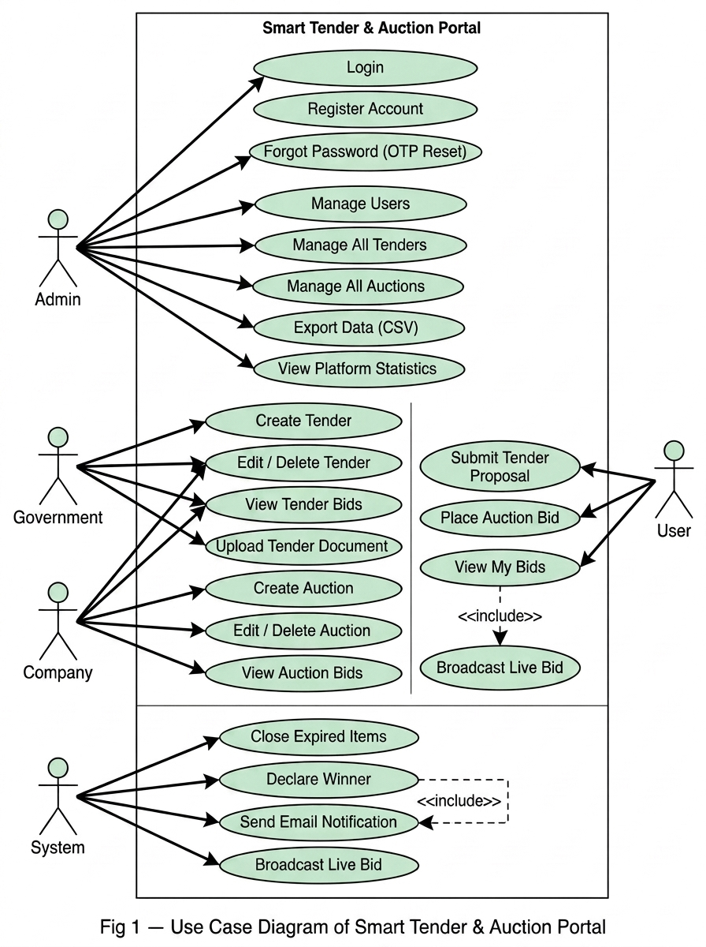
Fig 1 — Use Case Diagram of Smart Tender & Auction Portal

Key Relationships
- <<include>>: Place Auction Bid includes Broadcast Live Bid (every bid triggers a WebSocket broadcast). Declare Winner includes Send Email Notification.
- <<extend>>: Register Account is extended by Forgot Password (OTP Reset). Create Tender is extended by Upload Tender Document.

12. Class Diagram
The following Class Diagram is derived from the JPA entity model in the com.smartportal.model package. It shows the principal entity classes, their key attributes and methods, and the associations between them.

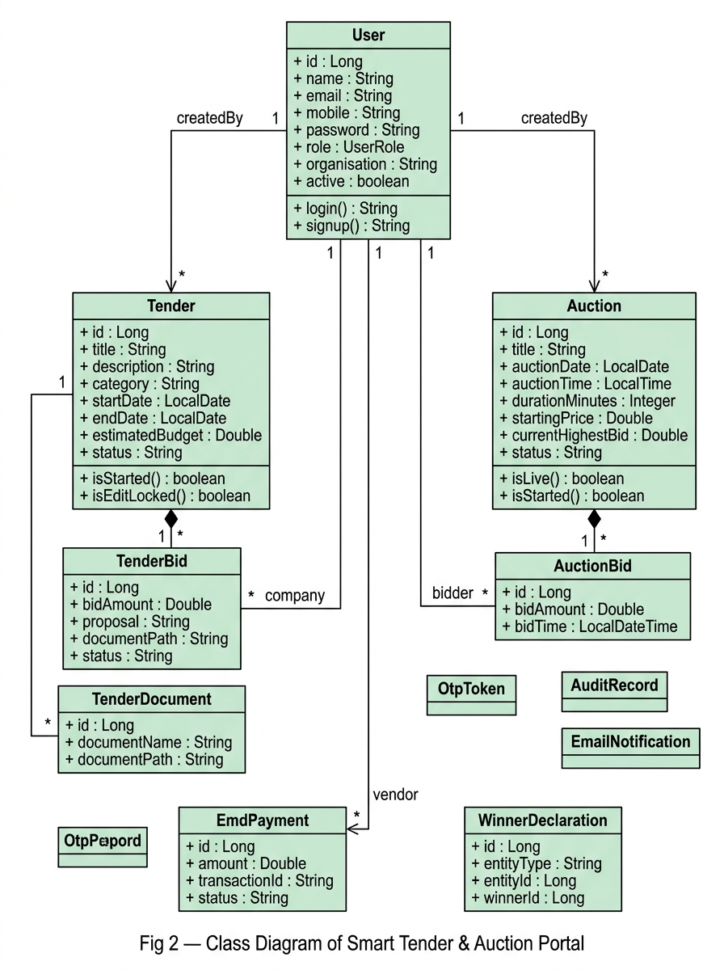
Fig 2 — Class Diagram of Smart Tender & Auction Portal

Key Classes
- User: Central entity with role-based access (ADMIN, GOVERNMENT, COMPANY, USER). Has associations to Tender, Auction, TenderBid, AuctionBid, and EmdPayment.
- Tender: Represents a procurement tender with status lifecycle (OPEN → CLOSED/CANCELLED). Composes TenderBid and TenderDocument collections.
- Auction: Represents a time-bounded auction with lifecycle states (UPCOMING → LIVE → CLOSED). Composes AuctionBid collection. Uses AuctionLifecycle utility for real-time state computation.
- EmdPayment: Earnest Money Deposit entity with mutual exclusivity constraint — targets either a tender or an auction, not both.
- WinnerDeclaration: Immutable record of winner decisions with unique constraint on (entityType, entityId).

Key Relationships
- User 1 ←→ * Tender (createdBy/winner); User 1 ←→ * Auction (createdBy/winner)
- Tender 1 ◆→ * TenderBid (composition); Auction 1 ◆→ * AuctionBid (composition)
- User 1 ←→ * TenderBid (company); User 1 ←→ * AuctionBid (bidder)
- Tender 1 → * TenderDocument; User 1 → * EmdPayment (vendor)

13. Interaction Diagram (Sequence Diagram)
The following Sequence Diagram describes the core real-time flow of the system: a Company user placing a bid on a live auction. The flow traces the message sequence from the user's browser through the controller, service, repository, and WebSocket layers.

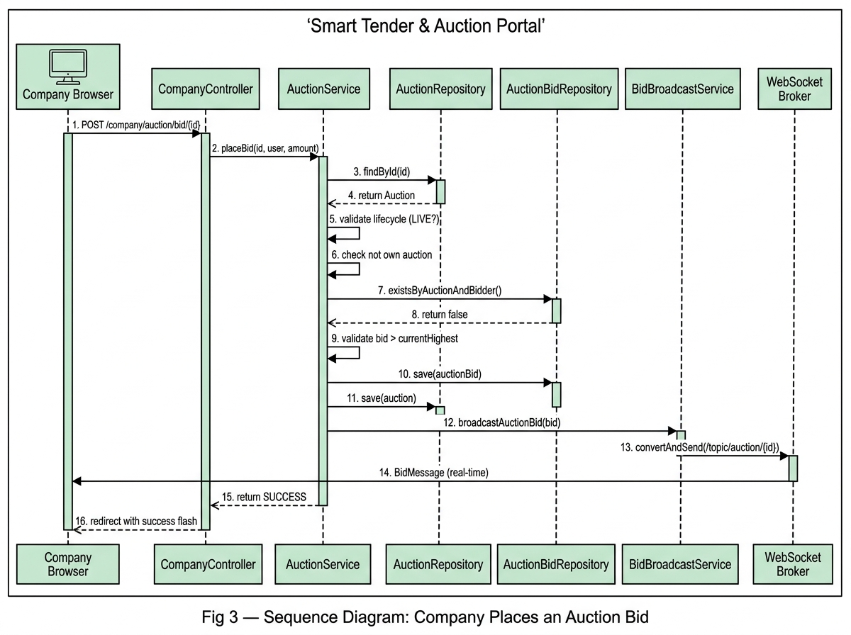
Fig 3 — Sequence Diagram: Company Places an Auction Bid

Message Flow Summary
1. The Company Browser sends a POST request to CompanyController with the bid amount and CSRF token.
2. CompanyController delegates to AuctionService.placeBid(), which loads the Auction entity and validates: (a) auction is LIVE, (b) bidder is not the creator, (c) bidder has not already bid, (d) bid exceeds current highest.
3. On successful validation, AuctionService persists the AuctionBid, updates the auction's currentHighestBid with optimistic locking (@Version), and delegates to BidBroadcastService.
4. BidBroadcastService constructs a BidMessage DTO and sends it via the WebSocket Broker to /topic/auction/{id}, where all subscribed participants receive the real-time update.
5. CompanyController redirects the browser with a success flash message.

14. Activity Diagram
The following Activity Diagram describes the end-to-end lifecycle of a tender, from creation through bidding, automatic closure, winner declaration, and notification dispatch. This is the system's primary asynchronous workflow.

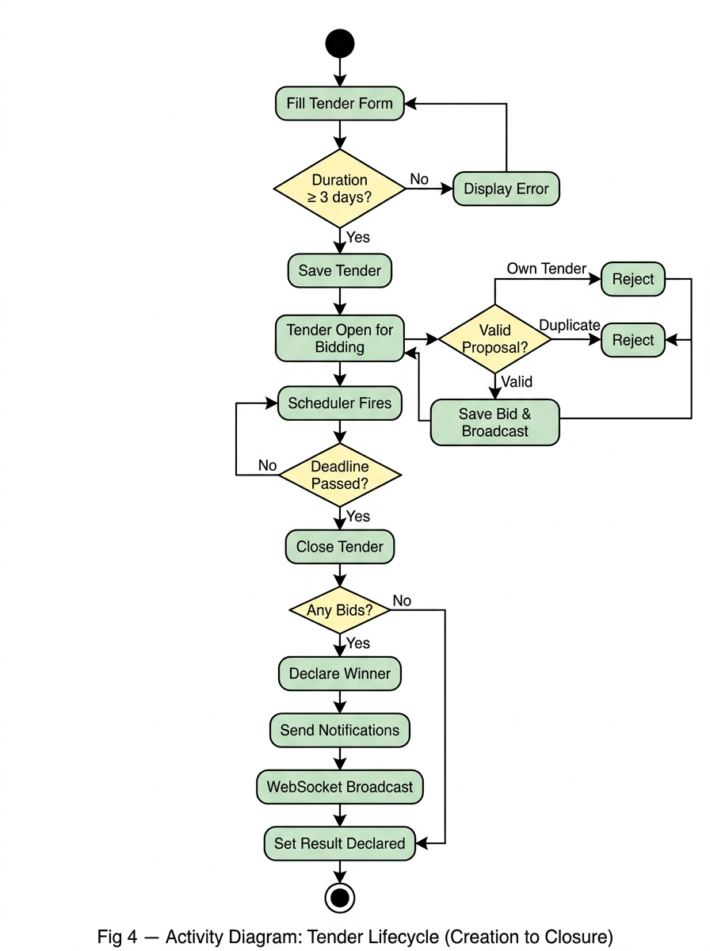
Fig 4 — Activity Diagram: Tender Lifecycle (Creation to Closure)

Flow Description
The flow begins when a Government or Company user fills the tender creation form. BusinessRuleValidator checks that the duration is at least 3 days and the end date is not in the past. If validation fails, an error is displayed and the user returns to the form.
Once validated, TenderService saves the tender with status OPEN and computes the deadline as endDate at 23:59:59. The tender is now visible to Company users who may submit proposals. Self-bidding and duplicate submissions are rejected.
The AuctionScheduler fires every 5 minutes, acquires a SchedulerLock, and queries for tenders whose deadline has passed. ClosureService closes each expired tender, determines the lowest bidder as the winner, sets bid statuses (ACCEPTED/REJECTED), persists a WinnerDeclaration record, and publishes email notifications to the winner, loser(s), and creator. A closure event is broadcast via WebSocket.

