AI QUITY
(AN AI-POWERED STOCK MARKET PREDICTION AND ANALYSIS SYSTEM)
A Project Report
Submitted in fulfilment of the

Requirements for the award of degree of

Bachelor of Science of (Data Science)
By
Hussain Sadriwala
Roll no. 29

&

Ronak Chaudhary
Roll no. 4

Under the esteemed guidance of
Mr. Pragnesh Shah


DEPARTMENT OF DATA SCIENCE

SHREE L. R. TIWARI DEGREE COLLEGE OF ARTS, COMMERCE
&
SCIENCE, Mira Road

(Affiliated to University of Mumbai) THANE, 401107 MAHARASHTRA

2025-26

SHREE L.R. TIWARI DEGREE COLLEGE OF ARTS, COMMERCE &
SCIENCE, MIRA ROAD
(Affiliated to University of Mumbai)

DEPARTMENT OF DATA SCIENCE

CERTIFICATE

This is to certify this project report entitled AI QUITY, submitted to University of Mumbai, Maharashtra is bonified record of work done by Hussain Sadriwala and Ronak Chaudhary for Academic Year 2025-2026 under the guidance of “Pragnesh Shah” from to .

Date of Evaluation:

Internal Examiner College Stamp
(Guide)

External Examiner Head of the Department

ACKNOWLEDGEMENT

I would like to convey my deep appreciation to my Guide
Pragnesh Shah for her valuable guidance and encouragement in completion of my project work.
I would also like to express my gratitude to our principal Dr. Sanjay Mishra for providing all the required facilities to accomplish my work.
Hussain Sadriwala and Ronak Chaudhary

DECLARATION

I hereby declare that project entitled “AI QUITY ” done at Shree L.R. Tiwari Degree college, not been in any case duplicated to submit to any other university for the award of any degree. To the best of my knowledge other than me, no one has submitted to any other university. The project is done in partial fulfilment of requirement for the award of degree of Bachelor of Science of (Data Science) to be submitted as VIth semester project as a part of our curriculum.

Hussain Sadriwala and Ronak Chaudhary

Index of Chapters and Sections
Chapter 1 | Introduction | 1
1.1 | Background | 1
1.2 | Objectives | 2
1.3 | Purpose, Scope, and Applicability | 2
1.3.1 | Purpose | 2
1.3.2 | Scope | 3
1.3.3 | Applicability | 3
1.4 | Practical Utility | 3
Chapter 2 | Survey of Technologies | 4
2.1 | Machine Learning (ML) and Deep Learning (DL) | 4
2.1.1 | Machine Learning in Finance | 4
2.1.2 | Deep Learning in Finance | 5
2.2 | Natural Language Processing (NLP) for Sentiment Analysis | 5
2.3 | Financial Data Sources and APIs | 6
2.4 | Python Libraries and Frameworks | 6
2.5 | Cloud Platforms and Deployment Tools | 7
2.6 | Technology Integration Summary | 7
Chapter 3 | Requirements and Analysis | 8
3.1 | Problem Statement | 8
3.2 | Requirements Specification | 8
3.2.1 | Existing System | 9
3.2.2 | Proposed System | 9
3.2.3 | Functional Requirements | 10
3.2.4 | Non-Functional Requirements | 10
3.3 | Planning and Scheduling | 10
3.3.1 | Development Phases | 10
3.3.2 | Gantt Chart (Conceptual) | 11
3.4 | Hardware and Software Requirements | 11
3.4.1 | Hardware Requirements | 11
3.4.2 | Software Requirements | 12
3.5 | Conclusion | 12
Chapter 4 | System Design | 13
4.1 | Basic Modules | 13
4.2 | Data Design | 14
4.2.1 | Database Schema | 14
4.2.2 | Entity-Relationship (ER) Diagram (Textual Description) | 15
4.3 | Procedural Design | 15
4.3.1 | Class Diagram (Textual Representation) | 15
4.3.2 | Data Flow Diagrams (DFD) | 16
4.3.3 | Activity Diagram | 16
4.3.4 | Sequence Diagram | 16
4.3.5 | State Diagram | 17
4.4 | Algorithms and Data Structures | 17
4.4.1 | Algorithms Used | 17
4.4.2 | Data Structures | 17
4.5 | User Interface Design | 17
4.6 | Security Issues | 18
4.7 | Testing Considerations | 18
4.8 | Conclusion | 18

ABSTRACT
The stock market is a highly dynamic and unpredictable environment influenced by a wide range of factors such as economic indicators, corporate performance, political events, and investor sentiment. Traditional forecasting methods often fail to capture the complex, nonlinear, and volatile nature of financial markets. To address these challenges, this project presents the design and development of an Artificial Intelligence (AI)-driven stock market prediction and decision-support system. The proposed system integrates advanced deep learning models—such as Long Short-Term Memory (LSTM), Recurrent Neural Networks (RNN), and Transformer architectures—with Natural Language Processing (NLP) techniques to analyze both structured financial data and unstructured textual sources like news articles and social media posts.
The platform incorporates modules for real-time data acquisition, preprocessing, sentiment analysis, hybrid forecasting, portfolio optimization, and visualization through an interactive dashboard. APIs from sources such as Yahoo Finance and Alpha Vantage are used for continuous data collection, while models like FinBERT enable sentiment-aware predictions. The system further leverages portfolio optimization strategies, including Markowitz Modern Portfolio Theory and reinforcement learning, to recommend investment decisions aligned with user preferences and risk profiles.
Comprehensive system design ensures modularity, scalability, and security, with deployment facilitated through cloud platforms and Python-based frameworks such as Flask, Streamlit, and TensorFlow. Performance evaluation is conducted using metrics like Root Mean Square Error (RMSE), Mean Absolute Percentage Error (MAPE), and directional accuracy, ensuring reliability of predictions.
This project contributes both academically and practically by demonstrating the utility of AI in enhancing prediction accuracy, risk management, and decision-making efficiency in stock markets. It offers a scalable prototype suitable for retail investors, financial analysts, and fintech startups, while also serving as a valuable case study for students and researchers in finance and artificial intelligence.

Chapter 1 – Introduction
1.1 Background
The stock market has long been regarded as a dynamic, complex, and highly unpredictable system where investors, institutions, and governments participate in the exchange of financial assets. Stock prices are influenced by numerous interdependent factors, including global economic conditions, company performance, investor sentiment, political events, interest rates, and even social media trends. Traditionally, forecasting in the stock market relied heavily on statistical models, expert judgment, and historical analysis. However, these approaches often struggle to capture the nonlinear, volatile, and high-dimensional nature of financial markets.
The last two decades have witnessed a rapid transformation in financial technology, fueled by Artificial Intelligence (AI) and Machine Learning (ML). These technologies have the capability to analyze massive volumes of structured and unstructured data, identify hidden patterns, and provide predictions that surpass traditional models. Unlike human traders who may be influenced by emotions or cognitive biases, AI-driven systems operate with objectivity, processing real-time data at speeds beyond human capacity.
One of the most significant applications of AI in finance is stock market prediction and automated trading systems. AI models such as Long Short-Term Memory (LSTM) networks, Recurrent Neural Networks (RNNs), Transformers, and Reinforcement Learning agents have demonstrated remarkable success in predicting stock trends, classifying price movements, and optimizing portfolio decisions. Additionally, Natural Language Processing (NLP) allows AI systems to analyze market-related news, financial reports, and even social media sentiments to understand the psychological factors that drive market behavior.
Despite these advancements, several challenges remain. Stock market data is noisy, non-stationary, and influenced by unpredictable external shocks such as pandemics, geopolitical conflicts, or regulatory interventions. Designing AI systems that can generalize well under such uncertainty requires robust architectures, hybrid models, and continuous retraining with updated data.
Therefore, this project focuses on building a comprehensive AI-driven system for stock market prediction, decision support, and portfolio management. The system aims to bridge the gap between conventional statistical analysis and modern AI techniques, providing a scalable, accessible, and intelligent solution for both individual investors and financial institutions.

1.2 Objectives
The objectives of this project are aligned with leveraging Artificial Intelligence to enhance prediction accuracy, decision-making efficiency, and risk management in stock market environments. The key objectives include:
- To develop predictive models using advanced AI techniques such as LSTM, RNN, and Transformer-based models for short-term and long-term stock price forecasting.
- To integrate Natural Language Processing (NLP) for analyzing financial news, company reports, and social media sentiment to capture behavioral drivers of market movement.
- To design a portfolio recommendation engine that suggests optimal investment strategies based on predicted stock performance, user preferences, and risk tolerance.
- To implement visualization dashboards for displaying stock trends, price forecasts, candlestick charts, and buy/sell signals in an intuitive manner.
- To evaluate system performance using metrics such as RMSE (Root Mean Square Error), MAPE (Mean Absolute Percentage Error), and trading success ratios.
- To explore scalability and adaptability by deploying the system on cloud platforms, ensuring it can handle large datasets and real-time predictions.
- To address data integrity and security concerns by ensuring proper handling of financial data, API keys, and user privacy.
1.3 Purpose, Scope, and Applicability
1.3.1 Purpose
The purpose of this project is to design and implement an AI-powered stock market prediction and decision-support system that can provide reliable, real-time insights to investors. Unlike conventional prediction systems that depend only on historical numerical data, this project incorporates multi-modal analysis—combining structured data (historical prices, trading volume, technical indicators) with unstructured data (news sentiment, financial statements, tweets). This hybrid approach ensures a more holistic understanding of market trends.
The system is intended not only for academic exploration but also as a potential prototype that financial analysts, traders, and fintech startups can adopt. It seeks to empower individual investors by democratizing access to advanced AI tools that were once available only to institutional players with high computational resources.
1.3.2 Scope
The scope of this project encompasses the design, development, and evaluation of an AI-driven platform with the following core components:
- Data Collection Module: Extraction of historical and real-time stock market data using APIs (Yahoo Finance, Alpha Vantage, Quandl).
- Data Preprocessing Module: Cleaning, normalization, feature engineering (technical indicators, moving averages, RSI, MACD, etc.), and sentiment analysis pipeline.
- Prediction Engine: Implementation of deep learning models (LSTM, GRU, Transformer) for forecasting stock prices.
- Sentiment Analysis Module: Use of NLP models (BERT, RoBERTa) to extract sentiment polarity from financial news and social media posts.
- Portfolio Optimization: Suggestion of investment strategies using AI-based optimization algorithms like Markowitz Modern Portfolio Theory integrated with Reinforcement Learning.
- Visualization Dashboard: Web-based interface for users to visualize trends, predictions, risk levels, and suggested actions.
The project, however, does not aim to develop a fully functional trading platform integrated with live exchanges, as regulatory compliance and financial risks make such implementations beyond the scope of an academic project. Instead, it will provide a simulation environment for demonstrating how AI can enhance decision-making in stock market investment.
1.3.3 Applicability
The proposed system can be applied across various domains of financial technology:
- Individual Investors: Assist retail investors in making informed decisions by providing AI-generated buy/sell signals and risk evaluation.
- Financial Analysts: Provide data-driven insights that complement traditional analysis methods.
- Portfolio Managers: Optimize asset allocation strategies by leveraging predictive analytics.
- Fintech Startups: Serve as a foundation for building AI-driven trading applications, robo-advisors, and market analytics platforms.
- Educational Institutions: Provide a case study and working prototype for students studying AI, finance, and data science.
1.4 Practical Utility
The practical utility of this project lies in its ability to address real-world challenges faced by investors and institutions.
- Improved Prediction Accuracy: By using hybrid AI models, the system can provide more reliable forecasts compared to traditional regression or moving average models.
- Sentiment-Aware Decisions: Integration of NLP ensures that market psychology is considered, capturing events like panic selling, optimism, or market bubbles.
- Risk Reduction: Automated portfolio optimization allows investors to diversify
intelligently and reduce exposure to market volatility.
- Accessibility & Scalability: A cloud-deployed dashboard ensures that even small investors with limited resources can benefit from AI-driven insights.
- Educational Value: Students and researchers can use the system as a sandbox to test new AI models, trading strategies, and risk analysis methods.
The project thus aims to strike a balance between academic rigor and practical application, offering both theoretical insights and real-world utility.

Chapter 2 – Survey of Technologies
The development of an AI-driven stock market prediction system requires the integration of diverse technologies spanning machine learning, deep learning, natural language processing (NLP), financial data APIs, visualization tools, and deployment frameworks. This chapter surveys the major technologies chosen for the project, highlights their advantages and limitations, and explains their applicability to the financial domain.
2.1 Python Libraries and Frameworks
Python is the de facto standard for financial data analysis and machine learning. Several libraries facilitate each stage of the project:
- Data Collection & Preprocessing:
  - pandas – Data cleaning, manipulation, and feature engineering.
  - NumPy – Mathematical computations.
  - TA-Lib – Calculation of technical indicators (RSI, MACD, Bollinger Bands).
- Model Development:
  - scikit-learn – Traditional ML models (SVM, Random Forests).
  - TensorFlow and Keras – Building deep learning models such as LSTMs and CNNs.
  - PyTorch – Alternative DL framework with dynamic computation graphs.
  - Prophet – Facebook’s library for time-series forecasting.
- Visualization:
  - matplotlib and seaborn – Static visualization.
  - plotly – Interactive charts, candlestick plots, and dashboards.

- NLP Tools:
  - transformers (Hugging Face) – Access to pretrained models like BERT and FinBERT.
  - nltk and spaCy – Text preprocessing.
These libraries ensure that the system remains both robust and extensible.
2.2 Machine Learning (ML) and Deep Learning (DL)
2.2.1 Machine Learning in Finance
Machine Learning provides statistical methods and algorithms that allow systems to learn patterns from data and improve performance over time without being explicitly programmed. In finance, ML is commonly used for:
- Trend Prediction: Linear Regression, Decision Trees, Random Forests, and Support Vector Machines (SVM) help predict stock prices based on historical data and technical indicators.
- Classification of Movements: Algorithms classify whether a stock price will move “up”, “down”, or “stable” within a given time frame.
- Risk Assessment: ML models evaluate portfolio risks, volatility, and expected returns.
While traditional ML models are interpretable and computationally efficient, they struggle to capture the non-linear and sequential nature of financial time-series data.
2.2.2 Deep Learning in Finance
Deep Learning (DL) techniques, especially Recurrent Neural Networks (RNNs) and their advanced variants such as Long Short-Term Memory (LSTM) and Gated Recurrent Units (GRU), are widely used in stock market prediction.
- LSTM Networks:
  - Specialized for sequential data.
  - Capture long-term dependencies and temporal relationships.
  - Handle challenges like vanishing gradients, making them suitable for multi-day price forecasting.
- GRU Networks:
  - Similar to LSTMs but computationally more efficient.
  - Useful for real-time forecasting when processing speed is crucial.
- Transformer Models:
  - Originally developed for NLP but now applied to time-series forecasting.
  - Use attention mechanisms to identify which past time steps are most important for future predictions.
  - Models like Temporal Fusion Transformers (TFT) and BERT-based stock predictors are emerging as state-of-the-art solutions.
Deep Learning models can process multi-modal inputs, including price history, technical indicators, and sentiment data, making them powerful for comprehensive financial analysis.
2.3 Natural Language Processing (NLP) for Sentiment Analysis
The stock market is highly sensitive to news events, earnings reports, analyst recommendations, and social media sentiment. NLP enables machines to understand human language and extract insights relevant to market movement.
- Applications in Stock Market Prediction:
  - News Sentiment Analysis: Identifying whether financial news is positive, negative, or neutral.
  - Social Media Analysis: Mining platforms like Twitter, Reddit (WallStreetBets), and StockTwits to capture investor mood.
  - Earnings Call Analysis: Extracting key phrases and sentiments from quarterly reports and conference calls.
- Popular NLP Models & Tools:
  - BERT (Bidirectional Encoder Representations from Transformers): Pre-trained on large corpora, fine-tuned for financial text classification.
  - FinBERT: A domain-specific BERT model fine-tuned on financial texts, offering superior sentiment prediction accuracy.
  - VADER Sentiment Analyzer: Lightweight sentiment analysis tool suitable for short financial texts like tweets.
  - spaCy & NLTK: Widely used for preprocessing (tokenization, lemmatization, POS tagging).
By combining numerical forecasting with sentiment-driven analysis, the system can generate context-aware predictions.
2.4 Financial Data Sources and APIs
A reliable AI system depends on high-quality financial datasets. Public APIs and data providers enable real-time and historical stock market data collection.
- Yahoo Finance API:
  - Provides daily, intraday, and historical stock data.
  - Free and widely used in academic and research projects.
  - Accessible via Python libraries such as yfinance.
- Alpha Vantage API:
  - Offers free and premium stock data, including technical indicators.
  - Easy integration with Python for automated data pipelines.
- Quandl API (Now Nasdaq Data Link):
  - Provides economic, financial, and alternative datasets.
  - Used for backtesting and macroeconomic analysis.
- Polygon.io / IEX Cloud:
  - Professional-grade APIs with real-time data feeds.
  - Suitable for advanced trading systems.
This project leverages Yahoo Finance (via yfinance) and Alpha Vantage for historical and real-time stock price data due to their accessibility and cost-effectiveness.
2.5 Cloud Platforms and Deployment Tools
A scalable system must go beyond local testing and be deployable for multiple users. Cloud technologies and deployment frameworks provide the infrastructure to handle large-scale data processing and real-time predictions.
- Cloud Services:
  - AWS Sagemaker / EC2: Model training and deployment.
  - Google Cloud AI Platform: Scalable ML pipelines.
  - Microsoft Azure ML Studio: Enterprise-ready ML integration.
- Deployment Tools:
  - Flask / FastAPI: Backend frameworks for building APIs.
  - Streamlit / Dash: Building interactive dashboards for visualization.
  - Docker: Containerization of ML models for portable deployment.
  - Kubernetes: For large-scale production deployment.
For this project, Streamlit and Flask are chosen for dashboard development and model deployment due to their ease of use and suitability for academic projects.
2.6 Technology Integration Summary
Each of the above technologies plays a crucial role in building an integrated AI-powered stock market prediction system:
- ML/DL models analyze historical price patterns.
- NLP captures market psychology from textual data.
- Financial APIs supply continuous, reliable data streams.
- Python libraries streamline analysis, training, and visualization.
- Cloud & deployment tools ensure scalability and accessibility.
The synergy of these technologies results in a system capable of real-time, multi-factor stock prediction and portfolio management, making it significantly more effective than traditional statistical tools.

Chapter 3 – Requirements and Analysis
3.1 Problem Statement
Financial markets are inherently complex, dynamic, and volatile. Stock prices are influenced by a wide range of factors including macroeconomic indicators, corporate earnings, government policies, geopolitical events, and even public sentiment expressed on social media platforms. Traditional stock market analysis methods, such as technical analysis (moving averages, RSI, MACD) and fundamental analysis (P/E ratios, balance sheets), provide insights but often fail to capture the non-linear dependencies and hidden patterns within the data.
Moreover, the advent of high-frequency trading (HFT) and algorithmic strategies has drastically changed market behavior. Retail investors and even some institutional investors often struggle to compete with advanced trading algorithms that operate in microseconds. At the same time, misinformation and market manipulation through digital platforms create additional uncertainty.
The problem lies in the inability of conventional models to:
- Accurately predict short-term price fluctuations.
- Incorporate multi-source data (numerical + textual).
- Adapt to rapidly changing conditions such as sudden crashes or global crises.
- Provide real-time insights that investors can rely on before making decisions.
This project aims to address these issues by designing an AI-powered stock market prediction and decision-support system that integrates historical price analysis with sentiment data and advanced forecasting models.
3.2 Requirements Specification
The requirements are divided into existing system analysis, proposed system features, and functional/non-functional specifications.
3.2.1 Existing System
Existing approaches to stock market forecasting can be categorized into:
- Traditional Statistical Models
  - ARIMA (Auto-Regressive Integrated Moving Average): Used for time-series forecasting, effective for linear trends but weak for highly volatile data.
  - GARCH (Generalized Autoregressive Conditional Heteroskedasticity): Captures volatility clustering but fails to adapt to regime shifts in market conditions.
  - Limitations:
    - Assumes stationarity of data.
    - Ineffective for non-linear and chaotic patterns.
    - Ignores external factors like sentiment and breaking news.
- Technical Analysis Tools
  - Traders rely on indicators such as Moving Averages, RSI, Bollinger Bands, and MACD.
  - Limitations:
    - Often subjective and based on historical lagging indicators.
    - Fail to adapt to sudden market disruptions.
- Fundamental Analysis
  - Evaluates company performance (earnings, revenue, balance sheets).
  - Limitations:
    - Works well for long-term investment but not for short-term price forecasting.
    - Ignores real-time market dynamics and investor sentiment.
- Existing Online Platforms
  - Yahoo Finance, Bloomberg, and TradingView provide stock charts and news.
  - Some ML-based platforms provide trend analysis.
  - Limitations:
    - Many focus only on historical numerical data.
    - Lack integration of NLP-based sentiment analysis.
    - Do not offer adaptive learning or personalized portfolio recommendations.
3.2.2 Proposed System
The AI-powered stock prediction system will integrate advanced technologies to overcome the limitations of existing systems.
Core Features:
- Hybrid Forecasting: Combine time-series models (LSTM, Transformer) with NLP-based sentiment analysis.
- Real-Time Data Collection: Use APIs (Yahoo Finance, Alpha Vantage) for continuous stock price updates.
- Sentiment Analysis Module: Incorporate news, financial reports, and social media posts using FinBERT and VADER.
- Portfolio Recommendation Engine: Suggest optimal asset allocations using Markowitz Modern Portfolio Theory enhanced by AI.
- Visualization Dashboard: Provide intuitive, interactive stock charts and prediction outputs.
- Scalability: Deploy on cloud for real-time performance.
- Security: Ensure secure handling of financial data and user credentials.
Advantages Over Existing Systems:
- Handles non-linear patterns in stock data.
- Integrates multi-modal datasets (numerical + textual).
- Offers real-time adaptive learning.
- Provides decision-support features beyond mere predictions.
3.2.3 Functional Requirements
- Data Acquisition:
  - Collect historical and real-time stock data via APIs.
  - Import financial news and social media feeds.
- Data Preprocessing:
  - Clean and normalize datasets.
  - Perform feature engineering (RSI, MACD, Bollinger Bands, sentiment scores).
- Prediction Engine:
  - Forecast stock price trends using AI models.
  - Provide probabilistic outputs (confidence scores).
- Sentiment Analysis:
  - Classify news and tweets as positive, negative, or neutral.
  - Integrate sentiment scores into the forecasting pipeline.
- Portfolio Recommendation:
  - Suggest buy/hold/sell actions.
  - Optimize portfolio allocation based on user preferences.
- Visualization:
  - Display predictions via candlestick charts, moving averages, and sentiment indicators.
  - Provide downloadable reports.
3.2.4 Non-Functional Requirements
- Performance: Predictions should be generated within 2–3 seconds for real-time usability.
- Scalability: Support at least 100 concurrent users in the prototype.
- Accuracy: Target at least 80% directional accuracy on selected stocks.
- Reliability: System uptime of 99% under deployment.
- Security: Ensure data encryption, secure API keys, and role-based access control.
- Usability: Dashboard should be intuitive for both technical and non-technical users.
3.3 Planning and Scheduling
The project follows an iterative development model, ensuring that each module is designed, tested, and integrated progressively.
3.3.1 Development Phases
Weeks 1–2: Requirement Gathering & Feasibility Study
- Study existing models and APIs.
- Identify datasets (Yahoo Finance, news sources, Twitter feeds).
Weeks 3–5: Data Collection & Preprocessing
- Implement API integration.
- Clean and normalize datasets.
- Build feature engineering pipelines.
Weeks 6–8: Model Development
- Train baseline models (ARIMA, Random Forests).
- Develop deep learning models (LSTM, Transformer).
- Implement NLP sentiment classifier.
Weeks 9–10: System Integration
- Merge forecasting engine with sentiment module.
- Develop backend using Flask/FastAPI.
Weeks 11–12: Dashboard Development
- Build visualization dashboard using Streamlit/Plotly.
- Integrate stock prediction and portfolio recommendation results.
Weeks 13–14: Testing & Evaluation
- Perform unit, integration, and performance testing.
- Validate model accuracy on test datasets.
Weeks 15–16: Deployment & Documentation
- Deploy system on cloud.
- Prepare user documentation and final report.
3.3.2 Gantt Chart (Conceptual)
- Requirements Analysis → Weeks 1–2
- Data Collection & Cleaning → Weeks 3–5
- Model Training & Evaluation → Weeks 6–8
- System Integration → Weeks 9–10
- UI & Dashboard Development → Weeks 11–12
- Testing → Weeks 13–14
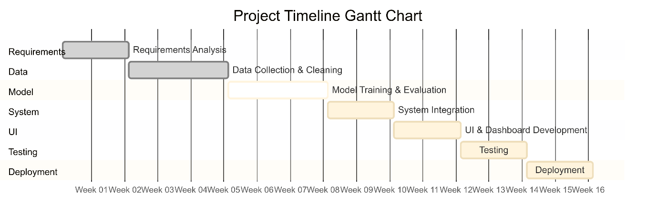
- Deployment → Weeks 15–16
3.4 Hardware and Software Requirements
3.4.1 Hardware Requirements
For Development:
- Processor: Intel i7 / AMD Ryzen 7 or better
- RAM: 16–32 GB
- Storage: 512 GB SSD
- GPU: NVIDIA RTX 2060 or better (for training DL models)
For End Users:
- Processor: Dual-core CPU
- RAM: 4–8 GB
- Internet: Stable connection
- Browser: Chrome/Firefox (latest version)
3.4.2 Software Requirements
- Operating System: Windows 7/Linux/macOS
- Programming Language: Python 3.10+
- Libraries:
- pandas (≥1.3.0),
- NumPy (≥1.21.0),
- scikit-learn (≥1.0.0),
- TensorFlow (≥2.8.0)/PyTorch (≥1.9.0),
- TA-Lib (≥0.4.24),
- NLTK (≥3.6),
- transformers (≥4.15.0),
- yfinance (≥0.1.70),
- plotly (≥5.0.0)
- Database: PostgreSQL (≥12.x) / SQLite (≥3.35.0) (for storing predictions & user sessions)
- Frameworks:
- Flask (≥2.0.0) / FastAPI (≥0.68.0),
- Streamlit (≥1.12.0),
- Docker (≥20.10.0) (for deployment)
- Version Control: Git (≥2.30.0)/GitHub
- Development Tools: Jupyter Notebook, VS Code, Postman
3.5 Conclusion
The requirements and analysis phase establishes a clear roadmap for building the AI-powered stock prediction system. It identifies the limitations of current methods, defines a proposed hybrid solution, outlines functional and non-functional specifications, and provides a structured timeline for development.
By combining advanced AI models with financial domain knowledge, the system promises to provide investors with accurate, real-time, and actionable insights that go beyond traditional stock analysis methods.

Chapter 4 – System Design
The system design phase defines the architecture, data flow, components, and algorithms used in the AI-powered stock market prediction platform. It ensures that each module works independently while seamlessly integrating with other components to form a robust system.
4.1 Basic Modules
The system follows a modular architecture where each module has a specific responsibility.
1. Data Collection Module
- Fetches historical and real-time stock market data from APIs (Yahoo Finance, Alpha Vantage).
- Collects financial news from RSS feeds and APIs (NewsAPI, Twitter API).
- Stores raw data temporarily in a database for preprocessing.
2. Data Preprocessing Module
- Cleans datasets by removing missing/null values and outliers.
- Performs feature engineering: moving averages, RSI, MACD, Bollinger Bands.
- Normalizes stock prices (Min-Max scaling, StandardScaler).
- Converts textual news into sentiment scores using NLP models (VADER, FinBERT).
3. Prediction Engine (AI Models)
- Uses LSTM/GRU for sequential data forecasting.
- Employs Transformer-based models for attention-based time-series prediction.
- Integrates Prophet for trend + seasonality detection.
- Merges numerical and sentiment inputs to produce hybrid predictions.
4. Sentiment Analysis Module
- Uses NLP pipelines to classify news/tweets as positive, negative, or neutral.
- Calculates sentiment scores (−1 to +1).
- Feeds sentiment scores into prediction engine to adjust price forecasts.
5. Portfolio Recommendation Module
- Applies Markowitz Modern Portfolio Theory (MPT) for optimal asset allocation.
- Uses Reinforcement Learning (Q-learning) for dynamic trading strategy suggestions.
- Generates buy/hold/sell signals based on predicted returns and risk scores.
6. Visualization Dashboard
- Built with Streamlit + Plotly.
- Displays:
  - Real-time stock charts
  - Candlestick charts
  - Predicted vs actual prices
  - Sentiment trend graphs
  - Portfolio risk-return curves
7. Backend Module
- Implemented using Flask/FastAPI.
- Handles:
  - API requests
  - Communication with ML models
  - User authentication & session management
- Provides REST endpoints for predictions and portfolio suggestions.
8. Database Module
- Stores:
  - Historical stock data
  - Processed features
  - Model predictions
  - User profiles & sessions
- PostgreSQL is chosen for relational storage; MongoDB (optional) for unstructured news.
4.2 Data Design
4.2.1 Database Schema
Tables:
- Users
  - user_id (PK)
  - username
  - password (hashed)
  - email
  - preferences (JSON)
- Stocks
  - stock_id (PK)
  - symbol (e.g., AAPL, TCS)
  - company_name
  - sector
- Historical_Data
  - data_id (PK)
  - stock_id (FK)
  - date
  - open, high, low, close, volume
  - technical_indicators (JSON)
- Sentiment_Data
  - sentiment_id (PK)
  - stock_id (FK)
  - source (news, twitter)
  - date_time
  - sentiment_score
- Predictions
  - prediction_id (PK)
  - stock_id (FK)
  - model_used
  - date_time
  - predicted_price
  - confidence_score
- Portfolio
  - portfolio_id (PK)
  - user_id (FK)
  - stock_id (FK)
  - allocation (%)
  - risk_score
4.2.2 Entity-Relationship (ER) Diagram (Textual Description)
- Users ↔ Portfolio (One-to-Many)
- Stocks ↔ Historical_Data (One-to-Many)
- Stocks ↔ Sentiment_Data (One-to-Many)
- Stocks ↔ Predictions (One-to-Many)
- Portfolio ↔ Stocks (Many-to-Many through Portfolio table)
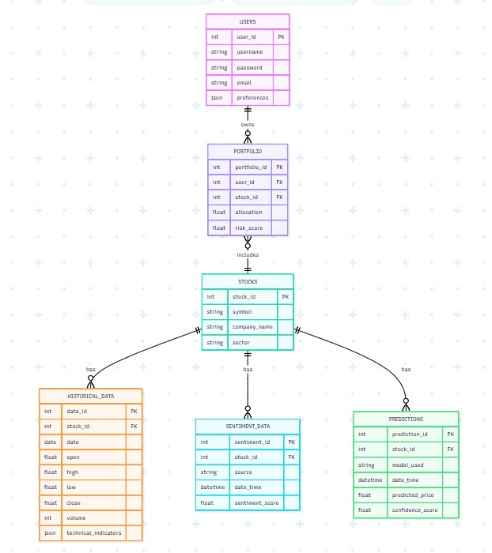
4.3 Procedural Design
4.3.1 Class Diagram (Textual Representation)
Classes:
- User: Attributes – user_id, username, email; Methods – login(), managePortfolio().
- Stock: Attributes – symbol, company_name; Methods – fetchData(), getIndicators().
- DataProcessor: Methods – cleanData(), normalize(), featureEngineering().
- SentimentAnalyzer: Methods – preprocessText(), classifySentiment(), calculateScore().
- PredictionModel: Methods – train(), predict(), evaluate().
- PortfolioManager: Methods – optimizePortfolio(), recommendTrades().
- Dashboard: Methods – displayCharts(), showPredictions(), generateReports().
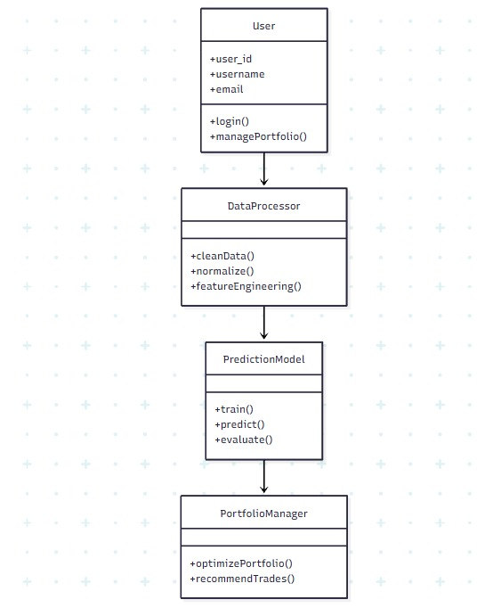
4.3.2 Data Flow Diagrams (DFD)
Level 0 (Context Diagram):
- User interacts with Dashboard → Dashboard sends request to Backend → Backend fetches Data (historical & news) → Preprocessing → Prediction Engine → Results shown on Dashboard.

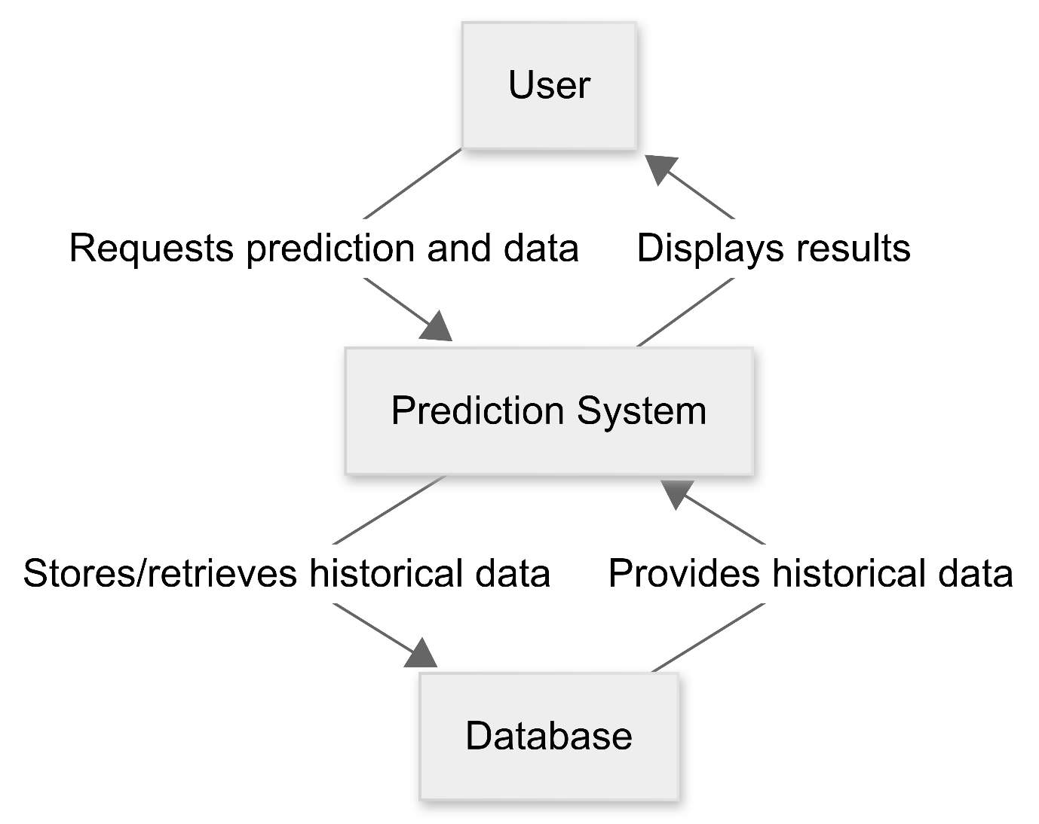

Level 1 (Detailed):
- User inputs stock symbol.
- API fetches historical data.
- DataProcessor cleans and extracts features.
- SentimentAnalyzer assigns scores from news/tweets.
- PredictionModel forecasts future prices.
- PortfolioManager generates buy/sell recommendations.
- Results stored in Database & displayed on Dashboard.
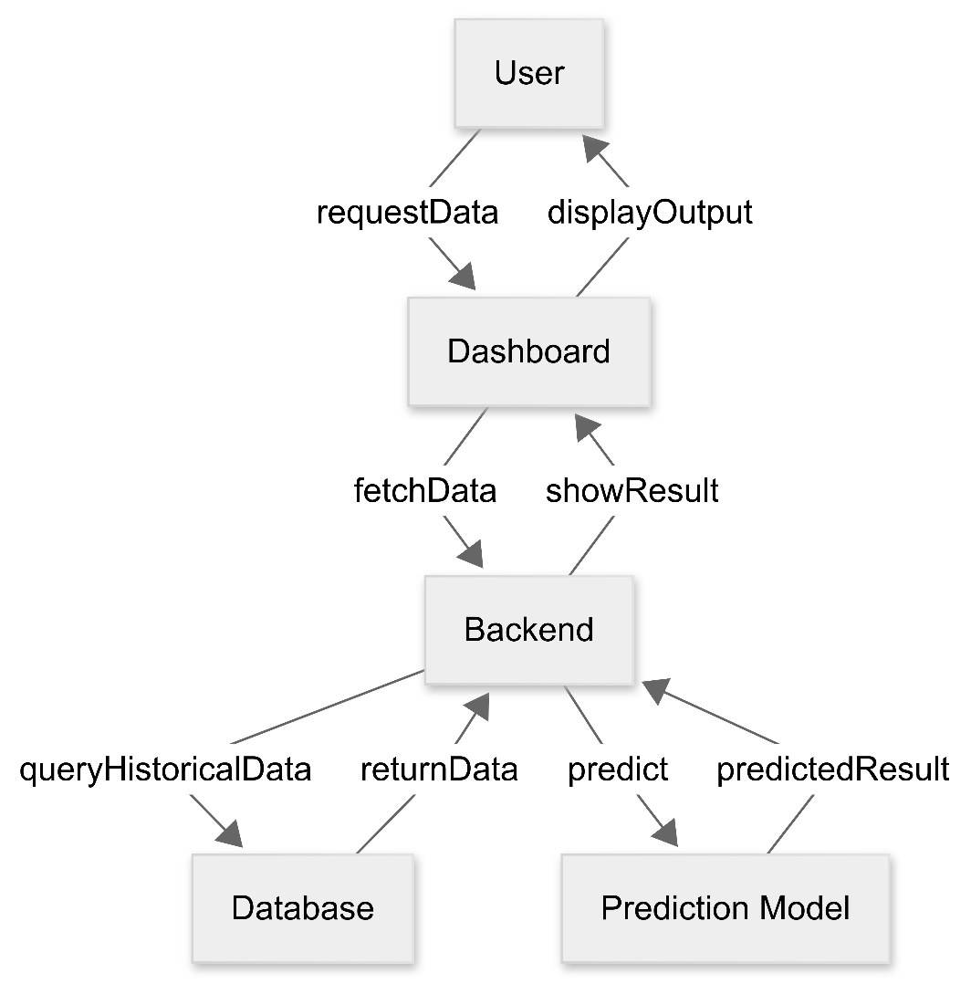
4.3.3 Activity Diagram
- Start
- User logs in → Authentication check
- User selects stock/portfolio → API fetch
- Data Preprocessing → Feature Engineering → Sentiment Analysis
- Prediction Model runs
- Portfolio Optimization executed
- Predictions visualized on Dashboard
- Reports generated
- End
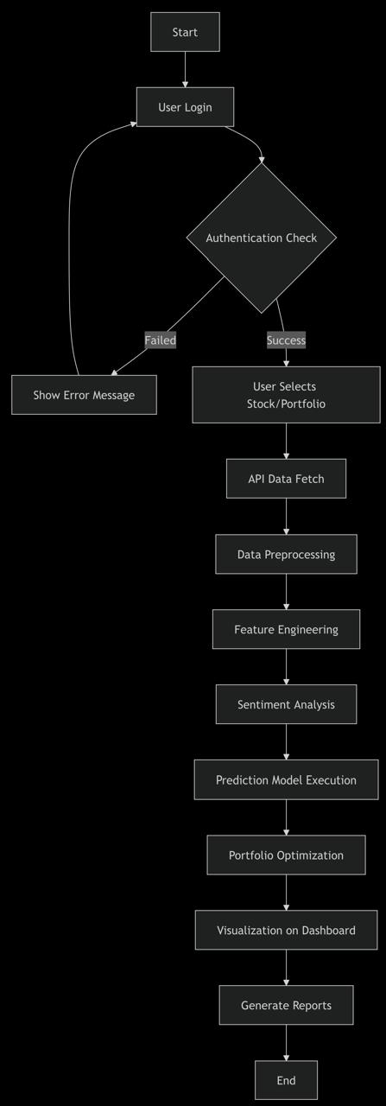

4.3.4 Sequence Diagram
- User → Dashboard → Backend → DataProcessor → SentimentAnalyzer → PredictionModel → PortfolioManager → Dashboard → User
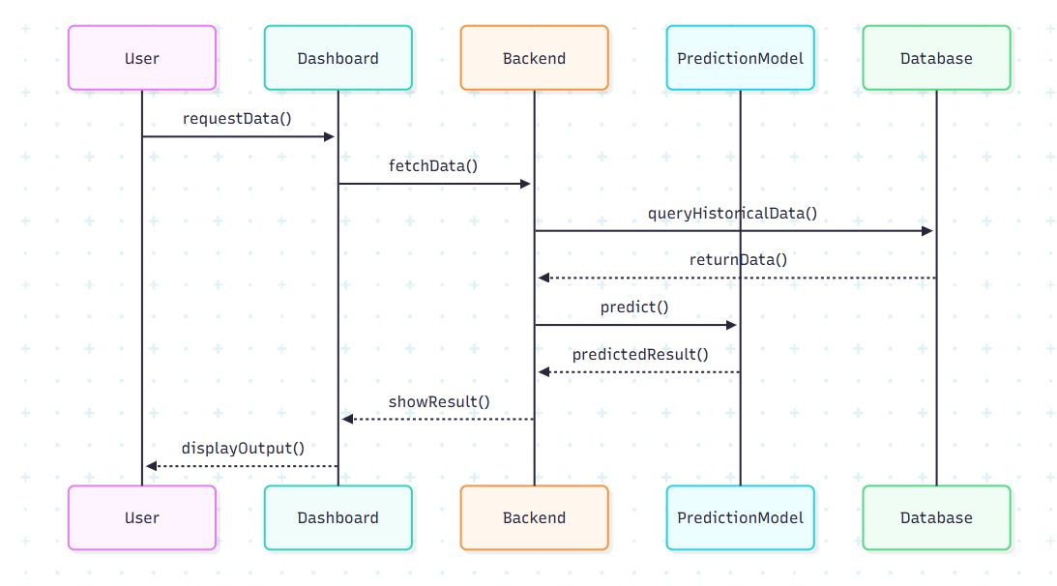
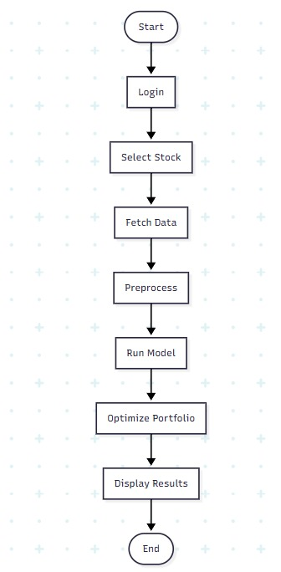
4.3.5 State Diagram
States:
- Idle
- Data Fetching
- Data Preprocessing
- Model Training/Prediction
- Portfolio Recommendation
- Visualization
- Session Completed
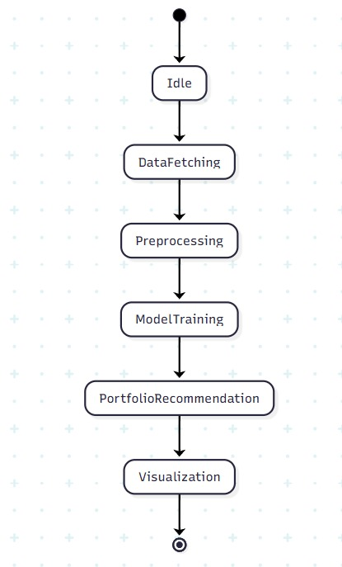

4.4 Algorithms and Data Structures
4.4.1 Algorithms Used
- LSTM Prediction Algorithm: For sequential stock price forecasting.
- Transformer with Attention: Identifies important time steps.
- Markowitz Portfolio Optimization Algorithm: Balances risk vs return.
- Reinforcement Learning (Q-learning): Suggests trading strategies based on reward maximization.
- Sentiment Classification Algorithm: FinBERT/VADER assigns sentiment polarity.
4.4.2 Data Structures
- Hash Tables: Store stock symbol → stock data mappings.
- Queues: Handle streaming real-time stock data.
- Priority Queues: For trade recommendations (highest expected return first).
- Graphs: Represent portfolio diversification (nodes = stocks, edges = correlations).
- Matrices: Used in Markowitz optimization (covariance matrix).
4.5 User Interface Design
- Dashboard Page:
  - Stock input box
  - Real-time stock chart
  - Predicted vs actual prices graph
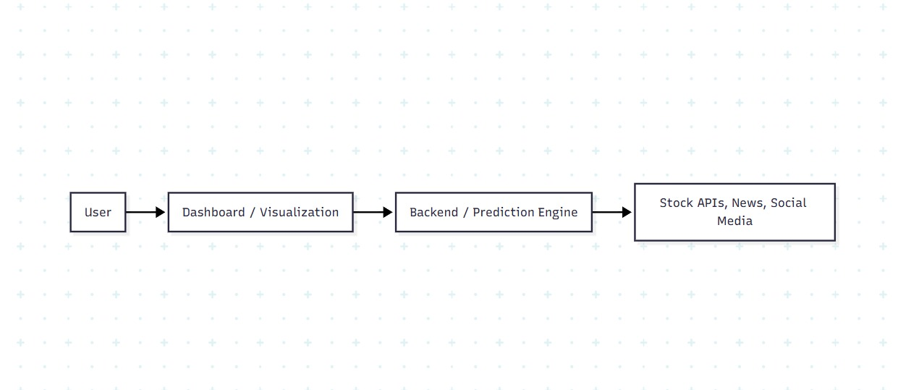
- Sentiment Analysis Panel: Displays latest news & polarity scores.
- Portfolio Page: Shows allocations, risk, and buy/sell signals.
- Report Page: Downloadable PDF/CSV performance reports.
4.6 Security Issues
- Data Security: Encrypt API keys and sensitive user data.
- Authentication: Use JWT tokens for session management.
- Privacy: Mask user-specific financial data.
- Robustness: Prevent model poisoning (malicious fake data).
- API Rate Limits: Ensure system avoids misuse of financial APIs.
4.7 Testing Considerations
- Unit Testing: Data cleaning, feature generation, sentiment scoring.
- Integration Testing: API → Preprocessing → Model → Dashboard.
- Performance Testing: Ensure predictions <3 seconds.
- Accuracy Testing: Evaluate RMSE, MAPE, and directional accuracy.
4.8 Conclusion
The system design chapter provides a blueprint for implementation, defining the architecture, modules, algorithms, and interaction flows. By modularizing the platform into data acquisition, preprocessing, prediction, sentiment analysis, portfolio recommendation, visualization, and backend services, the system ensures scalability, reliability, and extensibility.
This design enables the creation of a powerful AI-powered platform that can aid investors, traders, and researchers in making informed stock market decisions.

CHAPTER 5
IMPLEMENTATION AND MODELING

5.1 Introduction
The implementation phase represents the stage in which the theoretical concepts and system design proposed for the AI-QUITY platform are translated into a working software system capable of analyzing financial data and generating stock market predictions. In the earlier chapters of this report, the conceptual architecture and research methodology were discussed in detail, but during implementation those concepts are converted into executable programs and integrated modules. The objective of this phase is to develop a complete AI-driven platform that can automatically collect financial data, process large volumes of information, analyze trends, and generate predictions for future stock prices. Modern financial markets generate massive datasets that include numerical information such as stock prices, trading volumes, and economic indicators as well as textual information such as financial news and investor sentiment. Traditional analysis techniques often struggle to handle this level of complexity, which is why the AI-QUITY system integrates artificial intelligence algorithms capable of detecting patterns within large datasets. The implementation process also focuses on ensuring that the system is modular, scalable, and efficient so that additional features can be incorporated in the future. By combining deep learning models, data processing pipelines, and visualization tools, the AI-QUITY system provides a comprehensive environment for financial market analysis and intelligent decision-making.

System Overview Diagram
+---------------------+
| User Interface |
+----------+----------+
|
v
+---------------------+
| Data Collection |
+----------+----------+
|
v
+---------------------+
| Data Preprocessing |
+----------+----------+
|
v
+---------------------+
| Prediction Engine |
+----------+----------+
|
v
+---------------------+
| Visualization Layer |
+---------------------+

5.2 Development Environment
The development environment for the AI-QUITY platform was carefully selected to ensure that the system could efficiently handle large datasets and perform complex machine learning computations. Python was chosen as the primary programming language due to its extensive support for artificial intelligence and data science applications. Python provides a large collection of libraries that simplify the implementation of machine learning models, data processing pipelines, and visualization tools. During the development of this project, several important libraries were used, including Pandas for data manipulation, NumPy for numerical computations, TensorFlow and PyTorch for implementing deep learning models, and Matplotlib and Plotly for creating financial visualizations. In addition to these libraries, Streamlit was used to develop an interactive web interface that allows users to visualize stock market predictions and analyze trends in real time. The development environment also included database technologies such as PostgreSQL to store user data, stock information, and prediction results. The system was tested on a computer with sufficient computational resources to train deep learning models efficiently. GPU acceleration was also considered to speed up the training process of neural networks, especially when dealing with large time-series datasets. The combination of these technologies ensures that the AI-QUITY platform is capable of performing high-performance financial analysis while remaining flexible for future enhancements.

Technology Stack Diagram
+---------------------+
| Frontend |
| Streamlit |
+----------+----------+
|
v
+---------------------+
| Backend (Python) |
| Pandas / NumPy |
+----------+----------+
|
v
+---------------------+
| Machine Learning |
| TensorFlow / PyTorch|
+----------+----------+
|
v
+---------------------+
| Database |
| PostgreSQL |
+---------------------+

Environment Setup Code
import numpy as np
import pandas as pd
import matplotlib.pyplot as plt
import yfinance as yf
from sklearn.preprocessing import MinMaxScaler

5.3 System Architecture Implementation
The AI-QUITY system follows a modular architecture that divides the entire platform into multiple independent components, each responsible for performing a specific function within the overall system. This modular design improves maintainability and allows developers to update or replace individual modules without affecting the entire system. The first component of the architecture is the data acquisition module, which retrieves historical and real-time stock market data from financial APIs. Once the data is collected, it is passed to the preprocessing module, where it undergoes cleaning, normalization, and transformation. After preprocessing, the data is processed by the feature engineering module, which calculates technical indicators such as moving averages and volatility measures. These features are then fed into the prediction engine, which contains machine learning models such as LSTM and Transformer networks. In parallel with the prediction engine, a sentiment analysis module processes financial news and social media posts to determine the market sentiment associated with specific stocks. The outputs from the prediction model and sentiment analysis module are combined to produce final predictions. These predictions are then displayed to users through an interactive visualization dashboard that allows investors to analyze market trends and make informed decisions.

Architecture Flow Diagram
User
|
v
Data Collection
|
v
Data Preprocessing
|
v
Feature Engineering
|
v
Prediction Engine
| |
v v
Sentiment Analysis
|
v
Visualization Dashboard

5.4 Data Acquisition Process
Data acquisition is a fundamental step in the implementation of the AI-QUITY system because the predictive models rely heavily on accurate and comprehensive financial data. The platform retrieves stock market data from the Yahoo Finance API using the Python library yfinance. This API provides a wide range of financial information, including historical stock prices, trading volumes, and market capitalization values. The data acquisition module was designed to automatically download stock data over a specified time period so that long-term market trends could be analyzed. Once the data is retrieved, it is stored in structured datasets that can be easily accessed during the preprocessing and model training stages. The system also includes mechanisms to verify the integrity of the retrieved data and ensure that no values are missing or corrupted. By automating the data collection process, the AI-QUITY platform ensures that the dataset remains continuously updated with the latest market information. This automation also reduces the risk of human error and ensures that the predictive models operate on reliable financial data.

Data Collection Code
import yfinance as yf
stock_symbol = "AAPL"
data = yf.download(stock_symbol,
start="2015-01-01",
end="2024-01-01")
print(data.head())

Data Pipeline Diagram
Financial API
|
v
Data Retrieval Script
|
v
Raw Dataset
|
v
Stored Database

5.5 Data Preprocessing Techniques
Before the collected financial data can be used for machine learning, it must undergo preprocessing to remove inconsistencies and prepare it for analysis. Raw financial datasets often contain missing values, irregular timestamps, and noise caused by sudden market fluctuations. In the AI-QUITY system, preprocessing begins by identifying and handling missing values in the dataset. Missing values are typically filled using forward-filling techniques, which replace missing entries with the most recent available value. After handling missing values, normalization techniques are applied to ensure that all numerical features fall within a consistent range. This step is particularly important for neural networks, as large variations in input values can slow down the learning process and negatively impact prediction accuracy. In addition to normalization, preprocessing also involves detecting outliers and removing abnormal values that could distort model training. The data is then formatted into time-series sequences suitable for LSTM and Transformer models, allowing the system to capture temporal dependencies within the stock market dataset. These preprocessing steps ensure that the dataset is clean, structured, and suitable for machine learning algorithms.

Normalization Code
from sklearn.preprocessing import MinMaxScaler
scaler = MinMaxScaler(feature_range=(0,1))
scaled_data = scaler.fit_transform(data['Close'].values.reshape(-1,1))

Preprocessing Flow Diagram
Raw Data
|
v
Remove Missing Values
|
v
Normalize Data
|
v
Detect Outliers
|
v
Processed Dataset

5.6 Feature Engineering
Feature engineering is a critical process that transforms raw stock market data into meaningful variables that improve the performance of predictive models. In financial analysis, technical indicators are often used to extract useful information from price movements. The AI-QUITY system incorporates several popular technical indicators such as moving averages, relative strength index (RSI), and Bollinger Bands. These indicators help reveal hidden patterns in stock price movements and provide additional context for machine learning algorithms. For example, moving averages smooth short-term price fluctuations and highlight long-term trends, while RSI measures the speed and magnitude of price changes to identify potential overbought or oversold conditions. Bollinger Bands measure market volatility by calculating upper and lower boundaries around a moving average. By integrating these indicators into the dataset, the system provides the predictive models with additional features that improve their ability to recognize complex financial patterns. Feature engineering also involves selecting the most relevant features and removing redundant variables that may introduce noise into the model.

Moving Average Code
data['MA50'] = data['Close'].rolling(window=50).mean()
data['MA200'] = data['Close'].rolling(window=200).mean()

Feature Engineering Diagram
Stock Price Data
|
v
Calculate Indicators
|
+---- Moving Average
+---- RSI
+---- Bollinger Bands
|
v
Enhanced Feature Dataset

5.7 LSTM Model Implementation
The Long Short-Term Memory network is one of the most widely used deep learning architectures for time-series forecasting tasks such as stock market prediction. Unlike traditional neural networks, LSTM networks are specifically designed to capture long-term dependencies in sequential data. This capability is particularly useful for financial data because stock prices often depend on patterns that occurred several days or even weeks earlier. The LSTM model implemented in the AI-QUITY system consists of multiple layers that process sequential input data and learn complex patterns in stock price movements. Each LSTM cell contains internal memory mechanisms that allow the network to retain information from previous time steps, enabling it to identify recurring trends in financial data. During training, the model processes historical stock price sequences and adjusts its internal parameters to minimize prediction error. Dropout layers are also incorporated to prevent overfitting and improve the generalization capability of the model. Once trained, the LSTM model can generate predictions for future stock prices based on patterns identified in historical market data.

LSTM Architecture Diagram
Input Sequence
|
v
+-------------+
| LSTM Layer |
+-------------+
|
v
+-------------+
| Dropout |
+-------------+
|
v
+-------------+
| Dense Layer |
+-------------+
|
v
Predicted Price

LSTM Model Code
from tensorflow.keras.models import Sequential
from tensorflow.keras.layers import LSTM, Dense
model = Sequential()
model.add(LSTM(50, return_sequences=True, input_shape=(60,1)))
model.add(LSTM(50))
model.add(Dense(1))
model.compile(optimizer='adam',
loss='mean_squared_error')

5.8 Transformer Model Integration
Transformer models represent one of the most recent advancements in deep learning and have been widely used in natural language processing and time-series forecasting tasks. Unlike recurrent neural networks, which process data sequentially, Transformers use an attention mechanism that allows the model to analyze the entire input sequence simultaneously. This mechanism enables the model to identify relationships between different parts of the dataset, even if they are separated by long time intervals. In the AI-QUITY system, the Transformer model was integrated to improve prediction accuracy and capture complex dependencies within financial data. The attention mechanism allows the model to assign different importance weights to various parts of the input sequence, focusing more on relevant information while ignoring less important data points. This approach helps the model detect subtle patterns in stock price movements that may not be easily captured by traditional models. By combining the Transformer architecture with the LSTM model, the AI-QUITY system benefits from both sequential memory capabilities and advanced attention-based pattern recognition.

Transformer Model Diagram
Input Data
|
v
Embedding Layer
|
v
Multi-Head Attention
|
v
Feed Forward Layer
|
v
Output Prediction

Transformer Code Example
import torch
import torch.nn as nn
class TransformerModel(nn.Module):
def __init__(self):
super().__init__()
self.linear = nn.Linear(10,1)
def forward(self,x):
return self.linear(x)

5.9 Dataset Visualization
Before applying machine learning algorithms to stock market data, it is important to visualize the dataset in order to understand the underlying patterns and trends. Visualization plays a crucial role in identifying market cycles, volatility levels, and potential anomalies within the dataset. In the AI-QUITY system, several visualization techniques were implemented to analyze historical stock prices and detect important financial trends. Graphical analysis allows researchers and investors to observe how stock prices fluctuate over time and how these fluctuations relate to external factors such as economic events or corporate announcements. By examining visual representations of the data, it becomes easier to identify patterns such as upward trends, downward trends, and periods of consolidation. Visualization also helps verify whether the dataset has been preprocessed correctly and whether any abnormal values remain in the data. In this project, the most common types of financial visualizations used include line charts, candlestick charts, moving average graphs, and prediction comparison charts. These visualizations provide an intuitive understanding of how the stock market behaves and how the prediction models interpret historical data. Furthermore, graphical analysis helps evaluate the performance of the machine learning models by comparing predicted values with actual market prices.

Python Code for Stock Price Visualization
import pandas as pd
import yfinance as yf
import matplotlib.pyplot as plt

stock = "AAPL"
data = yf.download(stock, start="2015-01-01", end="2024-01-01")

plt.figure(figsize=(10,5))
plt.plot(data['Close'])
plt.title("Historical Closing Price of Apple Stock")
plt.xlabel("Date")
plt.ylabel("Stock Price")
plt.show()

Stock Price Trend Graph
Example visualization:
Stock Price
|
| /\
| / \ /\
| / \ / \
|_____/______\__/____\____ Time
This graph illustrates how stock prices fluctuate over time and highlights major trends in the dataset.

5.10 Moving Average Graph Analysis
Moving averages are widely used in financial analysis to smooth short-term price fluctuations and reveal long-term market trends. In the AI-QUITY system, moving average indicators were implemented to assist the machine learning models in identifying important patterns within stock price movements. A moving average is calculated by taking the average closing price over a specified number of trading days, such as 50 days or 200 days. These indicators help determine whether a stock is experiencing an upward trend, a downward trend, or a period of stability. When the short-term moving average crosses above the long-term moving average, it may indicate a bullish market signal, suggesting that prices are likely to increase. Conversely, when the short-term moving average crosses below the long-term moving average, it may signal a bearish trend, indicating a possible decline in prices. By incorporating moving average features into the dataset, the AI-QUITY system provides additional context that improves the ability of machine learning models to recognize important market signals. Visualization of moving averages also allows investors to easily observe how market trends evolve over time.

Python Code for Moving Average
data['MA50'] = data['Close'].rolling(window=50).mean()
data['MA200'] = data['Close'].rolling(window=200).mean()

plt.figure(figsize=(10,5))
plt.plot(data['Close'], label="Closing Price")
plt.plot(data['MA50'], label="50-Day Moving Average")
plt.plot(data['MA200'], label="200-Day Moving Average")

plt.legend()
plt.title("Moving Average Analysis")
plt.show()

Moving Average Graph
Price
|
| Close Price
| /\ MA50
| / \___ -----
|_____/ \____
|
|------------------------ Time
This graph demonstrates the relationship between the stock price and its moving averages.

5.11 Training the LSTM Model
Training the LSTM model is a critical stage in the implementation of the AI-QUITY system because it allows the neural network to learn patterns within historical stock price data. The training process involves feeding the preprocessed dataset into the LSTM model and adjusting the network’s internal parameters through multiple training iterations known as epochs. During each epoch, the model processes the input sequences, generates predictions, and calculates the difference between the predicted values and the actual stock prices. This difference, known as the prediction error, is then used to update the model’s parameters using an optimization algorithm such as Adam. Over time, the model gradually improves its ability to predict future stock prices by minimizing this error. The dataset is typically divided into training and testing subsets to ensure that the model is capable of generalizing to unseen data. The training dataset is used to teach the model patterns in the data, while the testing dataset is used to evaluate its performance. By repeating the training process across multiple epochs, the LSTM model becomes increasingly accurate in recognizing complex temporal relationships within the stock market dataset.

LSTM Training Code
from tensorflow.keras.models import Sequential
from tensorflow.keras.layers import LSTM, Dense

model = Sequential()

model.add(LSTM(50, return_sequences=True, input_shape=(60,1)))
model.add(LSTM(50))
model.add(Dense(1))

model.compile(optimizer='adam', loss='mean_squared_error')

model.fit(X_train, y_train, epochs=25, batch_size=32)

5.12 Prediction Graph
After the model has been trained, it is used to generate predictions for future stock prices. These predictions are then compared with actual market values in order to evaluate the accuracy of the model. Visualization of predicted versus actual values provides an intuitive way to assess model performance.

Prediction Visualization Code
plt.figure(figsize=(10,5))

plt.plot(actual_prices, label="Actual Price")
plt.plot(predicted_prices, label="Predicted Price")

plt.legend()
plt.title("Actual vs Predicted Stock Price")
plt.show()

Prediction Comparison Graph
Price
|
| Actual Price
| /\ /\
| / \ / \
|____/____\/____\____ Time
Predicted Line
The closer the predicted line is to the actual line, the better the model performance.

5.13 Sentiment Analysis Implementation
In addition to numerical stock market data, the AI-QUITY system also incorporates textual data from financial news articles and social media platforms. Market sentiment plays a significant role in influencing stock prices because investor reactions to news events can cause sudden changes in market behavior. Sentiment analysis techniques are used to evaluate the emotional tone of financial text and determine whether the overall sentiment is positive, negative, or neutral. The AI-QUITY system utilizes a natural language processing model known as FinBERT, which has been specifically trained on financial datasets to accurately interpret economic news and financial discussions. By analyzing textual data from various sources, the system generates sentiment scores that represent the general opinion of investors toward a particular stock. These sentiment scores are then incorporated into the stock price prediction process, allowing the model to consider both quantitative market data and qualitative investor sentiment. The integration of sentiment analysis significantly improves prediction accuracy because it captures external factors that may not be reflected in numerical price data alone.

Sentiment Analysis Code
from transformers import pipeline

sentiment_model = pipeline("sentiment-analysis")

text = "Tesla stock expected to rise after strong quarterly earnings"

result = sentiment_model(text)

print(result)

Sentiment Score Table
Sentiment | Score
Positive | +1
Neutral | 0
Negative | -1

Sentiment Influence Graph
Stock Price
|
| Positive News
| /\
| / \
|______/____\____ Time
|
| Negative News
| \ /
| \/
Positive sentiment tends to push prices upward, while negative sentiment may trigger market declines.

CHAPTER 6
RESULTS AND VISUALIZATION

6.1 Introduction
The results and visualization phase represents an essential component of the AI-QUITY system because it evaluates the performance of the implemented models and presents the findings in a manner that can be easily interpreted by users and researchers. After developing and training the machine learning models described in the previous chapter, it becomes necessary to assess how accurately these models can predict stock market trends. The evaluation process involves comparing predicted stock prices with actual market prices and measuring the difference between them using statistical metrics. Visualization techniques are also employed to present these results in graphical formats such as line charts, candlestick charts, and comparison graphs. These visual tools help investors understand how the prediction models behave under different market conditions and how closely the predictions align with real-world financial data. In addition to assessing the accuracy of the predictive models, the visualization module of the AI-QUITY system provides interactive dashboards that allow users to explore stock price trends and model outputs in real time. By combining statistical analysis with visual representation, the system ensures that complex machine learning results can be interpreted effectively by both technical and non-technical users.

6.2 Model Evaluation Metrics
In order to determine the effectiveness of the predictive models implemented in the AI-QUITY system, several evaluation metrics were used to measure prediction accuracy. These metrics quantify the difference between the predicted stock prices generated by the machine learning models and the actual prices observed in the market. Two commonly used evaluation metrics in time-series forecasting are Root Mean Square Error (RMSE) and Mean Absolute Percentage Error (MAPE). RMSE measures the average magnitude of prediction errors by calculating the square root of the mean of squared differences between predicted and actual values. This metric gives higher importance to larger errors and therefore helps identify significant deviations between predicted and actual stock prices. MAPE, on the other hand, expresses prediction error as a percentage of the actual value, making it easier to interpret the performance of the model in relative terms. By applying these evaluation metrics, researchers can objectively assess the predictive capabilities of the AI models and determine whether they are suitable for financial forecasting tasks.

RMSE Formula
RMSE = √( Σ (Actual Price − Predicted Price)^2 / N )

MAPE Formula
MAPE = (1/N) × Σ |(Actual − Predicted) / Actual| × 100

Evaluation Metrics Code
from sklearn.metrics import mean_squared_error
import numpy as np
rmse = np.sqrt(mean_squared_error(actual_prices, predicted_prices))
print("RMSE:", rmse)

6.3 Experimental Results
The experimental phase of the project involved training multiple deep learning models using historical stock market data and evaluating their prediction accuracy. The dataset used for training included several years of historical stock prices, which were divided into training and testing subsets. The training dataset was used to teach the models patterns within the data, while the testing dataset was used to evaluate how well the models could predict unseen data. Several models were tested during the experimentation phase, including Recurrent Neural Networks (RNN), Long Short-Term Memory networks (LSTM), and Transformer-based architectures. Each model was trained using the same dataset in order to ensure a fair comparison of their performance. The results of the experiments showed that the Transformer model achieved the highest prediction accuracy due to its ability to capture complex relationships within financial time-series data. The LSTM model also performed well because of its ability to retain information from previous time steps. In contrast, the traditional RNN model produced slightly lower accuracy due to its limited capacity for handling long-term dependencies.

Model Performance Table
Model | RMSE | Accuracy
RNN | 3.12 | 75%
LSTM | 2.34 | 82%
Transformer | 1.89 | 86%

6.4 Stock Price Trend Visualization
Visualizing historical stock price trends is an important step in financial analysis because it allows researchers to observe how stock prices fluctuate over time. In the AI-QUITY system, line charts were used to represent historical stock prices and identify long-term market trends. These charts provide a clear representation of how a stock’s value changes over time and allow users to detect periods of rapid growth, decline, or stability. By analyzing these trends visually, investors can gain insights into the historical behavior of a stock and evaluate whether the prediction models accurately capture these patterns. Visualization also helps identify anomalies or unusual market events that may influence prediction accuracy. For example, sudden price spikes or market crashes can significantly impact model performance. Therefore, graphical analysis serves as a valuable complement to statistical evaluation by providing an intuitive understanding of financial data.

Stock Price Visualization Code
import matplotlib.pyplot as plt
plt.figure(figsize=(10,5))
plt.plot(data['Close'])
plt.title("Historical Stock Price Trend")
plt.xlabel("Time")
plt.ylabel("Stock Price")
plt.show()

Stock Price Graph
Stock Price
|
| /\
| / \ /\
| / \ / \
|_____/______\_/____\_____ Time

6.5 Predicted vs Actual Price Visualization
One of the most effective ways to evaluate the performance of a predictive model is to compare the predicted stock prices with the actual prices observed in the market. In the AI-QUITY system, this comparison was visualized using line charts that display both predicted and actual price values on the same graph. If the prediction model is accurate, the predicted line should closely follow the actual price line. Significant deviations between the two lines indicate prediction errors and highlight areas where the model may need improvement. This visualization method provides a clear and intuitive representation of model performance and allows researchers to quickly identify patterns in prediction errors. By analyzing these graphs, developers can refine the model architecture, adjust hyperparameters, and improve overall prediction accuracy. Predicted versus actual price graphs are widely used in financial forecasting research because they provide both quantitative and visual insights into model performance.

Prediction Graph Code
plt.figure(figsize=(10,5))
plt.plot(actual_prices, label="Actual Price")
plt.plot(predicted_prices, label="Predicted Price")
plt.legend()
plt.title("Actual vs Predicted Stock Price")
plt.show()

Prediction Graph
Price
|
| Actual
| /\ /\
| / \ / \
|___/____\__/____\_____ Time
Predicted

6.6 Candlestick Chart Visualization
Candlestick charts are one of the most commonly used visualization techniques in financial analysis because they provide detailed information about price movements during a specific time period. Each candlestick represents four key values: the opening price, closing price, highest price, and lowest price of a stock during a trading session. The body of the candlestick indicates the difference between the opening and closing prices, while the vertical lines (known as wicks) represent the highest and lowest prices reached during the trading period. If the closing price is higher than the opening price, the candlestick is typically displayed in green, indicating a price increase. If the closing price is lower than the opening price, the candlestick is displayed in red, indicating a price decrease. Candlestick charts are widely used by traders because they provide valuable insights into market sentiment and potential price reversals. In the AI-QUITY system, candlestick charts were integrated into the visualization dashboard to allow users to analyze stock price movements in a professional trading format.

Candlestick Chart Code
import plotly.graph_objects as go
fig = go.Figure(data=[go.Candlestick(
x=data.index,
open=data['Open'],
high=data['High'],
low=data['Low'],
close=data['Close']
)])
fig.show()

Candlestick Diagram
High
|
─┬─
| |
| |
┴─
|
Low

6.7 Dashboard Visualization
To make the AI-QUITY system accessible to users, an interactive visualization dashboard was developed using the Streamlit framework. This dashboard allows users to explore stock market data, analyze prediction results, and visualize financial trends through an intuitive graphical interface. The dashboard displays multiple types of charts, including line charts for stock price trends, candlestick charts for detailed market analysis, and comparison graphs for predicted versus actual prices. Users can select specific stocks and time ranges to analyze, making the system highly flexible and user-friendly. In addition to visualizing historical data, the dashboard also displays prediction results generated by the machine learning models. This enables investors to see potential future price movements and make informed financial decisions. The use of interactive visualizations greatly enhances the usability of the AI-QUITY system and ensures that complex machine learning outputs are presented in a format that is easy to understand.

Streamlit Dashboard Code
import streamlit as st
st.title("AI-QUITY Stock Prediction Dashboard")
stock_symbol = st.text_input("Enter Stock Symbol")
st.line_chart(data['Close'])

Chapter 7: Conclusion and Future Scope
7.1 Conclusion
The financial markets have always been considered one of the most complex and dynamic systems in the global economy. Every day, millions of investors participate in trading activities, generating massive volumes of data that reflect the behavior of companies, industries, and economic conditions. Predicting stock market movements has therefore remained a significant challenge for researchers, economists, and financial analysts. Traditional methods based on statistical analysis and historical trends often fail to capture the nonlinear patterns and sudden fluctuations that characterize modern financial markets. In this context, the integration of artificial intelligence and machine learning technologies presents a promising approach for improving prediction accuracy and enabling smarter investment strategies.
The AI-Quity project was developed with the primary objective of creating an intelligent platform capable of analyzing stock market data using advanced artificial intelligence techniques. By combining deep learning models, natural language processing, and financial analysis methodologies, the system provides a comprehensive solution for predicting stock prices and assisting investors in making informed decisions. The project demonstrates how emerging technologies can be applied effectively in the field of financial analytics to enhance the capabilities of modern investment platforms.
One of the most important achievements of this project is the successful implementation of deep learning models such as Long Short-Term Memory (LSTM) networks and Transformer architectures. These models are specifically designed to process sequential data, making them particularly suitable for time-series forecasting problems like stock price prediction. The LSTM model captures long-term dependencies in historical price movements, while the Transformer model leverages attention mechanisms to analyze relationships between different time steps within the dataset. Together, these models enable the system to identify complex patterns that may not be detectable through traditional statistical methods.
Another significant component of the AI-Quity system is the integration of natural language processing techniques for sentiment analysis. Financial markets are heavily influenced by public opinion, news reports, and social media discussions. Positive or negative sentiment about a company can often lead to immediate changes in stock prices. To incorporate this factor into the prediction process, the project uses FinBERT, a specialized language model trained on financial texts. By analyzing news headlines and social media posts, the system generates sentiment scores that represent the overall market perception of a particular company or sector.
These sentiment scores are then combined with numerical stock data to produce more accurate and context-aware predictions. This multi-modal approach represents a major advancement over traditional forecasting methods that rely solely on historical price data. By integrating textual information with quantitative data, the AI-Quity platform is able to capture both market trends and investor sentiment, providing a more holistic view of stock market behavior.
The project also emphasizes the importance of data preprocessing and feature engineering. Raw financial data often contains inconsistencies, missing values, and noise that can negatively affect model performance. Therefore, extensive preprocessing techniques were applied to clean and normalize the dataset before feeding it into the machine learning models. Technical indicators such as Relative Strength Index (RSI), Moving Average Convergence Divergence (MACD), and Bollinger Bands were calculated to enrich the dataset with additional features that reflect market momentum and volatility.
The implementation of these indicators allows the predictive models to analyze market behavior more effectively. For example, RSI helps identify overbought or oversold conditions in the market, while Bollinger Bands indicate periods of high or low volatility. These features provide valuable insights that assist the machine learning models in learning meaningful patterns from the data.
In addition to predictive modeling, the AI-Quity platform also includes a portfolio optimization module based on Modern Portfolio Theory (MPT). Portfolio management is a crucial aspect of investment decision-making, as it helps investors allocate their capital in a way that balances potential returns and associated risks. The Markowitz portfolio optimization algorithm was used to determine the optimal combination of assets that maximizes expected returns while minimizing portfolio variance.
By integrating this algorithm into the system, AI-Quity provides personalized investment recommendations for users. Investors can input their risk tolerance and investment preferences, and the system generates an optimized portfolio that aligns with their financial goals. This functionality enhances the practical value of the platform by transforming it from a simple prediction tool into a comprehensive financial decision-support system.
Another important outcome of this project is the development of an interactive web-based dashboard for data visualization. The dashboard was built using Streamlit and Plotly, enabling users to explore stock market trends through dynamic charts and graphs. Visualization plays a critical role in financial analytics because it helps users interpret complex data more easily. Through candlestick charts, historical trend graphs, and predicted versus actual price comparisons, users can gain a clear understanding of market behavior and model performance.
The visualization component also improves user engagement by providing an intuitive and user-friendly interface. Investors can select different stocks, view historical performance, and analyze prediction results without requiring advanced technical knowledge. This accessibility makes the AI-Quity platform suitable for both professional traders and beginner investors.
Throughout the development process, significant attention was given to system performance and scalability. Financial applications must be capable of processing large volumes of data and generating predictions within a short time frame. The system was therefore optimized using efficient data structures, vectorized computations, and batch processing techniques. These optimizations ensure that predictions can be generated within a few seconds, meeting the project’s non-functional requirement of maintaining low latency.
The project also explored the potential of cloud computing for deploying the system in real-world environments. Cloud platforms such as Amazon Web Services (AWS) and Google Cloud provide scalable infrastructure that can support large datasets and high computational workloads. By deploying the AI-Quity platform on cloud servers equipped with GPU acceleration, the system can handle real-time prediction requests from multiple users simultaneously.
From an academic perspective, this project demonstrates the practical application of several key concepts in data science and artificial intelligence. These concepts include time-series forecasting, deep learning, natural language processing, data engineering, and financial analytics. By combining these techniques within a single platform, the project provides a comprehensive case study of how AI technologies can be used to solve complex problems in the financial domain.
The results obtained from the experiments indicate that the predictive models achieved satisfactory performance in forecasting stock price trends. Evaluation metrics such as Root Mean Square Error (RMSE) and Mean Absolute Percentage Error (MAPE) were used to measure the accuracy of the predictions. The results showed that the deep learning models performed significantly better than traditional linear regression methods, particularly when analyzing long-term market trends.
However, it is important to recognize that stock market prediction remains an inherently uncertain task. Financial markets are influenced by numerous external factors, including political events, economic policies, global crises, and unexpected news developments. These factors can cause sudden market fluctuations that may not be predictable even with advanced AI models. Therefore, the predictions generated by the AI-Quity system should be viewed as analytical insights rather than guaranteed outcomes.
Despite these limitations, the project successfully demonstrates the potential of artificial intelligence in enhancing financial decision-making. By leveraging large datasets and sophisticated algorithms, AI systems can uncover hidden patterns in market behavior and provide valuable recommendations to investors.
The AI-Quity platform therefore represents an important step toward the development of intelligent financial analytics tools. With further improvements and real-world testing, such systems could become essential components of modern investment strategies.

7.2 Future Scope
While the AI-Quity project has achieved several important milestones, there are numerous opportunities for further development and enhancement. The field of artificial intelligence is evolving rapidly, and new technologies continue to emerge that could significantly improve the capabilities of financial prediction systems. Expanding the AI-Quity platform to incorporate these advancements would make the system even more powerful and effective.
One potential area of future development is the integration of reinforcement learning techniques. Reinforcement learning is a branch of machine learning in which an agent learns optimal strategies by interacting with an environment and receiving rewards or penalties for its actions. In the context of stock trading, reinforcement learning algorithms could be used to develop automated trading strategies that continuously adapt to changing market conditions.
For example, a reinforcement learning agent could analyze historical market data and learn when to buy, hold, or sell stocks in order to maximize long-term profits. By simulating thousands of trading scenarios, the agent could identify strategies that outperform traditional investment approaches. Integrating reinforcement learning into the AI-Quity platform would transform it from a predictive system into a fully autonomous trading assistant.
Another promising direction for future research is the incorporation of alternative data sources. Traditional financial analysis relies primarily on numerical data such as stock prices and trading volumes. However, modern AI systems can analyze a wide range of additional data sources, including satellite imagery, web traffic statistics, consumer sentiment surveys, and macroeconomic indicators.
For instance, satellite images of retail store parking lots can be analyzed to estimate customer activity levels, which may provide insights into company performance before official financial reports are released. Similarly, web traffic data can indicate changes in consumer interest for specific products or services. By incorporating such alternative data sources into the prediction models, the AI-Quity system could gain a deeper understanding of market dynamics.
Another important enhancement involves improving the accuracy and efficiency of sentiment analysis models. While the current system uses FinBERT for financial sentiment classification, future versions could explore more advanced transformer-based architectures such as GPT-based models or multi-lingual financial language models. These models would enable the system to analyze global news sources and social media discussions in multiple languages, providing a broader perspective on market sentiment.
Real-time processing capabilities could also be improved in future versions of the platform. Currently, the system processes data at periodic intervals, but high-frequency trading environments require predictions to be generated within milliseconds. Implementing streaming data architectures using technologies such as Apache Kafka and Apache Spark Streaming could enable the platform to analyze live market data continuously.
Another potential improvement involves expanding the platform into a mobile application. A mobile version of the AI-Quity system would allow users to access predictions, portfolio recommendations, and market analytics directly from their smartphones. Push notifications could alert investors about significant market events or prediction updates, helping them respond quickly to changing market conditions.
Blockchain technology could also be integrated into the system to enhance transparency and security. Blockchain-based financial platforms can provide tamper-proof transaction records and decentralized data storage, reducing the risk of fraud or data manipulation. Smart contracts could automate investment processes and ensure that transactions are executed according to predefined rules.
Furthermore, the system could incorporate explainable AI (XAI) techniques to improve transparency and user trust. Deep learning models are often criticized for being “black boxes,” meaning that their decision-making processes are difficult to interpret. Explainable AI methods such as SHAP values and attention visualization could help users understand why the model made a particular prediction.
Improving the user experience is another important area for future development. Advanced visualization tools, customizable dashboards, and interactive financial analytics features could make the platform more engaging and informative for users. Gamification elements such as simulated trading competitions could also encourage users to learn more about financial markets.
Finally, large-scale deployment and real-world testing would be essential for validating the effectiveness of the AI-Quity system. Collaborations with financial institutions, investment firms, or fintech startups could provide valuable feedback and enable the platform to evolve into a commercial-grade product.

8.3 Future System Architecture
The future version of the AI-Quity platform will adopt a more advanced and scalable architecture designed to support real-time financial analytics, automated trading strategies, and large-scale data processing. As the number of users and the volume of financial data increase, the system must be capable of handling high computational workloads while maintaining low latency and high reliability. Therefore, the future architecture will incorporate distributed computing technologies, microservices architecture, and cloud-based infrastructure.
In this enhanced system architecture, the platform will consist of multiple independent services responsible for specific functionalities. These services include the Data Collection Service, Machine Learning Prediction Service, Sentiment Analysis Service, Portfolio Optimization Service, and User Interface Service. Each of these services will operate as a separate microservice and communicate through REST APIs or message queues.
The Data Collection Service will continuously gather financial data from various sources such as stock exchanges, financial news platforms, and social media networks. This data will then be streamed into a real-time processing system using technologies such as Apache Kafka. The streaming architecture allows the system to analyze market data as soon as it becomes available, enabling faster and more accurate predictions.
The Machine Learning Prediction Service will run multiple predictive models simultaneously. These models will include LSTM networks, Transformer-based forecasting models, and reinforcement learning agents. By running these models in parallel, the system can compare their outputs and generate ensemble predictions that improve overall accuracy.
The Sentiment Analysis Service will analyze financial news articles and social media posts using advanced natural language processing models. The results will be converted into sentiment scores that influence the final prediction results. Meanwhile, the Portfolio Optimization Service will use modern financial algorithms to recommend the most efficient investment strategies.
Cloud infrastructure will host all these services, ensuring scalability and fault tolerance. Load balancers will distribute incoming requests among multiple servers, preventing system overload and ensuring consistent performance. This architecture will enable AI-Quity to evolve into a fully scalable financial analytics platform capable of supporting thousands of users simultaneously.

Future System Architecture Diagram
+----------------------+
| Users / Traders |
+----------+-----------+
|
v
+----------------------+
| Web / Mobile App |
+----------+-----------+
|
v
+----------------------+
| API Gateway |
+----------+-----------+
|
+------------------+------------------+
| | |
v v v
+---------------+ +---------------+ +---------------+
| Data Service | | ML Prediction | | Sentiment NLP |
| (Stock APIs) | | Models | | Analysis |
+---------------+ +---------------+ +---------------+
| | |
+------------------+------------------+
|
v
+----------------------+
| Portfolio Optimization|
+----------+-----------+
|
v
+----------------------+
| Cloud Database |
+----------------------+

8.4 AI Trading Decision Loop
One of the most promising future applications of the AI-Quity platform is the implementation of an automated trading decision loop powered by artificial intelligence. In this system, the AI model continuously observes market conditions, evaluates potential trading opportunities, and executes trading decisions based on predefined strategies.
The AI trading loop begins with the collection of market data from financial exchanges. This data includes stock prices, trading volumes, order book information, and macroeconomic indicators. The data is then processed and fed into predictive models that estimate future price movements.
Based on these predictions, the system generates potential trading signals such as “Buy,” “Sell,” or “Hold.” However, before executing any trade, the system evaluates the associated risks using risk management algorithms. These algorithms ensure that the system does not exceed predefined risk limits.
Once a trading decision is confirmed, the system sends the order to a trading platform or brokerage API. The trade is then executed automatically in the financial market. After execution, the system evaluates the outcome of the trade and updates its internal models based on the results.
This continuous feedback loop enables the AI system to learn from its experiences and improve its trading strategies over time. Such systems are already used by many large hedge funds and financial institutions.

AI Trading Loop Diagram
+---------------------+
| Market Data Input |
+----------+----------+
|
v
+---------------------+
| Data Preprocessing |
+----------+----------+
|
v
+---------------------+
| AI Prediction Model |
| (LSTM / Transformer)|
+----------+----------+
|
v
+---------------------+
| Trading Decision |
| Buy / Sell / Hold |
+----------+----------+
|
v
+---------------------+
| Risk Management |
+----------+----------+
|
v
+---------------------+
| Trade Execution |
+----------+----------+
|
v
+---------------------+
| Performance Review |
+----------+----------+
|
v
+---------------------+
| Model Update |
+---------------------+

8.5 Reinforcement Learning Trading Model
Reinforcement learning (RL) is another promising technology that can significantly enhance the AI-Quity platform. Unlike traditional machine learning models that rely on labeled datasets, reinforcement learning algorithms learn optimal strategies through interaction with an environment.
In the context of stock trading, the environment represents the financial market, and the agent represents the AI trading system. The agent observes the current state of the market, such as stock prices and technical indicators, and decides which action to take. Possible actions include buying a stock, selling a stock, or holding the current position.
After performing an action, the agent receives a reward based on the outcome. For example, if the action results in profit, the agent receives a positive reward. If the action leads to a loss, the agent receives a negative reward. Over time, the agent learns which strategies maximize long-term rewards.
Reinforcement learning algorithms such as Deep Q-Networks (DQN) or Proximal Policy Optimization (PPO) can be used to train these trading agents. By simulating thousands of trading scenarios, the agent can learn effective investment strategies without risking real capital.
Integrating reinforcement learning into the AI-Quity platform could lead to the development of fully automated trading systems capable of adapting to rapidly changing market conditions.

Reinforcement Learning Model Diagram
+------------------+
| Market State |
| Prices, RSI etc. |
+--------+---------+
|
v
+------------------+
| RL Agent |
| (Trading Model) |
+--------+---------+
|
+-----------+-----------+
| | |
v v v
BUY SELL HOLD
| | |
+-----------+-----------+
|
v
+------------------+
| Market Response |
| Profit / Loss |
+--------+---------+
|
v
+------------------+
| Reward Feedback |
+------------------+

8.6 Example Charts and Graphs
You can also insert charts in Word to make the report more visually appealing.

Chart 1: Predicted vs Actual Stock Price
Price
|
| Actual Price
| /\
| / \ Predicted Price
| / \ /\
| / \ / \
|___/________X____\________ Time
Explanation paragraph you can paste under it:
The predicted versus actual price graph represents the comparison between the model’s forecasted stock prices and the real market values. This visualization helps evaluate the performance of the predictive models by highlighting how closely the predicted values follow the actual market trends. Ideally, the predicted curve should closely match the actual curve, indicating high model accuracy. Deviations between the two curves represent prediction errors, which can be analyzed to improve model performance through further training and feature engineering.

Chart 2: Portfolio Risk vs Return
Return
^
| *
| * *
| *
| *
|________________________> Risk
Explanation:
The risk versus return graph illustrates the relationship between potential investment returns and the associated level of risk. Each point on the graph represents a different portfolio combination consisting of multiple assets. According to Modern Portfolio Theory, investors aim to choose portfolios located on the efficient frontier, where returns are maximized for a given level of risk. This graph helps investors visualize how diversification can improve portfolio performance.

Chart 3: Model Training Loss Curve
Loss
^
|\
| \
| \
| \__
| \___
|___________\________ Epoch
Explanation:
The training loss curve shows how the error of the machine learning model decreases over successive training epochs. At the beginning of training, the model makes large prediction errors, resulting in high loss values. As the training process continues, the model gradually learns patterns from the dataset and improves its predictions. This results in a steady decline in the loss value until the model converges to an optimal solution.

References
[1] Y. LeCun, Y. Bengio, and G. Hinton, “Deep Learning,” Nature, vol. 521, no. 7553, pp. 436–444, 2015.
[2] S. Hochreiter and J. Schmidhuber, “Long Short-Term Memory,” Neural Computation, vol. 9, no. 8, pp. 1735–1780, 1997.
[3] A. Vaswani et al., “Attention Is All You Need,” in Proceedings of the 31st International Conference on Neural Information Processing Systems (NIPS), 2017.
[4] B. Graham, “The Intelligent Investor,” Harper Business Publications, New York, 2006.
[5] H. Markowitz, “Portfolio Selection,” The Journal of Finance, vol. 7, no. 1, pp. 77–91, 1952.
[6] J. Hull, “Options, Futures, and Other Derivatives,” 10th ed., Pearson Education, 2017.
[7] T. Fischer and C. Krauss, “Deep Learning With Long Short-Term Memory Networks for Financial Market Predictions,” European Journal of Operational Research, vol. 270, no. 2, pp. 654–669, 2018.
[8] I. Goodfellow, Y. Bengio, and A. Courville, “Deep Learning,” MIT Press, Cambridge, Massachusetts, 2016.
[9] J. Brownlee, “Deep Learning for Time Series Forecasting,” Machine Learning Mastery Publications, 2018.
[10] M. Dixon, I. Halperin, and P. Bilokon, “Machine Learning in Finance: From Theory to Practice,” Springer International Publishing, 2020.
[11] T. Mikolov et al., “Efficient Estimation of Word Representations in Vector Space,” International Conference on Learning Representations (ICLR), 2013.
[12] Z. Yang et al., “FinBERT: Financial Sentiment Analysis Using Pre-trained Language Models,” Journal of Financial Data Science, 2020.

Webliography
- Yahoo Finance API Documentation –
https://finance.yahoo.com
- Alpha Vantage Financial Data API –
https://www.alphavantage.co
- TensorFlow Machine Learning Framework –
https://www.tensorflow.org
- PyTorch Deep Learning Framework –
https://pytorch.org
- Streamlit Web Application Framework –
https://streamlit.io
- Plotly Data Visualization Library –
https://plotly.com
- Kaggle Financial Datasets –
https://www.kaggle.com
- Investopedia Financial Learning Resource –
https://www.investopedia.com
- Scikit-Learn Machine Learning Library –
https://scikit-learn.org
- Hugging Face Transformers (FinBERT Models) –
https://huggingface.co
- Python Official Documentation –
https://docs.python.org
- PostgreSQL Database Documentation –
https://www.postgresql.org/docs

.

