HTML – Frames

HTML frames are used to divide your browser window into multiple sections where each section can load a separate HTML document. A collection of frames in the browser window is known as a frameset. The window is divided into frames in a similar way the tables are organized: into rows and columns.

## Creating Frames

To use frames on a page we use <frameset> tag instead of <body> tag. The <frameset> tag defines, how to divide the window into frames. The **rows**attribute of <frameset> tag defines horizontal frames and **cols** attribute defines vertical frames. Each frame is indicated by <frame> tag and it defines which HTML document shall open into the frame.

**Note** − The <frame> tag deprecated in HTML5. Do not use this element.

### Example

Following is the example to create three horizontal frames –

<html>

<frameset rows = "20%,60%,20%">

<frame name = "top" src = "e://example/prog1.htm" />

<frame name = "main" src = "e://example/prog2.htm" />

<frame name = "bottom" src = "e://example/prog3.htm" />

</frameset>

</html>

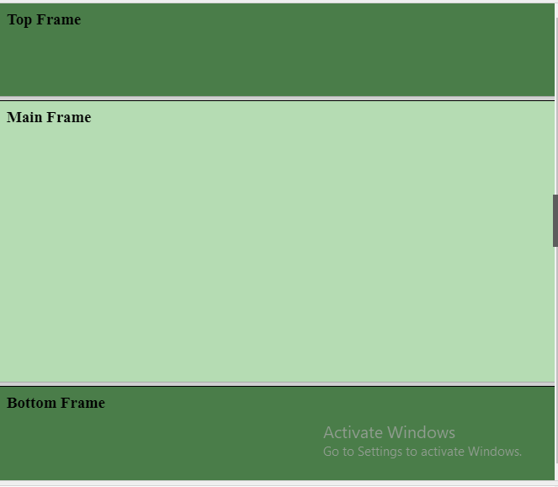

<html>

<frameset cols = "25%,50%,25%">

<frame name = "left" src = "/html/top_frame.htm" />

<frame name = "center" src = "/html/main_frame.htm" />

<frame name = "right" src = "/html/bottom_frame.htm" />

</frameset>

</html>

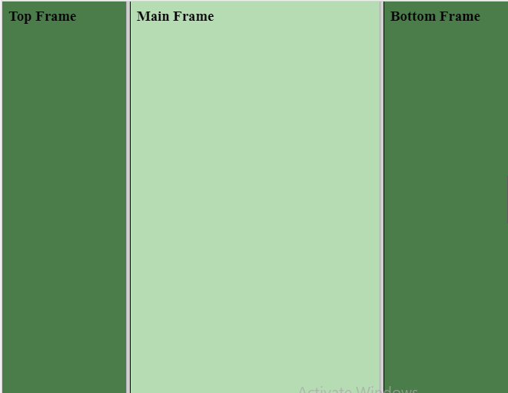

[Mixed frameset](https://www.w3schools.com/tags/tryit.asp?filename=tryhtml_frame_mix)

How to make a frameset with three documents, and how to mix them in rows and columns.

<!DOCTYPE html>

<html>

<frameset rows="50%,50%">

<frame src="frame_a.htm">

<frameset cols="25%,75%">

<frame src="frame_b.htm">

<frame src="frame_c.htm">

</frameset>

</frameset>

</html>

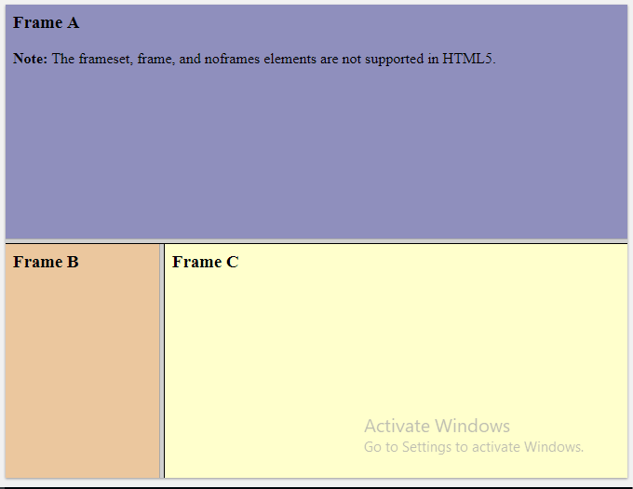

## The <frameset> Tag Attributes

Following are important attributes of the <frameset> tag −

|  |  |
| --- | --- |
| **Sr.No** | **Attribute & Description** |
| 1 | **cols**  Specifies how many columns are contained in the frameset and the size of each column. You can specify the width of each column in one of the four ways −  Absolute values in pixels. For example, to create three vertical frames, use *cols = "100, 500, 100"*.  A percentage of the browser window. For example, to create three vertical frames, use *cols = "10%, 80%, 10%"*.  Using a wildcard symbol. For example, to create three vertical frames, use *cols = "10%, *, 10%"*. In this case wildcard takes remainder of the window.  As relative widths of the browser window. For example, to create three vertical frames, use *cols = "3*, 2*, 1*"*. This is an alternative to percentages. You can use relative widths of the browser window. Here the window is divided into sixths: the first column takes up half of the window, the second takes one third, and the third takes one sixth. |
| 2 | **rows**  This attribute works just like the cols attribute and takes the same values, but it is used to specify the rows in the frameset. For example, to create two horizontal frames, use *rows = "10%, 90%"*. You can specify the height of each row in the same way as explained above for columns. |
| 3 | **border**  This attribute specifies the width of the border of each frame in pixels. For example, border = "5". A value of zero means no border. |
|  |  |

## The <frame> Tag Attributes

Following are the important attributes of <frame> tag −

|  |  |
| --- | --- |
| **Sr.No** | **Attribute & Description** |
| 1 | **src**  This attribute is used to give the file name that should be loaded in the frame. Its value can be any URL. For example, src = "/html/top_frame.htm" will load an HTML file available in html directory. |
| 2 | **name**  This attribute allows you to give a name to a frame. It is used to indicate which frame a document should be loaded into. This is especially important when you want to create links in one frame that load pages into an another frame, in which case the second frame needs a name to identify itself as the target of the link. |

## Frame's name and target attributes

One of the most popular uses of frames is to place navigation bars in one frame and then load main pages into a separate frame.

Myp.htm

<!DOCTYPE html>

<html>

<head>

<title>HTML Target Frames</title>

</head>

<frameset cols = "200, *">

<frame src = "/example/menu.htm" name = "menu_page" />

<frame src = "/example/main.htm" name = "main_page" />

</frameset>

</html>

Menu.htm

<!DOCTYPE html>

<html>

<body bgcolor = "#4a7d49">

<a href = "E://example/prog1.htm" target = "main_page">About HTML</a>

<br />

<br />

<a href = "E://example/prog2.htm" target = "main_page">About CSS</a>

<br />

<br />

<a href = "E://example/prog3.htm" target = "main_page">About PHP</a>

</body>

</html>

**Main.htm**

<!DOCTYPE html>

<html>

<body bgcolor = "#b5dcb3">

<h2>This is Welcome page</h2>

<p>Click any link and see the result.</p>

<p>Web Development</p>

<p>HTML Page</p>

</body>

</html>

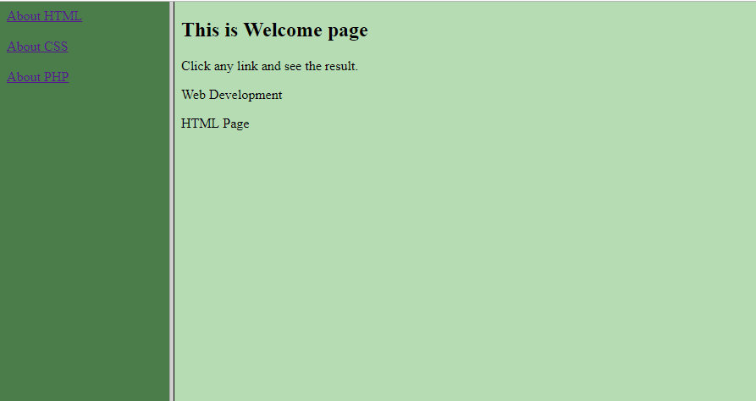

Prog1.htm

<!DOCTYPE html>

<html>

<head>

<title>Program One</title>

</head>

<body>

<h1> Program One Demo<h1>

<p>HTML frames are used to divide your browser window into multiple sections where <br>

each section can load a separate HTML document.<br> A collection of frames in the browser window is known<br> as a frameset. The window is divided into frames in a <br>similar way the tables are organized: into rows and columns. </p>

<p>Click To Back Link</p>

**<a href = "E://example/main.htm" target = "_self">Back</a>**

</body>

</html>

Prog2.htm

<!DOCTYPE html>

<html>

<head>

<title>Program Two</title>

</head>

<body>

<h1> Program Two Demo<h1>

<h1>CSS Notes<h1>

<p>Click To Back Link</p>

**<a href = "E://example/main.htm" target = "_self">Back</a>**

</body>

</html>

**Prog3.htm**

<!DOCTYPE html>

<html>

<head>

<title>Program Three</title>

</head>

<body>

<h1> Program Three Demo<h1>

<h1>PHP Notes<h1>

<p>Click To Back Link</p>

<a href = "E://example/main.htm" target = "_self">Back</a>

</body>

</html>

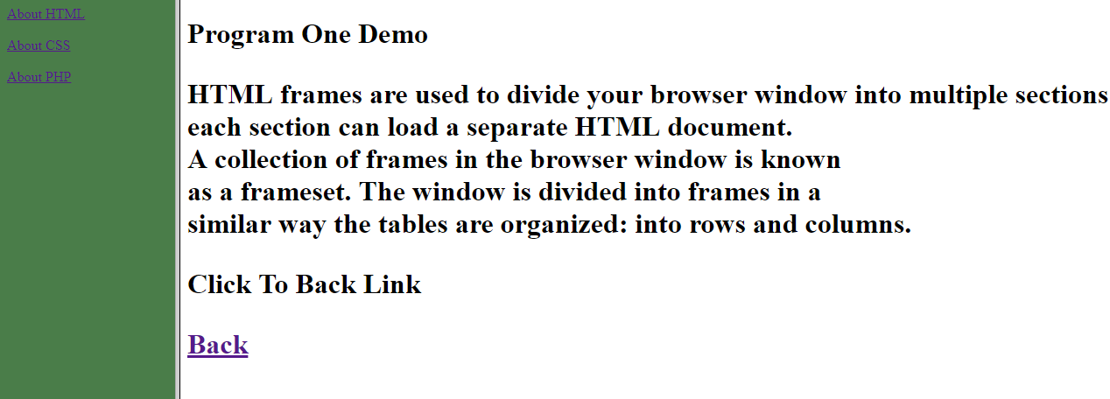

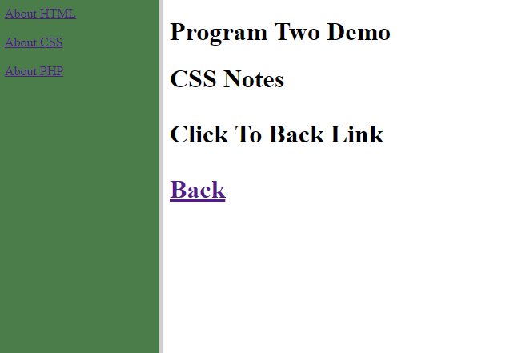

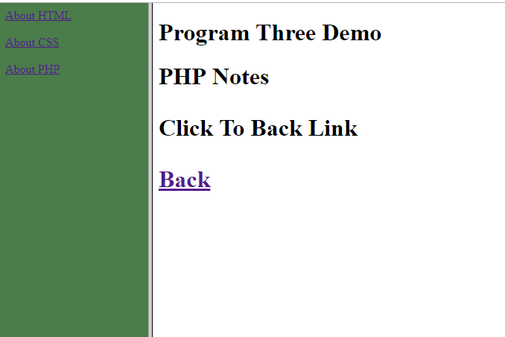

<!DOCTYPE html>

<html>

<frameset cols="50%,50%">

<frameset rows="50%,50%">

<frame src="frame_a.htm">

<frame src="frame_a.htm">

</frameset>

<frameset rows="35%,35%,30%">

<frame src="frame_b.htm">

<frame src="frame_b.htm">

<frame src="frame_b.htm">

</frameset>

</frameset>

</html>

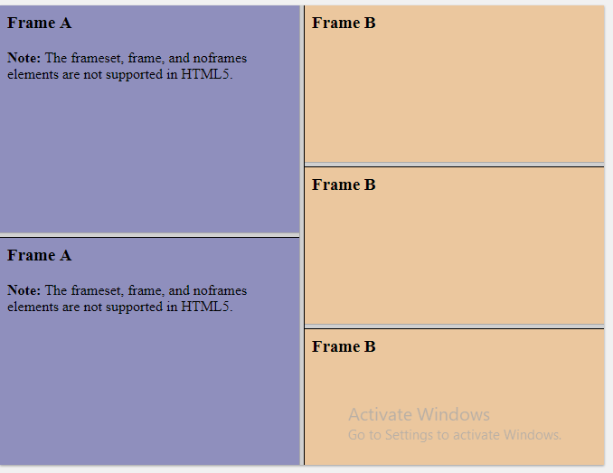

<!DOCTYPE html>

<html>

<frameset rows="35%,30%,35%">

<frameset cols="35%,30%,35%">

<frame src="frame_a.htm">

<frame src="frame_a.htm">

<frame src="frame_a.htm">

</frameset>

<frameset rows="100%">

<frame src="frame_b.htm">

</frameset>

<frameset cols="35%,30%,35%">

<frame src="frame_c.htm">

<frame src="frame_c.htm">

<frame src="frame_c.htm">

</frameset>

</frameset>

</html>

