What is CSS?

**C**ascading **S**tyle **S**heets, fondly referred to as CSS, is a simple design language intended to simplify the process of making web pages presentable.

CSS handles the look and feel part of a web page. Using CSS, you can control the color of the text, the style of fonts, the spacing between paragraphs, how columns are sized and laid out, what background images or colors are used, layout designs, and variations in display for different devices and screen sizes as well as a variety of other effects.

## Advantages of CSS

* **CSS saves time** − You can write CSS once and then reuse same sheet in multiple HTML pages. You can define a style for each HTML element and apply it to as many Web pages as you want.
* **Pages load faster** − If you are using CSS, you do not need to write HTML tag attributes every time. Just write one CSS rule of a tag and apply it to all the occurrences of that tag. So less code means faster download times.
* **Easy maintenance** − To make a global change, simply change the style, and all elements in all the web pages will be updated automatically.
* **Superior styles to HTML** − CSS has a much wider array of attributes than HTML, so you can give a far better look to your HTML page in comparison to HTML attributes.
* **Multiple Device Compatibility** − Style sheets allow content to be optimized for more than one type of device. By using the same HTML document, different versions of a website can be presented for handheld devices such as PDAs and cell phones or for printing.
* **Global web standards** − Now HTML attributes are being deprecated and it is being recommended to use CSS. So its a good idea to start using CSS in all the HTML pages to make them compatible to future browsers.

# CSS - Syntax

A CSS comprises of style rules that are interpreted by the browser and then applied to the corresponding elements in your document. A style rule is made of three parts −

* **Selector** − A selector is an HTML tag at which a style will be applied. This could be any tag like <h1> or <table> etc.
* **Property** − A property is a type of attribute of HTML tag. Put simply, all the HTML attributes are converted into CSS properties. They could be *color*, *border* etc.
* **Value** − Values are assigned to properties. For example, *color*property can have value either *red* or *#F1F1F1* etc.

You can put CSS Style Rule Syntax as follows −

selector { property: value }

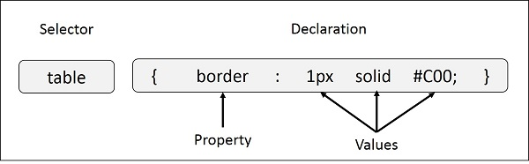

**Example** − You can define a table border as follows −

table{ border :1px solid #C00; }

Here table is a selector and border is a property and given value *1px solid #C00* is the value of that property.

You can define selectors in various simple ways based on your comfort. Let me put these selectors one by one.

## The Type Selectors

This is the same selector we have seen above. Again, one more example to give a color to all level 1 headings −

h1 {

color: #36CFFF;

}

There are four ways to associate styles with your HTML document. Most commonly used methods are inline CSS and External CSS.

## Internal CSS

An internal CSS is used to define a style for a single HTML page.

An internal CSS is defined in the <head> section of an HTML page, within a <style> element:

<!DOCTYPE html>

<html>

<head>

<style>

body {

background-color: yellow;

}

h1 {

color: blue;

}

p {

color: red;

}

</style>

</head>

<body>

<h1>This is a heading</h1>

<p>This is a paragraph.</p>

</body>

</html>

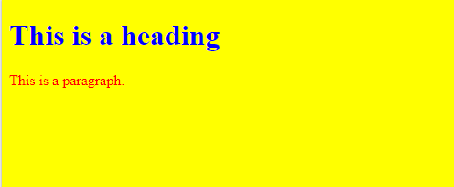

## Inline CSS

An inline CSS is used to apply a unique style to a single HTML element.

You can use *style* attribute of any HTML element to define style rules. These rules will be applied to that element only. Here is the generic syntax −

<element style = "...style rules....">

### Attributes

|  |  |  |
| --- | --- | --- |
| **Attribute** | **Value** | **Description** |
| style | style rules | The value of *style* attribute is a combination of style declarations separated by semicolon (;). |

<!DOCTYPE html>

<html>

<body>

<h1 style="color:blue;">Html CSS Demo</h1>

</body>

</html>

## 3-External CSS

An external style sheet is used to define the style for many HTML pages.

**With an external style sheet, you can change the look of an entire web site, by changing one file!**

To use an external style sheet, add a link to it in the <head> section of the HTML page:

The <link> element can be used to include an external stylesheet file in your HTML document.

An external style sheet is a separate text file with **.css** extension. You define all the Style rules within this text file and then you can include this file in any HTML document using <link> element.

Here is the generic syntax of including external CSS file −

<head>

<link type = "text/css" href = "..."/>

</head>

### Attributes

Attributes associated with <style> elements are −

|  |  |  |
| --- | --- | --- |
| **Attribute** | **Value** | **Description** |
| type | text css | Specifies the style sheet language as a content-type (MIME type). This attribute is required. |
| href | URL | Specifies the style sheet file having Style rules. This attribute is a required. |

An external style sheet can be written in any text editor. The file must not contain any HTML code, and must be saved with a .css extension.

Here is how the "myfile.css" looks:

body {  
  background-color: powderblue;  
}  
h1 {  
  color: blue;  
}  
p {  
  color: red;  
}

<!DOCTYPE html>

<html>

<head>

<link type = "text/css" href = "myfile.css" />

</head>

<body>

<h1>This is a heading</h1>

<p>This is a paragraph.</p>

</body>

</html>

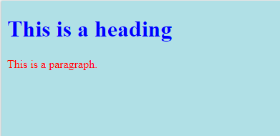

## 4-Imported CSS - @import Rule

@import is used to import an external stylesheet in a manner similar to the <link> element. Here is the generic syntax of @import rule.

<head>

<@import "URL";

</head>

Here URL is the URL of the style sheet file having style rules. You can use another syntax as well −

<head>

<@import url("URL");

</head>

### Example

Following is the example showing you how to import a style sheet file into HTML document −

<head>

@import "mystyle.css";

</head>

## CSS Rules Overriding

We have discussed four ways to include style sheet rules in an HTML document. Here is the rule to override any Style Sheet Rule.

* Any inline style sheet takes highest priority. So, it will override any rule defined in <style>...</style> tags or rules defined in any external style sheet file.
* Any rule defined in <style>...</style> tags will override rules defined in any external style sheet file.
* Any rule defined in external style sheet file takes lowest priority, and rules defined in this file will be applied only when above two rules are not applicable.

<!DOCTYPE html>

<html>

<head>

<style>

body {background-color: powderblue;}

h1 {color: green;}

p {color: red;}

</style>

</head>

<body>

<h1 style="color:blue;">This is a Blue Heading</h1>

<h1>This is a heading</h1>

<p>This is a paragraph.</p>

</body>

</html>

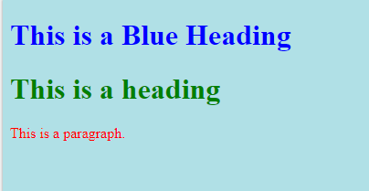

## CSS Fonts

The CSS color property defines the text color to be used.

The CSS font-family property defines the font to be used.

The CSS font-size property defines the text size to be used.

<!DOCTYPE html>  
<html>  
<head>  
<style>  
h1 {  
  color: blue;  
  font-family: verdana;  
  font-size: 300%;  
}  
p  {  
  color: red;  
  font-family: courier;  
  font-size: 160%;  
}  
</style>  
</head>  
<body>  
  
<h1>This is a heading</h1>  
<p>This is a paragraph.</p>  
</body>  
</html>

## CSS Syntax

A CSS rule-set consists of a selector and a declaration block:

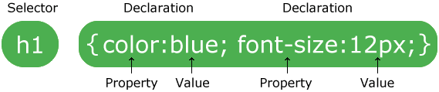

The selector points to the HTML element you want to style.

The declaration block contains one or more declarations separated by semicolons.

Each declaration includes a CSS property name and a value, separated by a colon.

A CSS declaration always ends with a semicolon, and declaration blocks are surrounded by curly braces.

In the following example all <p> elements will be center-aligned, with a red text color:

## CSS Selectors

CSS selectors are used to "find" (or select) HTML elements based on their element name, id, class, attribute, and more

## The element Selector

The element selector selects elements based on the element name.

You can select all <p> elements on a page like this (in this case, all <p> elements will be center-aligned, with a red text color):

p {  
  text-align: center;  
  color: red;  
}

## The id Selector

The id selector uses the id attribute of an HTML element to select a specific element.

The id of an element should be unique within a page, so the id selector is used to select one unique element!

To select an element with a specific id, write a hash (#) character, followed by the id of the element.

The style rule below will be applied to the HTML element with id="pg1":

**Note:** An id name cannot start with a number!

#pg1 {  
  text-align: center;  
  color: red;  
}

<!DOCTYPE html>

<html>

<head>

<style>

#pg1 {

text-align: center;

color: red;

}

</style>

</head>

<body>

<p id="pg1">Hello EveryBody</p>

<p>This paragraph is not affected by the style.</p>

</body>

</html>

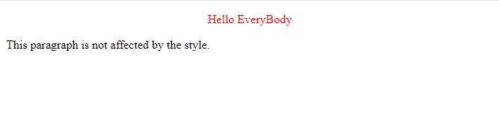

## The class Selector

The class selector selects elements with a specific class attribute.

To select elements with a specific class, write a period (.) character, followed by the name of the class.

In the example below, all HTML elements with class="cent" will be red and center-aligned:

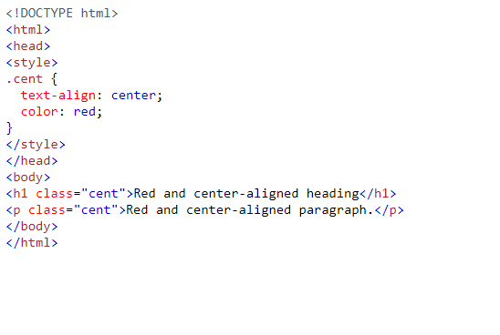

**You can also specify that only specific HTML elements should be affected by a class.**

**In the example below, only <p> elements with class="cent" will be center-aligned:**

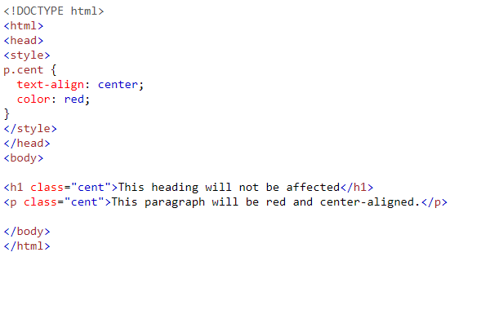

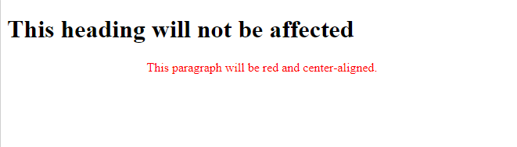

**HTML elements can also refer to more than one class.**

**In the example below, the <p> element will be styled according to class="cent" and to class="large":**

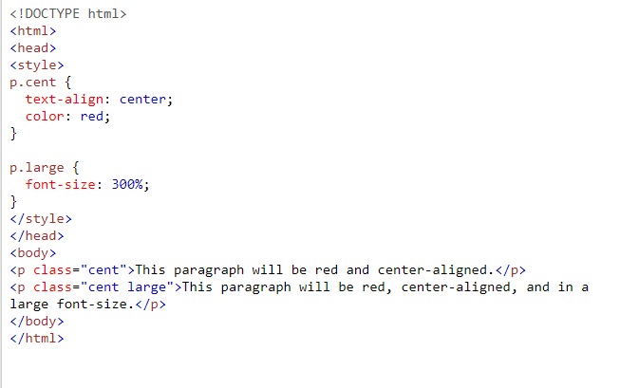

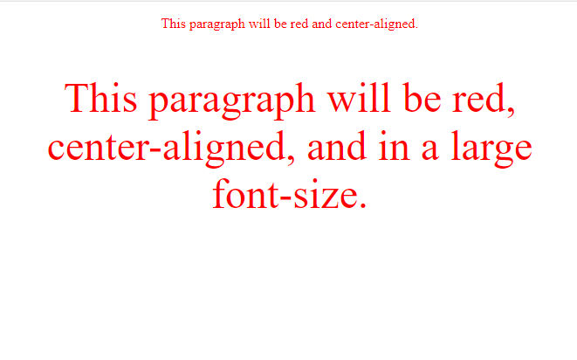

## Grouping Selectors

If you have elements with the same style definitions, like this:

h1 {  
  text-align: center;  
  color: red;  
}  
  
h2 {  
  text-align: center;  
  color: red;  
}  
  
p {  
  text-align: center;  
  color: red;  
}

It will be better to group the selectors, to minimize the code.

To group selectors, separate each selector with a comma.

In the example below we have grouped the selectors from the code above:

h1, h2, p {  
  text-align: center;  
  color: red;  
}

[Try it Yourself »](https://www.w3schools.com/css/tryit.asp?filename=trycss_grouping)

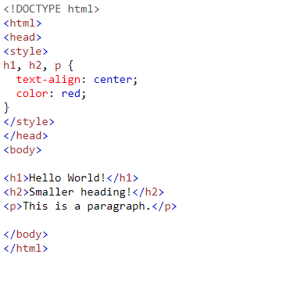

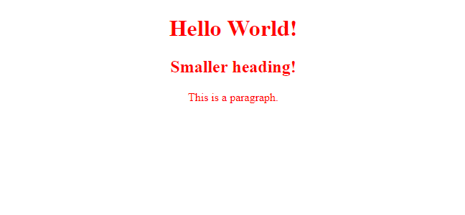

## CSS Comments

Comments are used to explain the code, and may help when you edit the source code at a later date.

Comments are ignored by browsers.

A CSS comment starts with /* and ends with */. Comments can also span multiple lines:

### Example

p {  
  color: red;  
  /* This is a single-line comment */  
  text-align: center;  
}  
  
/* This is  
a multi-line  
comment */