**Universal Selector**

**The universal selector, written as * i.e. asterisk or star symbol, matches every single element on the page. The universal selector may be omitted if other conditions exist on the target element.**

**The style rules inside the * selector will be applied to every element in a document.**

## <!DOCTYPE html>

## <html>

## <head>

## <style>

## *{

## text-align:center;

## color: red;

## font-family: verdana;

## font-size: 110%;

## }

## </style>

## </head>

## <body>

## <h1>Hello world!</h1>

## <h2>Hello EveryBody</h2>

## <p>CSS Example1</p>

## <p>CSS Example2</p>

## <p>CSS Example3</p>

## </body>

## </html>

## 

## Example2

**The universal selector may be omitted if other conditions exist on the target element.**

## <!DOCTYPE html>

## <html>

## <head>

## <style>

## *{

## text-align:center;

## color: red;

## font-family: verdana;

## font-size: 110%;

## }

## .myclass{

## text-align: left;

## color: blue;

## font-size: 150%;

## }

## </style>

## </head>

## <body>

## <h1>Hello world!</h1>

## <h2>Hello EveryBody</h2>

## <p>CSS Example1</p>

## <p class="myclass">CSS Example2</p>

## <p class="myclass">CSS Example3</p>

## </body>

## </html>

## 

[Combinator selectors](https://www.w3schools.com/css/css_combinators.asp)

**There are four different combinators in CSS:**

* **descendant selector (space)**
* **child selector (>)**
* **adjacent sibling selector (+)**
* **general sibling selector (~)**

## The Descendant Selectors

Suppose you want to apply a style rule to a particular element only when it lies inside a particular element.

The descendant selector matches all elements that are descendants of a specified element.

The following example selects all <p> elements inside <div> elements:

Example1

<!DOCTYPE html>

<html>

<head>

<style>

div p {

background-color: yellow;

border:5px dotted cyan;

text-align:center;

color: red;

font-family: verdana;

font-size: 110%;

}

</style>

</head>

<body>

<h2>Descendant Selector Example</h2>

<p>Hello EveryBody. This is an example of Descendant Selector</p>

<div>

<p>Java Programming </p>

<p>Full Stack Web Development</p>

<p> C++ Programming</p>

</div>

<p>Paragraph 1</p>

<p>Paragraph 2</p>

<h2>End of Program</h2>

</body>

</html>

# 

As given in the following example, style rule will apply to <em> element only when it lies inside <ul> tag.

# <em> tag

## Description

The HTML **<em> tag** marks text that has stress emphasis which traditionally means that the text is displayed in italics by the browser. This tag is also commonly referred to as the <em> element.

**Syntax**

In HTML, the syntax for the **<em> tag** is:

<body>

<p><em>Stress emphasized text goes here</em> but not here</p>

</body>

### Sample Output

Stress emphasized text goes here but not here

**Example2**

<!DOCTYPE html>

<html>

<head>

<title>Example of CSS Descendant Selectors</title>

<style type="text/css">

h1 em {

color: green;

}

</style>

</head>

<body>

<h1>Example of CSS <em> Descendant Selectors</em></h1>

<ul>

<li><a href="#">Home</a></li>

<li><a href="#">About</a></li>

<li><a href="#">Services</a></li>

<li><a href="#">Contact</a></li>

</ul>

</body>

</html>

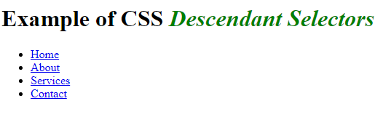

**Example3**

**<!DOCTYPE html>**

**<html>**

**<head>**

**<title>Example of CSS Descendant Selectors</title>**

**<style type="text/css">**

**h1 em {**

**color: green;**

**}**

**ul.menu {**

**padding: 0;**

**list-style: none;**

**}**

**ul.menu li{**

**display: inline;**

**}**

**ul.menu li a {**

**margin: 10px;**

**text-decoration: none;**

**}**

**</style>**

**</head>**

**<body>**

**<h1>This is a <em>heading</em></h1>**

**<ul class="menu">**

**<li><a href="#">Home</a></li>**

**<li><a href="#">About</a></li>**

**<li><a href="#">Services</a></li>**

**<li><a href="#">Contact</a></li>**

**</ul>**

**</body>**

**</html>**

The style rules inside the selector ul.menu li a applied to only those [<a>](https://www.tutorialrepublic.com/html-tutorial/html-links.php) i.e. anchor elements that contained inside an [unordered list](https://www.tutorialrepublic.com/html-tutorial/html-lists.php) having the class .menu, and has no effect on other links inside the document. Similarly, the style rules inside the h1 em selector applied to only [<em>](https://www.tutorialrepublic.com/html-reference/html-em-tag.php) elements that contained inside heading [<h1>](https://www.tutorialrepublic.com/html-tutorial/html-headings.php).

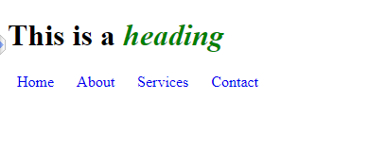

h1 {  
  text-decoration: overline;  
}  
  
h2 {  
  text-decoration: line-through;  
}  
  
h3 {  
  text-decoration: underline;  
}  
  
h3 {  
  text-decoration: underline overline;  
}

## Child Selectors

A child selector can be used to select only those elements that are the direct children of some element. A child selector is made up of two or more selectors separated by the greater than symbol (i.e. >).

**Example1**

**<!DOCTYPE html>**

**<html>**

**<head>**

**<style>**

**body > p {**

**text-align:center;**

**color: red;**

**font-family: verdana;**

**font-size: 110%;**

**}**

**</style>**

**</head>**

**<body>**

**<h2>Descendant Selector Example</h2>**

**<p>Hello EveryBody. This is an example of Descendant Selector</p>**

**<div>**

**<p>Java Programming </p>**

**<p>Full Stack Web Development</p>**

**<p> C++ Programming</p>**

**</div>**

**<p>Paragraph 1</p>**

**<p>Paragraph 2</p>**

**</body>**

**</html>**

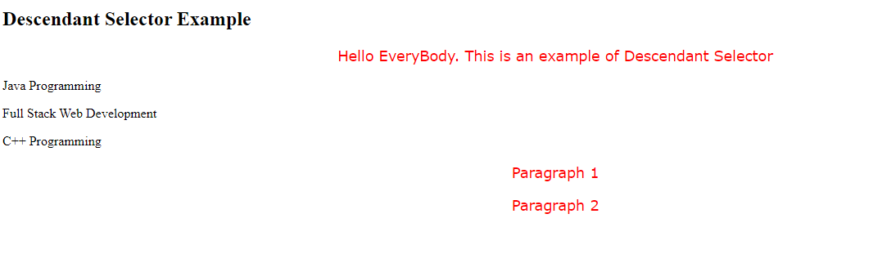

**Example2**

You can use these selectors for example, to select the first level of list elements inside a nested list that has more than one level.

**<!DOCTYPE html>**

**<html>**

**<head>**

**<title>Example of CSS Child Selectors</title>**

**<style type="text/css">**

**ul > li {**

**list-style: square;**

**}**

**ul > li ol {**

**list-style: none;**

**}**

**</style>**

**</head>**

**<body>**

**<ul>**

**<li><a href="#">Home</a></li>**

**<li><a href="#">About</a></li>**

**<li><a href="#">Services</a>**

**<ol>**

**<li><a href="#">Design</a></li>**

**<li><a href="#">Development</a></li>**

**</ol>**

**</li>**

**<li><a href="#">Contact</a></li>**

**</ul>**

**</body>**

**</html>**

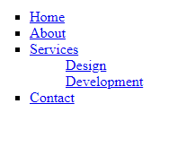

Adjacent Sibling Selectors

The adjacent sibling selectors can be used to select sibling elements. This selector has the syntax like: E1 + E2, where E2 is the target of the selector.

The selector h1 + p in the example below will select the [<p>](https://www.tutorialrepublic.com/html-tutorial/html-paragraphs.php) elements only if both the [<h1>](https://www.tutorialrepublic.com/html-tutorial/html-headings.php) and <p>elements share the same parent in the document tree and <h1> is immediately precedes the <p>element. That means only those paragraphs that come immediately after each <h1> heading will have the associated style rules.

**<!DOCTYPE html>**

**<html>**

**<head>**

**<title>Example of CSS Adjacent Sibling Selectors</title>**

**<style type="text/css">**

**h1 + p {**

**color: blue;**

**font-size: 18px;**

**}**

**ul.san + p {**

**color: #f0f;**

**text-indent: 30px;**

**}**

**</style>**

**</head>**

**<body>**

**<h1>This is a heading</h1>**

**<p>This is a paragraph.</p>**

**<h1>This is a heading</h1>**

**<p>This is another paragraph.</p>**

**<p>This is another paragraph But not effected.</p>**

**<ul class="san">**

**<li>Java </li>**

**<li>Web Design</li>**

**<li>Compiler</li>**

**</ul>**

**<p>This is one more paragraph.</p>**

**<p>This is also a paragraph.</p>**

**</body>**

**</html>**

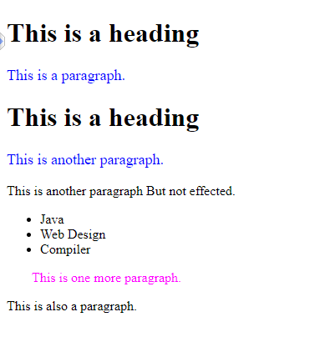

**Example2**

**<!DOCTYPE html>**

**<html>**

**<head>**

**<title>Example of CSS Adjacent Sibling Selectors</title>**

**<style type="text/css">**

**div + p {**

**text-align:center;**

**color: red;**

**font-family: verdana;**

**font-size: 110%;**

**}**

**</style>**

**</head>**

**<body>**

**<p>This is a paragraph 1</p>**

**<div>**

**<p>This is another paragraph But not effected.</p>**

**</div>**

**<p>This is paragraph 2</p>**

**<p>This is a paragraph 3</p>**

**</body>**

**</html>**

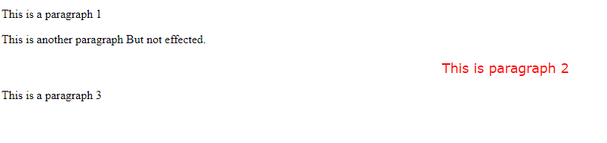

## General Sibling Selectors

**A general sibling selector is made up of two simple selectors separated by the tilde (∼) character. It can be written like: E1 ∼ E2, where E2 is the target of the selector.**

**The selector h1 ∼ p in the example below will select all the <p> elements that preceded by the <h1> element, where all the elements share the same parent in the document tree.**

The general sibling selector selects all elements that are next siblings of a specified element.

<!DOCTYPE html>

<html>

<head>

<title>Example of CSS General Sibling Selectors</title>

**<style type="text/css">**

**h1 ~ p {**

**color: blue;**

**font-size: 18px;**

**}**

**ul.san ~ p {**

**color: #f0f;**

**text-indent: 30px;**

**}**

**</style>**

</head>

<body>

<h1>This is a heading</h1>

<p>This is a paragraph.</p>

<p>This is another paragraph.</p>

<ul class="san">

<li>Java</li>

<li>WebDesign</li>

<li>Compiler</li>

</ul>

<p>This is one more paragraph.</p>

<p>This is also a paragraph.</p>

</body>

</html>

