# Group List

## Click on column dropdown list select column on which you want to do operations as shown below.

## C:\Users\pratiksha.mahamuni\Desktop\New folder\GroupColumn.png

## Select operator to search for different conditions.

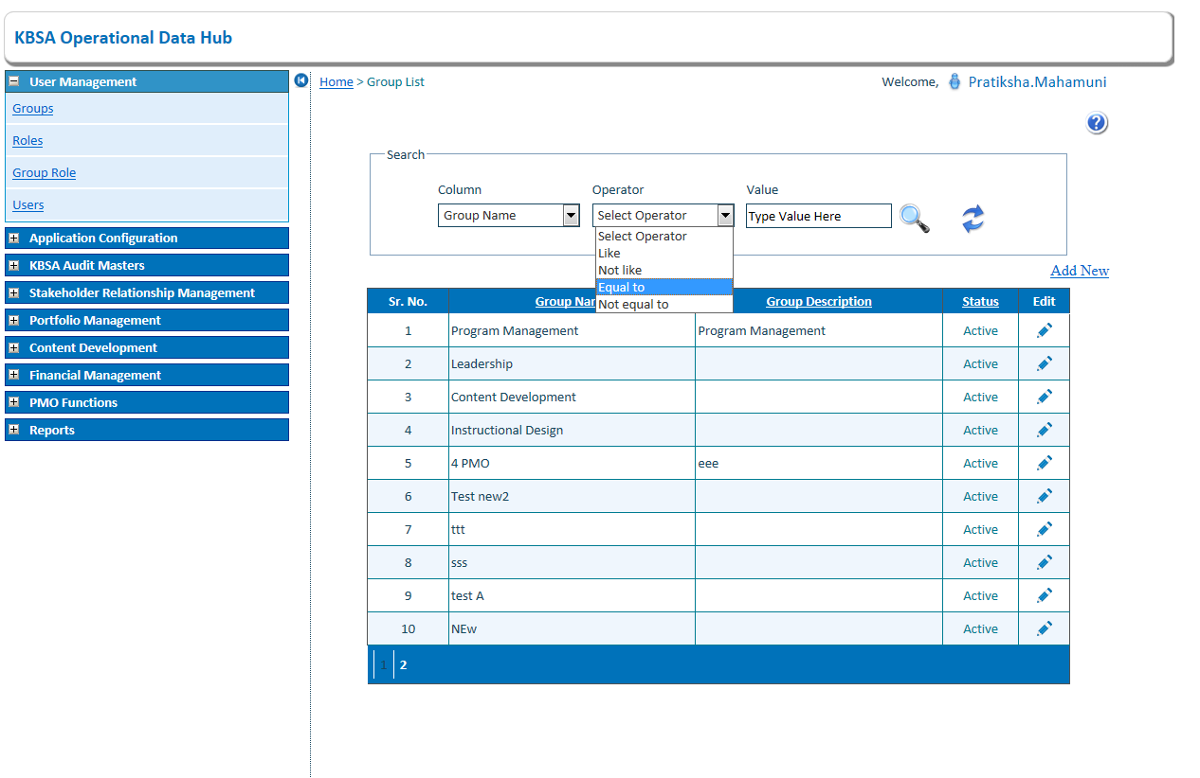

## Enter search value in textbox to search

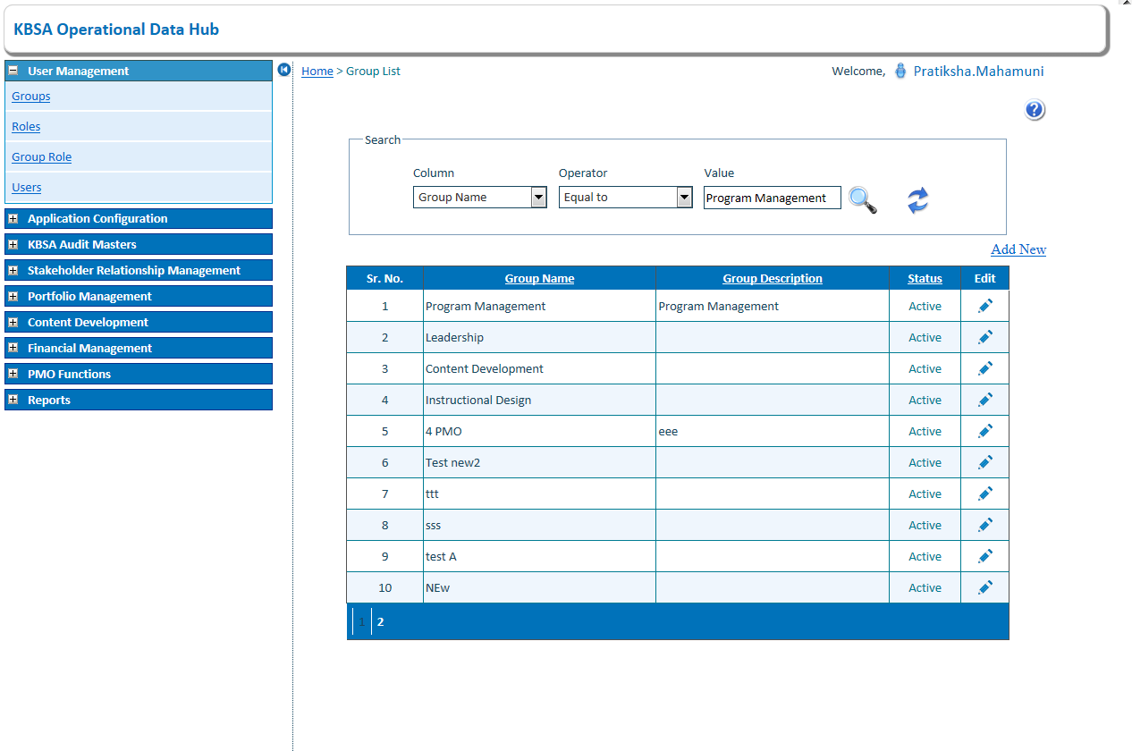

## Click on search button to search record for selected condition in grid will show filtered records

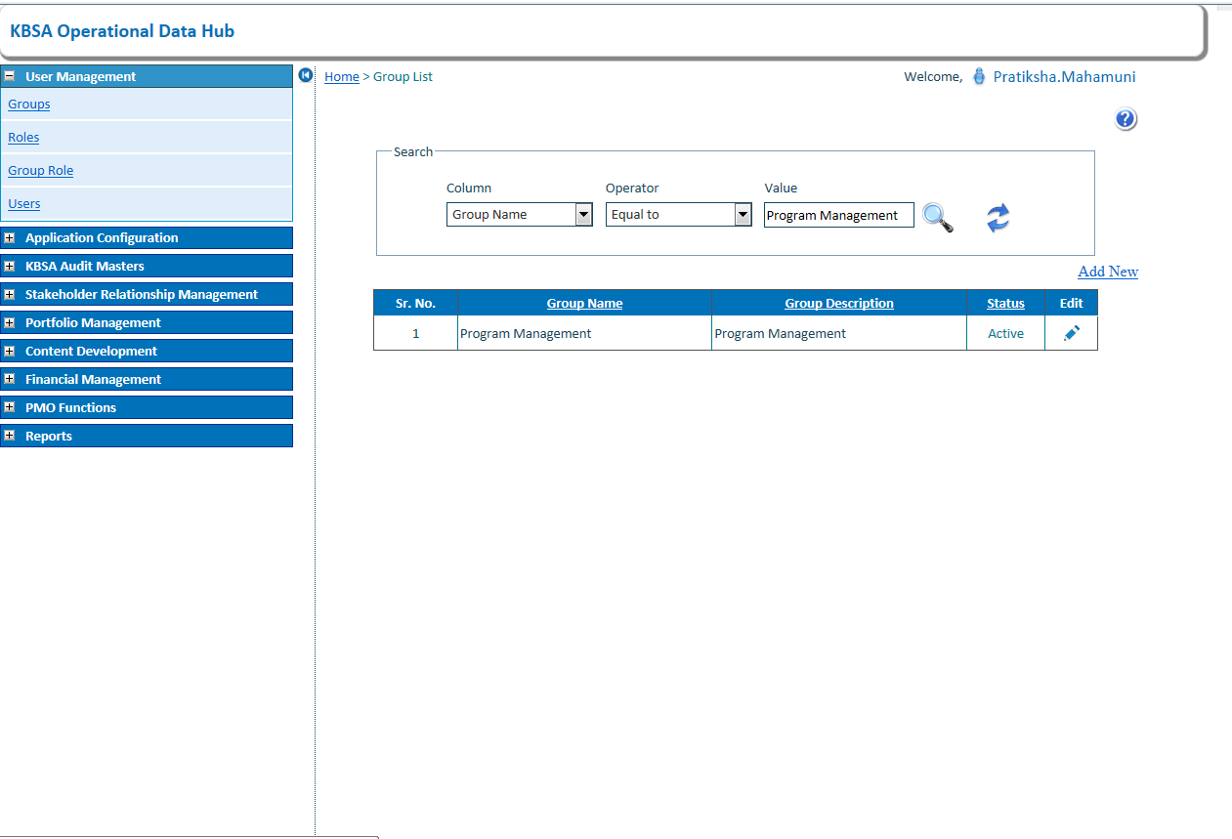

1. Click On Edit Button to Edit Group Details

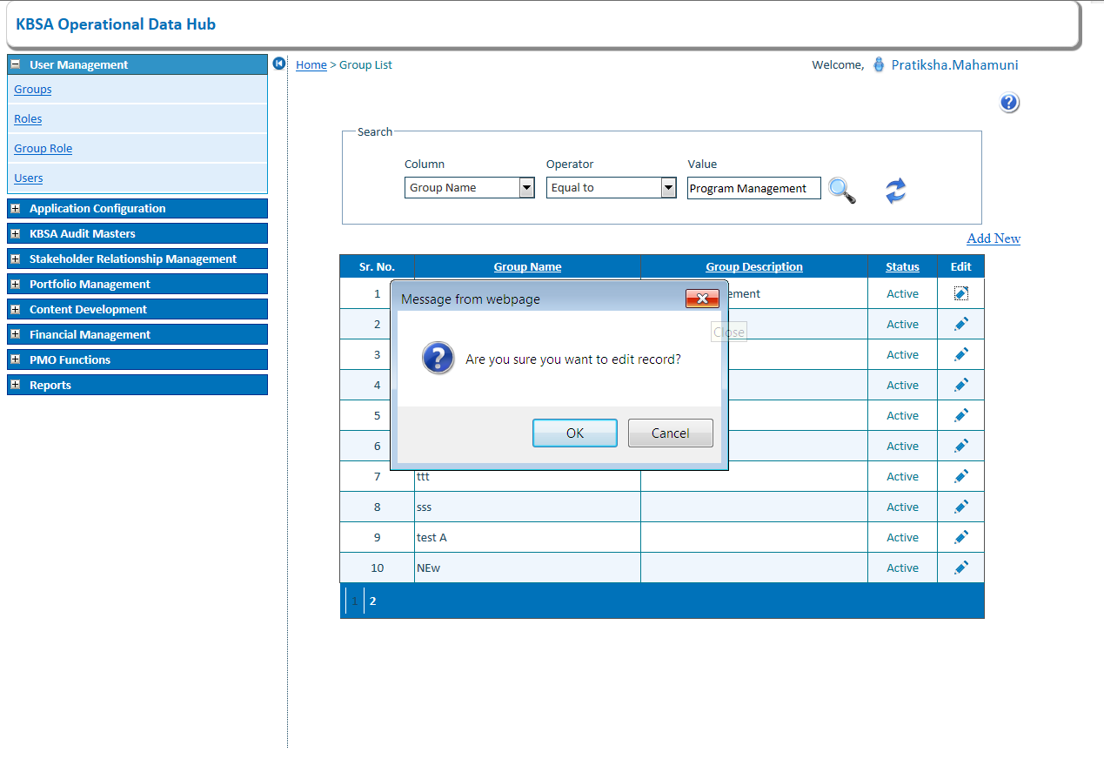

1. Edit the Group details and click on Update button

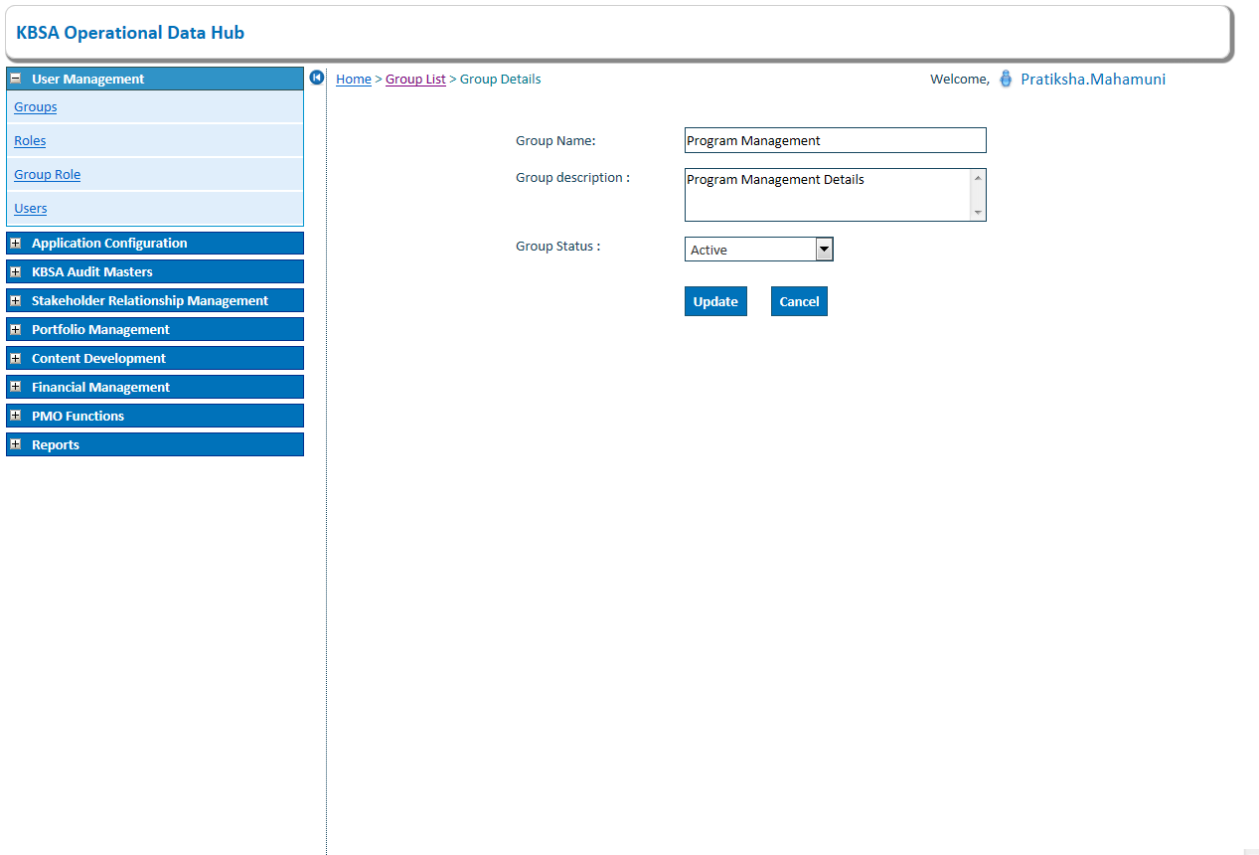

Group details updated in group list As below

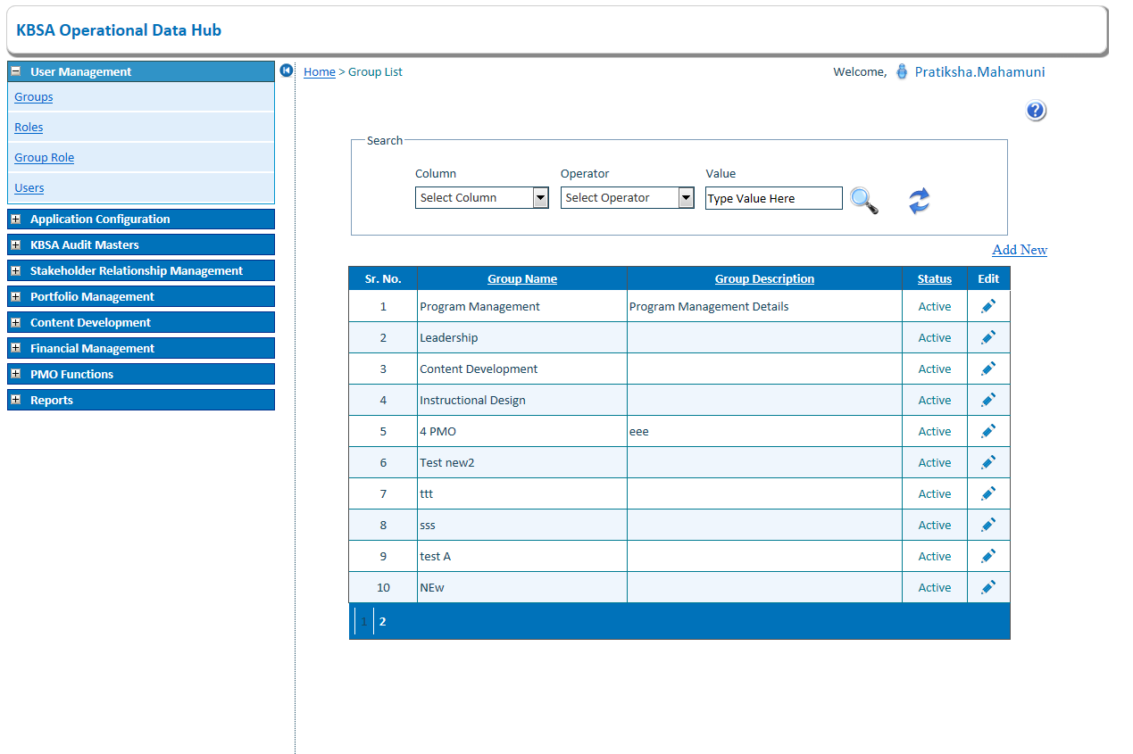

8)Add New Records in Group Details As Below on Clicking on Add New button on Upper side of grid will open new page like below

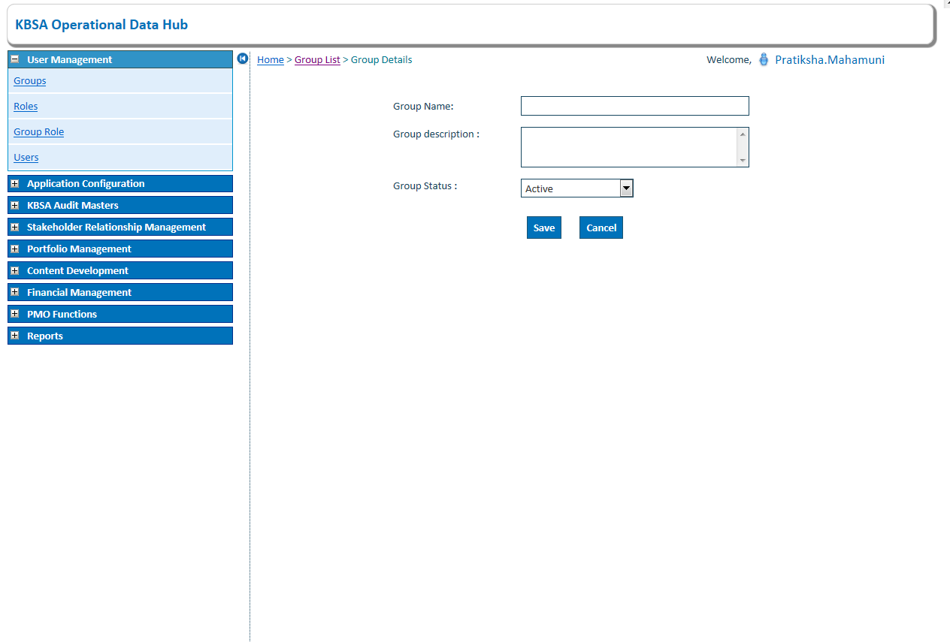

9) New group details is updated in grid shown below

