## User Group Role List

1. Select user to see permissions for Group Role

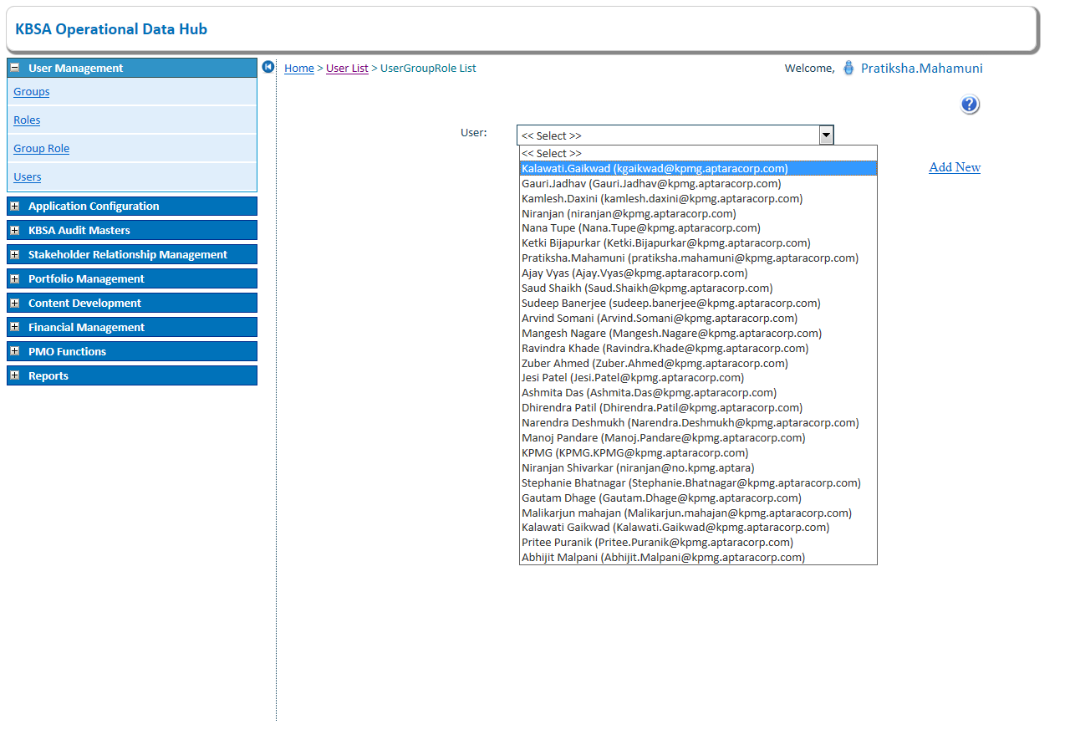

1. Click on Add new to add new group role permission

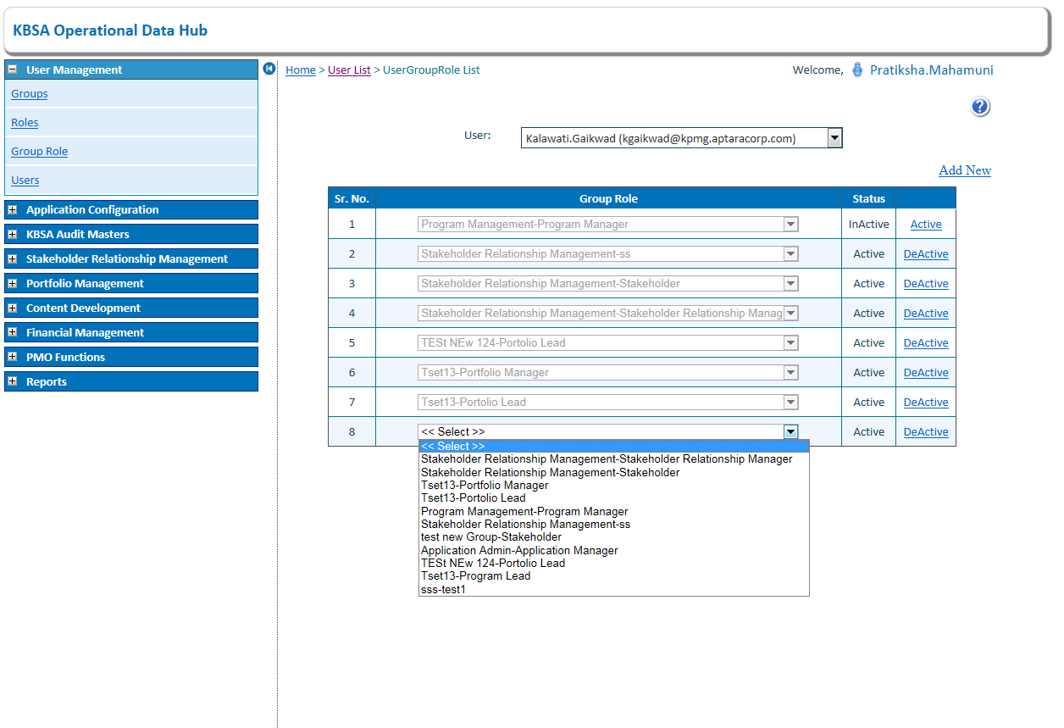

1. Select group role from dropdown to add and click on save button

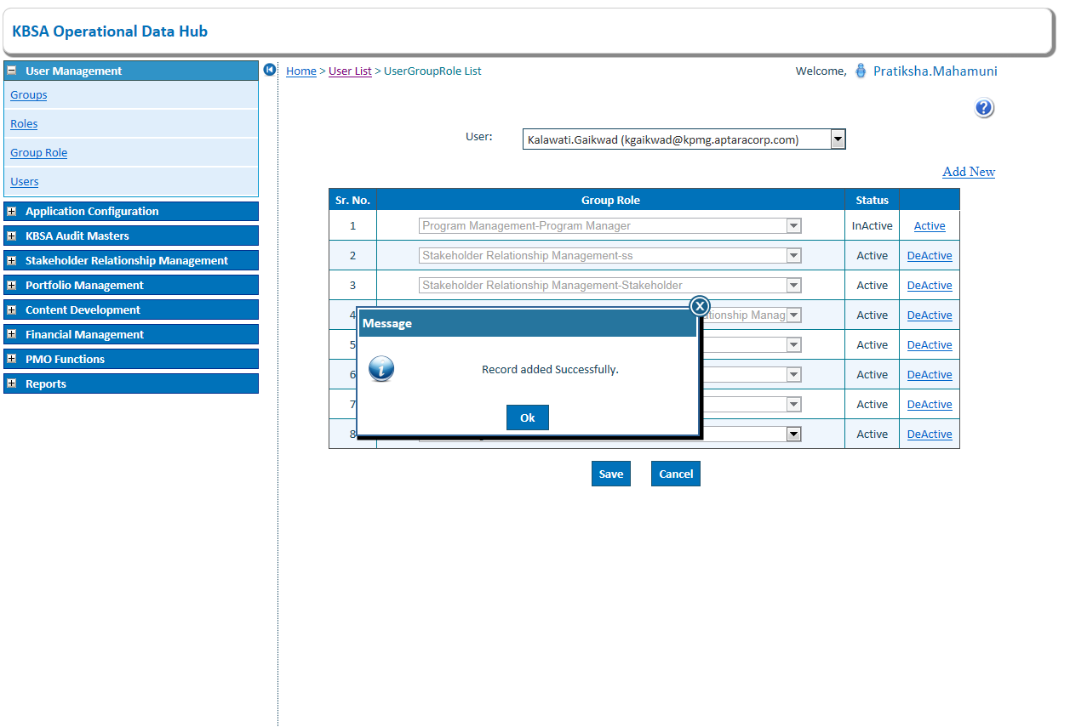

1. Click on status link Activate/Deactivate to change status of group role. Will change status.

