# User List

## Click on column dropdown list select column on which you want to do operations as shown below.

## C:\Users\pratiksha.mahamuni\Desktop\New folder\UserColumn.png

## Select operator to search for different conditions.

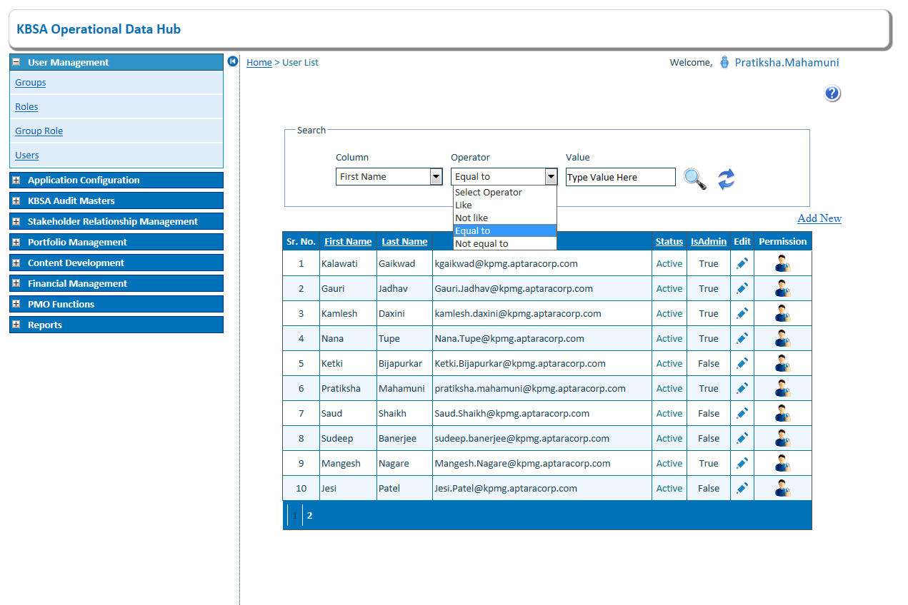

## Enter search value in textbox to search

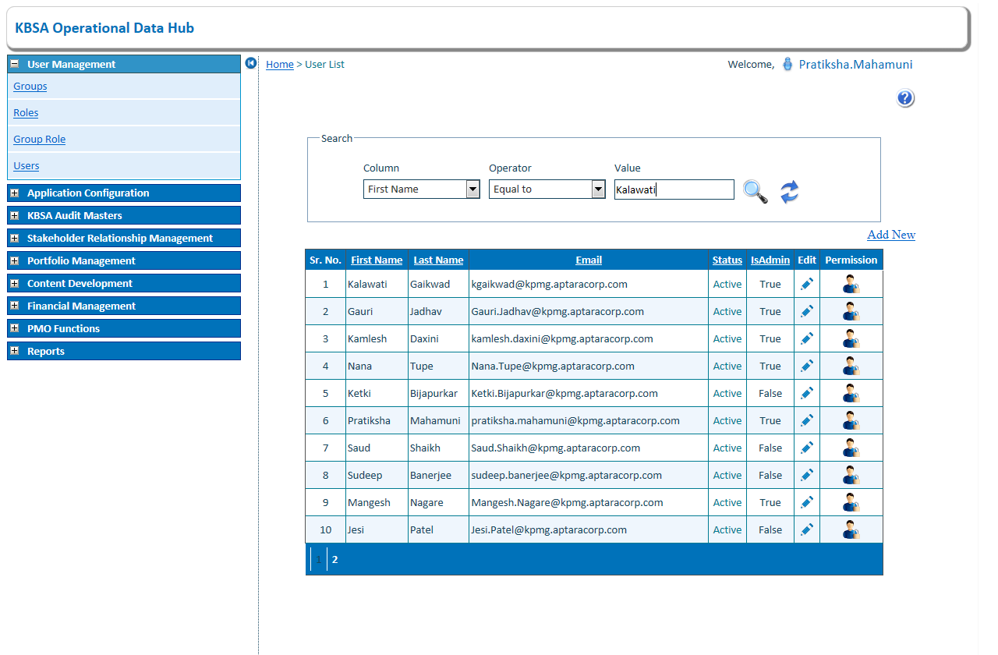

## Click on search button to search record for selected condition in grid will show filtered records

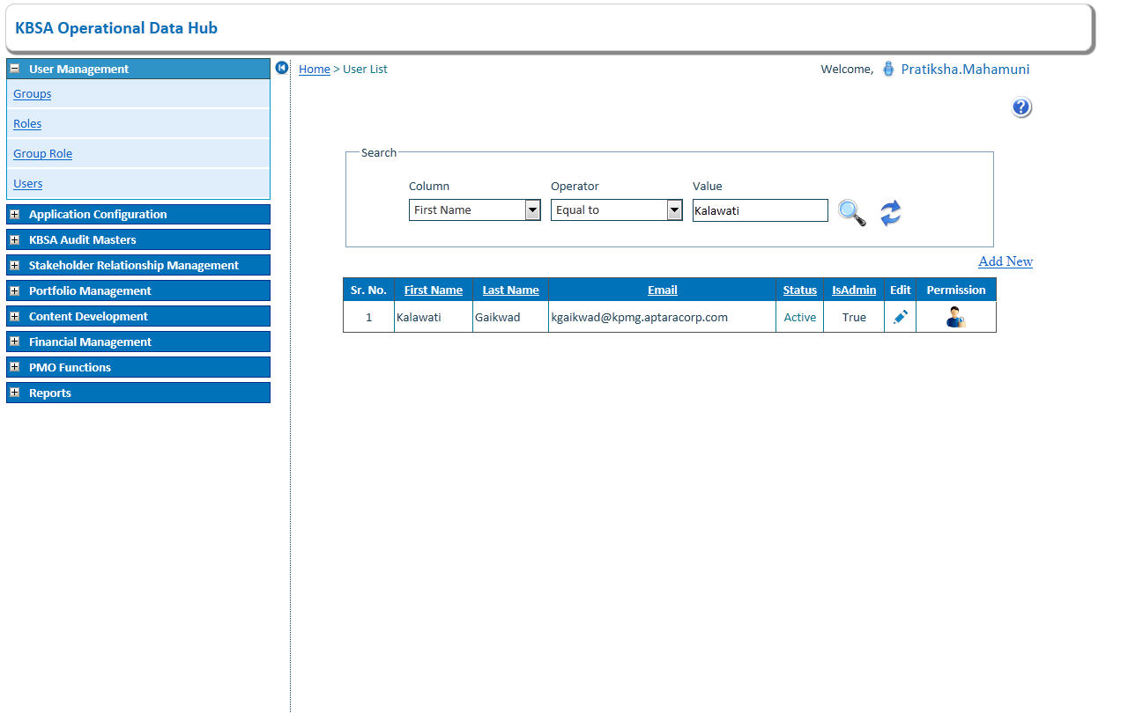

1. Click On Edit Button to Edit User Details

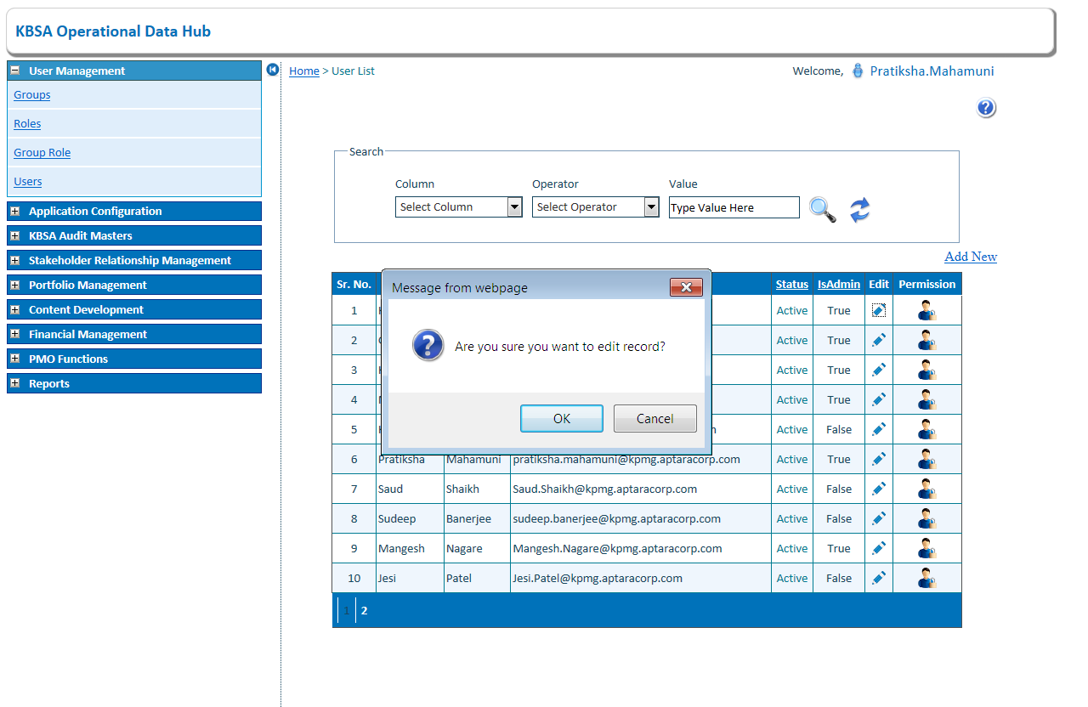

1. Edit the User details and click on Update button

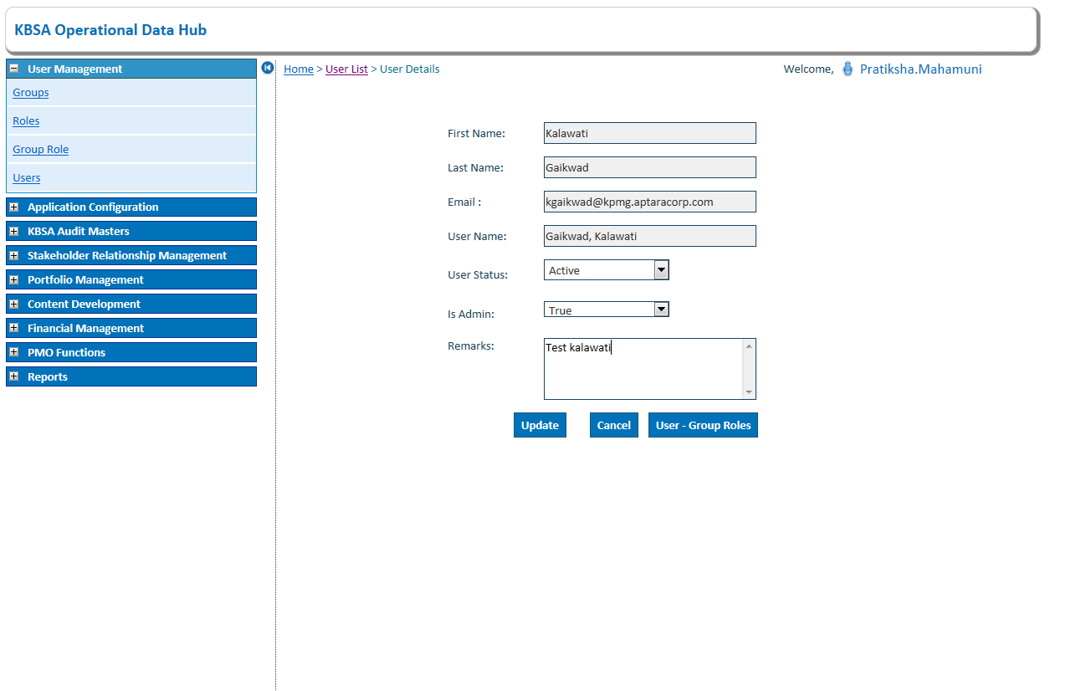

1. User details updated in group list As below

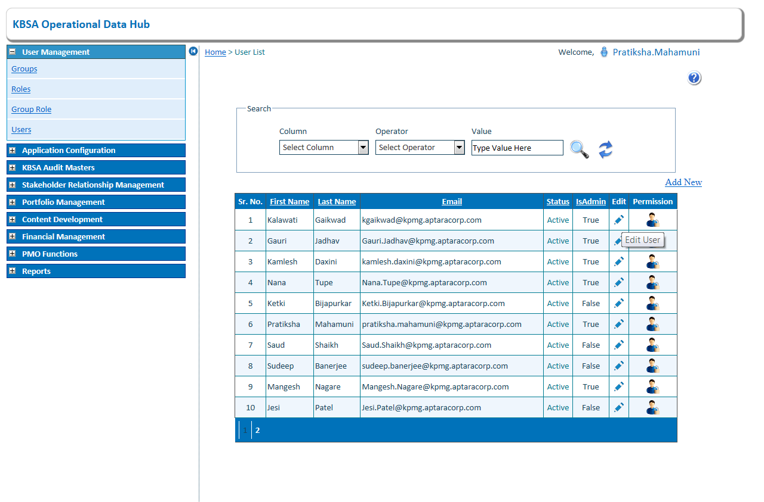

1. Click on User Permission to edit user permission 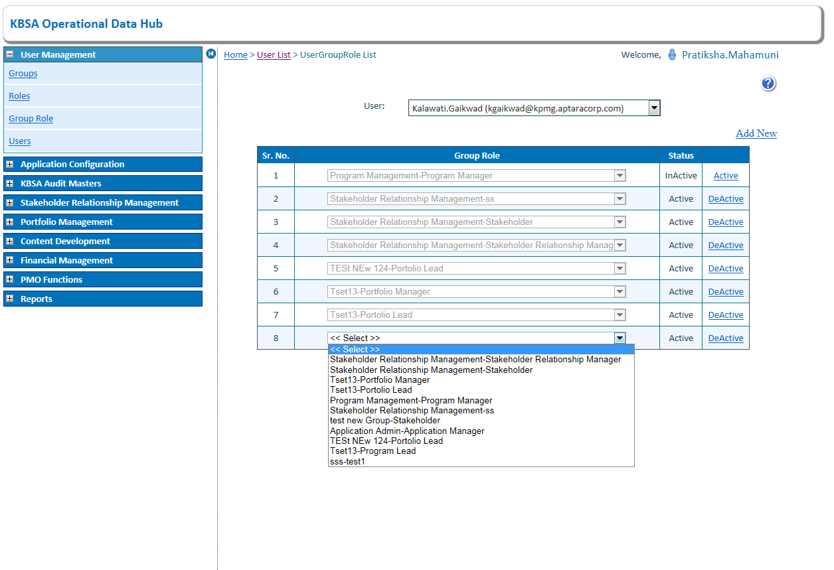
2. Click on Add new to add new group role and select specific group role then click on save. 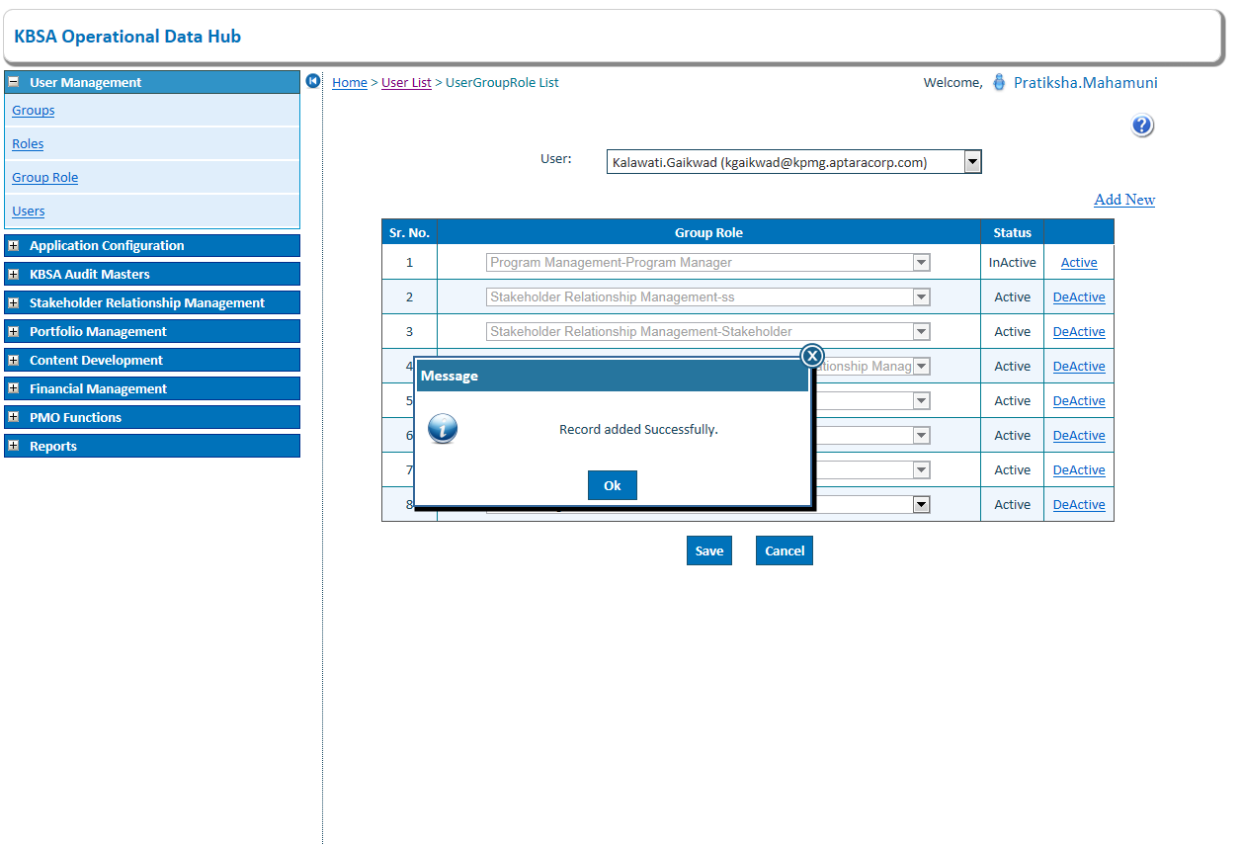
3. To change status click on link button of specific group role will change status of group role.

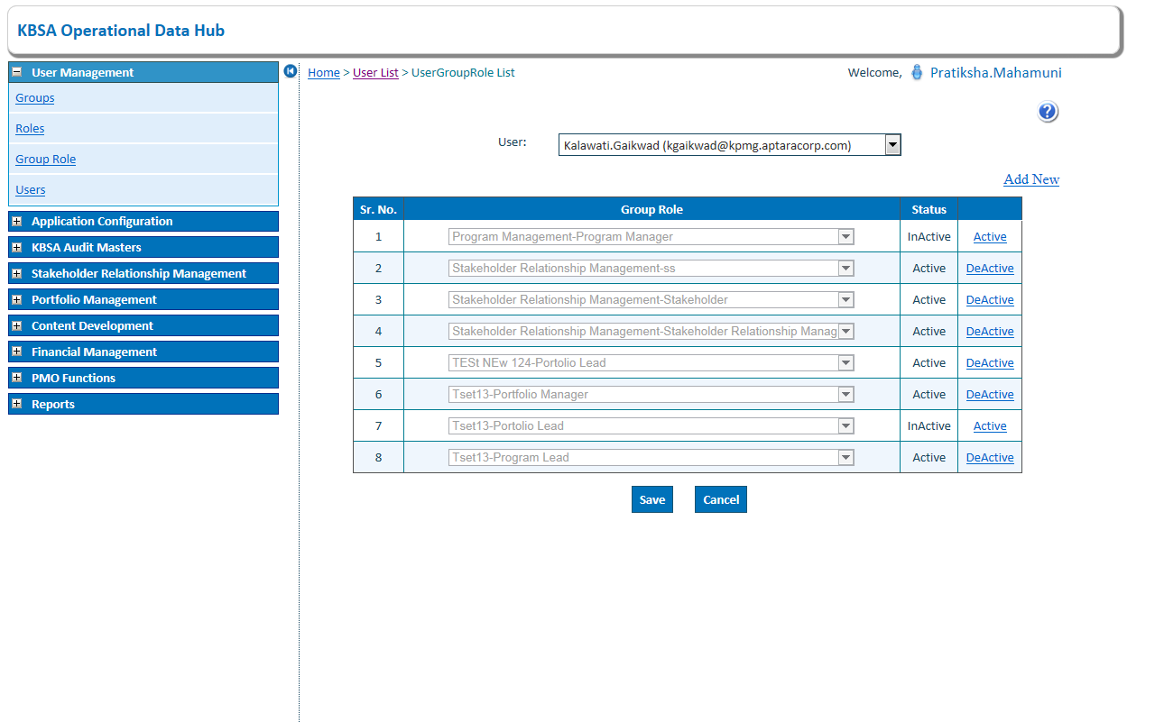

1. Add New Records in User Details As Below on Clicking on Add New button on Upper side of grid will open new page like below

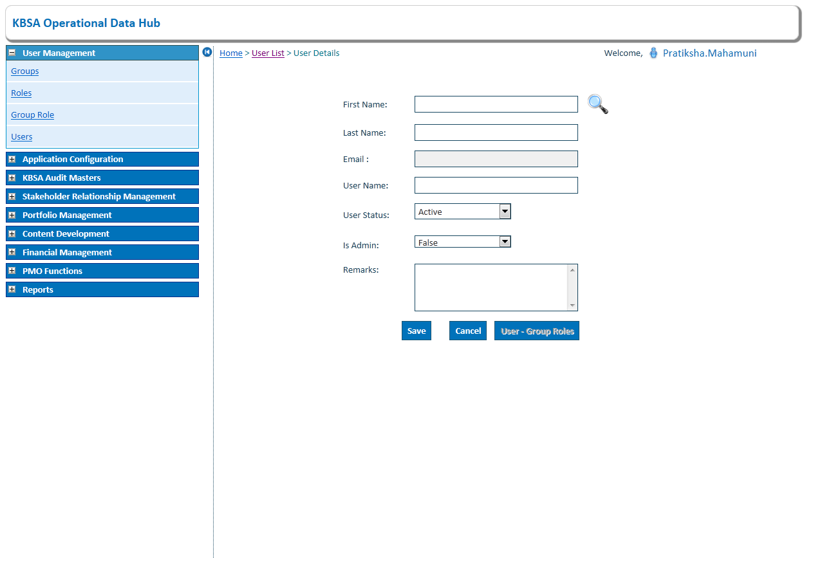

1. Enter value to search in first name and last name click on search button

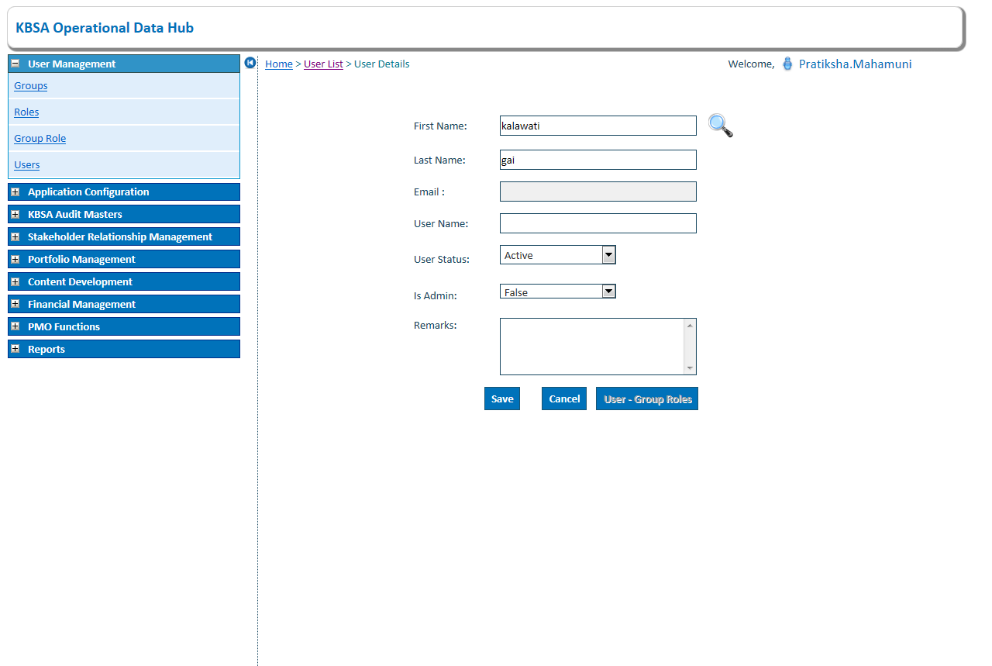

1. Click on search button to see details and click on select button to add select user

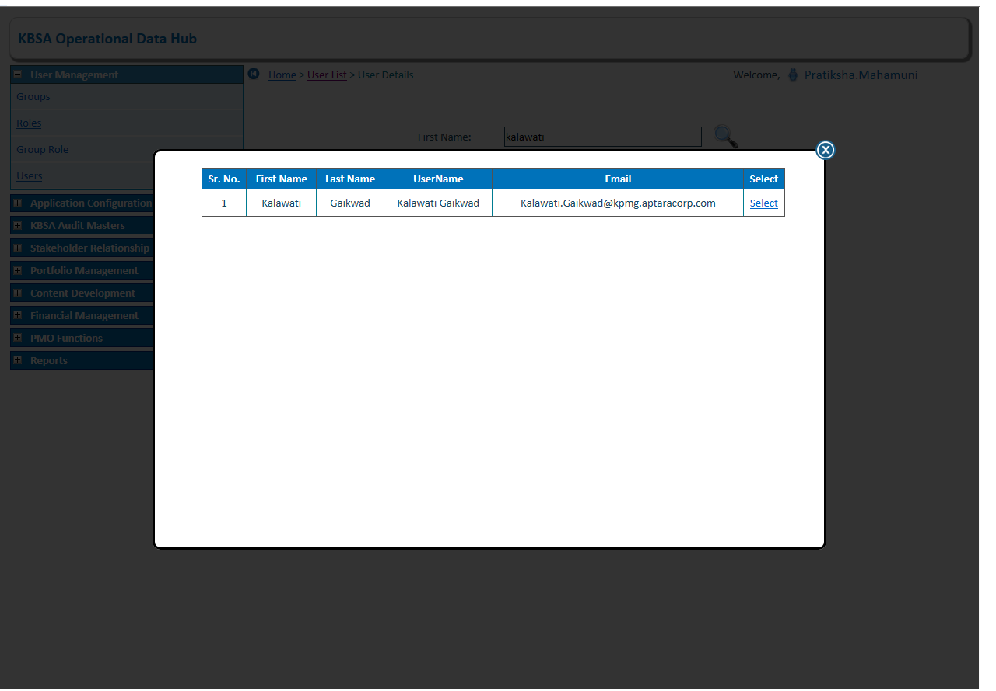

1. Clicking on save will save new user record.

