Content Developer

Click on column dropdown list select column on which you want to do operations as shown below.

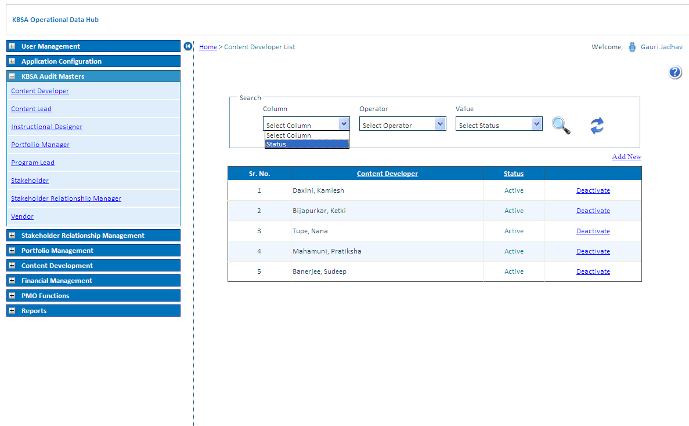

Select operator to search for different conditions.

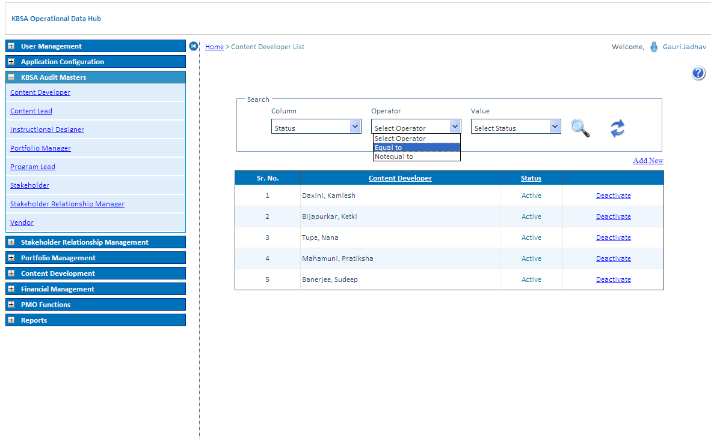

Select Value to search for different Status.

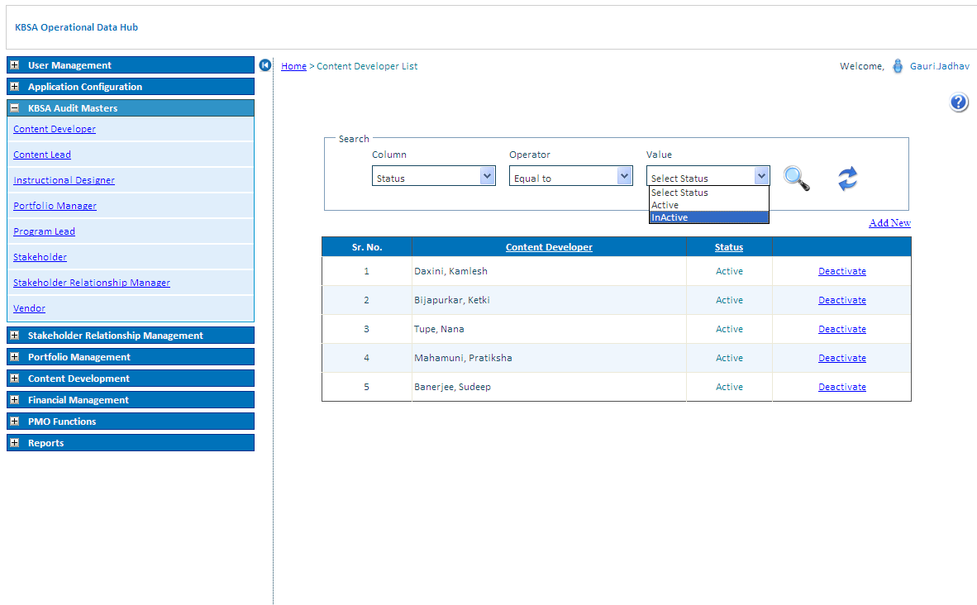

Click on search button to search record for selected condition in grid will show filtered records

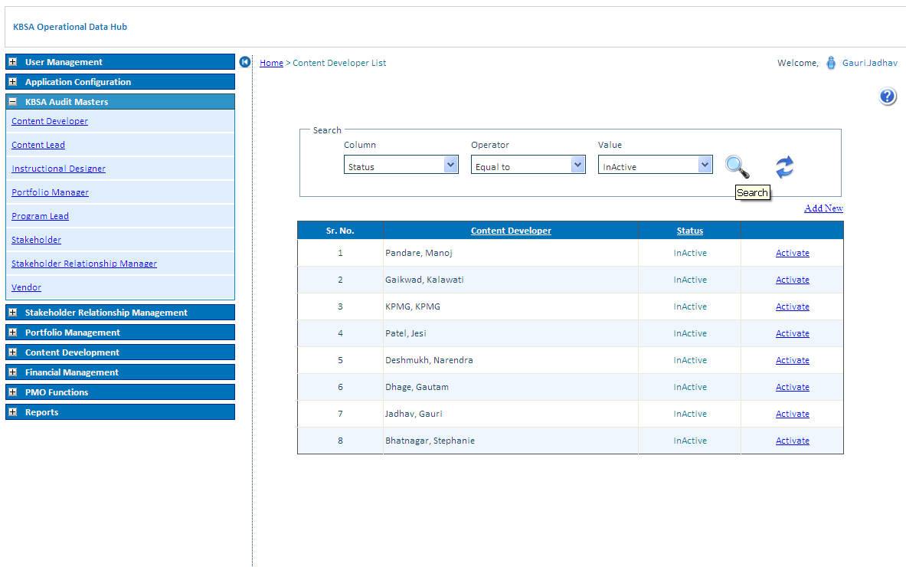

Click on Refresh button icon to reset Content Developer list grid to default values

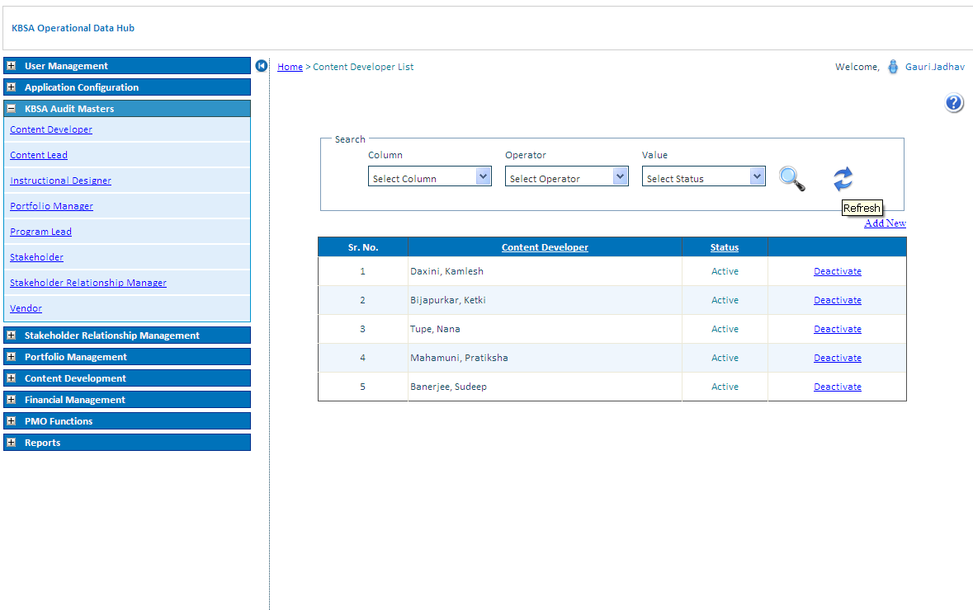

Click on Deactivate/Activate link Button to activate or deactivate status of Content Developer.

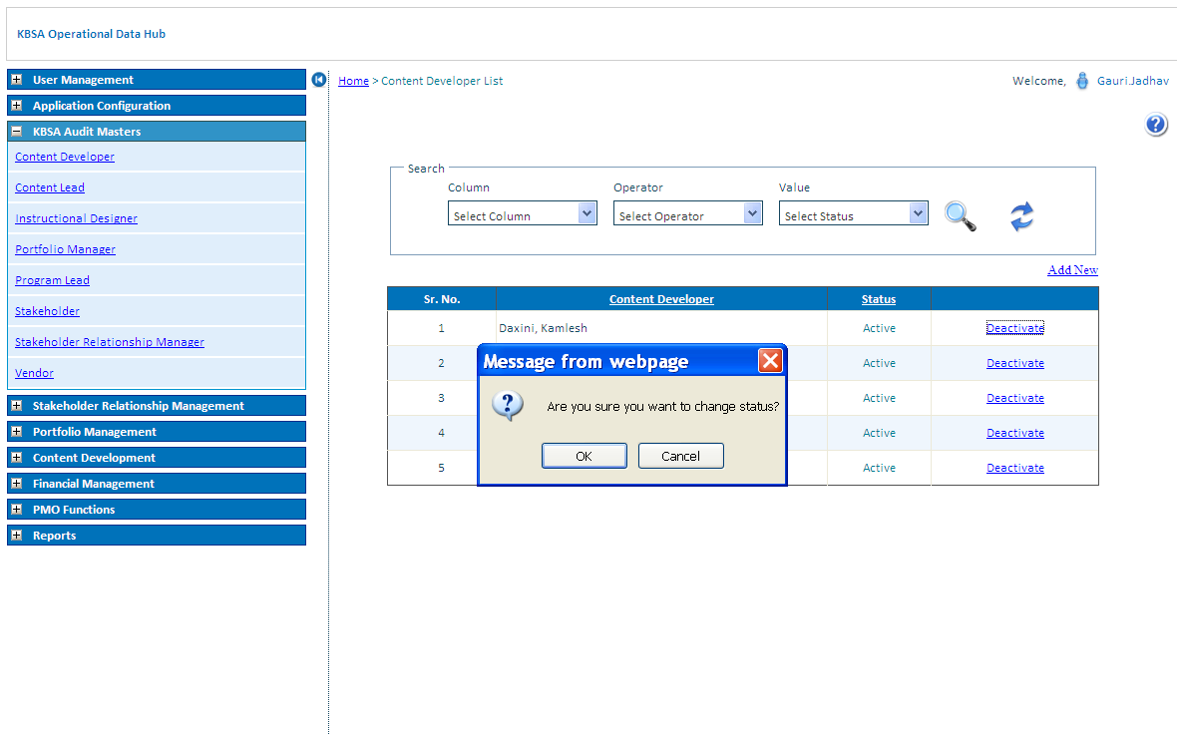

Content Developer Status updates in Content Developer list as below

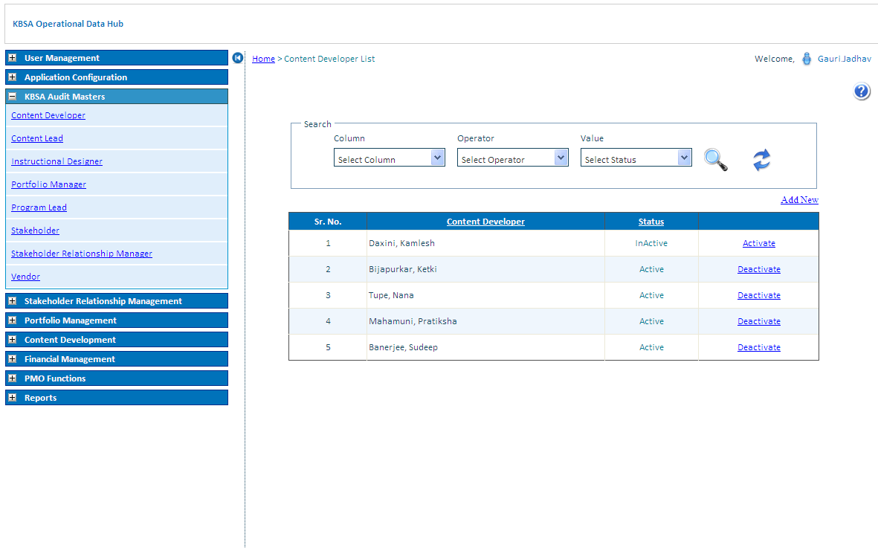

Add New Records in Content Developer Details as Below on Clicking on Add New button on Upper right side of grid will open new page like below

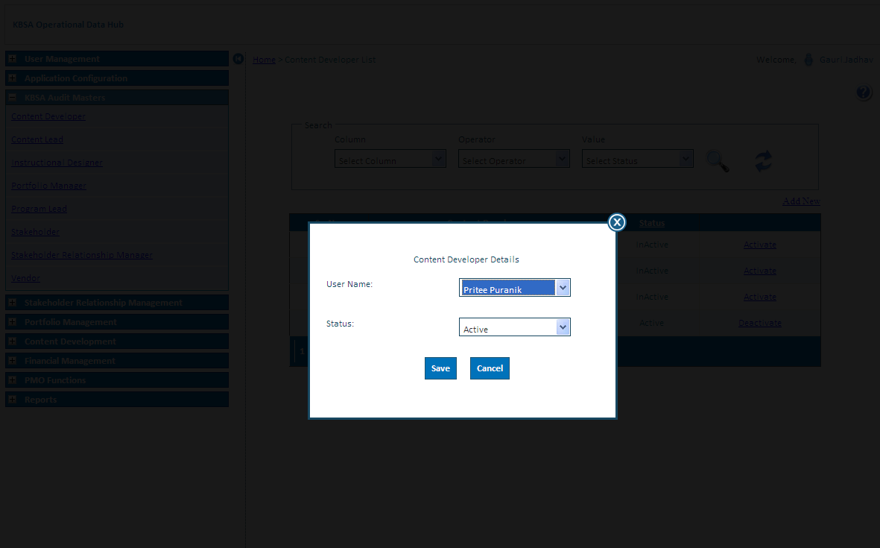

New Content Developer details is updated in grid shown below

