Instructional Designer

Click on column dropdown list select column on which you want to do operations as shown below.

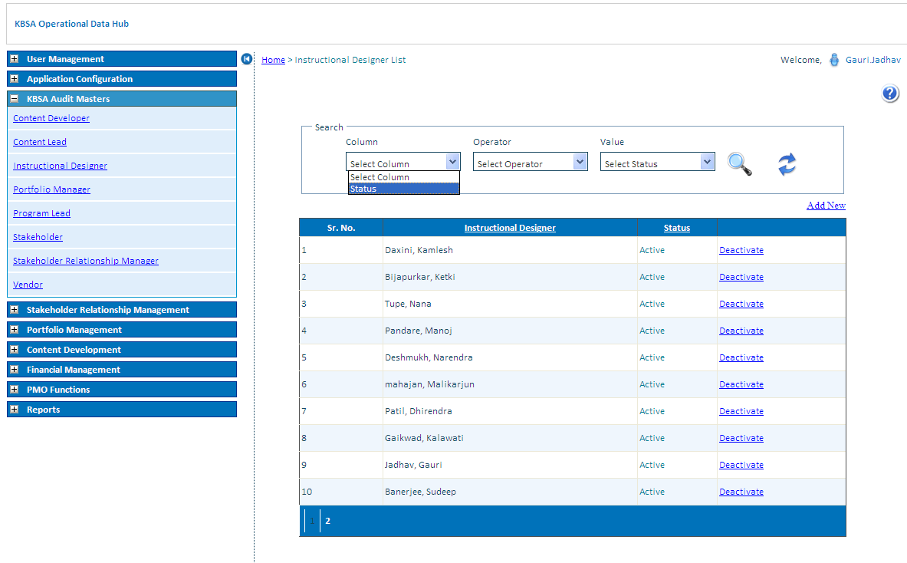

Select operator to search for different conditions.

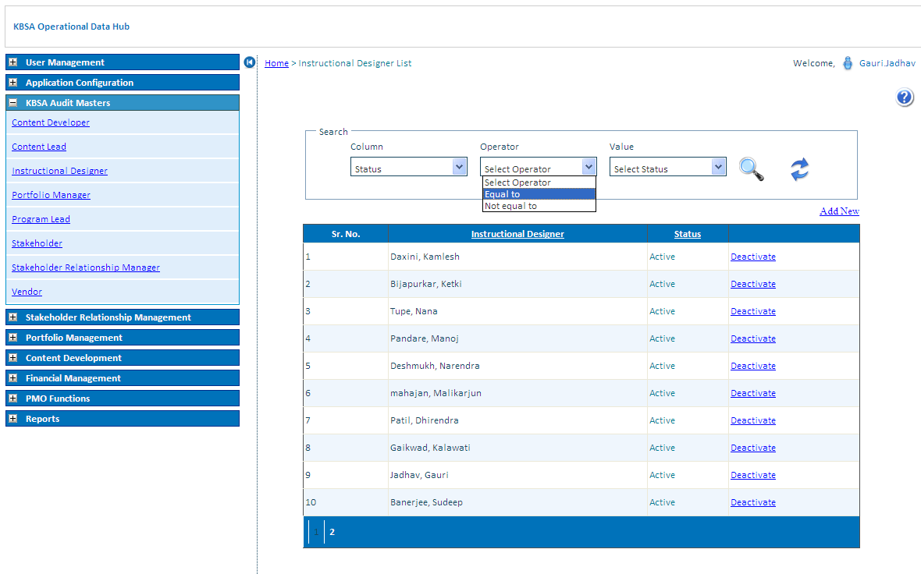

Select Value to search for different Status.

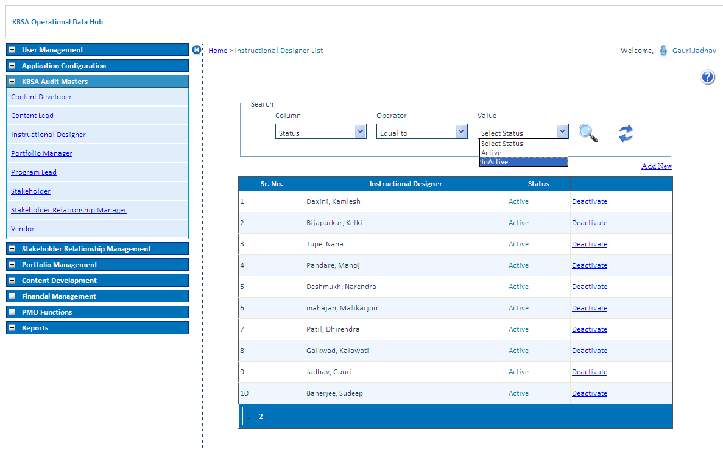

Click on search button to search record for selected condition in grid will show filtered records

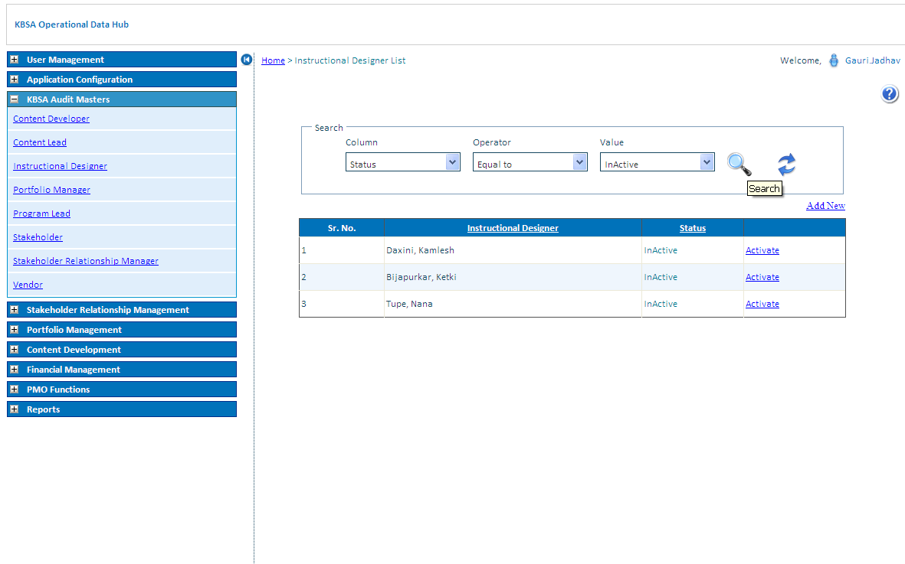

Click on Refresh button icon to reset Instructional Designer list grid to default values

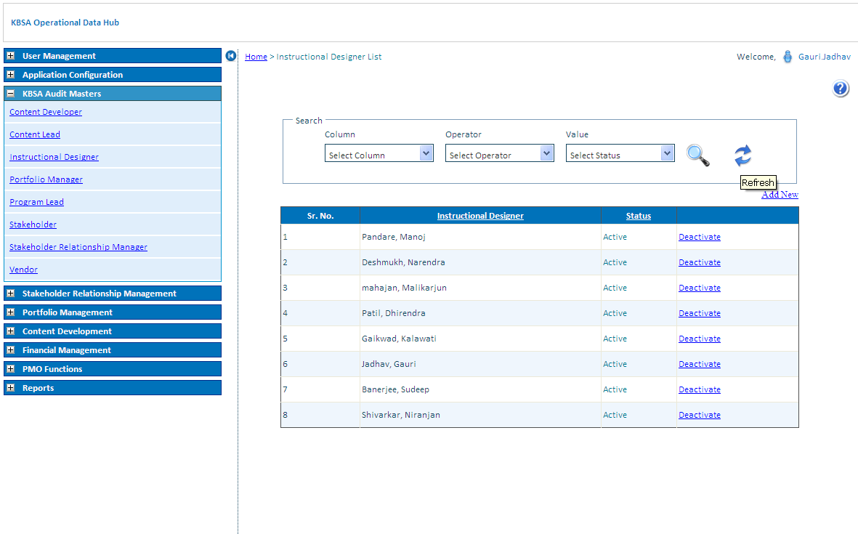

Click on Deactivate/Activate link Button to activate or deactivate status of Instructional Designer.

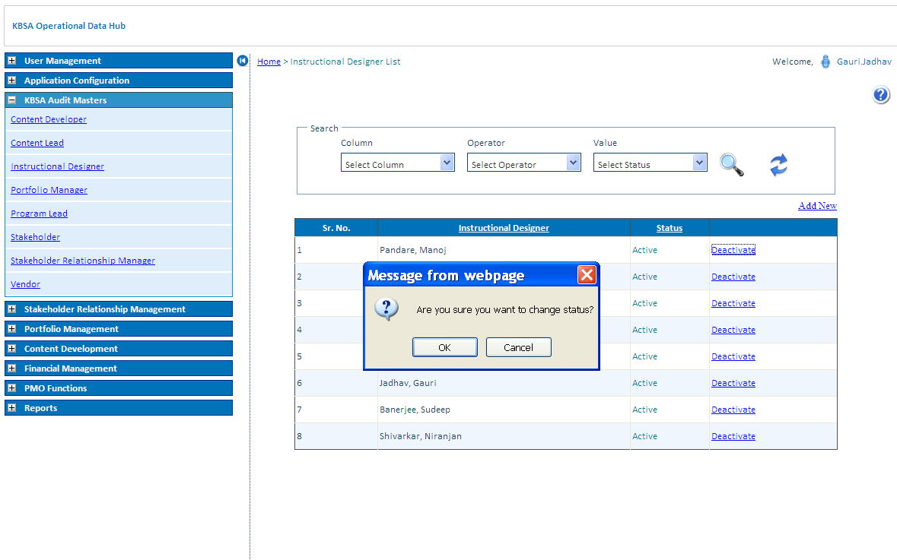

Instructional Designer Status updates in Instructional Designer list as below

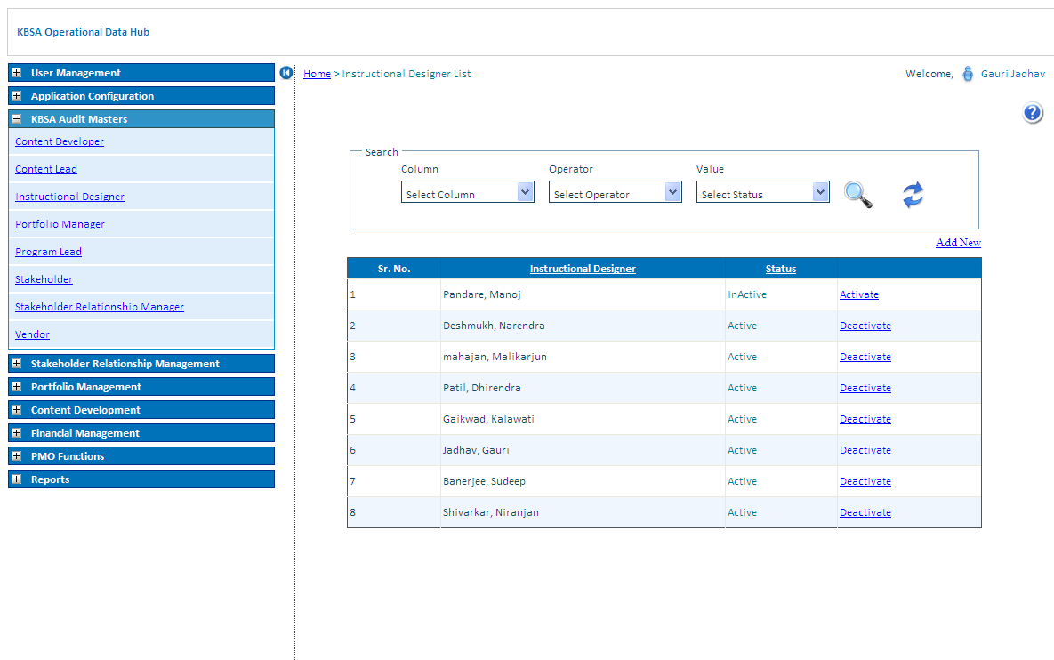

Add New Records in Instructional Designer Details as Below on Clicking on Add New button on Upper right side of grid will open new page like below

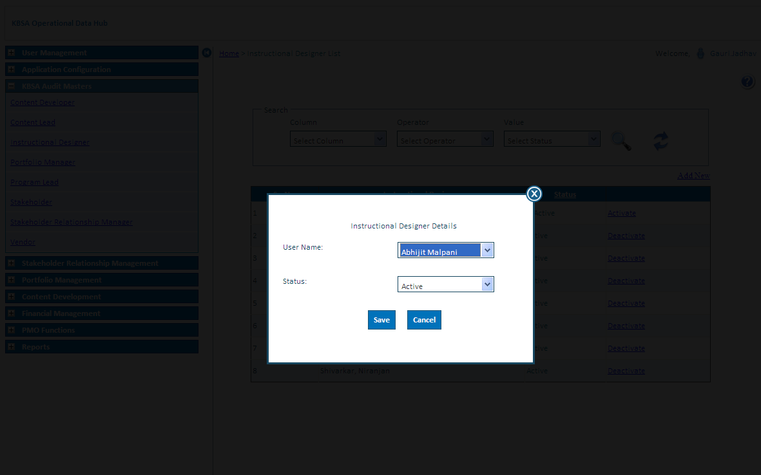

New Instructional Designer details is updated in grid shown below

