Menu List

Click on column dropdown list select column on which you want to do operations as shown below.

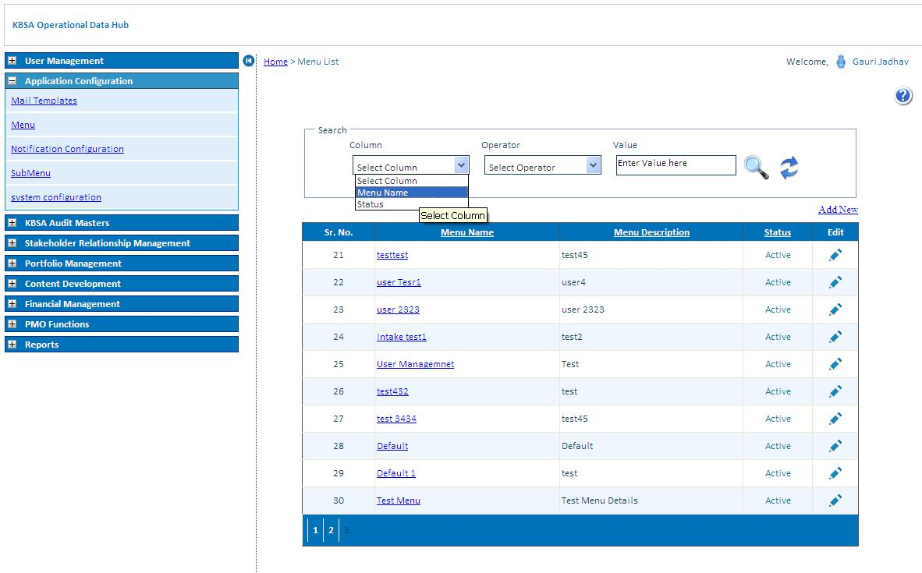

Select operator to search for different conditions.

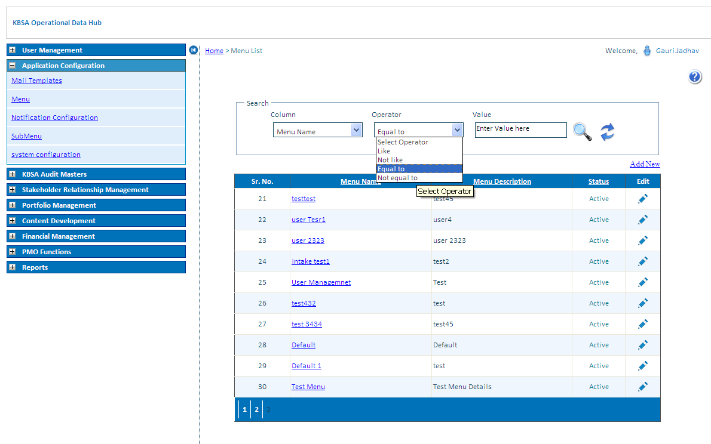

Enter search value in textbox to search.

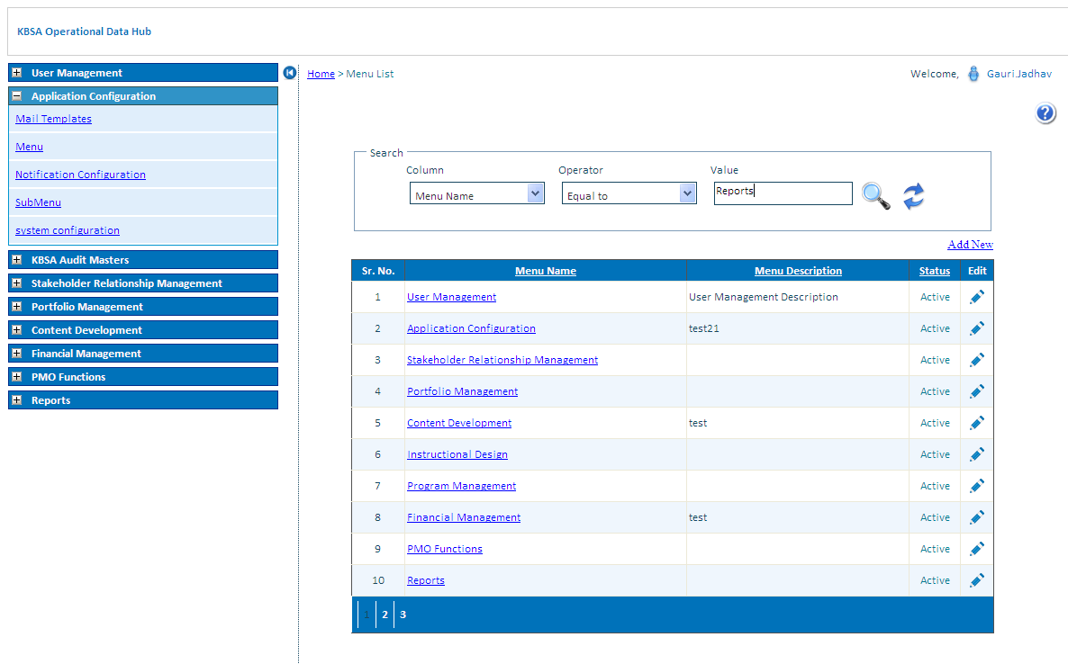

Click on search button to search record for selected condition in grid will show filtered records

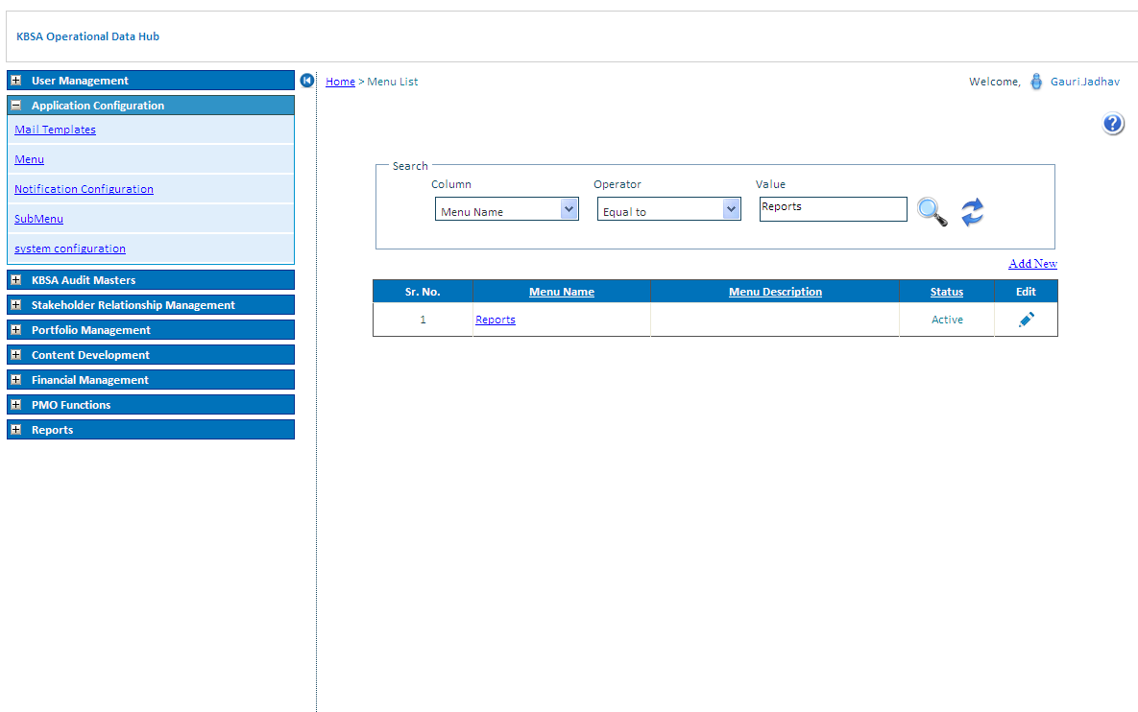

Click on Refresh button icon to reset Menu list grid to default values

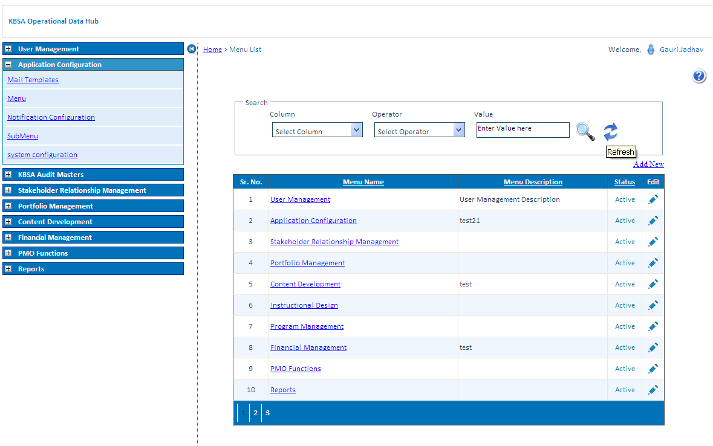

Click on Edit Button to Edit Menu Details

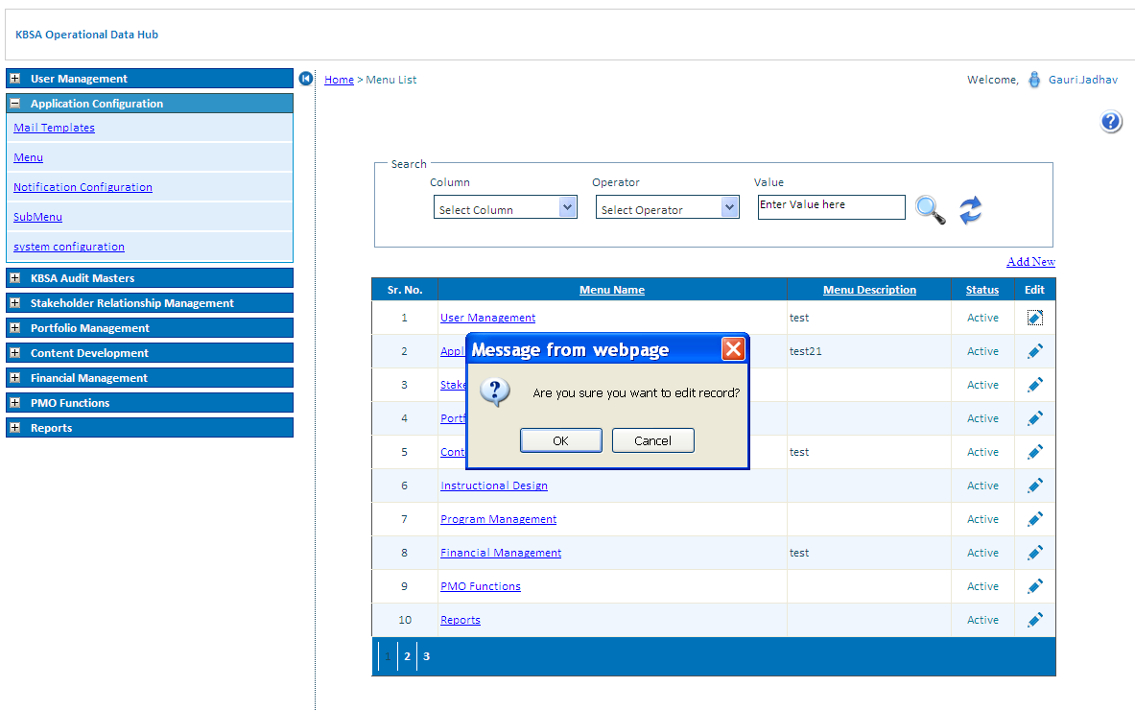

Edit Menu details and click on Update button

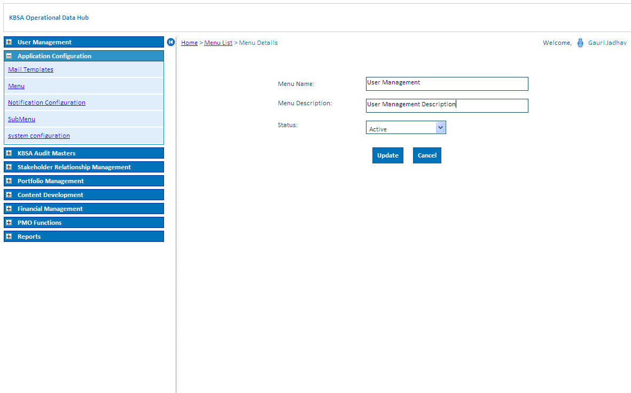

Menu details updates in Menu list as below

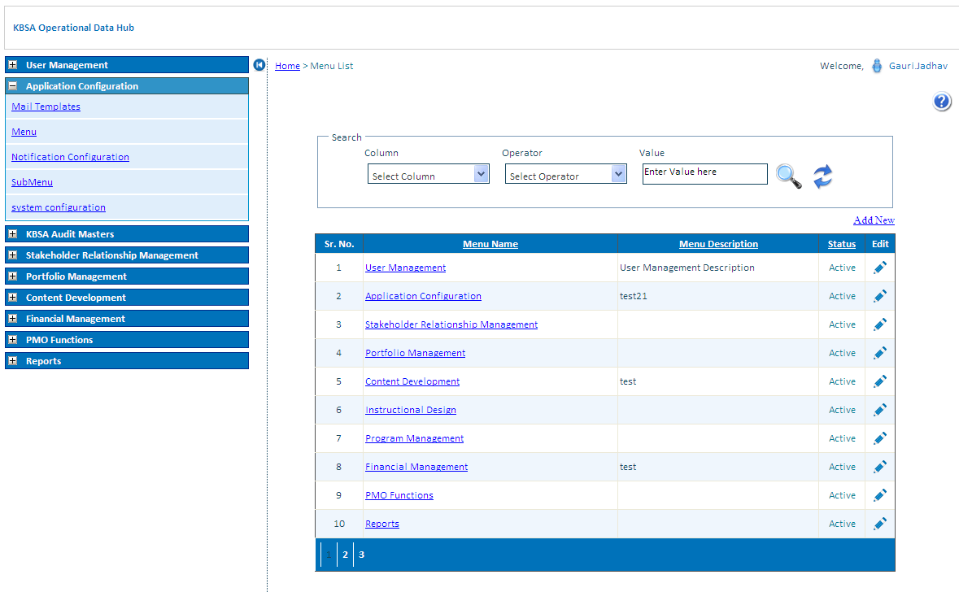

Add New Records in Menu Details as Below on Clicking on Add New button on Upper right side of grid will open new page like below

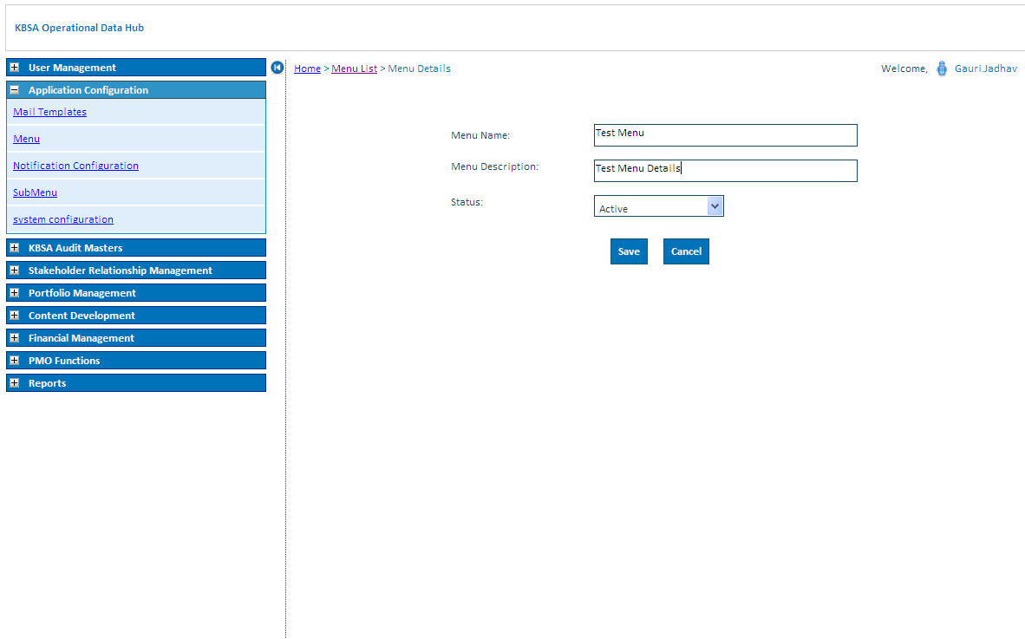

New Menu details is updated in grid shown below

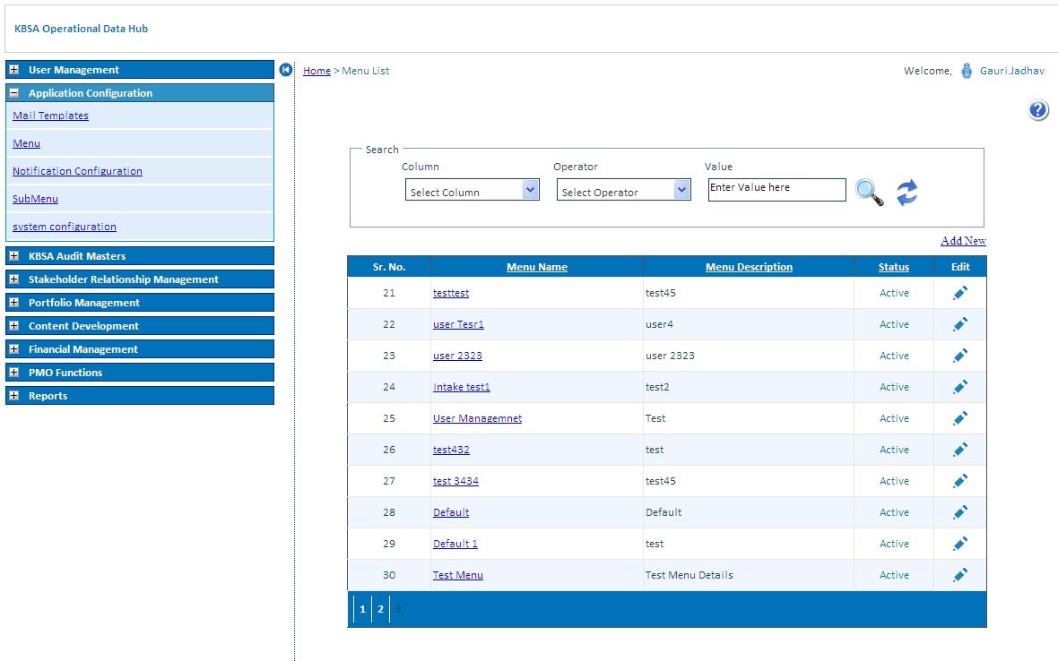

On Menu name click in grid view it will show existing submenus under that menu

