Portfolio Manager

Click on column dropdown list select column on which you want to do operations as shown below.

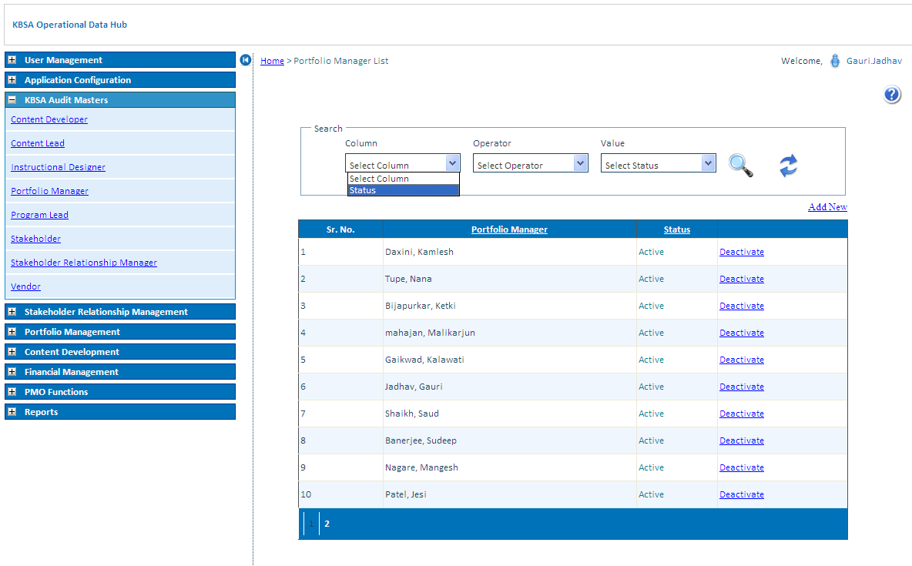

Select operator to search for different conditions.

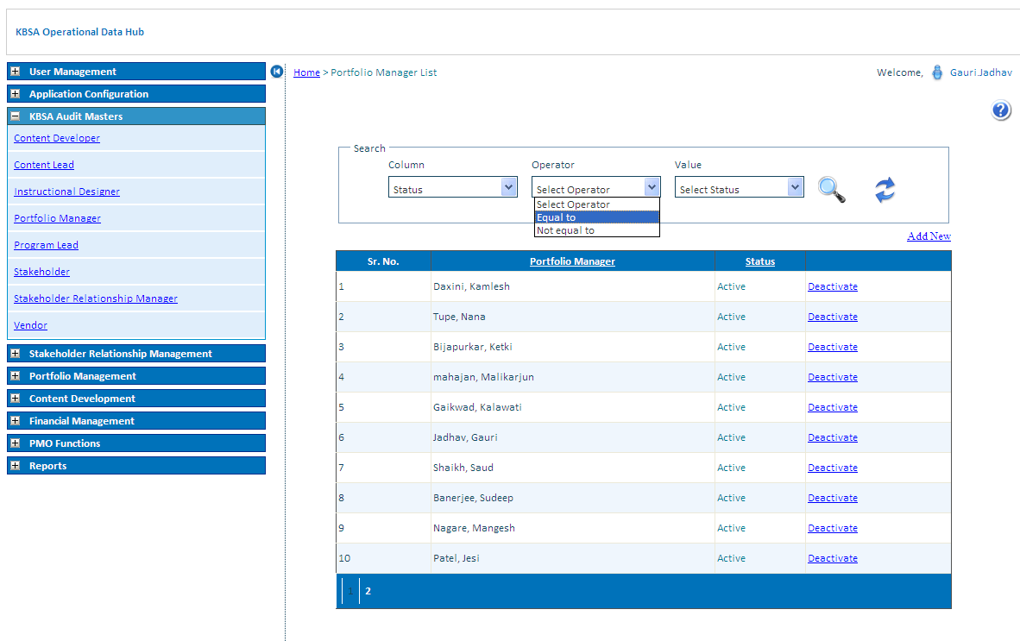

Select Value to search for different Status.

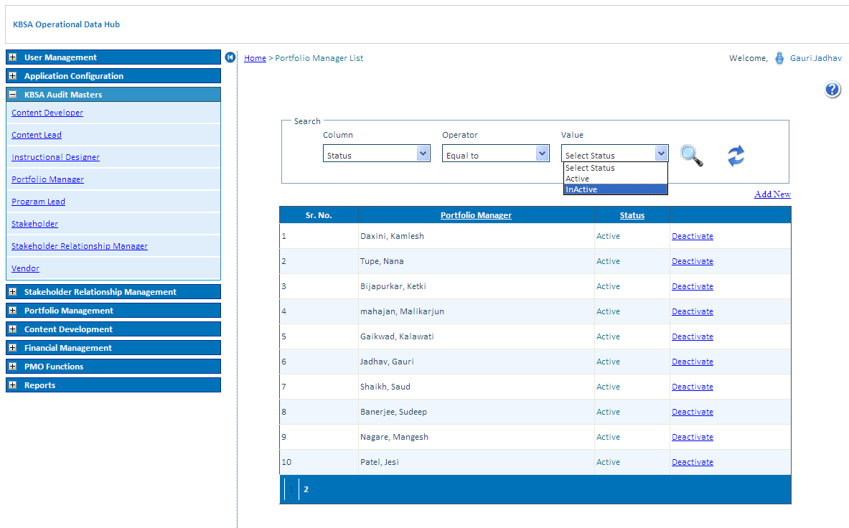

Click on search button to search record for selected condition in grid will show filtered records

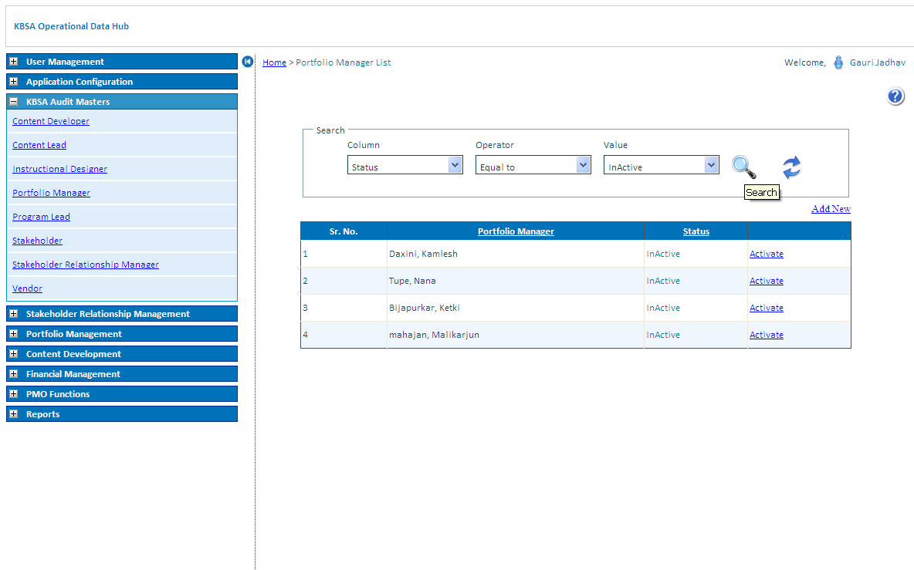

Click on Refresh button icon to reset Portfolio Manager list grid to default values

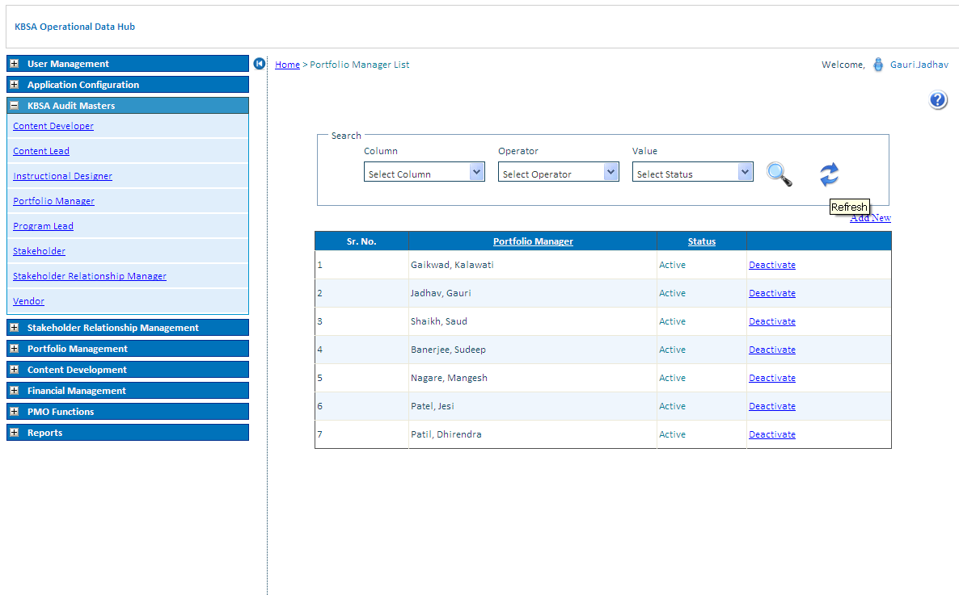

Click on Deactivate/Activate link Button to activate or deactivate status of Portfolio Manager.

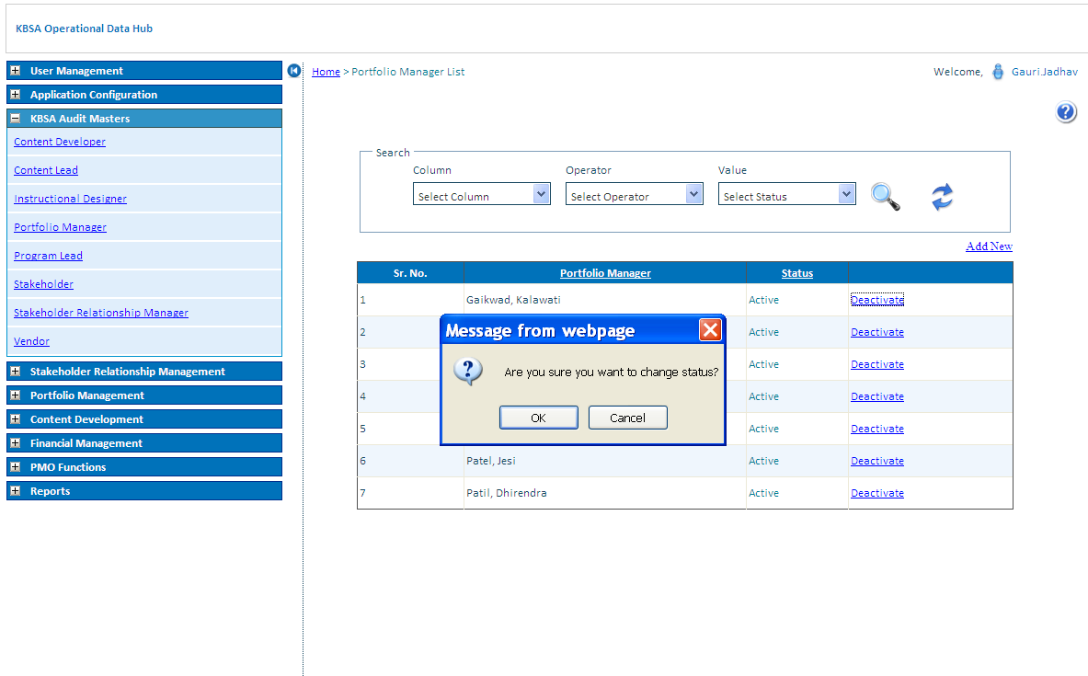

Portfolio Manager Status updates in Portfolio Manager list as below

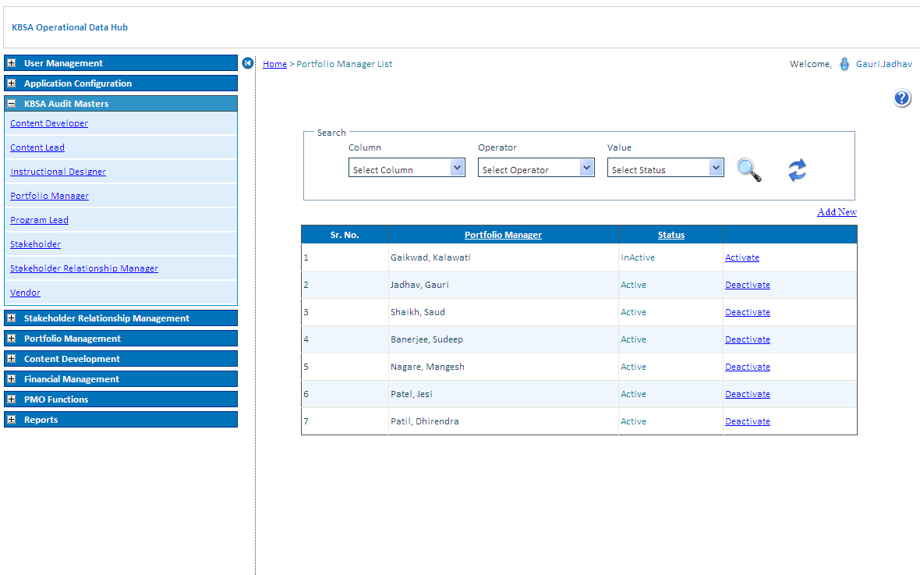

Add New Records in Portfolio Manager Details as Below on Clicking on Add New button on Upper right side of grid will open new page like below

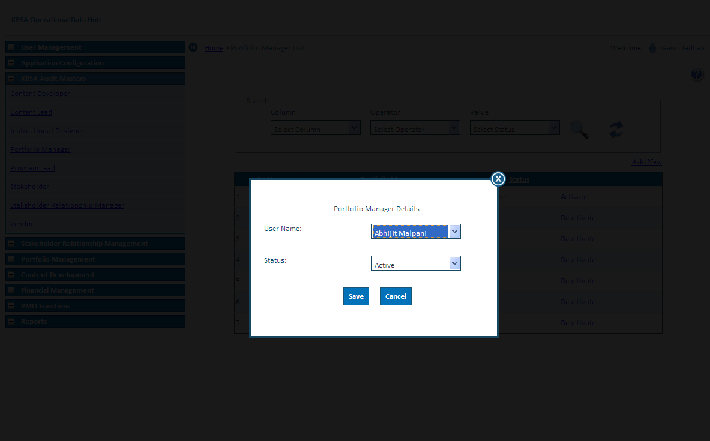

New Portfolio Manager details is updated in grid shown below

