**Access Data FTK Imager**

**STEP 1: SELECT SOURCE**

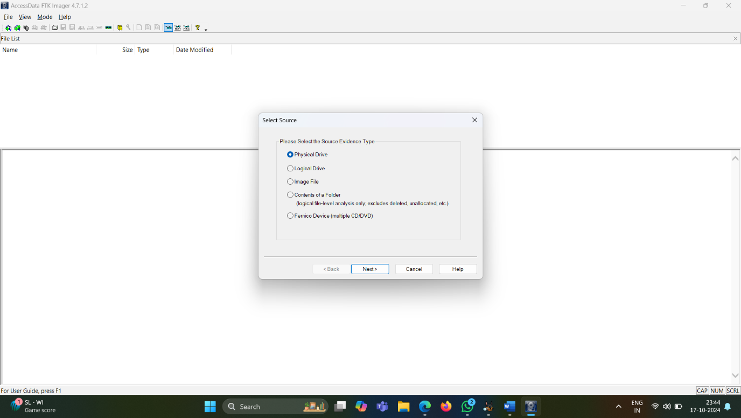

**STEP 2 : SELECT IMAGE TYPE**

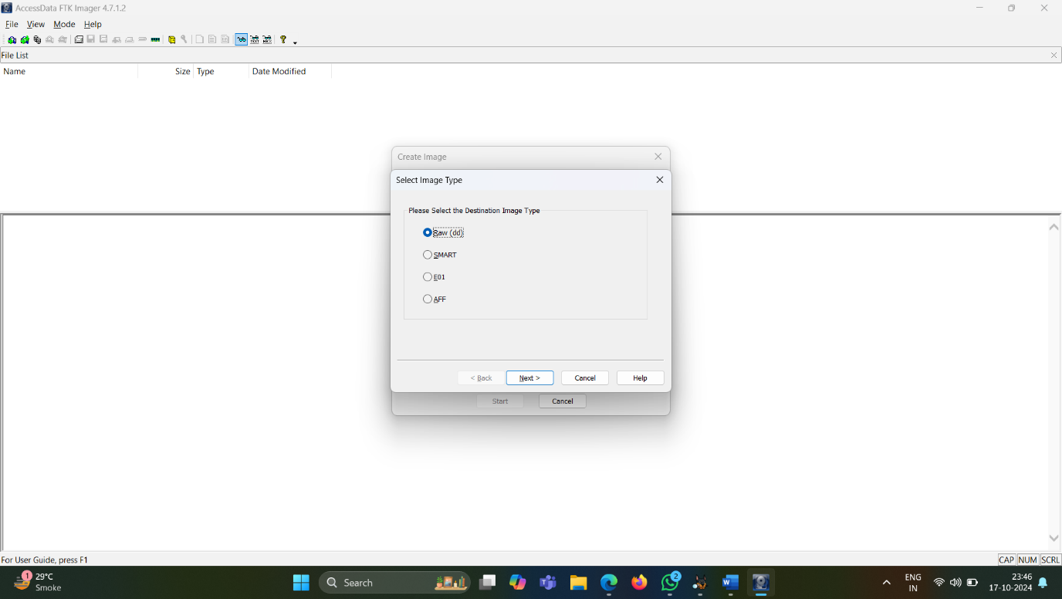

**STEP 3 : EVIDENCE ITEM INFORMATION**

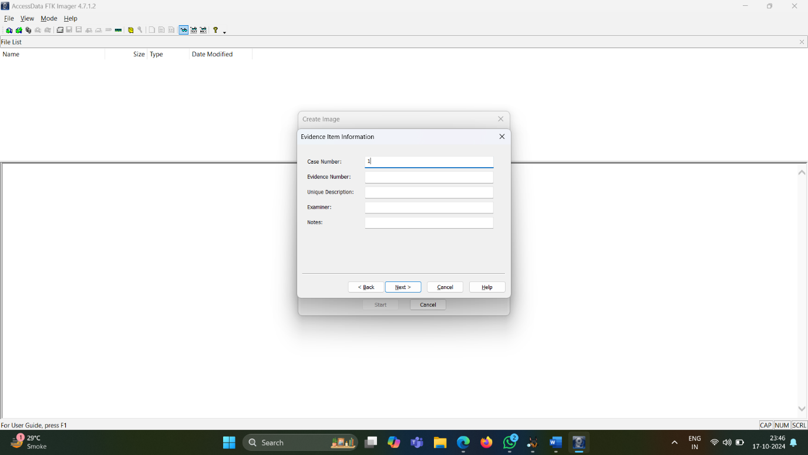

**Autopsy**

**STEP 1 : CREATE A NEW CASE**

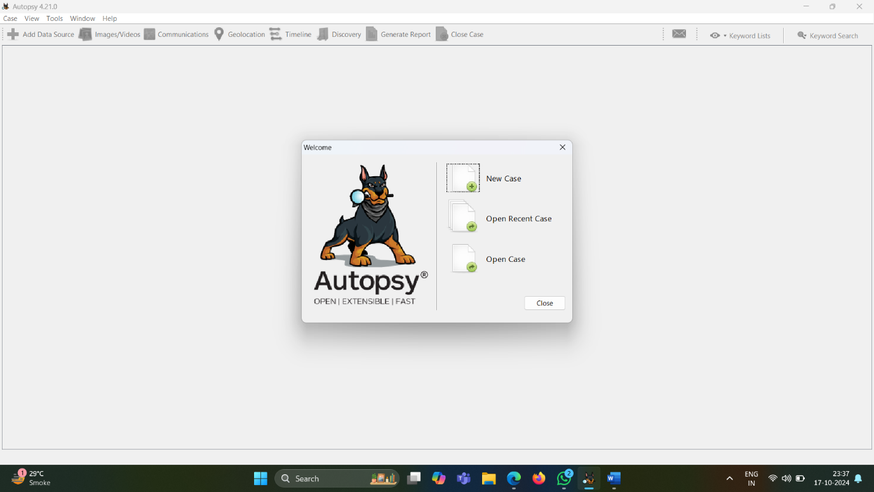

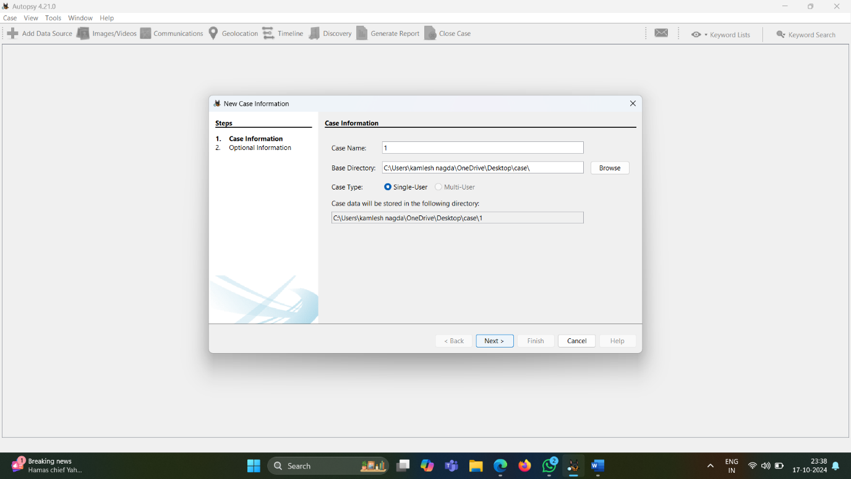**STEP 2: CASE INFORMATION**

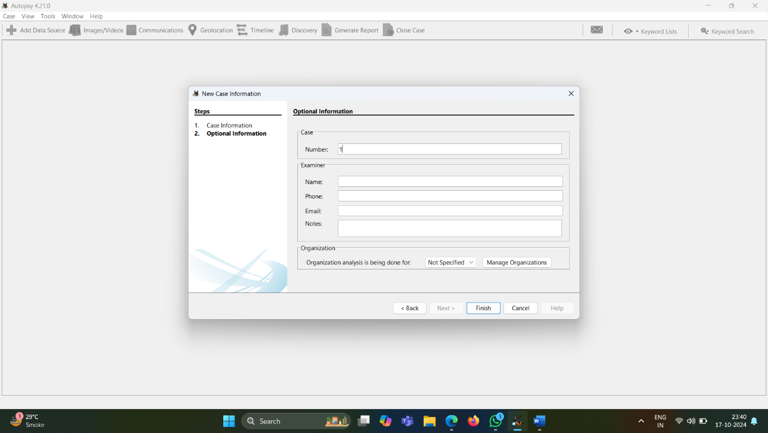**STEP 3 : OPTIONAL INFORMATION**

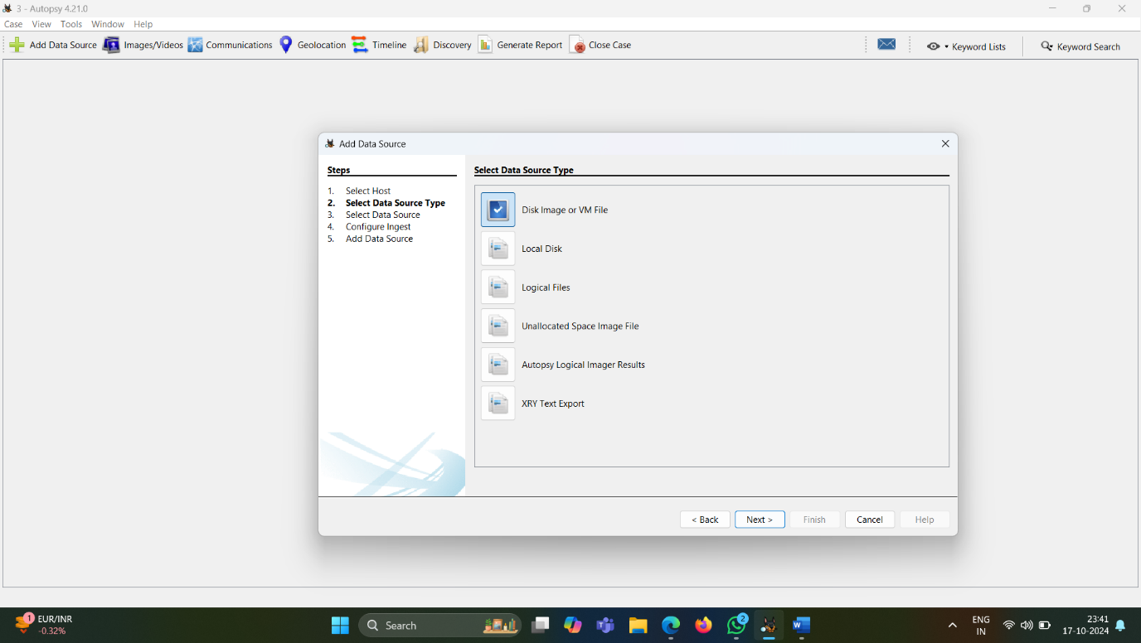**STEP 4 : SELECT DATA SOURCE TYPE**

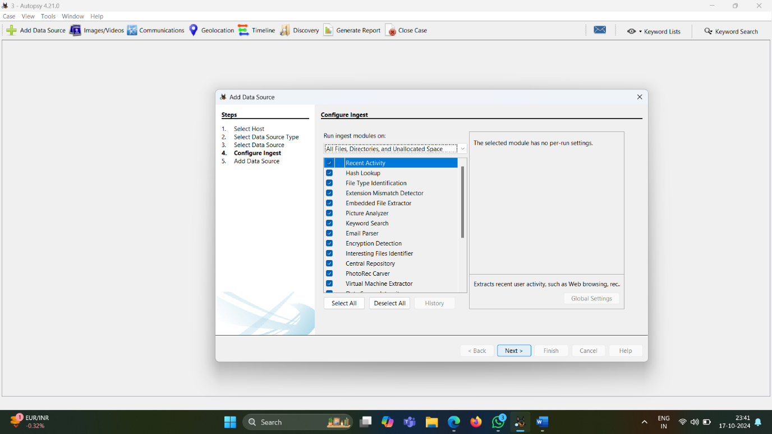**STEP 5 : CONFIGURE INGEST**

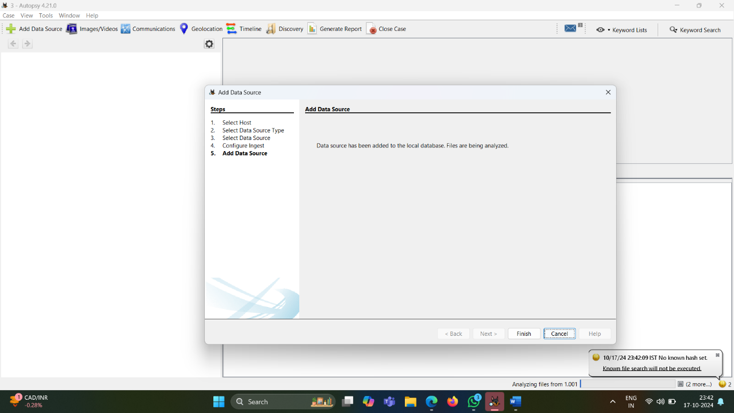**STEP 6 : CLICK ON FINISH**

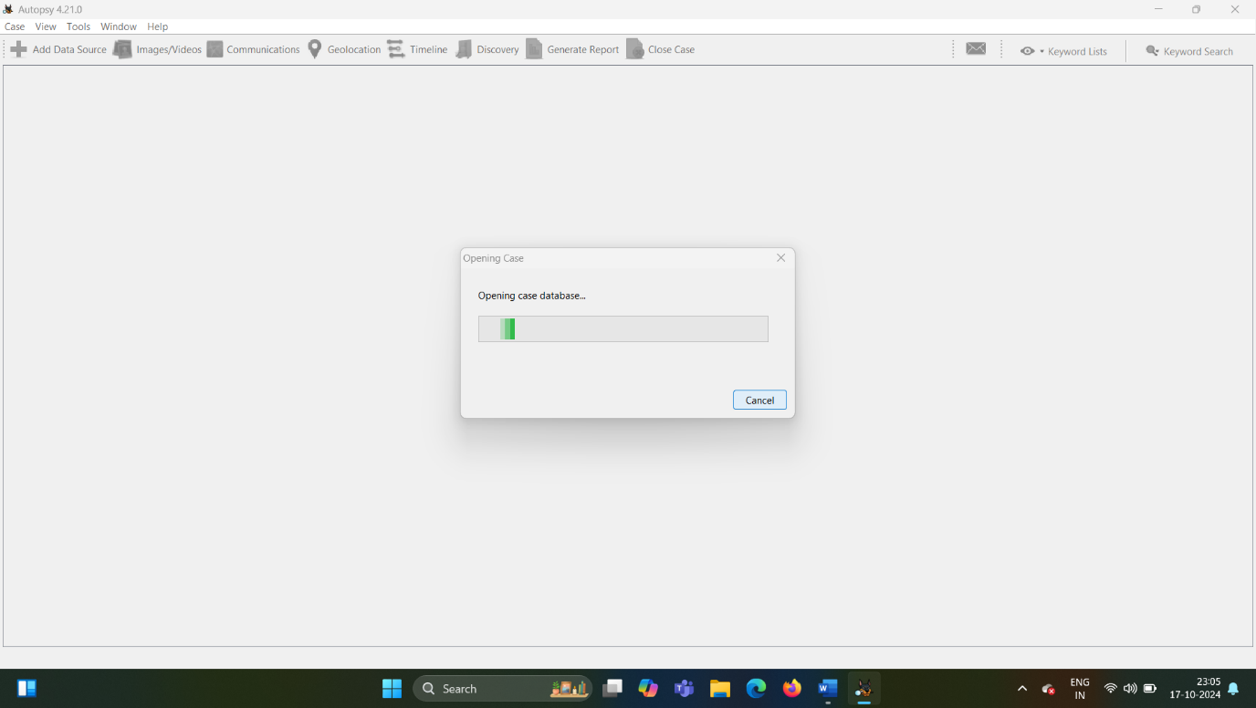**STEP 7: DATABASE OPENING**

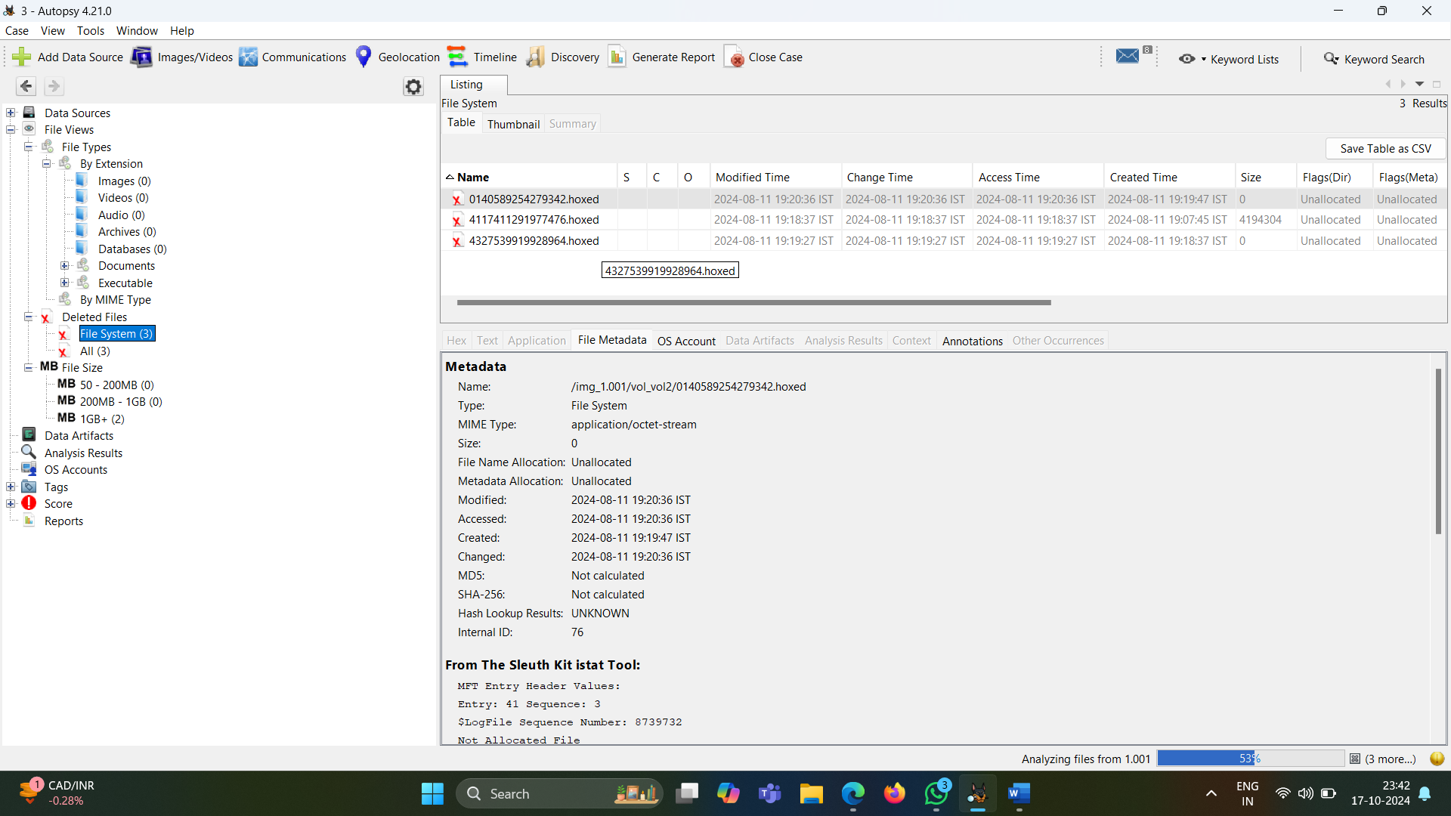**STEP 8: Start the Analysis**