Ques 1. What is Input and Output Stream in java ?

Ans:- A stream can be defined as the sequence of data or continuous flow of data. Streams are a clear way to deal with Input/Output. Streams are of two types as Depicted below:

1. Byte Stream
2. Character

Ques 2. What are the Method of Output Stream?

Ans:- Here are some of the methods:

write() - writes the specified byte to the output stream.

write(byte[] array) - writes the bytes from the specified array to the output stream.

flush() - forces to write all data present in output stream to the destination.

close() - closes the output stream.

Ques 3. What is serialization in java ?

Ans:- Serialization is a mechanism of converting the state of an object into a byte stream.

Ques 4. What is serializable Interface in java ?

Ans:- The Serializable interface is present in java.io package. It is a marker interface. A Marker Interface does not have any methods and fields. Thus classes implementing it do not have to implement any methods.

Ques 5. What is deserialization in java?

Ans:- Deserialization is the reverse process where the byte stream is used to recreate the actual Java object in memory. This mechanism is used to persist the object.

Ques 6. What is serialization achieved in java?

Ans:- Serialization is achieved in Java by implementing the Serializable interface. When an object is serialized, its

state is converted into a stream of bytes, which can then be transferred over a network or stored in a file or database.

Ques 7. How is deserialization achieved in java?

Ans:- Deserialization is achieved in Java by reading a stream of bytes and using them to recreate the original

object instance. This is done by calling the readMbject() method of an MbjectInputStream instanc.

Ques 8. How can you avoid certain member variables of class from getting Serialized?

Ans:- In Java, if you want to avoid certain member variables of a class from being serialized, you can use the transient modifier on those variables. When a variable is marked as transient, it tells the Java serialization mechanism to skip the serialization and deserialization of that specific variable. Here's how you can use the transient modifier to exclude variables from serialization:

Ques 9. What classes are available in the java IO file classes APL?

Ans:- The following classes are available in the Java IM API and are important to work with files in JavaP

File.

1.RandomAccessFile

2.FileInputStream

3.FileReader

4.FileMutputStream

5.FileWriter

Ques 10. What id Difference between Externalizable and Serialization interface.

Ans:- 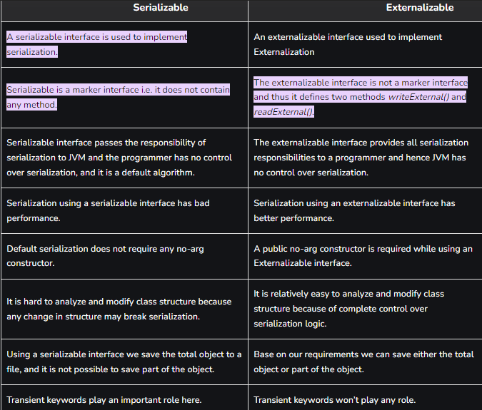

Ans:- 