Ques 1. What is inheritance in java ?

Ans:- Inheritance is a fundamental concept in object-oriented programming (OOP), including Java. It allows you to create a new class (called a subclass or derived class) that inherits properties and behaviors (fields and methods) from an existing class (called a superclass or base class). This concept promotes code reuse, extensibility, and the organization of code into a hierarchical structure.

Ques 2. What is Superclass and subclass ?

Ans:- A class that is derived from another class is called a subclass (also a derived class, extended class, or child class).

The class from which the subclass is derived is called a superclass (also a base class or a parent class).

Ques 3. How is Inheritance implemented/achieved in java?

Ans:- Inheritance in java is one of the core concepts of Object-Oriented Programming. Java Inheritance is used when we have is-a relationship between objects. Inheritance in Java is implemented using extends keyword.

Ques 4. What is Polymorphism ?

Ans:- Polymorphism means "many forms", and it occurs when we have many classes that are related to each other by inheritance. Like we specified in the previous chapter; Inheritance lets us inherit attributes and methods from another class. Polymorphism uses those methods to perform different tasks.

Ques 5. Differentiate between method overloading and overriding?

Ans:-

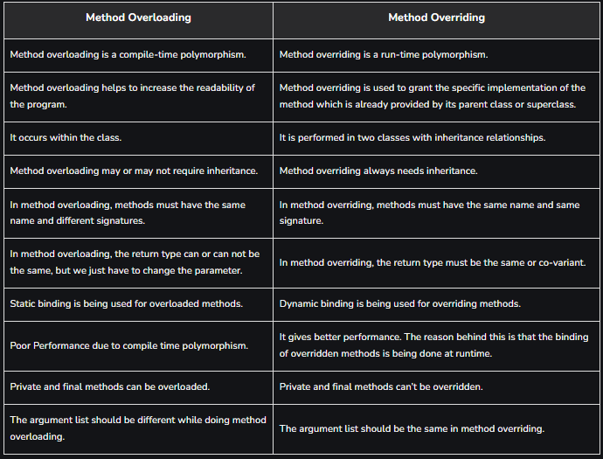

Ques 6. What is an abstraction explained with an example?

Ans:- In simple terms, abstraction “displays” only the relevant attributes of objects and “hides” the unnecessary details.

Example

abstract class Bike{

abstract void run();

}

class Honda4 extends Bike{

void run(){

System.out.println("running safely");

}

public static void main(String args[]){

Bike obj = new Honda4();

obj.run();

}

}

Ques 7. What is the difference between an abstract method and final method in java? Explain with an example?

Ans:-

The abstract method is incomplete while the final method is regarded as complete. The only way to use an abstract method is by overriding it, but you cannot override a final method in Java.

Ques 8. What is the final class in java ?

Ans:- The final class is a class that is declared with the final keyword. We can restrict class inheritance by making use of the final class. Final classes cannot be extended or inherited. If we try to inherit a final class, then the compiler throws an error during compilation.

Ques 9. Difference between abstraction and encapsulation ?

Ans:-

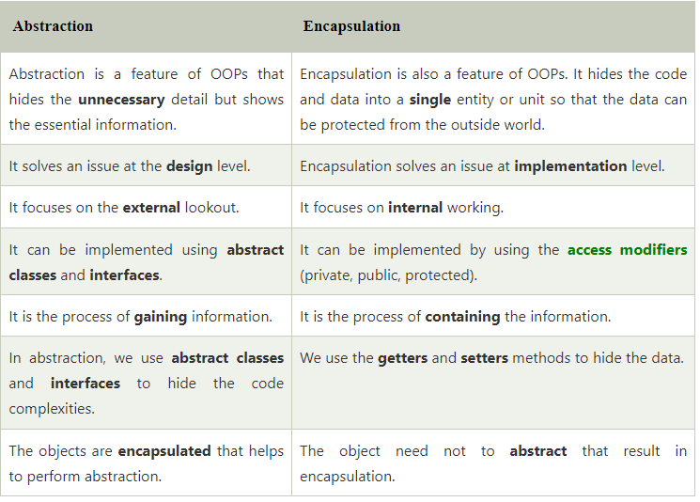

Ques 10. Difference between Runtime and compile time polymorphism explain with example?

Ans:-

