Ques 1. What is the Default value of Array for different data types?

Ans:- Here's a table summarizing the default values of arrays for different data types in Java:

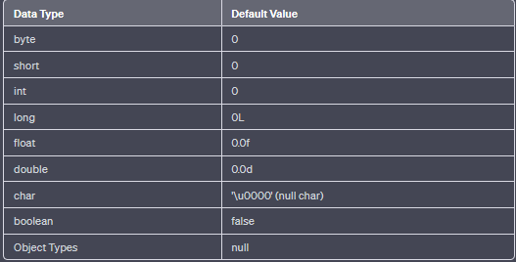

Ques 2. Can you pass the negative number in Array size?

Ans:- In Java, the size of an array must be a non-negative integer. Attempting to pass a negative number as the size of an array will result in an error or exception.

Ques 3. Where does Array stored in JVM memory?

Ans:- In the Java Virtual Machine (JVM), arrays are stored in the heap memory. The heap is a region of memory dedicated to dynamically allocated objects in Java, including arrays and objects created using the new keyword.

Ques 4. What are the Disadvantage of Array?

Ans:-There are many Disadvantage of Array:-

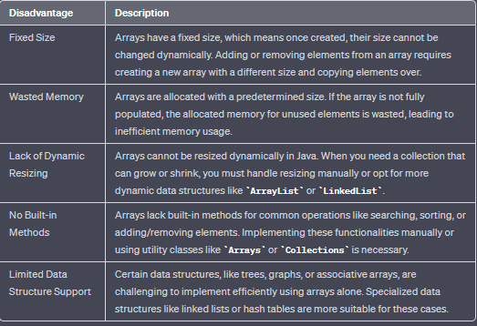

Ques 6. What is an Anonymous Array in java? Give an example?

Ans:- In Java, an anonymous array is an array that is declared and instantiated without explicitly assigning it to a variable. It is a one-time use array that is created on-the-fly as an argument to a method or during array initialization. Anonymous arrays are particularly useful when you need to pass a small array of values to a method without the need for a named array variable.

**Example:-**

**public class AnonymousArrayExample {**

**public static void printArray(int[] arr) {**

**for (int num : arr) {**

**System.out.print(num + " ");**

**}**

**System.out.println();**

**}**

**public static void main(String[] args) {**

**// Declaring and initializing an anonymous array as an argument**

**printArray(new int[]{1, 2, 3, 4, 5});**

**// Using an anonymous array during initialization**

**int[] anotherArray = new int[] {10, 20, 30, 40, 50};**

**printArray(anotherArray);**

**}**

**}**

Ques 7. What is difference between length and length() Method give an Example?

Ans:- In Java, length and length() are used to determine the size or length of different data structures:

1. **length** (Array Property):

length is a property of an array in Java that represents the number of elements present in the array.

It can be directly accessed using the array reference variable followed by .length.

**Example**:- public class LengthExample {

public static void main(String[] args) {

int[] numbers = {1, 2, 3, 4, 5};

System.out.println("Size of the array: " + numbers.length);

}

}

**Output:-** **Size of the array: 5**

**length**() (String Method):

**length**() is a method available for String objects in Java, used to find the number of characters (length) in the String.

. It is a method and not a property like length for arrays.

. It is called on a specific instance of the String class.

**Example:-**

**public class LengthExample {**

**public static void main(String[] args) {**

**String str = "Hello, World!";**

**System.out.println("Length of the string: " + str.length());**

**}**

**}**

**Output:-** **Length of the string: 13**