Assignment

Collection Framework and Maps Sol.

Ques 1. What is collection framework in java ?

Ans:- The Java Collection Framework is a set of classes and interfaces that provide a well-structured and efficient way to store, manipulate, and process collections of objects. Collections in Java refer to groups of objects, such as lists, sets, and maps, which are commonly used in programming. The Collection Framework was introduced to standardize the way collections are handled in Java and to make it easier for developers to work with collections of data.

Ques 2. What is the Difference between ArrayList and LinkedList?

Ans:-Here some difference between ArraList And linkeLlist.

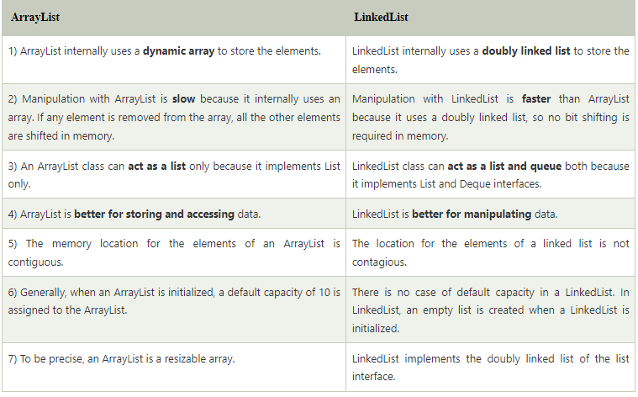

Ques 3. What is the Difference between Iterator and ListIterator?

Ans:-There are many difference between Iterator and ListIterator.

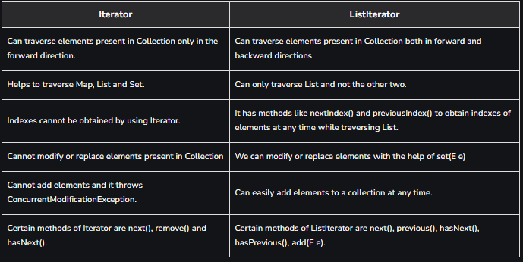

Ques 4. What is the difference between Iterator and Enumeration?

Ans:- The functionality of Enumeration and the Iterator are same. Using Enumeration you can only traverse and fetch the objects, where as using Iterator we can also add and remove the objects. So Iterator can be useful if you want

to manipulate the list and Enumeration is for read-only access.

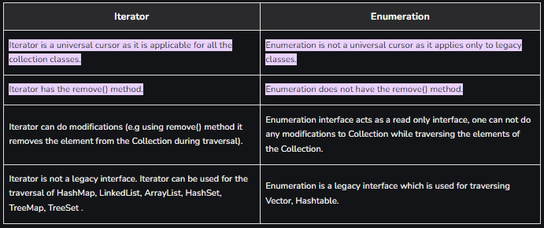

Ques 5. What is the Difference between List and Set?

Ans:-The Deffernce between list And Set

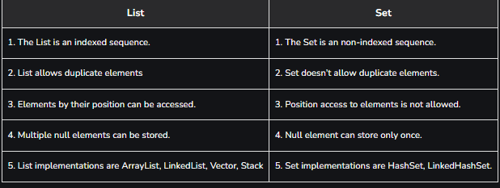

Ques 6. What is the Difference between HashSet and TreeSet?

Ans:-Ther are many difference between them.

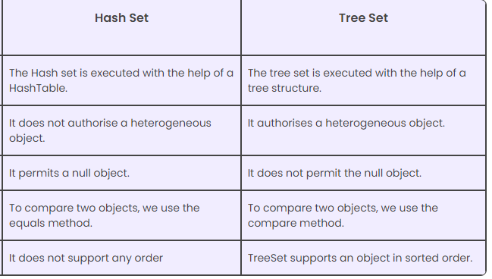

Ques 7. What is the Difference between Array and ArrayList?

Ans:-there are many Difference between Array and ArrayList

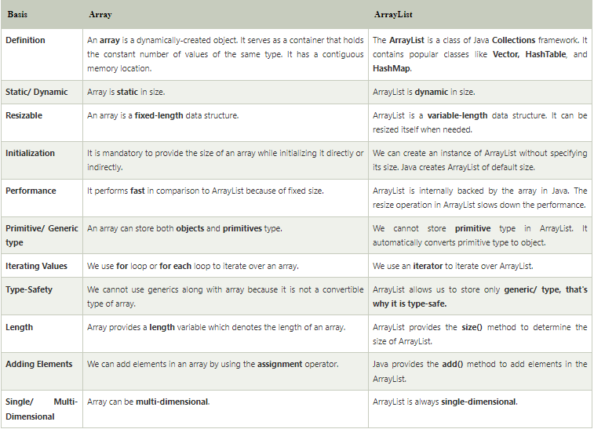

Ques 8. What is a Map in java?

Ans:- A map contains values on the basis of key, i.e. key and value pair. Each key and value pair is known as an entry. A Map contains unique keys.

A Map is useful if you have to search, update or delete elements on the basis of a key.

Ques 9. What are the commonly used to Implementations of Map in java ?

Ans:- The three general-purpose Map implementations are HashMap ,

TreeMap and LinkedHashMap .

Ques 10. What is the Difference between HashMap and treeMap ?

Ans:-Ther are many difference between HashMap and TreeMap.

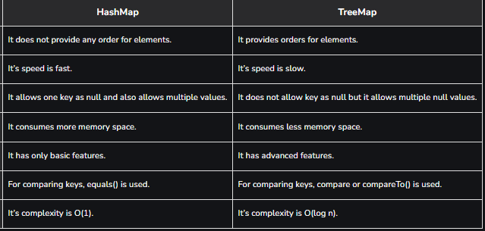

Ques 11. How do you check if a key exits in a Map in java?

Ans:- HashMap. containsKey() method is used to check whether a particular key is being mapped into the HashMap or not. It takes the key element as a parameter and returns True if that element is mapped in the map.