CREATE SCHEMA `tourism-management` ;

CREATE TABLE `tourism-management`.`touristcompany` (

`branchId` INT NOT NULL AUTO_INCREMENT,

`branchName` VARCHAR(45) NULL,

`place` VARCHAR(45) NULL,

`website` VARCHAR(45) NULL,

`contact` VARCHAR(45) NULL,

`email` VARCHAR(45) NULL,

`dateAdded` DATETIME NULL DEFAULT CURRENT_TIMESTAMP,

PRIMARY KEY (`branchId`));

CREATE TABLE `tourism-management`.`tariff` (

tariffId INT AUTO_INCREMENT PRIMARY KEY,

place VARCHAR(255) NOT NULL,

tariffAmount INT NOT NULL,

`createdDate` DATETIME NULL DEFAULT CURRENT_TIMESTAMP,

`updatedDate` DATETIME NULL DEFAULT NULL ON UPDATE CURRENT_TIMESTAMP,

branchId INT NOT NULL,

CONSTRAINT fk_tourist_company

FOREIGN KEY (branchId)

REFERENCES `tourism-management`.`touristcompany` (`branchId`)

ON DELETE CASCADE

ON UPDATE NO ACTION);

**OR**

CREATE TABLE `tourism-management`.`tariff` (

tariffId INT AUTO_INCREMENT PRIMARY KEY,

place VARCHAR(255) NOT NULL,

tariffAmount INT NOT NULL,

`createdDate` DATETIME NULL DEFAULT CURRENT_TIMESTAMP,

`updatedDate` DATETIME NULL DEFAULT NULL ON UPDATE CURRENT_TIMESTAMP,

branchId INT NOT NULL,

CONSTRAINT fk_tourist_company

FOREIGN KEY (branchId)

REFERENCES `tourism-management`.`touristcompany` (`branchId`)

ON DELETE NO ACTION

ON UPDATE NO ACTION,

UNIQUE KEY `unique_branch_place` (branchId, place)

);

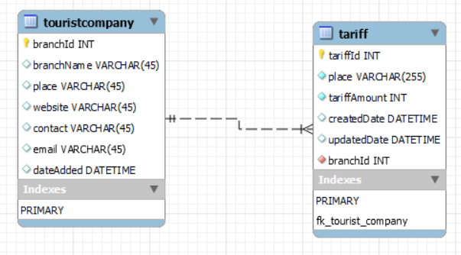

Jenkins: local port : 8045