BTI425

Lab6

Kam Man Chan 028081149

**Submit successful screenshot**

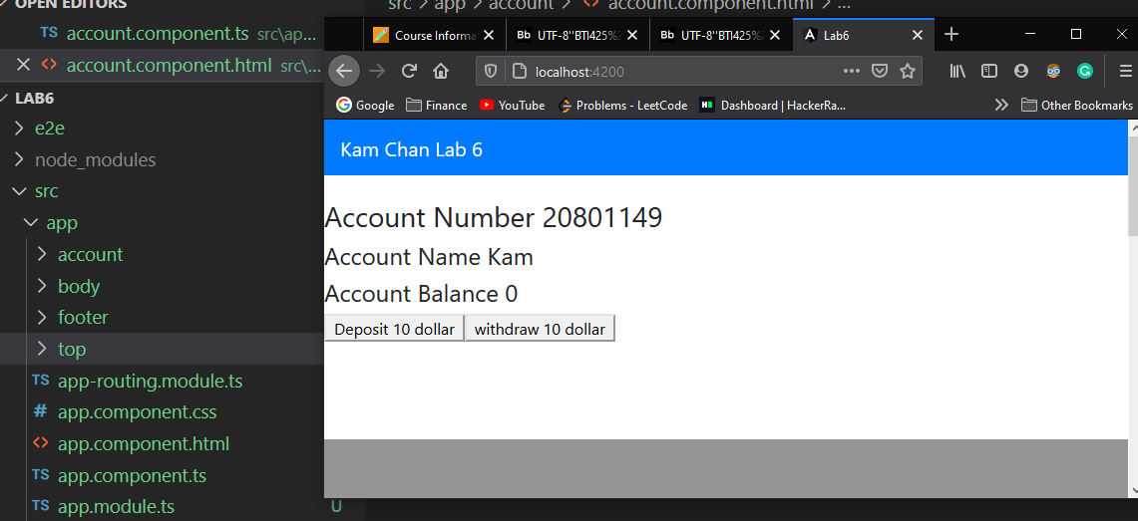

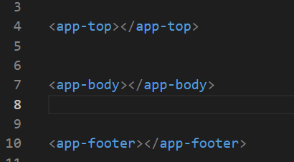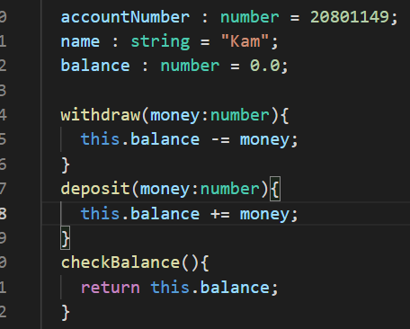

Top, body, footer component, account object class. 3 properties include balance

Withdraw, deposit, checkBalance methods

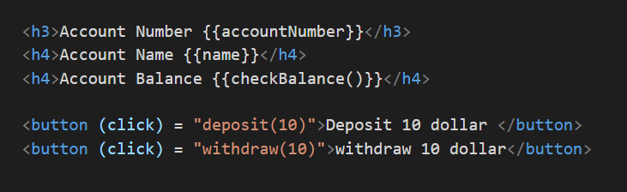

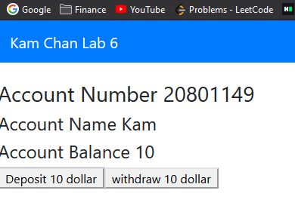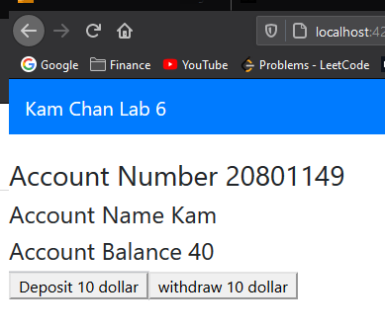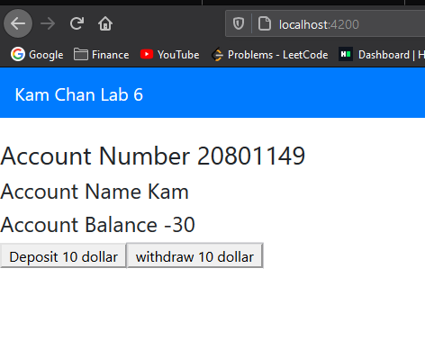

Click Deposit button will increment the Balance, withdraw will decrease the Balance

**Explain what the Decorator mean in Angular, and what the famous properties are?**

The below picture @component in angular we also call it Decorator, we will specific different option here, we can able to pass different parameter to the decorator, we can also pass different meta data information for our component, it have different configuration information .

For example, the famous properties are selector, it will have the name of the component, we can render the component with the name and use it in other component

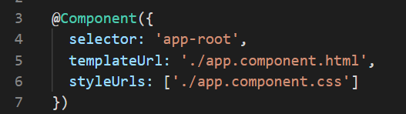

**What is TypeScript? and what the main differences between TypeScript and JavaScript?**

* Typescript is a programming languageAnd it is the main language to use for developing with Angular. Usually it is used to develop large applications and it is a superset of JavaScript with rich design-time support for type safety and tooling.
* Browsers understanding Javascript code, but Browsers don’t understanding Typescript code.
* Typescript is known as OOP language, but javascript is just a scripting language.
* Typescript is type sensitive, we need to define the type of the element{string, number, array etc} javascript is not type sensitive.

**(next page)**

**What is the Angular app folder structure?**

Within the project, it will contain 3 folder and other json file

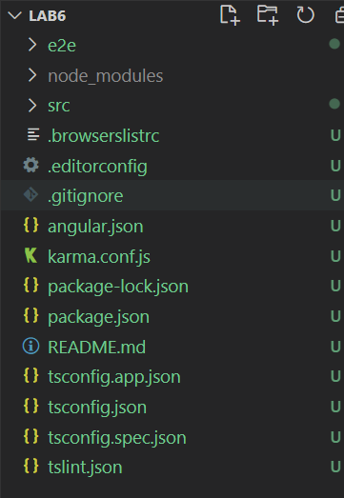

Json file is for all the package information and application configuration and package version, and debug feature also compile information.

Within src File

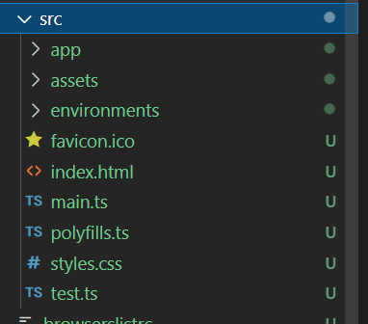

We will have a styles.css for global style setting.

The main playground is the **app** folder

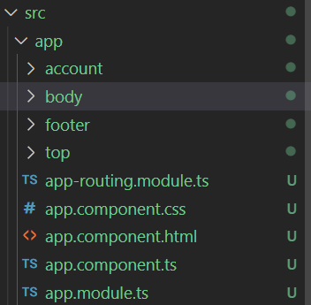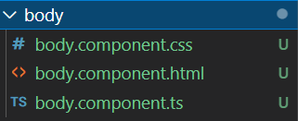

It contains the root component(app.component) and app.module.ts file for importing all the other components. Each time if we create a new component, it will generate a folder and contain a css, html and ts file. Css file is for style for that component, html is template for specific component, ts file contain logical function call and properties for that component