III B.Tech I Semester Examinations – November 2016

**OPERATIONS RESEARCH**

Time: **3** hours (CSE) Max. Marks: **60**

# SECTION – A

(Short Answer Questions)

**Answer all ten questions 10×1M=10M**

1. A LPP has six inequality constraints including three non-negative conditions. Then the number of slack variables required to solve by simplex method is _______.
2. Define an optimal solution.
3. What is a transportation problem?
4. With reference to transportation problem define feasible solution.
5. What are the types of assignment problems?
6. Which of the following method is not a method to solve transportation problem?

a) Simplex method b) Transportation Method

c) Hungarian Method d) Vogel’s approximation method

1. When minimax and maximini values of a game are same

a) No solution exists b) Saddle point exists c) Solution is mixed d) None of these

1. Define value of a game.
2. Define a Tree.
3. Define a Path in a Network.

**SECTION – B**

**Answer all five questions 5×2M= 10M**

1. What are the disadvantages of Big-M-method over Two–Phase method?
2. Define a loop in a transportation table.
3. Define a payoff matrix.
4. Give any two applications of Minimal Spanning tree problem.
5. What are types of transportation problem?

**SECTION – C**

**Answer all four questions 4×5M = 20M**

1. Explain procedure for northwest corner method.

**(OR)**

1. A company has three factories at Amethi, Baghpat and Gwalior having production capacity of 5,000, 6,000 and 2,500 tones respectively. Four distribution centres at Allahabad, Bombay, Kolkata and Delhi requiring 6,000, 4,000, 2,000 and 1,500 tones respectively of the product. The transportation costs per tone from different factories to different centres are given in table. Find an optimum transportation schedule and find the minimum cost of transport.

|  |  |  |  |  |
| --- | --- | --- | --- | --- |
|  | Allahabad | Bombay | Kolkata | Delhi |
| Amethi | 3 | 2 | 7 | 6 |
| Baghpat | 7 | 5 | 2 | 3 |
| Gwalior | 2 | 5 | 4 | 5 |

1. Two companies A and B competing for same product. Their different strategies are given in the payoff matrix. Use liner programing to determine the best strategies for both companies.

|  |  |  |  |
| --- | --- | --- | --- |
|  | A | | |
| B | 2 | -2 | 3 |
| -3 | 5 | -1 |

**(OR)**

1. Give the algorithm to solve $2×2$ games by Arithmetic method.
2. Solve the following $2×2$ game without saddle point.

|  |  |  |
| --- | --- | --- |
|  | B | |
| A | 5 | 1 |
| 3 | 4 |

**(OR)**

1. Use the relation of dominance to solve the game whose payoff matrix to the player A is given by

|  |  |  |  |
| --- | --- | --- | --- |
|  | B | | |
| A | 1 | 7 | 2 |
| 6 | 2 | 7 |
| 5 | 2 | 6 |

1. Using Dijkstra’s Algorithm find shortest path from A to all other nodes.

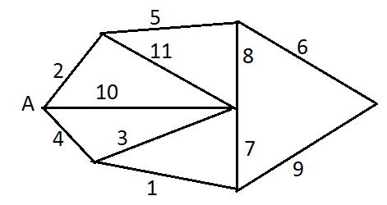

**(OR)**

1. Find a maximum flow from source A to sink B.

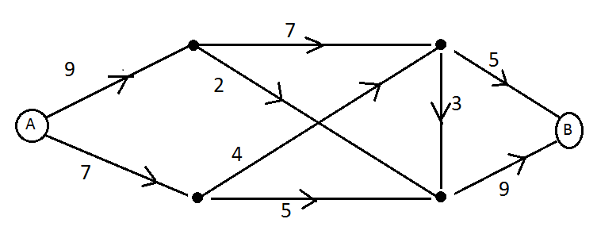

**SECTION – D**

**Answer all two questions 2×10M= 20M**

1. Write the management application of operations research.

**(OR)**

1. Write the algorithm to solve a LPP using Big-M-method. Hence solve, Min: $z=12x+20y$,subject to $6x+8y≥100$, $7x12y≥120$, $x,y≥0$.
2. Explain the Hungarian Method to solve an assignment problem.

**(OR)**

1. Use Branch and Bound method to solve the following integer programming problem. Max: $z=3x_{1}+3x_{2}+13x_{3}$ subject to $-3x_{1}+6x_{2}+7x_{3}≤8$, $5x_{1}-3x_{2}+7x_{3}≤8$, $0≤x_{i}≤5$ and all $x_{i}$’s are integers.