UNIT - IV
CODE GENERATION
4.1 Introduction:
- The final phase in compiler model is the code generator. It takes as input an intermediate representation of the source program and produces as output an equivalent target program.
- The code generation techniques presented below can be used whether or not an optimizing phase occurs before code generation.
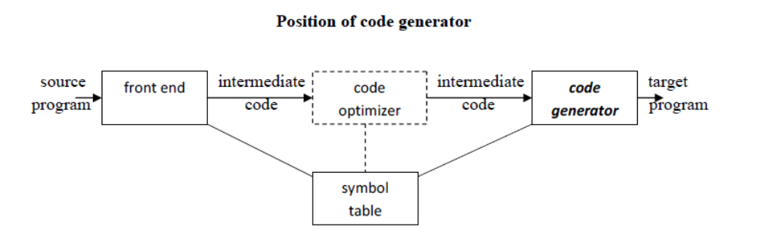

4.2 ISSUES IN THE DESIGN OF A CODE GENERATOR
- The following issues arise during the code generation phase:
- Input to code generator
- Target program
- Memory management
- Instruction selection
- Register allocation
- Evaluation order
1. Input to code generator:
- The input to the code generation consists of the intermediate representation of the source program produced by front end , together with information in the symbol table to determine run-time addresses of the data objects denoted by the names in the intermediate representation.
- Intermediate representation can be:
- Linear representation such as postfix notation
- Three address representation such as quadruples
- Virtual machine representation such as stack machine code
- Graphical representations such as syntax trees and dags.
- Prior to code generation, the front end must be scanned, parsed and translated into intermediate representation along with necessary type checking. Therefore, input to code generation is assumed to be error-free.
2. Target program:
- The output of the code generator is the target program. The output may be:
a. Absolute machine language
It can be placed in a fixed memory location and can be executed immediately.
b. Relocatable machine language
It allows subprograms to be compiled separately.
c. Assembly language
Code generation is made easier.
3. Memory management:
- Names in the source program are mapped to addresses of data objects in run-time memory by the front end and code generator.
- It makes use of symbol table, that is, a name in a three-address statement refers to a symbol-table entry for the name.
- Labels in three-address statements have to be converted to addresses of instructions.
- For example,
j : goto i generates jump instruction as follows :
- if i < j, a backward jump instruction with target address equal to location of code for quadruple i is generated.
- if i > j, the jump is forward. We must store on a list for quadruple i the location of the first machine instruction generated for quadruple j. When i is processed, the machine locations for all instructions that forward jumps to i are filled.
4. Instruction selection:
- The instructions of target machine should be complete and uniform.
- Instruction speeds and machine idioms are important factors when efficiency of target program is considered.
- The quality of the generated code is determined by its speed and size.
- The former statement can be translated into the latter statement as shown below:

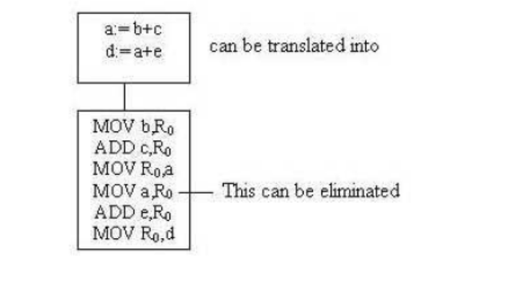
5. Register allocation
- Instructions involving register operands are shorter and faster than those involving operands in memory.
- The use of registers is subdivided into two subproblems :
Register allocation – the set of variables that will reside in registers at a point in the program is selected.
Register assignment – the specific register that a variable will reside in is
picked.
- Certain machine requires even-odd register pairs for some operands and results.
For example , consider the division instruction of the form : D x, y
where, x – dividend even register in even/odd register pair
y – divisor
even register holds the remainder
odd register holds the quotient
6. Evaluation order
- The order in which the computations are performed can affect the efficiency of the target code. Some computation orders require fewer registers to hold intermediate results than others.

  - TARGET MACHINE
- Familiarity with the target machine and its instruction set is a prerequisite for designing a good code generator.
- The target computer is a byte-addressable machine with 4 bytes to a word.
- It has n general-purpose registers, R0, R1, . . . , Rn-1.
- It has two-address instructions of the form:
op source, destination
where, op is an op-code, and source and destination are data fields
- It has the following op-codes :
MOV (move source to destination)
ADD (add source to destination)
SUB (subtract source from destination)
- The source and destination of an instruction are specified by combining registers and memory locations with address modes.
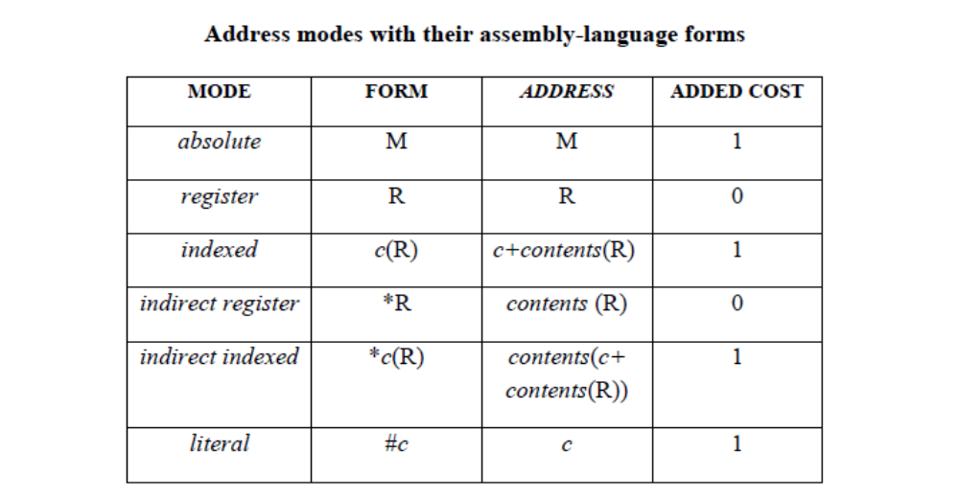
- For example : MOV R0, M stores contents of Register R0 into memory location M;
MOV 4(R0), M stores the value contents(4+contents(R0)) into M.

Instruction costs:
- Instruction cost = 1+cost for source and destination address modes. This cost corresponds to the length of the instruction.
- Address modes involving registers have cost zero.
- Address modes involving memory location or literal have cost one.
- Instruction length should be minimized if space is important. Doing so also minimizes the time taken to fetch and perform the instruction.

For example:
MOV R0, R1 copies the contents of register R0 into R1. It has cost one, since it occupies only one word of memory.
- The three-address statement a : = b + c can be implemented by many different instruction sequences :

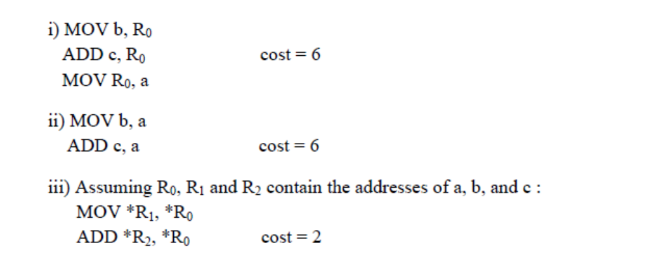
- In order to generate good code for target machine, we must utilize its addressing
capabilities efficiently.

4.4 RUN-TIME STORAGE MANAGEMENT

- Information needed during an execution of a procedure is kept in a block of storage called an activation record, which includes storage for names local to the procedure.
- The two standard storage allocation strategies are:
1. Static allocation
2. Stack allocation
- In static allocation, the position of an activation record in memory is fixed at compile time.
- In stack allocation, a new activation record is pushed onto the stack for each execution of a procedure. The record is popped when the activation ends.
- The following three-address statements are associated with the run-time allocation and deallocation of activation records:
1. Call,
2. Return,
3. Halt, and
4. Action, a placeholder for other statements.
- We assume that the run-time memory is divided into areas for:
1. Code
2. Static data
3. Stack

Static allocation:
Implementation of call statement:
The codes needed to implement static allocation are as follows:
MOV #here + 20, callee.static_area /*It saves return address*/
GOTO callee.code_area /*It transfers control to the target code for the called procedure */

where,
callee.static_area – Address of the activation record
callee.code_area – Address of the first instruction for called procedure
#here + 20 – Literal return address which is the address of the instruction following GOTO.
Implementation of return statement:
A return from procedure callee is implemented by :
GOTO *callee.static_area
This transfers control to the address saved at the beginning of the activation record.

Implementation of action statement:
The instruction ACTION is used to implement action statement.

Implementation of halt statement:
The statement HALT is the final instruction that returns control to the operating system.

Stack allocation:
- Static allocation can become stack allocation by using relative addresses for storage in activation records. In stack allocation, the position of activation record is stored in register so words in activation records can be accessed as offsets from the value in this register.
- The codes needed to implement stack allocation are as follows:
Initialization of stack:
MOV #stackstart , SP /* initializes stack */
Code for the first procedure
HALT /* terminate execution */

Implementation of Call statement:
ADD #caller.recordsize, SP /* increment stack pointer */
MOV #here + 16, *SP /*Save return address */
GOTO callee.code_area
where,
caller.recordsize – size of the activation record
#here + 16 – address of the instruction following the GOTO

Implementation of Return statement:
GOTO *0 ( SP ) /*return to the caller */
SUB #caller.recordsize, SP /* decrement SP and restore to previous value */

4.5 BASIC BLOCKS AND FLOW GRAPHS
Basic Blocks
- A basic block is a sequence of consecutive statements in which flow of control enters at the beginning and leaves at the end without any halt or possibility of branching except at the end.
- The following sequence of three-address statements forms a basic block:
t1 : = a * a
t2 : = a * b
t3 : = 2 * t2
t4 : = t1 + t3
t5 : = b * b
t6 : = t4 + t5
Basic Block Construction:
Algorithm: Partition into basic blocks
Input: A sequence of three-address statements
Output: A list of basic blocks with each three-address statement in exactly one block
Method:
1. We first determine the set of leaders, the first statements of basic blocks. The rules we use are of the following:
a. The first statement is a leader.
b. Any statement that is the target of a conditional or unconditional goto is aleader.
c. Any statement that immediately follows a goto or conditional goto statement is a leader.
2. For each leader, its basic block consists of the leader and all statements up to but not including the next leader or the end of the program.

- Consider the following source code for dot product of two vectors a and b of length 20
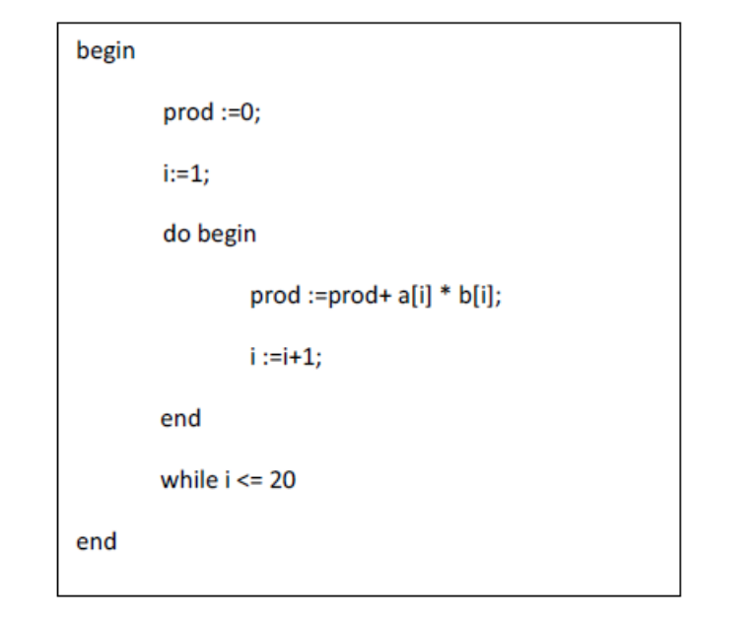

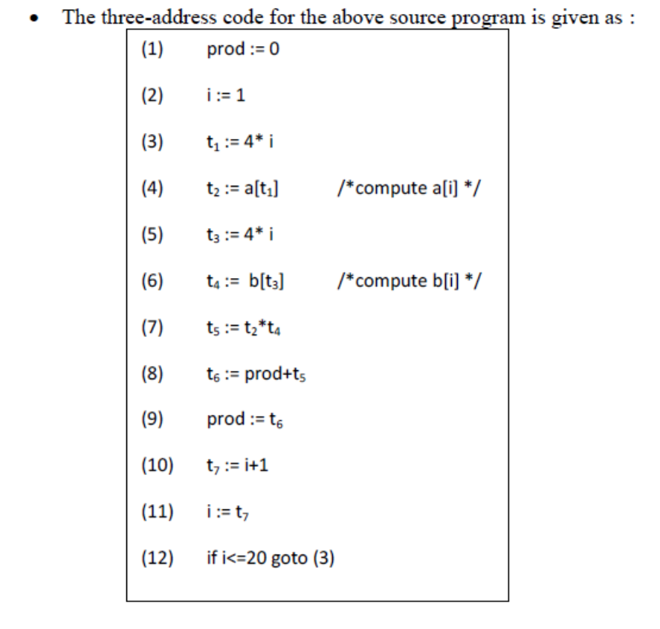
Transformations on Basic Blocks:
- A number of transformations can be applied to a basic block without changing the set of expressions computed by the block. Two important classes of transformation are:
- Structure-preserving transformations
- Algebraic transformations
1. Structure preserving transformations:
a) Common subexpression elimination:
a : = b + c a : = b + c
b : = a – d b : = a - d
c : = b + c c : = b + c
d : = a – d d : = b
Since the second and fourth expressions compute the same expression, the basic block can be transformed as above.

b) Dead-code elimination:
Suppose x is dead, that is, never subsequently used, at the point where the statement x : = y + z appears in a basic block. Then this statement may be safely removed without changing the value of the basic block.

c) Renaming temporary variables:
A statement t : = b + c ( t is a temporary ) can be changed to u : = b + c (u is a new temporary) and all uses of this instance of t can be changed to u without changing the value of the basic block. Such a block is called a normal-form block.
d) Interchange of statements:
Suppose a block has the following two adjacent statements:
t1 : = b + c
t2 : = x + y
We can interchange the two statements without affecting the value of the block if and
only if neither x nor y is t1 and neither b nor c is t2.

2. Algebraic transformations:
Algebraic transformations can be used to change the set of expressions computed by a basic block into an algebraically equivalent set.
Examples:
i) x : = x + 0 or x : = x * 1 can be eliminated from a basic block without changing the set of expressions it computes.
ii) The exponential statement x : = y * * 2 can be replaced by x : = y * y.

  - Flow Graphs
- Flow graph is a directed graph containing the flow-of-control information for the set of basic blocks making up a program.
- The nodes of the flow graph are basic blocks. It has a distinguished initial node.
- E.g.: Flow graph for the vector dot product is given as follows:
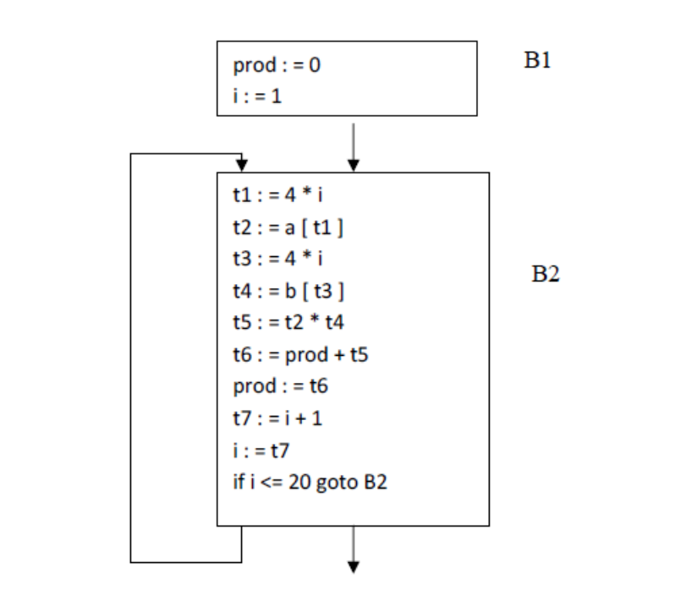

- B1 is the initial node. B2 immediately follows B1, so there is an edge from B1 to B2. The target of jump from last statement of B1 is the first statement B2, so there is an edge from B1 (last statement) to B2 (first statement).
- B1 is the predecessor of B2, and B2 is a successor of B1.

Loops
- A loop is a collection of nodes in a flow graph such that
1. All nodes in the collection are strongly connected.
2. The collection of nodes has a unique entry.
- A loop that contains no other loops is called an inner loop.

4.7 NEXT-USE INFORMATION

- If the name in a register is no longer needed, then we remove the name from the register and the register can be used to store some other names.
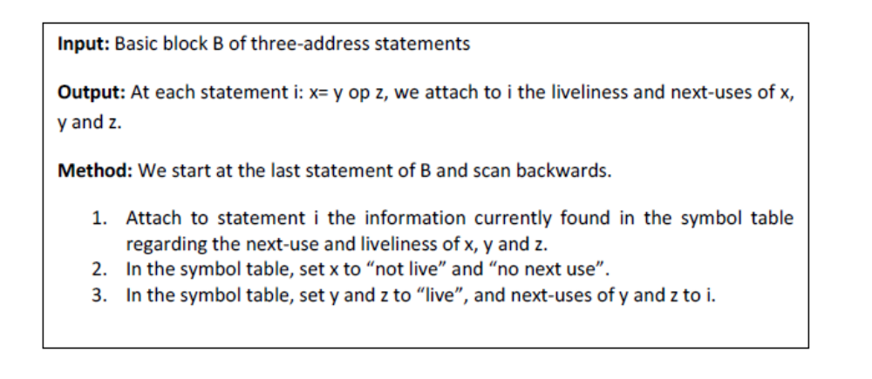
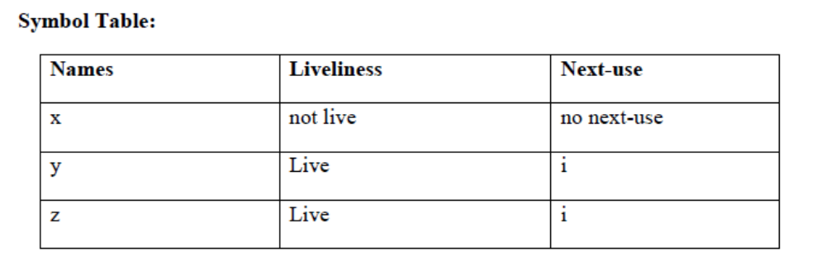

4.8 A SIMPLE CODE GENERATOR
- A code generator generates target code for a sequence of three- address statements and effectively uses registers to store operands of the statements.
- For example: consider the three-address statement a := b+c
- It can have the following sequence of codes:
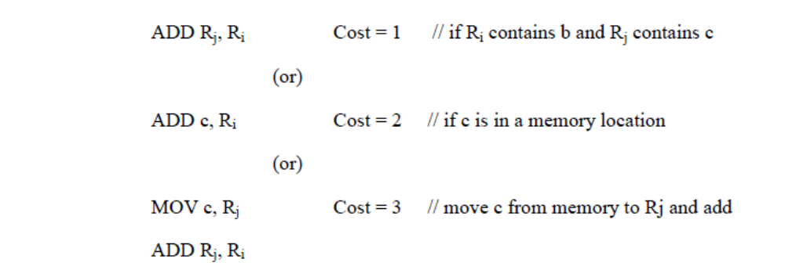

Register and Address Descriptors:
- A register descriptor is used to keep track of what is currently in each registers. The register descriptors show that initially all the registers are empty.
- An address descriptor stores the location where the current value of the name can be found at run time.
A code-generation algorithm:
- The algorithm takes as input a sequence of three-address statements constituting a basic block.
- For each three-address statement of the form x : = y op z, perform the following actions:
- Invoke a function getreg to determine the location L where the result of the computation y op z should be stored.
- Consult the address descriptor for y to determine y’, the current location of y. Prefer theregister for y’ if the value of y is currently both in memory and a register. If the value of y is not already in L, generate the instruction MOV y’ , L to place a copy of y in L.
- Generate the instruction OP z’ , L where z’ is a current location of z. Prefer a register to a memory location if z is in both. Update the address descriptor of x to indicate that x is in location L. If x is in L, update its descriptor and remove x from all other descriptors.
- If the current values of y or z have no next uses, are not live on exit from the block, and are in registers, alter the register descriptor to indicate that, after execution of x : = y op z , those registers will no longer contain y or z.

Generating Code for Assignment Statements:
- The assignment d : = (a-b) + (a-c) + (a-c) might be translated into the following three address code sequence:
t : = a – b
u : = a – c
v : = t + u
d : = v + u
with d live at the end.
Code sequence for the example is:
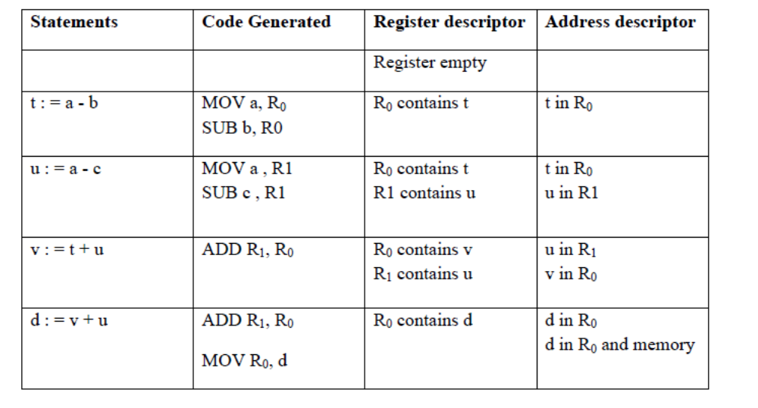

Generating Code for Indexed Assignments
The table shows the code sequences generated for the indexed assignment statements
a : = b [ i ] and a [ i ] : = b
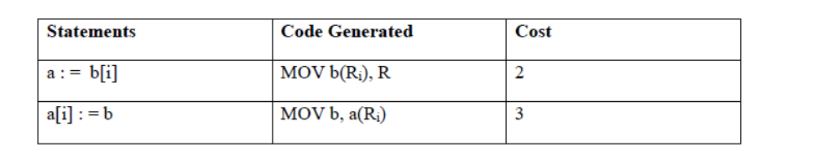
Generating Code for Pointer Assignments
The table shows the code sequences generated for the pointer assignments
a : = *p and *p : = a
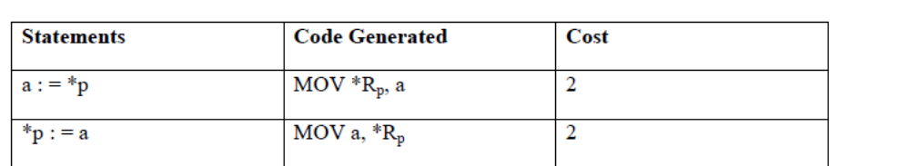

Generating Code for Conditional Statements
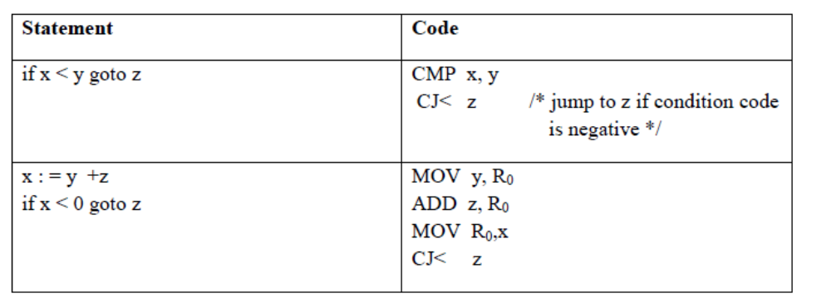

4.9 THE DAG REPRESENTATION FOR BASIC BLOCKS
- A DAG for a basic block is a directed acyclic graph with the following labels on nodes:
1. Leaves are labeled by unique identifiers, either variable names or constants.
2. Interior nodes are labeled by an operator symbol.
3. Nodes are also optionally given a sequence of identifiers for labels to store the computed values.
- DAGs are useful data structures for implementing transformations on basic blocks.
- It gives a picture of how the value computed by a statement is used in subsequent statements.
- It provides a good way of determining common sub - expressions.

Algorithm for construction of DAG
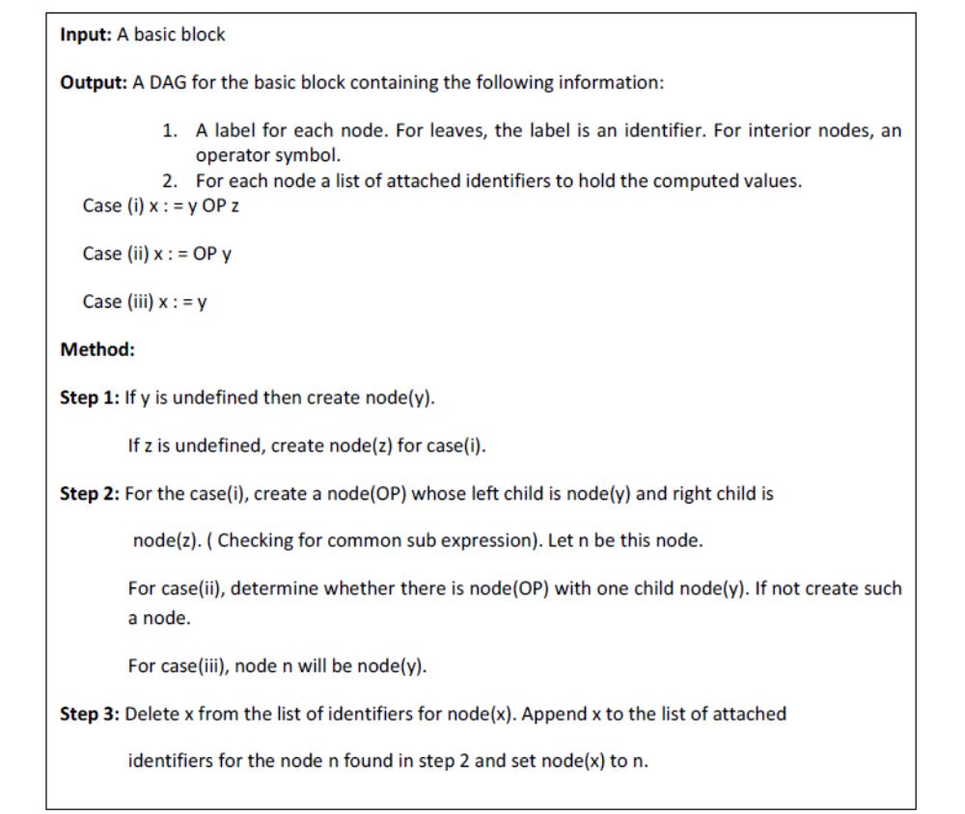

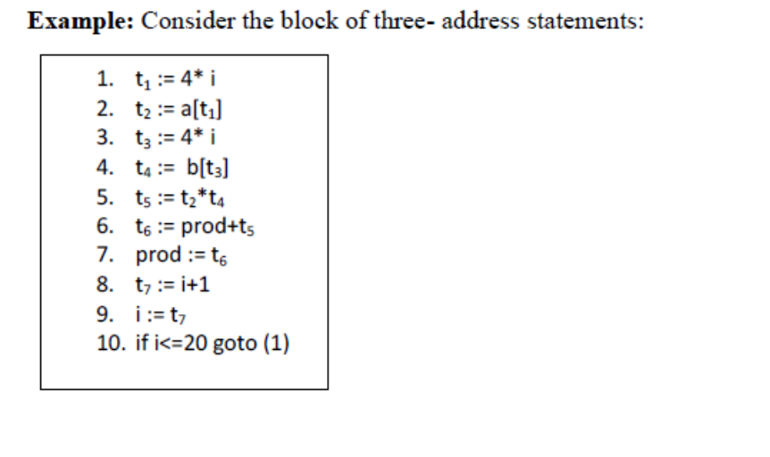

Stages in DAG Construction
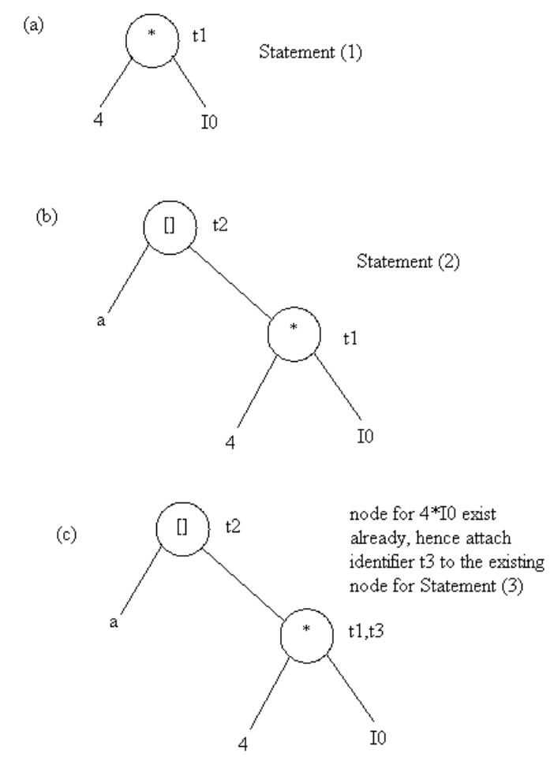
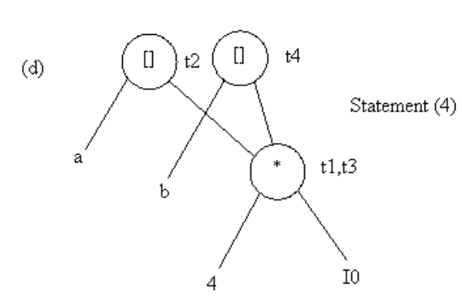
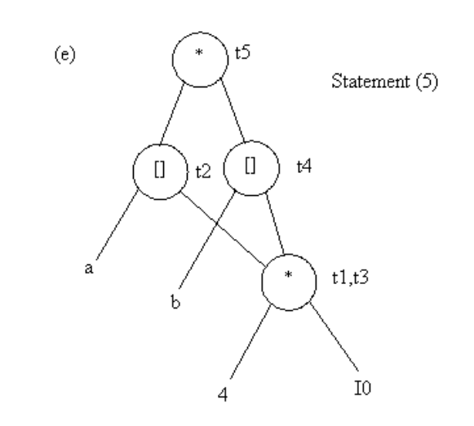
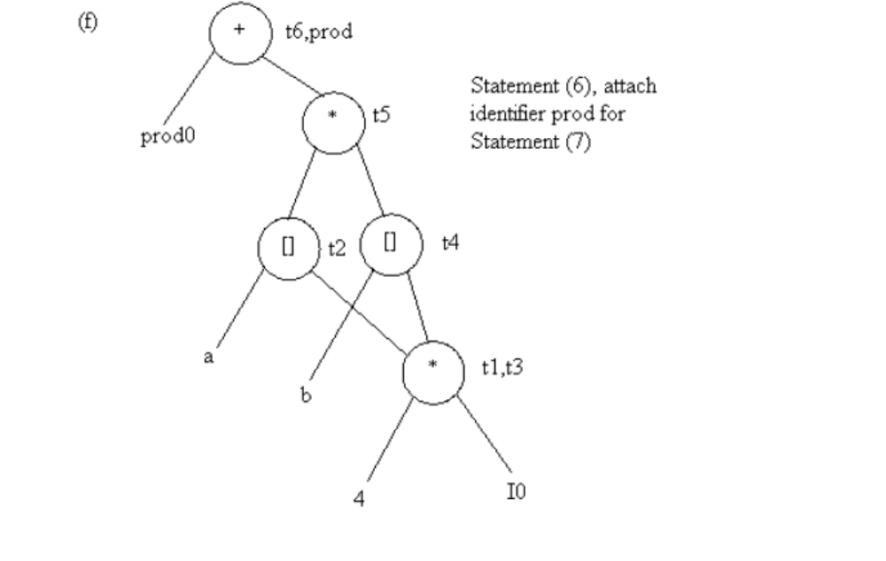
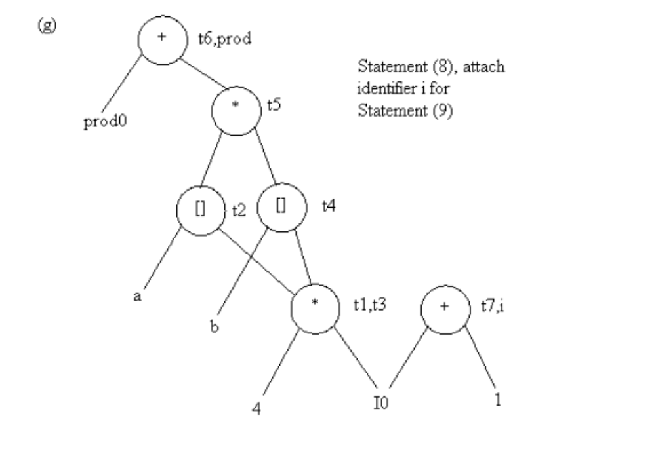
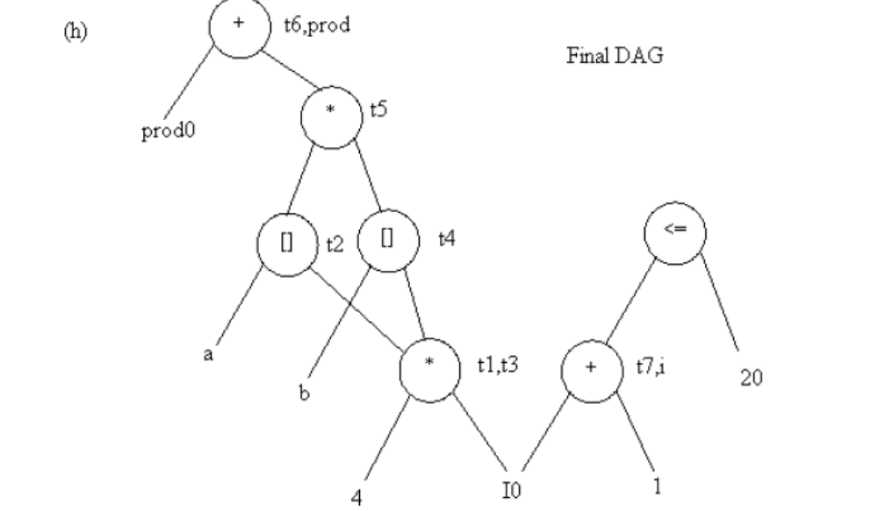
Application of DAGs:
1. We can automatically detect common sub expressions.
2. We can determine which identifiers have their values used in the block.
3. We can determine which statements compute values that could be used outside the block.
4.10 GENERATING CODE FROM DAGs
- The advantage of generating code for a basic block from its dag representation is that, from a dag we can easily see how to rearrange the order of the final computation sequence than we can starting from a linear sequence of three-address statements or quadruples.
Rearranging the order
- The order in which computations are done can affect the cost of resulting object code.
For example, consider the following basic block:
t1 : = a + b
t2 : = c + d
t3 : = e – t2
t4 : = t1 – t3
Generated code sequence for basic block:
MOV a , R0
ADD b , R0
MOV c , R1
ADD d , R1
MOV R0 , t1
MOV e , R0
SUB R1 , R0
MOV t1 , R1
SUB R0 , R1
MOV R1 , t4
Rearranged basic block:
Now t1 occurs immediately before t4.
t2 : = c + d
t3 : = e – t2
t1 : = a + b
t4 : = t1 – t3
Revised code sequence:
MOV c , R0
ADD d , R0
MOV a , R0
SUB R0 , R1
MOV a , R0
ADD b , R0
SUB R1 , R0
MOV R0 , t4
In this order, two instructions MOV R0 , t1 and MOV t1 , R1 have been saved.

A Heuristic ordering for Dags
- The heuristic ordering algorithm attempts to make the evaluation of a node immediately follow the evaluation of its leftmost argument.
- The algorithm shown below produces the ordering in reverse.

Algorithm:
while unlisted interior nodes remain do begin
select an unlisted node n, all of whose parents have been listed;
list n;
while the leftmost child m of n has no unlisted parents and is not a leaf do
begin
list m;
n : = m
end
end

Example: Consider the DAG shown below:

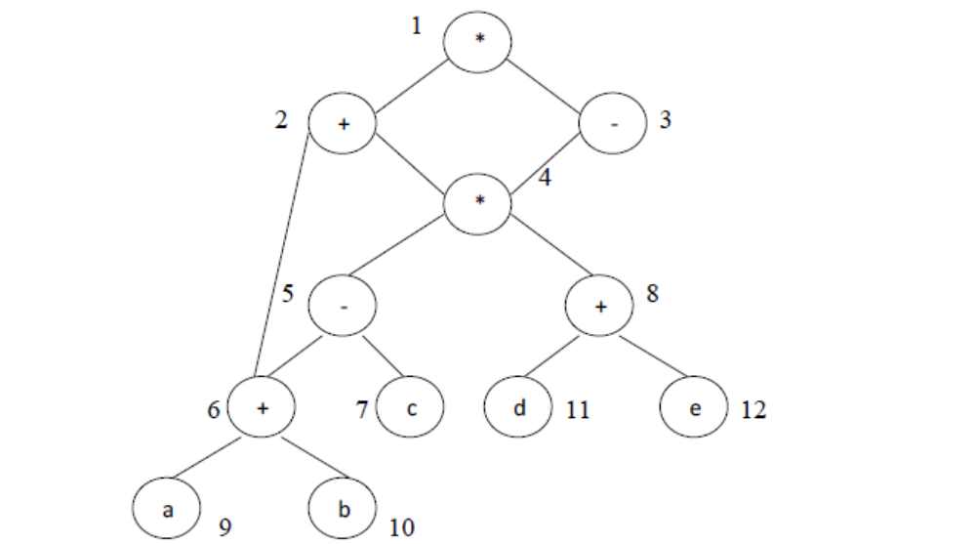
- Initially, the only node with no unlisted parents is 1 so set n=1 at line (2) and list 1 at line (3).
- Now, the left argument of 1, which is 2, has its parents listed, so we list 2 and set n=2 at line (6).
- Now, at line (4) we find the leftmost child of 2, which is 6, has an unlisted parent 5. Thus we select a new n at line (2), and node 3 is the only candidate. We list 3 and proceed down its left chain, listing 4, 5 and 6. This leaves only 8 among the interior nodes so we list that.
- The resulting list is 1234568 and the order of evaluation is 8654321.

Code sequence:
t8 : = d + e
t6 : = a + b
t5 : = t6 – c
t4 : = t5 * t8
t3 : = t4 – e
t2 : = t6 + t4
t1 : = t2 * t3
This will yield an optimal code for the DAG on machine whatever be the number of registers.

4.11 Peephole Optimization
- The target code contains redundant instructions and suboptimal constructs. The quality of such target code can be improved by applying “optimizing” transformations to the target program.
- A simple but effective technique for locally improving the target code is peephole optimization.
Peephole optimization is a method for trying to improve the performance of the target program by examining a short sequence of target instruction (called the peephole) and replacing these instructions by a shorter or faster sequence.
The characteristics of peephole optimization:
- Redundant-instruction elimination
- Flow-of-control optimizations
- Algebraic simplifications
- Use of machine idioms.

Redundant Loads and Stores
If the instruction sequence of the form:
(1) MOV R0, a
(2) MOV a, R0
In this instruction sequence, we can delete the instruction (2). Because whenever (2) is executed, (1) will ensure that the value of a is already in register R0.
Unreachable Code
1. The peephole optimization removes unreachable instructions.
2. An unlabeled instruction immediately following an unconditional jump may be removed.
For example:
#define debug 0
. . .
if ( debug ) {
print debugging information
}
- In the intermediate representation the if-statement may be translated as:
if debug = 1 goto L1
goto L2
L1: print debugging information
L2: (1)
- The peephole optimization eliminates jumps over jumps. Therefore the above three-address statements can be replaced by:
if debug ≠ 1 goto L2
print debugging information
L2: (2)
- Now debug is set to at the beginning of the program, constant propagation (2) should replace by
if 0 ≠ 1 goto L2
print debugging information
L2: (3)
- As the argument of the first statement of (3) evaluates to a constant true, it can be replaced by goto L2. Then all the statements that print debugging aids are manifestly unreachable and be eliminated one at a time.

Flow-of-control optimization
- The intermediate code generation produces jumps to jumps, jumps to conditional jumps, or conditional jumps to jumps.
- These unnecessary jumps can be eliminated in either the intermediate code or the target code by the following types of peephole optimizations.
- The jump sequence can be replaced as:
goto L1
. . .
L1: goto L2
by the sequence
goto L2
. . .
L1: goto L2
- If there are now no jumps to L1, then it may be possible to eliminate the statement L1: goto L2 provided it is preceded by an unconditional jump.
- Similarly, the sequence
if a < b goto L1
. . .
L1: goto L2
can be replaced by
if a < b goto L2
. . .
L1: goto L2
- Finally, suppose there is can jump to L1 and L1 is preceded by an unconditional goto. Then the sequence
goto L1
. . .
L1: if a < b goto L2
L3: (4)
may be replaced by
if a < b goto L2
goto L3
. . .
L3: (5)

while the number of instructions in (4) and (5) is the same. (4) can be skipped sometimes, but never in (4). Thus, (5) is superior to (4) in execution time.

Algebraic Simplification
- There is no end to the amount of algebraic simplification that can be attempted through peephole optimization.
- However, only few algebraic identities occur frequently enough that it is worth considering implementing them.
- For example:
x := x + 0
or
x := x *1
are often produced by straightforward intermediate code-generation algorithms, and they can be eliminated easily through peephole optimization.

Reduction in strength
- Reduction in strength replaces expensive operations by equivalent cheaper ones on the target machine.
- For example:
- x2 is invariably cheaper to implement as x * x than as a call to an exponentiation routine.
- Fixed-point multiplication or division by a power of two is cheaper to implement as a shift.
- Floating-point division by a constant can be implemented as multiplication by a constant.

Use of Machine idioms
- The target machine may have hardware instructions to implement certain specific operations efficiently.
- Detecting situations that permit the use of these instructions can reduce execution time significantly.
- For example:
- Some machine have auto-increment or decrement addressing modes.
- These add or subtract one from an operand before or after using its value.
- The use of these modes greatly improves the quality of code when pushing or popping a stack, as in parameter passing.
- These modes can also be used in code for statement like i := i +1.

