Combining and Merging Data Sets
Data contained in pandas objects can be combined together in a number of built-in ways:

• pandas.merge: connects rows in DataFrames based on one or more keys. This will be familiar to users of SQL or other relational databases, as it implements database join operations.
• pandas.concat: glues or stacks together objects along an axis.
• combine_first: instance method enables splicing together overlapping data to fill in missing values in one object with values from another.

Database-style DataFrame Merges

Merge or join operations combine data sets by linking rows using one or more keys. These operations are central to relational databases. The merge function in pandas is the main entry point for using these algorithms on your data.

Example:

In [15]: df1 = DataFrame({'key': ['b', 'b', 'a', 'c', 'a', 'a', 'b'],
....: 'data1': range(7)})
In [16]: df2 = DataFrame({'key': ['a', 'b', 'd'],
....: 'data2': range(3)})

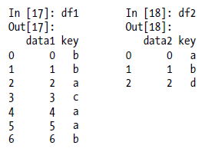

This is an example of a many-to-one merge situation; the data in df1 has multiple rows labeled a and b, whereas df2 has only one row for each value in the key column. Calling merge with these objects we obtain:

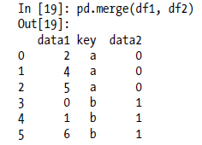

Note that I didn’t specify which column to join on. If not specified, merge uses the overlapping column names as the keys. It’s a good practice to specify explicitly, though:

pd.merge(df1, df2, on='key')

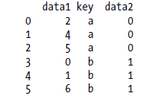

If the column names are different in each object, you can specify them separately:

df3 = DataFrame({'lkey': ['b', 'b', 'a', 'c', 'a', 'a', 'b'],
....: 'data1': range(7)})
df4 = DataFrame({'rkey': ['a', 'b', 'd'],
....: 'data2': range(3)})

In [23]: pd.merge(df3, df4, left_on='lkey', right_on='rkey')

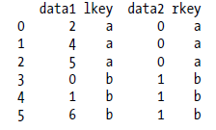

You probably noticed that the 'c' and 'd' values and associated data are missing from the result. By default merge does an 'inner' join; the keys in the result are the intersection.

Other possible options are 'left', 'right', and 'outer'. The outer join takes the union of the keys, combining the effect of applying both left and right joins:

In [24]: pd.merge(df1, df2, how='outer')
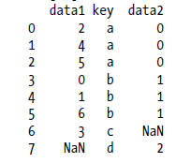

Many-to-many merges have well-defined though not necessarily intuitive behavior.

Here’s an example:

In [25]: df1 = DataFrame({'key': ['b', 'b', 'a', 'c', 'a', 'b'],
....: 'data1': range(6)})
In [26]: df2 = DataFrame({'key': ['a', 'b', 'a', 'b', 'd'],
....: 'data2': range(5)})

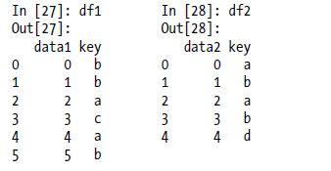
In [29]: pd.merge(df1, df2, on='key', how='left')

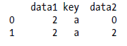
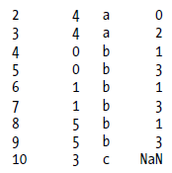
Many-to-many joins form the Cartesian product of the rows. Since there were 3 'b' rows in the left DataFrame and 2 in the right one, there are 6 'b' rows in the result.

The join method only affects the distinct key values appearing in the result:

In [30]: pd.merge(df1, df2, how='inner')
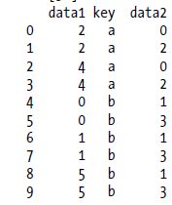

To merge with multiple keys, pass a list of column names:

In [31]: left = DataFrame({'key1': ['foo', 'foo', 'bar'],
....: 'key2': ['one', 'two', 'one'],
....: 'lval': [1, 2, 3]})
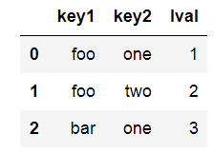

In [32]: right = DataFrame({'key1': ['foo', 'foo', 'bar', 'bar'],
....: 'key2': ['one', 'one', 'one', 'two'],
....: 'rval': [4, 5, 6, 7]})

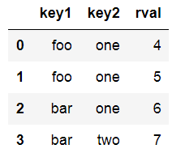

In [33]: pd.merge(left, right, on=['key1', 'key2'], how='outer')
Out[33]:
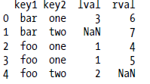

To determine which key combinations will appear in the result depending on the choice of merge method, think of the multiple keys as forming an array of tuples to be used as a single join key (even though it’s not actually implemented that way).

A last issue to consider in merge operations is the treatment of overlapping column names. While you can address the overlap manually (see the later section on renaming axis labels), merge has a suffixes option for specifying strings to append to overlapping names in the left and right DataFrame objects:

pd.merge(left, right, on='key1')
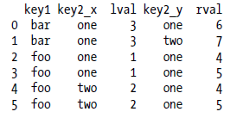

In [35]: pd.merge(left, right, on='key1', suffixes=('_left', '_right'))

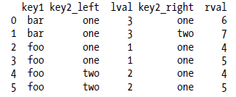

Table 7-1. merge function arguments
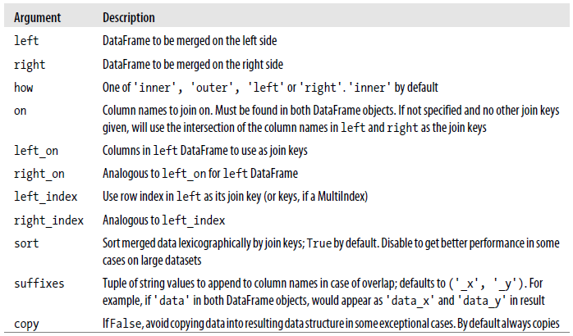

Merging on Index

In some cases, the merge key or keys in a DataFrame will be found in its index. In this case, you can pass left_index=True or right_index=True (or both) to indicate that the index should be used as the merge key:
In [36]: left1 = DataFrame({'key': ['a', 'b', 'a', 'a', 'b', 'c'],
....: 'value': range(6)})
In [37]: right1 = DataFrame({'group_val': [3.5, 7]}, index=['a', 'b'])

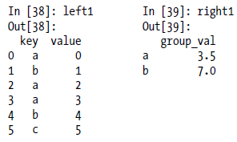
pd.merge(left1, right1, left_on='key', right_index=True)

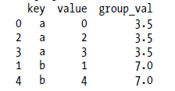
Since the default merge method is to intersect the join keys, you can instead form the union of them with an outer join:

In [41]: pd.merge(left1, right1, left_on='key', right_index=True, how='outer')
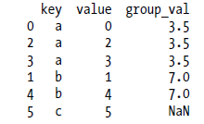

With hierarchically-indexed data, things are a bit more complicated:

In [42]: lefth = DataFrame({'key1': ['Ohio', 'Ohio', 'Ohio', 'Nevada', 'Nevada'],
....: 'key2': [2000, 2001, 2002, 2001, 2002],
....: 'data': np.arange(5.)})

In [43]: righth = DataFrame(np.arange(12).reshape((6, 2)),
....: index=[['Nevada', 'Nevada', 'Ohio', 'Ohio', 'Ohio', 'Ohio'],
....: [2001, 2000, 2000, 2000, 2001, 2002]],
....: columns=['event1', 'event2'])

Lefth

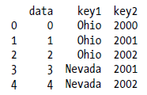

Righth

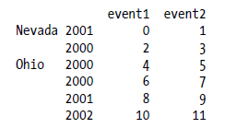
In this case, you have to indicate multiple columns to merge on as a list (pay attention to the handling of duplicate index values):

In [46]: pd.merge(lefth, righth, left_on=['key1', 'key2'], right_index=True)

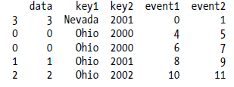

In [47]: pd.merge(lefth, righth, left_on=['key1', 'key2'], right_index=True, how='outer')

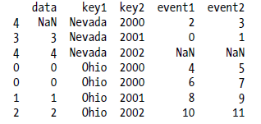

Using the indexes of both sides of the merge is also not an issue:

In [48]: left2 = DataFrame([[1., 2.], [3., 4.], [5., 6.]], index=['a', 'c', 'e'],
....: columns=['Ohio', 'Nevada'])
In [49]: right2 = DataFrame([[7., 8.], [9., 10.], [11., 12.], [13, 14]],
....: index=['b', 'c', 'd', 'e'], columns=['Missouri', 'Alabama'])

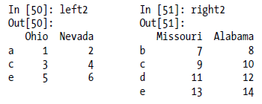
In [52]: pd.merge(left2, right2, how='outer', left_index=True, right_index=True)
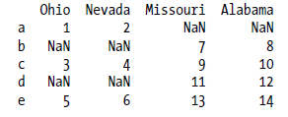
DataFrame has a more convenient join instance for merging by index. It can also be used to combine together many DataFrame objects having the same or similar indexes but non-overlapping columns. In the prior example, we could have written:

left2.join(right2, how='outer')

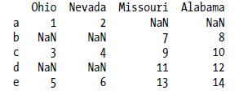
In part for legacy reasons (much earlier versions of pandas), DataFrame’s join method performs a left join on the join keys. It also supports joining the index of the passed DataFrame on one of the columns of the calling DataFrame:

left1.join(right1, on='key')

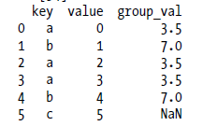

Lastly, for simple index-on-index merges, you can pass a list of DataFrames to join as an alternative to using the more general concat function described below:

In [55]: another = DataFrame([[7., 8.], [9., 10.], [11., 12.], [16., 17.]],
....: index=['a', 'c', 'e', 'f'], columns=['New York', 'Oregon'])

Another
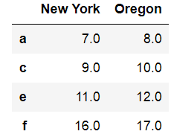
In [56]: left2.join([right2, another])

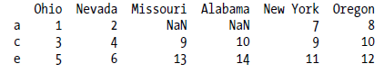
left2.join([right2, another], how='outer')
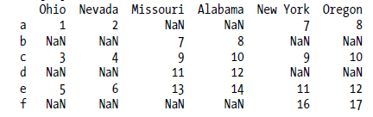

Concatenating Along an Axis

Another kind of data combination operation is alternatively referred to as concatenation, binding, or stacking. NumPy has a concatenate function for doing this with raw NumPy arrays:

In [58]: arr = np.arange(12).reshape((3, 4))
In [59]: arr

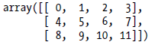

np.concatenate([arr, arr], axis=1)

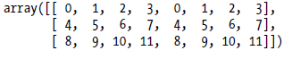

In the context of pandas objects such as Series and DataFrame, having labeled axes enable you to further generalize array concatenation. In particular, you have a number of additional things to think about:

• If the objects are indexed differently on the other axes, should the collection of axes be unioned or intersected?
• Do the groups need to be identifiable in the resulting object?
• Does the concatenation axis matter at all?

The concat function in pandas provides a consistent way to address each of these concerns.
I’ll give a number of examples to illustrate how it works. Suppose we have three Series with no index overlap:

In [61]: s1 = Series([0, 1], index=['a', 'b'])
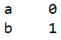
In [62]: s2 = Series([2, 3, 4], index=['c', 'd', 'e'])
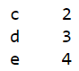

In [63]: s3 = Series([5, 6], index=['f', 'g'])
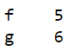

Calling concat with these object in a list glues together the values and indexes:

In [64]: pd.concat([s1, s2, s3])

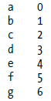
By default concat works along axis=0, producing another Series. If you pass axis=1, the result will instead be a DataFrame (axis=1 is the columns):

In [65]: pd.concat([s1, s2, s3], axis=1)

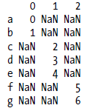
In this case there is no overlap on the other axis, which as you can see is the sorted union (the 'outer' join) of the indexes. You can instead intersect them by passing join='inner':
print(s1*5)
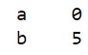

In [66]: s4 = pd.concat([s1 * 5, s3])
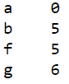
In [67]: pd.concat([s1, s4], axis=1)
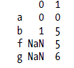

pd.concat([s1, s4], axis=1, join='inner')
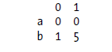
You can even specify the axes to be used on the other axes with join_axes:
In [69]: pd.concat([s1, s4], axis=1, join_axes=[['a', 'c', 'b', 'e']])

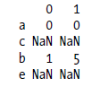
One issue is that the concatenated pieces are not identifiable in the result. Suppose instead you wanted to create a hierarchical index on the concatenation axis. To do this, use the keys argument:

In [70]: result = pd.concat([s1, s1, s3], keys=['one', 'two', 'three'])
In [71]: result
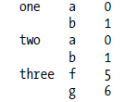
# Much more on the unstack function later
In [72]: result.unstack()
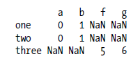
In the case of combining Series along axis=1, the keys become the DataFrame column headers:
In [73]: pd.concat([s1, s2, s3], axis=1, keys=['one', 'two', 'three'])
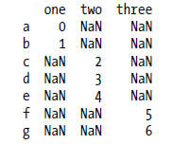
The same logic extends to DataFrame objects:

In [74]: df1 = DataFrame(np.arange(6).reshape(3, 2), index=['a', 'b', 'c'],
....: columns=['one', 'two'])
In [75]: df2 = DataFrame(5 + np.arange(4).reshape(2, 2), index=['a', 'c'],
....: columns=['three', 'four'])
In [76]: pd.concat([df1, df2], axis=1, keys=['level1', 'level2'])

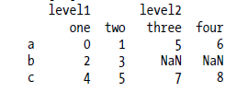
If you pass a dict of objects instead of a list, the dict’s keys will be used for the keys option:

In [77]: pd.concat({'level1': df1, 'level2': df2}, axis=1)
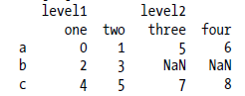
There are a couple of additional arguments governing how the hierarchical index is created (see Table 7-2):

In [78]: pd.concat([df1, df2], axis=1, keys=['level1', 'level2'], ....: names=['upper', 'lower'])

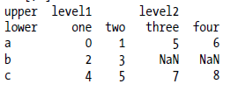

A last consideration concerns DataFrames in which the row index is not meaningful in the context of the analysis:

In [79]: df1 = DataFrame(np.random.randn(3, 4), columns=['a', 'b', 'c', 'd'])
In [80]: df2 = DataFrame(np.random.randn(2, 3), columns=['b', 'd', 'a'])

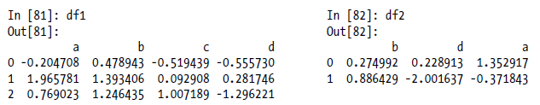
In this case, you can pass ignore_index=True:

pd.concat([df1, df2], ignore_index=True)

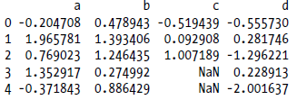
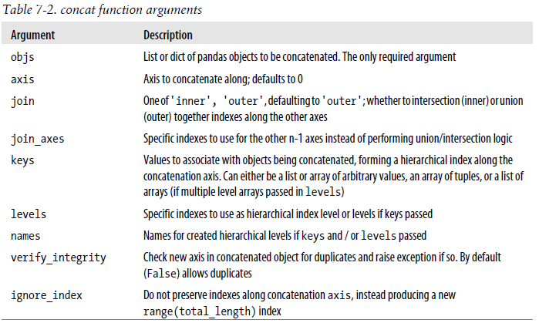

Combining Data with Overlap

combine_first()
Pandas combine_first() method is used to combine two series into one. The result is union of the two series that is in case of Null value in caller series, the value from passed series is taken. In case of both null values at the same index, null is returned at that index.
Syntax:
Series.combine_first(Other series)

Pandas combine_first() method is used to combine two DataFrame objects by filling null values in one DataFrame with non-null values from other DataFrame. The row and column indexes of the resulting DataFrame will be the union of the two.

Syntax:
DataFrame.combine_first(Other Dataframe)

Example: Using Series

import numpy as np
import pandas as pd

series1 = pd.Series([70, 5, 225, np.nan, 10, np.nan, np.nan])
series2 = pd.Series([27, np.nan, 23, 1, 95, 53, np.nan])

result1 = series1.combine_first(series2)
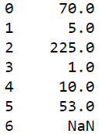

result2 = series2.combine_first(series1)

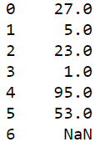

As shown in the output, even though the same series were combined, but the outputs are different. This is because of combine_first() method prioritize first series ( Caller series ) before. If there is null value at that position, it takes value at same index from second series.

Example : Using Dataframe

With Data Frames, combine_first naturally does the same thing column by column, so you can think of it as “patching” missing data in the calling object with data from the object you pass:

In [91]: df1 = DataFrame({'a': [1., np.nan, 5., np.nan],
....: 'b': [np.nan, 2., np.nan, 6.],
....: 'c': range(2, 18, 4)})

In [92]: df2 = DataFrame({'a': [5., 4., np.nan, 3., 7.],
....: 'b': [np.nan, 3., 4., 6., 8.]})

In [93]: df1.combine_first(df2)

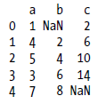

Data Transformation

Data transformation is the process of converting data or information from one format to another, usually from the format of a source system into the required format of a new destination system.

So far in this chapter we’ve been concerned with rearranging data. Filtering, cleaning, and other tranformations are another class of important operations.

Removing Duplicates

Duplicate rows may be found in a DataFrame for any number of reasons. Here is an example:

In [126]: data = DataFrame({'k1': ['one'] * 3 + ['two'] * 4,
.....: 'k2': [1, 1, 2, 3, 3, 4, 4]})
In [127]: data

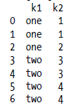

The DataFrame method duplicated returns a boolean Series indicating whether each row is a duplicate or not:

In [128]: data.duplicated()

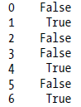

Relatedly, drop_duplicates returns a DataFrame where the duplicated array is True:

In [129]: data.drop_duplicates()

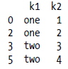
Both of these methods by default consider all of the columns; alternatively you can specify any subset of them to detect duplicates. Suppose we had an additional column of values and wanted to filter duplicates only based on the 'k1' column:

In [130]: data['v1'] = range(7)
In [131]: data.drop_duplicates(['k1'])

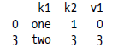

duplicated and drop_duplicates by default keep the first observed value combination.

Passing take_last=True will return the last one:
In [132]: data.drop_duplicates(['k1', 'k2'], take_last=True)

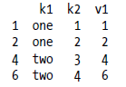

Transforming Data Using a Function or Mapping

For many data sets, you may wish to perform some transformation based on the values in an array, Series, or column in a DataFrame. Consider the following hypothetical data collected about some kinds of meat:

In [133]: data = DataFrame({'food': ['bacon', 'pulled pork', 'bacon', 'Pastrami','corned beef', 'Bacon', 'pastrami', 'honey ham', 'nova lox'],
'ounces': [4, 3, 12, 6, 7.5, 8, 3, 5, 6]})
In [134]: data

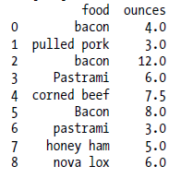
Suppose you wanted to add a column indicating the type of animal that each food came from. Let’s write down a mapping of each distinct meat type to the kind of animal:

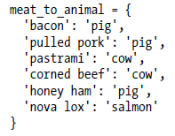
The map method on a Series accepts a function or dict-like object containing a mapping, but here we have a small problem in that some of the meats above are capitalized and others are not. Thus, we also need to convert each value to lower case:

In [136]: data['animal'] = data['food'].map(str.lower).map(meat_to_animal)
In [137]: data

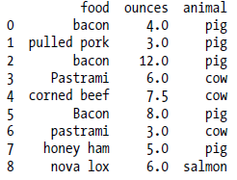

We could also have passed a function that does all the work:
In [138]: data['food'].map(lambda x: meat_to_animal[x.lower()])

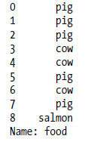
Using map is a convenient way to perform element-wise transformations and other data cleaning-related operations.

Replacing Values

Filling in missing data with the fillna method can be thought of as a special case of more general value replacement. While map, as you’ve seen above, can be used to modify a subset of values in an object, replace provides a simpler and more flexible way to do so. Let’s consider this Series:

In [139]: data = Series([1., -999., 2., -999., -1000., 3.])
In [140]: data

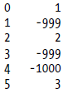

The -999 values might be sentinel values for missing data. To replace these with NA values that pandas understands, we can use replace, producing a new Series:

In [141]: data.replace(-999, np.nan)
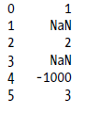
If you want to replace multiple values at once, you instead pass a list then the substitute value:

In [142]: data.replace([-999, -1000], np.nan)
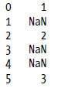
To use a different replacement for each value, pass a list of substitutes:

In [143]: data.replace([-999, -1000], [np.nan, 0])

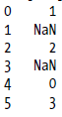

The argument passed can also be a dict:

In [144]: data.replace({-999: np.nan, -1000: 0})

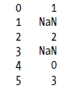
Renaming Axis Indexes

Like values in a Series, axis labels can be similarly transformed by a function or mapping of some form to produce new, differently labeled objects. The axes can also be modified in place without creating a new data structure. Here’s a simple example:

In [145]: data = DataFrame(np.arange(12).reshape((3, 4)),
.....: index=['Ohio', 'Colorado', 'New York'],
.....: columns=['one', 'two', 'three', 'four'])

Like a Series, the axis indexes have a map method:

In [146]: data.index.map(str.upper)
Out[146]: array([OHIO, COLORADO, NEW YORK], dtype=object)

You can assign to index, modifying the DataFrame in place:
In [147]: data.index = data.index.map(str.upper)
In [148]: data
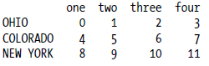

If you want to create a transformed version of a data set without modifying the original, a useful method is rename:

In [149]: data.rename(index=str.title, columns=str.upper)
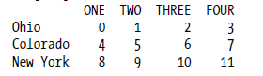

Notably, rename can be used in conjunction with a dict-like object providing new values for a subset of the axis labels:

In [150]: data.rename(index={'OHIO': 'INDIANA'},
.....: columns={'three': 'peekaboo'})

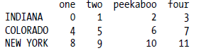

rename saves having to copy the DataFrame manually and assign to its index and columns attributes. Should you wish to modify a data set in place, pass inplace=True:

# Always returns a reference to a DataFrame
In [151]: _ = data.rename(index={'OHIO': 'INDIANA'}, inplace=True)
In [152]: data
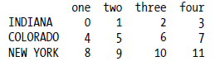

Discretization and Binning

Continuous data is often discretized or otherwised separated into “bins” for analysis. Suppose you have data about a group of people in a study, and you want to group them into discrete age buckets:

In [153]: ages = [20, 22, 25, 27, 21, 23, 37, 31, 61, 45, 41, 32]

Let’s divide these into bins of 18 to 25, 26 to 35, 35 to 60, and finally 60 and older. To do so, you have to use cut, a function in pandas:

In [154]: bins = [18, 25, 35, 60, 100]
In [155]: cats = pd.cut(ages, bins)
In [156]: cats

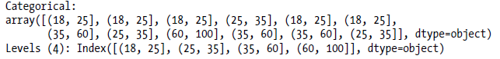

The object pandas returns is a special Categorical object. You can treat it like an array of strings indicating the bin name; internally it contains a levels array indicating the distinct category names along with a labeling for the ages data in the labels attribute:

In [157]: cats.labels
Out[157]: array([0, 0, 0, 1, 0, 0, 2, 1, 3, 2, 2, 1])
In [158]: cats.levels
Out[158]: Index([(18, 25], (25, 35], (35, 60], (60, 100]], dtype=object)
In [159]: pd.value_counts(cats)

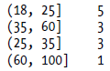

Consistent with mathematical notation for intervals, a parenthesis means that the side is open while the square bracket means it is closed (inclusive). Which side is closed can be changed by passing right=False:

In [160]: pd.cut(ages, [18, 26, 36, 61, 100], right=False)

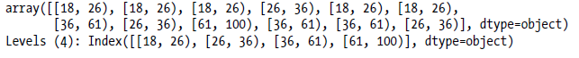
You can also pass your own bin names by passing a list or array to the labels option:

In [161]: group_names = ['Youth', 'YoungAdult', 'MiddleAged', 'Senior']
In [162]: pd.cut(ages, bins, labels=group_names)
Out[162]:

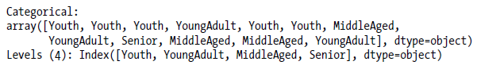

If you pass cut a integer number of bins instead of explicit bin edges, it will compute equal-length bins based on the minimum and maximum values in the data. Consider the case of some uniformly distributed data chopped into fourths:

In [163]: data = np.random.rand(20)
In [164]: pd.cut(data, 4, precision=2)

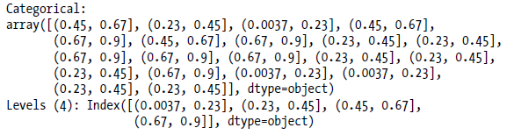

A closely related function, qcut, bins the data based on sample quantiles. Depending on the distribution of the data, using cut will not usually result in each bin having the same number of data points. Since qcut uses sample quantiles instead, by definition you will obtain roughly equal-size bins:

In [165]: data = np.random.randn(1000) # Normally distributed
In [166]: cats = pd.qcut(data, 4) # Cut into quartiles
In [167]: cats

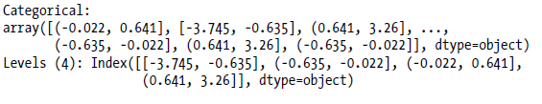

In [168]: pd.value_counts(cats)

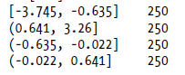

Similar to cut you can pass your own quantiles (numbers between 0 and 1, inclusive):
In [169]: pd.qcut(data, [0, 0.1, 0.5, 0.9, 1.])

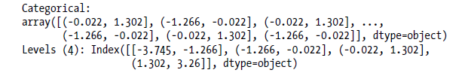
We’ll return to cut and qcut later in the chapter on aggregation and group operations, as these discretization functions are especially useful for quantile and group analysis.

Detecting and Filtering Outliers

Filtering or transforming outliers is largely a matter of applying array operations. Consider a DataFrame with some normally distributed data:

In [170]: np.random.seed(12345)
In [171]: data = DataFrame(np.random.randn(1000, 4))
In [172]: data.describe()

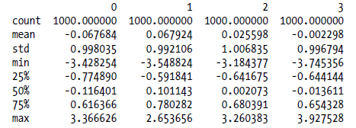

Suppose you wanted to find values in one of the columns exceeding three in magnitude:

In [173]: col = data[3]
In [174]: col[np.abs(col) > 3]
Out[174]:

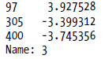

To select all rows having a value exceeding 3 or -3, you can use the any method on a boolean DataFrame:

In [175]: data[(np.abs(data) > 3).any(1)]

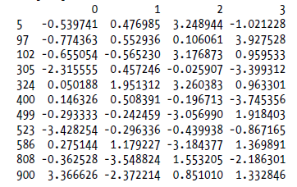

Values can just as easily be set based on these criteria. Here is code to cap values outside the interval -3 to 3:

In [176]: data[np.abs(data) > 3] = np.sign(data) * 3
In [177]: data.describe()

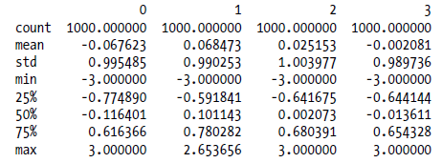

The ufunc np.sign returns an array of 1 and -1 depending on the sign of the values.

Permutation and Random Sampling:

Permuting (randomly reordering) a Series or the rows in a DataFrame is easy to do using
the numpy.random.permutation function. Calling permutation with the length of the axis
you want to permute produces an array of integers indicating the new ordering:

In [178]: df = DataFrame(np.arange(5 * 4).reshape(5, 4))
In [179]: sampler = np.random.permutation(5)
In [180]: sampler
Out[180]: array([1, 0, 2, 3, 4])

That array can then be used in ix-based indexing or the take function:

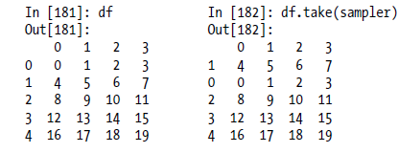
To select a random subset without replacement, one way is to slice off the first k elements of the array returned by permutation, where k is the desired subset size. There are much more efficient sampling-without-replacement algorithms, but this is an easy strategy that uses readily available tools:
In [183]: df.take(np.random.permutation(len(df))[:3])

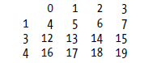
To generate a sample with replacement, the fastest way is to use np.random.randint to draw random integers:

In [184]: bag = np.array([5, 7, -1, 6, 4])
In [185]: sampler = np.random.randint(0, len(bag), size=10)
In [186]: sampler
Out[186]: array([4, 4, 2, 2, 2, 0, 3, 0, 4, 1])
In [187]: draws = bag.take(sampler)
In [188]: draws
Out[188]: array([ 4, 4, -1, -1, -1, 5, 6, 5, 4, 7])

Computing Indicator/Dummy Variables

Another type of transformation for statistical modeling or machine learning applications is converting a categorical variable into a “dummy” or “indicator” matrix. If a column in a DataFrame has k distinct values, you would derive a matrix or DataFrame containing k columns containing all 1’s and 0’s. pandas has a get_dummies function for doing this, though devising one yourself is not difficult. Let’s return to an earlier example DataFrame:

In [189]: df = DataFrame({'key': ['b', 'b', 'a', 'c', 'a', 'b'],
.....: 'data1': range(6)})
In [190]: pd.get_dummies(df['key'])

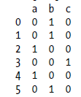

In some cases, you may want to add a prefix to the columns in the indicator DataFrame, which can then be merged with the other data. get_dummies has a prefix argument for doing just this:

In [191]: dummies = pd.get_dummies(df['key'], prefix='key')
In [192]: df_with_dummy = df[['data1']].join(dummies)
In [193]: df_with_dummy

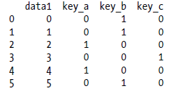

If a row in a DataFrame belongs to multiple categories, things are a bit more complicated.
Let’s return to the MovieLens 1M dataset from earlier in the book:

In [194]: mnames = ['movie_id', 'title', 'genres']
In [195]: movies = pd.read_table('ch07/movies.dat', sep='::', header=None,
.....: names=mnames)
In [196]: movies[:10]

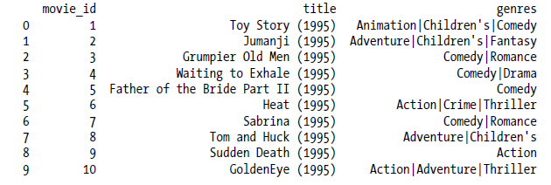

Adding indicator variables for each genre requires a little bit of wrangling. First, we extract the list of unique genres in the dataset (using a nice set.union trick):

In [197]: genre_iter = (set(x.split('|')) for x in movies.genres)
In [198]: genres = sorted(set.union(*genre_iter))

Now, one way to construct the indicator DataFrame is to start with a DataFrame of all zeros:
In [199]: dummies = DataFrame(np.zeros((len(movies), len(genres))), columns=genres)
Now, iterate through each movie and set entries in each row of dummies to 1:
In [200]: for i, gen in enumerate(movies.genres):
.....: dummies.ix[i, gen.split('|')] = 1

Then, as above, you can combine this with movies:
In [201]: movies_windic = movies.join(dummies.add_prefix('Genre_'))
In [202]: movies_windic.ix[0]

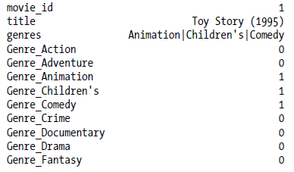

A useful recipe for statistical applications is to combine get_dummies with a discretization function like cut:

In [204]: values = np.random.rand(10)
In [205]: values

Out[205]:
array([ 0.9296, 0.3164, 0.1839, 0.2046, 0.5677, 0.5955, 0.9645,
0.6532, 0.7489, 0.6536])

In [206]: bins = [0, 0.2, 0.4, 0.6, 0.8, 1]
In [207]: pd.get_dummies(pd.cut(values, bins))

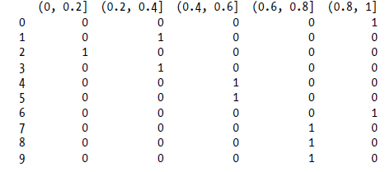

String Manipulation

Python has long been a popular data munging language in part due to its ease-of-use for string and text processing. Most text operations are made simple with the string object’s built-in methods. For more complex pattern matching and text manipulations, regular expressions may be needed. pandas adds to the mix by enabling you to apply string and regular expressions concisely on whole arrays of data, additionally handling the annoyance of missing data.

String Object Methods

In many string munging and scripting applications, built-in string methods are sufficient.
As an example, a comma-separated string can be broken into pieces with split:

In [208]: val = 'a,b, guido'
In [209]: val.split(',')
Out[209]: ['a', 'b', ' guido']

split is often combined with strip to trim whitespace (including newlines):

In [210]: pieces = [x.strip() for x in val.split(',')]
In [211]: pieces
Out[211]: ['a', 'b', 'guido']

These substrings could be concatenated together with a two-colon delimiter using addition:
In [212]: first, second, third = pieces
In [213]: first + '::' + second + '::' + third
Out[213]: 'a::b::guido'

But, this isn’t a practical generic method. A faster and more Pythonic way is to pass a
list or tuple to the join method on the string '::':

In [214]: '::'.join(pieces)
Out[214]: 'a::b::guido'

Other methods are concerned with locating substrings. Using Python’s in keyword is the best way to detect a substring, though index and find can also be used:

val = 'a,b, guido'
In [215]: 'guido' in val
Out[215]: True
In [216]: val.index(',')
Out[216]: 1

In [217]: val.find(':')
Out[217]: -1
Note the difference between find and index is that index raises an exception if the string isn’t found (versus returning -1):
In [218]: val.index(':')
---------------------------------------------------------------------------
ValueError Traceback (most recent call last)
<ipython-input-218-280f8b2856ce> in <module>()
----> 1 val.index(':')
ValueError: substring not found

Relatedly, count returns the number of occurrences of a particular substring:
In [219]: val.count(',')
Out[219]: 2

replace will substitute occurrences of one pattern for another. This is commonly used to delete patterns, too, by passing an empty string:

In [220]: val.replace(',', '::')
Out[220]: 'a::b:: guido'

In [221]: val.replace(',' , '')
Out[221]: 'ab guido'

Regular expressions can also be used with many of these operations as you’ll see below.
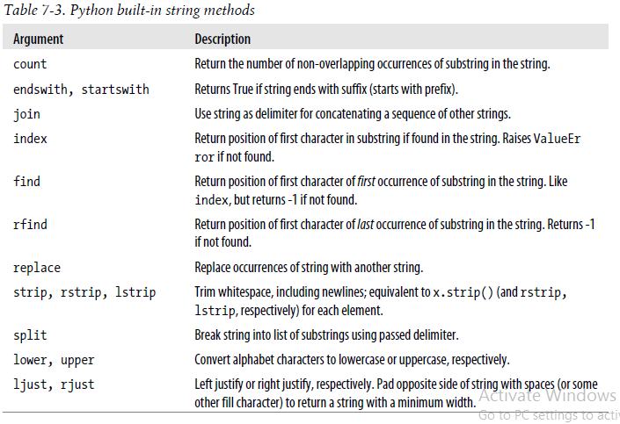

Regular expressions

Regular expressions provide a flexible way to search or match string patterns in text. A single expression, commonly called a regex, is a string formed according to the regular expression language. Python’s built-in re module is responsible for applying regular expressions to strings; I’ll give a number of examples of its use here.

The re module functions fall into three categories:
pattern matching,
substitution, and
splitting.

Naturally these are all related; a regex describes a pattern to locate in the text, which can then be used for many purposes.

Let’s look at a simple example: suppose I wanted to split a string with a variable number of whitespace characters (tabs, spaces, and newlines).

The regex describing one or more whitespace characters is \s+:

In [222]: import re
In [223]: text = "foo bar\t baz \tqux"
In [224]: re.split('\s+', text)
Out[224]: ['foo', 'bar', 'baz', 'qux']

When you call re.split('\s+', text), the regular expression is first compiled, then its split method is called on the passed text. You can compile the regex yourself with re.compile, forming a reusable regex object:

In [225]: regex = re.compile('\s+')
In [226]: regex.split(text)
Out[226]: ['foo', 'bar', 'baz', 'qux']

If, instead, you wanted to get a list of all patterns matching the regex, you can use the findall method:

In [227]: regex.findall(text)
Out[227]: [' ', '\t ', ' \t']

Creating a regex object with re.compile is highly recommended if you intend to apply the same expression to many strings; doing so will save CPU cycles.

match and search are closely related to findall. While findall returns all matches in a string, search returns only the first match. More rigidly, match only matches at the beginning of the string. As a less trivial example, let’s consider a block of text and a regular expression capable of identifying most email addresses:

text = """Dave dave@google.com
Steve steve@gmail.com
Rob rob@gmail.com
Ryan ryan@yahoo.com
"""
pattern = r'[A-Z0-9._%+-]+@[A-Z0-9.-]+\.[A-Z]{2,4}'

# re.IGNORECASE makes the regex case-insensitive

regex = re.compile(pattern, flags=re.IGNORECASE)

Using findall on the text produces a list of the e-mail addresses:

In [229]: regex.findall(text)
Out[229]: ['dave@google.com', 'steve@gmail.com', 'rob@gmail.com', 'ryan@yahoo.com']

search returns a special match object for the first email address in the text. For the above regex, the match object can only tell us the start and end position of the pattern in the string:

In [230]: m = regex.search(text)
In [231]: m
Out[231]: <_sre.SRE_Match at 0x10a05de00>
In [232]: text[m.start():m.end()]
Out[232]: 'dave@google.com'

regex.match returns None, as it only will match if the pattern occurs at the start of the string:

In [233]: print regex.match(text)
None

Relatedly, sub will return a new string with occurrences of the pattern replaced by the a new string:

In [234]: print regex.sub('REDACTED', text)
Dave REDACTED
Steve REDACTED
Rob REDACTED
Ryan REDACTED

Suppose you wanted to find email addresses and simultaneously segment each address into its 3 components: username, domain name, and domain suffix. To do this, put parentheses around the parts of the pattern to segment:

In [235]: pattern = r'([A-Z0-9._%+-]+)@([A-Z0-9.-]+)\.([A-Z]{2,4})'
In [236]: regex = re.compile(pattern, flags=re.IGNORECASE)

A match object produced by this modified regex returns a tuple of the pattern components with its groups method:

In [237]: m = regex.match('wesm@bright.net')
In [238]: m.groups()
Out[238]: ('wesm', 'bright', 'net')

findall returns a list of tuples when the pattern has groups:

In [239]: regex.findall(text)
Out[239]:
[('dave', 'google', 'com'),
('steve', 'gmail', 'com'),
('rob', 'gmail', 'com'),
('ryan', 'yahoo', 'com')]

sub also has access to groups in each match using special symbols like \1, \2, etc.:

In [240]: print regex.sub(r'Username: \1, Domain: \2, Suffix: \3', text)
Dave Username: dave, Domain: google, Suffix: com
Steve Username: steve, Domain: gmail, Suffix: com
Rob Username: rob, Domain: gmail, Suffix: com
Ryan Username: ryan, Domain: yahoo, Suffix: com

There is much more to regular expressions in Python, most of which is outside the book’s scope. To give you a flavor, one variation on the above email regex gives names to the match groups:

regex = re.compile(r"""
(?P<username>[A-Z0-9._%+-]+)
@
(?P<domain>[A-Z0-9.-]+)
\.
(?P<suffix>[A-Z]{2,4})""", flags=re.IGNORECASE|re.VERBOSE)

The match object produced by such a regex can produce a handy dict with the specified group names:

In [242]: m = regex.match('wesm@bright.net')
In [243]: m.groupdict()
Out[243]: {'domain': 'bright', 'suffix': 'net', 'username': 'wesm'}

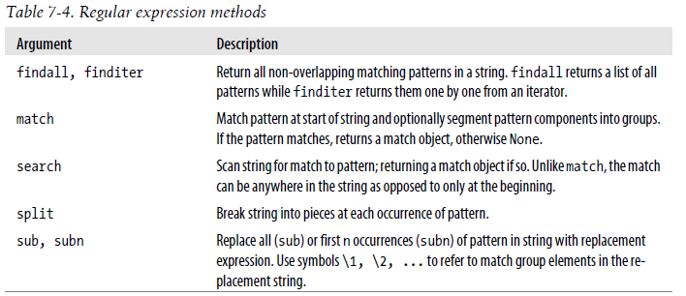

Vectorized string functions in pandas

Cleaning up a messy data set for analysis often requires a lot of string munging and regularization. To complicate matters, a column containing strings will sometimes have missing data:

In [244]: data = {'Dave': 'dave@google.com', 'Steve': 'steve@gmail.com',
.....: 'Rob': 'rob@gmail.com', 'Wes': np.nan}
In [245]: data = Series(data)

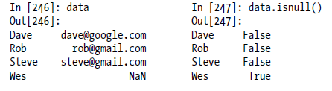

String and regular expression methods can be applied (passing a lambda or other function) to each value using data.map, but it will fail on the NA. To cope with this, Series has concise methods for string operations that skip NA values. These are accessed through Series’s str attribute; for example, we could check whether each email address has 'gmail' in it with str.contains:

data.str.contains('gmail')

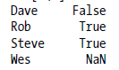

Regular expressions can be used, too, along with any re options like IGNORECASE:

In [249]: pattern
Out[249]: '([A-Z0-9._%+-]+)@([A-Z0-9.-]+)\\.([A-Z]{2,4})'
In [250]: data.str.findall(pattern, flags=re.IGNORECASE)

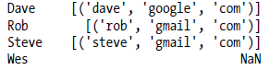

There are a couple of ways to do vectorized element retrieval. Either use str.get or index into the str attribute:

In [251]: matches = data.str.match(pattern, flags=re.IGNORECASE)
In [252]: matches

