UNIT-V
Chapter-1
RISK MANAGEMENT

Introduction: Risk can be defined as a potential problem which may happen or may not. Risk analysis and management are a series of steps that help a software team to understand and manage uncertainty

1.1 Risk management strategies:
Reactive strategy: This strategy is “never worry about problems until they happened”. the software team does nothing about risks until something goes wrong. When something goes wrong then, the team flies into action in an attempt to correct the problem rapidly and this is often called a fire fighting mode.

Proactive strategy: A considerably more intelligent strategy for risk management is to be proactive. A proactive strategy begins long before technical work is initiated. Potential risks are identified, their probability and impact are assessed, and they are ranked by importance. Then, the software team establishes a plan for managing risk. The primary objective is to avoid risk, but all risks are can’t be avoided, so the team works to develop a contingency plan that will enable it to respond in a controlled and effective manner.

1.2 Risk characteristics
Risk always involves two characteristics
• Uncertainty—the risk may or may not happen; that is, there are no 100% probable risks.
• Loss—if the risk becomes a reality, unwanted consequences or losses will occur.

1.3 Risk categories
When risks are analyzed, it is important to quantify the level of uncertainty and the degree of loss associated with each risk. To accomplish this, different categories of risks are considered.

Project risks: threat to the project plan. That is, if project risks become real, it is likely that project schedule will slip and costs will increase. Project risks identify potential budgetary, schedule, personnel (staffing and organization), resource, customer, and requirements problems and their impact on a software project. Project complexity, size, and the degree of structural uncertainty were also defined as project risk factors.

Technical risks: threat to the quality and timeline of the software to be produced. If a technical risk becomes a reality, implementation may become difficult or impossible. Technical risks identify potential design, implementation, interface, verification, and maintenance problems. In addition, specification ambiguity, technical uncertainty, technical obsolescence, and "leading-edge" technology are also risk factors. Technical risks occur because the problem is harder to solve than we thought it would be.

Business risks: threat to the possibility of the software to be built. Business risks often jeopardize the project or the product.
The top five business risks are
(1) Building an excellent product or system that no one really wants (market risk)
(2) Building a product that no longer fits into the overall business strategy for the company
(strategic risk)
(3) Building a product that the sales force doesn't understand how to sell.
(4) Losing the support of senior management due to a change in focus or a change in people (management risk), and
(5) Losing budgetary or personnel commitment (budget risks).

Known risks are those that can be uncovered after careful evaluation of the project plan, the business and technical environment in which the project is being developed, and other reliable information sources (e.g., unrealistic delivery date, lack of documented requirements or software scope, poor development environment).

Predictable risks are extrapolated from past project experience (e.g., staff turnover, poor communication with the customer, dilution of staff effort as ongoing maintenance requests are serviced).

Unpredictable risks are the joker in the deck. They can and do occur, but they are extremely difficult to identify in advance.

1.4 RISK IDENTIFICATION
Risk identification is a systematic attempt to specify threats to the project plan by identifying known and predictable risks.
{There are two distinct types of risks for each of the categories
Generic risks and product-specific risks.

Generic risks are a potential threat to every software project.
Product-specific risks can be identified only by those with a clear understanding of the technology, the people, and the environment that is specific to the project at hand.
To identify product-specific risks, the project plan and the software statement of scope are examined and an answer to the following question is developed: "What special characteristics of this product may threaten our project plan?"}

One method to identify risks is to create a risk item checklist. The checklist can be used for risk identification in the following generic subcategories:
• Product size—risks associated with the overall size of the software to be built or modified.
• Business impact—risks associated with constraints imposed by management or the marketplace.
• Customer characteristics—risks associated with the sophistication of the customer and the developer's ability to communicate with the customer in a timely manner.
• Process definition—risks associated with the degree to which the software process has been defined and is followed by the development organization.
• Development environment—risks associated with the availability and quality of the tools to be used to build the product.
• Technology to be built—risks associated with the complexity of the system to be built and the "newness" of the technology.
• Staff size and experience—risks associated with the overall technical and project experience of the software engineers who will do the work.

1.5 RISK COMPONENTS
The risk components are defined in the following manner:

• Performance risk—the degree of uncertainty that the product will meet its requirements and be fit for its intended use.
• Cost risk—the degree of uncertainty that the project budget will be
maintained.
• Support risk—the degree of uncertainty that the resultant software will be easy to correct, adapt, and enhance.
• Schedule risk—the degree of uncertainty that the project schedule will be maintained and that the product will be delivered on time.

The impact of each risk on the risk component is divided into one of four impact categories—negligible, marginal, critical, or catastrophic.

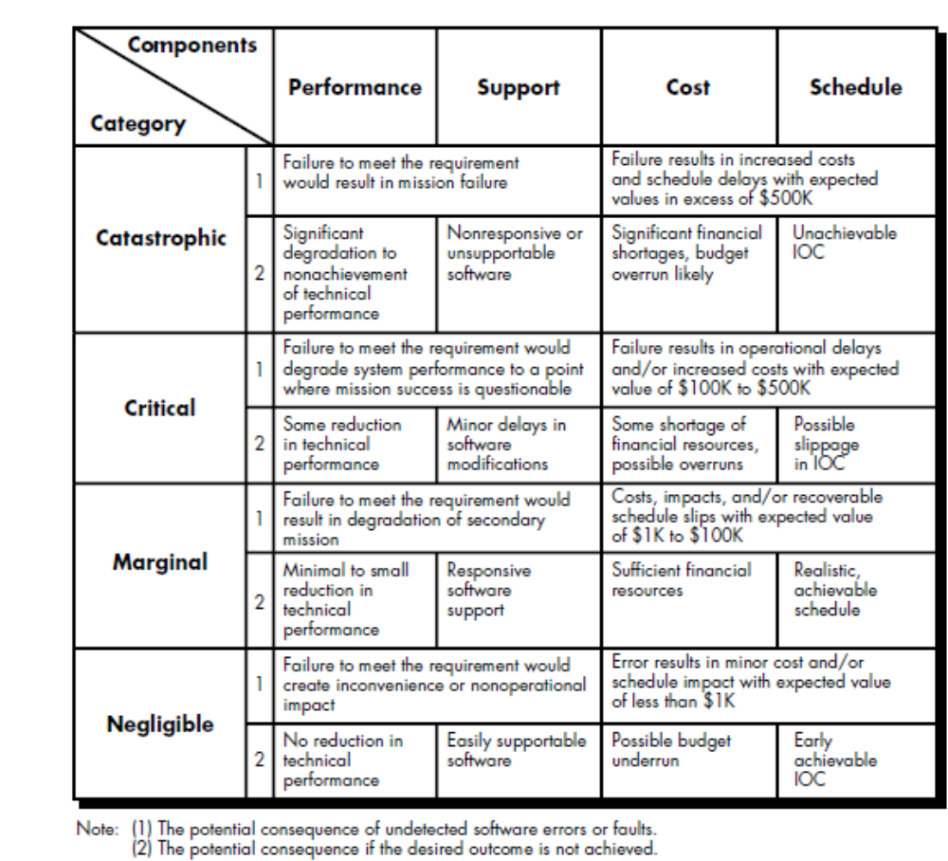

1.6 RISK PROJECTION
Risk projection, also called risk estimation, it attempts to rate each risk in two ways—the likelihood of the risk occurrence and the consequences of the risk occurrence.
The project planner, along with other managers and technical staff, performs four risk projection activities:
(1) Establish a scale that reflects the perceived likelihood of a risk
(2) Delineate the consequences of the risk
(3) Estimate the impact of the risk on the project and the product
(4) Note the overall accuracy of the risk projection so that there will be no misunderstandings.
The risk projection can be prepared using a risk table

Developing a Risk Table
A risk table provides a project manager with a simple technique for risk projection
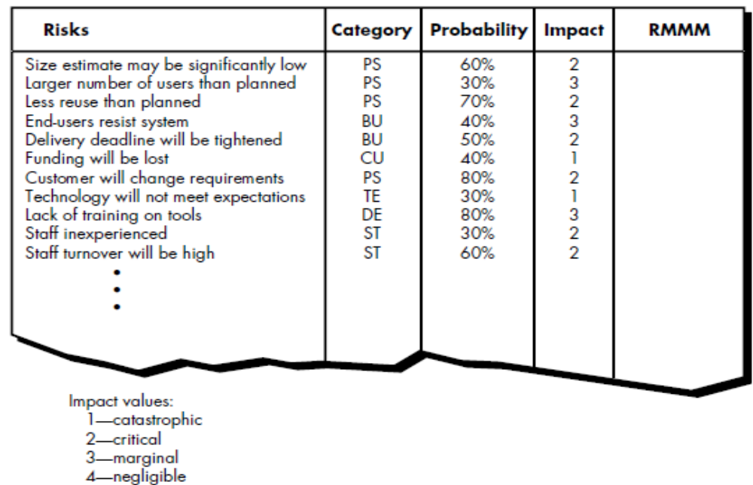

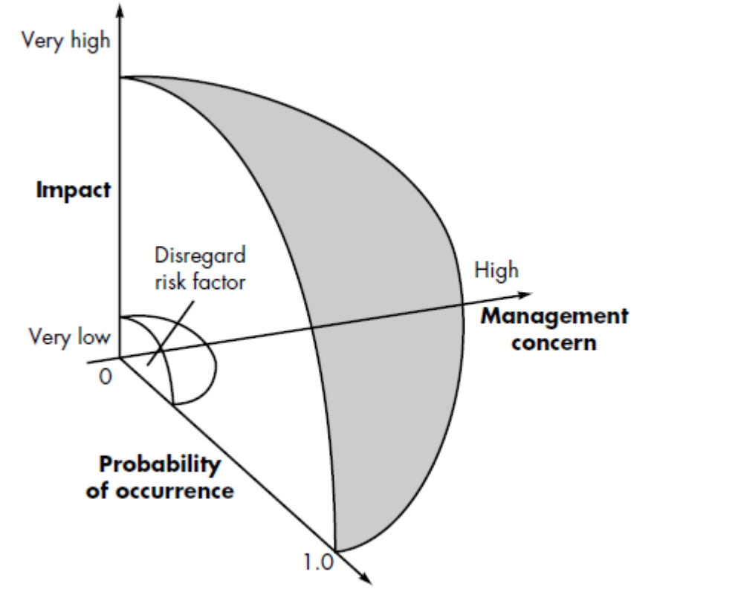

A project team begins by listing all risks (no matter how remote) in the first column of the table. This can be accomplished with the help of the risk item checklists. Each risk is categorized in the second column.
The probability of occurrence of each risk is entered in the next column of the table.
The probability value for each risk can be estimated by team members individually. Individual team members are polled in round-robin fashion until their assessment of risk probability begins to converge.
The impact of each risk is assessed. Each risk component is assessed and an impact category is determined.
The categories for each of the four risk components—performance, support, cost, and schedule—are averaged to determine an overall impact value.
Once the first four columns of the risk table have been completed, the table is sorted by probability and by impact. High-probability, high-impact risks move to the top of the table, and low-probability risks drop to the bottom. This accomplishes first-order risk prioritization.
The project manager studies the resultant sorted table and defines a cutoff line. The cutoff line (drawn horizontally at some point in the table) implies that only risks that lie above the line will be given further attention. Risks that fall below the line are re-evaluated to accomplish second-order prioritization.
Risk impact and probability have a distinct influence on management concern. A risk that has a high impact but a very low probability of occurrence should not absorb a significant amount of management time.
All risks that lie above the cutoff line must be managed. The column labeled RMMM contains a pointer into a Risk Mitigation, Monitoring and Management Plan or alternatively, a collection of risk information sheets developed for all risks that lie above the cutoff.

1.61 Assessing Risk Impact
Three factors of risk affect the consequences if it occurs: risk nature, risk scope and risk timing.

The nature of the risk indicates the problems that are likely if it occurs. For example, a poorly defined external interface to customer hardware (a technical risk) will preclude early design and testing and will likely lead to system integration problems late in a project.

The scope of a risk combines the severity (just how serious is it?) with its overall distribution (how much of the project will be affected or how many customers are harmed?).

The timing of a risk considers when and for how long the impact will be felt.

The following steps are recommended to determine the overall consequences of a risk:
1. Determine the average probability of occurrence value for each risk component.
2. Determine the impact for each component based on the criteria below shown.
3. Complete the risk table and calculate the risk exposure.

The overall risk exposure, RE, is determined using the following relationship
RE = P x C
where P is the probability of occurrence of a risk, and C is the the cost occurs to the project.
Example,
Assume that the software team defines a project risk in the following manner:
Risk identification: Only 70 percent of the software components scheduled for reuse will, in fact, be integrated into the application. The remaining functionality will have to be custom developed.
Risk probability: 80% (likely).
Risk impact: 60 reusable software components were planned. If only 70 percent can be used, 18 components would have to be developed from scratch (in addition to other custom software that has been scheduled for development). Since the average component is100 LOC and local data indicate that the software engineering cost for each LOC is Rs14.00,
the overall cost (impact) to develop the components would be 18 x 100 x 14 = Rs25,200.
Risk exposure: RE = 0.80 x 25,200 ~ Rs20,200.
Risk exposure can be computed for each risk in the risk table, once an estimate of the cost of the risk is made. The total risk exposure for all risks (above the cutoff in the risk table) can provide a means for adjusting the final cost estimate for a project.
It can also be used to predict the probable increase in staff resources required at various points during the project schedule.
The risk projection and analysis techniques described are applied iteratively as the software project proceeds. The project team should revisit the risk table at regular intervals, re-evaluating each risk to determine when new circumstances cause its probability and impact to change. As a consequence of this activity, it may be necessary to add new risks to the table, remove some risks that are no longer relevant, and change the relative positions of still others.

1.6.2 Risk Assessment
During risk assessment, we further examine the accuracy of the estimates that were made during risk projection, attempt to rank the risks that have been uncovered, and begin thinking about ways to control and/or avert risks that are likely to occur.
At this point in the risk management process, we have established a set of triplets to assess the overall risk.
[ri, li, xi] where
ri is risk,
li is the likelihood (probability) of the risk,
xi is the impact of the risk.

For best use of assessment , a risk referent level must be defined. For most software projects, the risk components performance, cost, support, and schedule represent risk referent levels. That is, there is a level for performance degradation, cost overrun, support difficulty, or schedule slippage (or any combination of the four) that will cause the project to be terminated. If a combination of risks create problems that cause one or more of these referent levels to be exceeded, work will stop. In the context of software risk analysis, a risk referent level has a single point, called the referent point or break point, at which the decision to proceed with the project or terminate it (problems are just too great) are equally weighted. Figure represents this situation graphically.

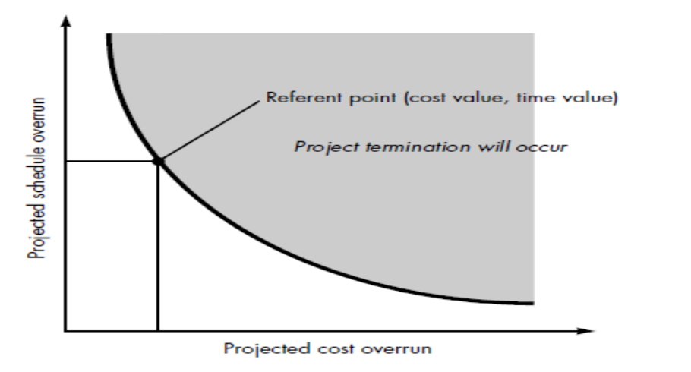

During risk assessment, perform the following
steps:
1. Define the risk referent levels for the project.
2. Attempt to develop a relationship between each (ri, li, xi) and each of the referent levels.
3. Predict the set of referent points that define a region of termination, bounded by a curve or areas of uncertainty.
4. Try to predict how compound combinations of risks will affect a referent level.

1.7 RISK REFINEMENT

During early stages of project planning, a risk may be stated quite generally. As time passes and more is learned about the project and the risk, it may be possible to refine the risk into a set of more detailed risks, each somewhat easier to mitigate, monitor, and manage.
For this we follow condition and consequence format i.e. for this condition there will be possibly this consequence.
We consider previously discussed example for refinement:
Given that all reusable software components must conform to specific design standards and that some do not conform, then there is concern that (possibly) only 70 percent of the planned reusable modules may actually be integrated into the as-built system, resulting in the need to custom engineer the remaining 30 percent of components.

This general condition can be refined in the following manner:
Subcondition 1. Certain reusable components were developed by a third party with no knowledge of internal design standards.
Subcondition 2. The design standard for component interfaces has not been solidified and may not conform to certain existing reusable components.
Subcondition 3. Certain reusable components have been implemented in a language that is not supported on the target environment.

The consequences associated with these refined sub conditions remains the same (i.e.,30 percent of software components must be customer engineered), but the refinement helps to isolate the underlying risks and might lead to easier analysis and response.

1.7 RISK MITIGATION, MONITORING, AND MANAGEMENT

All of the risk analysis activities presented to this point have a single goal—to assist the project team in developing a strategy for dealing with risk. An effective strategy must consider three issues:
• risk avoidance(mitigation)
• risk monitoring
• risk management and contingency planning

1.7.1 Mitigation:
If a software team adopts a proactive approach to risk, avoidance is always the best strategy. This is achieved by developing a plan for risk mitigation.
For example, assume that high staff turnover is noted as a project risk, r1. Based on past history and management intuition, the likelihood, l1, of high turnover is estimated to be 0.70 (70 percent, rather high) and the impact, x1, is projected at level 2. That is, high turnover will have a critical impact on project cost and schedule.
To mitigate this risk, project management must develop a strategy for reducing turnover. Among the possible steps to be taken are
• Meet with current staff to determine causes for turnover (e.g., poor working conditions, low pay, and competitive job market).
• Mitigate those causes that are under our control before the project starts.
• Once the project commences, assume turnover will occur and develop techniques to ensure continuity when people leave.
• Organize project teams so that information about each development activity is widely dispersed.
• Define documentation standards and establish mechanisms to be sure that documents are developed in a timely manner.
• Conduct peer reviews of all work (so that more than one person is "up to speed”).
• Assign a backup staff member for every critical technologist.

1.7.2 Monitoring:
As the project proceeds, risk monitoring activities commence. The project manager monitors factors that may provide an indication of whether the risk is becoming more or less likely. In the case of high staff turnover, the following factors can be monitored:

• General attitude of team members based on project pressures.
• The degree to which the team has jelled.
• Interpersonal relationships among team members.
• Potential problems with compensation and benefits.
• The availability of jobs within the company and outside it.

In addition to monitoring these factors, the project manager should monitor the effectiveness of risk mitigation steps. For example, a risk mitigation step noted here called for the definition of documentation standards and mechanisms to be sure that documents are developed in a timely manner. This is one mechanism for ensuring continuity, should a critical individual leave the project. The project manager should monitor documents carefully to ensure that each can stand on its own and that each imparts information that would be necessary if a newcomer were forced to join the software team somewhere in the middle of the project.

1.7.3 Management:
Risk management and contingency planning assumes that mitigation efforts have failed and that the risk has become a reality. Continuing the example, the project is well underway and a number of people announce that they will be leaving. If the mitigation strategy has been followed, backup is available, information is documented, and knowledge has been dispersed across the team. In addition, the project manager may temporarily refocus resources (and readjust the project schedule) to those functions that are fully staffed, enabling newcomers who must be added to the team to “get up to speed.” Those individuals who are leaving are asked to stop all work and spend their last weeks in “knowledge transfer mode.” This might include video-based knowledge capture, the development of “commentary documents,” and/or meeting with other team members who will remain on the project.

1.8 THE RMMM PLAN
A risk management strategy can be included in the software project plan or the risk management steps can be organized into a separate Risk Mitigation, Monitoring and Management Plan.
The RMMM plan documents all work performed as part of risk analysis and is used by the project manager as part of the overall project plan.
Once RMMM has been documented and the project has begun, risk mitigation and monitoring steps commence. As we have already discussed, risk mitigation is a problem avoidance activity. Risk monitoring is a project tracking activity with three primary objectives:
(1) to assess whether predicted risks do occur
(2) to ensure that risk aversion steps defined for the risk are being properly applied
(3) to collect information that can be used for future risk analysis. In many cases, the problems that occur during a project can be traced to more than one risk. Another job of risk monitoring is to attempt to allocate origin (what risk(s) caused which problems throughout the project).

b) THE SQA PLAN
The SQA Plan provides a road map for instituting software quality assurance. Developed by the SQA group, the plan serves as a template for SQA activities that are instituted for each software project. A standard for SQA plans has been recommended by the. Initial sections describe the purpose and scope of the document and indicate those software process activities that are covered by quality assurance. All documents noted in the SQA Plan are listed and all applicable standards are noted. The management section of the plan describes SQA’s place in the organizational structure, SQA tasks and activities and their placement throughout the software process, and the organizational roles and responsibilities relative to product quality.
The documentation section describes (by reference) each of the work products produced as part of the software process. These include
• project documents (e.g., project plan)
• models (e.g., ERDs, class hierarchies)
• technical documents (e.g., specifications, test plans)
• user documents (e.g., help files)
In addition, this section defines the minimum set of work products that are acceptable to achieve high quality.
The standards, practices, and conventions section lists all applicable standards and practices that are applied during the software process (e.g., document standards, coding standards, and review guidelines). In addition, all project, process, and (in some instances) product metrics that are to be collected as part of software engineering work are listed.
The reviews and audits section of the plan identifies the reviews and audits to be conducted by the software engineering team, the SQA group, and the customer. It provides an overview of the approach for each review and audit.

