AI Usage DISCLOSURE FORM

1. Team Details
Team Name: Neural Nomics
Project / Product Name: Integrated Team Intelligence System
Organization / Institution (if any): R. V. College of Engineering
Submission Date: May 8, 2026

2. AI Usage Declaration
Did your team use any Artificial Intelligence (AI) in developing this project? Yes / No
Yes

3. Purpose of AI Usage ( Brief Details)
Idea generation / brainstorming - Moderate
Code generation or assistance - High
UI / UX design - Moderate
Content creation - Moderate
Data analysis - Low
Testing / debugging - Moderate
Other - Agentic workflow design

4. Feature Origin Classification ( Please add/delete based on the number of the feature)
1. Feature Name - OpenClaw Agent Orchestrator + Multi-Agent System
2. Self-Generated/AI-Generated/Both - Both
3. Description ( include AI tools/platform Used, prompt used , Output Summary, Modification) - Core architecture and agent routing logic was designed by the team. Code scaffolding, worker implementation patterns, and advanced prompt engineering for the orchestrator were assisted by AI tools. Significant manual modifications for reliability, error handling, and integration with LanceDB.

1. Feature Name - RAG-powered Knowledge Base & Citation System
2. Self-Generated/AI-Generated/Both - Both
3. Description (include AI tools/platform Used, prompt used , Output Summary, Modification) - Vector store setup and retrieval pipeline built by team. Prompt templates for grounded Q&A and citation formatting heavily refined with AI assistance. All company document processing logic is original.

1. Feature Name - Real-time Team Health Dashboard & Analytics
2. Self-Generated/AI-Generated/Both - Mostly Self-Generated
3. Description (include AI tools/platform Used, prompt used , Output Summary, Modification) - Data ingestion from GitHub/Jira/Calendar, metric calculations, and Recharts visualizations developed primarily by the team. AI used for code suggestions and chart optimization.

1. Feature Name - Interactive Onboarding Checklist & Role-based UI
2. Self-Generated/AI-Generated/Both - Both
3. Description (include AI tools/platform Used, prompt used , Output Summary, Modification) - UI components and state management built by team. AI assisted in generating reusable React components and responsive design.

5. Ethical & Compliance Confirmation
AI usage complies with guidelines and policies. Yes
No proprietary or copyrighted data misused. I Agree
6. Declaration & Sign-Off
Name of Team Representative: Bhuvan K K
Role: Team Leader
Signature: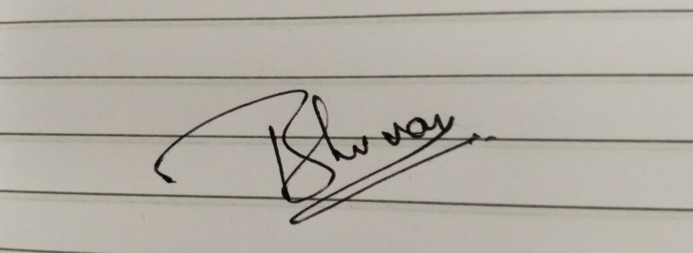
Date: May 08, 2026

