Krystal Maughan

CSIS 137 Advanced C++

**Extra Credit Exception Handling**

I used Exception Handling for every texture added, and also for my sound file. (five total exceptions).

Background, Ground and Quit Button were made in GIMP. (960x720px for background,

960 x 100px for ground and 200x100px for button)

Sprite Sheet was made in Pixel (32 x 32px each character; 9 on sheet total)

Load Background Texture

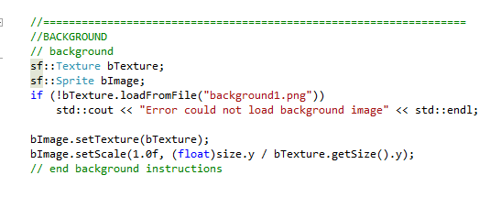

Load Ground (a rectangle texture) for collision with player (is loaded behind background)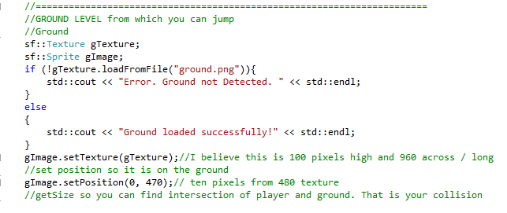

Player Sprite Sheet (Buzz2.png) – 9 images (made in Piskel)

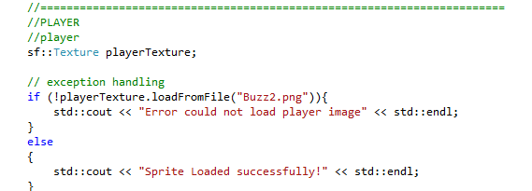

Quit button (button3.png) – made in Piskel

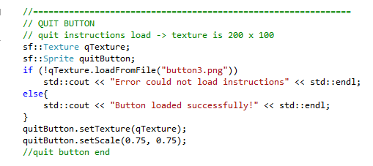

Load Sound (windhowl.wav) – wave file found online.

