Using Digilinet Nexys3 for control and DUT

This document describes how to use Nexys3 as a controller and DUT.

High level diagram for FOBOS boards. The din and dout buses are 4 bit each.

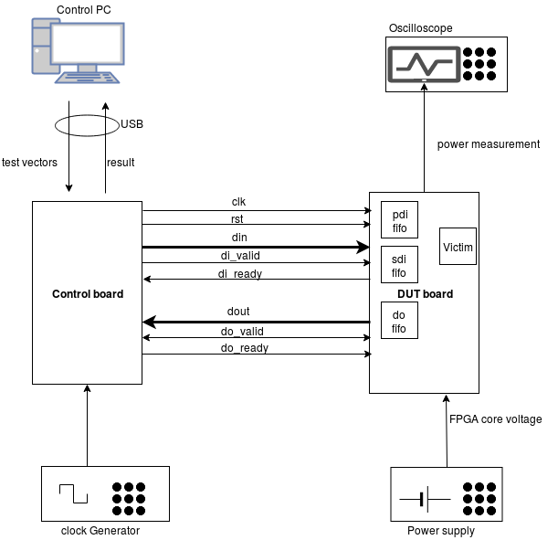

Controller

PMOD connector pin assignment on the control board.

PORT A | PORT B | PORT C | PORT D
JA1: | JB1: EXTClock (from clk Generator) | JC1: DUTClock | JD1: reset
JA2: | JB2: | JC2: do_ready | JD2: di_ready
JA3: trigger (to osciloscope) | JB3: | JC3: din(3) | JD3: dout(3)
JA4: | JB4: | JC4: din(1) | JD4: dout(1)
JA7: | JB7: | JC7: do_valid | JD7:
JA8: | JB8: | JC8: | JD8: di_valid
JA9: | JB9: | JC9: din(2) | JD9: dout(2)
JA10: | JB10: | JC10: din(0) | JD10: dout(0)

PMOD connector pin assignment on the DUT board.

PORT A | PORT B | PORT C | PORT D
JA1: | JB1: | JC1: DUTClock | JD1: reset
JA2: | JB2: | JC2: do_ready | JD2: di_ready
JA3: trigger | JB3: | JC3: din(3) | JD3: dout(3)
JA4: | JB4: | JC4: din(1) | JD4: dout(1)
JA7: | JB7: | JC7: do_valid | JD7:
JA8: | JB8: | JC8: | JD8: di_valid
JA9: | JB9: | JC9: din(2) | JD9: dout(2)
JA10: | JB10: | JC10: din(0) | JD10: dout(0)

Note that the two boards must share GND. PMOD ports C and D are connected, each pin to its corresponding pin in the other board (e.g. JA1 -> JA1 and GND-> GND). However the 3.3 V pin is not connected in the PMOD connector.

