Used this but not sure if the part related to tools→ Device properties is necessary
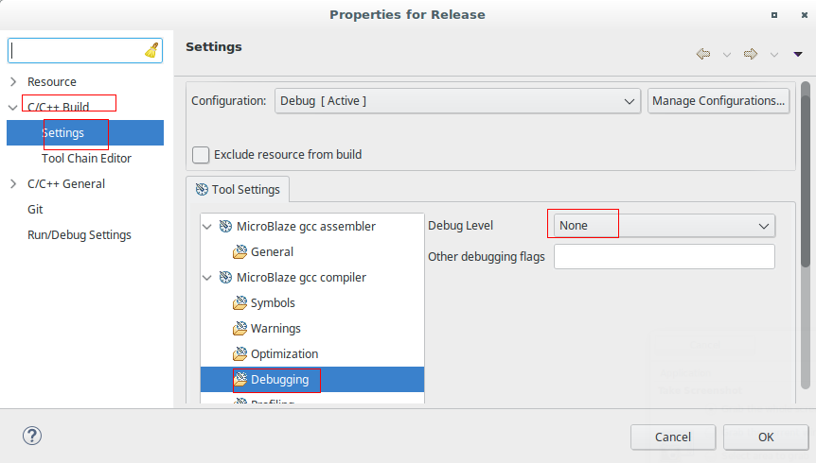
https://www.instructables.com/id/Flashing-a-MicroBlaze-Program/
Make sure that the program have no debug settings

