AI Usage DISCLOSURE FORM

1. Team Details
Team Name: VITV_DEBUG907_01
Project / Product Name: debug907 - Natural Language Code Retrieval
Institution (if any): VIT Vellore
Submission Date: 30 September 2026
2. AI Usage Declaration
Did your team use any Artificial Intelligence (AI) in developing this project? Yes
3. Purpose of AI Usage ( Brief Details)
Idea generation / brainstorming: No AI was used for idea generation or brainstorming.
Code generation or assistance: Limited AI assistance was used for small coding suggestions. The team reviewed, changed, and tested the final code.
UI / UX design: No UI/UX AI tools were used.
Content creation: AI assistance was used only to refine project documentation.
Data analysis: No AI tool was used for data analysis.
Testing / debugging: No AI was used for testing or debugging; tests and validation were run by the team.
Other: None.
4. Feature Origin Classification
1. Feature Name: Natural-language code search
2. Self-Generated/AI-Generated/Both: Self-Generated
3. Description: This feature was independently conceived, designed, and implemented by the team. The retrieval logic, integration, final code, and testing were all completed and validated by the team.
1. Feature Name: Version-aware repository indexing
2. Self-Generated/AI-Generated/Both: Self-Generated
3. Description: This feature was independently conceived, designed, and implemented by the team. The version tracking logic, incremental indexing, final code, and testing were completed and validated by the team.

5. Ethical & Compliance Confirmation
AI usage complies with guidelines and policies. Yes
No proprietary or copyrighted data misused. I Agree
6. Declaration & Sign-Off
Name of Team Representative: Kamneev Singh
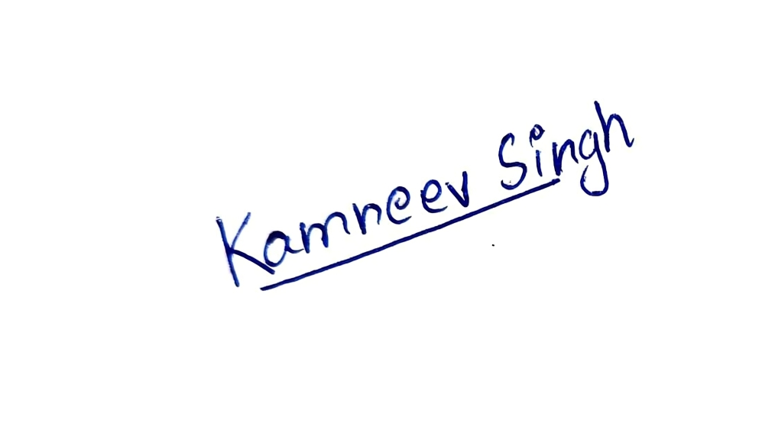
Role: Team Member
Signature:

Date: 30 September 2026

