# CS372 – Java Application Development

# Final Project

## Group Member #1: TimmY B

## Group Member #2: Zeus

1. **Specifications due 16 Jan.**
2. **Beta due 22 Jan.**
3. **Final due 27 Jan.**

**Application Requirements:**

* GUI (either Android or desktop)
* Classes and UML
* High cohesion and low coupling
* As appropriate
  + Inheritance
  + File I/O
  + Internet Access
  + Data structures, including ArrayList, Stack, Queue, and HashMap

**Specification:** A *specification* document describes the problem your application is trying to solve, and how it will solve that problem. Your document should include the following:

* Description of your application. What is the problem your application is trying to solve? How will it solve that problem?
* Logical design of your database application. What classes will be required? What attributes and behaviors will the classes require? This should be in the UML.
* What challenges will you encounter as part of the project? For example, are there techniques or tools you’ll need to implement your solution?
* Recommended: Schedule for when you will start working on specific features, and when you will be complete

**Beta:**

* Parts of your application should be working
* Demo your progress to me
* Documentation
  + What features are complete
  + What features are in progress
  + What features still need to be implemented
  + What concerns do you have toward completing on 27 January?
  + How are you doing according to the schedule?

**Final Deliverable:**

* The project should be accessible for me to grade on GitHub. I should be able to download and run your applications without having to modify your code (e.g. I shouldn’t have to change file paths).
* Project presentation in class 27 January. Presentations should take 7-10 minutes.

**Specification:** A *specification* document describes the problem your application is trying to solve, and how it will solve that problem. Your document should include the following:

* Description of your application. What is the problem your application is trying to solve? How will it solve that problem?
* Logical design of your JAVA application. What classes will be required? What attributes and behaviors will the classes require? This should be in the UML.
* What challenges will you encounter as part of the project? For example, are there techniques or tools you’ll need to implement your solution?
* Recommended: Schedule for when you will start working on specific features, and when you will be complete

Tim and I will be building an audio loop mixing tool. This tool will allow the user to access different audio files and combine them to create a new one. The primary focus is to combine loops in a liner fashion, if time allow we would like to allow the user to overlay loops to create a complex audio body with volume control and fading. This program will be a console app utilizing drag and

drop placement.

Main

Classes (may spawn sub-classes as needed):

AudioFile

-object? audioFile

-string Name

-string Type

-double Length

-int Volume

+Object? GetAudioFile() return audioFile

+String GetName() return name

+String GetType() return type

+double GetLength() return length

+int GetVolume() return volume

+void SetAudioFile(Object? audioFile)

+void SetName(String name)

+ void SetType(String type)

+ void SetLength(double Length)

+ void SetVolume(int Volume)

FileStreamManager

+ void LoadAudioFiles ()

+ ArrayList getAudioFiles () {calls LoadAudioFiles()}

GUI (to link into UI controls)

-FileStreamManager fileStreamManager

-ArrayList <AudioFile> audioFiles (call fileStreamManger.getAudioFiles())

-Queue <AudioFile> tracks

jTreeTracks {contains organized audioFiles)

JListTracks (contains DnD items from jTreeTracks)

jButtonPlay{plays audio from tracks}

jButtonExport{exports audio from tracks as a new audioFile}

Data Structures:

ArrayList <AudioFile>

Queue for play back and recording

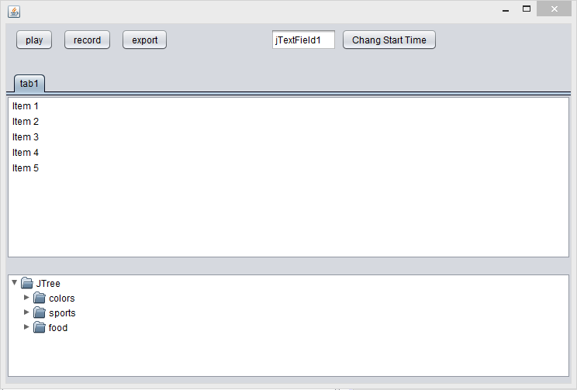

Handling audio, implementation of GUI drag and drop will be our primary challenges as we have not covered nor used these features in any language.

Tim and I will meet daily at 8:30 as often as work schedules allow. We will start with a GUI frame (above) and create a framework that handles classes (we will make the above listed classes). Next we will ensure that we can drag audioFile.name() from the jTreeTracks to jList. Our last step will be to implement audio playback and combination for exporting. We hope to have step one completed today and step two completed by Wednesday of next week. Audio play back done by Friday of next week. GUI interfacing by Monday of the last week.