Skating

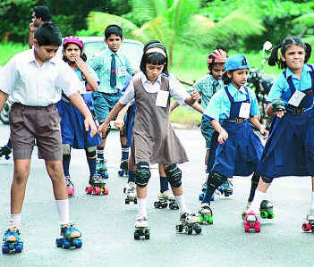

**Roller skating** is the traveling on surfaces with roller skates. It is a form of recreational activity as well as a sport, and can also be a form of transportation. Skates generally come in three basic varieties: quad roller skates incline skates or blades and tri-skates, though some have experimented with a single-wheeled "quintessence skate" or other variations on the basic skate design. In America, this hobby was most popular, first between 1935 and the early 1960s and then in the 1970s, when polyurethane wheels were created and "Disco" oriented roller rinks were the rage and then again in the 1990s when in-line outdoor roller skating, thanks to the improvement made to inline roller skates in 1981 by Scott Olson, took hold.

There so many events in Roller Skating such as:- Figures skating, dance skating, group skating, free style skating, speed skating, singles and pairs skating, aggressive inline, roller derby, roller hockey etc. These all the events are international events and player up to Olympic level.

We are collaborated with Roller skating Federation of India and we also helps the students to achieve their targets and to get the benefits from the Government on sports basis and to get the scholarships.

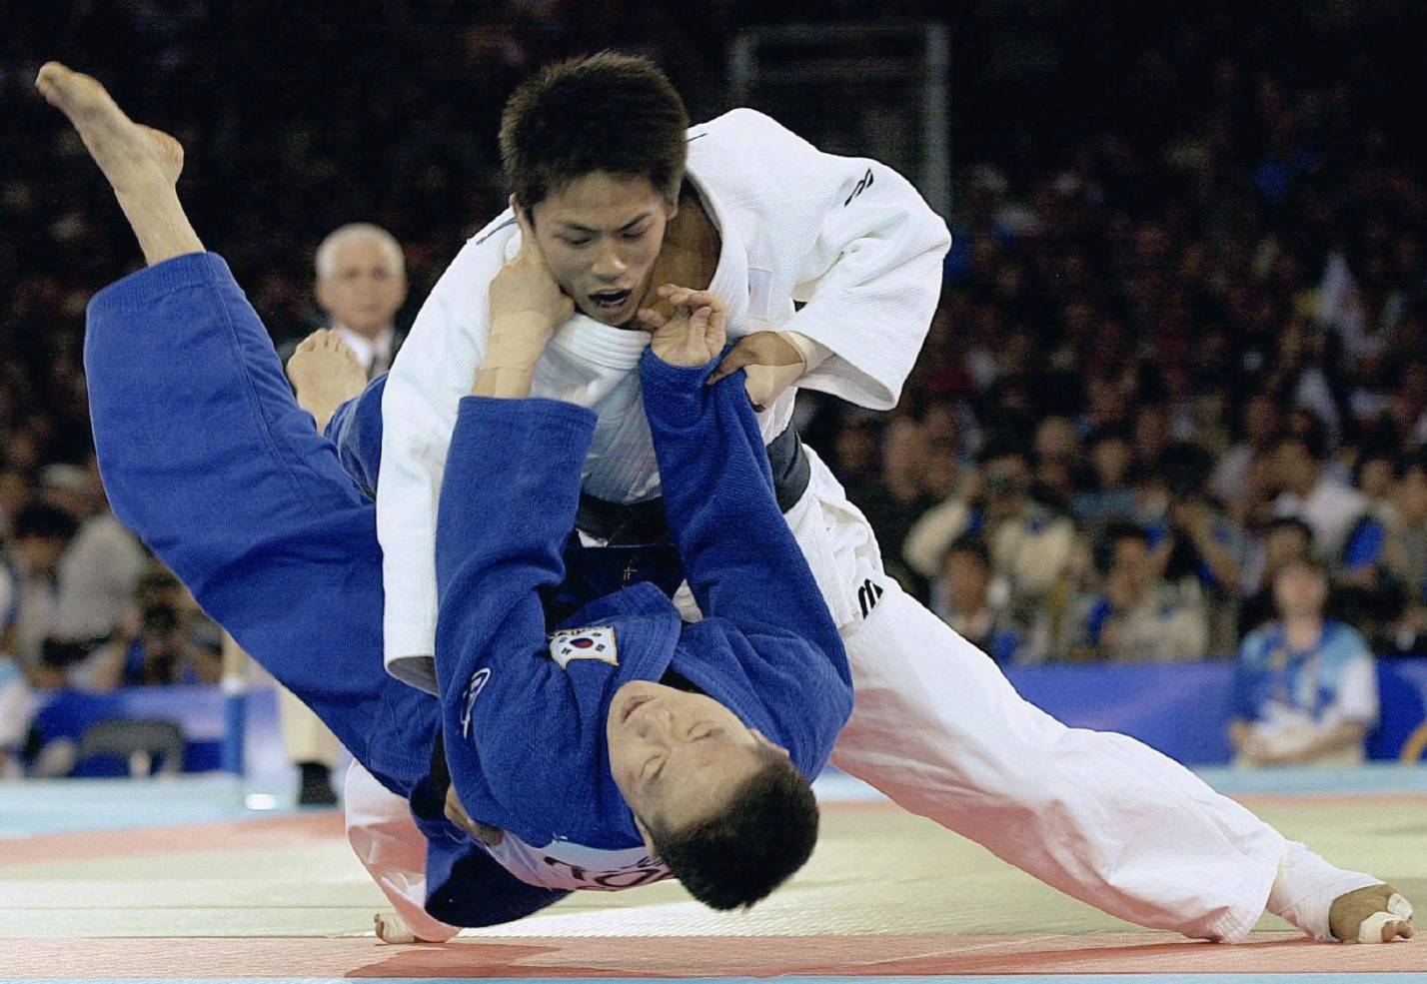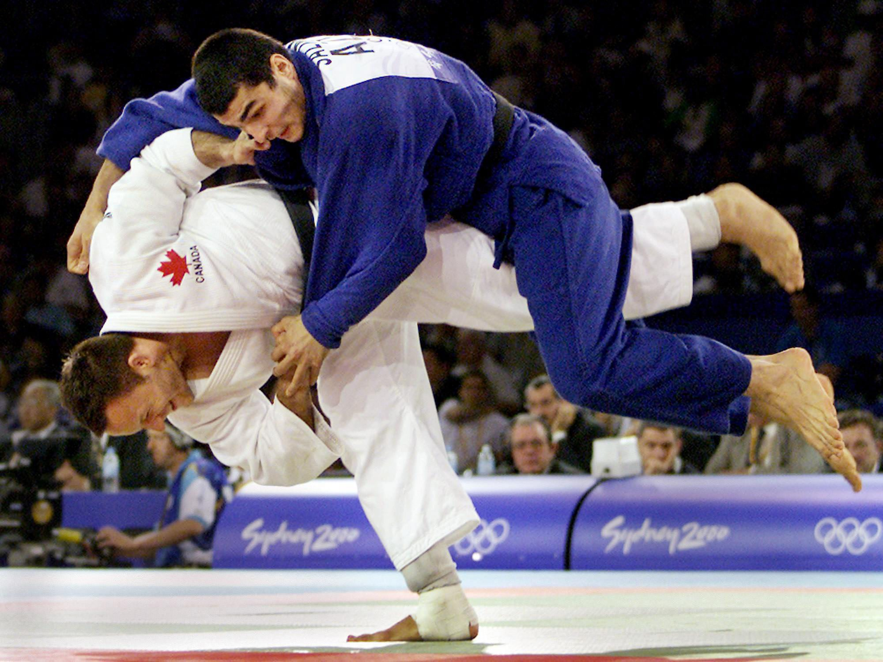JUDO

History: - Judo is a sport of unarmed combat derived from ju-jitsu and intended to train the body and mind. It involves using holds and leverage to unbalance the opponent.Safety in the practice of throwing techniques depends on the skill level of both tori and uke. Inexpertly applied throws have the potential to injure both tori and uke, for instance when tori compensates for poor technique by powering through the throw. Similarly, poor ukemi can result in injury, particularly from more powerful throws that uke lacks the skill to breakfall from. For these reasons, throws are normally taught in order of difficulty for both tori and uke.

This is the game for the self-defense; it is an Olympian event and also the modified face of Wrestling.

TAEKWONDO

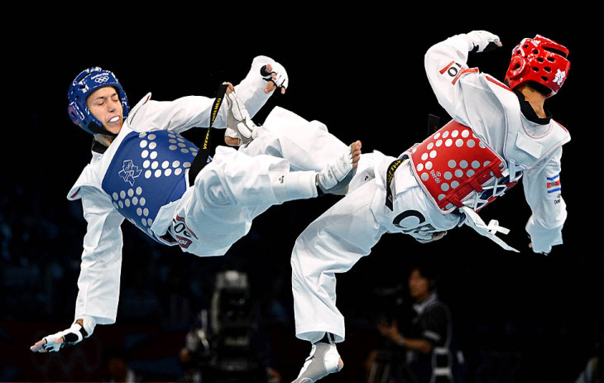

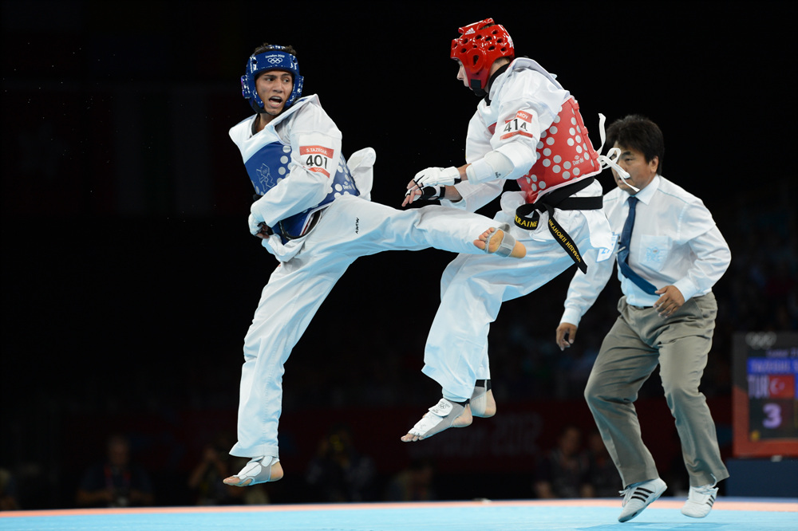

History: **Taekwondo History**. The name **Taekwondo** is derived from the Korean word "Tae" meaning foot, "Kwon" meaning fist and "Do" meaning way of. So, literally **Taekwondo** means "the way of the foot and fist". The name **Taekwondo**, however, has only been used since 1955 while the arts' roots began 2,300 years ago in Korea.WTF became an International Olympic Committee (IOC) recognized sports federation, making Taekwondo a demonstration sport for the 1988 and 1992 Olympic Games. Taekwondo is now an official event for the 2000 Olympiad to be held in Australia.

This game is an Olympic game and itfamous in the girls section and most of the kicks used in this game is modified and used in basically all the martial arts games, its origin is from South Korea and points oriented game.

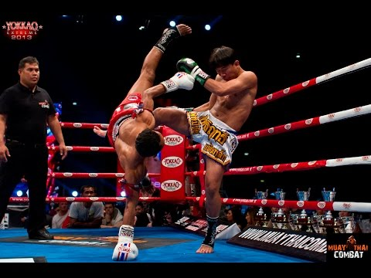Muay Thai

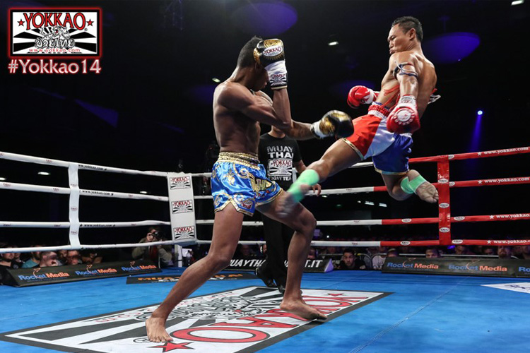

History: This physical and mental discipline which includes combat on shins is known as "the art of eight limbs" because it is characterized by the combined use of fists, elbows, knees, shins, being associated with a good physical preparation that makes a full contact fighter very efficient. Muay Thai became widespread internationally in the twentieth century, when practitioners defeated notable practitioners of other martial arts.Muay Thai is referred to as the "Art of Eight Limbs" or the "Science of Eight Limbs", because it makes use of punches, kicks, elbows and knee strikes, thus using eight "points of contact", as opposed to "two points" (fists) in boxing and "four points" (hands and feet) used in other more regulated combat sports, such as kickboxing and savate A practitioner of muay Thai is known as a nakmuay.

This game is the origin from THAILAND country designed for the self-defense game and full contact combat.As well as being a practical fighting technique for use in actual warfare, muay became a sport in which the opponents fought in front of spectators who went to watch for entertainment. These muay contests gradually became an integral part of local festivals and celebrations, especially those held at temples. Eventually, the previously bare-fisted fighters started wearing lengths of hemp rope around their hands and forearms. This type of match was called muaykhatchueak. Kickboxing was also a component of military training and gained prominence during the reign of King Naresuan in 1560 CE.

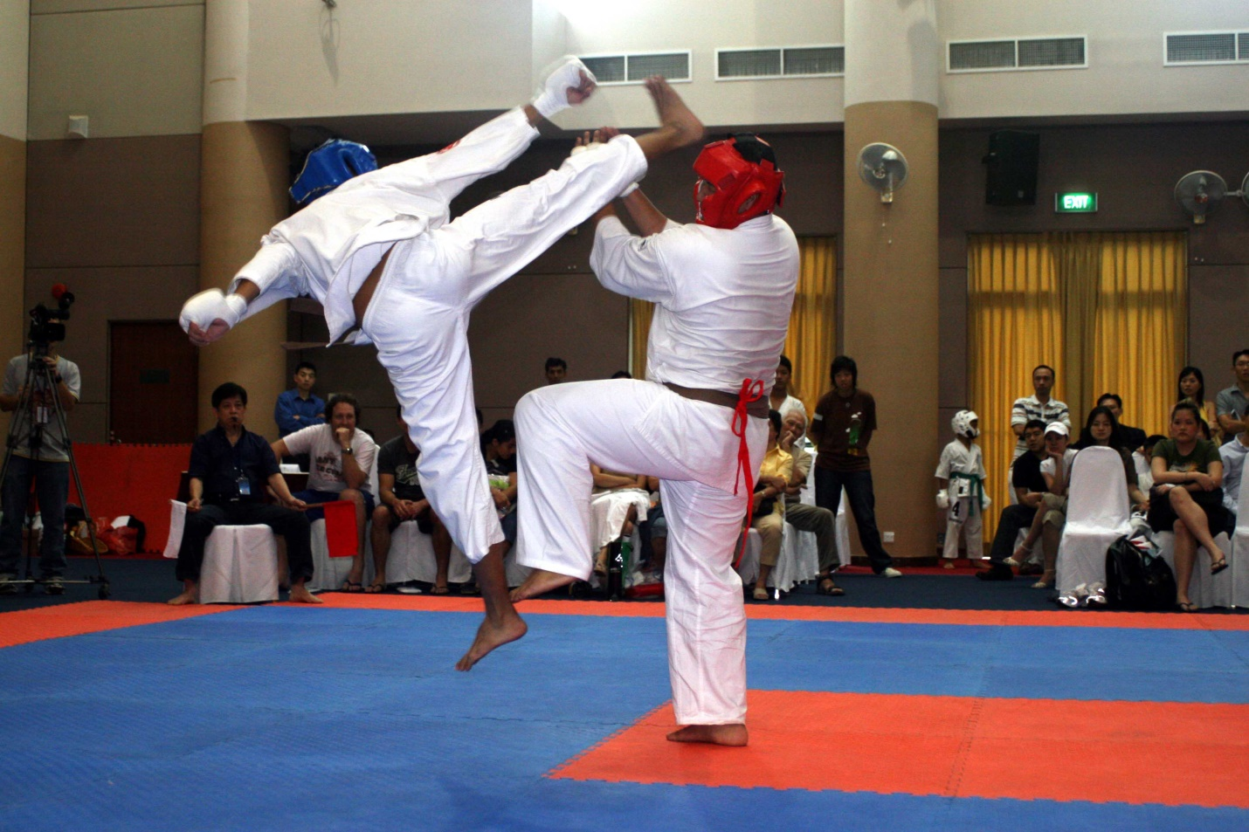KARATE

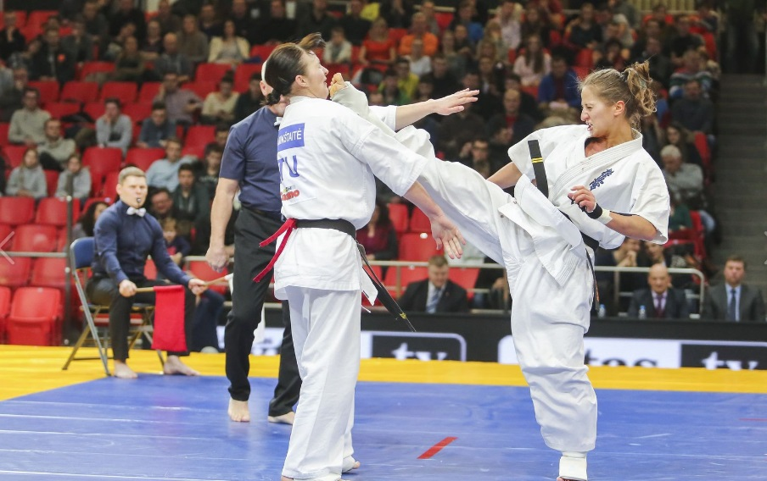

History: Karate is aJapanese game.**Shotokan Karate** is a way for an individual to realize greater potential and expand the limits of that individual's physical and mental capabilities. **Karate** in an excellent, time-proven method of personal development. **Shotokan Karate** is a traditional Japanese Martial Art founded by Master Gichin Funakoshi.The forms he created are common across nearly all styles of karate. His students became some of the most well-known karate masters, including **Gichin Funakoshi**, KenwaMabuni, and MotobuChōki. Itosu is sometimes referred to as "the Grandfather of Modern Karate."**Karate** is a Martial Art. That is, it is a means of self-defense and an art in itself. "Kata" is more aligned with performance as the basis for winning in tournaments is by judgment of several people. "Kumite" is the aspect of **Karate** that can be more considered as a **sport**; some defines this as "**Sport Karate**".History of Shotokan Karate. Gichin Funakoshi is known today as the father of modern day karate. He was born in 1868 in **Okinawa**.On September 28, 2015, **karate** was featured on a shortlist along with baseball, softball, skateboarding, surfing, and sport climbing to be considered for inclusion in the 2020 Summer **Olympics**.

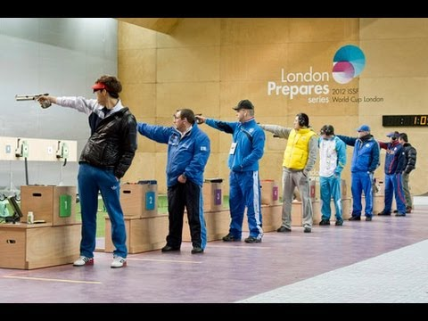SHOOTING

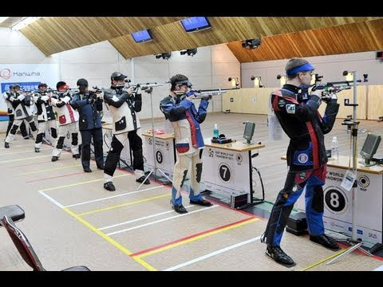

History: Shooting made its Olympic debut at the Games of the I Olympiad in Athens in 1896. It was then staged at most editions of the Games, with the exception of the Games in St Louis in 1904 and Amsterdam 1928. Women made their shooting debut at the Games of the XIX Olympiad in Mexico City in 1968, competing in men’s events. The first purely women’s events appeared in 1984, and it was only in 1996 that the men’s and women’s programmes were completely separated.A **shooting sport** is a competitive sport involving tests of proficiency (accuracy and speed) using various types of [guns](https://en.wikipedia.org/wiki/Gun), such as [firearms](https://en.wikipedia.org/wiki/Firearm) and [airguns](https://en.wikipedia.org/wiki/Air_gun). Shooting sports are categorized by the type of firearm, target, and distance at which the targets are shot.This is the 10mtr air rifle and 10mtr air pistol game.

KICKBOXING

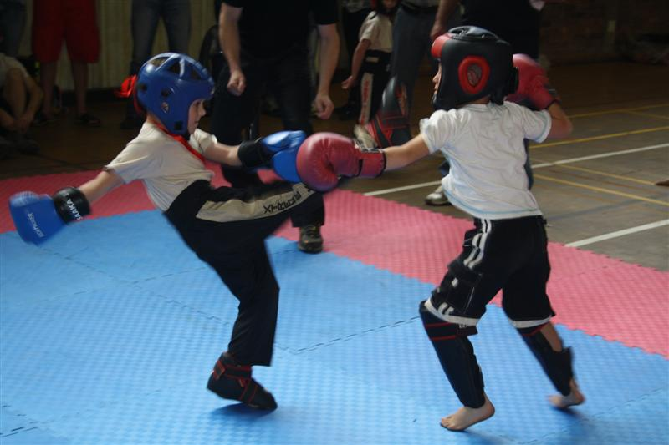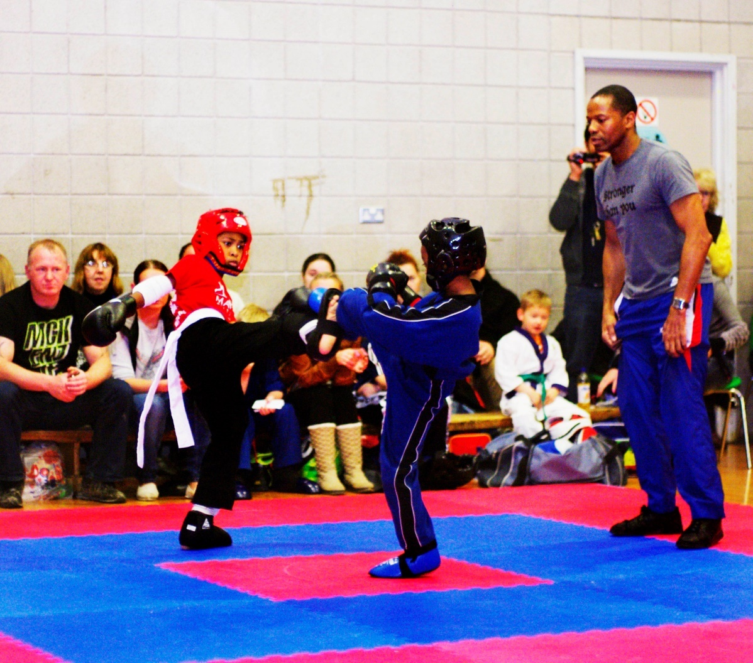

History: **Kickboxing** is a group of stand-up combat sports based on kicking and punching, historically developed from Karate, Muay Thai, Khmer Boxing, and Western boxing.**Kickboxing** is practiced for self-defense, general fitness, or as a contact sport.MMA often involves Judo, Muay Thai, Brazilian Jiu-Jitsu, Boxing, **Karate**,**Kickboxing**, and wrestling. **Martial arts** are practiced for a variety of different reasons including self-defense, physical fitness, entertainment and competition.Combining martial arts techniques and heart-pumping **cardio**, **kickboxing** is a high-energy workout that is guaranteed to burn calories and fat. “It's an incredibly efficient workout."Many laymen are under the impression that modern day kickboxing originated in**Thailand**, **Japan** or elsewhere in the Far East, in fact, the real origins of the sport are revealed by the real name by which it was known, full contact karate.