=
DATA STRUCTURES AND ALGORITHMS
23CSE203
Submitted by
Name | K.SHOBHAN PRABHAS
Roll No | AV.SC.U4CSE25032
Year/sem/section | 2nd year/sem-3/CSE-A
Credits | 5

Submitted to
Name | DR.RAJKUMAR BATCHU
Department | School of computing
Designation | Asst. professor(SI. Grade)

Index
S.NO | TITLE | DATE | PG. NO.
1. | WEEK-1:  1A). Recursive countdown from n to Launch.  1B). Recursive calculation of compound growth factor.  1C). Recursive search for employee ID in list.  1D). Recursive factorial calculation for parcel arrangements.  1E). Recursive Fibonacci series generation. | 23-07-26 | 5-14
2. | WEEK-2:  2A). write a python program to perform linear search on the given input.  2B).write a python program to perform binary search on the given input verify by taking sorted array.  2C). write a python program to perform binary search on the given input verify by taking unsorted array. | 30-07-26 | 15-21
3. | WEEK-3:  3A).Write a python program to sort the elements using bubble sort technique. Take an input from the user.  3B). Write a python program to sort the elements using insertion sort technique. Take an input from the user.  3C). Write a python program to sort the elements using selection sort technique. Take an input from the user.  3D). Write a python program to sort the elements using quick sort technique. Take an input from the user.  3E). Write a python program to sort the elements using merge sort technique. Take an input from the user. | 06-08-26 | 22-35
4. | WEEK-4:  4A). Aim :Write a program to implement a single linked list which would perform the below operations, by taking an input from the user.  a)create a linked list  b)insert at beginning  c)insert at end  d)insert at a specified index  e)delete by value  f)delete 1st node  g)delete last node  h)count no.of nodes  i)display or traverse  j)search for a number  k)exit  4B). Aim :Write a program to implement a double linked list which would perform the below operations, by taking an input from the user.  a)create a linked list  b)insert at beginning  c)insert at end  d)insert at a specified index  e)delete by value  f)delete 1st node  g)delete last node  h)count no.of nodes  i)display or traverse  j)search for a number  k)exit  4C). Aim:Write a program to implement a circular linked list which would perform the below operations, by taking an input from the user.  a)create a linked list  b)insert at beginning  c)insert at end  d)insert at a specified index  e)delete by value  f)delete 1st node  g)delete last node  h)count no.of nodes  i)display or traverse  j)search for a number  k)exit | 13-08-26 | 36-68
5. | WEEK- 5:  Write a python program to implement a stack using an Array, Linked list. Implement the stack operations such as push, pop, peak and also display the stack elements. | 27-08-26 | 69-79
6. | WEEK- 6:  Write a python program to implement a queue using an Array, Linked list, circular queue. Implement the queue operations such as enqueue, dequeue, peek and also display the queue elements. | 03-09-26 | 80-93
7. | WEEK- 7:  7A).write a python program to implement binary tree search using an array with all its operations.  7B).write a python program to implement binary tree using an linked list with all its operations. | 24-09-26 | 94-106
8. | WEEK-8:  write a python program to implement Binary tree with its operations using array and linked list. | 08-10-26 | 107-113
9. | WEEK-9:  write a python Program for AVL tree using array and linked list with all its operations. | 22-10-26 | 114-141
10. | WEEK-10:  Hashing – Separate Chaining, Linear Probing and Quadratic Probing | 29-10-26 | 142-148

WEEK-1
1A. AIM: A Rocket launch system displays a countdown before launch. Instead of suing a loop, implement the countdown using recursion. Write a recursive python program to display a countdown from n to 1 followed by “launch”.
Program:
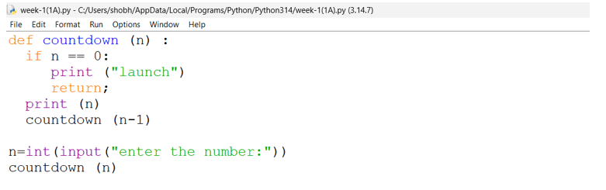
Output:

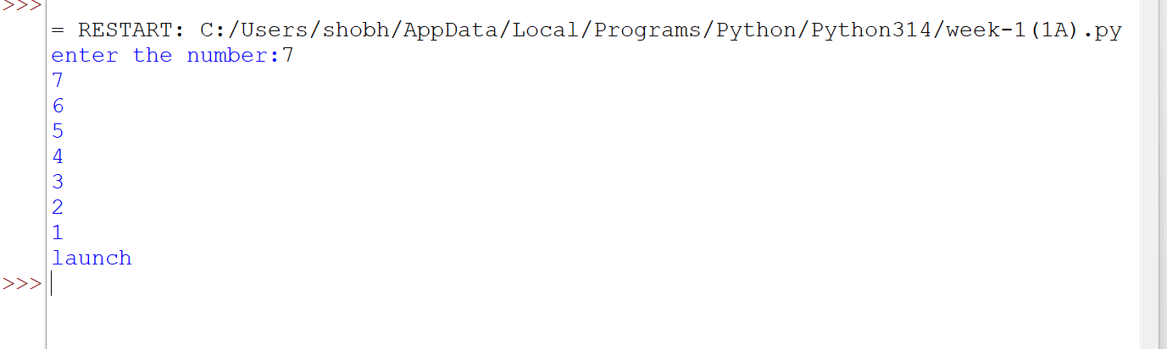

Explanation
Condition 1: Positive Input (n > 0)
- The function checks whether n == 0.
- Since n is positive, the condition is False.
- It executes:
- print(n) → prints the current value of n.
- countdown(n-1) → calls the same function again with n-1.
- This process continues until n becomes 0.
- When n == 0, the condition becomes True.
- It prints launch.
- The return statement stops that function call.
- Then the recursive calls return one by one.
- Since there is no value returned by the function, it returns None.
Condition 2: Zero Input (n == 0)
- The function checks if n == 0.
- The condition is immediately True.
- It prints launch.
- The return statement stops the function.
- No recursive call takes place.
- The function returns None.
Condition 3: Negative Input (n < 0)
- The condition n == 0 is False.
- It prints the negative value.
- Then it calls itself with n-1, making the value even more negative.
- Therefore, it will never reach 0.
- The recursion continues indefinitely.
- Eventually, Python raises a RecursionError because the maximum recursion depth is exceeded

Error table:
s.no | Error obtained | Rectification
1 | Negative input in countdown | Add a condition to handle negative numbers before recursion.

1B. Aim: Banks calculate the growth of an investment using compound interest. The formula requires calculating powers, which can be implemented recursively. Write a recursive program to calculate p(n) where p=principal growth, n= no. of years.
Program:
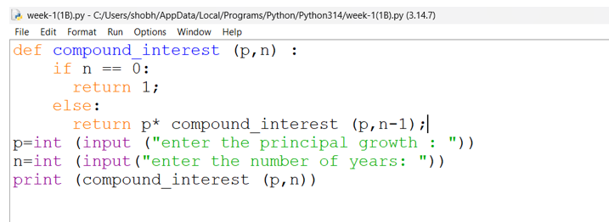
Output:
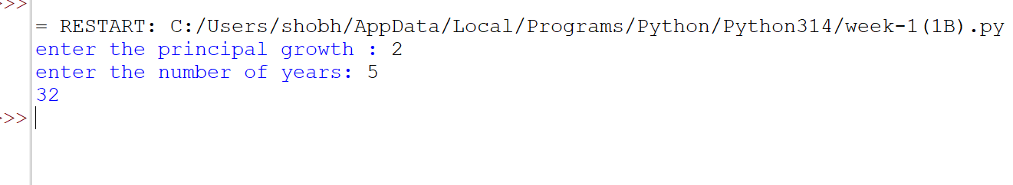

Explanation
Condition 1: n > 0
- The function compound_interest(p, n) is called with the principal amount p and number of years n.
- The function checks whether n == 0.
- Since n is greater than 0, the condition is False.
- It executes the else block.
- It calculates:
- p * compound_interest(p, n-1)
- The function calls itself recursively with n-1.
- This process continues until n becomes 0.
- Each recursive call multiplies p one more time.
- Therefore, the function calculates pⁿ.
Condition 2: n == 0
- When n becomes 0, the condition n == 0 becomes True.
- The function returns 1.
- This 1 acts as the base case for the multiplication.
- The recursive calls then return one by one.
- Each returned value is multiplied by p.
- Finally, the result is printed using print(compound_interest(p,n))
Error table:
s.no | Error obtained | rectification
1 | Wrong indentation | Maintain proper indentation.

1C. AIM . An Hr department stores employee IDs in a list .Develop a recursive program to search for a given employee ID write a recursive function to search for an employee ID in a list.
Program:
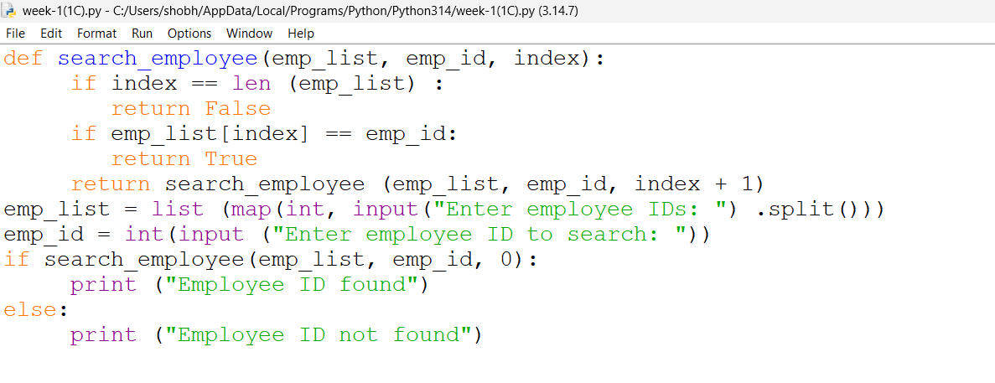

Output:
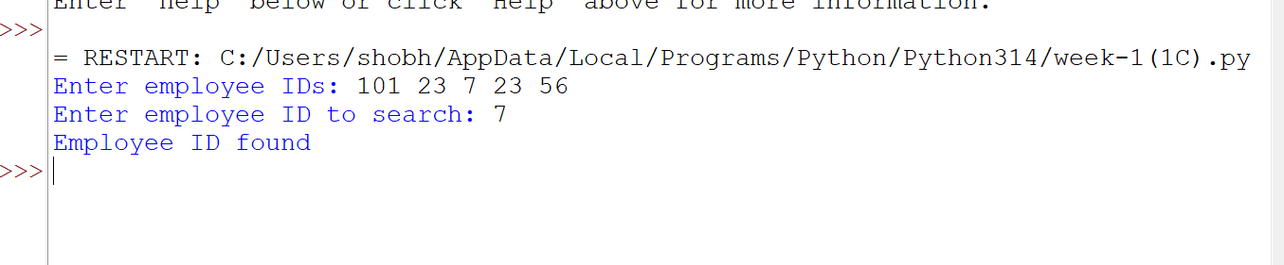
Explanation
Condition 1: index == len(emp_list)
- The function checks whether index has reached the length of the employee list.
- If index == len(emp_list), it means we have checked all employee IDs.
- The employee ID was not found.
- The function returns False.
- No further recursion takes place.
Condition 2: emp_list[index] == emp_id
- The function checks whether the current employee ID is equal to the ID we are searching for.
- If both IDs are equal, the condition becomes True.
- The function returns True.
- The recursion stops because the employee ID has been found.
Condition 3: Employee ID does not match
- If the current employee ID is not equal to emp_id, the condition is False.
- The function calls itself recursively with:
- index + 1
- This moves to the next employee ID in the list.
- The process continues until:
- The employee ID is found, or
- The entire list is checked.
Error table:
s.no | Error obtained | Rectification
1 | Missing return statement | Add the required return statement

1D. AIM. In a logistics company , the no . of possible ways to arrange in different parcels is calculated using the factorial formula (n!). Develop a recursive program to calculate the factorial of a given number.
Program:
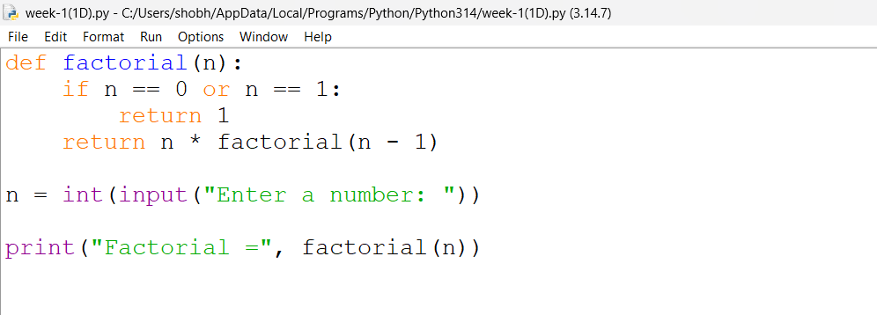
Output:
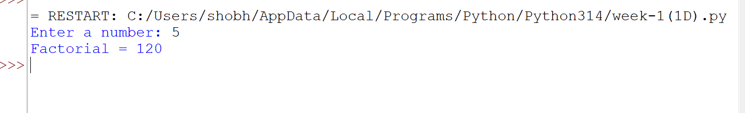
Explanation
Condition 1: Negative Input (n < 0)
- The program first checks whether n < 0.
- If n is negative, the condition is True.
- Factorial is not defined for negative numbers.
- It prints:
Factorial is not defined for negative numbers.
- The factorial() function is not called.
Condition 2: Base Case (n == 0 or n == 1)
- Inside the factorial() function, it checks:
n == 0 or n == 1
- If n is 0 or 1, the condition is True.
- The function returns 1.
- This is the base case of the recursion.
- It stops further recursive calls.
Condition 3: n > 1
- If n is greater than 1, the condition n == 0 or n == 1 is False.
- The else block is executed.
- It returns:
n * factorial(n - 1)
- The function calls itself with n - 1.
- This continues until n becomes 1.
- Then the returned values are multiplied together
Error table:
s.no | Error obtained | Rectification
1 | Wrong recursive value | Updated the recursive value correctly

1E. AIM. Write a recursive program to print the first n terms of the fibonacci series
Program:
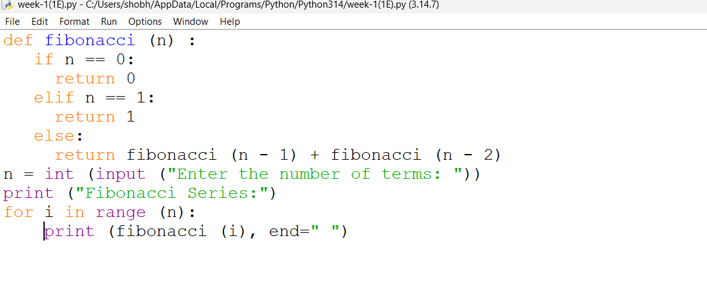
Output:
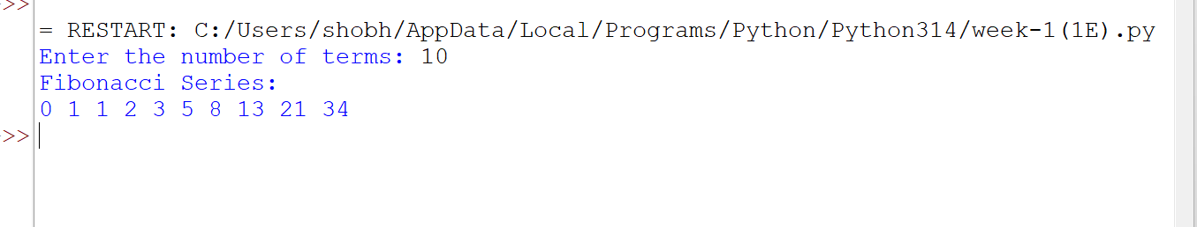
Explanation
Condition 1: n == 0
- The function checks whether n == 0.
- If the condition is True, the function returns 0.
- This is the first base case.
- No further recursive call takes place.
Condition 2: n == 1
- If n is not 0, the function checks whether n == 1.
- If the condition is True, the function returns 1.
- This is the second base case.
- No further recursive call takes place
Condition 3: n > 1
- If n is neither 0 nor 1, both conditions are False.
- The else block is executed.
- The function calls itself two times:
- fibonacci(n - 1)
- fibonacci(n - 2)
- The two returned values are added together.
- This process continues until the base cases n == 0 and n == 1 are reached.
Error table:
s.no | Error obtained | Rectification
1 | Incorrect Fibonacci recursion | Use fibonacci(n-1) + fibonacci(n-2).

WEEK-2
2A. AIM: Write a python program to perform linear search on the give input.
Program:
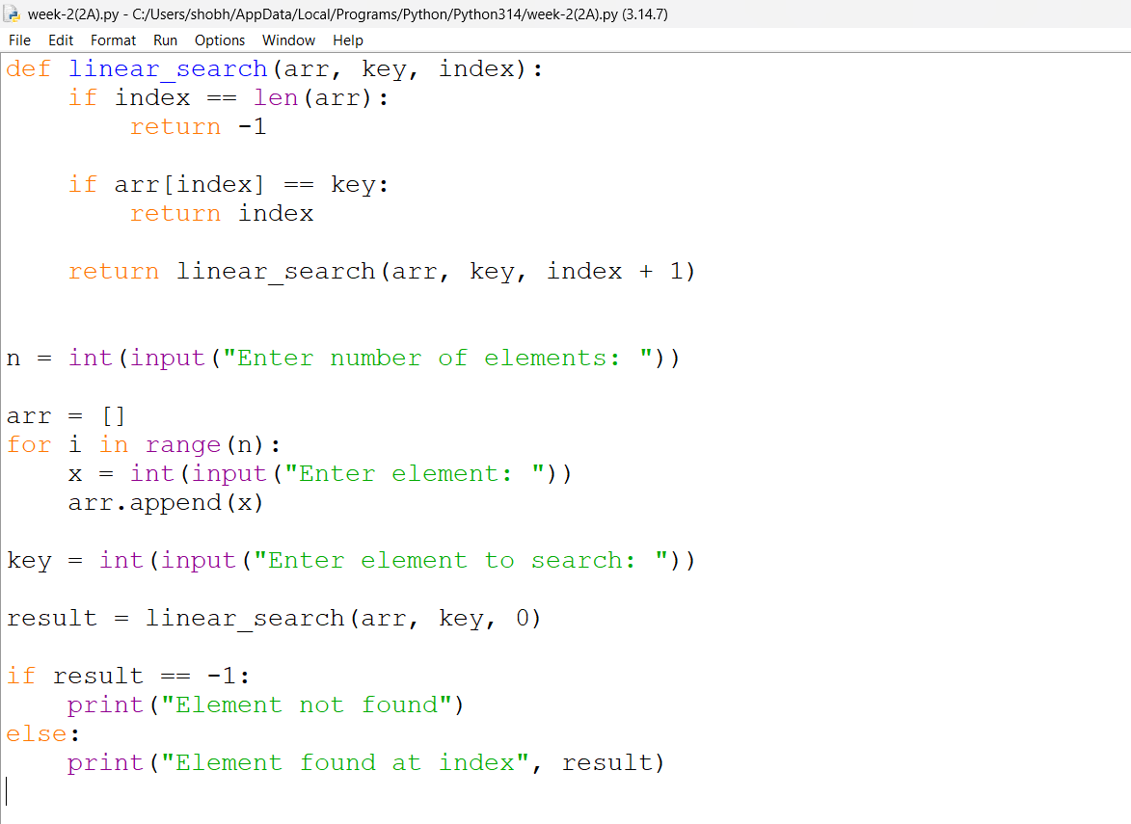
Output:
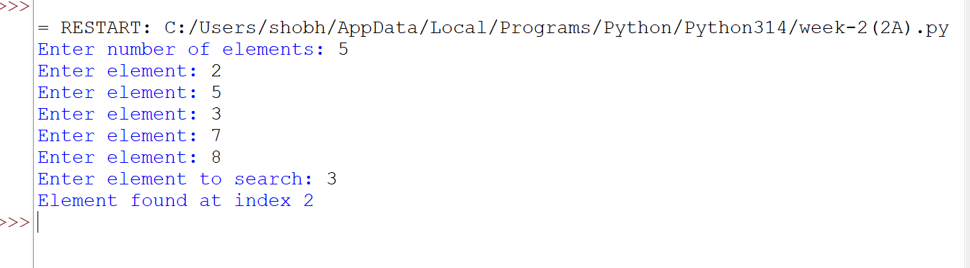

Explanation
Condition 1: Element is Found (arr[i] == k)
- The function linear_search(arr, k) receives the array arr and the search element k.
- The for loop starts from the first element of the array.
- It checks each element one by one using:
arr[i] == k
- If the current element is equal to k, the condition becomes True.
- The function immediately returns the index i.
- Since the function returns the index, the loop stops immediately.
- The remaining elements are not checked.
Condition 2: Element is Not Found
- The loop checks every element in the array.
- If none of the elements is equal to k, the if condition is always False.
- After the loop finishes, the statement return -1 is executed.
- -1 indicates that the search element is not present in the array.
Error table:
s.no | Error obtained | Rectification
1 | Wrong loop range | Use range(n) to process exactly n elements.

2B. AIM: Write a python program to perform binary search on the given. Verify by taking sorted array as an input.
Program:
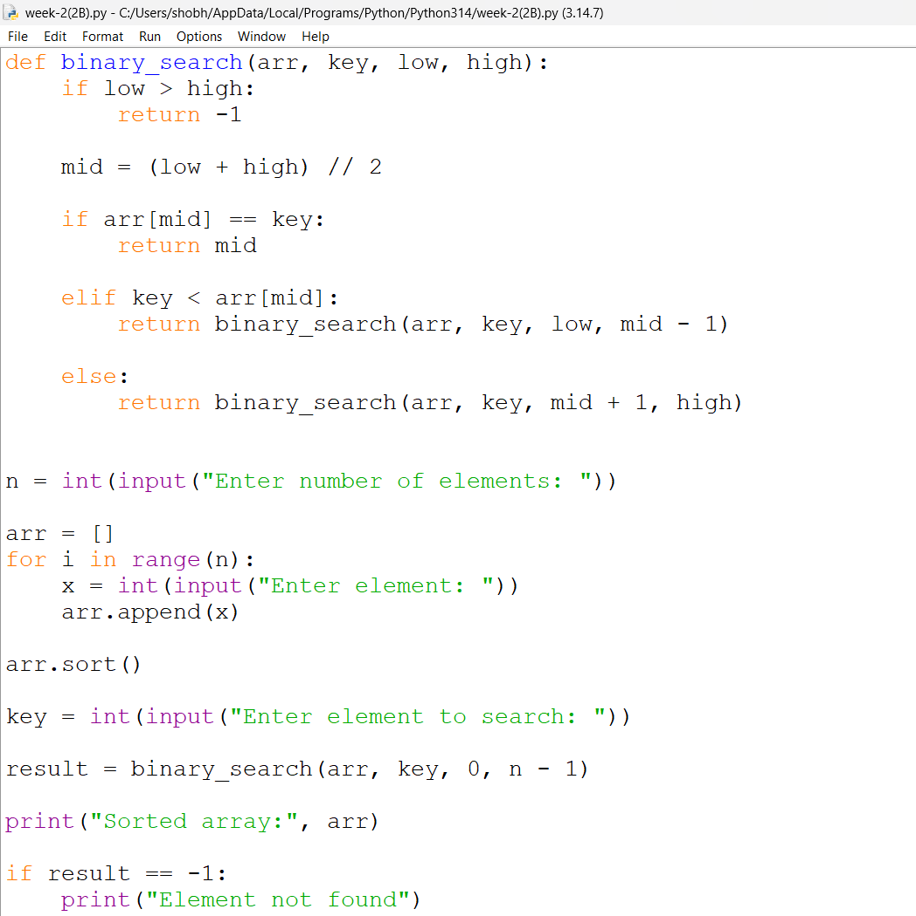
Output:
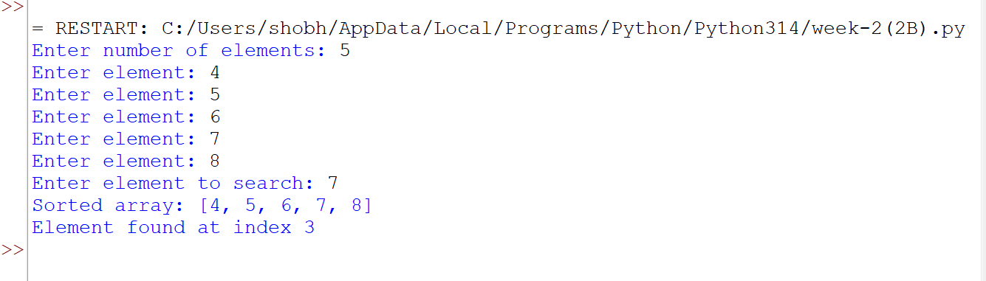
Explanation
Condition 1: k == arr[mid] — Element Found
- The function binary_search(arr, k) receives the array and the search element.
- low is initialized to 0, which represents the first index.
- high is initialized to len(arr)-1, which represents the last index.
- The while loop runs as long as low <= high.
- mid is calculated using:
mid = (low + high) // 2
- The middle element is compared with the search element k.
- If k == arr[mid], the element is found.
- The function returns the index mid and stops searching.
Condition 2: k < arr[mid] — Search Left Half
- If k is smaller than the middle element, the condition is True.
- This means the search element can only be present in the left half.
- Therefore:
high = mid - 1
- The right half is eliminated.
- The process continues with the remaining left half
Condition 3: k > arr[mid] — Search Right Half
- If k is greater than the middle element, the elif condition is False.
- The else block is executed.
- This means the search element can only be present in the right half.
- Therefore:
low = mid + 1
- The left half is eliminated.
- The process continues with the remaining right half.
Condition 4: low > high — Element Not Found
- The while loop continues until low <= high becomes False.
- When low > high, there are no elements left to search.
- This means the search element is not present in the array.
- The function returns -1.
Error table:
s.no | Error obtained | Rectification
 | Wrong index in binary search | Use high = mid - 1 for the left half and low = mid + 1 for the right half.

2C.Aim: write a python program to perform a bianry search on the given input verify by Taking unsorted array as input
Program: 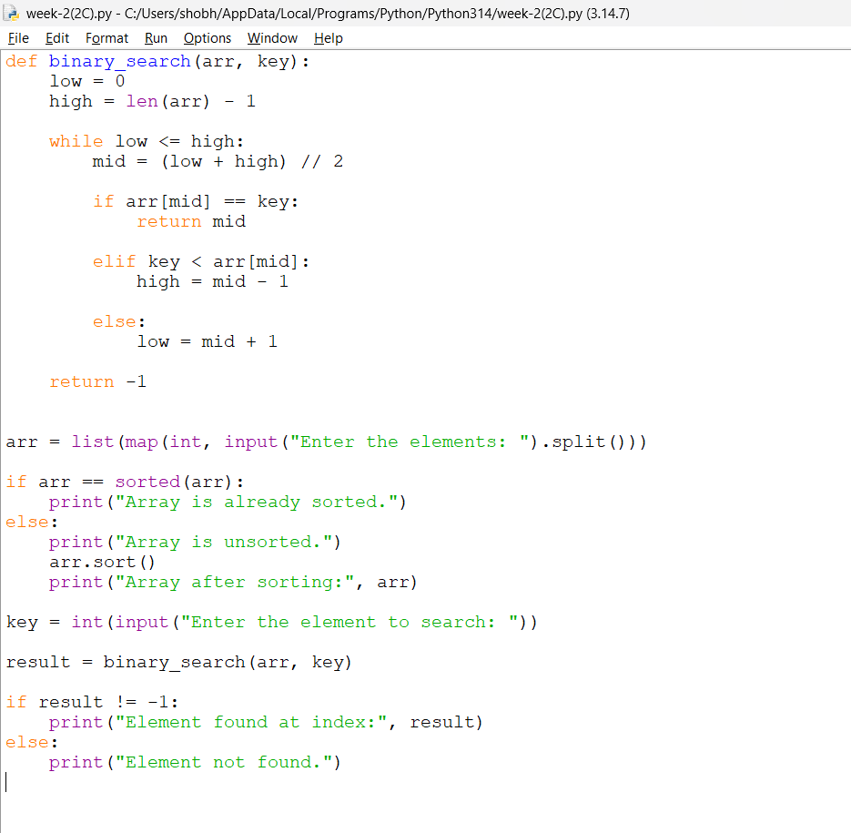

Output:
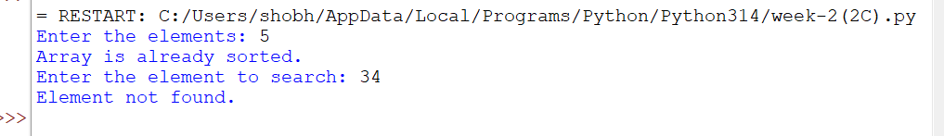

Explanation
Condition 1: arr[mid] == key — Element Found
- The function first calculates the middle index using mid = (low + high) // 2.
- It compares the middle element arr[mid] with the search element key.
- If arr[mid] == key, the condition is True.
- The element is found.
- The function returns the index mid.
- The search stops.
Condition 2: key < arr[mid] — Search Left Half
- If key is smaller than arr[mid], the condition is True.
- This means the required element may be present in the left half.
- The right half is ignored.
- high is changed to mid - 1.
- The search continues in the left half.
Condition 3: key > arr[mid] — Search Right Half
- If key is greater than arr[mid], the previous conditions are False.
- The element may be present in the right half.
- The left half is ignored.
- low is changed to mid + 1.
- The search continues in the right half.
Condition 4: low > high — Element Not Found
- The while low <= high loop continues until there are elements left to search.
- When low > high, the loop stops.
- This means the element is not present in the array.
- The function returns -1.
- The program prints "Element not found."
Condition 5: Array is Already Sorted
- The program checks whether the given array is already sorted.
- It uses:
arr == sorted(arr)
- If the condition is True, it prints:
"Array is already sorted."
- The array is directly used for binary search.
Condition 6: Array is Unsorted
- If arr == sorted(arr) is False, the array is unsorted.
- The program prints:
"Array is unsorted."
- It then uses arr.sort() to sort the array.
- The sorted array is displayed.
- Binary search is then performed on the sorted array.

Error table:
s.no | Error obtained | Rectification
1 | Binary search on unsorted array | sort the array first using arr.sort() or provide a sorted array.

WEEK-3
3A.Aim.Write a python program to sort the elements using a bubble sort technique. Take an input elements from the user.
Program:
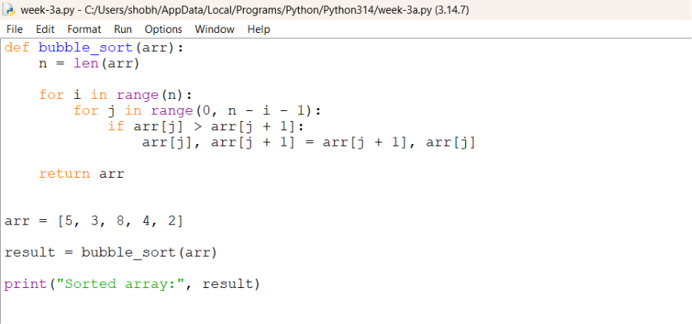

Output:
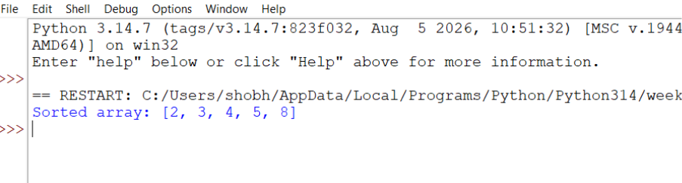

Explanation
Condition 1: arr[j] > arr[j+1] — Elements Need to Be Swapped
- The function bubble_sort(arr) receives the array as an argument.
- The outer for loop runs from 0 to n-1 and controls the number of passes.
- The inner for loop runs from 0 to n-2 and compares adjacent elements.
- The condition arr[j] > arr[j+1] checks whether the current element is greater than the next element.
- If the condition is True, the two elements are in the wrong order.
- Therefore, the two elements are swapped using:
- Arr[j],arr[j+1]=arr[j+1],arr[j]
- After the swap, the smaller element moves toward the left and the larger element moves toward the right.
Condition 2: arr[j] <= arr[j+1] — No Swap Required
- If arr[j] > arr[j+1] is False, it means the current element is smaller than or equal to the next element.
- Therefore, the elements are already in the correct ascending order.
- No swapping is performed.
- The inner loop continues to compare the next pair of adjacent elements.
Condition 3: for i in range(n) — Repeated Passes
- The outer loop repeats the comparison process for all the elements.
- After each complete pass, the largest unsorted element moves to the end of the array.
- The process is repeated until all elements are arranged in ascending order.
- Finally, the function returns the sorted array using:
Error table:
sno | Error obtained | Rectification
1 | IndexError: list index out of range | Use correct loop range

3B.Aim. write a python program to sort the elements using a insertion sort technique. Take an input elements from the user.
Program:
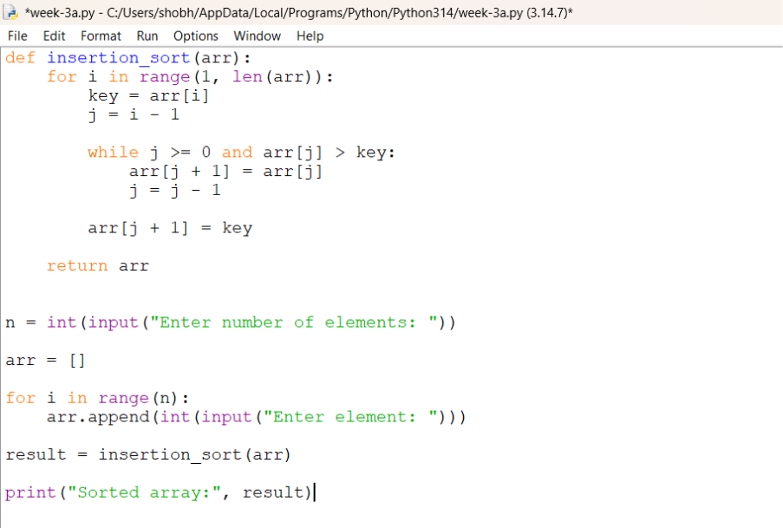
Output:
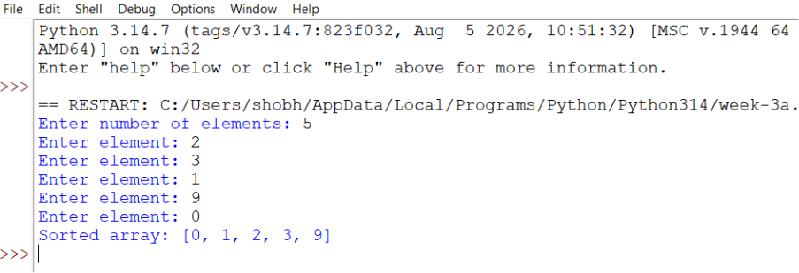
Explanation:
Condition 1: for i in range(1, len(arr)) — Selecting Element
- The loop starts from the second element.
- The first element is considered already sorted.
- i represents the element that needs to be placed correctly.
Condition 2: key = arr[i] — Storing Element
- The current element is stored in key.
key = arr[i]
- This element will be compared with the elements before it.
Condition 3: j = i - 1 — Getting Previous Position
- j points to the element just before the current element.
j = i - 1
Condition 4: while j >= 0 and key < arr[j] — Comparing Elements
- The current element is compared with the previous elements.
- If the previous element is greater than key, it is moved one position to the right.
while j >= 0 and key < arr[j]:
arr[j + 1] = arr[j]
j -= 1
- This creates space for the current element.
Condition 5: arr[j + 1] = key — Inserting Element
- The key is placed in its correct position.
arr[j + 1] = key
- The elements before the current position are now sorted.
Condition 6: return arr — Returning Sorted Array
- After all elements are processed, the function returns the sorted array.
return arr
error table:
sno | Error obtained | Rectification
1 | Elements not sorted correctly | Shift elements before insertion

3C.write a python program to sort the elements using selection sort technique . take an input from the user.
Program:
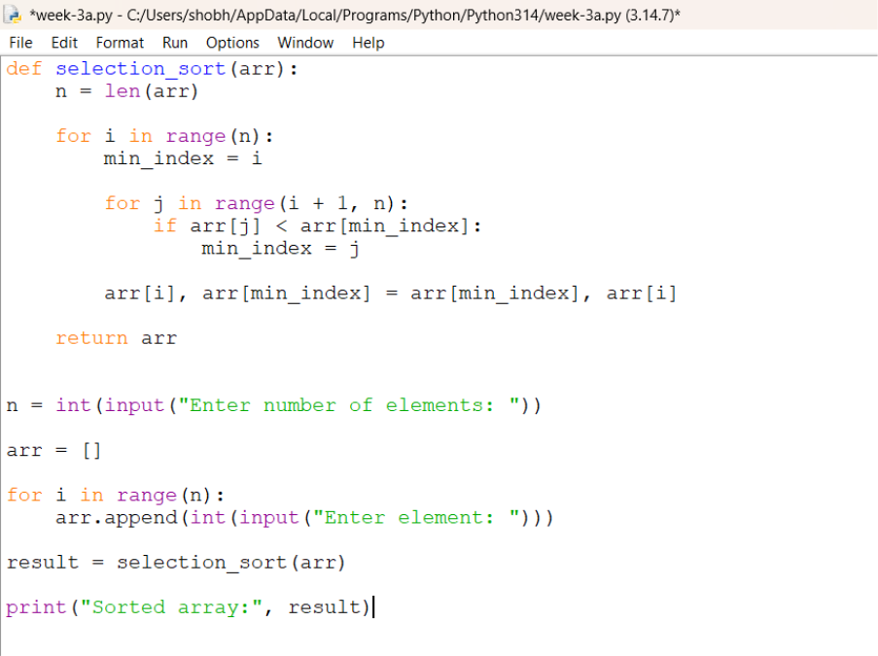
Output:
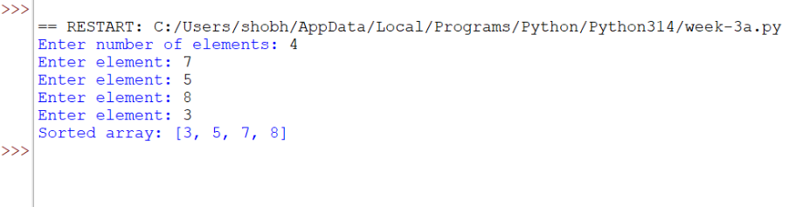

Explanation:
Condition 1: for i in range(n) — Selecting Position
- The loop goes through each position in the array.
- i represents the current position where the smallest element will be placed.
Condition 2: mini = i — Assuming Minimum
- Initially, the element at index i is assumed to be the smallest.
Condition 3: for j in range(i+1,n) — Finding Minimum
- The loop checks all elements after position i.
- It searches for the smallest element.
Condition 4: if arr[mini] > arr[j] — Comparing
- Compares the current minimum with arr[j].
- If arr[j] is smaller, mini is updated.
Condition 5: mini = j — Updating Minimum
- Stores the index of the newly found smallest element.
Condition 6: arr[mini], arr[i] = arr[i], arr[mini] — Swapping
- The smallest element is swapped with the element at position i.
- This places the smallest element in its correct position.
Condition 7: return arr — Returning Result
- Returns the completely sorted array.
Error table:
Sno | Error obtained | Rectification
1 | Wrong minimum value | Update min_index properly

3D.write a python program to sort the elements using the merge sort technique . take an input from the user.
Program:
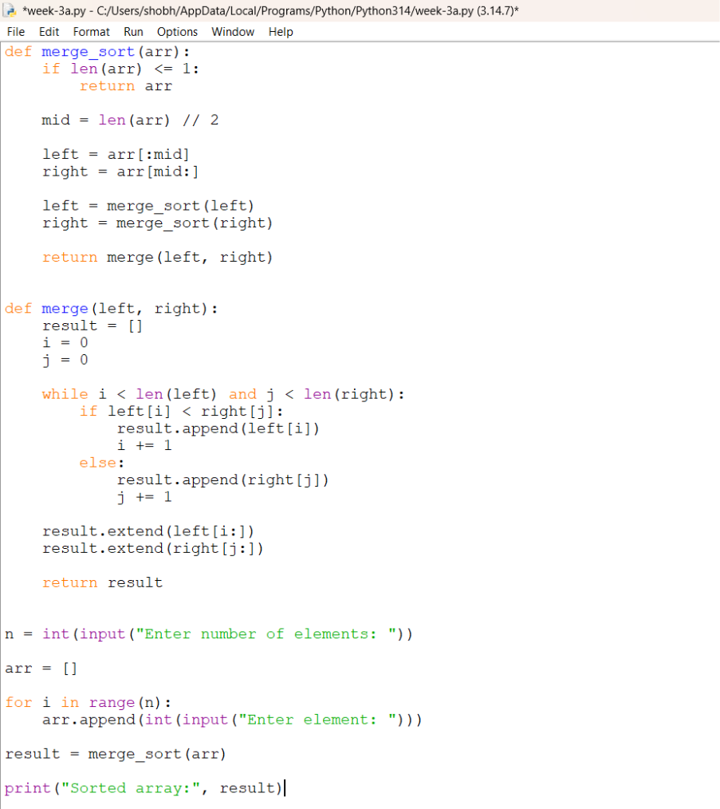

Output:
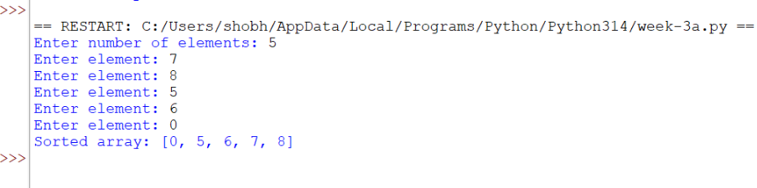

Explanation:
Condition 1: if len(arr) <= 1 — Checking the Base Condition
- The function first checks whether the array contains one or zero elements.
if len(arr) <= 1:
return arr
- If the array has one or zero elements, it is already sorted.
- No further division or comparison is required.
- The function returns the array as it is:
return arr
Condition 2: mid = len(arr) // 2 — Finding the Middle
- The array is divided into two parts.
- The middle position is calculated using:
mid = len(arr) // 2
- len(arr) gives the total number of elements.
- // 2 performs integer division and finds the middle index.
Condition 3: left = arr[:mid] — Creating the Left Part
- The elements before the middle position are stored in left.
left = arr[:mid]
Condition 4: right = arr[mid:] — Creating the Right Part
- The elements from the middle position to the end are stored in right.
right = arr[mid:]
Condition 5: merge_sort(left) and merge_sort(right) — Sorting Both Parts
- The left and right parts are recursively sorted.
merge_sort(left)
merge_sort(right)
- The array continues to be divided until each part contains only one element.
- A single element is already sorted.
- The smaller sorted parts are then merged together.
Condition 6: i = j = k = 0 — Initializing Indexes
- Three variables are initialized:
i = j = k = 0
- i keeps track of the current element in the left array.
- j keeps track of the current element in the right array.
- k keeps track of the position in the original array where the element will be placed.
Condition 7: while i < len(left) and j < len(right) — Comparing Both Parts
- The program compares elements from the left and right arrays.
while i < len(left) and j < len(right):
- The loop continues as long as both arrays still have elements to compare.
- This allows the program to select the smaller element and place it into the original array.
Condition 8: if left[i] < right[j] — Comparing Elements
- The current elements of the left and right arrays are compared.
if left[i] < right[j]:
- If the left element is smaller than the right element, it is placed into the original array.
arr[k] = left[i]
- Then i is increased:
i += 1
- This moves to the next element of the left array.
Condition 9: else — Taking the Right Element
- If the right element is smaller than or equal to the left element, the right element is placed into the original array.
else:
arr[k] = right[j]
- Then j is increased:
j += 1
- This moves to the next element of the right array.
Condition 10: k += 1 — Moving to the Next Position
- After placing an element into the original array, k is increased.
k += 1
Condition 11: while i < len(left) — Copying Remaining Left Elements
- Sometimes the right array becomes empty before the left array.
while i < len(left):
- Any remaining elements in the left array are copied into the original array.
arr[k] = left[i]
- Then both i and k are increased:
i += 1
k += 1
- The remaining elements are already sorted, so no comparison is needed.
Condition 12: while j < len(right) — Copying Remaining Right Elements
- Sometimes the left array becomes empty before the right array.
while j < len(right):
- Any remaining elements in the right array are copied into the original array.
arr[k] = right[j]
- Then j and k are increased:
j += 1
k += 1
- This completes the merging process.
Error table:
sno | Error obtained | Rectification
1 | Recursive error | Use if len(arr) <= 1
2 | IndexError | Check left/right array indices

3E. Aim. Write a python program to sort the elements using a quick sort technique . take an input elements from the user
Program:
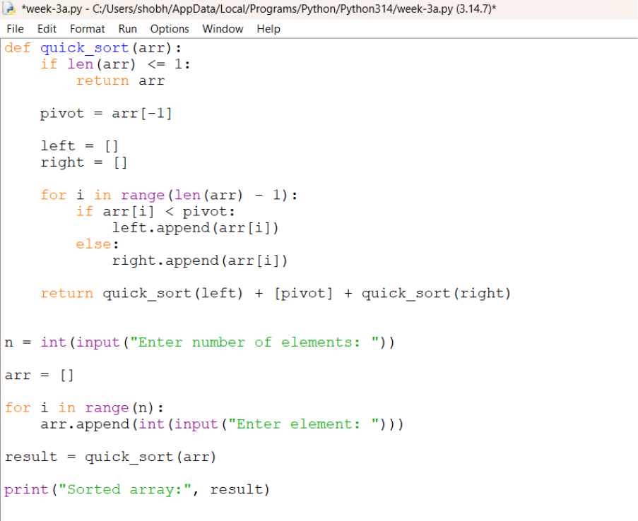

Output:
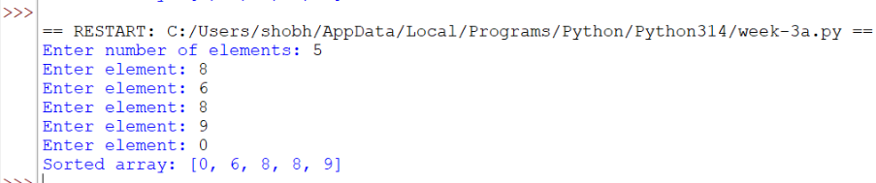

Explanation:
Condition 1: if arr[j] < pivot — Element Smaller Than Pivot
- The function partition(arr, low, high) is used to divide the array into two parts.
- pivot = arr[high] selects the last element of the array as the pivot.
- i = low - 1 is initialized to keep track of the position where elements smaller than the pivot should be placed.
- The for loop checks each element from index low to high-1.
- The condition arr[j] < pivot checks whether the current element is smaller than the pivot.
- If the condition is True, i is increased by 1.
- The current element is then swapped with the element at index i:
arr[i], arr[j] = arr[j], arr[i]
- This places all elements smaller than the pivot toward the left side.
Condition 2: arr[j] >= pivot — No Swap Required
- If arr[j] < pivot is False, it means the current element is greater than or equal to the pivot.
- No swapping is performed.
- The loop continues to check the next element.
- These elements will remain on the right side of the pivot after partitioning.
Condition 3: arr[i+1], arr[high] = arr[high], arr[i+1] — Placing the Pivot
- After all elements have been checked, the pivot is placed in its correct position.
- The pivot is swapped with the element at index i+1:
arr[i+1], arr[high] = arr[high], arr[i+1]
- After this operation:
- Elements smaller than the pivot are on the left.
- The pivot is in its correct position.
- Elements greater than or equal to the pivot are on the right.
- The function returns the pivot position:
return i+1
Condition 4: if low < high — Continue Quick Sort
- The function quick_sort(arr, low, high) is used to sort the array.
- The condition low < high checks whether the current part of the array contains more than one element.
- If the condition is True, the array needs to be sorted.
- The partition() function is called:
pi = partition(arr, low, high)
- pi stores the final position of the pivot.
Condition 5: quick_sort(arr, low, pi-1) — Sort Left Part
- After partitioning, the elements on the left side of the pivot are sorted separately.
- This is done using:
quick_sort(arr, low, pi-1)
- The pivot itself is not included because it is already in its correct position.
Condition 6: quick_sort(arr, pi+1, high) — Sort Right Part
- The elements on the right side of the pivot are sorted separately.
- This is done using:
quick_sort(arr, pi+1, high)
- Again, the pivot is not included because it is already correctly positioned.
Input Section
- n = int(input("enter the no of elements:")) takes the number of elements from the user.
- arr = [] creates an empty list to store the elements.
- The for loop runs n times and takes each element from the user:
- for i in range(n):
arr.append(int(input("enter the elements:")))
- Each entered value is converted into an integer and added to the array using append().
Calling the Quick Sort Function
quick_sort(arr, 0, n-1)
- This calls the quick_sort() function.
- 0 represents the first index of the array.
- n-1 represents the last index of the array.
- The complete array is therefore passed for sorting.
.
Error table:
sno | Error obtained | Rectification
1 | IndexError | Check i, j, and pivot boundaries
2 | Wrong swapping conditions | By shifting to the correct spaces

WEEK-4
4A). AIM: write a python program to implement a single linked list which could perform the below operations by taking an input from the user
I .create a linked list
ii. insert at beginning
iii. insert at end
iv. insert at specific index
v. delete by value
vi. delete at beginning
vii. delete at the end
viii. count no of nodes
ix. display or travsere
x. exit

Program:
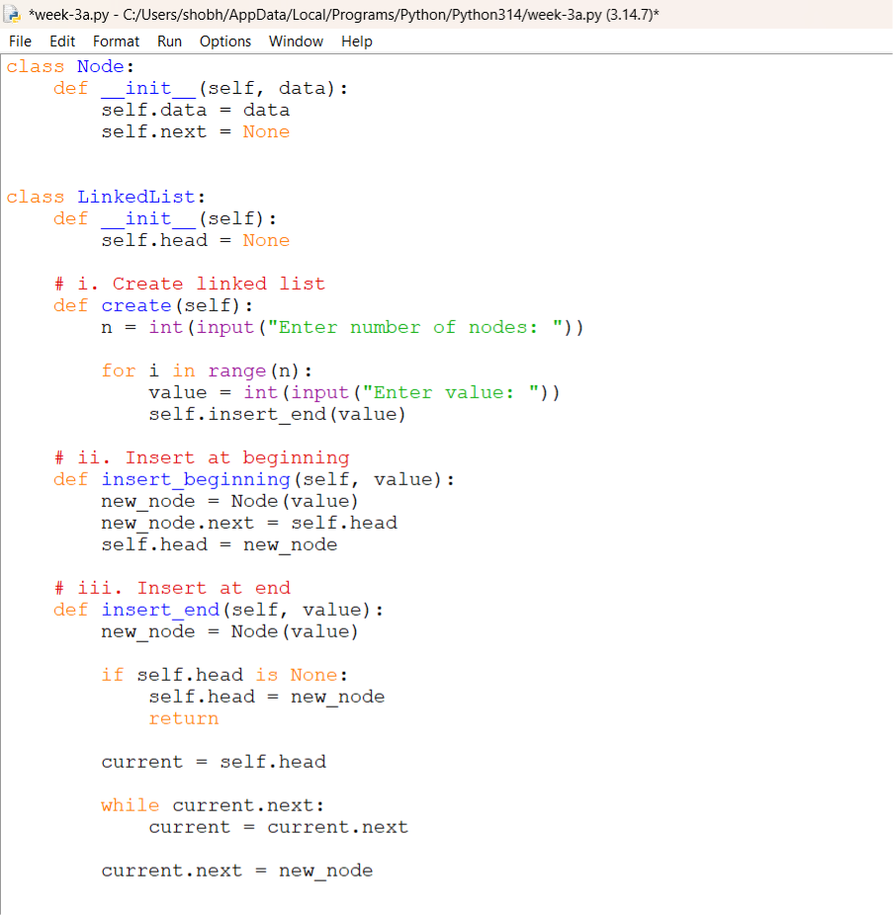
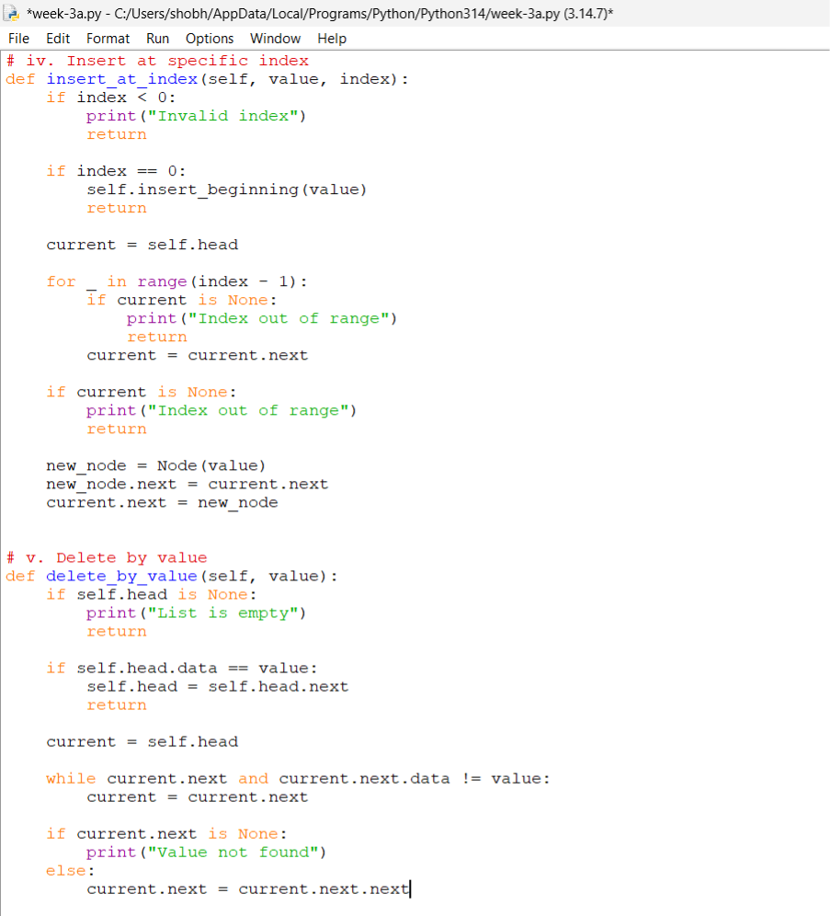
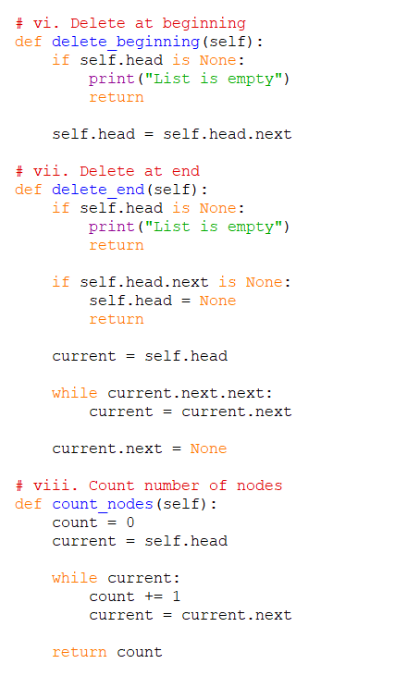
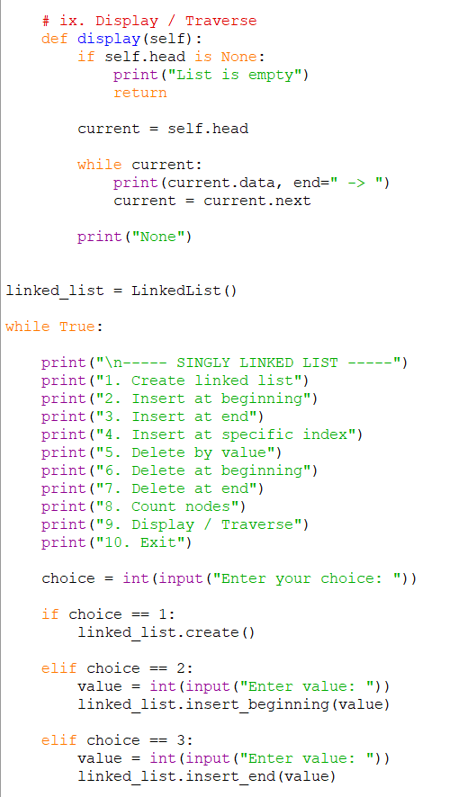

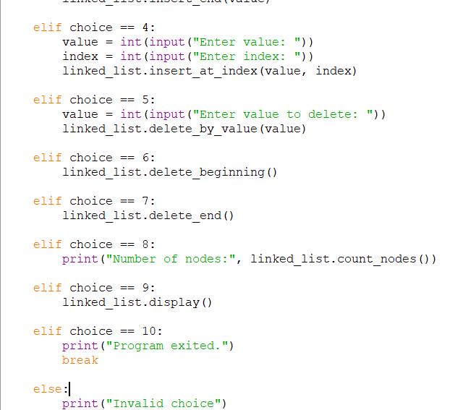

Output:
Creating a linked list
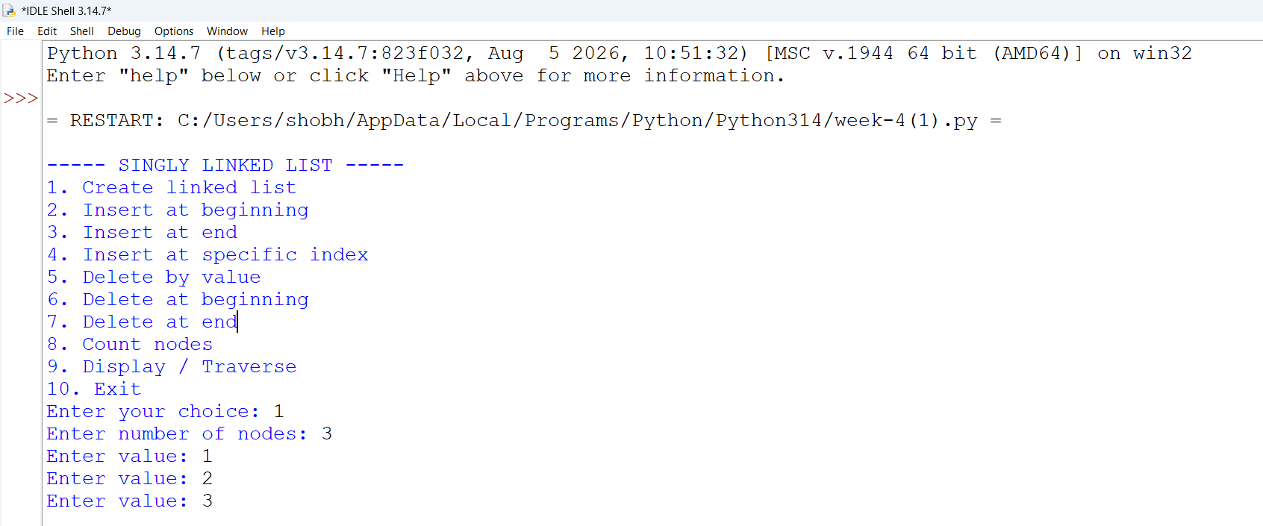

Inserting at the begininnig
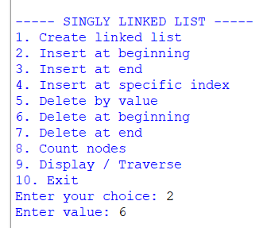

Insertion at the end:
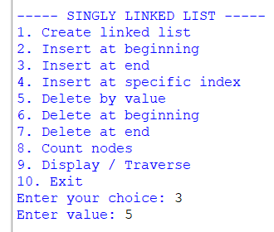
Insertion at specific index:
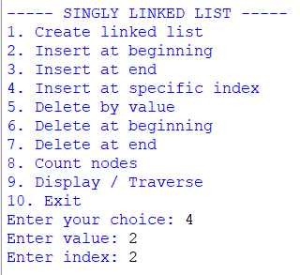

Delete at beginning:
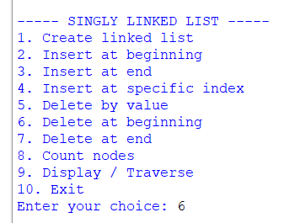

Delete at the end:
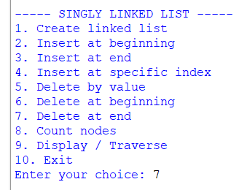
Delete at the specific index:
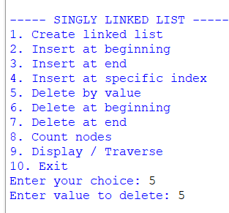

Number of nodes:
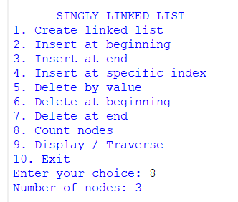

Display all the nodes:
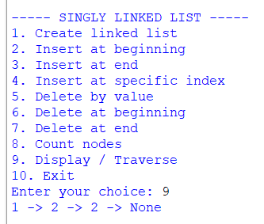

Exiting the program:
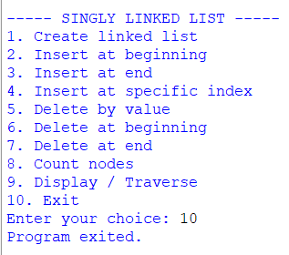

Explanation:
- A singly linked list is a collection of nodes where each node contains two parts: data and a link to the next node.
- Each node contains:
- Data – stores the value.
- Next (next) – stores the reference/address of the next node.
- The program maintains two references:
- Head – points to the first node.
- Tail – points to the last node.
- Initially, when the list is empty, both head and tail are set to None.
- A Node class is used to create individual nodes and store the data and reference to the next node.
- During creation of the linked list, the user enters the number of nodes and their data. The nodes are created one by one and added to the list.
- For the first node, both head and tail point to the same node, and the next of the tail is None.
- During insertion at the beginning, a new node is created and placed before the current head. The new node's next points to the current head, and the new node becomes the new head.
- During insertion at the end, the new node is added after the current tail. The current tail's next points to the new node, and the new node becomes the new tail.
- During insertion at a specific index, the list is traversed until the required position is reached. The new node is inserted between the appropriate nodes by adjusting their next links.
- During deletion by value, the list is searched for the node containing the given value. The node is removed by making the previous node point to the node after the deleted node.
- If the node to be deleted is the head, the next node becomes the new head.
- If the node to be deleted is the tail, the previous node becomes the new tail and its next is set to None.
- If the list contains only one node and that node is deleted, both head and tail are set to None.
- During deletion at the beginning, the head node is removed and the next node becomes the new head.
- During deletion at the end, the list is traversed to find the node before the tail. That node becomes the new tail and its next is set to None.
- The count operation traverses the list from the head to the end and counts the total number of nodes.
- The display/traverse operation starts from the head and moves through the list using the next link until None is reached.
20.The program continues to execute until the user selects the Exit option.
Error table:
sno | Error obtained | rectification
1 | Infinite loop or incomplete traversal due to not updating current | Move to the next node using temp = temp.next
2 | Forgetting to update head while inserting/deleting at the beginning | Update head to point to the new first node using head = new_node or head = head.next

4B). AIM: write a python program to implement a double linked list which could perform the below operations by taking an input from the user
I .create a linked list
ii. insert at beginning
iii. insert at end
iv. insert at specific index
v. delete by value
vi. delete at beginning
vii. delete at the end
viii. count no of nodes
ix. display or travsere
x. exit
Program:
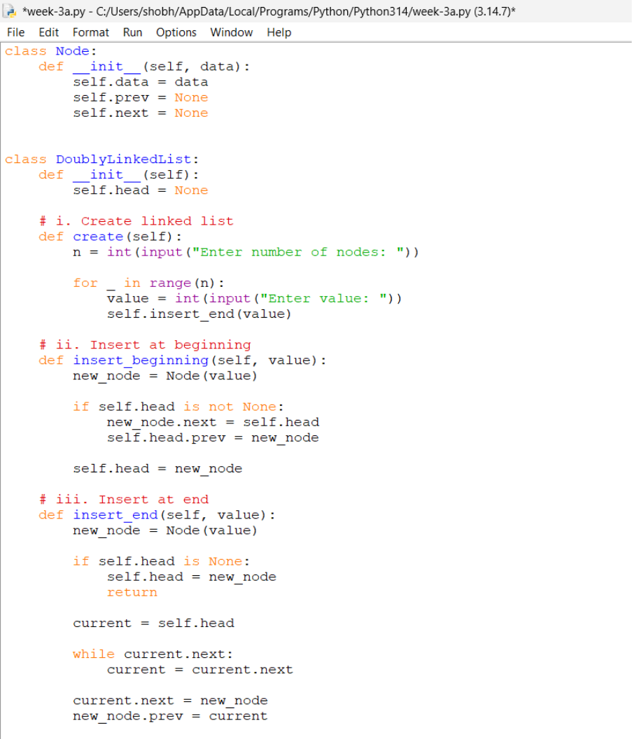

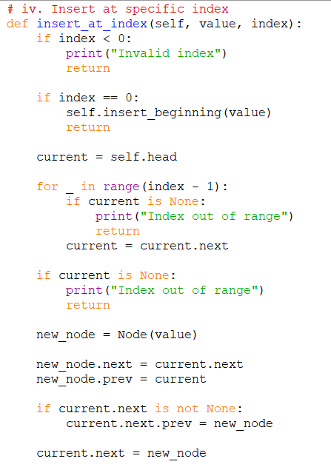
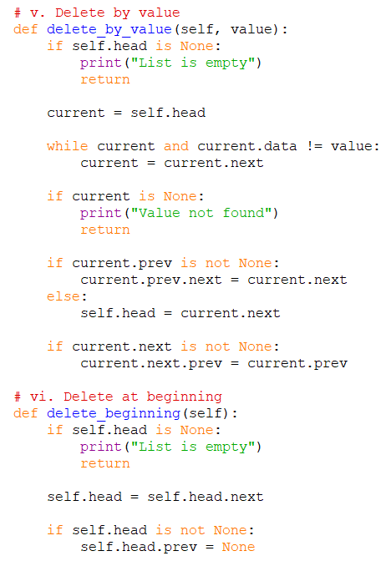
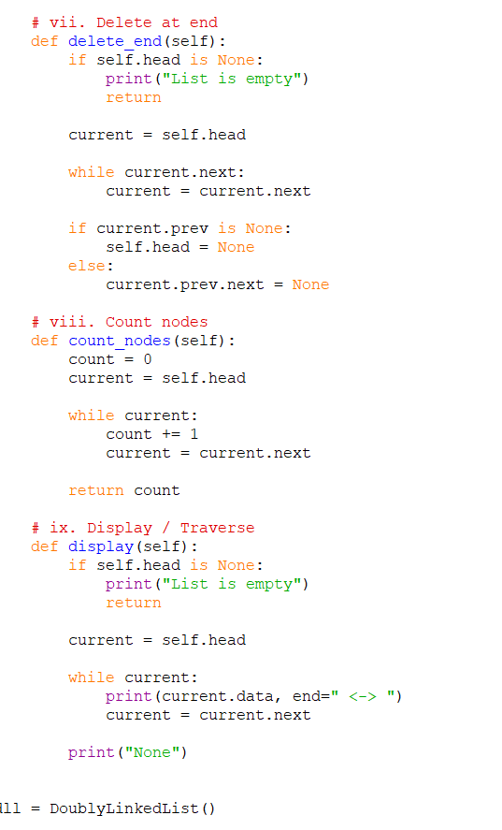
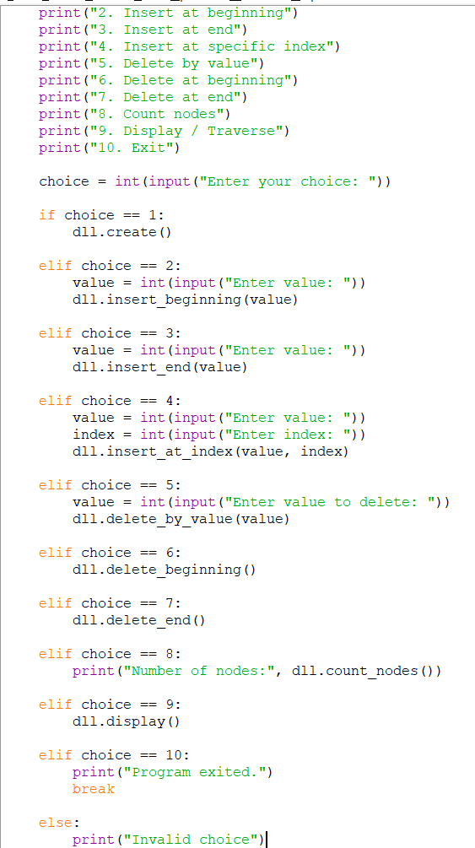

Output:
Creating a linked list:
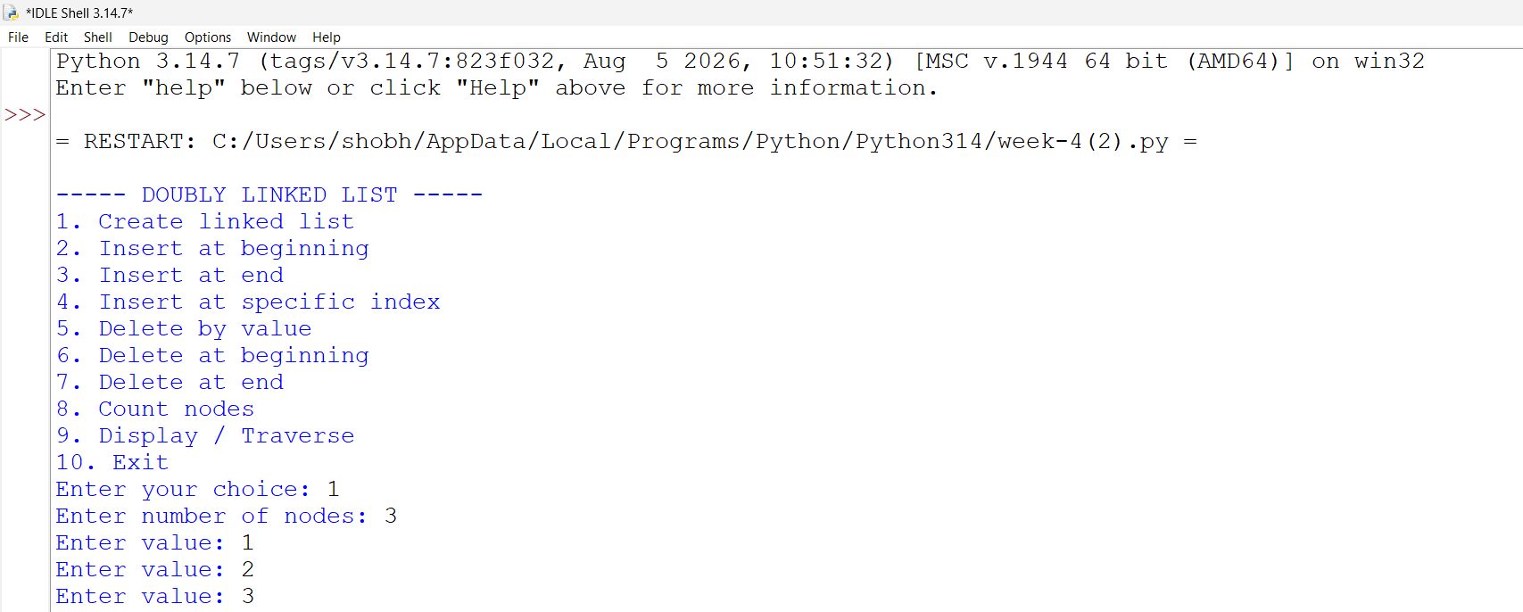
Inserting at the beginning:
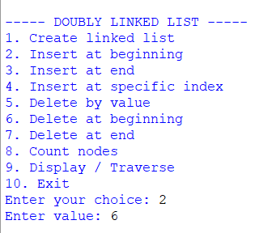
Insert at the end:
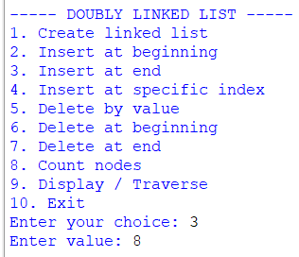

Insert at the specific index:

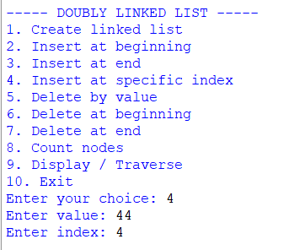

Delete By value
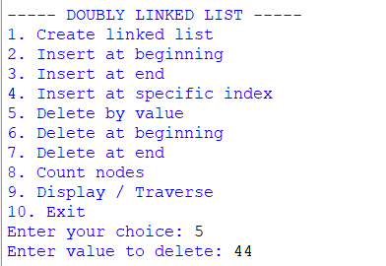

Delete at the beginning:
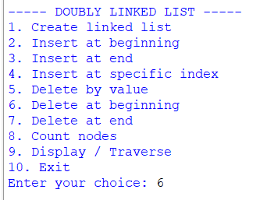

Delete at the end:
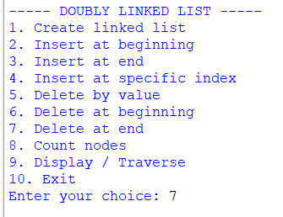
Number of nodes:
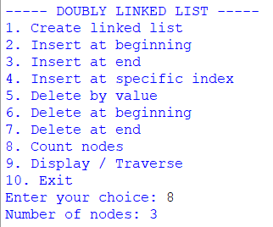
Display the nodes:
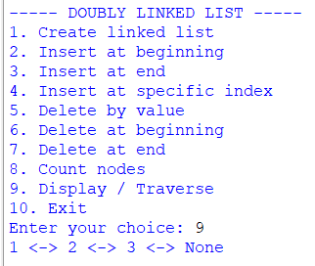

Exiting the program:
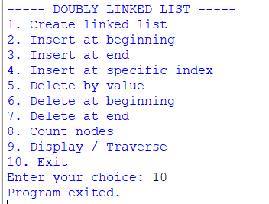
Explanation:
- A doubly linked list is a collection of nodes where each node contains three parts: data, a link to the previous node, and a link to the next node.
- Each node has:
- Data – stores the value.
- Previous (prev) – points to the previous node.
- Next (next) – points to the next node.
- The program maintains two references:
- Head – points to the first node.
- Tail – points to the last node.
- Initially, when the list is empty, both head and tail are set to None.
- A Node class is used to create individual nodes and maintain the data, prev, and next references.
- During creation of the linked list, the user enters the number of nodes and their data. The nodes are added one by one at the end of the list.
- For the first node, both head and tail point to the same node. The prev of the head and the next of the tail are None.
- During insertion at the beginning, a new node is created and placed before the current head. The new node becomes the head, its next points to the previous head, and the previous head's prev points back to the new node.
- During insertion at the end, the new node is placed after the current tail. The new node's prev points to the old tail, the old tail's next points to the new node, and the new node becomes the tail.
- During insertion at a specific index, the list is traversed until the required position is reached. The new node is inserted between the previous and next nodes, and both prev and next links are updated.
- During deletion by value, the list is searched for the node containing the given value. Once found, its previous and next nodes are connected to each other, removing the selected node from the list.
- If the node to be deleted is the head, the next node becomes the new head and its prev is set to None.
- If the node to be deleted is the tail, the previous node becomes the new tail and its next is set to None.
- If the list contains only one node and that node is deleted, both head and tail are set to None.
- During deletion at the beginning, the head node is removed and the next node becomes the new head. The new head's prev is set to None.
- During deletion at the end, the tail node is removed and the previous node becomes the new tail. The new tail's next is set to None.
- The count operation traverses the list from the head to the tail and counts the total number of nodes.
- The display/traverse operation starts from the head and moves forward using the next link to display all the nodes.
- Since it is a doubly linked list, the program can also traverse the list backwards, starting from the tail and using the prev links.
- The program displays the head and tail values to show the starting and ending nodes of the list.
- The important relationships maintained in a doubly linked list are:
head.prev = None
tail.next = None
- The overall structure of a doubly linked list is:
None ← [10] ⇄ [20] ⇄ [30] ⇄ [40] → None
↑ ↑
HEAD TAIL
- The arrows in both directions allow the list to be traversed forward as well as backward.
- The program is menu-driven, allowing the user to perform creation, insertion, deletion, counting, displaying, and other operations repeatedly until the Exit option is selected.
Error table:
Sno | Error obtained | Rectification
1 | Forgetting to update the prev pointer | Update both prev and next pointers whenever a node is inserted
2 | Incorrect head.prev | Maintain head.prev = None

4C). AIM: write a python program to implement a circular linked list which could perform the below operations by taking an input from the user
I .create a linked list
ii. insert at beginning
iii. insert at end
iv. insert at specific index
v. delete by value
vi. delete at beginning
vii. delete at the end
viii. count no of nodes
ix. display or travsere
x: display the head and tail
xi. exit

Program:
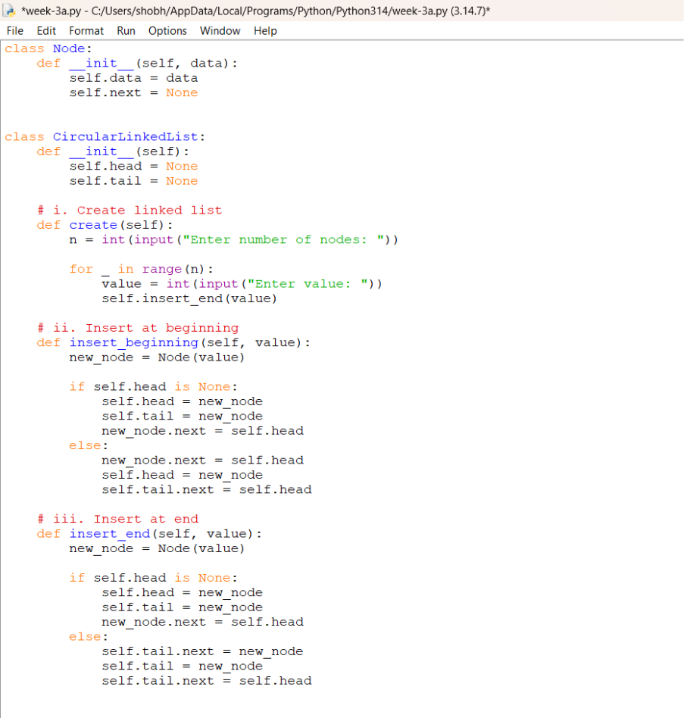
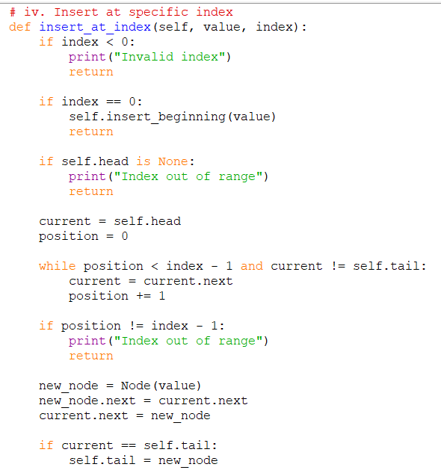
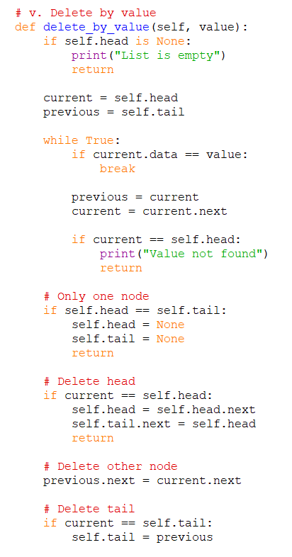
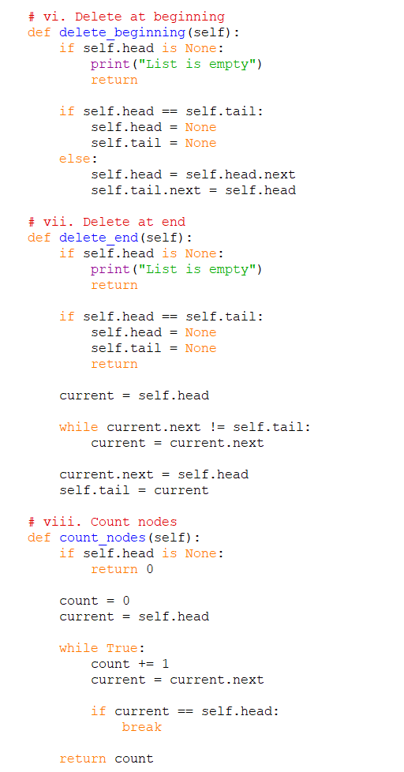
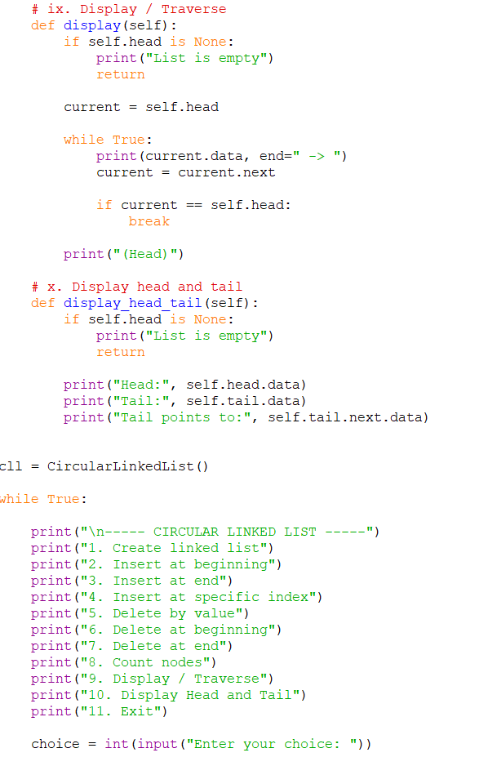
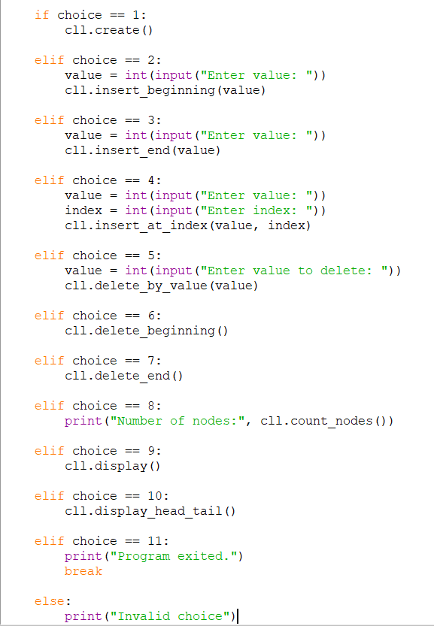

Output:
Creating a linked list:
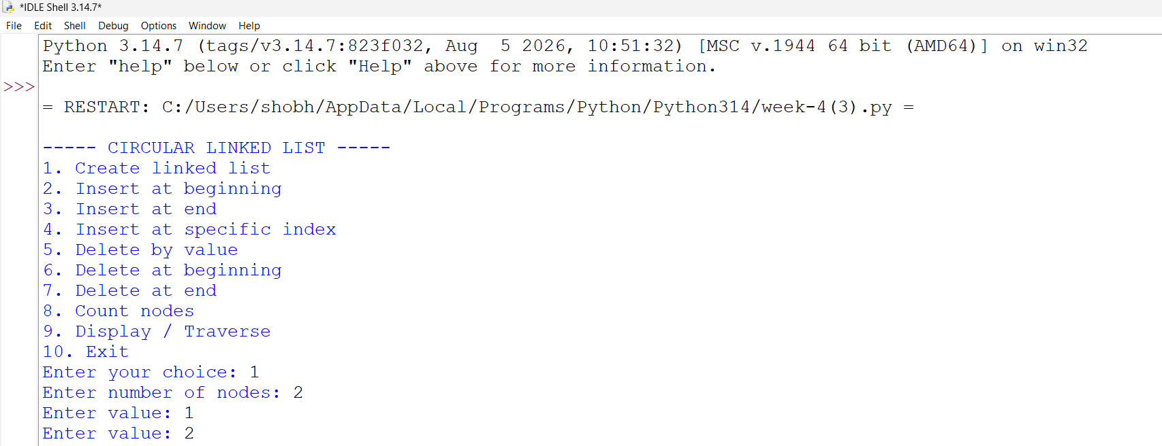
Inserting at the beginning:
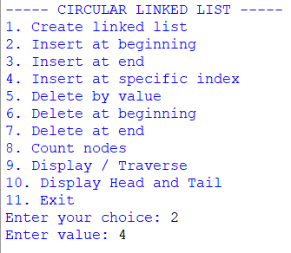
Insert at the end:
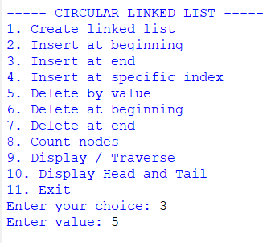
Insert at the specific index:
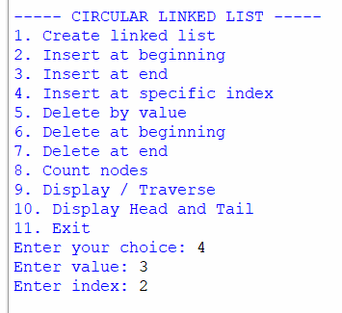
Delete by value:
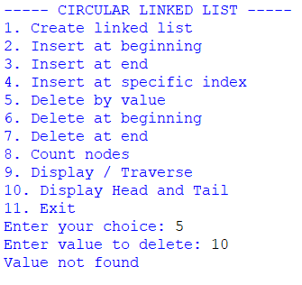
Delete at the beginning:
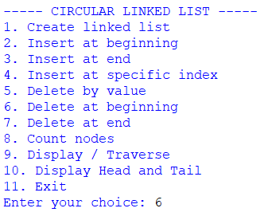

Delete at the end:
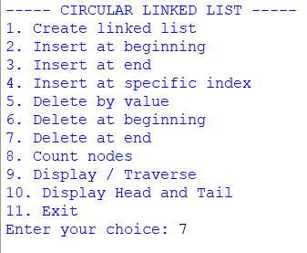
Number of nodes:
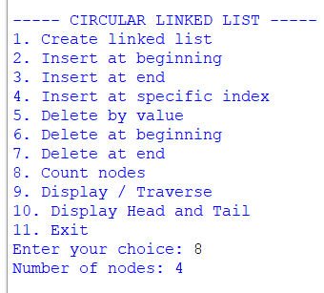

Display all the nodes:
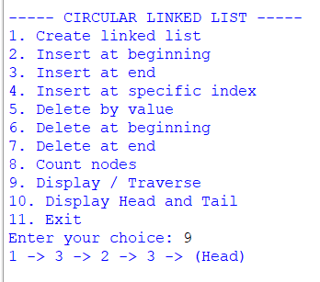

Display the head and the tail
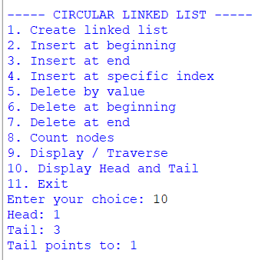
Exit: the program:
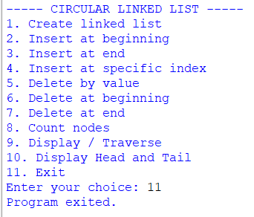
Explanation :
- A circular singly linked list is a collection of nodes where each node contains data and a link to the next node.
- In a circular linked list, the last node points back to the first node (head) instead of pointing to None.
- The program uses two references:
- Head – points to the first node.
- Tail – points to the last node.
- Initially, when the list is empty, both head and tail are set to None.
- A Node class is used to create individual nodes and store the data and reference to the next node.
- During creation of the linked list, the user enters the number of nodes and their data. Each new node is inserted at the end of the list.
- If the list is empty, the first node becomes both the head and tail, and its next points back to itself.
- During insertion at the beginning, the new node is placed before the current head. The new node becomes the head, and the tail is connected to the new head.
- During insertion at the end, the new node is added after the current tail. The new node becomes the tail, and its next points to the head.
- During insertion at a specific index, the list is traversed until the required position is reached, and the new node is inserted between two existing nodes.
- During deletion by value, the list is searched for the node containing the given value. The node is removed by connecting its previous node directly to its next node.
- If the node to be deleted is the head, the next node becomes the new head and the tail is connected to it.
- If the node to be deleted is the tail, the previous node becomes the new tail and its next is connected to the head.
- During deletion at the beginning, the head node is removed and the next node becomes the new head.
- During deletion at the end, the node before the tail is found and made the new tail.
- The count operation traverses the list and counts all the nodes. Traversal stops when the head is reached again.
- The display/traverse operation starts from the head and visits every node until it reaches the head again.
- Since the list is circular, traversal does not use current != None. Instead, it stops when current becomes equal to head.
- The program also displays the head, tail, and tail.next to show the circular connection.
- The program is menu-driven, so the user can repeatedly perform different operations until the Exit option is selected.
- The most important property maintained throughout the program is:
tail.next = head
- Thus, the structure of the circular linked list is:
HEAD → Node → Node → Node → TAIL
↑ |
|______________________________|
This ensures that the linked list remains circular after every insertion and deletion operation.
Error table:
sno | Error obtained | Rectification
1 | Using temp != None as the traversal condition | Stop traversal when temp == head
2 | Forgetting to update tail.next when the head changes | After changing the head, update tail.next = head

WEEK-5:
5A). Aim: write a python program to implement the stack using the arrays. And also implement stack operations such as push, pop, peek and also display the stack elements.
Program:
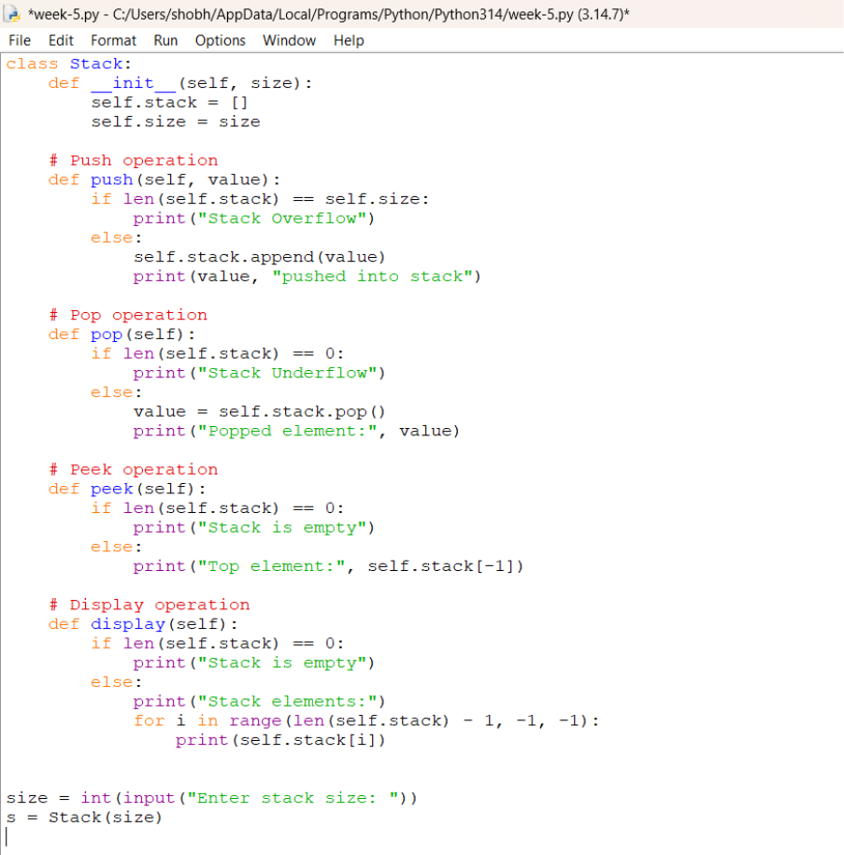
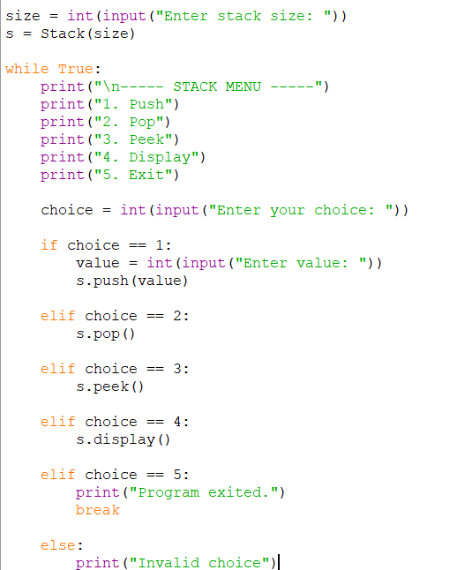

OUTPUT:
Pushing an element into the stack
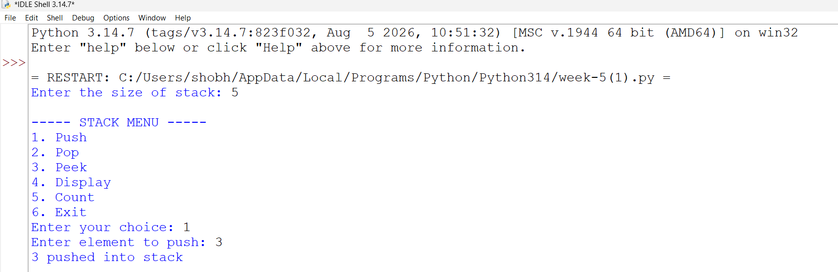

Popping an element from the stack
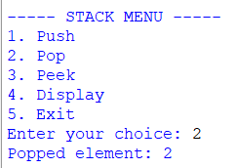
Peek element
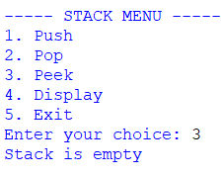
Display all the elements in the stack
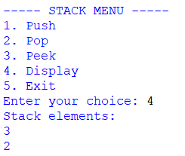
Exiting the program
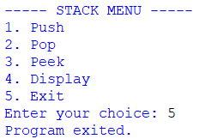
Explanation:
1. Class and Initialization
- A class named Stack is created.
- The __init__() method acts as the constructor.
- An empty list self.stack is created to store stack elements.
- The stack follows the LIFO (Last In, First Out) principle.
2. Push Operation
- The push() method is used to insert an element into the stack.
- The append() function adds the element to the end of the list.
- The newly inserted element becomes the top element.
- A message is displayed after the element is inserted.
3. Pop Operation
- The pop() method is used to remove the top element.
- The program first checks whether the stack is empty.
- If the stack is empty, Stack Underflow is displayed.
- Otherwise, the pop() function removes the last element.
- The removed element is displayed.
4. Peek Operation
- The peek() method is used to view the top element.
- The program checks whether the stack is empty.
- If the stack is empty, Stack is empty is displayed.
- Otherwise, self.stack[-1] is used to access the top element.
- The top element is displayed without removing it.
5. Display Operation
- The display() method is used to display all stack elements.
- The program first checks whether the stack is empty.
- If empty, Stack is empty is displayed.
- Otherwise, a for loop is used to traverse the stack.
- The elements are displayed from top to bottom.
6. Count Operation
- The count() method is used to find the number of elements in the stack.
- The len() function returns the number of elements.
- The count is displayed to the user.
Error table:
sno | Error obtained | Error rectification
1 | Stack underflow | Check whether the stack is empty before poping
2 | Name error | Define the class before creating the object

5B). Aim: write a python program to implement the stack using the linked list. And also implement stack operations such as push, pop, peek,count and also display the stack elements.
Program:
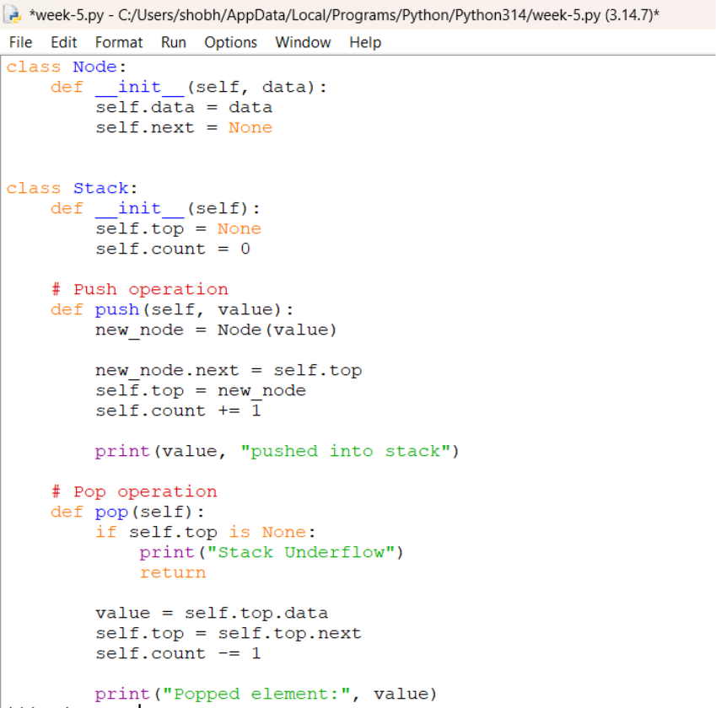

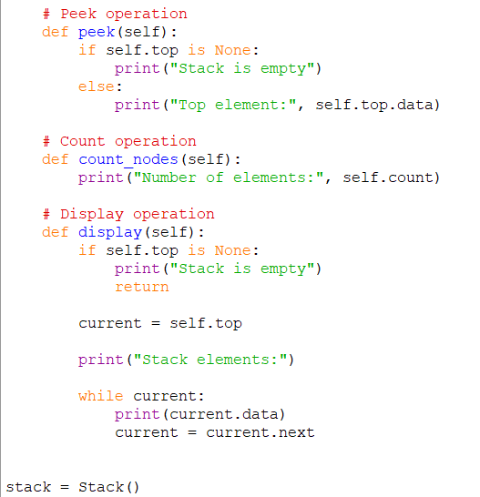
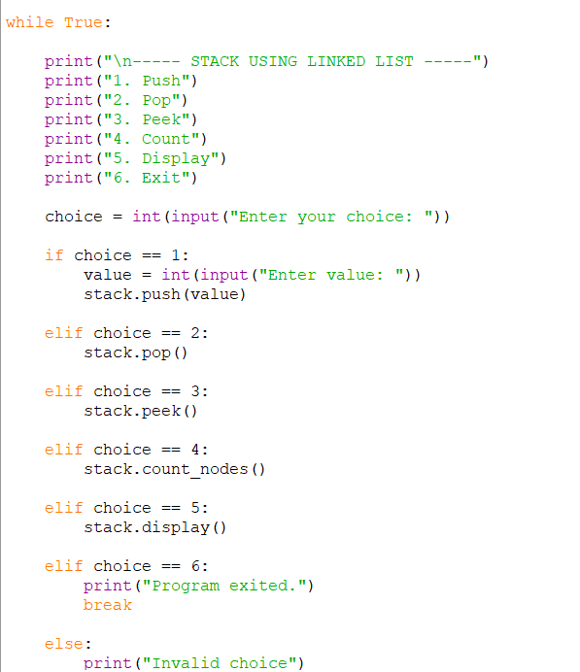

Output:
Pushing an element into the stack
=RESTART: C:\Users\shobh\AppData\Local\Programs\Python\Python314\week 6.py =
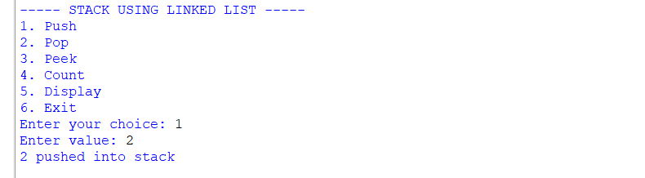

Poping an element from the stack
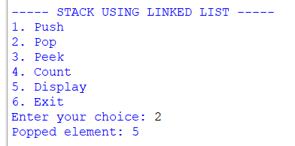
Peek element
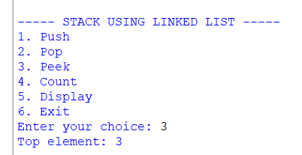
Display all the elements in the stack
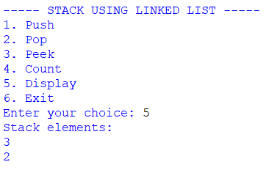
count
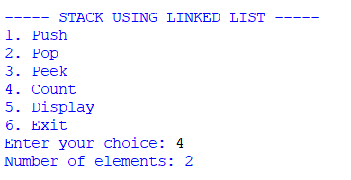

Exiting the program
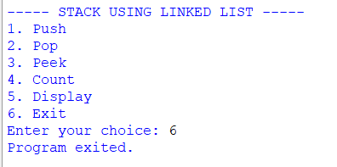
Explanation:
1. Node Class
- A class named Node is created to represent each element of the linked list.
- The __init__() method initializes a node.
- self.data stores the value of the node.
- self.next stores the reference to the next node.
- Initially, self.next is set to None.
2. Stack Class
- A class named Stack is created to implement the stack operations.
- The __init__() method initializes the stack.
- self.top = None indicates that the stack is initially empty.
- The top variable stores the reference to the top node of the stack.
3. Push Operation
- The push() method is used to insert an element into the stack.
- A new node is created using Node(data).
- The new node is connected to the current top node using:
new_node.next = self.top
- The new node is then made the top node using:
self.top = new_node
- The inserted element is displayed.
- The operation follows the LIFO (Last In, First Out) principle.
4. Pop Operation
- The pop() method is used to remove the top element.
- The program first checks whether self.top is None.
- If self.top is None, the stack is empty and Stack Underflow is displayed.
- Otherwise, the data of the top node is stored in data.
- The top is moved to the next node using:
self.top = self.top.next
- The removed element is displayed.
5. Peek Operation
- The peek() method is used to view the top element without removing it.
- The program checks whether the stack is empty.
- If the stack is empty, Stack is empty is displayed.
- Otherwise, self.top.data is used to display the top element.
- The stack remains unchanged after the peek operation.
6. Display Operation
- The display() method is used to display all the elements of the stack.
- The program first checks whether the stack is empty.
- A temporary variable current is initialized with self.top.
- A while loop is used to traverse the linked list.
- current.data displays the value of each node.
- current = current.next moves to the next node.
- The elements are displayed from top to bottom.
7. Count Operation
- The count() method is used to find the number of elements in the stack.
- A variable count is initialized to 0.
- A temporary variable current starts from self.top.
- The linked list is traversed using a while loop.
- The count value is increased for every node.
- The total number of elements is displayed.

Error table:
sno | Error obtained | Error rectification
1 | Incorrect push | Set new_node.next = self.top before updating self.top
2 | Infinte loop | Use break when choice == 6

WEEK-6
Aim : Write a python program to implement a queue using an Array, Linked list, circular queue. Implement the queue operations such as enqueue, dequeue, peak and also display the queue elements.
Program: Circular Queue

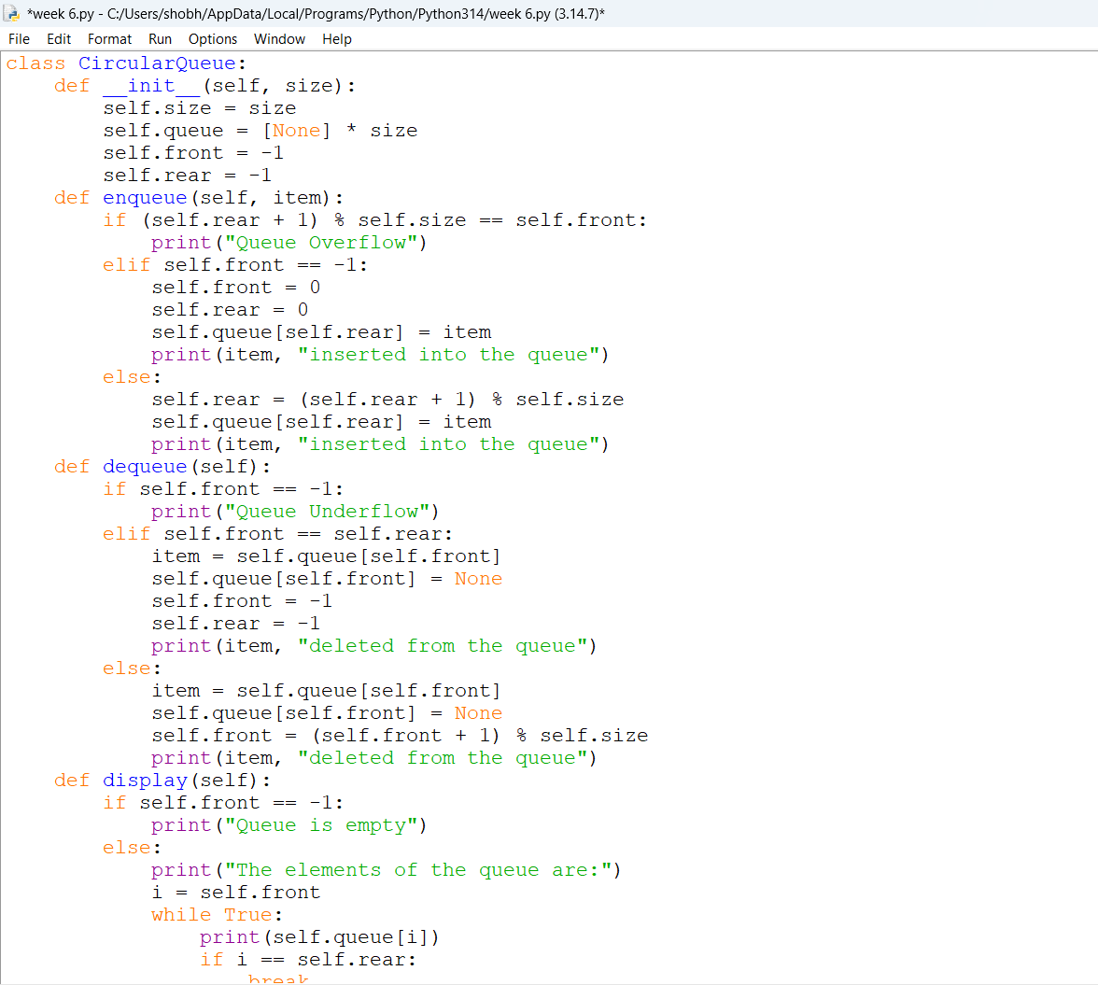
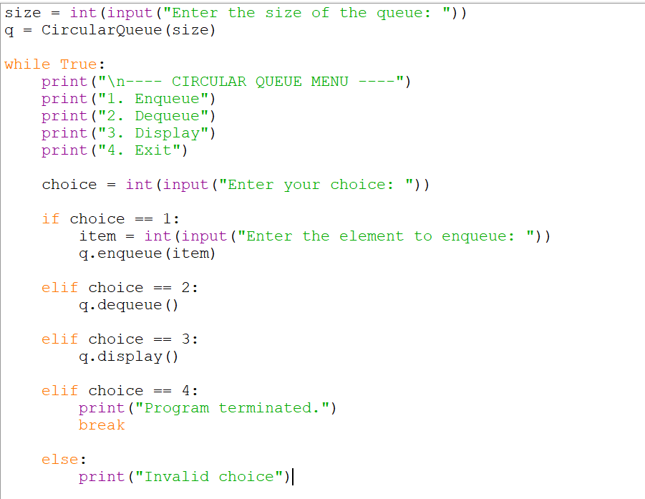

Output:
Positive case:
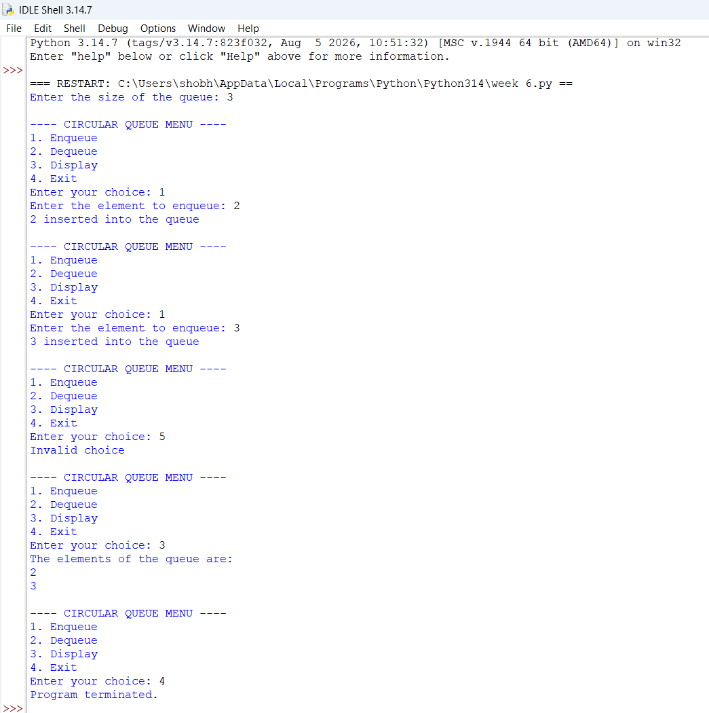

Negative case:
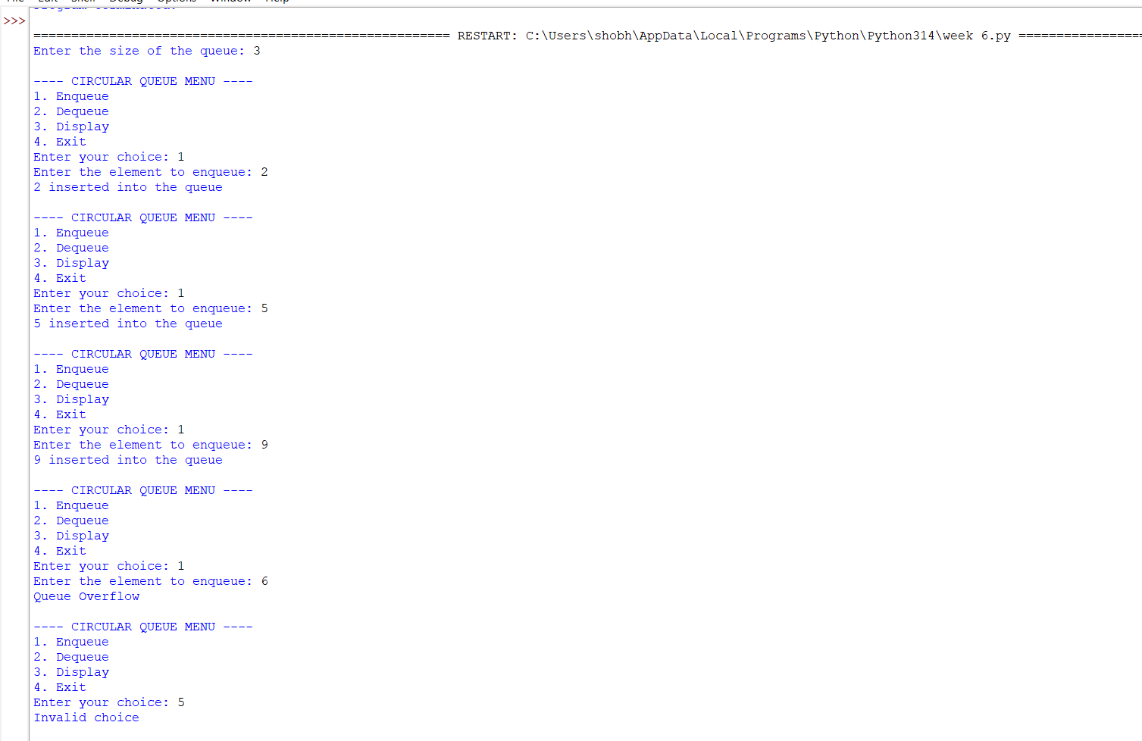
Explanation:
Queue Using Array
Structure:
- Uses a Python list self.queue to store elements.
- self.front keeps track of the first element in the queue.
- self.rear keeps track of the last element in the queue.
- self.size defines the maximum capacity of the queue.
- Initially:
  - front = -1
  - rear = -1
Operations:
1. Enqueue
- Check if rear == size - 1 → Overflow (queue is full).
- If the queue is empty, set front = 0.
- Increment rear.
- Insert the element at rear.
2. Dequeue
- Check if front == -1 or front > rear → Underflow (queue is empty).
- Remove the element at front.
- Increment front.
- If the queue becomes empty, reset front and rear to -1.
3. Peek
- Shows the element at front without removing it.
- If the queue is empty → Underflow/empty message.
4. Display
- Prints elements from front to rear.
- Elements are displayed in front-to-rear order.
Important Points:
- Queue follows FIFO (First In, First Out).
- Insertion takes place at the rear.
- Deletion takes place at the front.
- Overflow → queue is full.
- Underflow → queue is empty.

ERROR TABLE:
S.NO | Error Obtained | Rectification
1. | Display on empty circular queue. | Add condition: if self.front == -1: → print "Queue is empty".
2. | Circular Queue Overflow | Add a check: if (self.rear + 1) % self.size == self.front: → print "Circular Queue Overflow".
3. | Circular Queue Underflow | Add a check: if self.front == -1: → print "Circular Queue Underflow".
4. | rear does not wrap around to the beginning of the array. | Update using: self.rear = (self.rear + 1) % self.size.

Program: Using Array

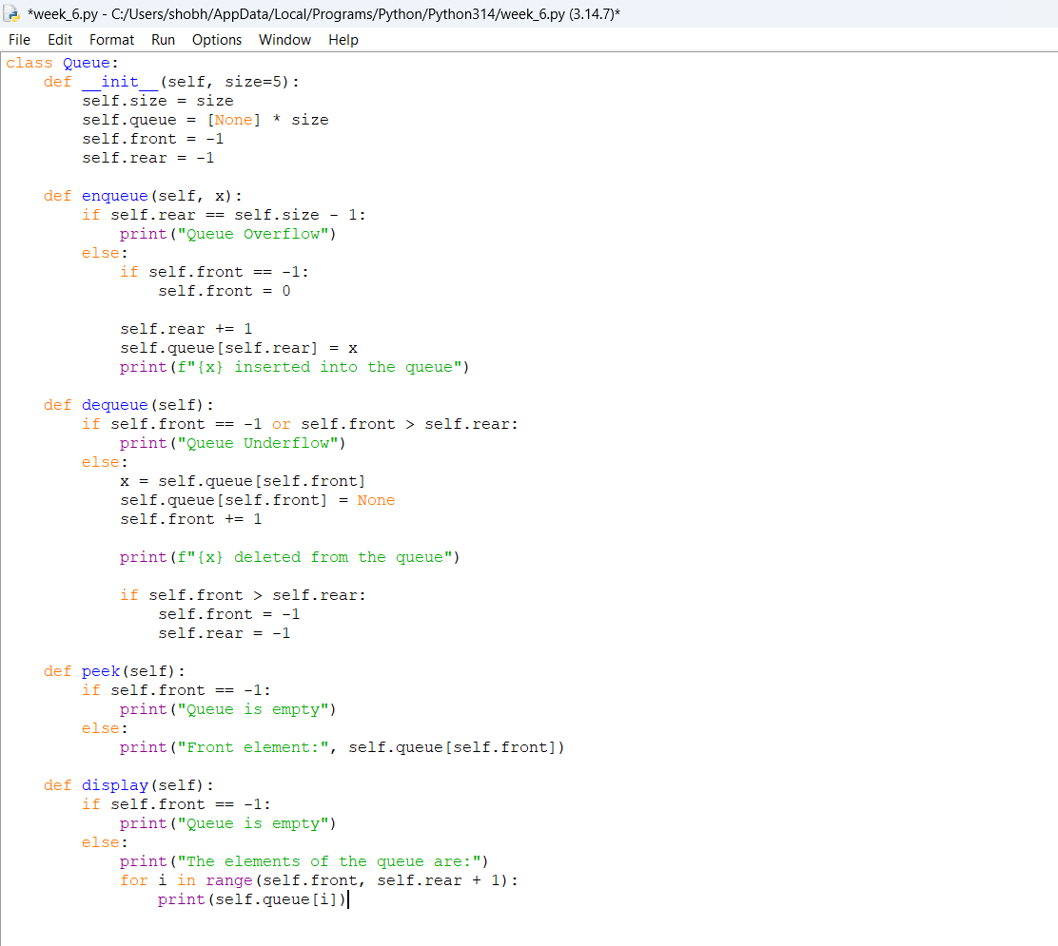

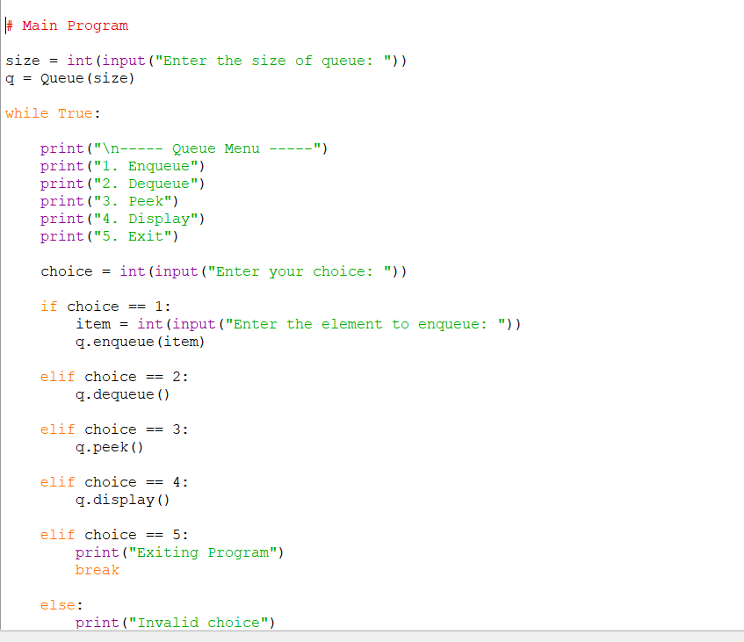

Output:
Positive case:
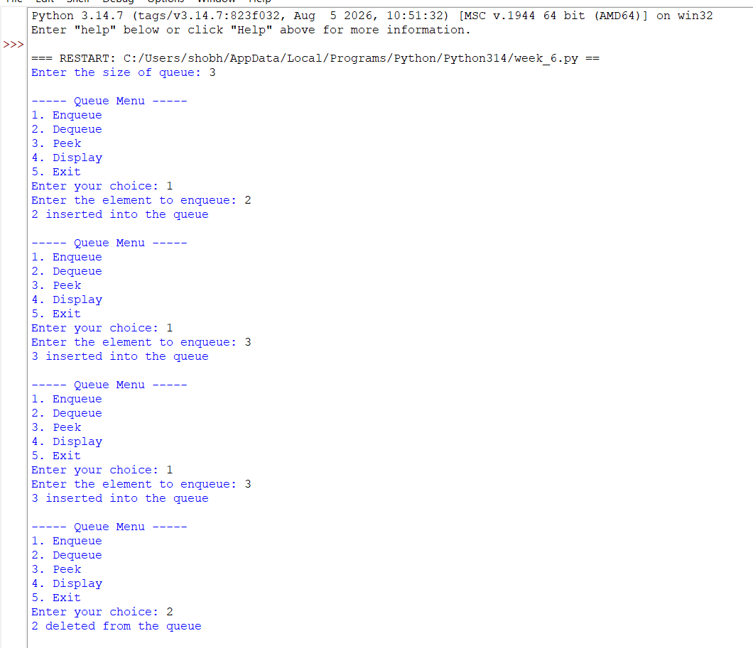
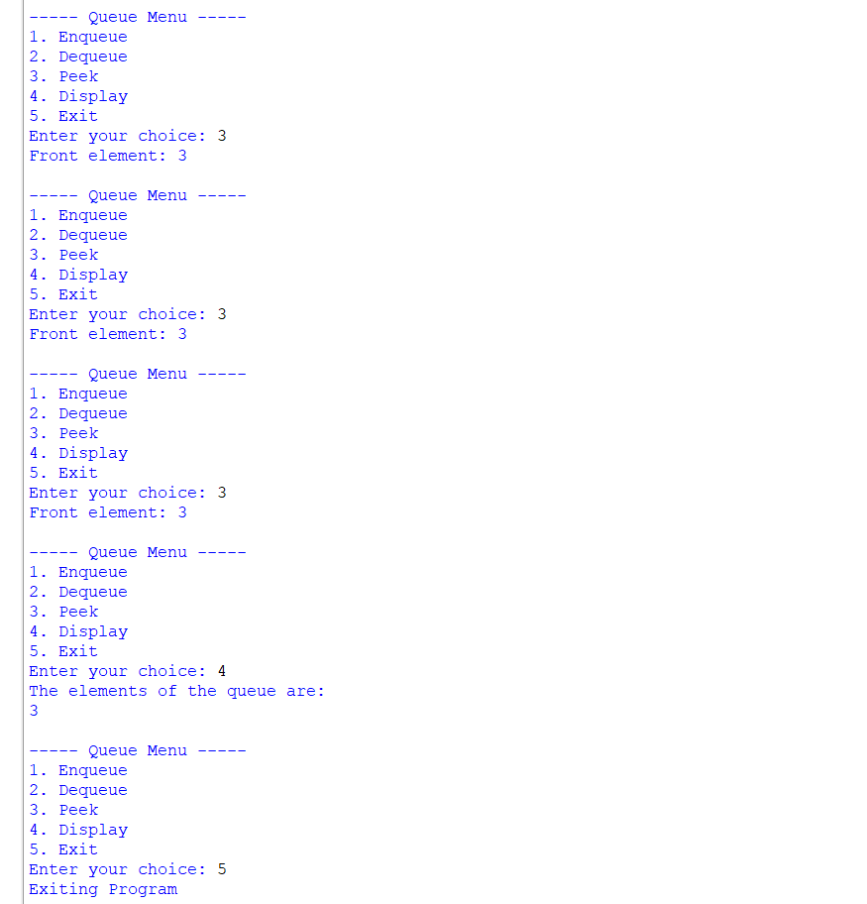

Negative case:
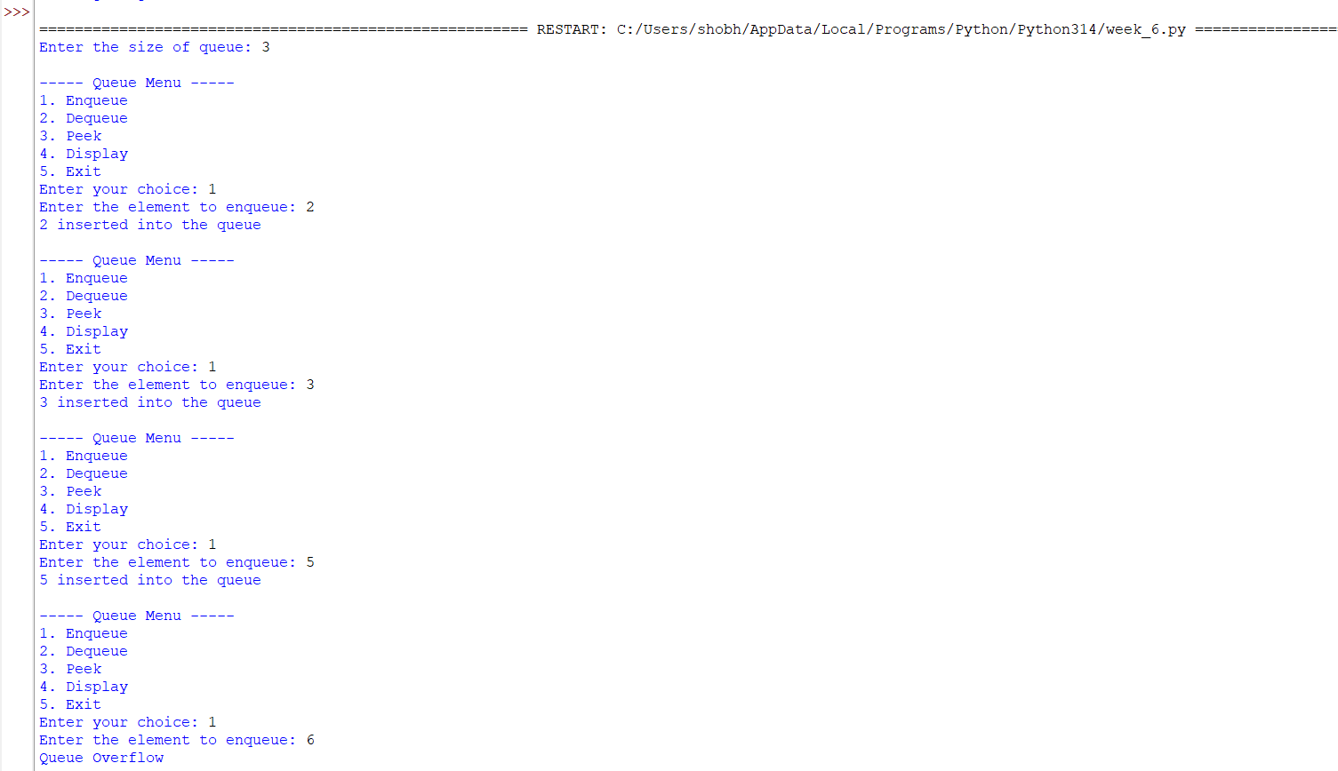

Explanation:
Queue Using Linked List
Structure:
- Each element is represented using a Node.
- Each Node contains:
  - data → stores the value.
  - next → points to the next node.
- self.front points to the first node.
- self.rear points to the last node.
- Initially:
  - front = None
  - rear = None
Operations:
1. Enqueue
- Create a new node.
- If the queue is empty:
  - Set both front and rear to the new node.
- Otherwise:
  - Link rear.next to the new node.
  - Update rear to the new node.
2. Dequeue
- Check if front is None → Underflow.
- Store/remove the node at front.
- Move front to front.next.
- If front becomes None, set rear = None.
3. Peek
- Shows the data stored at front without removing it.
- If front is None, the queue is empty.
4. Display
- Start from front.
- Traverse using next.
- Print each element until None.
Important Points:
- Follows FIFO.
- Insertion → rear.
- Deletion → front.
- No fixed size is required.
- Memory is allocated dynamically.
ERROR TABLE: QUEUE USING LINKED LIST
S.NO | Error Obtained | Rectification
1. | Display on empty queue. | Add condition: if self.front is None: → print "Queue is empty".
2. | Queue Underflow when deleting from an empty queue. | Add a check: if self.front is None: → print "Queue Underflow".
3. | First node inserted without updating front and rear. | If the queue is empty, set self.front = self.rear = new.
4. | rear not updated after insertion. | Update using self.rear = new after linking the new node.

Program: Using Linked List:
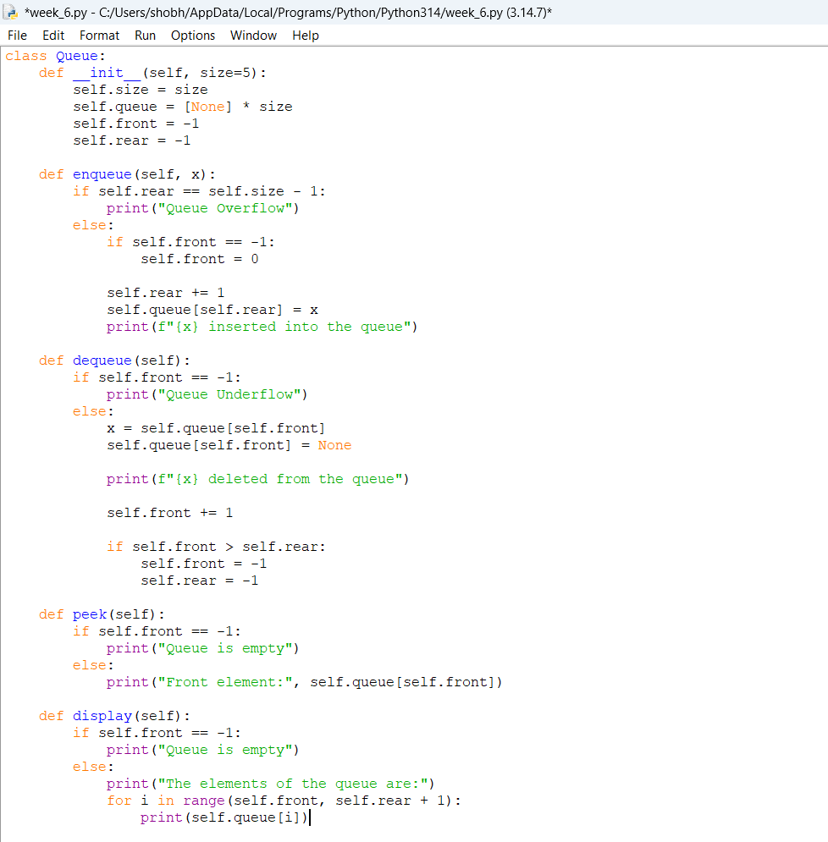
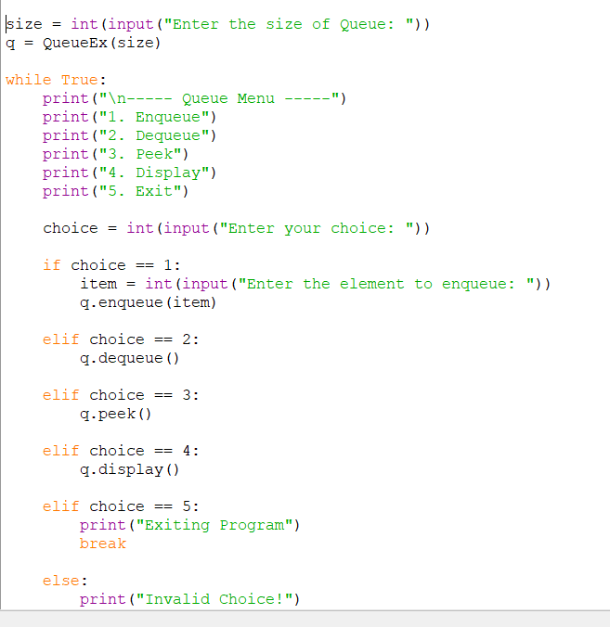

Output:
Positive case:
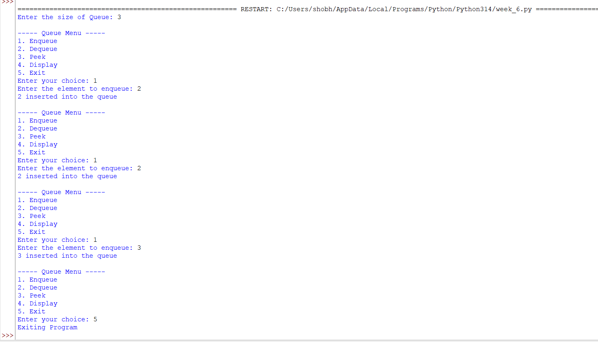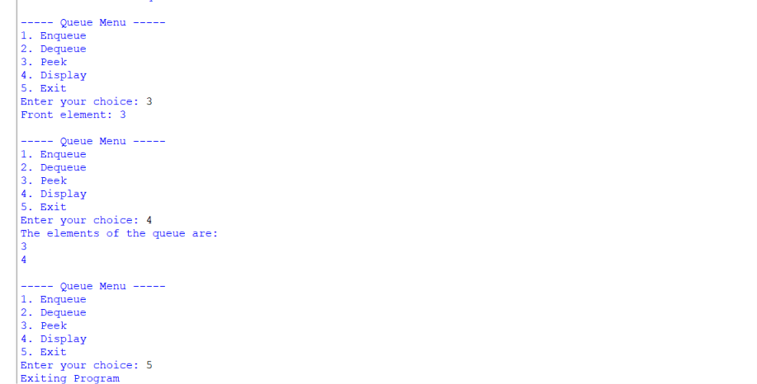

Negative case:
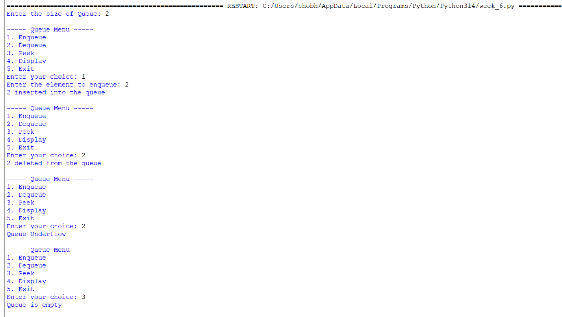
Explanation:
Circular Queue Using Array
Structure:
- Uses a Python list self.queue to store elements.
- self.front points to the first element.
- self.rear points to the last element.
- self.size defines the maximum capacity.
- When rear reaches the last index, it can wrap around to index 0.
- This allows previously freed positions to be reused.
Operations:
1. Enqueue
- Check if (rear + 1) % size == front → Overflow (circular queue is full).
- If the queue is empty:
  - Set front = 0
  - Set rear = 0
- Otherwise:
  - Move rear using:
rear = (rear + 1) % size
- Insert the element at rear.
2. Dequeue
- Check if front == -1 → Underflow.
- Remove the element at front.
- If front == rear:
  - The queue becomes empty.
  - Set front = -1 and rear = -1.
- Otherwise:
  - Move front using:
front = (front + 1) % size
3. Peek
- Shows the element at front without removing it.
- If front == -1, the queue is empty.
4. Display
- Start from front.
- Move towards rear.
- Use modulo % size to wrap around to the beginning of the array.
Important Points:
- Follows FIFO.
- Insertion → rear.
- Deletion → front.
- The last position connects logically back to the first position.
- Unused spaces can be reused, unlike a simple linear array queue.
- Overflow occurs when the next rear position becomes the front.

Error Table:
S.NO | Error Obtained | Rectification
1. | Display on empty queue. | Add condition: if self.front == -1: → print "Queue is empty".
2. | Queue Overflow when inserting beyond the defined size. | Add a check: if self.rear == self.size - 1: → print "Queue Overflow".
3. | Queue Underflow when deleting from an empty queue. | Add a check: if self.front == -1 or self.front > self.rear: → print "Queue Underflow".
4. | First element inserted without setting front. | If the queue is empty, set self.front = 0 before increasing rear.

WEEK-7:
7A).AIM: awrite a python program to implement binary search tree using an array with all its operations.
Program:

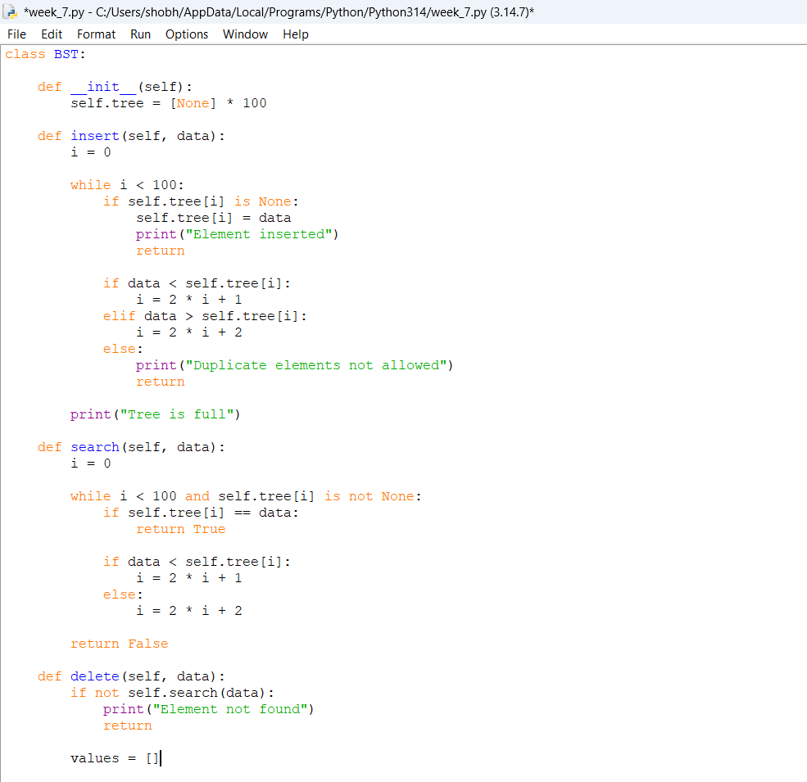
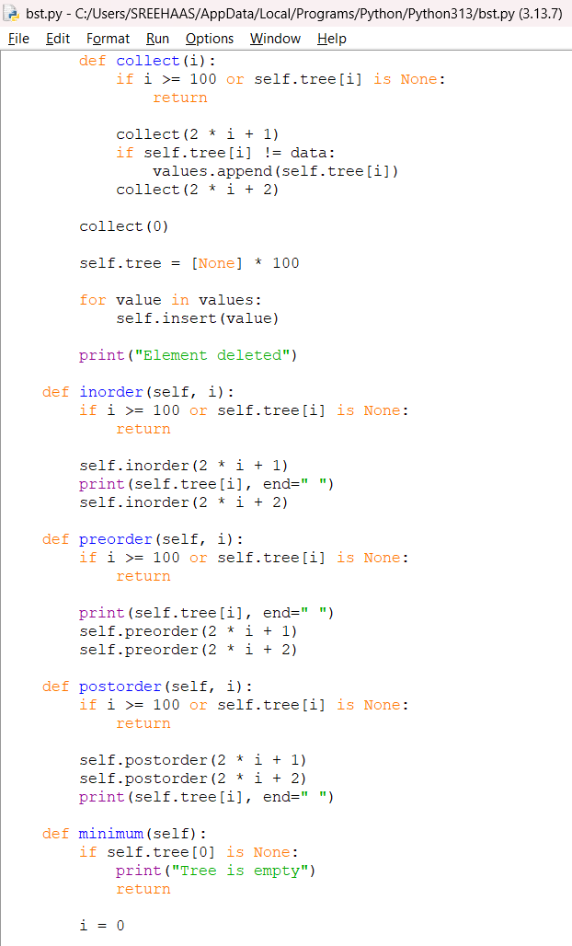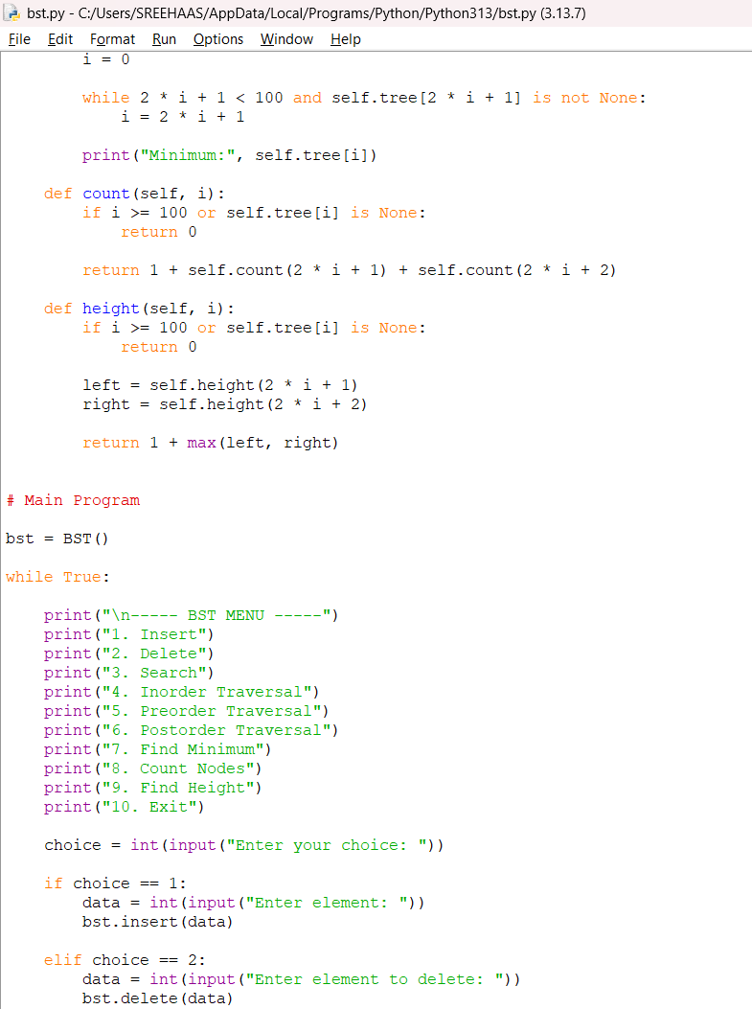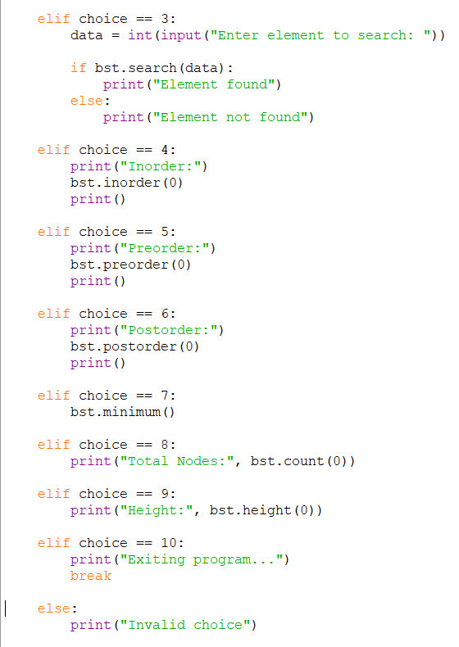
output:
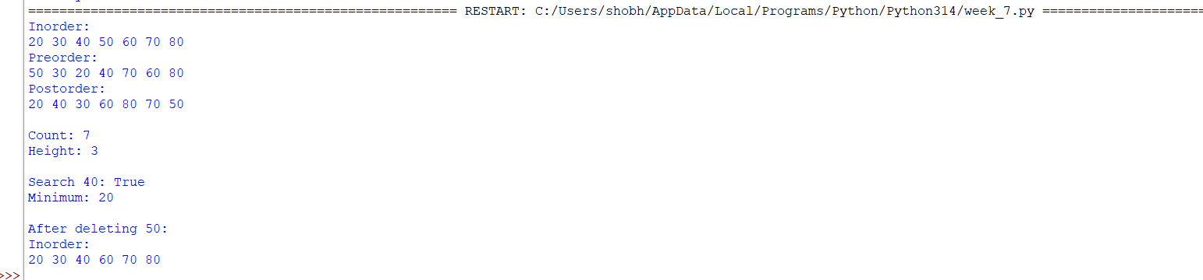
Explanation:
Binary Search Tree (BST) Using Array
Structure:
- Uses a Python list self.tree to store the elements.
- The root element is stored at index 0.
- For a node at index i:
  - Left child → 2*i + 1
  - Right child → 2*i + 2
- An empty position is represented using None.
- BST follows the rule:
  - Left subtree contains smaller elements.
  - Right subtree contains greater elements.
Operations:
1. Insert
- Start from index 0 (root).
- Compare the new element with the current element.
- If the element is smaller → move to 2*i + 1.
- If the element is greater → move to 2*i + 2.
- Continue until an empty position (None) is found.
- Insert the element at that position.
2. Search
- Start from the root.
- Compare the required element with the current element.
- If equal → element is found.
- If smaller → move to the left child.
- If greater → move to the right child.
- If None is reached → element is not present.
3. Delete
There are three cases:
- No child: Set that position to None.
- One child: Replace the node with its child.
- Two children: Find the minimum element in the right subtree (inorder successor), replace the deleted element with it, and remove the original successor.
4. Minimum
- Start from the given node.
- Keep moving to the left child.
- The leftmost element is the minimum value.
5. Maximum
- Start from the given node.
- Keep moving to the right child.
- The rightmost element is the maximum value.
6. Inorder Traversal
- Traverse Left → Root → Right.
- Inorder traversal of a BST gives elements in sorted order.
7. Preorder Traversal
- Traverse Root → Left → Right.
8. Postorder Traversal
- Traverse Left → Right → Root.
9. Count
- Counts the total number of nodes in the BST.
- Formula:
Count = 1 + left subtree count + right subtree count
10. Height
- Finds the longest path from the root to a leaf.
- Formula:
Height = 1 + max(left height, right height)
Important Points:
- Root is at index 0.
- Left child → 2*i + 1.
- Right child → 2*i + 2.
- None represents an empty position.
- Inorder traversal gives sorted elements.
- BST provides efficient searching when the tree is balanced.
Error Table:
S.NO | Error Obtained | Rectification
1. | Inserting into an occupied position without comparing the value. | Compare data with self.tree[i]. If data is smaller, move to 2*i + 1; otherwise move to 2*i + 2.
2. | Searching beyond the array limit. | Check the index condition: while i < 100 and self.tree[i] is not None.
3. | Searching for a value that does not exist. | If self.tree[i] is None, return False.
4. | Incorrect child index calculation. | Use left child = 2*i + 1 and right child = 2*i + 2.

7B).AIM: write a python program to implement binary tree using an linked list with all its operations.

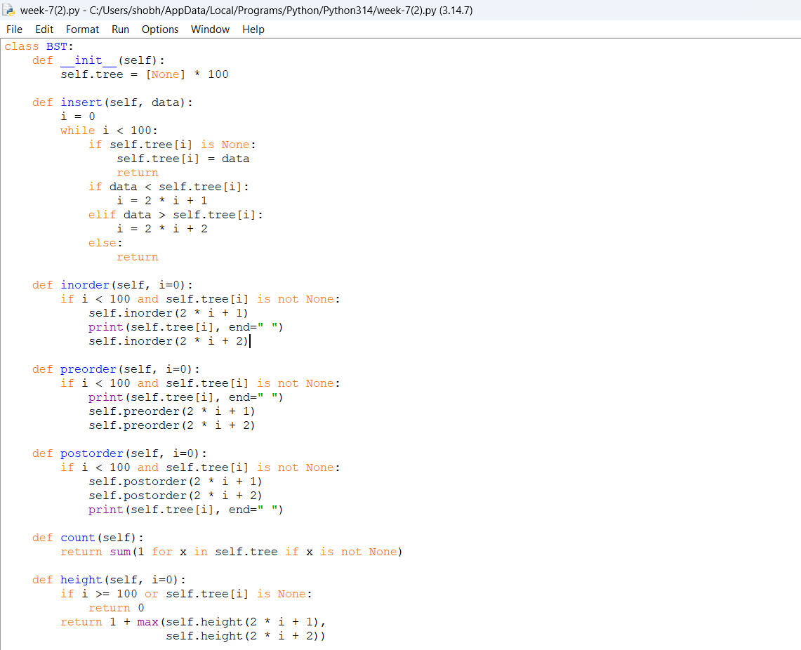
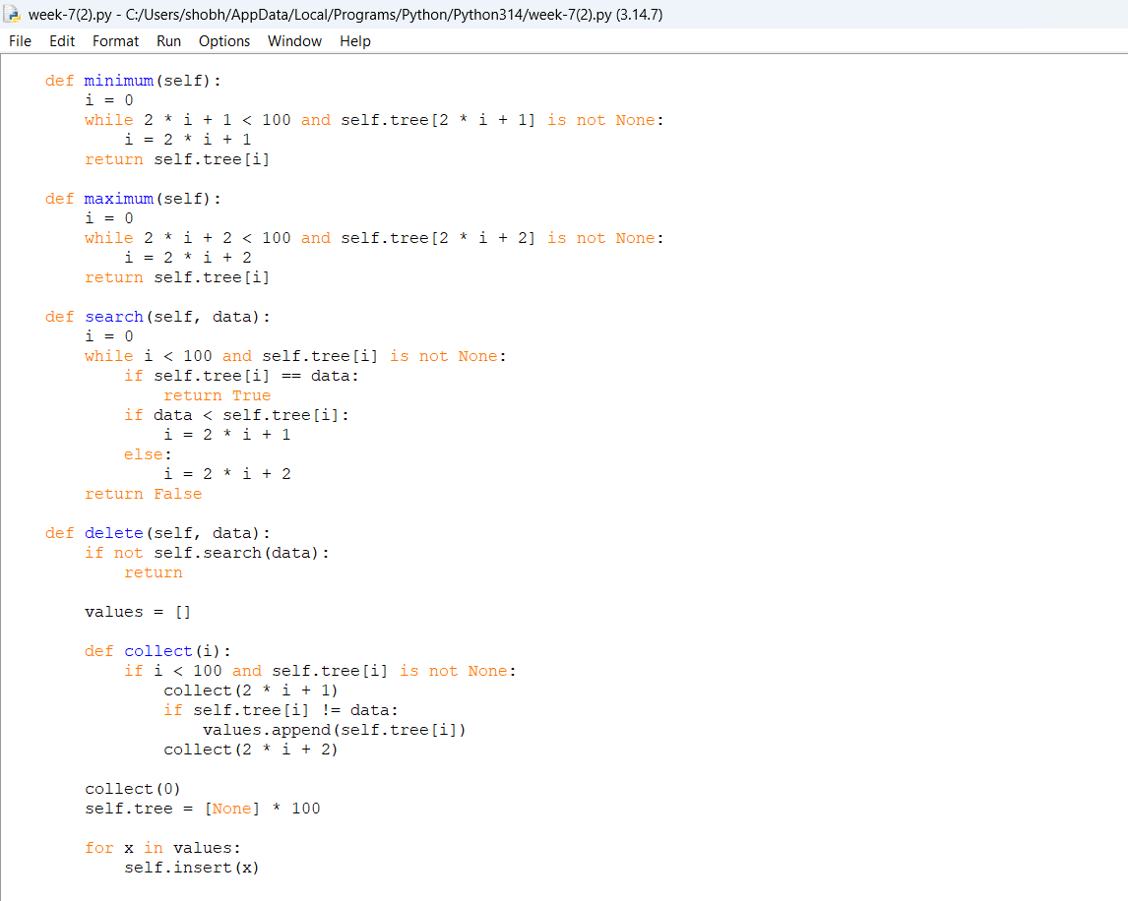

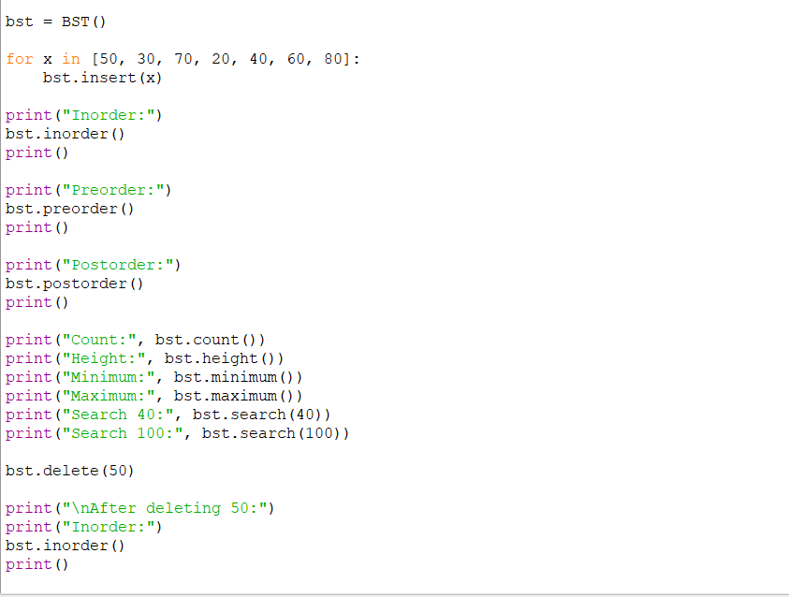

Output:
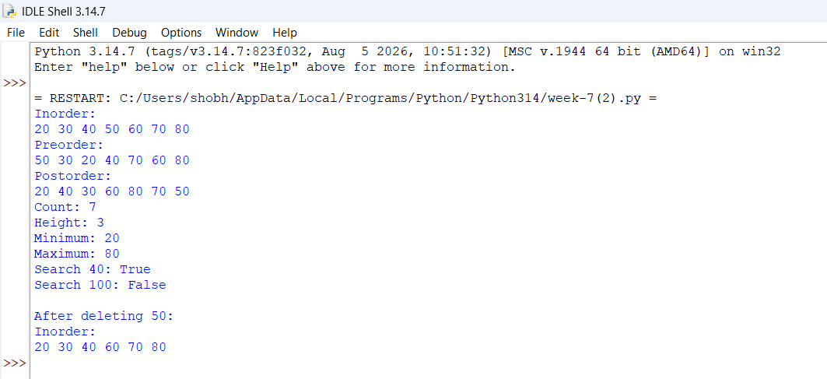

Explanation:
Binary Search Tree (BST) Using Linked List
Structure:
- Each element is represented using a Node.
- Each Node contains:
  - data → stores the value.
  - left → points to the left child.
  - right → points to the right child.
- self.root points to the root node of the BST.
- Initially, root = None, which means the tree is empty.
- BST follows the rule:
  - Left subtree contains smaller elements.
  - Right subtree contains greater elements.
Operations:
1. Insert
- Create a new node.
- If the tree is empty, make the new node the root.
- Otherwise, start from the root.
- If the new element is smaller → move to the left.
- If the new element is greater → move to the right.
- Continue until an empty position is found.
- Link the new node at that position.
2. Search
- Start from the root.
- Compare the required element with the current node.
- If equal → element is found.
- If smaller → move to the left child.
- If greater → move to the right child.
- If None is reached → element is not present.
3. Delete
There are three cases:
- No child: Remove the node.
- One child: Replace the node with its child.
- Two children: Find the minimum element in the right subtree (inorder successor), copy its value into the node, and delete the original successor node.
4. Minimum
- Start from the given node.
- Keep moving to the left child.
- The leftmost node contains the minimum value.
5. Maximum
- Start from the given node.
- Keep moving to the right child.
- The rightmost node contains the maximum value.
6. Inorder Traversal
- Traverse Left → Root → Right.
- Gives BST elements in sorted order.
7. Preorder Traversal
- Traverse Root → Left → Right.
8. Postorder Traversal
- Traverse Left → Right → Root.
9. Count
- Counts the total number of nodes.
- Formula:
Count = 1 + left subtree count + right subtree count
10. Height
- Finds the longest path from the root to a leaf.
- Formula:
Height = 1 + max(left height, right height)
Important Points:
- root points to the first node.
- left stores the reference to the left child.
- right stores the reference to the right child.
- None represents an empty child.
- Inorder traversal gives sorted elements.
- Linked-list representation uses dynamic memory.

Error table:
S.NO | Error Obtained | Rectification
1. | Inserting the first node without setting root. | If self.root is None, set self.root = new and return.
2. | Searching for a value that does not exist. | Continue while temp is not None; if temp becomes None, return False.
3. | Incorrect movement while searching. | If data < temp.data, move to temp.left; otherwise move to temp.right.
4. | Deleting a node with two children incorrectly. | Find the minimum value in the right subtree, replace the node data, and delete the successor.

WEEK- 8
Aim : write a python program to implement Binary tree with its operations using array and linked list.

Program: using array

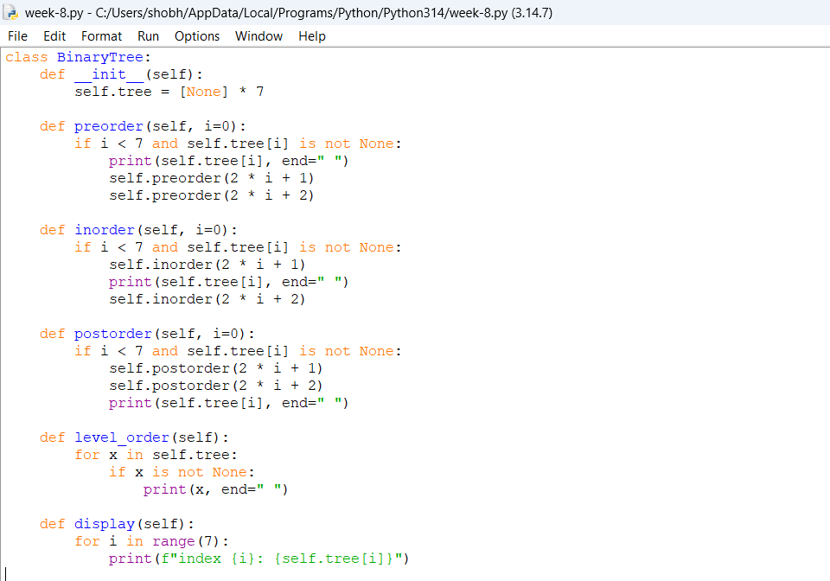
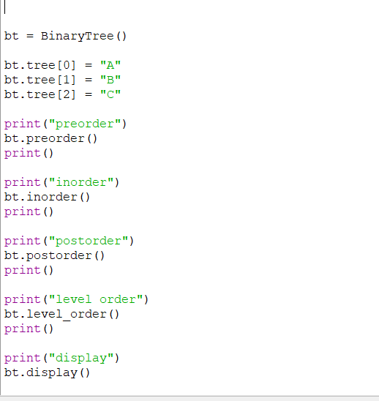

Output:
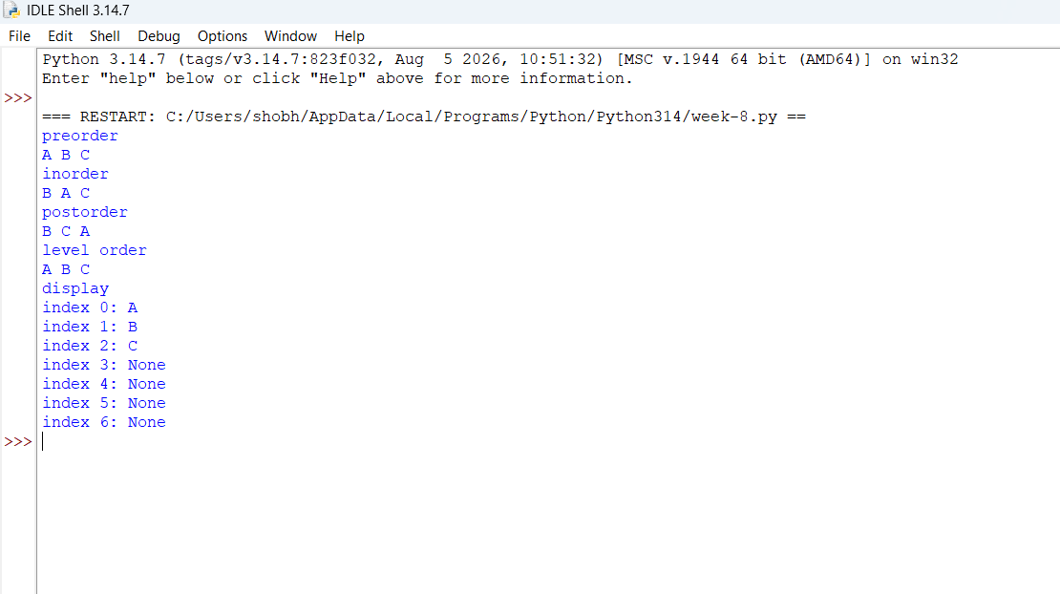

Explanation:
- The binarytree class is used to implement a binary tree using an array. The tree list is initialized with None values according to the given size.
- The insert_root() function stores the root node at index 0 because the root is always the first element in the array representation.
- The set_left() function is used to insert the left child of a node. For a node at index i, its left child is stored at index 2*i + 1.
- The set_right() function is used to insert the right child of a node. For a node at index i, its right child is stored at index 2*i + 2.
- The if child < self.size condition checks whether the calculated child index is within the available array size. If it exceeds the size, an index-out-of-range message is displayed.
- The preorder() function visits the current node first, followed by its left subtree and right subtree. The child indexes are calculated using 2*index + 1 and 2*index + 2.
- The inorder() function first visits the left subtree, then the current node and finally the right subtree.
- The postorder() function first visits the left subtree, then the right subtree and finally the current node.
- The levelorder() function visits the elements from the beginning to the end of the array. Since the array stores the binary tree level by level, this directly gives the level-order traversal.
- The display() function uses a loop to display every index of the array along with the value stored at that index.
- The condition self.tree[index] is None is used during traversal to stop when an empty position is reached.

Error Table:
S.No | Common Error | Correction
1 | Not setting left and right references to None while creating a node. | Initialize both left and right as None in the Node constructor.
2 | Calling traversal functions without passing the current node correctly. | Pass the current node during recursive calls.
3 | Forgetting the base condition when the current node is None. | Use a condition such as if root is None: return.
4 | Using the wrong traversal order. | Preorder: Root-Left-Right, Inorder: Left-Root-Right, Postorder: Left-Right-Root.

Program: using linked list
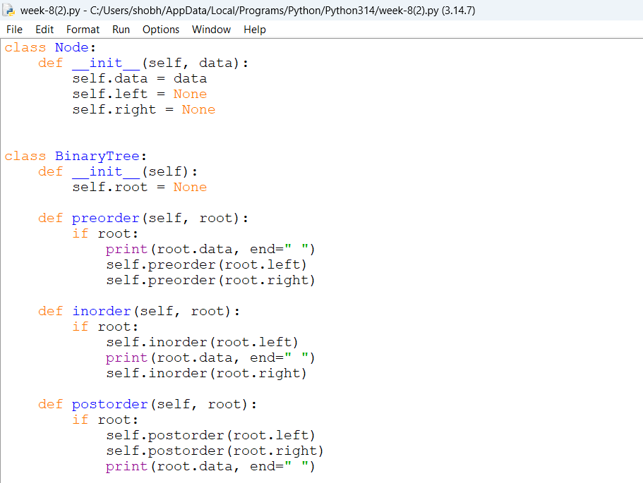

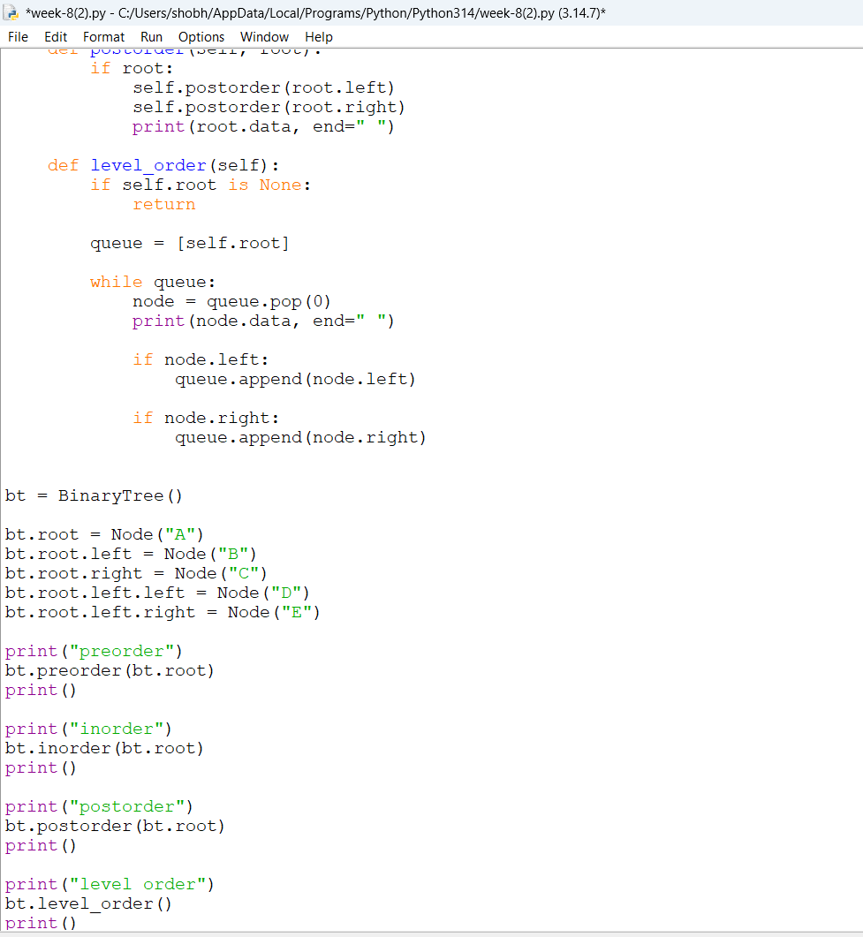

Output:
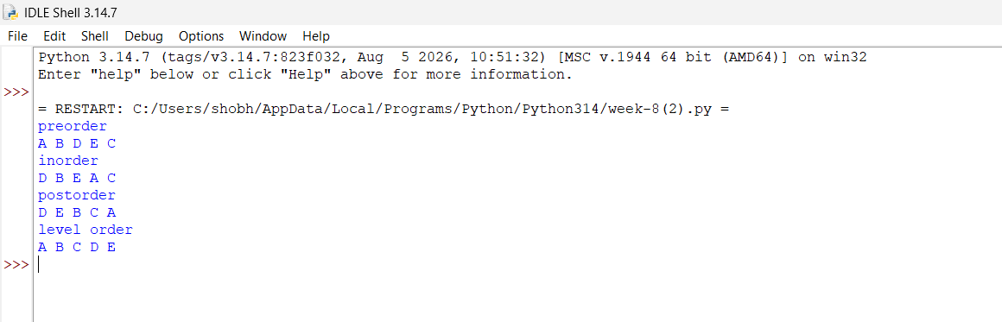
Explanation:
- The Node class is used to create each node of the binary tree. Each node contains three parts: data, left, and right. The data stores the value, while left and right store references to the left and right child nodes.
- The __init__() method initializes the node with the given data. Initially, both left and right are set to None because the node does not have any children.
- The root represents the first node of the binary tree. New nodes are connected to the root using the left and right references.
- The preorder() function performs preorder traversal. It first visits the root node, then recursively visits the left subtree and finally the right subtree. The order followed is Root → Left → Right.
- The inorder() function performs inorder traversal. It first visits the left subtree, then the root node and finally the right subtree. The order followed is Left → Root → Right.
- The postorder() function performs postorder traversal. It first visits the left subtree, then the right subtree and finally the root node. The order followed is Left → Right → Root.
- The condition if root: checks whether the current node exists. If the node is None, the recursive function stops for that particular branch.

Error Table:
S.No | Common Error | Correction
1 | Not setting left and right references to None while creating a node. | Initialize both left and right as None in the Node constructor.
2 | Calling traversal functions without passing the current node correctly. | Pass the current node during recursive calls.
3 | Forgetting the base condition when the current node is None. | Use a condition such as if root is None: return.
4 | Using the wrong traversal order. | Preorder: Root-Left-Right, Inorder: Left-Root-Right, Postorder: Left-Right-Root.

WEEK-9
Aim : write a python Program for AVL tree using array and linked list with all its operations.
Program:

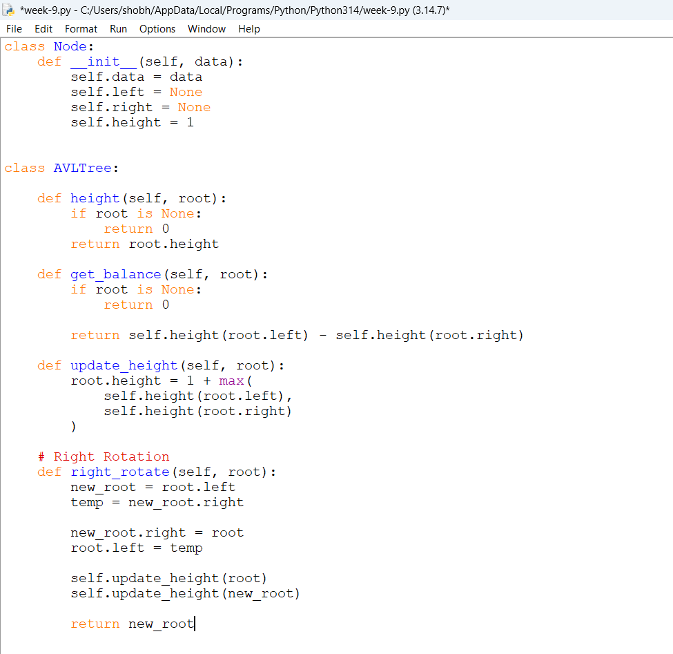
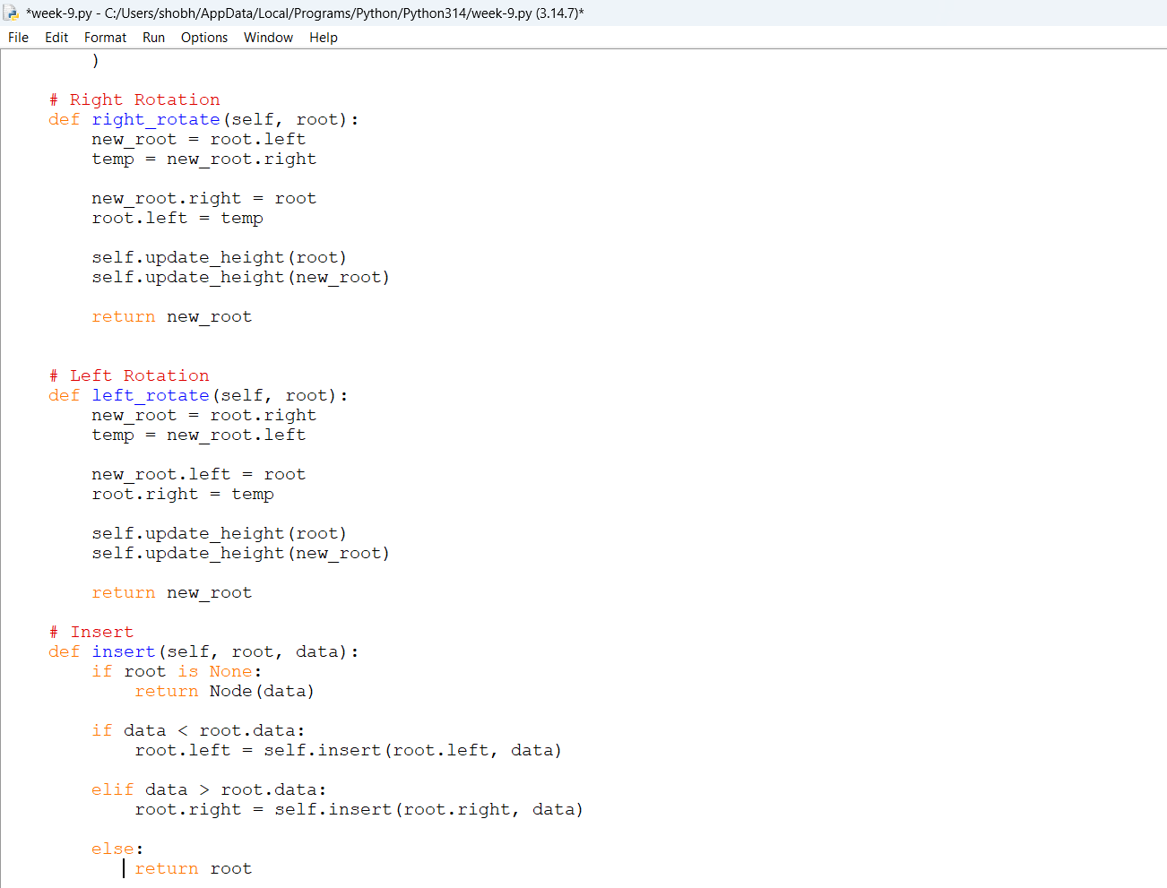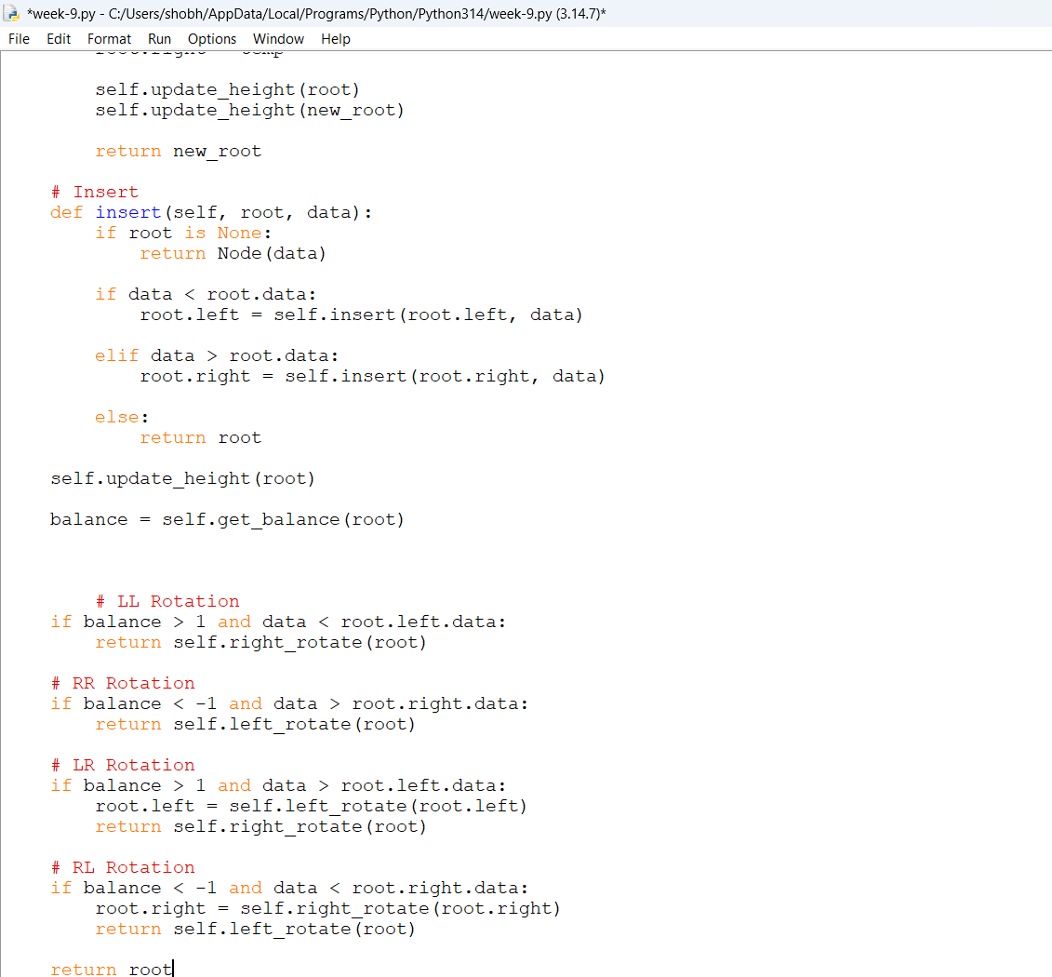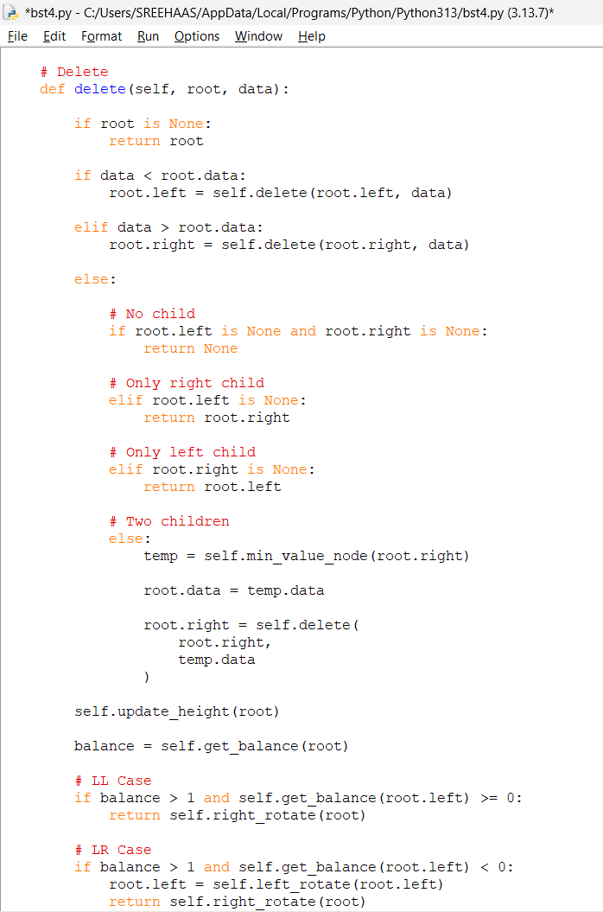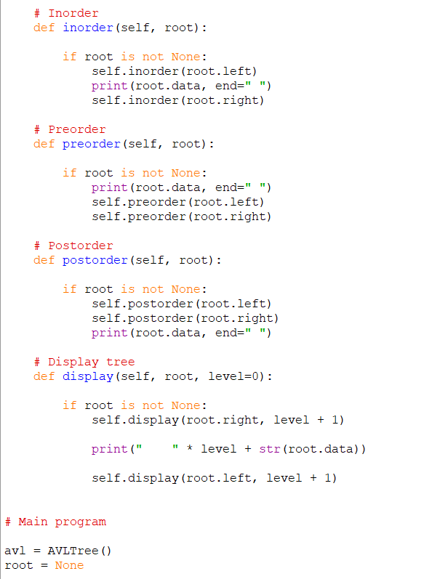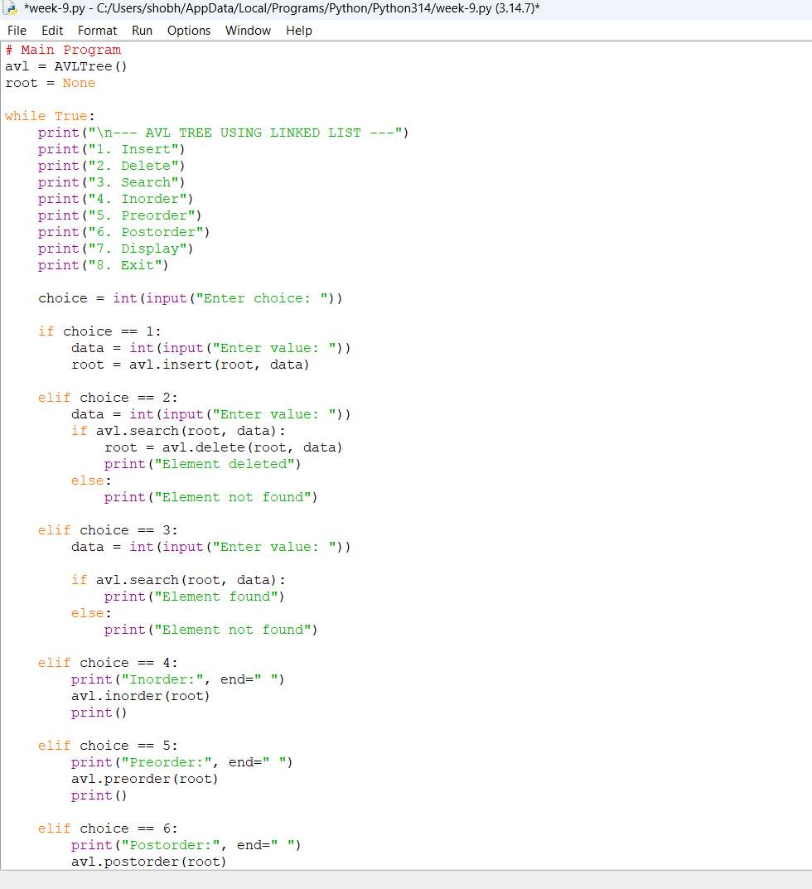

Output:
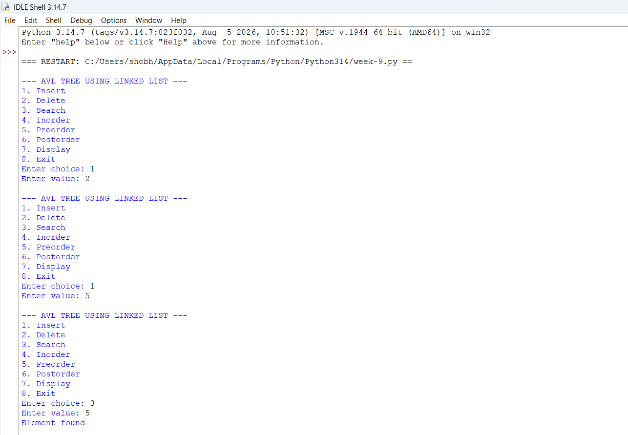

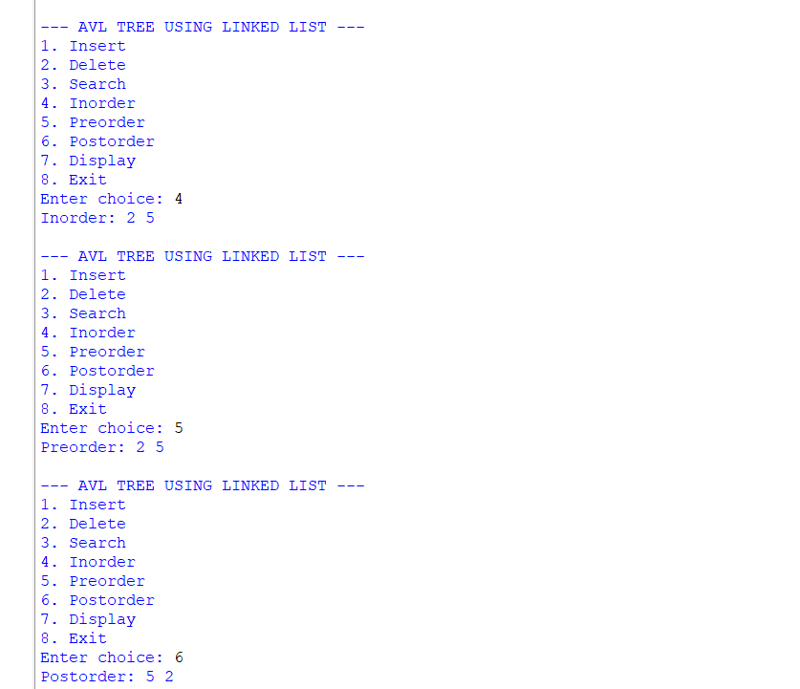
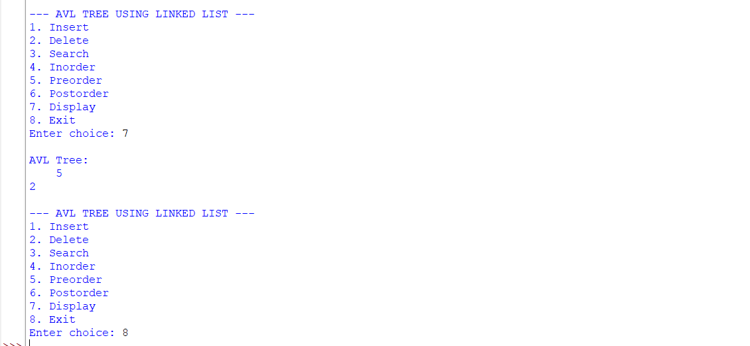

Explanation:
- An AVL tree is a self-balancing Binary Search Tree (BST).
- In an AVL tree, the difference between the height of the left and right subtrees is called the Balance Factor.
- The Balance Factor of every node must be -1, 0, or +1.
- In the array implementation, the tree nodes are stored inside a fixed-size array.
- For a node at index i:
  - Left child is stored at 2*i + 1.
  - Right child is stored at 2*i + 2.
- None is used to represent an empty position in the array.
Main Functions
- __init__()
  - Creates the array for storing the tree.
  - The size of the array is given by the user/program.
  - Initially, all positions contain None.
- height()
  - Calculates the height of a node.
  - It recursively checks the left and right subtrees.
  - The greater height is selected and 1 is added.
- balance_factor()
  - Calculates the balance factor of a node.
  - It is calculated as:
    - Height of Left Subtree - Height of Right Subtree
  - A value greater than 1 indicates that the tree is left-heavy.
  - A value less than -1 indicates that the tree is right-heavy.
- insert()
  - Adds a new element to the AVL tree.
  - The element is placed according to Binary Search Tree rules.
  - Smaller values are placed in the left subtree.
  - Larger values are placed in the right subtree.
  - After insertion, the tree is checked and rotations are performed if required.
- search()
  - Searches for a particular element.
  - If the element is found, it returns True.
  - If the element does not exist, it returns False.
- delete()
  - Removes an element from the tree.
  - It handles nodes with no child, one child, or two children.
  - After deletion, the tree is rebalanced.
- find_min()
  - Finds the smallest element in a subtree.
  - It repeatedly moves to the left child.
  - It is mainly used when deleting a node having two children.
- rotate_left()
  - Performs a left rotation when the tree becomes right-heavy.
  - It helps restore the AVL property.
- rotate_right()
  - Performs a right rotation when the tree becomes left-heavy.
  - It helps restore the AVL property.
- balance_tree()
  - Checks the balance factor of the nodes.
  - If the tree becomes unbalanced, suitable rotations are performed.
- inorder()
  - Traverses the tree in:
    - Left → Root → Right
  - It displays the elements in sorted order.
- preorder()
  - Traverses the tree in:
    - Root → Left → Right
- postorder()
  - Traverses the tree in:
    - Left → Right → Root
- display()
  - Displays the elements along with their array indexes.
  - It helps to understand how the tree is stored in the array.
Main Program
- The main program provides a menu-driven interface.
- The user can choose:
  - Insert
  - Delete
  - Search
  - Inorder
  - Preorder
  - Postorder
  - Display
  - Exit
- This allows all major AVL tree operations to be performed interactively.

2. AVL Tree Using Linked List – Explanation
- In the linked-list implementation, every tree element is represented using a Node.
- Each node contains:
  - Data
  - Left child
  - Right child
  - Height
- The left and right pointers connect the nodes and form the tree.
- Unlike the array implementation, memory is allocated dynamically as new nodes are created.
Node Class
- The Node class represents one node of the AVL tree.
- data stores the value.
- left stores the reference to the left child.
- right stores the reference to the right child.
- height stores the height of the node.
- Initially, a new node has height 1.
Main Functions
- height()
  - Returns the height of a node.
  - If the node is None, its height is considered 0.
- get_balance()
  - Calculates the balance factor.
  - Formula:
    - Height(Left) - Height(Right)
  - It is used to determine whether rotations are required.
- update_height()
  - Updates the height of a node after insertion, deletion, or rotation.
  - It takes the maximum height of the left and right subtrees and adds 1.
- right_rotate()
  - Performs a right rotation.
  - It is mainly used for the LL imbalance.
  - The left child becomes the new root of that subtree.
- left_rotate()
  - Performs a left rotation.
  - It is mainly used for the RR imbalance.
  - The right child becomes the new root of that subtree.
- insert()
  - Inserts a new value according to BST rules.
  - Smaller values go to the left.
  - Larger values go to the right.
  - The height of each affected node is updated.
  - The balance factor is checked.
  - If the tree becomes unbalanced, the appropriate rotation is performed.
Four Cases During Insertion
- LL Case
  - New node is inserted into the left subtree of the left child.
  - A right rotation is performed.
- RR Case
  - New node is inserted into the right subtree of the right child.
  - A left rotation is performed.
- LR Case
  - New node is inserted into the right subtree of the left child.
  - First, a left rotation is performed on the left child.
  - Then, a right rotation is performed.
- RL Case
  - New node is inserted into the left subtree of the right child.
  - First, a right rotation is performed on the right child.
  - Then, a left rotation is performed.
- min_value_node()
  - Finds the node with the minimum value.
  - It keeps moving to the left until the left child is None.
  - It is used during deletion of a node with two children.
- delete()
  - Deletes a node from the AVL tree.
  - Three situations are handled:
    - Node has no child.
    - Node has one child.
    - Node has two children.
  - For two children, the inorder successor is used.
  - After deletion, heights are updated.
  - The balance factor is checked and rotations are performed if required.
- search()
  - Searches for a given value.
  - If the value matches the current node, it returns True.
  - If the value is smaller, it searches the left subtree.
  - If the value is larger, it searches the right subtree.
- inorder()
  - Traverses:
    - Left → Root → Right
  - Produces the elements in sorted order.
- preorder()
  - Traverses:
    - Root → Left → Right
- postorder()
  - Traverses:
    - Left → Right → Root
- display()
  - Displays the tree structure vertically.
  - It helps visualize the relationship between parent and child nodes.
Main Program
- The main program creates an AVL tree object.
- root = None represents an initially empty tree.
- A menu is provided to perform different operations.
- The user can perform:
  - Insert
  - Delete
  - Search
  - Inorder
  - Preorder
  - Postorder
  - Display
  - Exit
Error Table:
S.No. | Common Error | Reason / Correction
1 | AttributeError: NoneType | The Program tries to access a property of an empty node. Check whether the node is None before accessing its data or children.
2 | Incorrect rotation | The left/right child references are changed incorrectly. Verify the temporary node and child links during rotation.
3 | Wrong height or balance factor | The height is not updated after insertion, deletion, or rotation. Call the height update function at the correct place.
4 | Element not found during deletion/search | The value does not exist in the tree or the search path is incorrect. Follow BST comparison rules correctly.

Program: Array
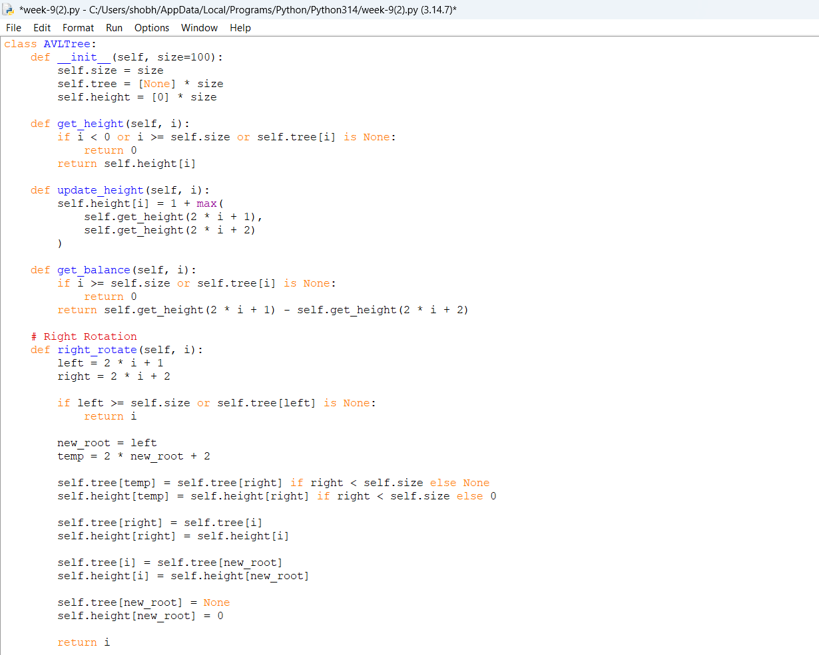
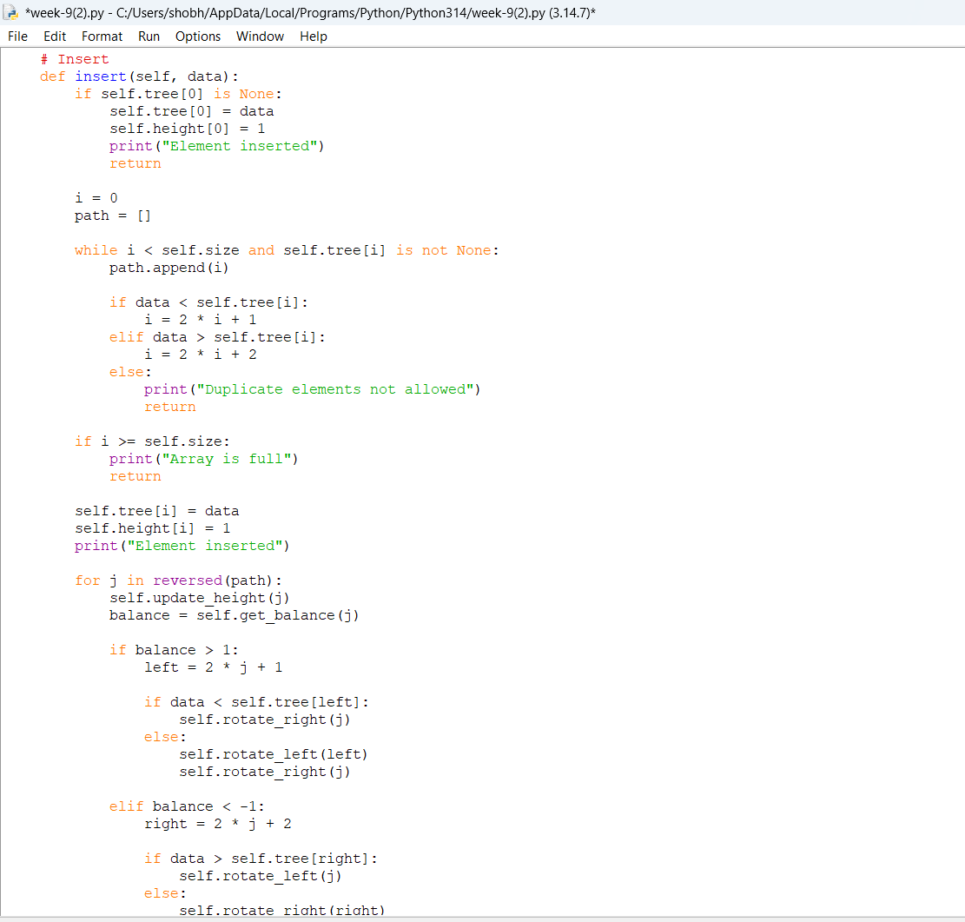
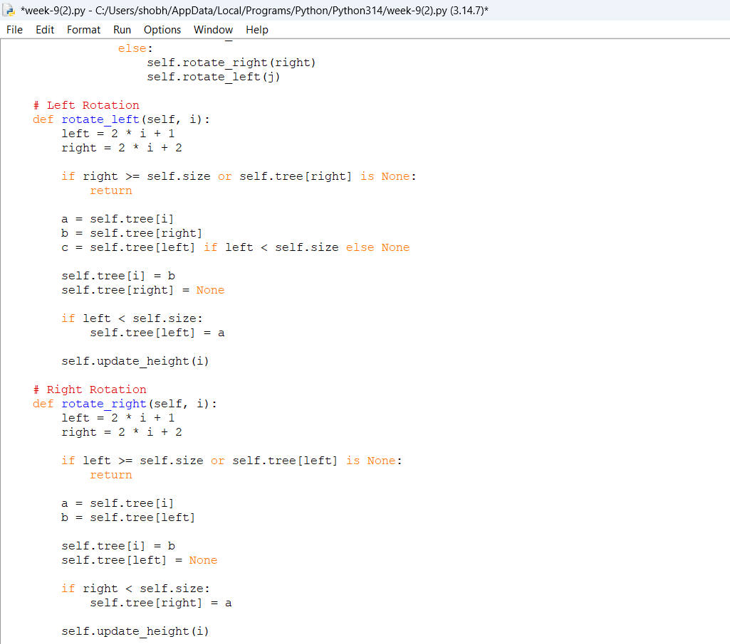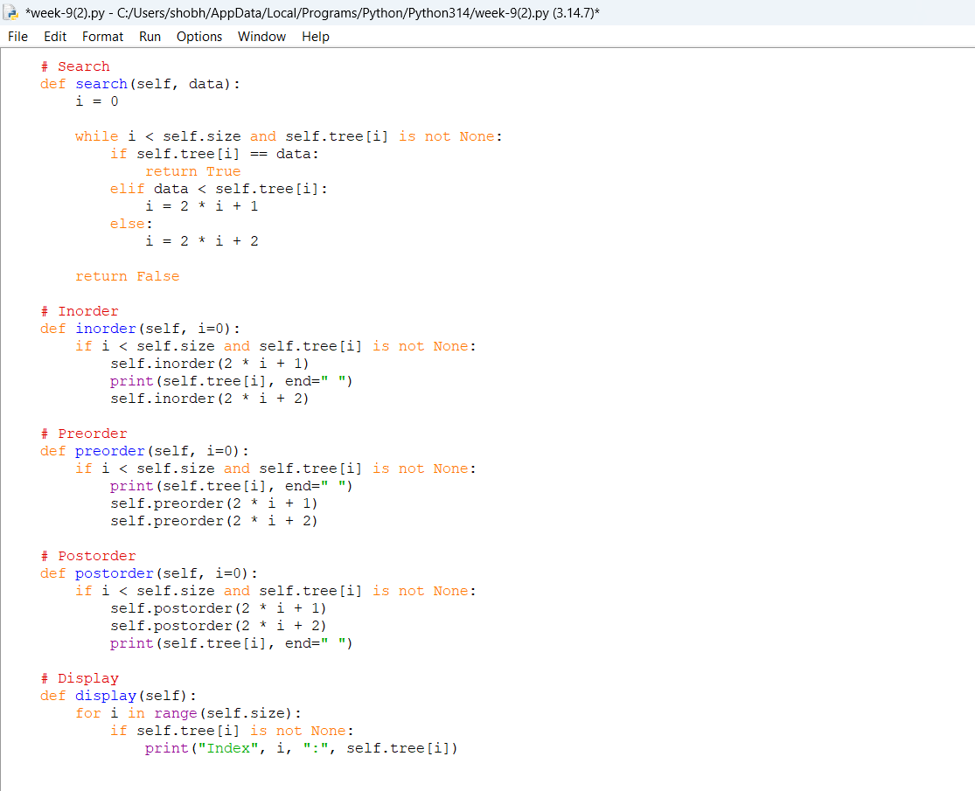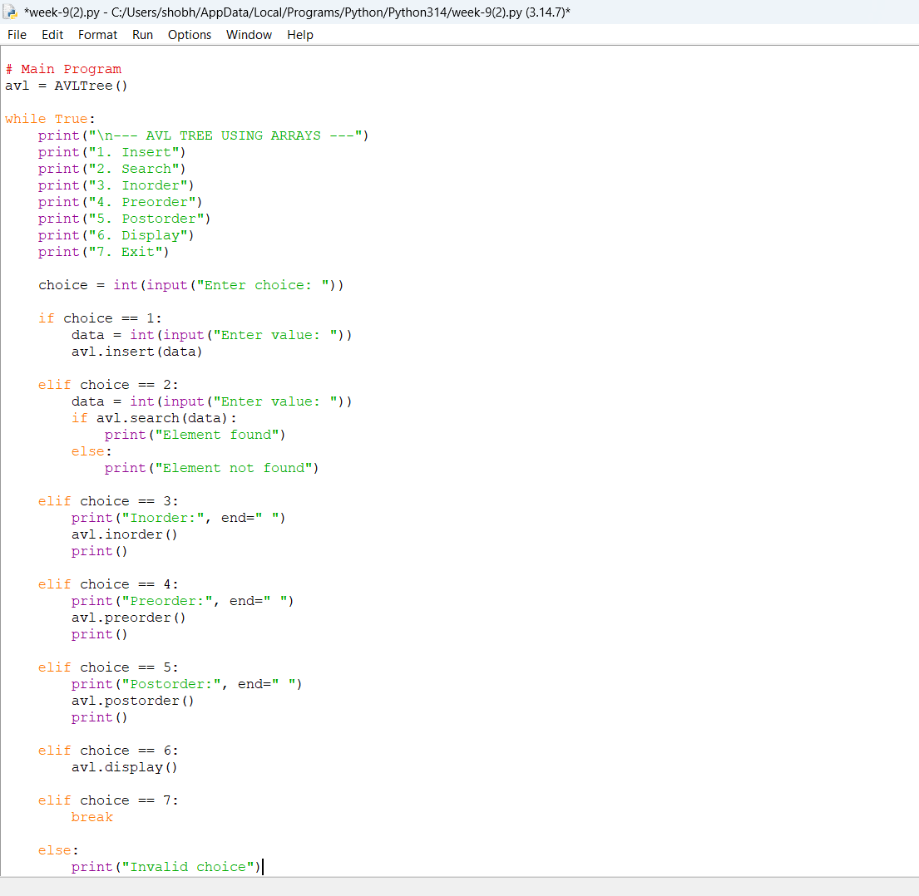

Output:
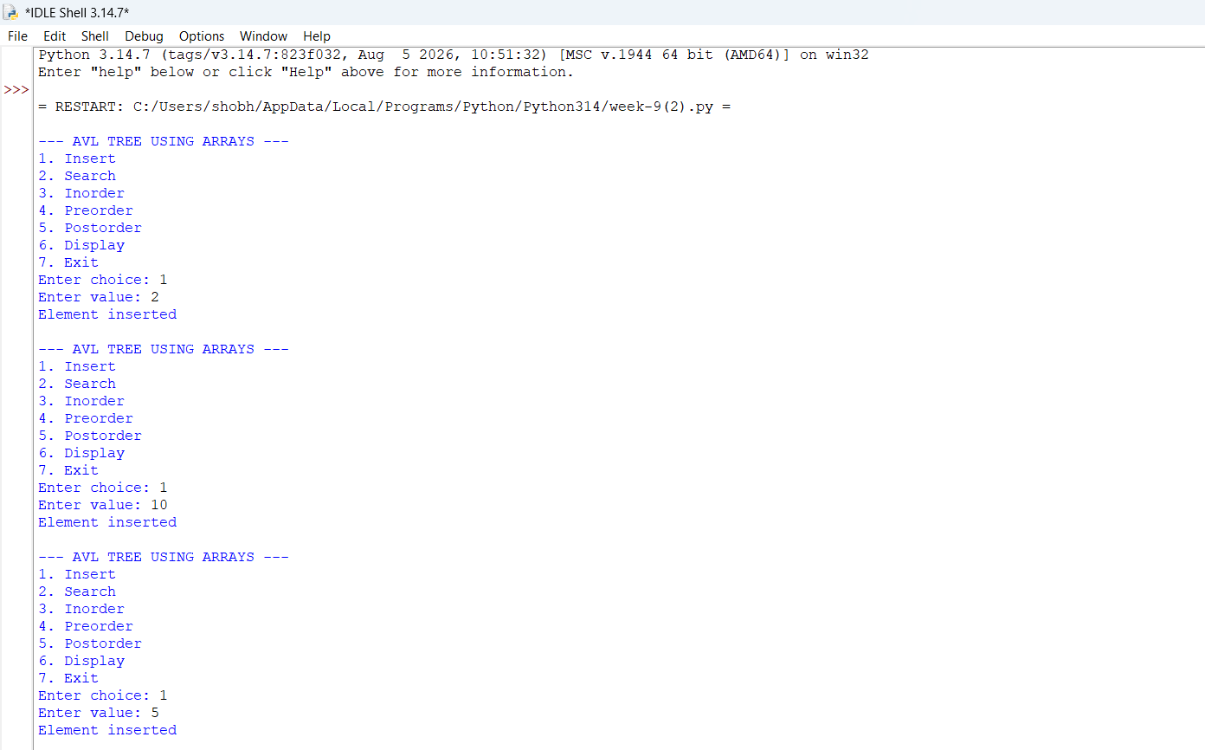
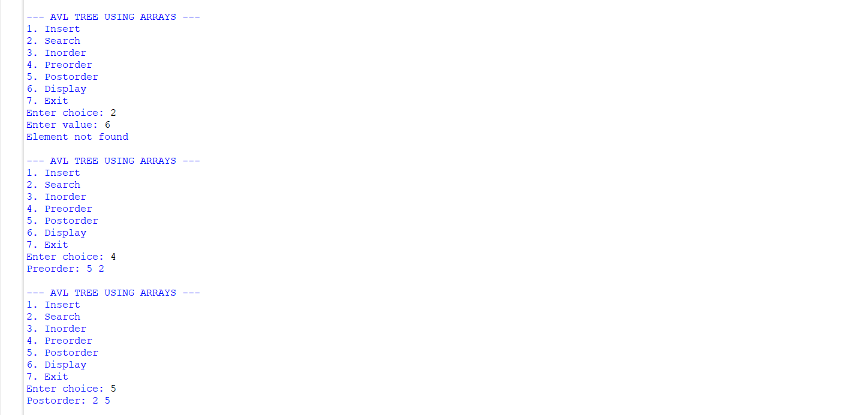
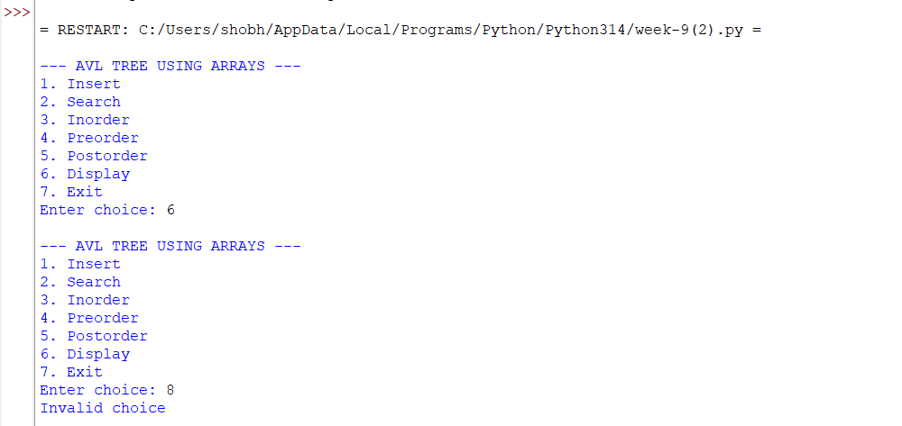

Explanation:
- An AVL tree is a self-balancing Binary Search Tree (BST).
- In an AVL tree, the difference between the height of the left and right subtrees is called the Balance Factor.
- The Balance Factor of every node must be -1, 0, or +1.
- In the array implementation, the tree nodes are stored inside a fixed-size array.
- For a node at index i:
  - Left child is stored at 2*i + 1.
  - Right child is stored at 2*i + 2.
- None is used to represent an empty position in the array.
Main Functions
- __init__()
  - Creates the array for storing the tree.
  - The size of the array is given by the user/program.
  - Initially, all positions contain None.
- height()
  - Calculates the height of a node.
  - It recursively checks the left and right subtrees.
  - The greater height is selected and 1 is added.
- balance_factor()
  - Calculates the balance factor of a node.
  - It is calculated as:
    - Height of Left Subtree - Height of Right Subtree
  - A value greater than 1 indicates that the tree is left-heavy.
  - A value less than -1 indicates that the tree is right-heavy.
- insert()
  - Adds a new element to the AVL tree.
  - The element is placed according to Binary Search Tree rules.
  - Smaller values are placed in the left subtree.
  - Larger values are placed in the right subtree.
  - After insertion, the tree is checked and rotations are performed if required.
- search()
  - Searches for a particular element.
  - If the element is found, it returns True.
  - If the element does not exist, it returns False.
- delete()
  - Removes an element from the tree.
  - It handles nodes with no child, one child, or two children.
  - After deletion, the tree is rebalanced.
- find_min()
  - Finds the smallest element in a subtree.
  - It repeatedly moves to the left child.
  - It is mainly used when deleting a node having two children.
- rotate_left()
  - Performs a left rotation when the tree becomes right-heavy.
  - It helps restore the AVL property.
- rotate_right()
  - Performs a right rotation when the tree becomes left-heavy.
  - It helps restore the AVL property.
- balance_tree()
  - Checks the balance factor of the nodes.
  - If the tree becomes unbalanced, suitable rotations are performed.
- inorder()
  - Traverses the tree in:
    - Left → Root → Right
  - It displays the elements in sorted order.
- preorder()
  - Traverses the tree in:
    - Root → Left → Right
- postorder()
  - Traverses the tree in:
    - Left → Right → Root
- display()
  - Displays the elements along with their array indexes.
  - It helps to understand how the tree is stored in the array.
Main Program
- The main program provides a menu-driven interface.
- The user can choose:
  - Insert
  - Delete
  - Search
  - Inorder
  - Preorder
  - Postorder
  - Display
  - Exit
- This allows all major AVL tree operations to be performed interactively.

Error table:

S.No. | Common Error | Reason / Correction
1 | Index out of range | The calculated child index exceeds the array size. Use a sufficiently large array and check the index before accessing it.
2 | Tree becomes full | The fixed-size array has no empty position available. Increase the array size.
3 | Incorrect child index | Using the wrong formula for child positions causes incorrect tree structure. Use left = 2*i+1 and right = 2*i+2.
4 | Incorrect balancing after insertion/deletion | The balance factor or rotation is not handled correctly. Check the balance factor and perform the required rotation.

WEEK-10

Aim: Write a Python program to implement Hashing using Separate Chaining, Linear Probing, and Quadratic Probing.

Program:

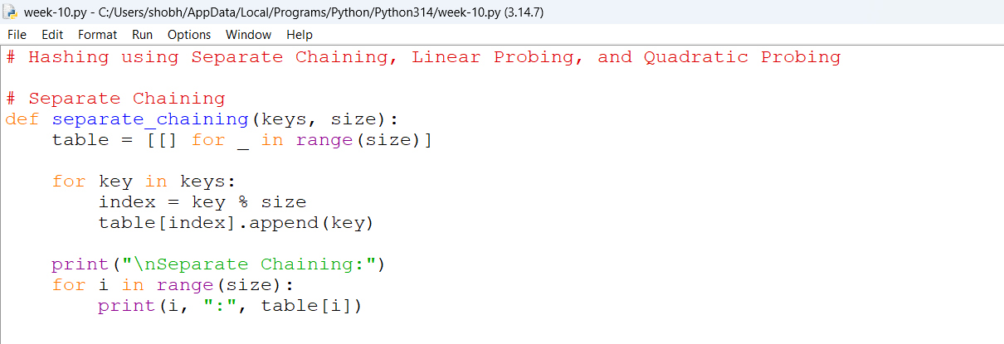

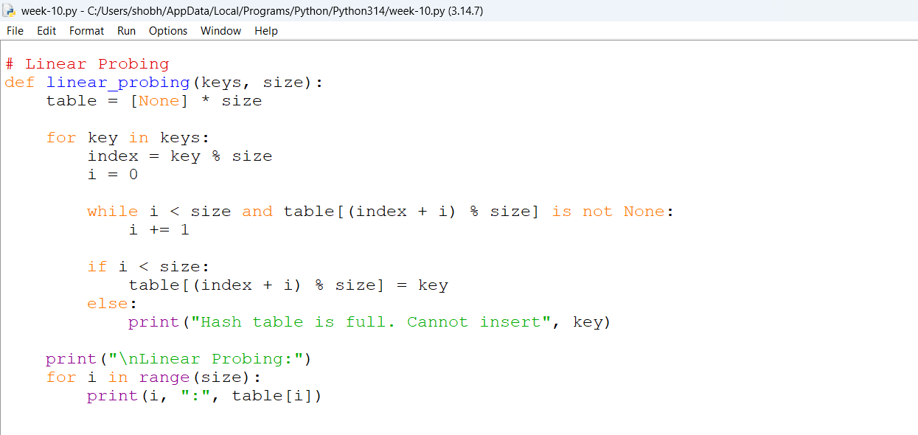

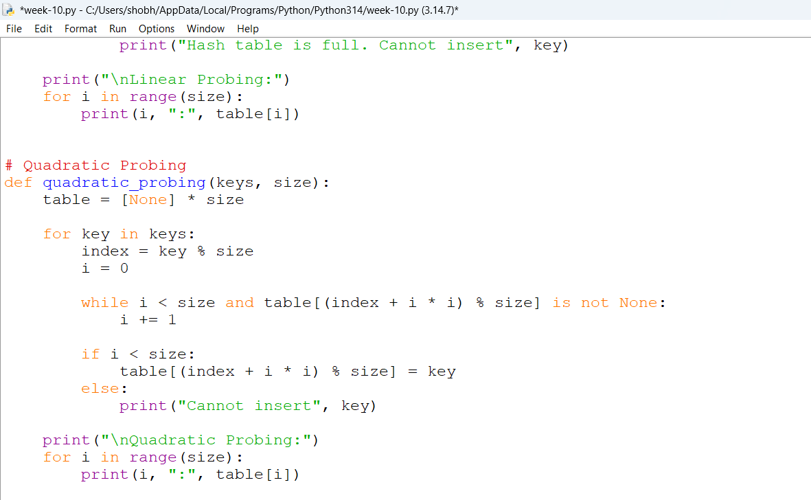

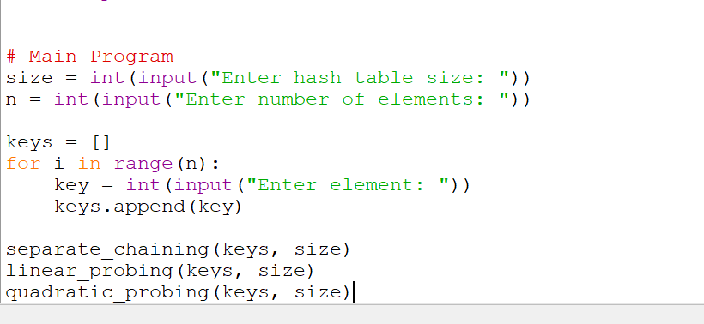

Output:

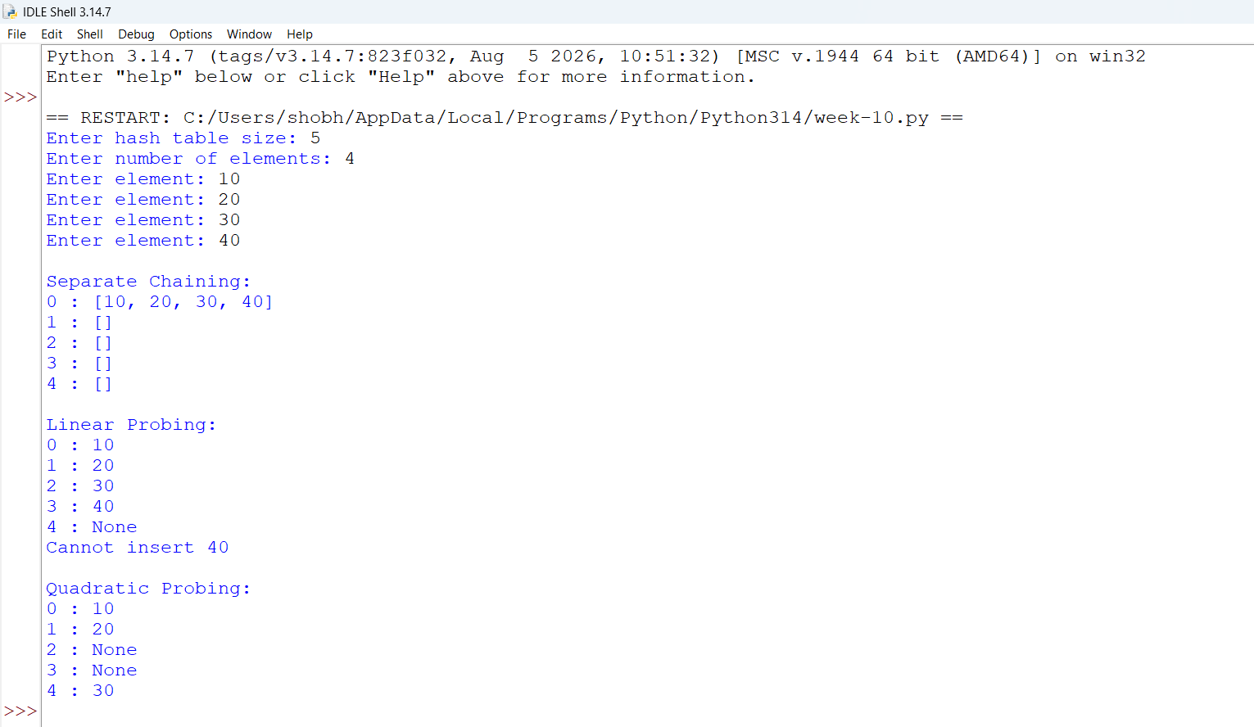

Explanation:
- The Hashing class is used to implement hashing using three collision-resolution techniques: Separate Chaining, Linear Probing, and Quadratic Probing.
- The __init__() method initializes the hash table with a given size. Three different structures are created to store elements using the three techniques.
- The hash_function() calculates the index for a given key using the modulo operator. The formula used is key % size.
- The insert_chaining() function inserts elements into a list at the calculated index. If multiple elements produce the same index, they are stored in the same list.
- The insert_linear() function handles collisions by checking the next available position sequentially until an empty position is found.
- The insert_quadratic() function resolves collisions by checking positions using the square of the iteration number.
- The search_chaining() function searches for an element inside the list at the calculated hash index.
- The search_linear() function searches for an element by checking consecutive positions in the hash table.
- The search_quadratic() function searches for an element using the quadratic probing formula.
- The display_chaining() function displays all the indexes and their corresponding lists.
- The display_linear() function displays all the indexes and values stored using linear probing.
- The display_quadratic() function displays all the indexes and values stored using quadratic probing.
- In the main program, a hash table of size 11 is created, and multiple values are inserted using all three collision-resolution techniques.
- Finally, all three hash tables are displayed, and the search operation is performed to check whether the element 43 exists.

Error Table:
S.No | Common Error | Correction
1 | Using an incorrect hash function. | Use key % size to calculate the index.
2 | Not handling collisions during insertion. | Use Separate Chaining, Linear Probing, or Quadratic Probing.
3 | Accessing an index outside the hash table. | Use modulo operation to keep the index within the table size.
4 | Overwriting an existing element during linear probing. | Check whether the position is empty before inserting.
5 | Using an incorrect quadratic probing formula. | Use (index + i*i) % size.
6 | Not checking whether an element exists during searching. | Compare the key with the stored elements and return True or False.

