WEEK-7
7)
Aim:
create a GitHub account and create a repository in it and push all the week 6 code files in it.
Procedure:
Step 1: browse for GitHub and enter it.
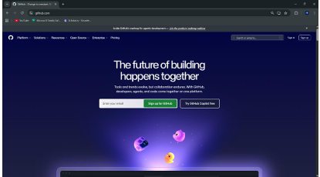
Step 2:login to GitHub account
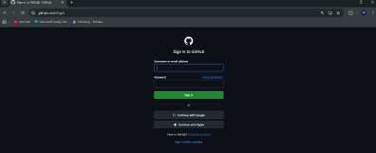

Step 3: create a repository after login by clicking new.
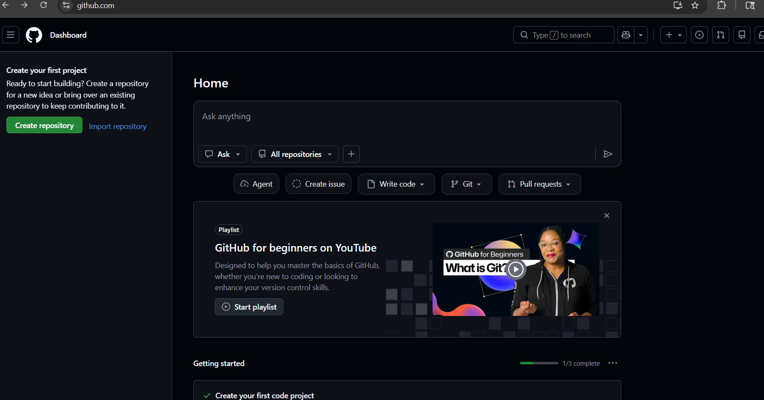
Step4: specify the repository specifications.
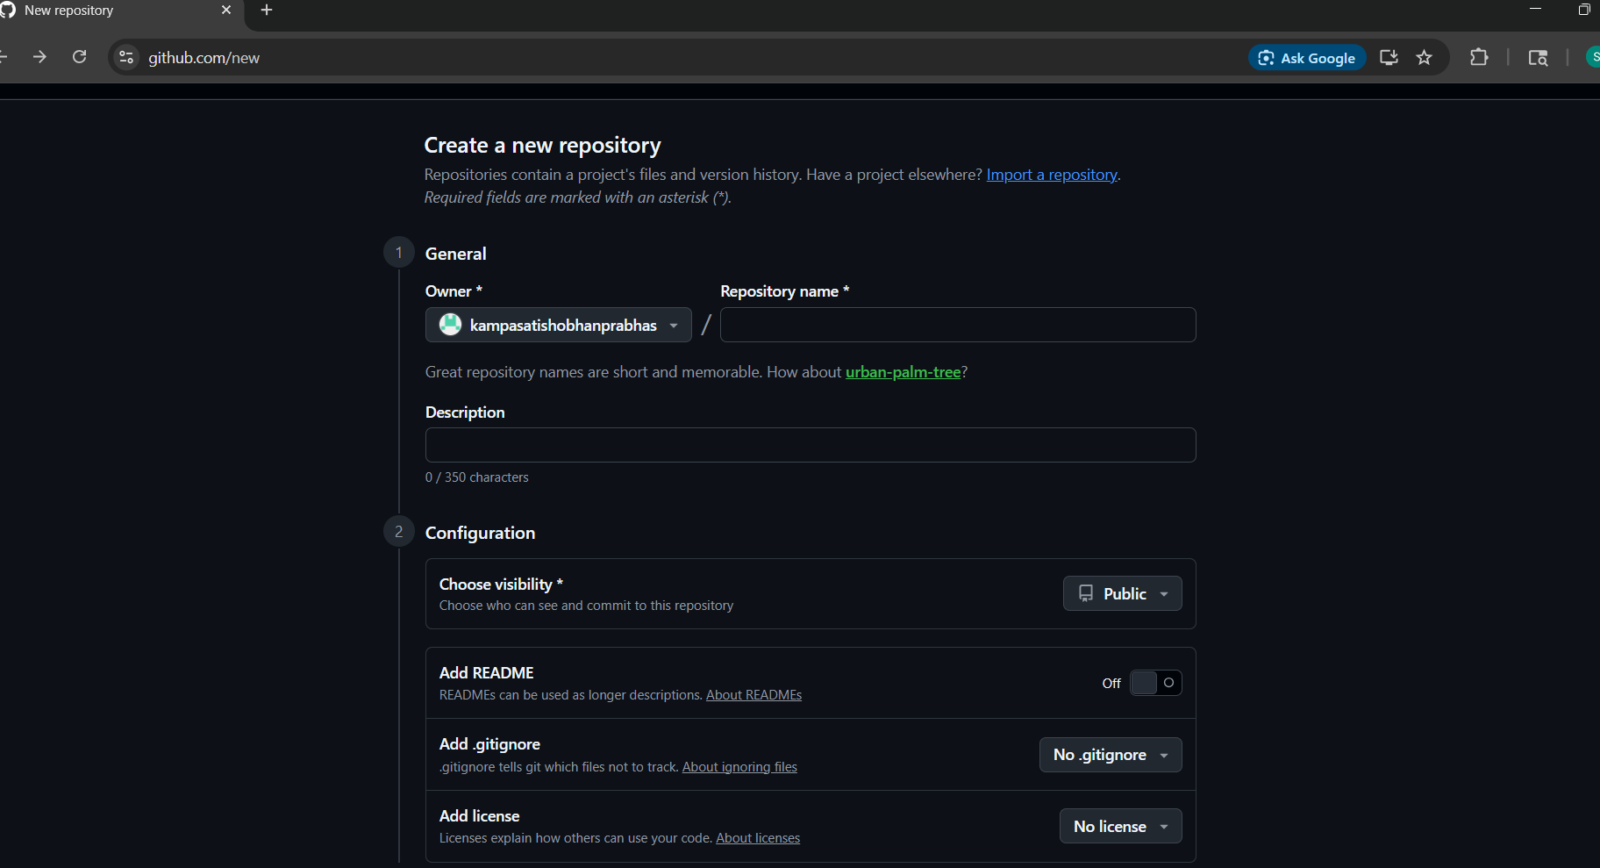

Step5: give name and all folders onto it
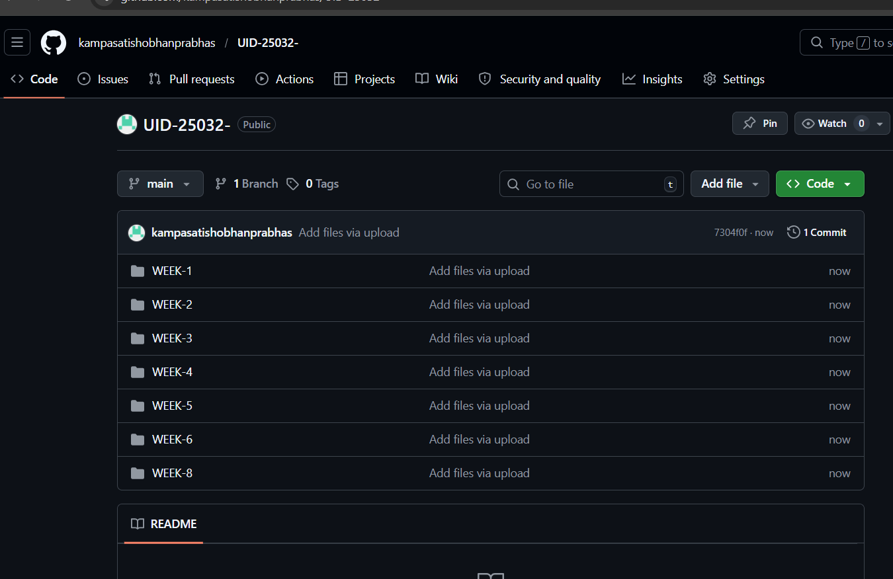

My repository link for the uid all week’s work:
https://github.com/kampasatishobhanprabhas/UID-25032-

