SIMATS ENGINEERING (SAVEETHA SCHOOL OF ENGINEERING)
Department of Computer Science and Engineering
CO1 ASSESSMENT TOOL 1: Case Study Analysis
Course Code: CSA10 / CSA1005 | Course Title: Software Engineering
CO Assessed: CO1 (Apply advanced methodologies and agile project management techniques)
Weightage: 20% | Total Marks: 25 | Duration: 60 minutes
Student Name: K. Pavan kumar | Reg. No.: 192524333 | Date: October 10, 2026
Case Study Analysis: Intelligent Document Approval Workflow System
1. Understand the Problem Statement
1.1 Problem Explanation in Own Words
Modern enterprise operational ecosystem relies heavily on formal documentation—including purchase requests, capital expenditure proposals, policy updates, strategic project plans, compliance reports, and administrative requisitions—to govern business actions and financial commitments. In legacy administrative setups, these crucial documents are routed manually via email chains, paper folders, or ad-hoc messaging channels. This informal mechanism introduces significant operational vulnerabilities: approval chains become opaque, pending requests get buried under high email volume, trackability is lost, and accountability is compromised.
The Intelligent Document Approval Workflow System is designed as an enterprise-grade digital solution to replace unstructured communication with structured, automated, and policy-driven approval workflows. The platform centralizes document ingestion, standardizes multi-tier review paths, enforces deadline-driven SLAs, provides full auditability, and gives leadership real-time visibility into operational bottlenecks through analytical dashboards.
1.2 Objectives of the Proposed System
- Document Ingestion & Management: Enable seamless uploading, metadata tagging, and secure storage of administrative and operational documents across diverse file formats (PDF, DOCX, XLSX).
- Configurable Workflow Modeling: Provide dynamic tools for administrators to build custom multi-tier approval chains based on organizational hierarchy, monetary thresholds, and document types.
- Automated Rules & Routing: Direct documents automatically to authorized approvers based on predefined conditional logic and authorization matrices.
- Collaborative Decision Recording: Allow approvers to record binding decisions (Approve, Reject, Request Revision) along with structured contextual comments and annotations.
- Robust Version Control: Maintain complete version history for revised documents, enabling side-by-side comparison and preventing unauthorized overwrites.
- Automated Reminders & Escalations: Issue automated notification alerts, deadline reminders, and SLA-driven escalation triggers for overdue pending approvals.
- Seamless Approval Delegation: Support temporary delegation of approval rights to peer authorities during out-of-office or leave periods without compromising security.
- Immutable Audit Trail: Maintain cryptographically verifiable, timestamped logs of every action, comment, status change, and approval decision for compliance auditability.
- Workflow Analytics & BI: Deliver visual dashboards analyzing approval throughput, average cycle times, departmental bottlenecks, and SLA compliance performance.
1.3 Scope of the Problem
The scope of this system encompasses enterprise-wide document lifecycle management across business units, including Finance, Human Resources, Procurement, Legal, R&D, and Executive Leadership. It covers technical capabilities ranging from role-based access control (RBAC), dynamic rule engines, digital signatures, automated notification channels (Email/SMS/Webhooks), and data warehousing for process analytics. Outside the scope are core document authoring tools (e.g., word processing applications), which remain external to the system.
2. Identify Key Stakeholders and Challenges
2.1 Stakeholder Identification and Roles
A comprehensive stakeholder analysis identifies primary, secondary, and governing actors in the document approval workflow ecosystem:
- Document Submitters (Initiators / Employees): Responsible for drafting documents, attaching mandatory supporting files, categorizing requests, selecting appropriate workflow templates, and responding to reviewer inquiries or revision requests.
- Approvers & Reviewers (Managers, Department Heads, Executives): Authorized individuals evaluated at distinct hierarchy levels responsible for reviewing document details, validating policy alignment, adding formal comments, and registering binding decisions (Approve/Reject/Revert).
- System Administrators: IT operational staff responsible for user onboarding, Role-Based Access Control (RBAC) management, workflow rule configuration, system health monitoring, and system integration maintenance.
- Compliance Officers & Internal Auditors: Governing stakeholders who inspect approval histories, verify regulatory compliance, audit delegation logs, and ensure strict adherence to corporate governance protocols.
- Executive Management / Leadership: Strategic consumers who monitor high-level workflow analytics, operational throughput, departmental efficiency KPIs, and resource allocation bottlenecks.
2.2 Major Challenges and Pain Points Experienced by Stakeholders
Stakeholders operating under legacy email-based workflows encounter severe operational bottlenecks:
- Lack of Visibility & Status Tracking: Submitters have zero visibility into where a document is stalled in a multi-tier email chain, leading to constant manual follow-ups and unproductive administrative overhead.
- Bottlenecks During Absence / Out-of-Office: When a key decision-maker is absent, approval requests sit unattended in inbox folders for days because no formal delegation mechanism exists.
- Version Confusion & Document Proliferation: Multiple email threads result in circulating contradictory document versions, leading to situations where wrong or outdated document drafts receive final signatures.
- Compliance & Audit Vulnerabilities: Email threads can be accidentally deleted, tampered with, or misplaced. External auditors cannot easily reconstruct an unbroken audit trail of authorization decisions.
- High SLA Slippage & Delays: Without automated reminders, deadline tracking, or escalation pathways, routine purchase orders or project proposals take weeks instead of hours.
3. Analyze the Current Approach
3.1 Description of the Existing System (Legacy Email Process)
The existing approval approach relies on an ad-hoc combination of email messaging (e.g., Microsoft Outlook, Gmail), shared network drives, and manual spreadsheet tracking. A typical workflow involves a submitter attaching a PDF or Word document to an email, copying immediate managers, and requesting sign-off. Approvers reply inline with 'Approved' or forward the thread to upper management. Trackers are maintained manually by administrative assistants to update document statuses.
3.2 Strengths and Limitations of the Current Approach
While simple, the legacy process presents massive structural weaknesses:
Strengths of Legacy Approach | Limitations of Legacy Approach
Low immediate monetary cost (utilizes existing email infrastructure). | Complete lack of centralized real-time tracking and process visibility.
Zero learning curve for basic email users. | High risk of version chaos and unauthorized document modifications.

3.3 Gap Analysis and Strategic Opportunities
The primary gaps between legacy practices and enterprise requirements include: (1) Absence of automated workflow state engines, (2) Non-existence of formal SLA monitoring, (3) Lack of cryptographically secure digital signatures, and (4) Zero automated operational intelligence. Addressing these gaps requires a specialized software engineering architecture.

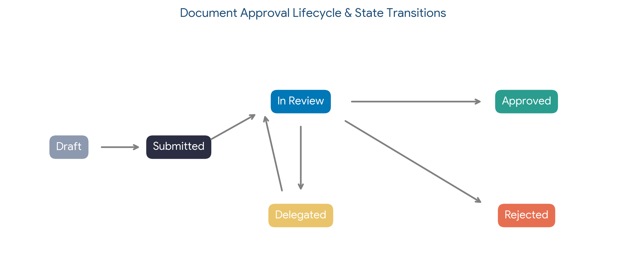
Figure 1: Lifecycle and Transition States of the Intelligent Workflow Engine
4. Propose a Suitable Solution Using Software Engineering Principles
4.1 Proposed System Architecture & Solution Overview
The proposed Intelligent Document Approval Workflow System is an enterprise Web/Mobile Application built on a Microservices Architecture. The solution isolates business domain responsibilities into lightweight, independently deployable services communicating via REST APIs and asynchronous message queues.
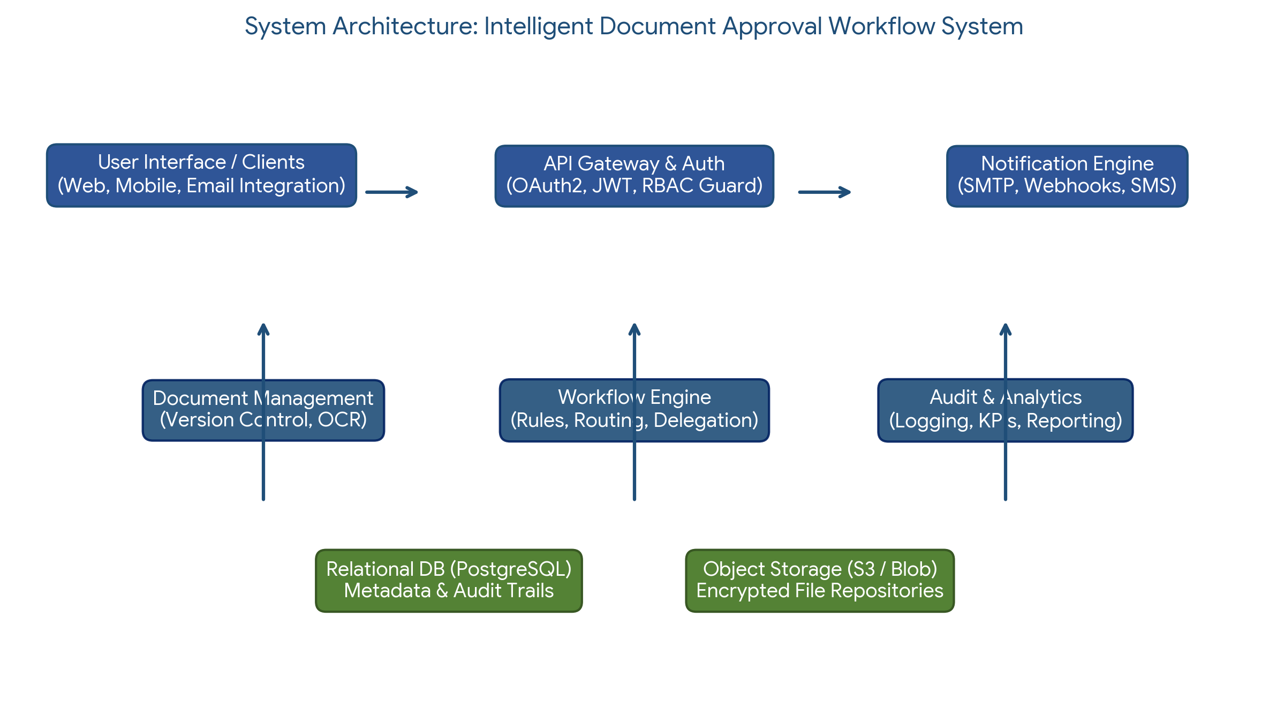
Figure 2: Multi-Tier Microservices System Architecture Diagram
4.2 Functional Modules of the Proposed System
- User & Role Management Module: Handles authentication, Single Sign-On (SSO) integration (SAML/OAuth2), RBAC policies, and organizational hierarchy mapping.
- Document Ingestion & Version Control Module: Manages file uploads, metadata extraction, digital signatures, document diffing, and cloud object store integration.
- Dynamic Workflow & Rule Engine Module: Executes approval flows based on configurable logic (e.g., IF Amount > $50,000 THEN require CFO sign-off), handles dynamic branching, and manages step transitions.
- Delegation & Notification Engine: Manages scheduled/out-of-office delegation rules, routes escalation triggers, and generates multi-channel notifications (Email, Push, Slack, SMS).
- Audit & Compliance Service: Records immutable event logs for every user interaction, storing SHA-256 digital hashes of documents and decisions in append-only storage.
- Analytics & Reporting Dashboard Module: Aggregates workflow telemetry to generate cycle time reports, SLA breach alerts, throughput metrics, and bottleneck visualizations.
4.3 Functional and Non-Functional Requirements
Functional Requirements (FR) | Non-Functional Requirements (NFR)
FR1: Users shall upload documents with mandatory metadata. | NFR1 (Performance): Page load times < 2s; API response < 500ms.
FR2: Admins shall create multi-tier sequential/parallel workflows. | NFR2 (Scalability): Support 10,000+ concurrent active workflows.
FR3: System shall auto-route documents based on monetary thresholds. | NFR3 (Security): AES-256 storage encryption & TLS 1.3 in transit.
FR4: Approvers shall record decision (Approve/Reject/Revert) + comments. | NFR4 (Availability): 99.9% uptime SLA with active-passive failover.
FR5: System shall auto-trigger SLA reminders & auto-escalations. | NFR5 (Usability): Responsive UI complying with WCAG 2.1 AA standards.
FR6: Users shall set out-of-office delegation with valid time windows. | NFR6 (Maintainability): Microservices architecture with >80% test coverage.

4.4 Incorporation of Software Engineering Principles
- Modularity: Achieved by separating system concerns into independent microservices (Auth, Document, Workflow, Notification, Analytics).
- Scalability: Horizontal auto-scaling of backend stateless services containerized via Docker and managed by Kubernetes.
- Maintainability: Adherence to Clean Code practices, standardized OpenAPI/Swagger REST contracts, and automated CI/CD pipelines.
- Reliability & Resilience: Implementation of Circuit Breaker patterns, automated database backups, and health check probes.
- Security & Compliance: Zero Trust security posture, Least Privilege RBAC, input sanitization, and SHA-256 hashed audit trails.
5. Justify the Chosen Methodology/Framework
5.1 Selection of Software Development Life Cycle (SDLC) Framework
For the design and development of the Intelligent Document Approval Workflow System, the Agile-Scrum methodology combined with DevOps practices is selected as the optimal software development framework.
5.2 Technical & Operational Justification for Agile-Scrum
The rationale for selecting Agile-Scrum over traditional Waterfall models includes:
- Iterative Evolution of Complex Workflows: Organizational approval rules vary across departments. Agile bi-weekly Sprints allow the team to develop core routing modules first, gather stakeholder feedback, and incrementally refine complex rule engines.
- Frequent Stakeholder Feedback Loops: Sprint Reviews ensure that business units (Finance, HR, Legal) interact with working software increments early, validating usability and UI responsiveness before full deployment.
- Risk Mitigation through Incremental Delivery: Deploying foundational modules (Document Ingestion, Basic Approvals) in early sprints mitigates integration risks prior to releasing complex analytics and delegation engines.
- DevOps Integration for Continuous Delivery: Automated CI/CD pipelines enable continuous integration, automated unit/integration testing, and zero-downtime deployments.
6. Discuss Expected Outcomes and Limitations
6.1 Expected Business & Operational Outcomes
- Accelerated Approval Cycles: Reduces average approval turnaround time from 8.5 days to under 1.2 days through automated notifications and real-time mobile approvals.
- 85%+ Reduction in Email Overhead: Eliminates cluttered inbox threads by centralizing discussions, annotations, and decisions directly within the workflow portal.
- 100% Audit Compliance & Transparency: Provides an unbroken, tamper-proof historical record of every document decision, satisfying regulatory compliance demands.
- Elimination of Operational Bottlenecks: Out-of-office delegation and automated SLA escalations prevent approval stagnation.
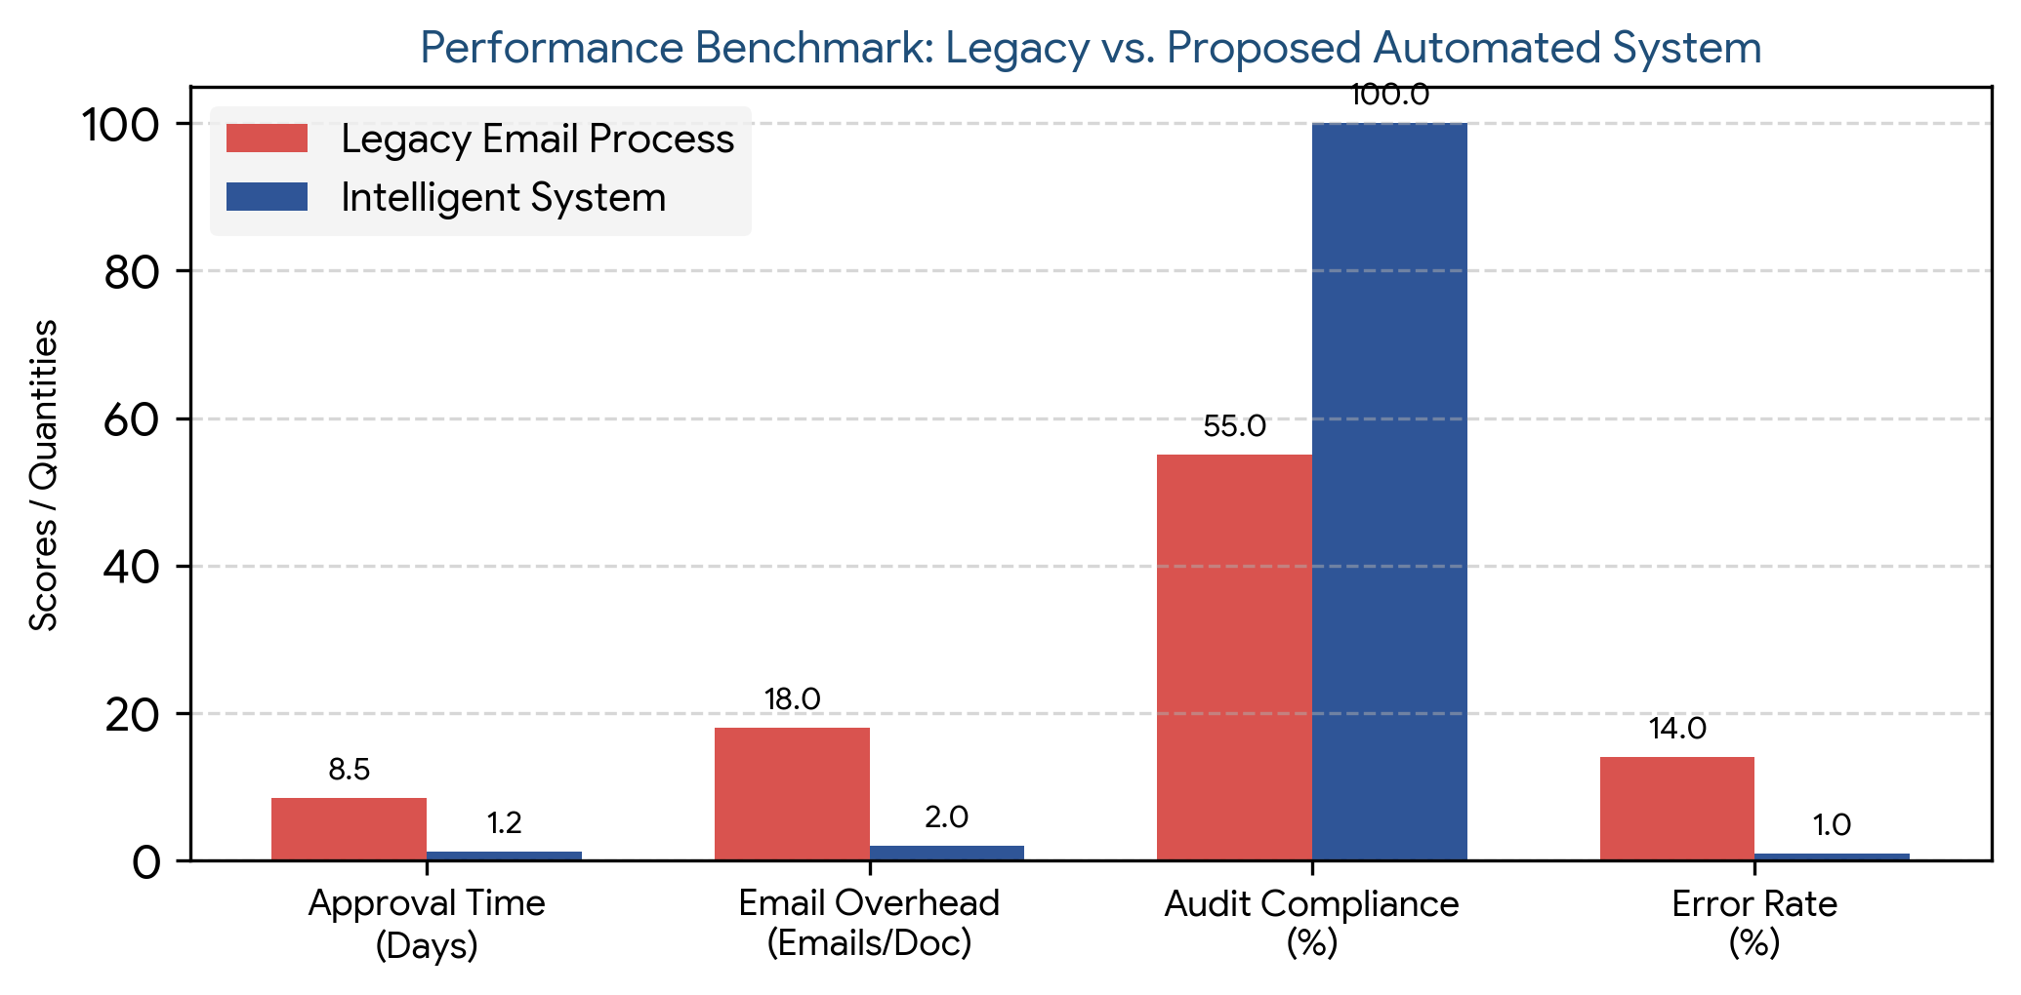
Figure 3: Comparative Performance Benchmarks (Legacy vs. Proposed Automated System)
6.2 Potential Risks, Implementation Challenges, and Limitations
- Organizational Change Resistance: Employees accustomed to informal email approvals may resist adhering to structured digital forms and workflow portals.
- Complex Hierarchy Configuration: Mapping intricate multi-subsidiary authorization matrices into automated rule engines can introduce initial configuration complexity.
- Legacy Enterprise System Integration: Integrating with legacy ERP or HR system databases may present data formatting and API incompatibility challenges.
6.3 Suggested Future Enhancements
- AI-Powered Smart Document Parsing (OCR & NLP): Leverage Generative AI and OCR to automatically extract metadata, detect budget anomalies, and summarize lengthy contract proposals.
- Predictive Approval Analytics: Implement Machine Learning models to predict potential approval delays and recommend optimal routing paths.
- Blockchain-Based Audit Ledger: Integrate hyper-ledger blockchain technology for cross-organizational verifiable audit trails.

