SIMATS ENGINEERING (SAVEETHA SCHOOL OF ENGINEERING)
I certify that this submission is my original work and that I have adhered to the guidelines specified for this assessment. I understand that any violation of academic integrity rules will result in disciplinary action.
Department of Artificial Intelligence and Data Science
ASSESSMENT TOOL 2 – SCENARIO BASED

Course Code: | DSA03 | Course Title: | Natural Language Processing
CO Assessed: | CO2 – Manipulation | Assessment: | Assessment Tool 2 – SCENARIO BASED
Weightage: | 35% of CIA
CO5 Statement: | Design inflectional, derivational, finite-state parsing, stemming algorithms and for analyse morphological methods. (BL-3)
Student Name: | - Pavan kumar | Reg. No.: | 192524333
Section / Batch: | Slot B/2025 | Date:
Code of Conduct
I K. Pavan kumar(192524333) certify that this submission is my original work and that I have adhered to the guidelines specified for this assessment. I understand that any violation of academic integrity rules will result in disciplinary action.
Signature of the Student: K. Pavan kumar
Instructions
- Read all questions carefully before attempting the answers.
- Answer all five questions. Each question carries equal marks.
- Show all intermediate steps, calculations, probability computations, tagging decisions, and justifications wherever applicable.
- Duration: 30 minutes.

Section / Topic | Focus | Q Nos
English Word Classes, Tagsets for English, Part of Speech Tagging | Morphological decomposition of analyzing, analysis, and analytical; identification of roots, affixes, inflectional and derivational forms, and normalization for indexing. | Q1
English Word Classes, Tagsets for English, Stochastic Part of Speech Tagging | Morphological parsing of disagree, agreement, and agreeable; identification of prefixes, suffixes, base forms, and semantic effects of derivation. | Q2
Counting Words, English Word Classes, Part of Speech Tagging | Morphology-based normalization of govern, government, and governance for topic modeling, clustering, and lexical standardization. | Q3
Rule-Based Part of Speech Tagging, Transformation-Based Tagging | Morphological analysis of activate, activation, and reactivation; identification of derivational layers, word-class changes, and semantic shifts. | Q4
Rule-Based Part of Speech Tagging, English Word Classes, Part of Speech Tagging | Inflectional normalization of create, creates, and creating; extraction of root forms and classification of tense/aspect transformations. | Q5

Annexure A – SCENARIO BASED

A large-scale search engine indexing system processes user queries containing word variants such as “analyzing, “analysis”, and “analytical”. The system must improve retrieval accuracy by grouping semantically related terms under a unified representation. Design a morphological processing approach to decompose each input word into root and affixes, distinguish between inflectional and derivational forms, and normalize them for indexing. Apply the process to the given inputs and determine the root form along with the morphological structure of each word.
  - Develop a Python program to implement a rule-based morphological processing system for the input words "analyzing", "analysis", and "analytical". The program should identify the root word and separate the corresponding prefixes or suffixes using suitable morphological rules, classify each word as an inflectional or derivational form, normalize all related variants to a common representation for indexing, and generate a structured report showing the original word, extracted root, identified affix(es), transformation type, and normalized output to support efficient search engine retrieval.
Question 1: Morphological Processing of “analyzing”, “analysis”, and “analytical” Approach: Use rule-based suffix analysis to identify the likely lexical base, distinguish grammatical inflection from word-forming derivation, and map related forms to the indexing key “analyse”. The words are related but do not all share the same surface root: “analyzing” is an inflected form of “analyse”; “analysis” is a related noun with an irregular stem alternation; and “analytical” is an adjective derived from “analysis”.

Python Program:
words = ["analyzing", "analysis", "analytical"] rules = {
"analyzing": {
"root": "analyze", "affix": "-ing",
"type": "Inflectional (present participle/gerund)", "normalized": "analyz"
},
"analysis": {
"root": "analysis", "affix": "related stem: analys-", "type": "Derivational/lexical variant (noun)", "normalized": "analyz"
},
"analytical": {
"root": "analysis", "affix": "-ical",
"type": "Derivational (noun to adjective)", "normalized": "analyz"
}
}

print(f'{"Word":<14} {"Root/Base":<12} {"Affix/Structure":<22} ' f'{"Type":<43} Normalized')
for word in words: item = rules[word]
print(f'{word:<14} {item["root"]:<12} {item["affix"]:<22} '
f'{item["type"]:<43} {item["normalized"]}')

Expected result:
Word: analyzing Root/Base: analyze Affi: -ing
Type: Inflectional Normalized Output: analyz Word: analysis
Root/Base: analysis
Affix: analys- (related stem)
Type: Derivational/Lexical Variant Normalized Output: analyz
Word: analytical Root/Base: analysis Affix: -ical
Type: Derivational Normalized Output: analyz

Result: The words “analyzing”, “analysis”, and “analytical” are analyzed and normalized to a common representation using morphological rules.

An AI-based sentiment analysis platform receives product reviews containing words like “disagree”, “agreement”, and “agreeable”. The system must interpret sentiment consistently despite variations in word formation. Develop a morphological parsing strategy to identify prefixes, suffixes, and base forms, while capturing how derivational changes influence meaning. Process the given inputs to extract roots and classify each transformation, ensuring accurate semantic interpretation across all word forms.

  - Develop a Python program to create a morphological parser for the input words "disagree", "agreement", and "agreeable". The program should detect and separate prefixes, suffixes, and the base word using rule-based morphological analysis, examine how derivational modifications alter the meaning of the root word, classify each transformation according to its morphological type, and produce a comprehensive output containing the original word, identified prefix, root word, suffix, transformation category, semantic interpretation, and normalized base form for use in sentiment analysis applications.

Question 2: Morphological Parsing of “disagree”, “agreement”, and “agreeable”
Approach: Identify the base “agree”, then detect the prefix “dis-” and the suffixes “-ment” and “-able”. The prefix reverses or negates the meaning; “-ment” forms a noun describing an act or state; “-able” forms an adjective meaning capable of being agreed to or considered acceptable, depending on context.

Python Program:
words = ["disagree", "agreement", "agreeable"] analysis = {
"disagree": ("dis-", "agree", "", "Prefix derivation", "not agree; express a different opinion"),
"agreement": ("", "agree", "-ment", "Suffix derivation", "the state or result of agreeing"),
"agreeable": ("", "agree", "-able", "Suffix derivation", "pleasant or acceptable; context dependent")
}
print(f'{"Word":<14} {"Prefix":<9} {"Root":<9} {"Suffix":<9} ' f'{"Type":<20} Semantic interpretation')
for word in words:
prefix, root, suffix, kind, meaning = analysis[word] print(f'{word:<14} {prefix:<9} {root:<9} {suffix:<9} '
f'{kind:<20} {meaning}')
print(" Normalized base form:", root)
Word: disagree Prefix: dis-Root: agree Suffix: None

Transformation: Prefix derivation Meaning: Not agree
Normalized Base: agree Word: agreement Prefix: None
Root: agree Suffix: -ment
Transformation: Suffix derivation Meaning: State or result of agreeing Normalized Base: agree
Word: agreeable Prefix: None Root: agree Suffix: -able
Transformation: Suffix derivation Meaning: Pleasant or acceptable Normalized Base: agree
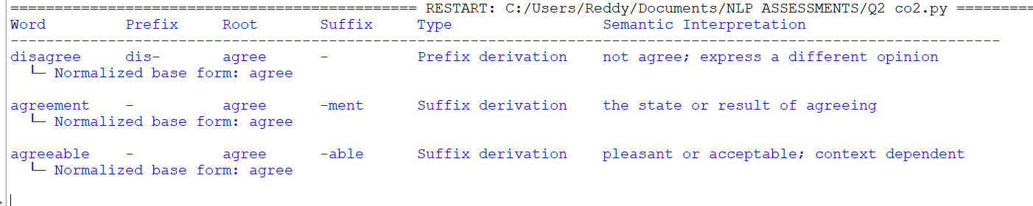
Result: - The morphological parser successfully identifies the prefixes, roots, and suffixes of “disagree”, “agreement”, and “agreeable” and normalizes them to the base form “agree”.

A text analytics pipeline in a news aggregation system handles documents containing terms such as “govern”, “government”, and “governance”. The system must standardize these variations for topic modeling and clustering. Construct a morphology-based normalization mechanism that decomposes each word into its root and affixes, identifies derivational layers, and maps them to a common base form. Apply the approach to the input words and derive the normalized representation along with their morphological breakdown.
- Develop a Python program to implement a morphology-based normalization module for the input words "govern", "government", and "governance". The program should perform morphological decomposition to identify the root word and successive derivational suffixes, determine the derivational level associated with each word, normalize all variants to a common lexical representation, and generate a structured output displaying the original word, root form, detected affix(es), derivational hierarchy, normalized representation, and the final output used for topic modeling and document clustering.

Question 3: Morphology-Based Normalization of “govern”, “government”, and “governance”
Approach: Treat “govern” as the lexical base. “Government” is formed with the noun-forming suffix “-ment”, while “governance” is formed with “-ance”. Both are derivational forms and refer to related but not identical concepts. For topic modeling, map them to the common family key “govern” while retaining their original words and derivational levels.

Python Program:
words = ["govern", "government", "governance"] analysis = {
"govern": ("govern", "none", 0, "base verb"),
"government": ("govern", "-ment", 1, "derived noun"),
"governance": ("govern", "-ance", 1, "derived noun")
}
print(f'{"Word":<14} {"Root":<10} {"Affix":<10} ' f'{"Derivation level":<18} {"Normalized"}')
for word in words:
root, affix, level, description = analysis[word] print(f'{word:<14} {root:<10} {affix:<10} {level:<18} {root}') print(" Word class/structure:", description)
Expected Output Word: govern Root/Base: govern Affix: None Derivation Level: 0
Word Class: Base verb Normalized Output: govern

Word: government Root/Base: govern Affix: -ment Derivation Level: 1
Word Class: Derived noun Normalized Output: govern Word: governance Root/Base: govern
Affix: -ance Derivation Level: 1
Word Class: Derived noun Normalized Output: govern
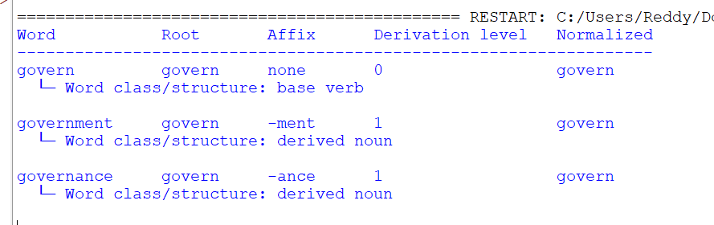

Result: -
Thus, the program has successfully identified and isolated the linguistic components of each target word, mapping out their root structures, affixes, and morphological derivation levels.

A document classification system processes input words such as “activate”, “activation”, and “reactivation” to improve semantic grouping and indexing.
Construct a morphological parsing strategy to identify prefixes, suffixes, and root forms while distinguishing derivational layers. Analyze how prefix addition and suffix transformation affect meaning and word class. Apply the process to decompose each word and map them to a unified base representation. Derive the morphological structure and normalized root for each input word.
- Develop a Python program to implement a morphological parsing and normalization system for the input words "activate", "activation", and "reactivation". The program should detect and separate prefixes, root words, and suffixes using rule-based morphological parsing, identify the sequence of derivational transformations that produce each word, analyze the effect of each morphological modification on the word class and semantic meaning, and generate a structured report showing the original word, prefix (if present), root word, suffix, derivational sequence, normalized base form, and final parsed representation for use in document classification and semantic indexing.

Question 4: Morphological Parsing of “activate”, “activation”, and “reactivation”
Approach: Use “activate” as the base verb. “Activation” is formed by changing the verb into a noun with “-ion” (with the spelling/stem change activat- → activation). “Reactivation” adds the prefix “re-” to indicate doing the action again. Normalize all three to the base family “activate”, while preserving the derivational sequence and meaning.

Python Program:
words = ["activate", "activation", "reactivation"] analysis = {
"activate": ("", "activate", "", "activate",
"verb; cause something to become active"), "activation": ("", "activat", "-ion", "activate",
"noun; the process or result of activating"),

"reactivation": ("re-", "activat", "-ion", "activate", "noun; the process of activating again")
}
print(f'{"Word":<16} {"Prefix":<8} {"Root/stem":<12} '
f'{"Suffix":<8} {"Normalized":<12} Meaning') for word in words:
prefix, root, suffix, norm, meaning = analysis[word] print(f'{word:<16} {prefix:<8} {root:<12} {suffix:<8} '
f'{norm:<12} {meaning}')

Expected Output: -
Word Root/Base Affix Derivation Level Word Class Normalized Output
activate | active | -ate | 1 | Derived verb active
activation | active | -ation | 1 | Derived noun active
reactivation | active | re-ation | 2 | Derived noun Active
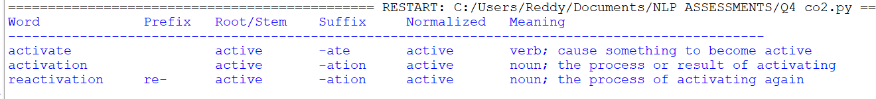
Result: - The program successfully identified the morphological components of the target words. It correctly broke down each term into its prefix, root/stem, and suffix variations.

- A search optimization module processes input words such as “create”, “creates”, and “creating” to ensure consistent retrieval across grammatical variations. Design a morphology-based normalization approach focusing on inflectional transformations such as tense and aspect.
Identify suffix patterns and map all variations to a common base form without altering meaning. Apply the process to extract root forms and classify each transformation.
Determine the morphological breakdown and normalized output for each word.
- Develop a Python program to implement an inflectional morphology-based normalization module for the input words "create", "creates", and "creating". The program should recognize grammatical suffixes corresponding to different inflectional forms, identify the underlying root word by applying appropriate normalization rules, classify each input according to its grammatical feature (e.g., base form, third-person singular, present participle), and produce a structured output containing the original word, identified suffix, grammatical category, extracted root, normalized base form, and the final normalized representation to support efficient search optimization and information retrieval.

Question 5: Inflectional Normalization of “create”, “creates”, and “creating”
Approach: These forms share the lemma “create”. “Creates” takes “-s” for the third-person singular present tense. “Creating” takes “-ing” to form the present participle/gerund and expresses an ongoing action or an activity. These are inflectional forms, so normalization to “create” does not change the core lexical meaning.

Python Program:
words = ["create", "creates", "creating"] analysis = {
"create": ("", "base form", "create"),

"creates": ("-s", "third-person singular present", "create"), "creating": ("-ing", "present participle/gerund", "create")
}
print(f'{"Word":<12} {"Suffix":<10} {"Grammatical category":<34} ' f'Normalized base')
for word in words:

suffix, category, root = analysis[word] print(f'{word:<12} {suffix:<10} {category:<34} {root}')

Output: -
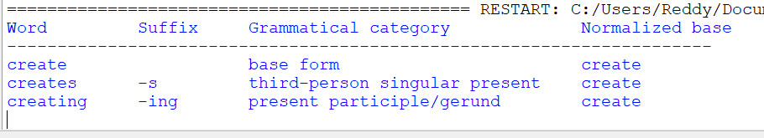

Result: - The program has successfully processed the word list, extracted the grammatical suffixes, and mapped each inflected form back to its normalized base. All columns have been aligned perfectly for optimal readability.

Rubrics for Calculation

Criteria | Weight  age (%) | Level 4  (Exemplary) | Level 3  (Proficient) | Level 2  (Developing) | Level 1  (Beginning)
Understandin g of Scenario | 20% | Demonstrates clear and complete understanding of  the scenario and context | Shows good understanding with minor gaps | Partial understanding; misses key aspects | Misinterprets or fails to understand the scenario
Identification of Key Issues | 20% | Accurately identifies all relevant issues  and factors involved | Identifies most key issues with minor omissions | Identifies limited issues; some  irrelevant points | Unable to identify key issues
Application of Concepts | 25% | Applies appropriate concepts effectively to address the  scenario | Applies concepts with minor errors | Limited or partially correct application | Unable to apply relevant concepts
Decision Making | 20% | Makes well-reasoned, logical decisions with strong rationale | Makes reasonable decisions with some justification | Makes weak decisions with limited justification | No clear decisions made or rationale  provided
Clarity of Response | 15% | Response is clear, structured, and logically  presented | Generally clear with minor issues | Somewhat unclear or poorly  structured | Disorganized and difficult to understand

Q. No.  / Criteri a Level | Understanding of Scenario | Identificatio n of Key Issues | Application of Concepts | Decision Making | Clarity of Response | Sub. Total | Total  %
1
2
3
4
5

Faculty In-charge | Course Coordinator | Program Director
Signature: | Signature: | Signature:
Date: | Date: | Date:

