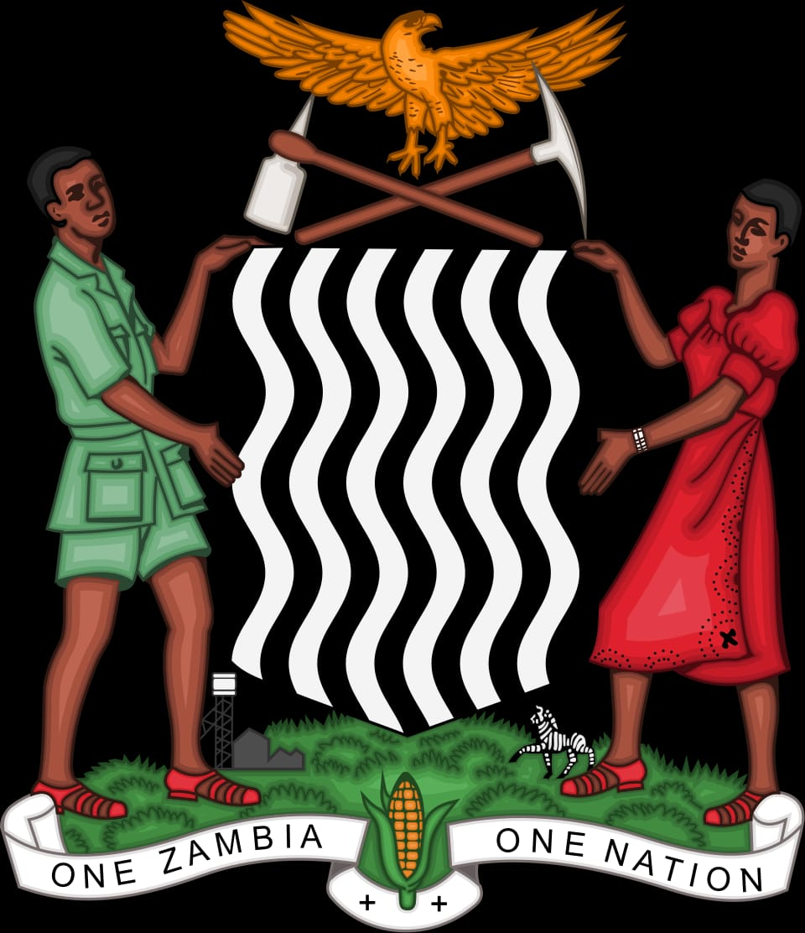
REPUBLIC OF ZAMBIA
Ministry of Education
Senior Secondary School Lesson Plan
NAME OF TEACHER | GRADE/CLASS | DATE

NAME OF SCHOOL
SUBJECT
TOPIC
SUB-TOPIC
DURATION/TIME | |
1. SPECIFIC COMPETENCE / LEARNING OUTCOME
________________________________________________________________________________
________________________________________________________________________________
2. LESSON GOAL
________________________________________________________________________________
________________________________________________________________________________
3. RATIONALE
________________________________________________________________________________
________________________________________________________________________________
4. PRIOR / PRE-REQUISITE KNOWLEDGE
________________________________________________________________________________
5. REFERENCES
________________________________________________________________________________
6. TEACHING AND LEARNING MATERIALS / RESOURCES
________________________________________________________________________________
7. LESSON DEVELOPMENT / PROGRESSION
STAGE / TIME | CONTENT / LEARNING POINTS | TEACHERS’ ROLE | LEARNERS’ ROLE | ASSESSMENT/Evidence
INTRODUCTION
Time: ______
DEVELOPMENT
Time: ______
CONCLUSION
Time: ______
8. TEACHER EVALUATION/ASSESSMENT
________________________________________________________________________________
________________________________________________________________________________
9. LEARNER EVALUATION
_______________________________________________________________________________
________________________________________________________________________________
10. HOMEWORK / EXTENSION ACTIVITY
________________________________________________________________________________

