Communication
Effect of Palletisation and Temperature on Bag-in-Box Wine Packaging under Simulated Export Conditions
Nicola Mercanti ¹, Monica Macaluso ^{1*}, Bruno Casu ², Kamran Mehravar ², Fabrizio Palla ², Piero Giorgio Verdini ^{2,3}, and Angela Zinnai ^{1,4}
Academic Editor: Firstname Lastname
Received: date
Revised: date
Accepted: date
Published: date
Citation: To be added by editorial staff during production.
Copyright: © 2025 by the authors. Submitted for possible open access publication under the terms and conditions of the Creative Commons Attribution (CC BY) license (https://creativecommons.org/licenses/by/4.0/).
¹ Department of Agriculture, Food and Environment, University of Pisa, Via del Borghetto 80,
56124 Pisa, Italy; nicola.mercanti@phd.unipi.it (N.M.); monica.macaluso@unipi.it (M.M.);
angela.zinnai@unipi.it (A.Z.)
² INFN Pisa Section, Largo Bruno Pontecorvo 3, 56127 Pisa, Italy; bruno.casu@cern.ch (B.C); k.mehravar@studenti.unipi.it (K.M) fabrizio.palla@cern.ch (F.P)
³ European Organization for Nuclear Research Espl. des Particules 1, 1211 Meyrin, Switzerland; pie-ro.giorgio.verdini@cern.ch (P.G.V)
⁴ Interdepartmental Research Centre “Nutraceuticals and Food for Health”, University of Pisa, Via del Bor-ghetto 80, 56124 Pisa, Italy
*Correspondence: monica.macaluso@unipi.it
Abstract
The growing demand for sustainable and efficient wine packaging has promoted the use of Bag-in-Box (BiB) systems for international markets, yet little is known about how palletisation and thermal conditions during transport affect wine stability. This study evaluated the influence of stacking position and temperature on the internal pressure and chemical stability of 3-litre BiB units under conditions reproducing transoceanic shipment. In a first trial, units were palletised in stacks of two heights and held for twenty days in parallel temperature-controlled chambers, one at 19 °C as a neutral reference and one whose contents reached 26–34 °C; a second trial of fifteen days was then run at approximately 50 °C. Pressure and temperature were recorded inside the bags with miniaturised MEMS sensors, and chemical parameters were determined by standard oenological protocols. In the first trial the internal pressure of every unit rose to a maximum on the fourth day of the testing period, some 60–90 mbar above its own starting value, and then relaxed towards a lower, steady level. Referred to each sensor’s own baseline, the rise was greater in the BiBs at the bottom of the stacks than in those at the top, by about 21 mbar, whereas the two chambers behaved alike; by the twentieth day of testing the units had converged. At approximately 50 °C the pressure rose by no more than 9–26 mbar and returned to its starting value within five days, so a compliant bag absorbs thermal expansion by deforming rather than by pressurising, and vertical load rather than temperature governs the mechanical response. Storage in the warmer chamber nevertheless halved total and free sulphur dioxide and produced a small rise in volatile acidity, whereas pH, ethanol, titratable acidity and total phenols were essentially unchanged, and the compositional shifts remained within ranges that are not expected to compromise sensory quality over the short transport window studied. Taken together, the results show that palletisation governs the physical behaviour of the bag while temperature governs its chemical stability, and that in-bag sensing offers a practical tool to monitor these critical export stages and to support the use of BiB as a sustainable packaging alternative.

Keywords: wine logistics, pressure variation, shelf-life, sensor-based monitoring

1. Introduction
In recent years, the wine industry has faced increasing pressure to combine product quality, environmental sustainability and competitiveness on international markets. In this context, the role of wine packaging, historically based on glass, has undergone a major review [1–4]. Export requirements, such as resistance to thermal and mechanical stress, reduction of environmental impact and the need to maintain the organoleptic properties of the product intact during transport, are driving the adoption of alternative solutions [5]. Among these, the Bag-in-Box (BiB) system has gradually established itself as one of the most promising options [6].
In line with growing environmental awareness and the need to reduce the logistical impact of glass packaging, the Bag-in-Box system presents itself as a concrete and sustainable alternative for international markets [7,8]. Recent studies indicate that this format reduces the carbon footprint per litre of packaged wine by up to 90% [6,9–11]. Actually, Bag in Box can be considered an environmentally sustainable solution, especially thanks to the capacity of its most popular formats, which range from 3 to 20 litres [12]. Bag in Box consists of cardboard on the outside, which can be easily folded and disposed of in the paper recycling bin, while the inner bag and plastic tap can be disposed of in the plastic recycling bin. [7,13,14] .
Bag in Box reduces the amount of materials used, simplifies recycling and contributes to more efficient resource and waste management, offering a sustainable alternative for wine packaging [8].
Although initially used for mid-range table wines, BiB has also gained increasing popularity in the premium segments, thanks to its lightness, logistical practicality and good oxygen barrier properties [4]. However, for large-scale use in international flows, it is necessary to investigate its performance in real transport and storage conditions, with particular attention to the mechanical effects resulting from industrial packaging practices, indeed, unlike other food products, wine is particularly sensitive to changes in temperature, pressure and oxidative contamination. During international transport, bottles or containers can be exposed to unstable temperature conditions, vibrations, vertical compression and pressure changes for weeks [15,16]. In such a scenario, the robustness of the packaging and the efficiency of the palletising system become key elements in ensuring the safety and preservation of the wine until it is finally consumed [17].
Previous research has examined how storage temperature and packaging affect wine composition, showing that prolonged exposure to elevated temperatures accelerates the loss of sulphur dioxide and the development of volatile acidity, and that the barrier properties of the container strongly condition the rate of these reactions [20,21]. Most of this evidence, however, refers to bottled wine or to static storage, and the behaviour of BiB units when they are palletised and simultaneously exposed to the thermal and mechanical stresses of long-distance shipping has received little attention. In particular, the internal pressure that builds up inside the flexible bag as a function of temperature and stacking height, and its possible link with chemical stability, has not previously been described. The present work was therefore designed to test whether stacking configuration and storage temperature measurably affect the internal pressure and the chemical stability of 3-litre BiB units under conditions that reproduce transoceanic export. We hypothesised that a higher temperature and a greater vertical load would raise the internal pressure of the bags, and that severe thermal exposure would drive measurable, though possibly limited, changes in the more heat-sensitive chemical parameters. To address this, internal pressure was followed in real time with in-bag MEMS sensors while the main oenological parameters were monitored in parallel.

2. Materials and Methods
The purpose of the work was to simulate the environmental conditions to which wine may be exposed during shipment by sea container to foreign markets, particularly the United States. It comprised two experiments. In the main trial, palletised units were stored for 20 days under two temperature conditions applied in parallel in two temperature-controlled chambers:
- Condition 1: temperature-controlled chamber set at 19 °C (neutral/stable reference).
- Condition 2: temperature-controlled chamber set at 50 °C, representative of the critical conditions found in non-refrigerated containers during ocean transport. Internal temperatures of this order have been reported inside non-refrigerated containers during long ocean voyages [15].
- The temperature recorded inside the bags subsequently showed that the chamber set to 50 °C had not attained its set point under a full pallet (Section 3.2). A second, verification trial was therefore carried out at 50 °C, and is described in Section 2.3. The two trials are set out together in Table 1.
The wine used in this study was a commercial white wine supplied by Castellani S.p.A. and packaged in standard 3-L Bag-in-Box units representative of those used for commercial export (Figure 1). Information regarding the grape variety and vintage was not available, as the study focused on evaluating the influence of palletisation and storage temperature on packaging performance rather than on varietal characteristics. The main compositional parameters of the wine before thermal exposure correspond to the reference (19 °C) values reported in Table 2. The inner bag consisted of a flexible multilayer film provided with an oxygen-barrier layer and an integrated dispensing valve, housed in a corrugated cardboard case that supplied mechanical protection during palletisation.
For each storage temperature (19 °C and 50 °C), three independent experimental replicates were performed simultaneously using two climate-controlled chambers, so that both conditions ran in parallel throughout the 20-day storage period and shared an identical experimental timing. Each replicate consisted of one vertical stack of 3-L Bag-in-Box units built to one of two heights: per chamber, one stack of four boxes (128 cm) and two stacks of three boxes (97 cm) (Figure 2; Table 1). MEMS pressure sensors were positioned in the uppermost and the lowermost BiB of every stack, giving six sensors per temperature (three top, three bottom; n = 3 independent stacks per position) and twelve sensors in total. One bottom sensor in the 19 °C chamber did not return a complete record, so eleven pressure traces were available for analysis. The 20-day window was chosen to reproduce the typical duration of transoceanic shipment to distant markets such as the United States, which usually spans two to four weeks [15].

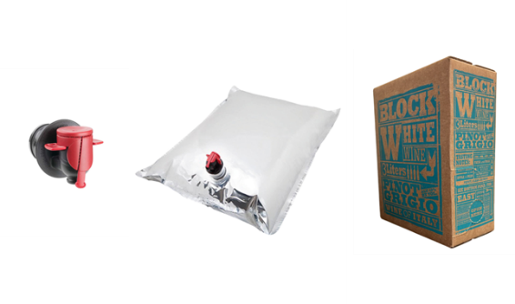
Figure 1. Principal components of the Bag-in-Box (BiB) packaging system: on the left, the tap/dispenser for dispensing the product; in the centre, the flexible multi-layer bag used to contain the wine, equipped with a valve; on the right, the external corrugated cardboard container that provides mechanical protection and stability during transport and palletisation.
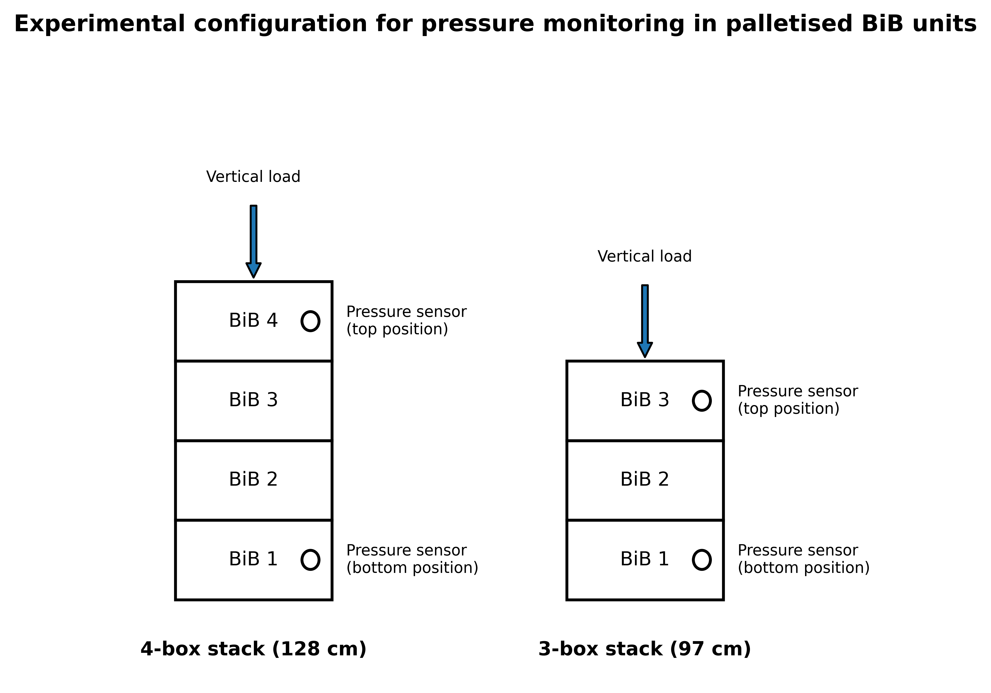
Figure 2. Experimental configuration used for pressure monitoring in palletised 3-L Bag-in-Box (BiB) units. Two stack heights were investigated: a 4-box stack (128 cm) and a 3-box stack (97 cm). MEMS pressure sensors were positioned in the uppermost and lowermost BiBs of each stack to evaluate the effect of vertical load on internal pressure development during storage.
Table 1. Structure of the experimental samples and placement of the pressure sensors.
Trial | Chamber set point | Duration | Stack | Boxes in stack (height) | MEMS sensors
Main | 19 °C | 20 days | Stack 1 | 4 (128 cm) | Top + bottom BiB
Main | 19 °C | 20 days | Stack 2 | 3 (97 cm) | Top + bottom BiB
Main | 19 °C | 20 days | Stack 3 | 3 (97 cm) | Top + bottom BiB *
Main | 50 °C | 20 days | Stack 1 | 4 (128 cm) | Top + bottom BiB
Main | 50 °C | 20 days | Stack 2 | 3 (97 cm) | Top + bottom BiB
Main | 50 °C | 20 days | Stack 3 | 3 (97 cm) | Top + bottom BiB
Verification | 50 °C | 15 days | Stack 1 | 3 (97 cm) | 2 top + 2 bottom BiB
Main trial: twelve MEMS pressure sensors in total — one in the top and one in the bottom BiB of each of the three independently built stacks, in each of the two chambers, the two temperature regimes being applied in parallel in separate climate-controlled chambers. * The bottom sensor of one 19 °C stack did not return a complete record, so eleven of the twelve traces were available for analysis. Verification trial: a single stack instrumented with four sensors, of which one ceased to transmit on the fourth day of that trial. Chemical analyses were carried out on the wine of the main trial only, and are reported in Table 2; they were not resolved by stack position.

2.1 Chemical parameters
During and at the end of the thermal exposure period, quality checks were carried out to assess the impact of storage conditions on the characteristics of the wine.
The chemical analyses necessary for characterising the wine (free sulphur dioxide, total sulphur dioxide, titratable acidity (g/L tartaric acid), volatile acidity (g/L acetic acid), ethanol, malic acid, lactic acid, total phenols and pH) were carried out according to the protocols described in a previous study [18].

2.2 Physical parameters
Pressure monitoring within the Bag-in-Box containers was carried out using custom-designed sensing units, as described in a previous study [19]. Each unit was built around an MS5803-05BA miniature altimeter module (TE Connectivity), a 24-bit MEMS pressure and temperature sensor with SPI and I²C interfaces. According to its data sheet [24] the device covers 0–5 bar and −40 to +85 °C, resolves pressure to between 0.036 and 0.195 mbar depending on the oversampling ratio and temperature to better than 0.01 °C, and is specified to ±1.5 mbar between 300 and 1100 mbar at 20 °C, widening to ±100 mbar over the whole 0–5 bar and 0–50 °C envelope, with a long-term stability of ±1 mbar per year and a temperature accuracy of ±2.5 °C. The sensor was driven by an ESP8285 microcontroller on an ESP-M2 board (Adafruit) [25] and powered by a lithium battery. The assembly was enclosed in an oil-filled plastic casing, the oil transmitting the pressure of the wine to the transducer while dispersing the small amount of heat released by the electronics, whose draw is below 1 mA. The casing was introduced into each bag through the existing filling/dispensing valve before the bag was finally sealed, so that the multilayer film was not punctured and the barrier integrity of the bag was preserved; sealing then followed the standard procedure of the filling line, which prevented leakage and any artificial perturbation of the internal pressure.
Twelve sensing units were deployed in total, two per stack (one in the uppermost and one in the lowermost BiB) across the three stacks of each chamber. The stacks were prepared and filled independently and are therefore treated as independent replicates (n = 3 per position and temperature); each pressure trace originates from a distinct sensor in a distinct BiB, so the replicates are independent units rather than repeated measures of the same bag. Pressure and temperature were recorded every 30 minutes throughout the storage period, an interval that follows the slow evolution of the palletised units but is too coarse to resolve rapid transients. Each trace was referred to its own initial value and the analysis carried out on the pressure change (ΔP), so that the comparison depends on the stability of a single sensor — ±1 mbar per year — rather than on the agreement between different sensors. The two temperature regimes were run in parallel in two separate chambers.

2.3 Verification trial at 50 °C
Because the main trial did not reach the intended high temperature, a further experiment was carried out to characterise the physical response of the packaging to a verified thermal load. A single stack of three boxes of the same 3-litre Bag-in-Box format was instrumented with four MEMS sensors of the same type, two in the uppermost and two in the lowermost BiB, and held for 15 days in a temperature-controlled chamber set at 50 °C. Pressure and temperature were logged every minute, against the 30-minute interval used in the main trial. The trial was designed to establish the pressure that develops inside a bag whose contents actually reach the target temperature; it was not replicated across stacks and no chemical analyses were performed on it, so it complements the main trial rather than repeating it. One of the two upper sensors ceased to transmit on the fourth day and the remaining three completed the 15-day record.

2.4 Statistical analyses
One-way analysis of variance was performed using CoStat, Version 6.451, CoHort 6.0 Software (Pacific Grove, CA, USA) to assess the presence of significant differences in the compositional parameters among the investigated samples, while the JMP Pro 14.0 statistical package (SAS Institute, Cary, NC, USA) was used to evaluate differences in the relative content of the identified chemical classes. In both cases the means were separated by Tukey’s post hoc test at p ≤ 0.05, and each analysis was performed in triplicate.
The pressure data were treated separately, because each unit is described by two factors at once — the position it occupies in the stack (top or bottom) and the chamber it was stored in (19 °C or 50 °C). A two-way analysis of variance is the appropriate tool in this situation [26]. Where a one-way ANOVA asks whether a single factor shifts the mean of a response, a two-way ANOVA partitions the total variability of the response between two factors at once and estimates the effect of each while holding the other constant, together with their interaction, that is, whether the effect of one factor depends on the level of the other. Each observation is described by the linear model
y_{ijk} = μ + α_{i} + β_{j} + (αβ)_{ij} + ε_{ijk} (1)
in which y is the summary value extracted from the ΔP curve of a single sensor — the peak reached on the fourth day of the testing period, and separately the residual value on the twentieth day — for the k-th stack at position i (top or bottom) in chamber j (19 or 50 °C); μ is the overall mean, α and β are the effects of position and of chamber, (αβ) their interaction and ε the residual, assumed independent and normally distributed with zero mean and constant variance. The total sum of squares is decomposed into the contribution of each factor, of the interaction and of the residual, and each factor is tested with the variance ratio
F = MS_{factor} / MS_{error} = (SS_{factor} / df_{factor}) / (SS_{error} / df_{error}) (2)
which follows an F distribution when the factor has no effect, so that the associated p value gives the probability of observing a ratio at least as large as the one measured under that null hypothesis [26]. With two levels per factor and eleven sensors, the additive model leaves one degree of freedom for each factor and N − a − b + 1 = 8 for the residual, which is the origin of the notation F(1,8) used below. The design is unbalanced, because one bottom sensor at 19 °C returned no record and the four cells therefore hold three, three, three and two units; the sums of squares were consequently computed by the Type II method, in which each factor is adjusted for the other, this being the recommended choice for unbalanced data when the interaction is not significant [27]. Effects with p ≤ 0.05 are reported as significant. The computation was carried out in Python 3 with the statsmodels package [28].

3. Results and Discussion

3.1 Chemical parameters
The comparative analysis between the wine held in the chamber set at 19 °C and the wine held in the chamber set at 50 °C for 20 days revealed significant variations in several parameters, with particular reference to sulphur dioxide content, volatile acidity and lactic acid. One point must be made before these values are interpreted. As the sensors placed inside the bags subsequently showed (Section 3.2), the hot chamber did not sustain its set point once loaded with a full pallet: the wine in it experienced between 25 and 34 °C according to its position in the stack, rather than 50 °C, while the reference chamber held close to its own set point. The comparison below is therefore between roughly 23 °C and roughly 30 °C, and the labels 19 °C and 50 °C in Table 2 denote the nominal conditions of the two chambers rather than the temperature of the wine. This does not weaken the comparison — the two groups remain clearly separated and the exposure is, if anything, closer to what a container actually reaches — but it does bear on the mechanisms that can reasonably be invoked.
The lactic acid content was slightly but significantly higher in the wine from the hot chamber (0.29 ± 0.20 g/L) than in the reference (0.16 ± 0.05 g/L) (Table 2). The difference is unlikely to reflect any secondary malolactic activity, and the argument rests on the wine itself rather than on the temperature: had malic acid been decarboxylated to lactic acid, the malic acid concentration would have fallen, whereas it did not vary significantly (1.0 ± 0.16 g/L against 1.1 ± 0.23 g/L), and the increase of about 0.13 g/L in lactic acid has no stoichiometric counterpart in the malic acid data. A shift of this size, with a standard deviation of ± 0.20 g/L on a mean of 0.29 g/L, is in any case at the limit of what the method resolves at these low concentrations, and heat-driven chemical change together with analytical variability accounts for it without invoking fermentation. Studies on wine held at elevated storage temperatures likewise report only limited, non-fermentative shifts in the organic acid fraction [20,21].
Volatile acidity, expressed as acetic acid, rose significantly in the wine from the hot chamber (0.39 ± 0.03 g/L) relative to the reference (0.30 ± 0.02 g/L) (Table 2). The most economical explanation is the acceleration of chemical reactions by heat — the oxidation of ethanol and the hydrolysis of esters and other acetyl compounds, both of which release acetic acid [22] — and this is consistent with the absence of any parallel movement in the other microbiological indicators. It should be stressed that 0.39 g/L remains well below the sensory perception threshold for acetic acid in wine, commonly cited at around 0.7 g/L, and far below regulatory limits, so the practical effect of a change of this magnitude on wine quality over the period studied is limited.
The most marked difference concerned total and free SO₂, both significantly lower in the wine from the hot chamber. Total SO₂ decreased from 50 ± 5.5 to 25 ± 8.2 mg/L and free SO₂ from 31 ± 2.5 to 16 ± 1.8 mg/L (Table 2). This is consistent with the known degradative effect of temperature on sulphur dioxide, whose decline compromises the antioxidant and antimicrobial protection of the wine during storage [23]. That the reserve was halved at the temperatures the wine actually reached — between 25 and 34 °C rather than 50 °C — makes the observation more relevant to practice, not less, since those values are well within the range a non-refrigerated container reaches on an ordinary voyage.
With respect to pH, alcohol content and titratable acidity, no significant variation was found between the two treatments, indicating that the thermal load did not affect the acid–base balance or the alcohol concentration over the short observation period. Total phenols, expressed as catechins, also remained stable (1.02 ± 0.12 g/L in the reference against 1.10 ± 0.07 g/L in the hot chamber), with no statistically significant difference (Table 2).

3.2 Physical parameters
In accordance with the design described in the Materials and Methods and summarised in Table 1, three stacks of 3-litre BiB units — one of four boxes (128 cm) and two of three boxes (97 cm) — were held in a chamber set at 50 °C and, in a parallel chamber set at 19 °C, for the same 20-day period. The complete record of both chambers is shown in Figure 3, where the internal pressure of the bags is plotted above the temperature registered by the same sensors on a common time axis. In every unit the pressure followed the same three-stage course: a brief initial transient, a pressurisation phase that reached its maximum on the fourth day of the testing period, and a slow relaxation towards a lower, steady level that persisted until the end of the test.
The first hours of the record deserve separate comment, and Figure 4 shows them on an expanded time axis. Over roughly the first five hours the pressure and the temperature of every unit moved irregularly, the units arriving at about 28 °C, cooling to some 13 °C and only then beginning to warm towards the temperature of their chamber, while the pressure stepped up by 30 to 40 mbar at around the fifth hour. This interval does not describe the behaviour of wine in storage. The instrumented bags were filled at the manufacturer and driven by car to the laboratory, so that both the temperature and the ambient pressure around them varied in transit, and the filling and sealing of the BiB on the production line disturbs the units mechanically as well; the step at the fifth hour corresponds to the moment the boxes were assembled into their stacks and the vertical load was applied. The electronics themselves can be excluded as a source: the sensing unit draws less than 1 mA and sits in an oil-filled casing that disperses what little heat it produces. It should also be borne in mind that with one reading every 30 minutes this part of the record is sampled too coarsely to resolve rapid variation, and only its overall shape can be interpreted. The interval was therefore excluded from the quantitative comparison, which begins once the units were in place; beyond it the signal became regular and was tracked without interruption for the full twenty days.
Once the units were in place the pressure of every one of them rose steadily and reached its maximum on the fourth day of the testing period, at about 60–90 mbar above its own starting value, after which it declined gradually, passed through a minimum around the fourteenth day and recovered slightly towards the end. Referred to each sensor’s own baseline, the rise at the peak was 83.0 ± 17.2 mbar in the bottom units against 66.6 ± 10.1 mbar in the top ones at 50 °C, and 84.8 ± 8.8 mbar against 59.6 ± 5.1 mbar at 19 °C (Figure 5A). Entering these eleven peak values into the two-way model described in Section 2.4, with stack position and chamber as factors, the position of the unit emerges as the only factor that matters: it accounts for 1119 of the 2124 mbar² of total variability, giving F(1,8) = 9.14 and p = 0.017, the bottom BiBs developing on average 21 mbar more than the top ones. The chamber contributes only 25 mbar² (F(1,8) = 0.21; p = 0.66) and the two factors do not interact (p = 0.56), so the effect of position is the same in both chambers. The advantage of the lower units did not persist: repeating the analysis on the residual ΔP of the twentieth day, neither factor remains significant (position, F(1,8) = 0.35, p = 0.57; chamber, F(1,8) = 0.81, p = 0.39; Figure 5B), the units having converged towards a common residual overpressure of roughly 40–60 mbar. The effect of vertical load is therefore real but transient, expressed while the bag is being pressurised and progressively relieved thereafter. That relaxation, which occurred while the units were still slowly warming, is not consistent with a purely thermal expansion of the liquid and headspace, and is better explained by the progressive accommodation of the flexible multilayer film under sustained load together with the slow permeation of headspace gas through the film.
The lower panels of Figure 3 report the temperature registered by the same sensors inside the bags, and they show that the first trial did not deliver the thermal condition it was designed for. In the chamber set at 19 °C the wine equilibrated close to the set point, at 23.5 ± 0.8 °C in the top units and 22.7 ± 0.7 °C in the bottom ones. In the chamber set at 50 °C, however, the units warmed asymptotically over the first days and then stabilised far below the set point, at 33.6 ± 1.5 °C at the top of the stacks and 25.5 ± 0.9 °C at the bottom, remaining there for the rest of the storage with a vertical gradient of about 8 °C between the two positions. The enclosure failed to hold its set point once loaded with a full pallet, a fault later attributed to its air circulation, and the persistent stratification between the top and the bottom of the same stack is itself the signature of inadequate air movement rather than of the thermal inertia of the packaging. Two consequences follow. The comparison between positions is unaffected, since the two positions were exposed to the same environment, and the effect of stack load reported above therefore stands. The comparison between the two chambers, on the other hand, cannot be read as 19 °C against 50 °C: the wine actually experienced about 23 °C against 25–34 °C, which is why no effect of the nominal storage temperature on the internal pressure could be resolved. To cover the interval that the first trial left empty, a dedicated verification experiment was carried out at 50 °C, and it is described in Section 3.3.
When the two sets of measurements are considered together, the physical and the chemical responses turn out to be governed by different drivers. The internal pressure was dictated by the vertical load, with the units at the base of the stacks consistently more pressurised than those at the top and with no resolvable contribution from the storage temperature. The chemical changes, on the contrary, were driven by temperature alone: the loss of free and total SO₂ and the modest increase in volatile acidity reflect the acceleration of oxidative and hydrolytic reactions at 50 °C. It is worth emphasising which parameters did not move: pH, titratable acidity, ethanol and total phenols remained statistically unchanged, showing that the acid–base framework, the alcoholic strength and the phenolic pool of the wine were essentially preserved even under this extreme regime. The changes that did occur were limited in magnitude; the most relevant from a preservation standpoint is the fall of free SO₂ to roughly half its initial value, because it erodes the antioxidant reserve of the wine, whereas volatile acidity stayed below the threshold of sensory perception. In practical terms the main risk of prolonged high-temperature transport is therefore the depletion of the sulphur dioxide buffer rather than a gross chemical destabilisation of the wine, while the mechanical demand on the bag is set by how high it is stacked.

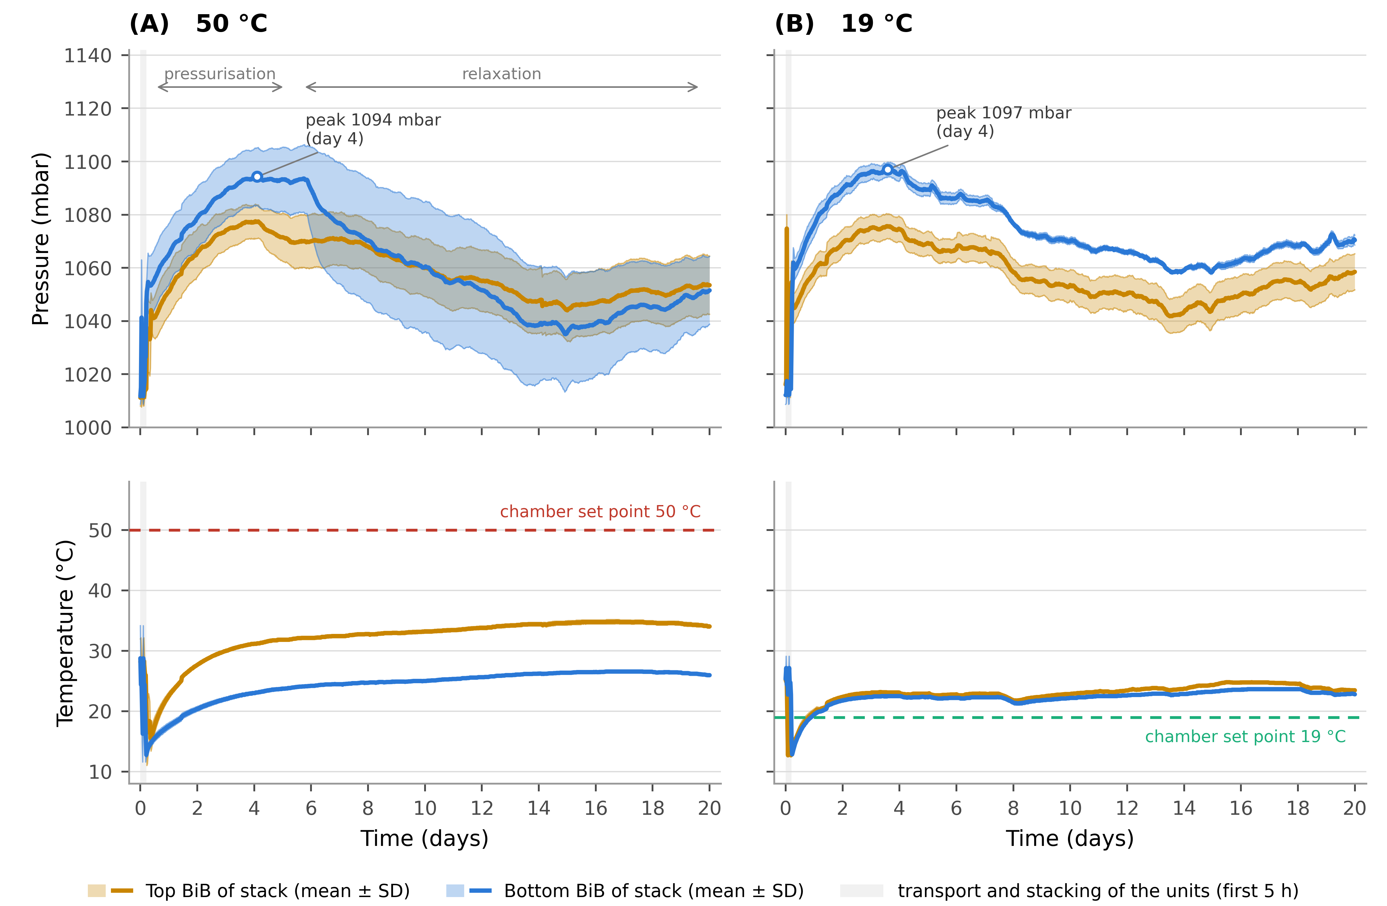
Figure 3. Internal pressure (upper panels) and temperature (lower panels) recorded inside the palletised 3-L Bag-in-Box units over the complete 20-day storage period, by MEMS sensors placed in the uppermost (amber) and lowermost (blue) BiB of each stack. (A) chamber set at 50 °C; (B) chamber set at 19 °C. Solid lines are the mean across stacks and the shaded band is ± 1 SD (n = 3 stacks per position, except the bottom position at 19 °C, for which n = 2). The dashed line marks the chamber set point. The shaded band at the left of each panel marks the first five hours, during which the units were being transported to the laboratory and assembled into stacks; this interval is shown on an expanded axis in Figure 4 and is excluded from the analysis. The statistical comparison of the units is based on the change from each sensor’s own baseline (Figure 5), which is independent of the agreement between sensors.
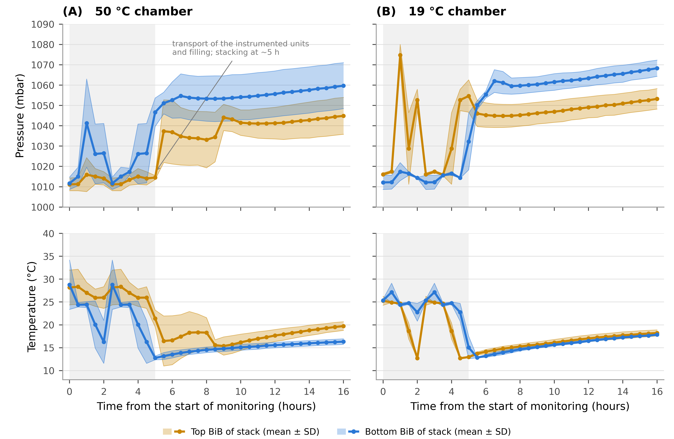
Figure 4. The first sixteen hours of the record of the main trial, on an expanded time axis: internal pressure (upper panels) and temperature (lower panels) inside the bags, for the chamber set at 50 °C (A) and at 19 °C (B). Solid lines are the mean across stacks, markers the individual 30-minute readings and the shaded band ± 1 SD; amber is the top BiB of each stack and blue the bottom one. The shaded interval at the left covers the transport of the instrumented units from the filling line to the laboratory and their assembly into stacks, completed at about the fifth hour, after which the pressure steps up and the record becomes regular. This portion of the trace reflects handling rather than storage and is excluded from the analysis.
[AUTHORS — TO RESOLVE BEFORE SUBMISSION: in Results.xlsx the readings at 0.0, 0.5, 1.5 and 2.0 h are byte-identical to those at 2.5, 3.0, 4.0 and 4.5 h across all 22 sensor columns, i.e. the first block of the record appears to have been duplicated when the Compare sheet was assembled. The first 4.5 h of Figure 4 are therefore not trustworthy and should be re-exported from the raw logger files before this figure is published. The rest of the record, from 5 h onwards, is unaffected.]

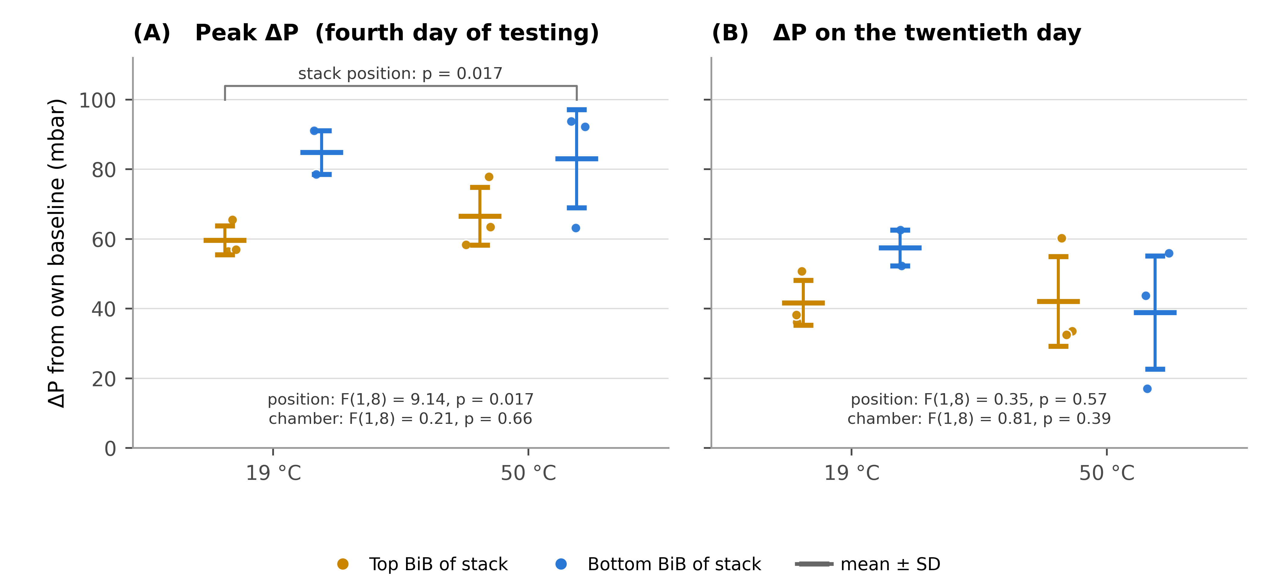
Figure 5. Change in internal pressure referred to each sensor’s own baseline (ΔP), by stack position and storage temperature. (A) peak value, reached on the fourth day of the testing period in every condition; (B) residual value on the twentieth day of testing. Circles are individual sensors (n = 3 stacks per position, except the bottom position at 19 °C, for which n = 2) and the bars give the mean ± 1 SD. Referring each trace to its own starting value makes the comparison independent of the agreement between sensors. At the pressurisation peak the BiBs at the bottom of the stacks had developed a significantly larger increase than those at the top (two-way ANOVA, F(1,8) = 9.14; p = 0.017), with no effect of storage temperature (F(1,8) = 0.21; p = 0.66); by the twentieth day of testing the units had converged and neither factor remained significant.

Table 2. Chemical parameters of the wine of the main trial after 20 days in the chambers set at 19 °C and 50 °C. Values are expressed as mean ± standard deviation (n = 3).
Samples | Lactic Acid (g/L) | Malic Acid (g/L) | pH | Titratable acidity (g/L of tartaric acid) | Volatile acidity (g/L of acetic acid) | Total phenols (g/L of catechins) | Ethanol content (%v/v) | Total Sulphur dioxide content  (mg/L) | Free Sulphur dioxide content  (mg/L)
Wine at 19 °C | 0.16 ± 0.05^{B} | 1.1 ± 0.23^{A} | 3.4 ± 0.1^{A} | 6.6 ± 0.04^{A} | 0.30 ± 0.02^{B} | 1.02 ± 0.12^{A} | 11.6 ± 0.6^{A} | 50 ± 5.5^{A} | 31 ± 2.5^{A}
Wine at 50 °C | 0.29 ± 0.20^{A} | 1.0 ± 0.16^{A} | 3.4 ± 0.1^{A} | 6.6 ± 0.13^{A} | 0.39 ± 0.03^{A} | 1.10 ± 0.07^{A} | 11.6 ± 0.9^{A} | 25 ± 8.2^{B} | 16 ± 1.8^{B}
Superscript uppercase letters (A–B) indicate statistically significant differences among the samples, p ≤ 0.05. The headings 19 °C and 50 °C are the set points of the two chambers; as reported in Section 3.2, the wine in the chamber set at 50 °C actually reached 25–34 °C depending on its position in the stack, while the reference chamber held close to its set point.

3.3 Verification of the high-temperature condition
Because the first trial had reached only 34 °C, a second experiment was run to cover the interval between that value and the intended 50 °C. A stack of three boxes was instrumented with four MEMS sensors, two in the uppermost and two in the lowermost BiB, and held in a chamber set at 50 °C with pressure and temperature logged every minute. This verification record covers 15 days rather than the 20 of the main trial, which is long enough to follow the units well beyond thermal equilibrium — reached on the fifth day — but means that the two experiments are not matched in duration and that the last five days of a shipment window are not represented. Figure 6 places the temperature attained in the two trials side by side; to keep them apart at a glance, the verification trial is drawn in teal and violet against the amber and blue of the first trial, while in Figure 7, which concerns the verification trial alone, each sensor carries its own colour.
On this occasion the set point was met. The wine warmed from about 20 °C to 34.5 °C within the first day and to 45.2 °C by the fourth day, and settled at 46.7 °C from the fifth day until the end of the test, that is within 2 to 5 °C of the chamber air (Figure 6B and Figure 7B). A residual gap of this size is what one expects of a sensor immersed in three litres of wine inside a closed bag, and it establishes that the shortfall of the first trial belonged to the enclosure and not to the packaging or to the instrument: the same bags, the same cardboard and the same sensors reached the set point once the chamber performed as intended.
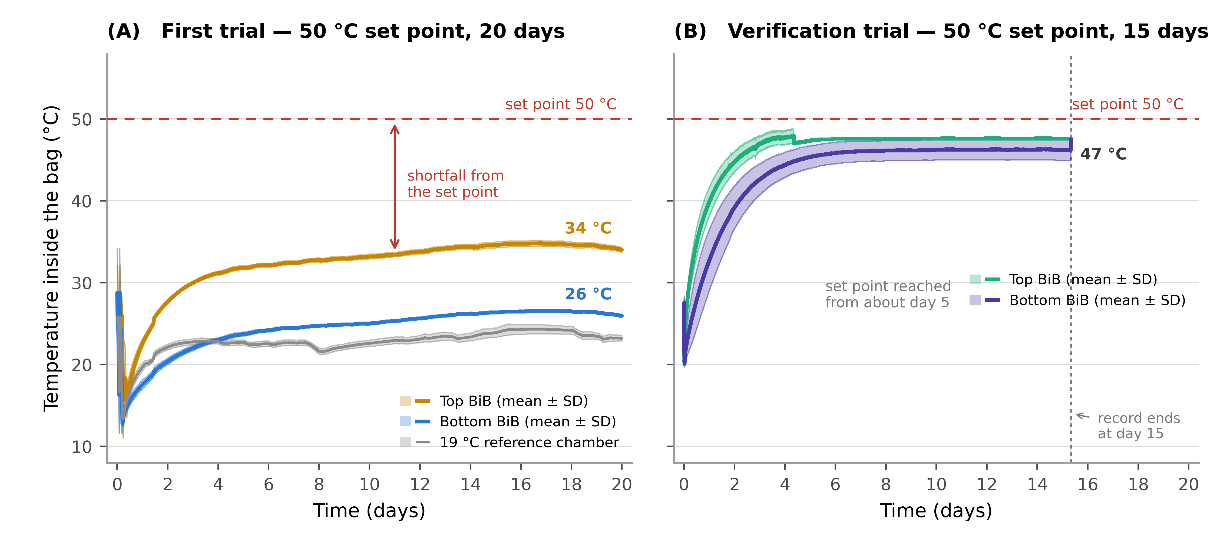
Figure 6. Temperature recorded inside the bags in the two trials, both with the chamber set to 50 °C. (A) first trial, 20 days: the units stabilise at 34 °C at the top of the stacks and 26 °C at the bottom, far short of the set point; the 19 °C reference chamber of the same trial is shown in grey. (B) verification trial, 15 days: the wine reaches the set point to within 2–5 °C from about day 5, and the dashed vertical line marks the end of the record. Solid lines are the mean across units and the shaded band is ± 1 SD; the dashed horizontal line marks the chamber set point. The first trial is drawn in amber (top) and blue (bottom), the verification trial in teal (top) and violet (bottom), so that the two experiments cannot be confused.
The pressure response to this genuine thermal load was small (Figure 7A). Referred to each sensor’s own baseline, the internal pressure rose by 9 to 26 mbar over the first two days and had returned to its starting value by about day 5, where it remained for the last ten days of the record while the wine was held at 47 °C. Warming the wine from 20 to 47 °C therefore produced no sustained overpressure inside the bag. This is the behaviour expected of a compliant container: the thermal expansion of the liquid and of the headspace is taken up by the flexible film, which deforms rather than resists, so that the pressure inside the bag stays close to that of the air around it. The verification trial thus confirms, under the very condition that the first trial failed to deliver, the conclusion drawn in Section 3.2 — that the internal pressure of a Bag-in-Box is governed by the mechanical load the unit carries and not by the temperature at which it is stored.
One feature of Figure 7A deserves comment. The four traces move together, and the excursion of some 25 mbar around the sixth day appears simultaneously in every sensor, at both positions in the stack. Because the transducer measures absolute pressure, each record contains the barometric pressure of the room in addition to any overpressure developed inside the bag. This common component does not affect the comparison between positions, which is a difference between two sensors breathing the same atmosphere and in which the barometric term cancels; but it does mean that the absolute course of any single trace should not be read as the behaviour of the bag alone. The same caution applies to the slow drift seen in Figure 3, and the point is taken up again in Section 3.4.
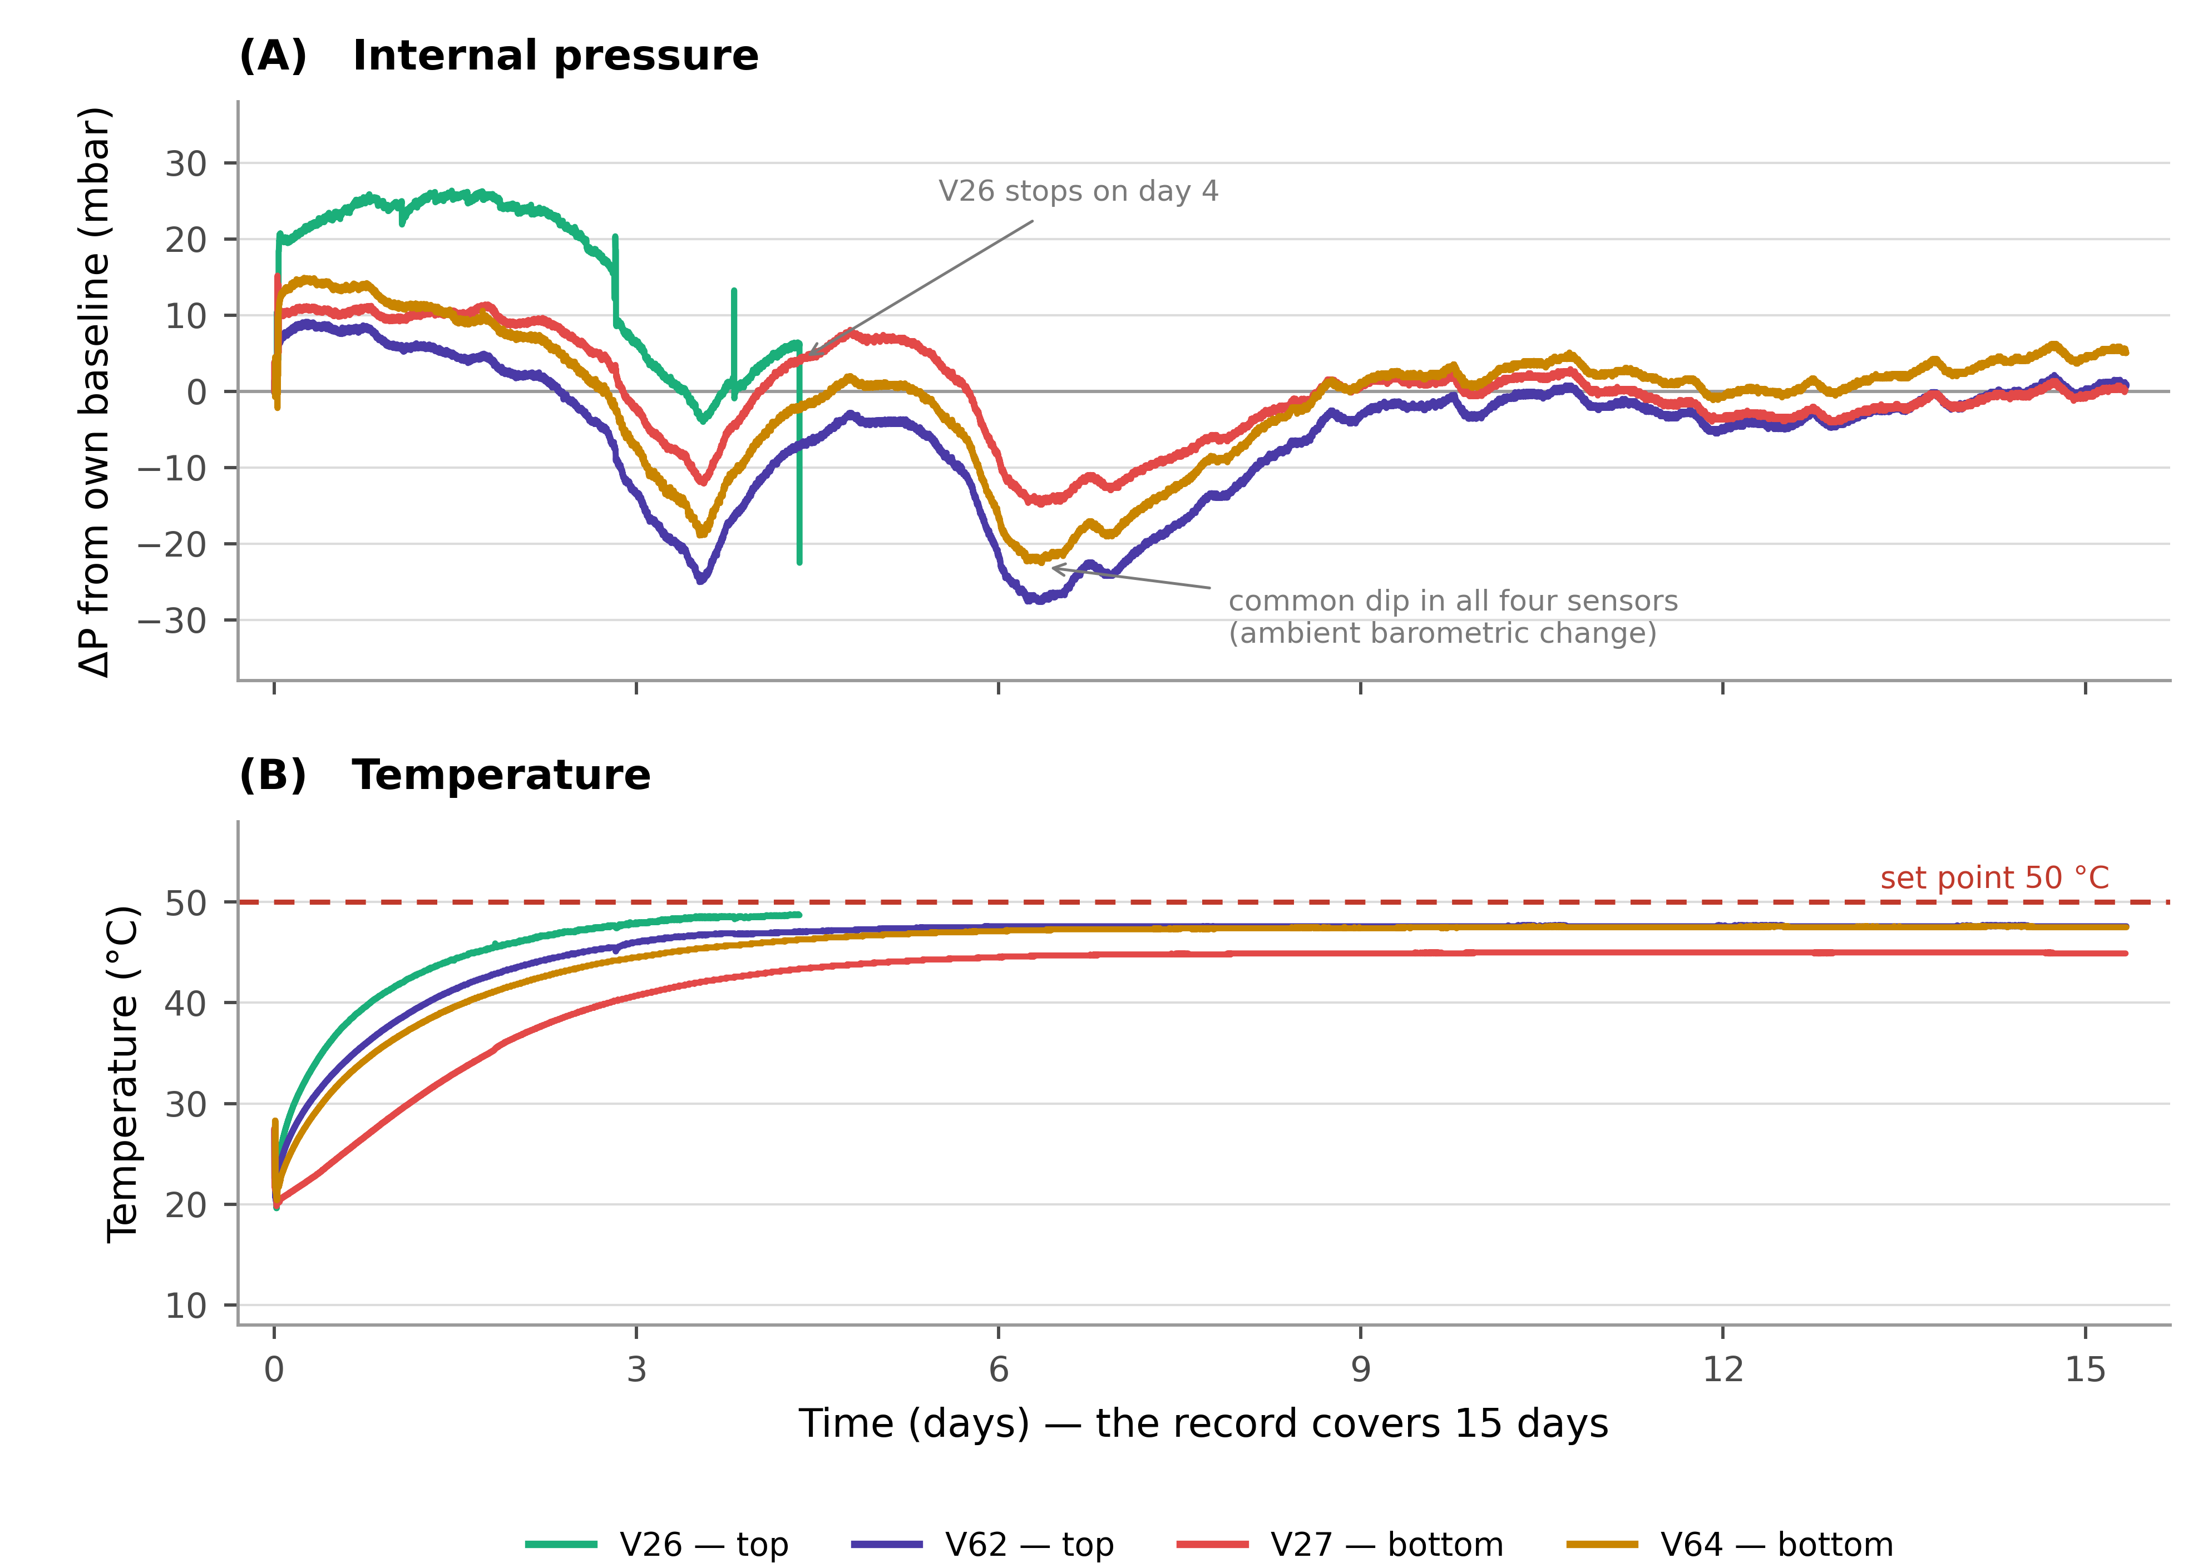
Figure 7. Verification trial at 50 °C: internal pressure referred to each sensor’s own baseline (A) and temperature (B), logged every minute over the 15 days of the record, in a three-box stack. Each of the four sensors is drawn in its own colour and identified in the legend by its position in the stack; V26 ceased to transmit on the fourth day. The pressure rises by only 9–26 mbar and returns to its starting value by about day 5, while the temperature climbs to and then holds at 47 °C, so a genuine thermal load produces no sustained overpressure. The simultaneous dip near day 6, common to all four sensors, reflects a change in ambient barometric pressure rather than a change inside the bags.

3.4 Limitations and future perspectives
This work was conceived as a preliminary, single-wine assessment, and its scope entails some limitations. Only one wine and one BiB format were tested, so the absolute pressure and compositional values should not be generalised to other products or bag geometries without further verification; the grape variety and vintage of the commercial wine used were not available from the supplier. The most serious limitation concerns the thermal condition of the first trial: the chamber set to 50 °C did not sustain its set point under a full pallet, the wine reaching only 25–34 °C, so the twenty-day comparison between chambers is not the 19 °C against 50 °C contrast originally intended, and the compositional data in Table 2, which refer to the nominal conditions, must be read with this in mind. The verification trial reported in Section 3.3 establishes what a genuine 50 °C exposure does to the internal pressure, but it ran for fifteen rather than twenty days, on a single three-box stack with two sensors per position, so it has little power to resolve the effect of position and cannot by itself replace the main trial. A second constraint is instrumental: the transducers measure absolute pressure and were not paired with a reference sensor logging the barometric pressure of the room, so each record carries an ambient component that cannot be subtracted retrospectively. Comparisons between positions are immune to this, because the barometric term is common to both sensors and cancels in the difference, but the absolute trajectory of a single unit is not, and the slow drift visible in Figures 3 and 6 should be interpreted accordingly. The 50 °C set point is in any case a deliberately severe, worst-case scenario, whereas real shipments experience fluctuating temperatures and vibration that a constant-temperature design does not reproduce. Chemical parameters were measured on the wine as a whole and were not resolved by stack position, which limits any direct correlation between the position-dependent pressure behaviour and composition. Finally, the transducer is specified to ±1.5 mbar only between 300 and 1100 mbar at 20 °C, the tolerance widening to ±100 mbar across its full range, so absolute readings from different sensors are not directly comparable and only the change referred to each sensor’s own baseline, which relies on the ±1 mbar per year stability of a single device, can be compared; with three stacks per condition the design resolves the position effect at the pressurisation peak but not once the units converge, and the two stack heights examined (97 and 128 cm) span a narrow range. The first hours of the record cannot be used either, since the instrumented units were filled at the manufacturer and driven to the laboratory before the test began, and a 30-minute sampling interval is in any case too coarse to resolve rapid transients. Future studies should log the chamber air alongside the bags and include a barometric reference sensor, repeat the palletised comparison at a verified 50 °C for the full twenty days, broaden the range of wines, formats and stack heights towards full pallet loads, apply realistic fluctuating temperature and vibration profiles, and pair position-resolved pressure data with position-resolved sampling.

4. Conclusions
This study provides new information on the behaviour of Bag-in-Box (BiB) wine packaging under conditions that reproduce long-distance export. By monitoring the internal pressure of 3-litre BiBs for 20 days in chambers set at 50 °C and at 19 °C, in stacks of two heights, a common pattern emerged: a short transient reflecting the transport and stacking of the instrumented units, a pressurisation phase peaking on the fourth day of the testing period, and a slow relaxation to a steady level. Referred to their own baselines, the BiBs at the base of the stacks became more pressurised at the peak than those at the top by about 21 mbar, the only significant factor in the analysis (F(1,8) = 9.14; p = 0.017), whereas the two chambers were statistically indistinguishable (F(1,8) = 0.21; p = 0.66). The difference between positions faded as the storage went on and had disappeared by the twentieth day of testing, which indicates that the flexible bag accommodates the load it carries rather than sustaining the extra pressure indefinitely. Two stack heights were compared precisely in order to test whether vertical load matters: the position of a unit within the stack demonstrably does, at least while the bag is pressurising, while the difference between a 97 cm and a 128 cm stack is small, so stack height within this range is not in itself a critical variable.
From a compositional standpoint, storage at 50 °C caused a marked decrease in total and free sulphur dioxide and a small increase in volatile acidity, while pH, titratable acidity, ethanol and total phenols were unchanged. The loss of sulphur dioxide is the change of greatest practical concern, since it reduces the antioxidant and antimicrobial reserve of the wine; the other shifts remained within ranges that are unlikely to be perceived sensorially over the transport window studied. These compositional data refer to the wine as a whole and were not resolved by stack position, so they should not be read as a direct chemical signature of palletisation.
Overall, the two stress factors act on different compartments of the system: palletisation governs the mechanical state of the bag, whereas temperature governs the chemical stability of the wine inside it. The verification trial makes the first half of that statement firm, since raising the wine to 47 °C left the internal pressure unchanged after five days, while the position of a unit in the stack did not. The practical value of in-bag sensing is that it makes both dimensions measurable in real time: it identifies which units in a pallet are the most stressed and when, and it reports what the product actually experiences rather than what the container is set to — as the first trial showed, the two can differ by more than 15 °C, and nothing outside the bag would have revealed it. Because the pressure response proved insensitive to temperature while the SO₂ reserve did not, the two variables are best controlled separately: keeping containers below the extreme temperatures tested is the effective lever for protecting composition, whereas limiting the load carried by the lowest units is the lever for protecting the integrity of the bag. On this basis the BiB system confirms its potential as a viable and sustainable alternative to traditional packaging for international markets.

Author Contributions: For research articles with several authors, a short paragraph specifying their individual contributions must be provided. The following statements should be used “Conceptualization, M.M., F.P., P.G.V., and A.Z.; methodology, B.C., and N.M.; software, B.C. and K.M, and N.M; validation, M.M., B.C., and N.M.; formal analysis, B.C., P.G.V., and N.M.; investigation, B.C., and N.M; resources, F.P., P.G.V., and A.Z; data curation, M.M., B.C., K.M and N.M; writing—original draft preparation, M.M., and N.M.; writing—review and editing, M.M., and N.M; visualization, M.M., B.C., and N.M.; supervision, F.P., and A.Z.; project administration, F.P., and A.Z.; funding acquisition, A.Z.
All authors have read and agreed to the published version of the manuscript.” Please turn to the CRediT taxonomy for the term explanation. Authorship must be limited to those who have contributed substantially to the work reported.
Funding: This research was funded by TRACEWINDU (Traceability at wine industry through inte- 402 grated labelling of typicality, health protection effect and organoleptic attributes), project co- 403 founded by Horizon 2020 Framework Programme of European Union under the Grant Agreement 404 no 101007979 running from 1 June 2021 to 31 May 2025.
Institutional Review Board Statement: Not applicable.
Informed Consent Statement: Not applicable.
Data Availability Statement: The original contributions presented in the study are included in the article. The pressure and temperature records of both trials, and the commented Python script that derives the summary values and reproduces the two-way analyses of variance reported in Section 3.2 (anova_pressure.py), are available from the corresponding author on request.
Conflicts of Interest: The authors declare no conflicts of interest.

References
1. Rui, M.; Rosa, F.; Viberti, A.; Brun, F.; Massaglia, S.; Blanc, S. Understanding Factors Associated with Interest in Sustainability-Certified Wine among American and Italian Consumers. Foods 2024, 13, 1468, doi:10.3390/foods13101468.
2. Valenzuela, L.; Ortega, R.; Moscovici, D.; Gow, J.; Alonso Ugaglia, A.; Mihailescu, R. Consumer Willingness to Pay for Sustainable Wine—The Chilean Case. Sustainability 2022, 14, 10910, doi:10.3390/su141710910.
3. Work, H.H. The Shape of Wine: Its Packaging Evolution; 1st ed.; Routledge, 2018; ISBN 978-0-203-73263-2.
4. Thompson-Witrick, K.A.; Pitts, E.R.; Nemenyi, J.L.; Budner, D. The Impact Packaging Type Has on the Flavor of Wine. Beverages 2021, 7, 36, doi:10.3390/beverages7020036.
5. Mura, R.; Vicentini, F.; Botti, L.M.; Chiriacò, M.V. Achieving the Circular Economy through Environmental Policies: Packaging Strategies for More Sustainable Business Models in the Wine Industry. Bus. Strategy Environ. 2024, 33, 1497–1514, doi:10.1002/bse.3556.
6. Scozzafava, G.; Dominici, A.; Canuti, V.; Casini, L.; Boncinelli, F. Beyond Bottles: Exploring Consumer Perceptions and Preferences for Bag-in-Box Wine Packaging. Aust. J. Grape Wine Res. 2024, 2024, 9946341, doi:10.1155/ajgw/9946341.
7. Bichescu, C.; Stoica, D.; Ivan, A.; Stoica, M. Innovative Packaging for Wine. ACROSS 2024, 8, 1–13.
8. Ruggeri, G.; Mazzocchi, C.; Corsi, S.; Ranzenigo, B. No More Glass Bottles? Canned Wine and Italian Consumers. Foods 2022, 11, 1106, doi:10.3390/foods11081106.
9. Gonen, L.D.; Tavor, T.; Spiegel, U. Adapting and Thriving: Global Warming and the Wine Industry. Sage Open 2024, 14, 21582440241227750, doi:10.1177/21582440241227750.
10. Gerini, F.; Dominici, A.; Casini, L. The Effects of the COVID-19 Pandemic on the Mass Market Retailing of Wine in Italy. Foods 2021, 10, 2674, doi:10.3390/foods10112674.
11. Versari, A.; Ricci, A.; Moreno, C.P.; Parpinello, G.P. Packaging of Wine in Aluminum Cans – A Review. Am. J. Enol. Vitic. 2023, 74, 0740022, doi:10.5344/ajev.2023.22071.
12. Nesselhauf, L.; Deker, J.S.; Fleuchaus, R. Information and Involvement: The Influence on the Acceptance of Innovative Wine Packaging. Int. J. Wine Bus. Res. 2017, 29, 285–298, doi:10.1108/IJWBR-08-2016-0026.
13. Ferrara, C.; Migliaro, V.; Ventura, F.; De Feo, G. An Economic and Environmental Analysis of Wine Packaging Systems in Italy: A Life Cycle (LC) Approach. Sci. Total Environ. 2023, 857, 159323, doi:10.1016/j.scitotenv.2022.159323.
14. Mierczynska-Vasilev, A. The Future of Wine Packaging — A Perspective. Sustain. Agric. Environ. 2024, 1, 3506, doi:10.1002/sae2.3506.
15. Tchouakeu Betnga, P.F.; Longo, E.; Poggesi, S.; Boselli, E. Effects of Transport Conditions on the Stability and Sensory Quality of Wines. OENO One 2021, 55, doi:10.20870/oeno-one.2021.55.2.4524.
16. Chung, H.-J.; Son, J.-H.; Park, E.-Y.; Kim, E.-J.; Lim, S.-T. Effect of Vibration and Storage on Some Physico-Chemical Properties of a Commercial Red Wine. J. Food Compos. Anal. 2008, 21, 655–659, doi:10.1016/j.jfca.2008.07.004.
17. Ghidossi, R.; Poupot, C.; Thibon, C.; Pons, A.; Darriet, P.; Riquier, L.; De Revel, G.; Mietton Peuchot, M. The Influence of Packaging on Wine Conservation. Food Control 2012, 23, 302–311, doi:10.1016/j.foodcont.2011.06.003.
18. Mercanti, N.; Macaluso, M.; Pieracci, Y.; Bertonelli, L.; Flamini, G.; Zinnai, A. Influence of Microbial Treatments on Vine Growth and Must Quality: Preliminary Results. Plants 2024, 13, 3168, doi:10.3390/plants13223168.
19. Mercanti, N.; Pieracci, Y.; Macaluso, M.; Fedel, M.; Brazzarola, F.; Palla, F.; Verdini, P.G.; Zinnai, A. Exploring Red Wine Aging: Comparative Analysis of Cellar and Sea Underwater Aging on Chemical Composition and Quality. Foods 2024, 13, 1812, doi:10.3390/foods13121812.
20. Scrimgeour, N.; Nordestgaard, S.; Lloyd, N.D.R.; Wilkes, E.N. Exploring the Effect of Elevated Storage Temperature on Wine Composition. Aust. J. Grape Wine Res. 2015, 21, 713–722, doi:10.1111/ajgw.12196.
21. Hopfer, H.; Buffon, P.A.; Ebeler, S.E.; Heymann, H. The Combined Effects of Storage Temperature and Packaging on the Sensory, Chemical, and Physical Properties of a Cabernet Sauvignon Wine. J. Agric. Food Chem. 2013, 61, 3320–3334, doi:10.1021/jf3051736.
22. Malherbe, S.; Bauer, F.F.; Du Toit, M. Understanding Problem Fermentations – A Review. South Afr. J. Enol. Vitic. 2016, 28, doi:10.21548/28-2-1471.
23. Kulhankova, M.; Prusova, B.; Baron, M. Study of Oxygen in Wines with Different Proportions of Yeast Lees. Ital. J. Food Sci. 2024, 36, 44–52, doi:10.15586/ijfs.v36i1.2313.
24. TE Connectivity. MS5803-05BA Miniature Altimeter and Diving Module — Data Sheet; TE Connectivity: Schaffhausen, Switzerland, 2017.
25. Adafruit Industries. ESP-M2 Board (ESP8285) — Product Documentation. Available online: https://www.adafruit.com (accessed on 15 July 2026).
26. Montgomery, D.C. Design and Analysis of Experiments, 10th ed.; Wiley: Hoboken, NJ, USA, 2019; ISBN 978-1-119-49244-3.
27. Langsrud, Ø. ANOVA for Unbalanced Data: Use Type II Instead of Type III Sums of Squares. Stat. Comput. 2003, 13, 163–167, doi:10.1023/A:1023260610025.
28. Seabold, S.; Perktold, J. Statsmodels: Econometric and Statistical Modeling with Python. In Proceedings of the 9th Python in Science Conference; Austin, TX, USA, 2010; pp. 92–96, doi:10.25080/Majora-92bf1922-011.

Disclaimer/Publisher’s Note: The statements, opinions and data contained in all publications are solely those of the individual author(s) and contributor(s) and not of MDPI and/or the editor(s). MDPI and/or the editor(s) disclaim responsibility for any injury to people or property resulting from any ideas, methods, instructions or products referred to in the content.

