Communication
Palletisation and In-Bag Thermal Exposure in Bag-in-Box Wine Packaging under Simulated Export Conditions
Nicola Mercanti ¹, Monica Macaluso ^{1*}, Bruno Casu ², Kamran Mehravar ², Fabrizio Palla ², Piero Giorgio Verdini ^{2,3}, and Angela Zinnai ^{1,4}
Academic Editor: Firstname Lastname
Received: date
Revised: date
Accepted: date
Published: date
Citation: To be added by editorial staff during production.
Copyright: © 2025 by the authors. Submitted for possible open access publication under the terms and conditions of the Creative Commons Attribution (CC BY) license (https://creativecommons.org/licenses/by/4.0/).
¹ Department of Agriculture, Food and Environment, University of Pisa, Via del Borghetto 80,
56124 Pisa, Italy; nicola.mercanti@phd.unipi.it (N.M.); monica.macaluso@unipi.it (M.M.);
angela.zinnai@unipi.it (A.Z.)
² INFN Pisa Section, Largo Bruno Pontecorvo 3, 56127 Pisa, Italy; bruno.casu@cern.ch (B.C); k.mehravar@studenti.unipi.it (K.M) fabrizio.palla@cern.ch (F.P)
³ European Organization for Nuclear Research Espl. des Particules 1, 1211 Meyrin, Switzerland; pie-ro.giorgio.verdini@cern.ch (P.G.V)
⁴ Interdepartmental Research Centre “Nutraceuticals and Food for Health”, University of Pisa, Via del Bor-ghetto 80, 56124 Pisa, Italy
*Correspondence: monica.macaluso@unipi.it
Abstract
Bag-in-Box (BiB) packaging can reduce the logistical and environmental burden of wine exports, but its behaviour under combined stacking and thermal stress is still poorly documented. This study monitored 3-L BiB units during a 20-day simulated export trial in two chambers nominally set to 19 °C and 50 °C, followed by a 15-day verification trial under a nominal 50 °C condition. In the main trial, in-bag sensors showed that the nominal 50 °C chamber did not produce 50 °C wine exposure: package temperatures stabilised at 33.6 ± 1.5 °C in top units and 25.5 ± 0.9 °C in bottom units, while reference-chamber packages were about 23 °C. Internal pressure rose in all units, peaked on day 4, and then relaxed. In an exploratory sensor-level analysis, bottom-position BiBs had a larger peak baseline-referred pressure increase than top-position BiBs (adjusted difference 20.4 mbar; 95% CI 4.8-35.9 mbar; F(1,8) = 9.14; p = 0.017), whereas no statistically detectable nominal chamber-condition effect was observed in this small dataset. By day 20 neither sensor-level factor was statistically detectable. Bulk wine from the nominally warmer chamber showed lower free and total SO₂, higher volatile acidity and a numerically higher lactic-acid value after 20 days, while pH, ethanol, titratable acidity and total phenols did not differ significantly; these chemical data were not resolved by stack position. In the verification trial, a single three-box stack approached 47 °C and showed only a transient 9-26 mbar pressure increase, providing limited supporting observations that the flexible bag did not sustain thermally induced overpressure under that configuration. The results support cautious use of in-bag or sentinel sensing to document actual package conditions and identify mechanically stressed positions, while highlighting the limitations of inferring product exposure from chamber set points alone.

Keywords: wine logistics, pressure variation, storage stability, sensor-based monitoring

1. Introduction
Wine packaging is increasingly evaluated not only for product protection but also for environmental and logistical performance. Glass remains the dominant format, but export requirements, material use and waste management have encouraged interest in lighter alternatives [1-5].
The Bag-in-Box (BiB) format is one such alternative. It combines a corrugated cardboard outer case with a flexible inner bag and dispensing valve, uses less packaging mass per litre than glass, and is available in formats from about 3 to 20 L [6-14]. Its lower transport weight can reduce distribution impacts, but the same flexibility that gives BiB practical advantages also makes its mechanical response under stacking load important.
During international transport, wine packages may experience temperature fluctuations, vibration, vertical compression and pressure changes for periods of several weeks [15,16]. For BiB, these stresses are applied to a package in which the container wall can deform, the headspace can compress or exchange gas through the film, and the cardboard case carries part of the pallet load.
Previous studies have examined storage temperature and packaging effects on wine composition, including sulphur dioxide loss, volatile acidity and sensory ageing [17,20,21]. Most of that evidence concerns bottled wines, static storage, or chemical composition alone. Less is known about the pressure developed inside palletised BiB units during a simulated export period, or about how measured in-package thermal exposure compares with nominal chamber settings.
The present work was designed to test whether stack position and a severe nominal chamber condition measurably affected internal pressure and selected chemical parameters of commercial 3-L BiB white wine. The original intention was to compare a neutral reference condition with a nominal 50 °C high-temperature condition. Because the main trial did not achieve 50 °C in-bag exposure, the realised study is interpreted as a comparison between nominal chamber conditions and the package temperatures actually measured inside the bags.

2. Materials and Methods
The purpose of the work was to simulate selected environmental stresses that wine may encounter during sea-container shipment to distant markets, particularly the United States. The work comprised a 20-day main trial and a 15-day verification trial. In the main trial, palletised units were stored in parallel in two temperature-controlled chambers defined by their nominal set points:
- Condition 1: chamber nominally set at 19 °C, used as the reference condition.
- Condition 2: chamber nominally set at 50 °C, selected as a deliberately severe thermal condition relevant to worst-case non-refrigerated transport scenarios rather than as a routine shipment temperature [15].
- In-bag sensors subsequently showed that the nominal 50 °C chamber did not achieve 50 °C wine exposure when loaded with the test stacks (Section 3.2). A verification trial was therefore carried out under a nominal 50 °C condition with a single three-box stack (Section 2.3). The two trials are summarised in Table 1.
The wine used in this study was a commercial white wine supplied by Castellani S.p.A. and packaged in standard 3-L Bag-in-Box units representative of those used for commercial export (Figure 1). The supplier did not provide grape variety or vintage information. The main compositional parameters measured after the reference condition are reported in Table 2. The inner bag consisted of a flexible multilayer film with an oxygen-barrier layer and an integrated dispensing valve, housed in a corrugated cardboard case that provided mechanical protection during palletisation.
For each nominal chamber condition, three independently built stacks were tested simultaneously: one stack of four boxes (128 cm) and two stacks of three boxes (97 cm) per chamber (Figure 2; Table 1). MEMS pressure sensors were positioned in the uppermost and lowermost BiB of every stack, giving six intended traces per chamber and twelve in total. One bottom-position sensor in the nominal 19 °C chamber did not return a complete record, leaving eleven usable pressure traces. The pressure comparison therefore had cells of n = 3, 3, 3 and 2. The top and bottom observations came from different BiBs within the same stacks, so they represent instrumented package positions within replicated stacks rather than repeated measurements of the same bag. The 20-day window was chosen to approximate the duration of transoceanic shipment, commonly on the order of two to four weeks [15].
The available experimental record did not include the chamber model, chamber volume, fan power, airflow rate, or a formal pallet-occupancy ratio. These unrecorded chamber characteristics limit diagnosis of the thermal lag and vertical temperature gradient observed in the main trial. The manuscript therefore reports only measured in-bag temperatures and treats chamber-performance explanations as hypotheses rather than established mechanisms.

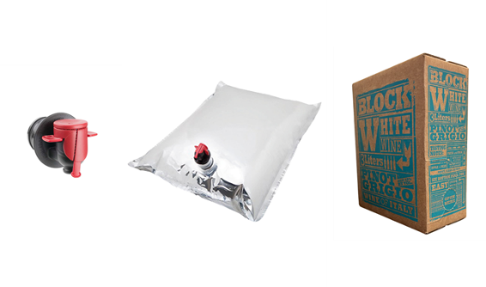
Figure 1. Principal components of the Bag-in-Box (BiB) packaging system: on the left, the tap/dispenser for dispensing the product; in the centre, the flexible multi-layer bag used to contain the wine, equipped with a valve; on the right, the external corrugated cardboard container that provides mechanical protection and stability during transport and palletisation.
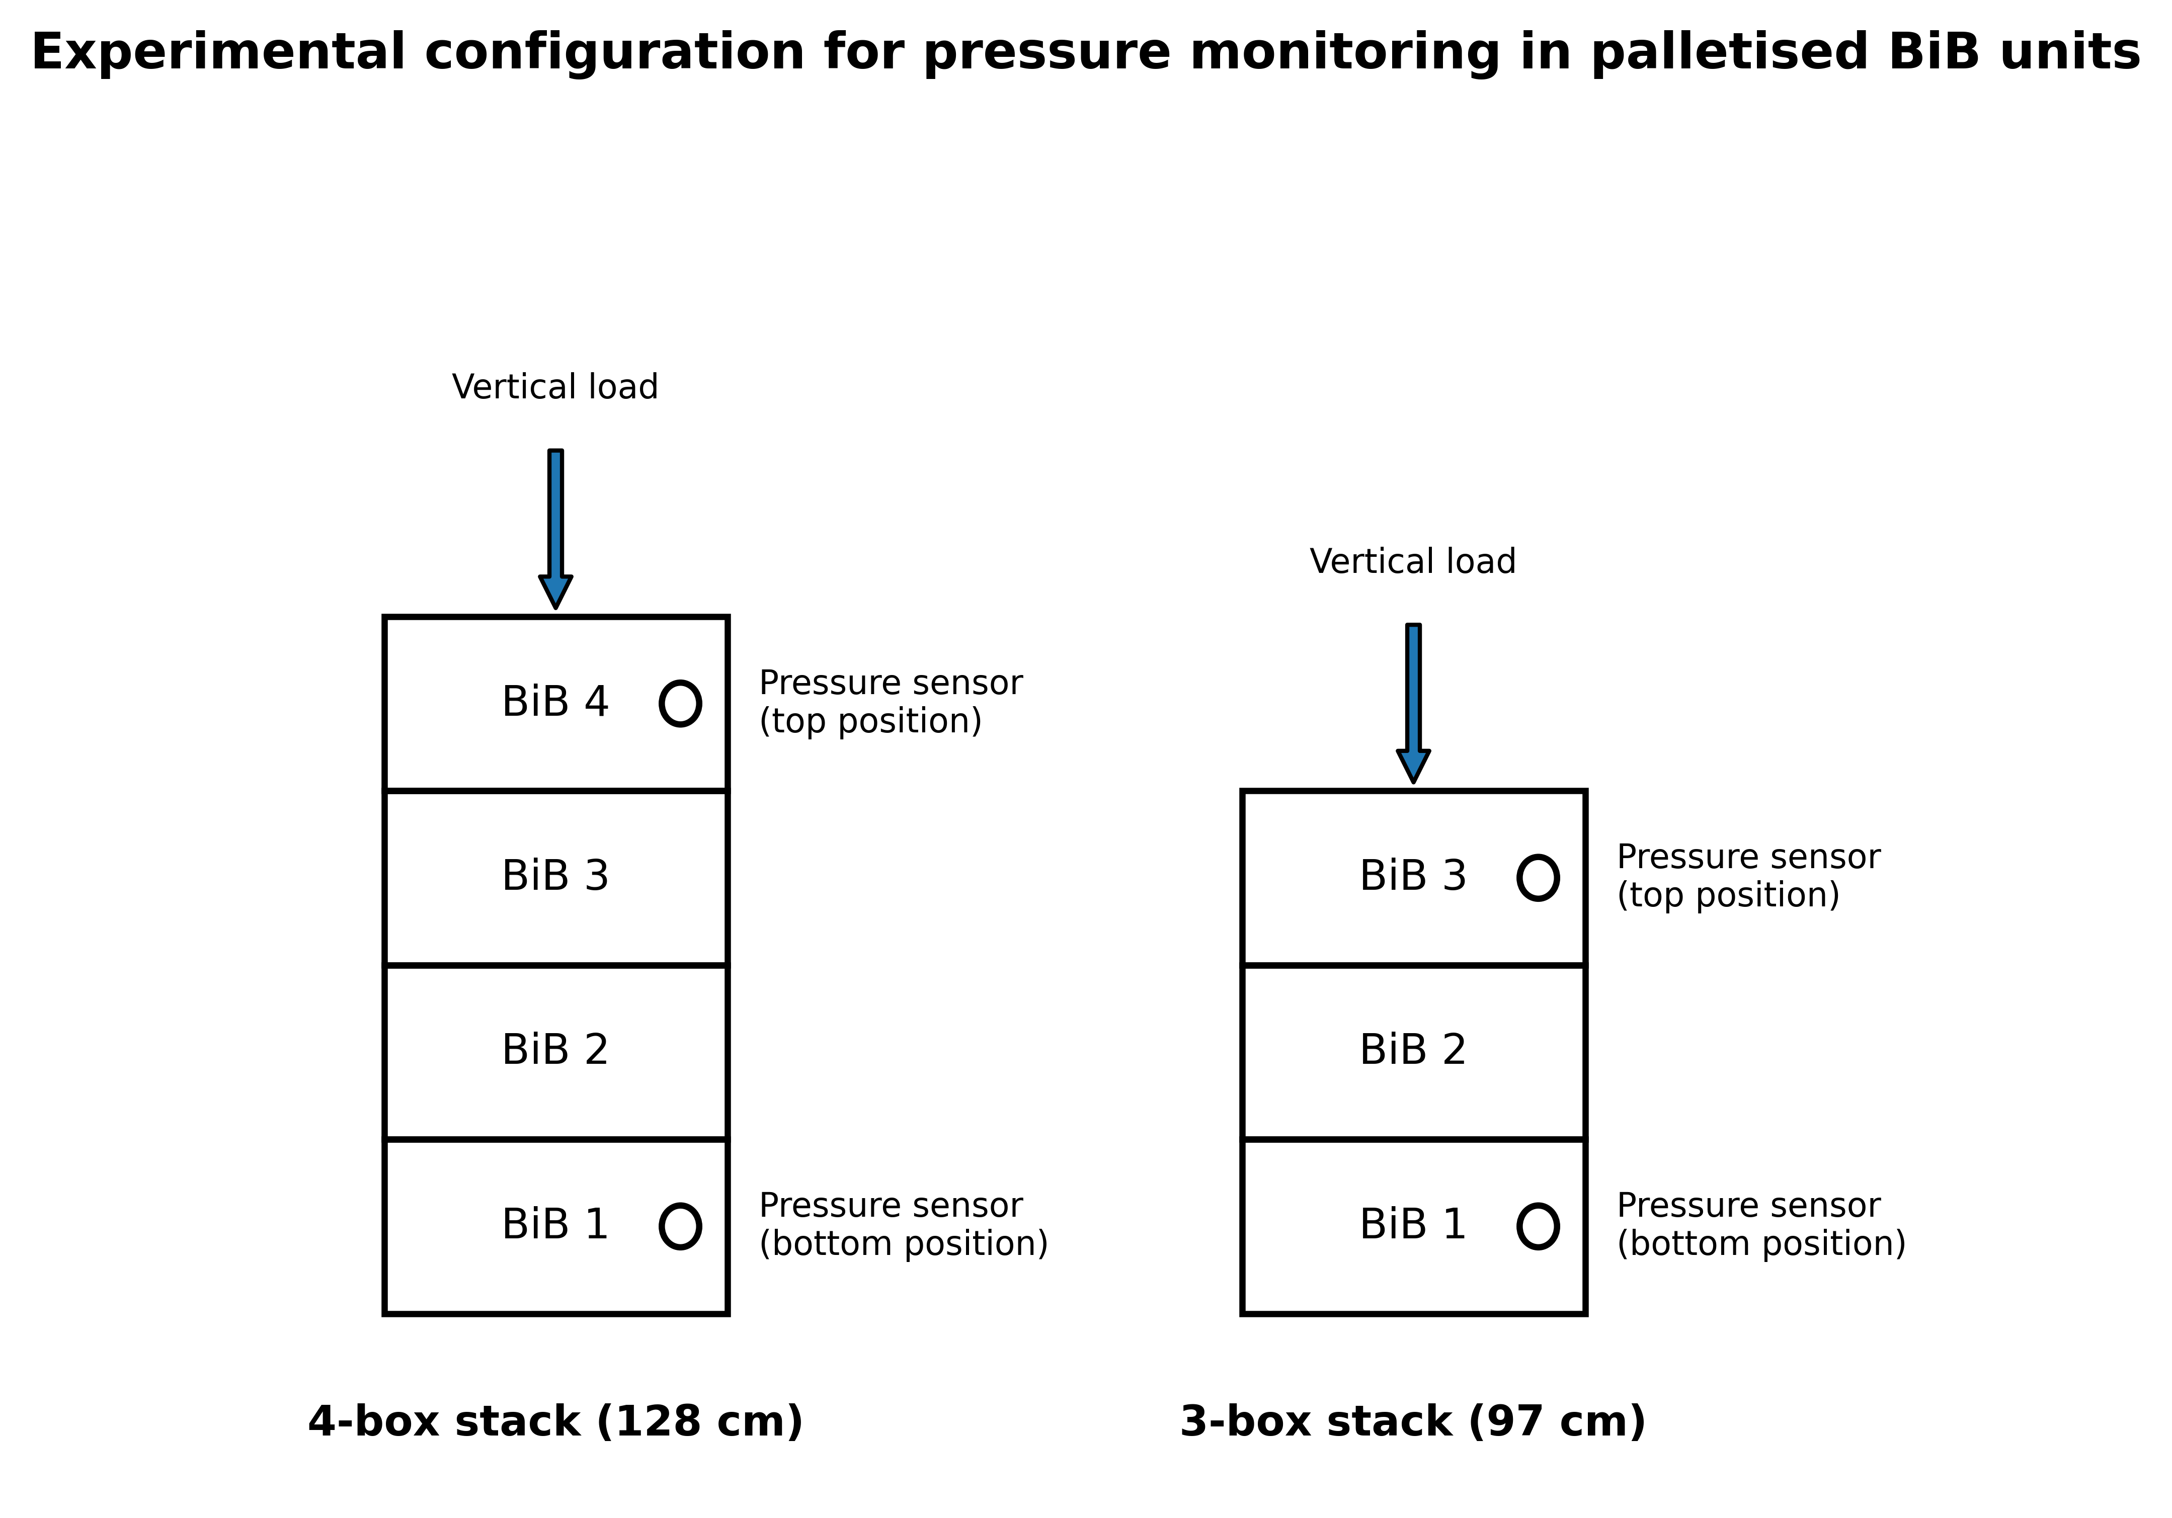
Figure 2. Experimental configuration used for pressure monitoring in palletised 3-L Bag-in-Box (BiB) units. The main trial included one 4-box stack (128 cm) and two 3-box stacks (97 cm) in each nominal chamber condition. MEMS pressure sensors were positioned in the uppermost and lowermost BiBs of each stack to compare package position under the tested stacking configuration. Stack height was not analysed as an independent factor because only one 4-box stack was present per chamber.
Table 1. Structure of the experimental samples and placement of the pressure sensors.
Trial | Nominal chamber set point | Duration | Stack | Boxes in stack (height) | MEMS sensors
Main | 19 °C | 20 days | Stack 1 | 4 (128 cm) | Top + bottom BiB
Main | 19 °C | 20 days | Stack 2 | 3 (97 cm) | Top + bottom BiB
Main | 19 °C | 20 days | Stack 3 | 3 (97 cm) | Top + bottom BiB *
Main | 50 °C | 20 days | Stack 1 | 4 (128 cm) | Top + bottom BiB
Main | 50 °C | 20 days | Stack 2 | 3 (97 cm) | Top + bottom BiB
Main | 50 °C | 20 days | Stack 3 | 3 (97 cm) | Top + bottom BiB
Verification | 50 °C | 15 days | Stack 1 | 3 (97 cm) | 2 top + 2 bottom BiB
Main trial: twelve MEMS pressure sensors in total - one in the top and one in the bottom BiB of each of three independently built stacks in each nominal chamber condition. The two nominal chamber conditions were applied in parallel in separate climate-controlled chambers. * The bottom sensor of one nominal 19 °C stack did not return a complete record, so eleven traces were available for pressure analysis. Verification trial: a single three-box stack instrumented with four sensors, one of which ceased to transmit on day 4. Chemical analyses were carried out on wine from the main trial only and were not resolved by stack position.

2.1 Chemical parameters
At the end of the thermal exposure period, chemical checks were carried out to assess selected compositional differences in the wine under the two nominal chamber conditions.
Free sulphur dioxide, total sulphur dioxide, titratable acidity (g/L tartaric acid), volatile acidity (g/L acetic acid), ethanol, malic acid, lactic acid, total phenols and pH were determined according to the protocols described in a previous study [18]. The reported chemical values are triplicate determinations for the main-trial wine grouped by nominal chamber condition. Chemical sampling was not resolved by stack position, and no microbiological measurements or viable cell counts were performed.

2.2 Physical parameters
Pressure monitoring within the Bag-in-Box containers was carried out using custom-designed sensing units, as described in a previous study [19]. Each unit was built around an MS5803-05BA miniature altimeter module (TE Connectivity), a 24-bit MEMS pressure and temperature sensor with SPI and I2C interfaces. According to its data sheet [24] the device covers 0-5 bar and -40 to +85 °C, resolves pressure to between 0.036 and 0.195 mbar depending on the oversampling ratio and temperature to better than 0.01 °C, and is specified to ±1.5 mbar between 300 and 1100 mbar at 20 °C, widening to ±100 mbar over the whole 0-5 bar and 0-50 °C envelope, with a long-term stability of ±1 mbar per year and a temperature accuracy of ±2.5 °C. The sensor was driven by an ESP8285 microcontroller on an ESP-M2 board (Adafruit) [25] and powered by a lithium battery. The assembly was enclosed in an oil-filled plastic casing, the oil transmitting the pressure of the wine to the transducer while dispersing the small amount of heat released by the electronics, whose draw is below 1 mA. The casing was introduced into each bag through the existing filling/dispensing valve before the bag was finally sealed, so that the multilayer film was not punctured and the barrier integrity of the bag was preserved; sealing then followed the standard procedure of the filling line, which was intended to minimise leakage and artificial perturbation of the internal pressure.
Twelve sensing units were deployed in the main trial, two per stack (uppermost and lowermost BiB) across the three stacks of each chamber. Pressure and temperature were recorded every 30 minutes throughout the storage period. Each pressure trace was referred to its own initial value and analysed as pressure change (ΔP), so the comparison depends primarily on within-sensor stability rather than on agreement between different sensors. Because there was one chamber per nominal set point, chamber condition and chamber identity cannot be separated. The chamber factor is therefore interpreted as a nominal chamber-condition comparison, not as a replicated test of actual wine temperature.

2.3 Verification trial under nominal 50 °C chamber condition
Because the main trial did not reach the intended high in-bag temperature, a verification experiment was carried out to document the physical response of the packaging when the wine approached the nominal 50 °C set point. A single stack of three boxes of the same 3-L BiB format was instrumented with four MEMS sensors of the same type, two in the uppermost and two in the lowermost BiB, and held for 15 days in a chamber nominally set at 50 °C. Pressure and temperature were logged every minute, compared with the 30-minute interval used in the main trial. The trial was not replicated across stacks and no chemical analyses were performed, so it provides supporting observations under one configuration rather than an independent population-level test of position effects. One upper sensor ceased to transmit on day 4 and the remaining three completed the 15-day record.

2.4 Statistical analyses
One-way analysis of variance was performed using CoStat, Version 6.451, CoHort 6.0 Software (Pacific Grove, CA, USA) to assess differences in the compositional parameters among the investigated samples. Means were separated by Tukey's post hoc test at p ≤ 0.05. Because the repository available for this revision does not contain the raw chemical replicate data, these chemical statistics could not be independently recalculated during revision. The available revision record contained inconsistent standard deviations for lactic acid in the nominal 50 °C chamber; because raw replicates were not available, lactic acid is treated descriptively rather than as an independently verified significant difference.
The pressure data were analysed separately because each instrumented BiB was described by stack position (top or bottom) and nominal chamber condition (19 °C or 50 °C set point). For each sensor, two summary responses were extracted from the ΔP curve: the peak reached after the handling window and within the 20-day storage period, and the residual value on day 20. The primary exploratory analysis used the additive two-way linear model
yijk = μ + αi + βj + εijk (1)
in which y is the summary value from one instrumented BiB, μ is the overall mean, α is the position term, β is the nominal chamber-condition term and ε is the residual. The position-by-chamber interaction was checked separately with the full model and was not statistically significant, so the additive model is reported. The model assumes independent residuals with constant variance; with only eleven usable traces, these assumptions cannot be tested with high power. The top and bottom observations are package-position measurements within stacks, and the chamber factor is unreplicated at the chamber level.
F = MS_{factor} / MS_{error} = (SS_{factor} / df_{factor}) / (SS_{error} / df_{error}) (2)
With two levels per factor and eleven usable traces, the additive model leaves one degree of freedom for each factor and eight residual degrees of freedom, giving the notation F(1,8). The design is unbalanced because one bottom-position sensor in the nominal 19 °C chamber returned no complete record; the four cells therefore contain three, three, three and two traces. Sums of squares were computed by the Type II method, in which each main effect is adjusted for the other [27]. Sensor-level effects with p ≤ 0.05 are reported as statistically significant within this exploratory analysis, but lack of significance is interpreted only as lack of a statistically detectable difference under this small design. Because the embedded summary data do not retain stack identifiers for a paired or blocked stack-level sensitivity analysis, the p-values should not be read as definitive stack-level tests. The computation was carried out in Python 3; the repository contains the commented script and embedded per-sensor summary values used for the pressure ANOVA [28].

3. Results and Discussion

3.1 Chemical parameters
The chemical comparison concerns wine from the main trial grouped by nominal chamber condition. The labels 19 °C and 50 °C in Table 2 denote chamber set points, not measured wine temperatures. In-bag sensors showed that the nominal 50 °C chamber produced actual package temperatures of about 25-34 °C depending on stack position, while the reference chamber packages were about 23 °C (Section 3.2). The chemical results should therefore be read as differences associated with the nominally warmer chamber condition, not as the effect of exposing wine to 50 °C.
Lactic acid was numerically higher in the wine from the nominally warmer chamber (0.29 ± 0.20 g/L) than in the reference (0.16 ± 0.05 g/L) (Table 2), but this difference is not treated as statistically verified because the available repository files contained inconsistent standard deviations and the raw chemical replicates were unavailable. The available measurements do not justify assigning the numerical difference to a single mechanism. Malic acid did not decrease significantly (1.0 ± 0.16 g/L against 1.1 ± 0.23 g/L), which does not support a clear malolactic conversion pattern; however, no microbiological analyses, viable cell counts or method-sensitivity study were available. Residual microbial activity therefore cannot be ruled out. The result is reported as a descriptive compositional observation under the tested conditions rather than as evidence that malolactic fermentation was absent.
Volatile acidity, expressed as acetic acid, was also higher in the wine from the nominally warmer chamber (0.39 ± 0.03 g/L) than in the reference (0.30 ± 0.02 g/L) (Table 2). This magnitude is below commonly used spoilage limits for table wine, but the study did not include sensory testing. The between-condition difference is consistent with accelerated chemical ageing under warmer storage, including oxidative and hydrolytic pathways described for wine storage [20,21], but a microbiological contribution cannot be excluded because microbiological measurements were not collected.
The largest practical between-condition difference concerned total and free SO₂, both lower in the wine from the nominally warmer chamber. Total SO₂ was 25 ± 8.2 mg/L in that wine compared with 50 ± 5.5 mg/L in the reference, and free SO₂ was 16 ± 1.8 mg/L compared with 31 ± 2.5 mg/L (Table 2). Elevated storage temperature is known to accelerate SO₂ decline and related ageing reactions [20,21]. In this study, the lower SO₂ values were observed after storage at measured in-bag temperatures of 25-34 °C rather than 50 °C, suggesting that moderate but sustained warming may reduce the antioxidant and antimicrobial reserve available after transport. Actual post-transport shelf life was not measured.
No significant between-condition difference was reported for pH, ethanol content or titratable acidity. Total phenols, expressed as catechins, also did not differ significantly (1.02 ± 0.12 g/L in the reference against 1.10 ± 0.07 g/L in the nominally warmer chamber) (Table 2).

3.2 Physical parameters
In accordance with the design described in Materials and Methods and summarised in Table 1, three stacks of 3-L BiB units were held for 20 days in each nominal chamber condition. The complete record is shown in Figure 3, with internal pressure above the temperature registered by the same sensors. In every usable trace, pressure showed a brief initial transient, a pressurisation phase that reached its maximum on day 4, and a gradual relaxation towards a lower residual level.
The first five hours of the record are shown separately in Figure 4 because they contain transport, filling-line and stacking events rather than settled chamber storage. During this interval the instrumented units arrived from the manufacturer, cooled from about 28 °C to about 13 °C, and were assembled into stacks; pressure also changed irregularly and stepped upward near the time when vertical load was applied. This window may resemble some real logistics disturbances, but in this study it was not a controlled storage exposure and the 30-minute sampling interval was too coarse to resolve rapid transients. The primary analysis therefore begins after the handling window. Because the raw logger export is not present in the repository, a full-record sensitivity analysis could not be recalculated during this revision; this is treated as a reproducibility and generalisability limitation.
After the handling window, pressure rose in all units and peaked on day 4, at about 60-90 mbar above each sensor's own baseline, before declining and partly recovering towards the end of the record. Mean peak ΔP was 83.0 ± 17.2 mbar in bottom units and 66.6 ± 10.1 mbar in top units under the nominal 50 °C chamber condition, and 84.8 ± 8.8 mbar in bottom units and 59.6 ± 5.1 mbar in top units under the nominal 19 °C condition (Figure 5A). In the exploratory sensor-level Type II two-way ANOVA, stack position was associated with peak ΔP (F(1,8) = 9.14; p = 0.017), with an adjusted bottom-minus-top difference of 20.4 mbar (95% CI 4.8-35.9 mbar). No statistically detectable nominal chamber-condition effect was observed (F(1,8) = 0.21; p = 0.66; adjusted nominal 50-minus-19 °C difference 3.1 mbar, 95% CI -12.5 to 18.6 mbar), and the interaction was not significant (p = 0.56). By day 20, neither position (F(1,8) = 0.35; p = 0.57; adjusted difference 5.2 mbar, 95% CI -15.3 to 25.7 mbar) nor nominal chamber condition (F(1,8) = 0.81; p = 0.39) was statistically detectable (Figure 5B). These results provide exploratory evidence for a transient position-associated pressure difference under the tested configuration, but the small and unbalanced design and absence of stack identifiers in the embedded summary data limit precision and prevent a paired stack-level analysis.
The lower panels of Figure 3 show that the realised thermal exposure differed substantially from the nominal set points. In the nominal 19 °C chamber, in-bag temperatures stabilised at 23.5 ± 0.8 °C in top units and 22.7 ± 0.7 °C in bottom units. In the nominal 50 °C chamber, packages warmed asymptotically but stabilised far below the set point: 33.6 ± 1.5 °C at the top of the stacks and 25.5 ± 0.9 °C at the bottom. The resulting vertical gradient of about 8 °C may reflect thermal inertia, chamber loading, limited heat transfer through the pallet, or airflow constraints, but the chamber model, airflow and occupancy data needed to diagnose the mechanism were not recorded. The pressure comparison between top and bottom positions must therefore be interpreted with the recognition that, in the nominally hot chamber, position also corresponded to different local package temperatures. The chamber comparison cannot be read as an actual 19 °C versus 50 °C wine-temperature contrast.
Taken together, the physical and chemical measurements identify different response patterns, but they do not support a strict causal division between palletisation and temperature. The pressure measurements were position-resolved and showed a transient bottom-position peak in ΔP. The chemical measurements were bulk samples grouped by nominal chamber condition and were not resolved by stack position. Consequently, the data support the practical distinction that pressure monitoring can identify mechanically stressed package positions, while chemical measurements indicated lower SO₂ and selected acidity differences under the nominally warmer chamber condition; they do not demonstrate that palletisation and temperature act independently or exclusively on separate parts of the system.

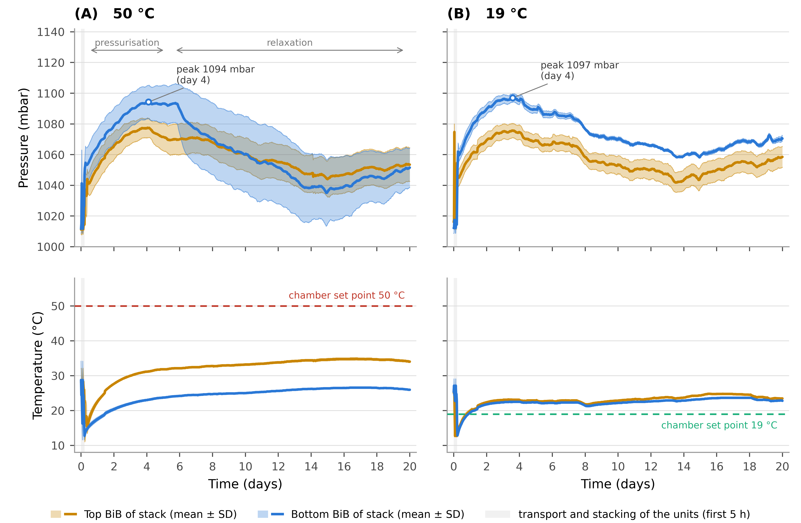
Figure 3. Internal pressure (upper panels) and temperature (lower panels) recorded inside the palletised 3-L Bag-in-Box units over the complete 20-day main trial by MEMS sensors placed in the uppermost (amber) and lowermost (blue) BiB of each stack. (A) nominal 50 °C chamber set point; (B) nominal 19 °C chamber set point. Solid lines are means across stacks and shaded bands are ± 1 SD (n = 3 stacks per position, except the bottom position at nominal 19 °C, for which n = 2). Dashed lines mark chamber set points. The shaded band at the left marks the first five hours, during which units were transported to the laboratory and assembled into stacks; this interval is shown in Figure 4 and excluded from the primary pressure analysis. The lower panels show measured in-bag temperatures, which differed from the chamber set points.
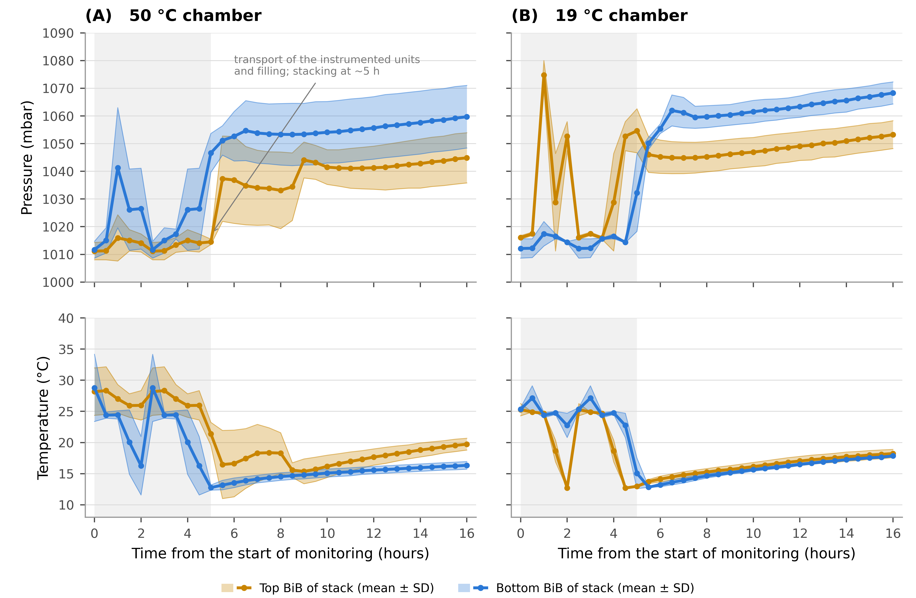
Figure 4. First sixteen hours of the main-trial record: internal pressure (upper panels) and temperature (lower panels) inside the bags for the nominal 50 °C chamber condition (A) and nominal 19 °C chamber condition (B). Solid lines are means across stacks, markers are individual 30-minute readings and shaded bands are ± 1 SD; amber is the top BiB of each stack and blue the bottom BiB. The shaded interval covers transport from the filling line to the laboratory and assembly into stacks, completed at about the fifth hour. This portion of the trace is treated as a handling window and excluded from the primary storage analysis.

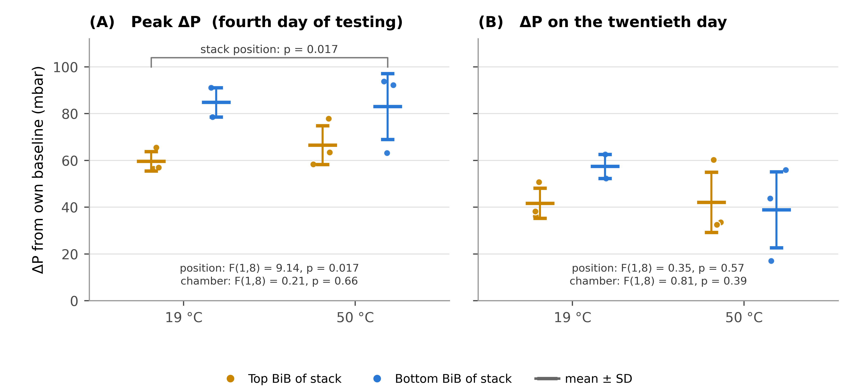
Figure 5. Change in internal pressure referred to each sensor's own baseline (ΔP), by stack position and nominal chamber condition. (A) peak value after the handling window, reached on day 4; (B) residual value on day 20. Circles are individual sensors (n = 3 stacks per position, except bottom position at nominal 19 °C, for which n = 2) and bars give mean ± 1 SD. At the pressurisation peak, bottom-position BiBs had a larger ΔP than top-position BiBs in the exploratory sensor-level analysis (two-way ANOVA, F(1,8) = 9.14; p = 0.017), while no statistically detectable nominal chamber-condition effect was observed (F(1,8) = 0.21; p = 0.66). By day 20 neither factor was statistically detectable.

Table 2. Chemical parameters of wine from the main trial after 20 days in chambers nominally set at 19 °C and 50 °C. The labels refer to chamber set points, not actual in-bag wine temperatures. Values are expressed as mean ± standard deviation (n = 3). Lactic acid is treated descriptively because available records contained inconsistent standard deviations and raw chemical replicates were unavailable for verification.
Sample | Lactic Acid (g/L) | Malic Acid (g/L) | pH | Titratable acidity (g/L of tartaric acid) | Volatile acidity (g/L of acetic acid) | Total phenols (g/L of catechins) | Ethanol content (%v/v) | Total Sulphur dioxide content  (mg/L) | Free Sulphur dioxide content  (mg/L)
Wine from nominal 19 °C chamber | 0.16 ± 0.05A | 1.1 ± 0.23^{A} | 3.4 ± 0.1^{A} | 6.6 ± 0.04^{A} | 0.30 ± 0.02^{B} | 1.02 ± 0.12^{A} | 11.6 ± 0.6^{A} | 50 ± 5.5^{A} | 31 ± 2.5^{A}
Wine from nominal 50 °C chamber | 0.29 ± 0.20A | 1.0 ± 0.16^{A} | 3.4 ± 0.1^{A} | 6.6 ± 0.13^{A} | 0.39 ± 0.03^{A} | 1.10 ± 0.07^{A} | 11.6 ± 0.9^{A} | 25 ± 8.2^{B} | 16 ± 1.8^{B}
Superscript uppercase letters (A-B) indicate statistically significant differences among the samples, p ≤ 0.05. The sample labels refer to nominal chamber set points, not actual wine temperatures. In the main trial, in-bag temperatures in the nominal 50 °C chamber reached about 25-34 °C depending on stack position, while the nominal 19 °C chamber packages were about 23 °C. For lactic acid, no significant difference is claimed because available records contained inconsistent standard deviations for the nominal 50 °C chamber and raw chemical replicates were unavailable for verification.

3.3 Verification under the nominal 50 °C chamber condition
Because the main trial reached only about 34 °C in the warmest in-bag location, a second experiment was run to document package behaviour closer to the intended high-temperature exposure. A single three-box stack was instrumented with four MEMS sensors, two in the uppermost BiB and two in the lowermost BiB, and held in a chamber nominally set at 50 °C with pressure and temperature logged every minute. The record covers 15 days rather than the 20 days of the main trial. It is therefore useful as a limited verification of qualitative behaviour under one configuration, but it is not a replicated replacement for the main trial and cannot establish a general position effect.
In this verification trial, in-bag temperatures approached the chamber set point. The wine warmed from about 20 °C to 34.5 °C within the first day, to 45.2 °C by day 4, and stabilised at about 46.7 °C from day 5 to the end of the record (Figures 6B and 7B). The much higher achieved temperature than in the main trial is consistent with a difference in chamber performance, loading, airflow or scale, but the available records do not identify which factor was responsible.
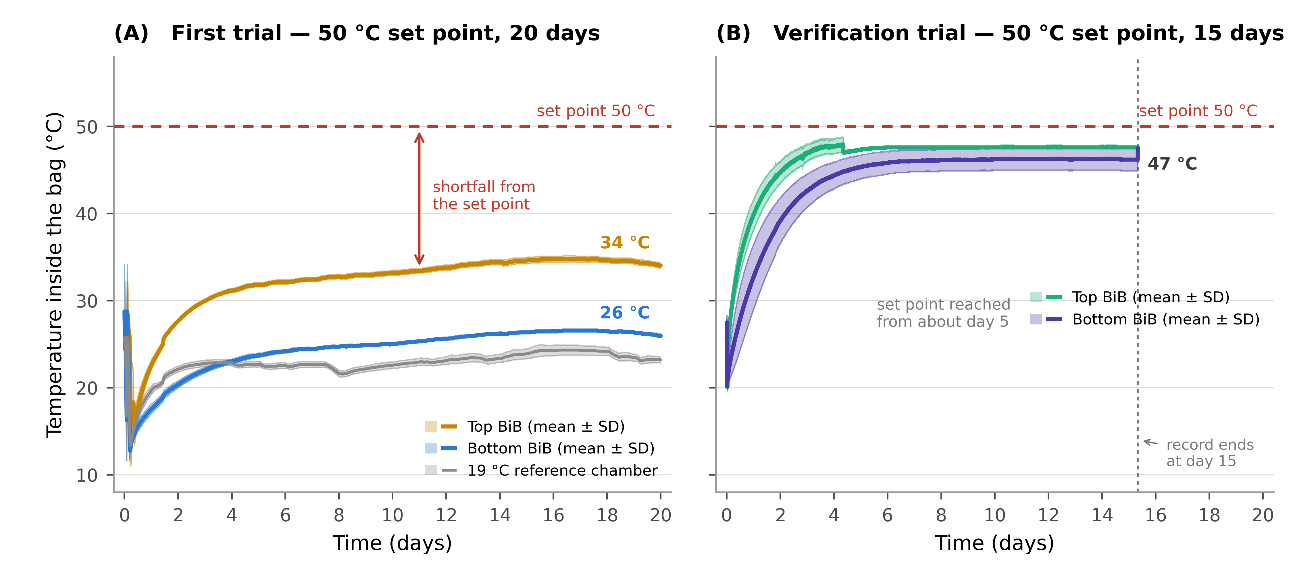
Figure 6. Temperature recorded inside bags in the two trials run under a nominal 50 °C chamber set point. (A) Main trial, 20 days: units stabilised at about 34 °C at the top of the stacks and 26 °C at the bottom; the nominal 19 °C reference chamber is shown in grey. (B) Verification trial, 15 days: wine approached the set point and stabilised around 47 °C from about day 5; the dashed vertical line marks the end of the record. Solid lines are means across units and shaded bands are ± 1 SD; the dashed horizontal line marks the chamber set point.
The pressure response in the verification trial was small and transient (Figure 7A). Referred to each sensor's own baseline, internal pressure rose by 9-26 mbar over the first two days and had returned close to its starting value by about day 5, where it remained while the wine was held near 47 °C. This observation is consistent with a compliant container in which thermal expansion is accommodated by deformation of the flexible film rather than by sustained pressurisation. Because the verification trial used one stack and one configuration, it should be read as supporting evidence that near-50 °C in-bag exposure did not create sustained overpressure in that stack, not as proof that temperature cannot affect BiB pressure under all configurations.
One feature of Figure 7A deserves comment. The four traces move together, and the excursion of about 25 mbar around day 6 appears simultaneously in every sensor at both positions. Because the transducer measures absolute pressure, each record contains ambient barometric pressure in addition to any pressure developed inside the bag. This common component limits interpretation of the absolute trajectory of a single trace. The same caution applies to the slow drift visible in Figure 3, and future work should include a barometric reference sensor.
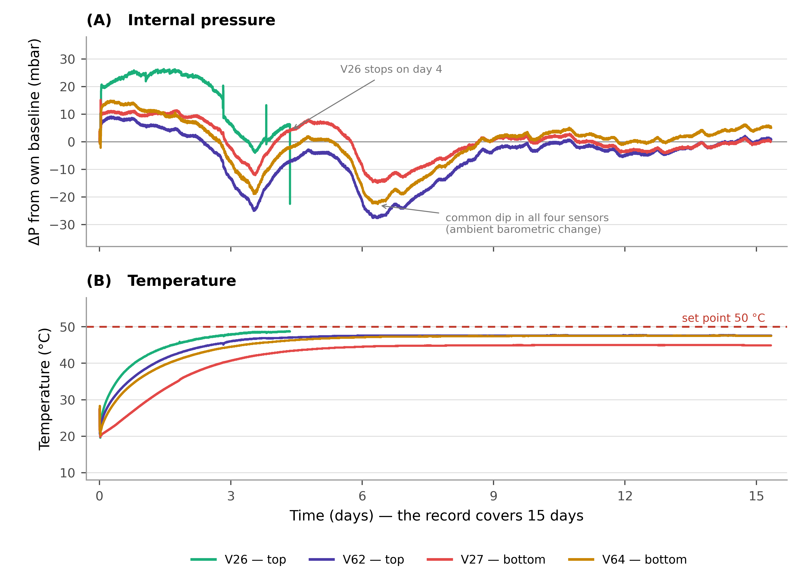
Figure 7. Verification trial under a nominal 50 °C chamber set point: internal pressure referred to each sensor's own baseline (A) and temperature (B), logged every minute over 15 days in a single three-box stack. Each sensor is drawn separately and identified by position; V26 ceased to transmit on day 4. Pressure rose by 9-26 mbar and returned close to baseline by about day 5 while temperature stabilised near 47 °C. The simultaneous dip near day 6, common to all sensors, is consistent with ambient barometric pressure variation rather than a package-position effect.

3.4 Limitations and future perspectives
This work was a preliminary, single-wine and single-format assessment, and its scope limits generalisation. The commercial wine's grape variety and vintage were unavailable. Only one BiB format was tested. Chemical analyses were grouped by nominal chamber condition and were not resolved by stack position, so the pressure and chemical datasets cannot be directly linked. No microbiological measurements, viable cell counts, sensory analysis or post-transport storage follow-up were performed; therefore malolactic or other microbial contributions cannot be excluded and the consequences of lower SO₂ reserve remain potential implications rather than measured outcomes.
The most important design limitation is the thermal mismatch in the main trial. The chamber nominally set to 50 °C produced actual in-bag temperatures of only 25-34 °C, with a persistent top-bottom gradient, so the 20-day comparison was not the intended 19 °C versus 50 °C wine exposure. Chamber model, volume, fan power, airflow and pallet occupancy were not recorded, preventing a definitive diagnosis of the thermal lag. There was also only one chamber per nominal set point, so chamber identity and nominal condition are confounded.
The pressure analysis is limited by eleven usable traces, one missing bottom-position sensor, an unbalanced cell of n = 2, possible within-stack pairing of top and bottom observations, and a narrow stack-height range in which height was not independently replicated. The first five hours were excluded because they contained transport and stacking events, but these transients may be relevant to some logistics scenarios; without the raw logger export, a full-record sensitivity analysis could not be recalculated from the repository. The verification trial reached near-50 °C in-bag exposure, but it used a single three-box stack for 15 days and cannot establish a general position effect. Finally, this study did not include a techno-economic analysis of sensor deployment, so monitoring recommendations should be understood as sentinel, validation or quality-control uses rather than universal instrumentation of every commercial package.
Despite these limitations, the study illustrates why direct package-level measurement matters: chamber set points did not predict the realised wine temperature in the main trial, and the sensor-level pressure summaries differed by package position under the tested stacking configuration. Future studies should include replicated chambers, chamber-air and barometric reference logging, full raw-data release, position-resolved chemical sampling, microbiological assays, realistic fluctuating temperature and vibration profiles, broader stack heights and formats, and cost-benefit evaluation of sentinel sensing strategies.

4. Conclusions
This study monitored pressure and temperature inside 3-L Bag-in-Box wine units during a simulated export period and showed that nominal chamber settings did not necessarily represent the temperature experienced by the wine. In the main trial, the chamber nominally set to 50 °C produced in-bag temperatures of about 34 °C at the top of the stacks and 26 °C at the bottom, while the reference chamber packages were about 23 °C. This mismatch changes the interpretation of the experiment: the main trial supports conclusions about the realised nominal chamber conditions and measured package temperatures, not about a 20-day exposure of wine to 50 °C.
For pressure, bottom-position BiBs had a larger mean peak ΔP than top-position BiBs under the tested stacking configuration, with an adjusted difference of 20.4 mbar at day 4 in the exploratory sensor-level analysis (F(1,8) = 9.14; p = 0.017). No statistically detectable nominal chamber-condition effect was observed in this small dataset, and by day 20 neither sensor-level factor remained significant. These findings are consistent with a transient contribution of package position or vertical load to peak pressurisation, followed by relaxation of the flexible bag system. The experiment does not provide a separate, well-powered test of stack height.
For chemistry, wine from the nominally warmer chamber showed lower free and total SO₂, higher volatile acidity and a numerically higher lactic-acid value, while pH, ethanol, titratable acidity and total phenols did not differ significantly. Because the wine did not reach 50 °C in the main trial and chemical sampling was not position-resolved, these results should be interpreted as bulk compositional differences associated with the nominally warmer chamber condition. The lower SO₂ values may indicate reduced reserve available for later storage, but actual shelf life and sensory quality after transport were not measured. The verification trial, in which one three-box stack approached 47 °C, showed no sustained pressure increase beyond an early transient, providing limited supporting observations for the compliance of the BiB under that configuration. Practical monitoring should therefore focus on selected sentinel packages or validation deployments that record actual in-package conditions and mechanically stressed positions, while economic feasibility and deployment density remain topics for future work.

Author Contributions: For research articles with several authors, a short paragraph specifying their individual contributions must be provided. The following statements should be used “Conceptualization, M.M., F.P., P.G.V., and A.Z.; methodology, B.C., and N.M.; software, B.C. and K.M, and N.M; validation, M.M., B.C., and N.M.; formal analysis, B.C., P.G.V., and N.M.; investigation, B.C., and N.M; resources, F.P., P.G.V., and A.Z; data curation, M.M., B.C., K.M and N.M; writing—original draft preparation, M.M., and N.M.; writing—review and editing, M.M., and N.M; visualization, M.M., B.C., and N.M.; supervision, F.P., and A.Z.; project administration, F.P., and A.Z.; funding acquisition, A.Z.
All authors have read and agreed to the published version of the manuscript.” Please turn to the CRediT taxonomy for the term explanation. Authorship must be limited to those who have contributed substantially to the work reported.
Funding: This research was funded by TRACEWINDU (Traceability at wine industry through inte- 402 grated labelling of typicality, health protection effect and organoleptic attributes), project co- 403 founded by Horizon 2020 Framework Programme of European Union under the Grant Agreement 404 no 101007979 running from 1 June 2021 to 31 May 2025.
Institutional Review Board Statement: Not applicable.
Informed Consent Statement: Not applicable.
Data Availability Statement: The per-sensor pressure summary values used for the two-way analyses of variance are embedded in anova_pressure.py in the repository. The raw pressure and temperature logger exports and raw chemical replicate data were not present in the repository audited for this revision and are available from the corresponding author on request.
Conflicts of Interest: The authors declare no conflicts of interest.

References
1. Rui, M.; Rosa, F.; Viberti, A.; Brun, F.; Massaglia, S.; Blanc, S. Understanding Factors Associated with Interest in Sustainability-Certified Wine among American and Italian Consumers. Foods 2024, 13, 1468, doi:10.3390/foods13101468.
2. Valenzuela, L.; Ortega, R.; Moscovici, D.; Gow, J.; Alonso Ugaglia, A.; Mihailescu, R. Consumer Willingness to Pay for Sustainable Wine—The Chilean Case. Sustainability 2022, 14, 10910, doi:10.3390/su141710910.
3. Work, H.H. The Shape of Wine: Its Packaging Evolution; 1st ed.; Routledge, 2018; ISBN 978-0-203-73263-2.
4. Thompson-Witrick, K.A.; Pitts, E.R.; Nemenyi, J.L.; Budner, D. The Impact Packaging Type Has on the Flavor of Wine. Beverages 2021, 7, 36, doi:10.3390/beverages7020036.
5. Mura, R.; Vicentini, F.; Botti, L.M.; Chiriacò, M.V. Achieving the Circular Economy through Environmental Policies: Packaging Strategies for More Sustainable Business Models in the Wine Industry. Bus. Strategy Environ. 2024, 33, 1497–1514, doi:10.1002/bse.3556.
6. Scozzafava, G.; Dominici, A.; Canuti, V.; Casini, L.; Boncinelli, F. Beyond Bottles: Exploring Consumer Perceptions and Preferences for Bag-in-Box Wine Packaging. Aust. J. Grape Wine Res. 2024, 2024, 9946341, doi:10.1155/ajgw/9946341.
7. Bichescu, C.; Stoica, D.; Ivan, A.; Stoica, M. Innovative Packaging for Wine. ACROSS 2024, 8, 1–13.
8. Ruggeri, G.; Mazzocchi, C.; Corsi, S.; Ranzenigo, B. No More Glass Bottles? Canned Wine and Italian Consumers. Foods 2022, 11, 1106, doi:10.3390/foods11081106.
9. Gonen, L.D.; Tavor, T.; Spiegel, U. Adapting and Thriving: Global Warming and the Wine Industry. Sage Open 2024, 14, 21582440241227750, doi:10.1177/21582440241227750.
10. Gerini, F.; Dominici, A.; Casini, L. The Effects of the COVID-19 Pandemic on the Mass Market Retailing of Wine in Italy. Foods 2021, 10, 2674, doi:10.3390/foods10112674.
11. Versari, A.; Ricci, A.; Moreno, C.P.; Parpinello, G.P. Packaging of Wine in Aluminum Cans – A Review. Am. J. Enol. Vitic. 2023, 74, 0740022, doi:10.5344/ajev.2023.22071.
12. Nesselhauf, L.; Deker, J.S.; Fleuchaus, R. Information and Involvement: The Influence on the Acceptance of Innovative Wine Packaging. Int. J. Wine Bus. Res. 2017, 29, 285–298, doi:10.1108/IJWBR-08-2016-0026.
13. Ferrara, C.; Migliaro, V.; Ventura, F.; De Feo, G. An Economic and Environmental Analysis of Wine Packaging Systems in Italy: A Life Cycle (LC) Approach. Sci. Total Environ. 2023, 857, 159323, doi:10.1016/j.scitotenv.2022.159323.
14. Mierczynska-Vasilev, A. The Future of Wine Packaging — A Perspective. Sustain. Agric. Environ. 2024, 1, 3506, doi:10.1002/sae2.3506.
15. Tchouakeu Betnga, P.F.; Longo, E.; Poggesi, S.; Boselli, E. Effects of Transport Conditions on the Stability and Sensory Quality of Wines. OENO One 2021, 55, doi:10.20870/oeno-one.2021.55.2.4524.
16. Chung, H.-J.; Son, J.-H.; Park, E.-Y.; Kim, E.-J.; Lim, S.-T. Effect of Vibration and Storage on Some Physico-Chemical Properties of a Commercial Red Wine. J. Food Compos. Anal. 2008, 21, 655–659, doi:10.1016/j.jfca.2008.07.004.
17. Ghidossi, R.; Poupot, C.; Thibon, C.; Pons, A.; Darriet, P.; Riquier, L.; De Revel, G.; Mietton Peuchot, M. The Influence of Packaging on Wine Conservation. Food Control 2012, 23, 302–311, doi:10.1016/j.foodcont.2011.06.003.
18. Mercanti, N.; Macaluso, M.; Pieracci, Y.; Bertonelli, L.; Flamini, G.; Zinnai, A. Influence of Microbial Treatments on Vine Growth and Must Quality: Preliminary Results. Plants 2024, 13, 3168, doi:10.3390/plants13223168.
19. Mercanti, N.; Pieracci, Y.; Macaluso, M.; Fedel, M.; Brazzarola, F.; Palla, F.; Verdini, P.G.; Zinnai, A. Exploring Red Wine Aging: Comparative Analysis of Cellar and Sea Underwater Aging on Chemical Composition and Quality. Foods 2024, 13, 1812, doi:10.3390/foods13121812.
20. Scrimgeour, N.; Nordestgaard, S.; Lloyd, N.D.R.; Wilkes, E.N. Exploring the Effect of Elevated Storage Temperature on Wine Composition. Aust. J. Grape Wine Res. 2015, 21, 713–722, doi:10.1111/ajgw.12196.
21. Hopfer, H.; Buffon, P.A.; Ebeler, S.E.; Heymann, H. The Combined Effects of Storage Temperature and Packaging on the Sensory, Chemical, and Physical Properties of a Cabernet Sauvignon Wine. J. Agric. Food Chem. 2013, 61, 3320–3334, doi:10.1021/jf3051736.
22. Malherbe, S.; Bauer, F.F.; Du Toit, M. Understanding Problem Fermentations - A Review. South Afr. J. Enol. Vitic. 2007, 28, 169-186, doi:10.21548/28-2-1471.
23. Kulhankova, M.; Prusova, B.; Baron, M. Study of Oxygen in Wines with Different Proportions of Yeast Lees. Ital. J. Food Sci. 2024, 36, 44–52, doi:10.15586/ijfs.v36i1.2313.
24. TE Connectivity. MS5803-05BA Miniature Altimeter and Diving Module — Data Sheet; TE Connectivity: Schaffhausen, Switzerland, 2017.
25. Adafruit Industries. ESP-M2 Board (ESP8285) — Product Documentation. Available online: https://www.adafruit.com (accessed on 15 July 2026).
26. Montgomery, D.C. Design and Analysis of Experiments, 10th ed.; Wiley: Hoboken, NJ, USA, 2019; ISBN 978-1-119-49244-3.
27. Langsrud, Ø. ANOVA for Unbalanced Data: Use Type II Instead of Type III Sums of Squares. Stat. Comput. 2003, 13, 163–167, doi:10.1023/A:1023260610025.
28. Seabold, S.; Perktold, J. Statsmodels: Econometric and Statistical Modeling with Python. In Proceedings of the 9th Python in Science Conference; Austin, TX, USA, 2010; pp. 92–96, doi:10.25080/Majora-92bf1922-011.

Disclaimer/Publisher’s Note: The statements, opinions and data contained in all publications are solely those of the individual author(s) and contributor(s) and not of MDPI and/or the editor(s). MDPI and/or the editor(s) disclaim responsibility for any injury to people or property resulting from any ideas, methods, instructions or products referred to in the content.

