Comparative Study of Traditional Machine Learning and DistilBERT
for Email Spam Classification
Technical Project Report

Abstract
This project compares traditional machine-learning approaches and neural language models for classifying email messages as Ham (legitimate) or Spam. The traditional baselines are TF-IDF with Logistic Regression and Multinomial Naive Bayes. The neural approaches are an LSTM classifier and a pretrained DistilBERT model fine-tuned with a custom PyTorch training loop. Models are evaluated using accuracy, precision, recall, F1-score and confusion matrices. In the reported experiments, DistilBERT achieved the highest overall scores, while traditional models required substantially less training time.

1. Problem Statement and Objectives
Email spam creates unwanted messages and may expose users to scams or malicious links. The goal is to build and compare automated text classifiers that distinguish Ham from Spam. The objectives are to inspect and clean the dataset, establish traditional ML baselines, implement transformer fine-tuning without the Hugging Face Trainer API, evaluate models with common classification metrics, visualize results, and discuss performance versus computational cost.

2. Dataset and Preprocessing
The project uses the Kaggle Spam Email Classification dataset by ashfakyeafi. The DistilBERT run reported a dataset shape of 5,572 rows and three columns before final preparation. The reported class counts were 4,825 Ham and 747 Spam, indicating class imbalance. The working CSV uses columns Category and Message. Category values are stripped and lowercased; labels outside ham/spam and empty messages are removed. Labels are encoded as Ham = 0 and Spam = 1.
The DistilBERT script used a stratified 80/20 train/test split with random_state=42. For CPU feasibility, it then limited training to 1,200 examples while retaining 1,115 test examples. The LSTM experiment reported 4,456 training examples and 1,114 test examples. The traditional ML screenshot reported 1,032 test examples for each baseline. Because these test-set sizes differ, the current metric comparison is indicative rather than a perfectly controlled head-to-head experiment.

3. Models and Experimental Setup

3.1 TF-IDF + Logistic Regression
TF-IDF converts text into weighted numerical features based on term importance. Logistic Regression learns a decision boundary for the two classes and serves as a fast text-classification baseline.

3.2 TF-IDF + Multinomial Naive Bayes
Multinomial Naive Bayes estimates class probabilities from word features using a conditional-independence assumption. It is computationally inexpensive and often useful for spam filtering.

3.3 LSTM
The LSTM model maps tokens to embeddings and processes sequences recurrently. The implementation uses packed sequences to avoid treating padding as real message content, dropout for regularization, and a sigmoid probability for the Spam class. Reported results were accuracy 97.76%, precision 93.66%, recall 89.26%, and F1-score 91.41%.

3.4 DistilBERT with a Custom PyTorch Training Loop
DistilBERT is a pretrained transformer adapted for two-class sequence classification. The experiment used distilbert-base-uncased, maximum sequence length 64, batch size 8, learning rate 2e-5, one epoch, and CPU execution. It used a custom loop for forward pass, loss calculation, backpropagation, and optimizer updates rather than the high-level Trainer API. The classification head was newly initialized for the Ham/Spam task and trained during fine-tuning.

4. Evaluation Metrics
Accuracy is the proportion of all predictions that are correct. Precision measures how many messages predicted as Spam are truly Spam. Recall measures how many actual Spam messages are detected. F1-score is the harmonic mean of precision and recall. For spam filtering, precision helps limit legitimate messages incorrectly flagged as Spam, while recall helps reduce Spam messages that pass through as Ham.

5. Results
Model | Accuracy | Precision | Recall | F1-score | Train time
Logistic Regression | 96.71% | 86.15% | 87.50% | 86.82% | 0.25 s
Multinomial Naive Bayes | 95.83% | 100.00% | 66.41% | 79.81% | 0.01 s
LSTM | 97.76% | 93.66% | 89.26% | 91.41% | 37.08 s
DistilBERT | 98.74% | 97.87% | 92.62% | 95.17% | 25,348.76 s
Values are transcribed from the terminal outputs and screenshots. LSTM values were shown rounded to four decimal places; DistilBERT reported 0.9874 accuracy, 0.9787 precision, 0.9262 recall and 0.9517 F1-score.
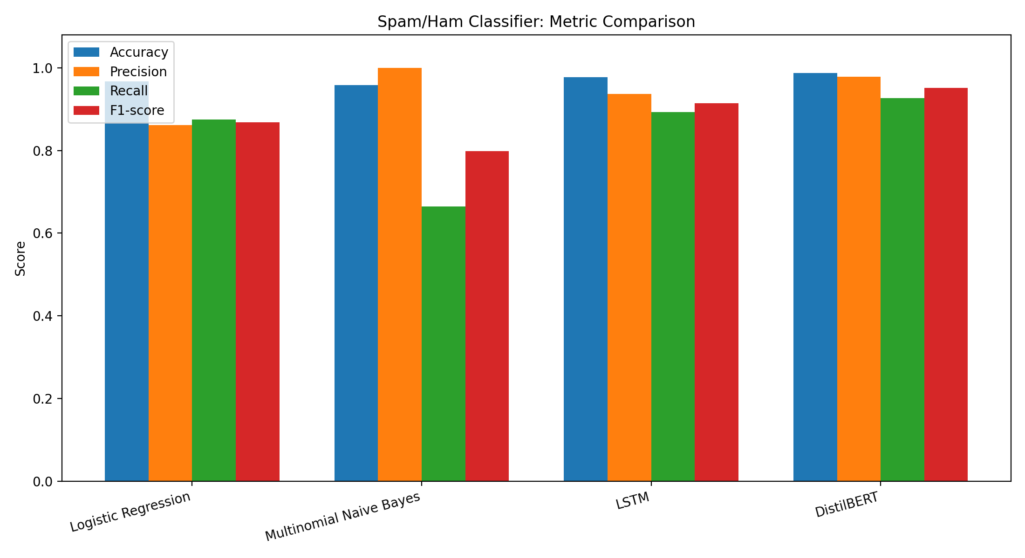
Figure 1. Comparison of accuracy, precision, recall and F1-score.
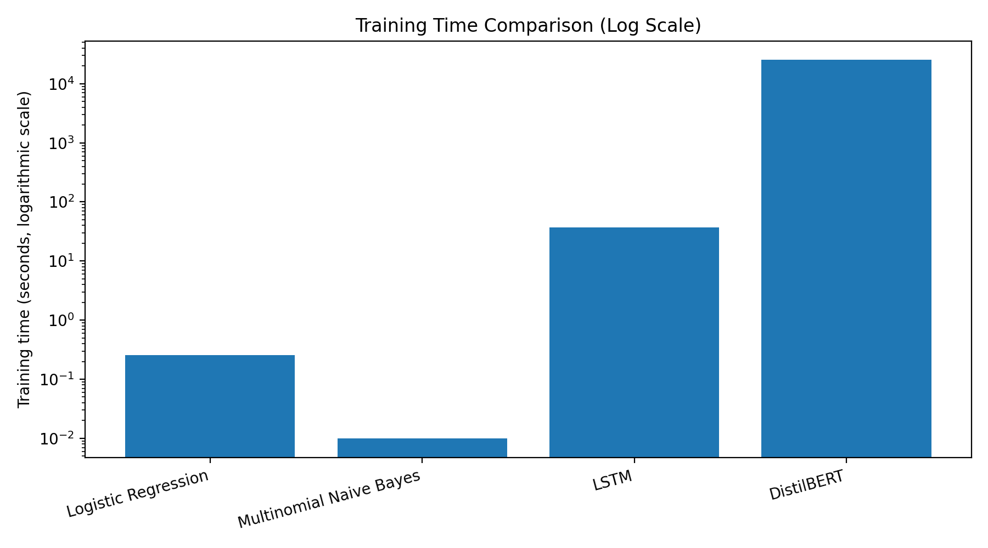
Figure 2. Training time comparison on a logarithmic scale.

6. Discussion
DistilBERT produced the highest reported accuracy (98.74%) and F1-score (95.17%), with precision of 97.87% and recall of 92.62%. This suggests contextual representations were useful for this task. However, it required approximately 25,348.76 seconds (about 7.04 hours) on CPU and used only 1,200 training examples.
LSTM achieved 97.76% accuracy and a 91.41% F1-score with a much shorter reported training time of about 37.08 seconds. Logistic Regression reached 96.71% accuracy and 86.82% F1-score in about 0.25 seconds. Multinomial Naive Bayes trained in about 0.01 seconds and had 100% precision, but its 66.41% recall indicates that it missed a larger portion of actual Spam messages.

7. Limitations and Fairness of Comparison
- Test-set sizes differed: 1,032 for traditional baselines, 1,114 for LSTM, and 1,115 for DistilBERT.
- DistilBERT used 1,200 training examples for CPU feasibility; LSTM used 4,456. The traditional training counts were not visible in the supplied screenshot.
- DistilBERT used one epoch and maximum sequence length 64. More tuning could change the results, but additional training was not practical within the available time.
- The dataset is imbalanced, with more Ham than Spam, so accuracy should be considered alongside Spam precision, recall and F1-score.
- Training time depends on hardware and software environment and is not a universal benchmark.

8. Conclusion
In these reported experiments, DistilBERT achieved the strongest overall classification scores, while LSTM offered a middle ground between score and training cost. Logistic Regression provided a fast baseline, and Multinomial Naive Bayes was the fastest but had comparatively low Spam recall. A stricter comparison would rerun every model with the same split and identical test examples.

Reproducibility Notes
DistilBERT settings: distilbert-base-uncased, learning rate 2e-5, batch size 8, one epoch, maximum length 64, CPU, and 1,200 training examples. LSTM settings shown in the project: embedding dimension 64, hidden dimension 64, dropout 0.3, and maximum sequence length 100. Keep the source scripts and saved outputs together when submitting.
Dataset source: Kaggle, “Spam Email Classification” by ashfakyeafi; use the dataset URL provided in the assignment brief.

