
Features & Test cases
Key Capabilities and Validation Scenarios

Software Manual and Testing Report by -

This is a document consistent test report of idpicker. This document will contain the developer test report for the idpicker platform. It will detail the testing procedures, results, and any identified issues or observations related to the platform's functionality and performance.

TOC

Heading 1

Heading2

heading 3

Heading 4

normal

Project overview
We have developed a system called IDPicker, which is designed to assist users in making better decisions by providing personalized recommendations. The system analyzes user input and preferences to suggest suitable options in different aspects — such as recommending universities, courses, or other related choices.
The goal of this project is to:

- Help users save time by narrowing down relevant options.
- Provide reliable and structured recommendations.
- Create a simple, user-friendly interface that guides users step by step.

IDPicker aims to act as a decision-support tool, making it easier for individuals (like students) to identify the most suitable opportunities based on their needs.

Technical Summary
The platform combines Django REST Framework for the backend, Next.js for the frontend interfaces, and Google Gemini AI for personalized assessments and recommendations. The system is designed to help students and professionals discover their ideal career paths through AI-driven analysis and tailored recommendations.
Key Features

  - AI-Powered Assessments: Personalized questionnaires generated using Google Gemini

  - University Recommendations: AI-driven university matching with web search capabilities

  - Mentor System: AI-powered mentorship with different personality types

  - Admin Dashboard: Comprehensive management interface

  - Multi-language Support: English and Turkish language support

  - OAuth Integration: Google OAuth for seamless authentication

  - Analytics: Comprehensive user behavior tracking System Architecture

High-Level Architecture
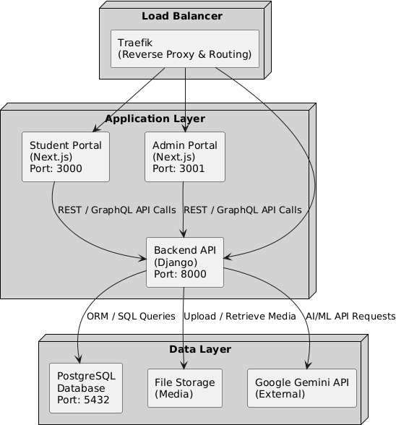

Service Architecture

Frontend Services
- Student Module Frontend (student-module-frontend/)

- Student-facing interface for assessments, results, and mentor interactions

- Built with Next.js 15, TypeScript, and Tailwind CSS

- Responsive design with mobile optimization

- Admin Dashboard (admin-dashboard/)

- Administrative interface for managing users, content, and analytics

- Built with Next.js 15, TypeScript, and Tailwind CSS

- Advanced data visualization with Recharts

Backend Services
- Main API (shift_backend/)

- Django REST Framework-based API

- Handles authentication, user management, assessments, and recommendations

- Integrates with Google Gemini AI for intelligent features

Communication Flow

User Request → Traefik → Frontend (Next.js) → Backend API (Django) → Database/AI Services
↘ Google Gemini API
↘ PostgreSQL Database

Technology Stack
Backend Technologies

Component | Technology | Version | Purpose
API Framework | Django REST Framework | 4.2+ | REST API backend
Language | Python | 3.11+ | Core backend language
Database | PostgreSQL | 15+ | Primary data storage

AI Integration | Google Gemini | Latest | AI assessments & recommendations
Authentication | Django Token Auth + OAuth | Latest | User authentication
Image Processing | Pillow | Latest | Avatar/image handling
HTTP Client | Requests | Latest | External API calls
Environment | python-dotenv | Latest | Configuration management

Frontend Technologies

Component | Technology | Version | Purpose
Framework | Next.js | 15.3+ | React framework with SSR
Language | TypeScript | 5.3+ | Type-safe JavaScript
Styling | Tailwind CSS | 3.3+ | Utility-first CSS framework
UI Components | Radix UI | Latest | Accessible component library
State Management | React Context | Built-in | Application state
Animation | Framer Motion | 12.10+ | UI animations
Icons | Lucide React | Latest | Icon library
HTTP Client | Fetch API | Built-in | API communication

DevOps & Infrastructure

Component | Technology | Purpose
Containerization | Docker & Docker Compose | Development & deployment
Reverse Proxy | Traefik | Load balancing & SSL
CI/CD | GitHub Actions | Automated deployment
SSL | Let's Encrypt | Automatic SSL certificates
Environment | Linux/Docker | Production hosting

Admin side testing

- Admin Dashboard Features

The Admin Dashboard provides administrators with centralized control over the platform. It includes tools for monitoring usage analytics, managing prompts, users, and subscriptions, as well as overseeing system activity and AI model configurations. With features like token usage tracking, activity feeds, quick links, and exportable reports, the dashboard ensures that admins can efficiently manage operations, maintain system health, and support user needs in real time.

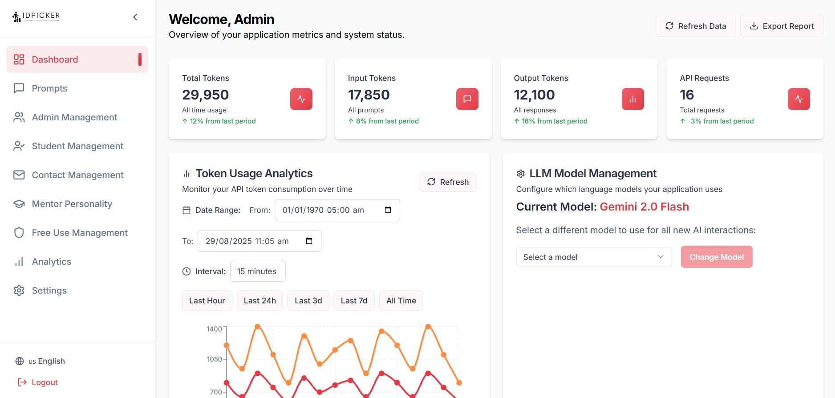

Feature | Description | Expected Behavior | API Endpoint(s)
Overview Dashboard | Displays key application metrics and system status | Metrics like total tokens, input/output tokens, and API requests are shown accurately | GET /api/admin/usage
Refresh Data | Allows admin to reload the latest metrics | Metrics update to reflect current usage | GET /api/admin/usage
Token Usage Analytics | Visualize API token consumption over time | Graphs display input/output tokens for selected date ranges and intervals | GET /api/admin/usage/tokens?from&to&interval

Testcases

Test Case | Action | Expected Result | Status
TC-AL01 | Open Admin Landing Page | Dashboard loads with all sections visible | Pass
TC-AL02 | Refresh metrics | Total tokens, input/output tokens, and API requests update | Pass
TC-AL03 | View token usage analytics | Graph displays correct input/output tokens over selected date range | Pass
TC-AL04 | Change date range in analytics | Graph updates to reflect new date range | Pass
TC-AL09 | Select different interval in analytics | Graph refreshes according to chosen interval (15 min, last hour, last 24h, etc.) | Pass
TC-AL10 | Refresh analytics graph | Graph reloads without errors and shows latest data | Pass

- Prompt Management Features

The Prompt Management module allows administrators to oversee and fine-tune all system prompts that drive assessments, recommendations, and AI interactions across the platform

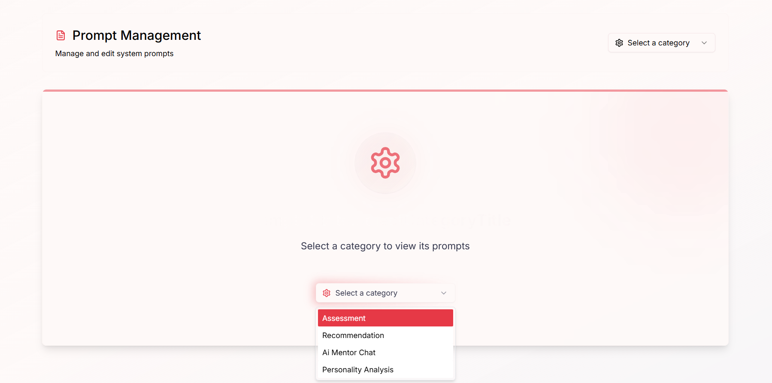

Feature | Description | Expected Behavior | API Endpoint(s)
Category Selection | Allows browsing of different prompt categories (Assessments, recommendation,etc.). | Selecting a category lists all prompts under it. | GET  /api/prompts/categori es
Prompt Listing | Displays all prompts within the selected category. | Full list with prompt ID, name, and content shown. | GET  /api/prompts?category  ={id}
Prompt Editing | Edit and update prompt text. | Saving updates the prompt in DB and reflects in usage.And create it’s new version | PUT /api/prompts/{id}
Selecting sub category | filter by category or status. | Matching prompts are displayed instantly. | GET  /api/prompts/search?q uery={text}
Version Control | Tracks changes and allows rollback to older prompt versions. | Admin can restore any previous version. | GET  /api/prompts/{id}/his tory / PUT rollback

Testcases

Test Case ID | Action | Expected Result | Status
TC-PM01 | Select a prompt category | Prompts under the selected category are displayed | Pass
TC-PM02 | View all prompts in a category | Full list of prompts (version,content) is shown | Pass
TC-PM03 | Edit an existing prompt and save | Prompt updates and create its new version | Pass
TC-PM07 | Selecting sub category of prompt | selecting prompt are displayed correctly | Pass
TC-PM08 | Rollback to a previous version of a prompt | Previous version replaces current version | Pass

- Admin Management Features

The Admin Management module provides full control over administrator accounts within the platform. It ensures that only authorized users can manage system-level settings and operations.

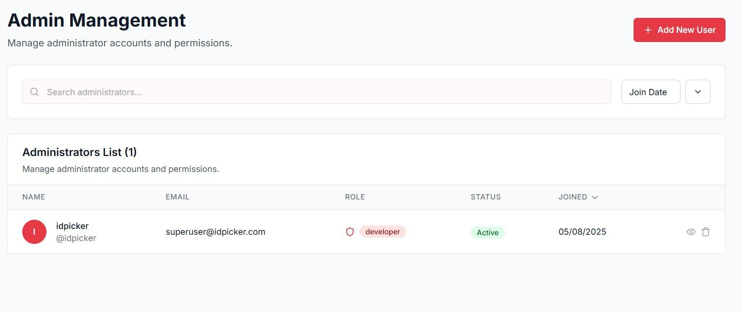

Feature | Description | Expected Behavior | API Endpoint(s)
Admin Users | View list of all admin users with details (Name, Role, Email, Organization). | The table displays all admins with their info and available actions. | GET  /api/admin/users
Add New User | Create a new admin user by providing name, email, role, and org. | The user is saved in DB and appears in the admin users list. | POST  /api/admin/users
Delete User | Remove an admin user from the system. | User deleted from DB and no longer visible in the admin list. | DELETE  /api/admin/users/{i d}
ViewUser | View user details | Show the use details like his permissions,account details etc.
Send reset link | Admin can send the reset link to the user | Email shall be sent to the user and he can reset his password

Testcases

Test Case ID | Action | Expected Result | Status
TC-AM01 | View list of admin users | All admin users with details (Name, Role, Email, Date join) are shown | Pass

TC-AM02 | Add a new admin user | User is created and appears in the admin list | Pass
TC-AM04 | Delete an admin user | User is removed and no longer visible | Pass
TC-AM05 | View a specific user | User details appear with his permissions date joining | Pass
TC-AM06 | Send email link | Email sent and able to change his password | Pass

4. Parents Management

The Parents Management module allows administrators to oversee parent accounts and their linked students. Admins can invite new parents, search and filter existing parent accounts, monitor account status, view linked students, and track activity such as join date and last login. This ensures efficient management and monitoring of parent-student connections.

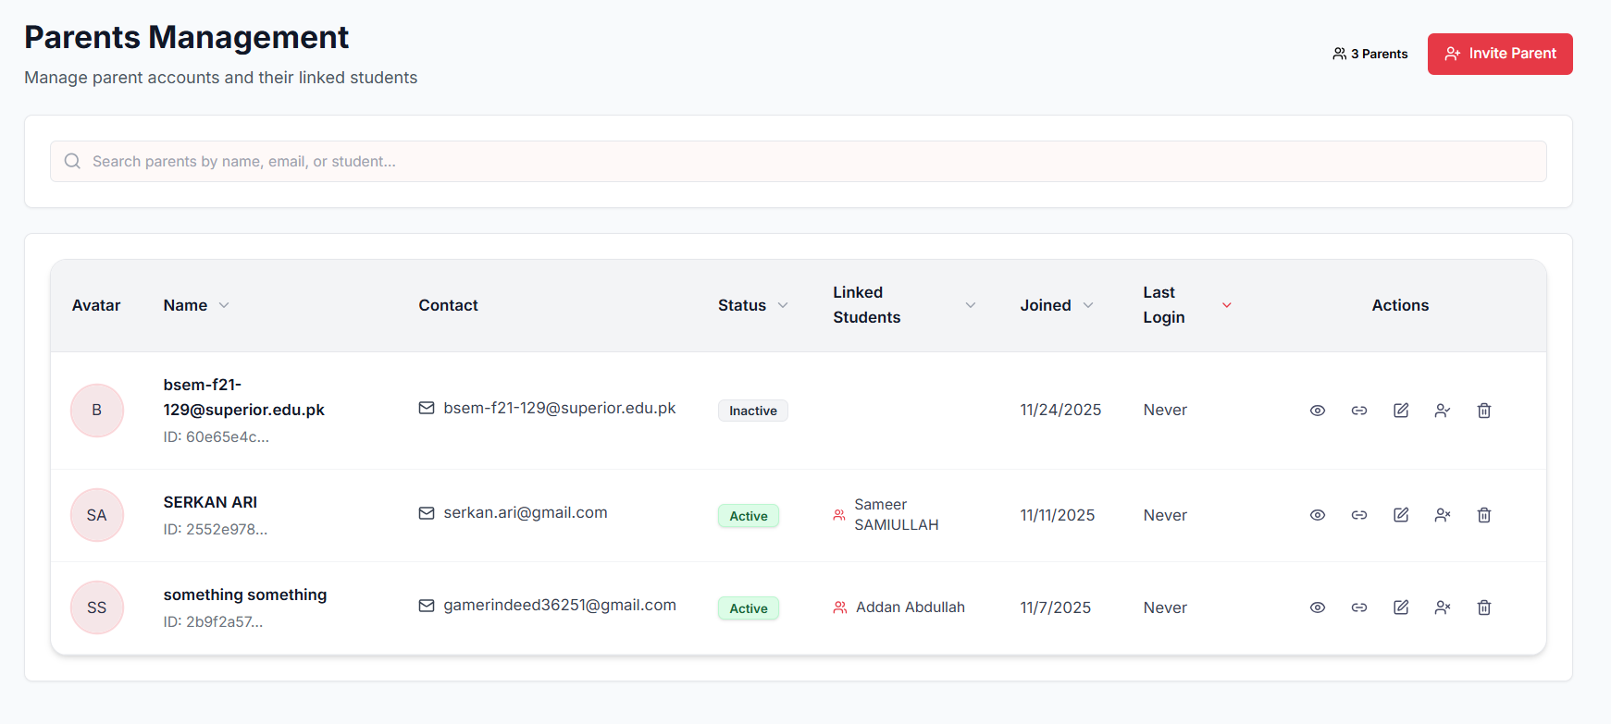

Feature | Description | Expected Behavior
Invite Parent | Send invitation to a parent to link with a student | Parent receives invite and account created upon confirmation
Parent Search | Search parents by name, email, or student | Search results display matching parent accounts
Parent List | Display all parent accounts | Shows avatar, name, contact, status, linked students, join date, and last login
Account Status Management | Monitor if parent accounts are active or inactive | Status updates correctly reflect account state
Linked Students View | View which students are linked to each parent | Linked students listed accurately
Actions Management | Perform actions like editing or removing parent accounts | Actions apply successfully without errors

TestCases

Test Case | Action | Expected Result | Status
TC-PM01 | Open Parents Management page | Page loads with list of all parent accounts | Pass
TC-PM02 | Search parent by name | Matching parent(s) displayed | Pass
TC-PM03 | Search parent by email | Matching parent(s) displayed | Pass
TC-PM04 | Search by student name | Parents linked to that student displayed | Pass
TC-PM05 | Invite a new parent | Invitation sent and parent account created upon acceptance | Pass
TC-PM06 | View parent account details | Avatar, name, contact, status, linked students, join date, and last login displayed | Pass
TC-PM07 | Check account status | Active/inactive status reflected correctly | Pass
TC-PM08 | Edit parent account | Changes saved successfully | Pass
TC-PM09 | Remove parent account | Parent account removed and updates reflected in the list | Pass
TC-PM10 | Manage links | We can able to manage links like create link with some specific user and unlink the user from parents accounts | Pass
TC-PM11 | View Details | We are able to view the parents' details like their links, contact information. | Pass

5. Organization Management

The Organization Management module enables administrators to create, view, edit, and delete organizations within the system. Admins can create organizations individually or via bulk import using spreadsheets, manage member counts, track status and expiration, and update organizational details such as name, description, location, and status. This ensures structured control over all organizations in the platform.

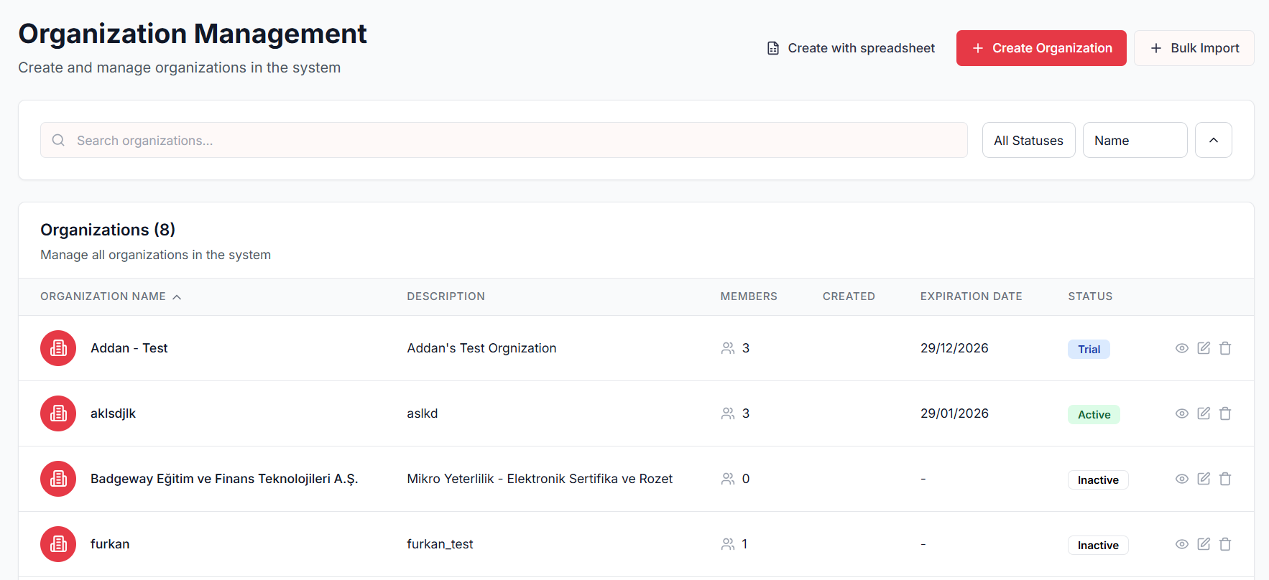

Feature | Description | Expected Behavior
Create Organization | Add a new organization individually or via spreadsheet | Organization created successfully with required details
Bulk Import | Add multiple organizations at once | Organizations imported and listed in the system
View Organizations | Display all organizations in a list | Shows name, description, members, created date, expiration date, status, and actions
Edit Organization | Update organization details | Changes saved correctly and reflected in the list
Delete Organization | Remove an organization from the system | Organization removed from the list and database
Manage Members | Track number of members in each organization | Member count displays accurately
Filter & Search | Search organizations by name or status | Filtered results shown based on input criteria
Organization Details | View detailed information for each organization | Name, description, status, expiration date, country, city, and members displayed

Test Cases

Test Case | Action | Expected Result | Status
TC-OM01 | Open Organization Management page | Page loads with all organizations listed | Pass
TC-OM02 | Search organization by name | Matching organizations displayed | Pass
TC-OM03 | Filter organizations by status | Only organizations with selected status shown | Pass
TC-OM04 | Create new organization individually | Organization added and appears in list | Pass
TC-OM05 | Create new members in the organization and assign their role. | Members added according to role and their task. | pass
TC-OM06 | View,Edit and Delete member. | Members shall edit, we can change his role name and we can delete. | Pass
TC-OM07 | Bulk import organizations via spreadsheet | All organizations from file added successfully | Pass
TC-OM08 | View organization details | Details like name, description, members, status, expiration date, country, and city displayed | Pass
TC-OM09 | Edit organization details | Changes saved and reflected in organization list | Pass
TC-OM010 | Delete an organization | Organization removed and no longer visible in list | Pass
TC-OM11 | Check member count | Number of members matches actual linked users | Pass
TC-OM12 | Refresh organization list | List updates with latest changes | Pass

6. Demo Approvals

The Demo Approvals module allows administrators to review and manage advisor demo access requests and launch trial organizations. Requests can be manually reviewed or auto-approved after 24 hours, creating 14-day trial environments. Admins can track pending requests, auto-approvals, and approved trials, as well as search and filter requests by organization, contact, or email

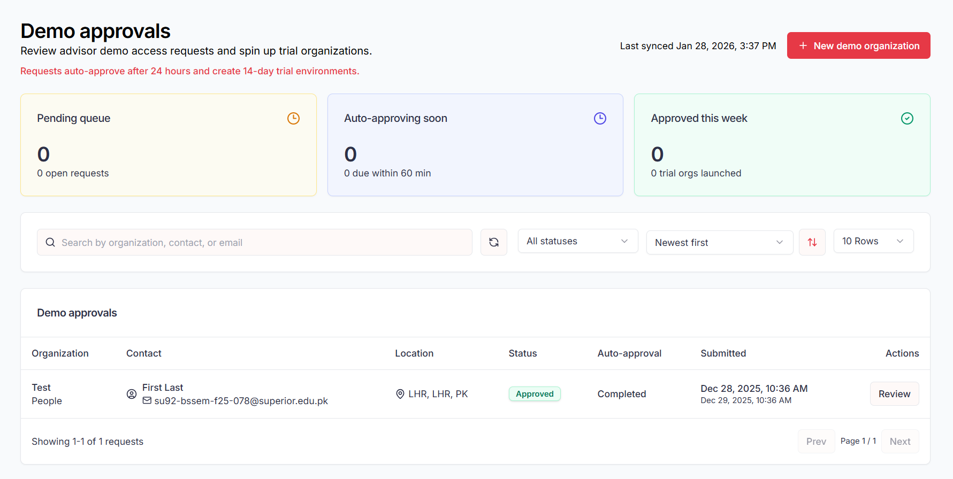

Feature | Description | Expected Behavior
Review Demo Requests | View all advisor demo access requests | Requests displayed with organization, contact, location, status, auto-approval time, and submission date
Auto-Approval | Automatically approve requests after 24 hours | Trial organizations created automatically for approved requests
Pending Queue | Track requests awaiting approval | Pending requests shown in queue with time remaining for auto-approval
Approved Queue | Monitor approved demo requests | Approved requests listed with trial organizations launched
Search & Filter | Search requests by organization, contact, or email | Filtered requests displayed based on search criteria
Sorting | Sort requests by newest first or other criteria | Requests reordered according to chosen sort option

Test Cases

Test Case | Action | Expected Result | Status
TC-DA01 | Open Demo Approvals page | Page loads with pending, auto-approving, and approved requests displayed | Pass
TC-DA02 | Search by organization name | Requests matching organization displayed | Pass
TC-DA03 | Search by contact name | Requests matching contact displayed | Pass
TC-DA05 | Review a pending request | Request opens for review with all details | Pass
TC-DA06 | Approve a request manually | Request status changes to Approved; trial org launched | Pass
TC-DA07 | Reject a request | Request status changes to Rejected; no trial org created | Pass
TC-DA08 | Auto-approval trigger | Pending requests auto-approved after 24 hours and trial org launched | Pass
TC-DA09 | Filter by status | Only requests with selected status shown | Pass
TC-DA10 | Sort requests by newest first | Requests reordered correctly by submission date | Pass

7. Platform Assessment

The Platform Assessments module allows administrators to create, manage, and publish assessments for different student cohorts across the platform. Admins can generate assessments manually or using AI, define availability periods, allow retakes, and manage multilingual content. This ensures standardized, scalable assessments aligned with platform learning objectives

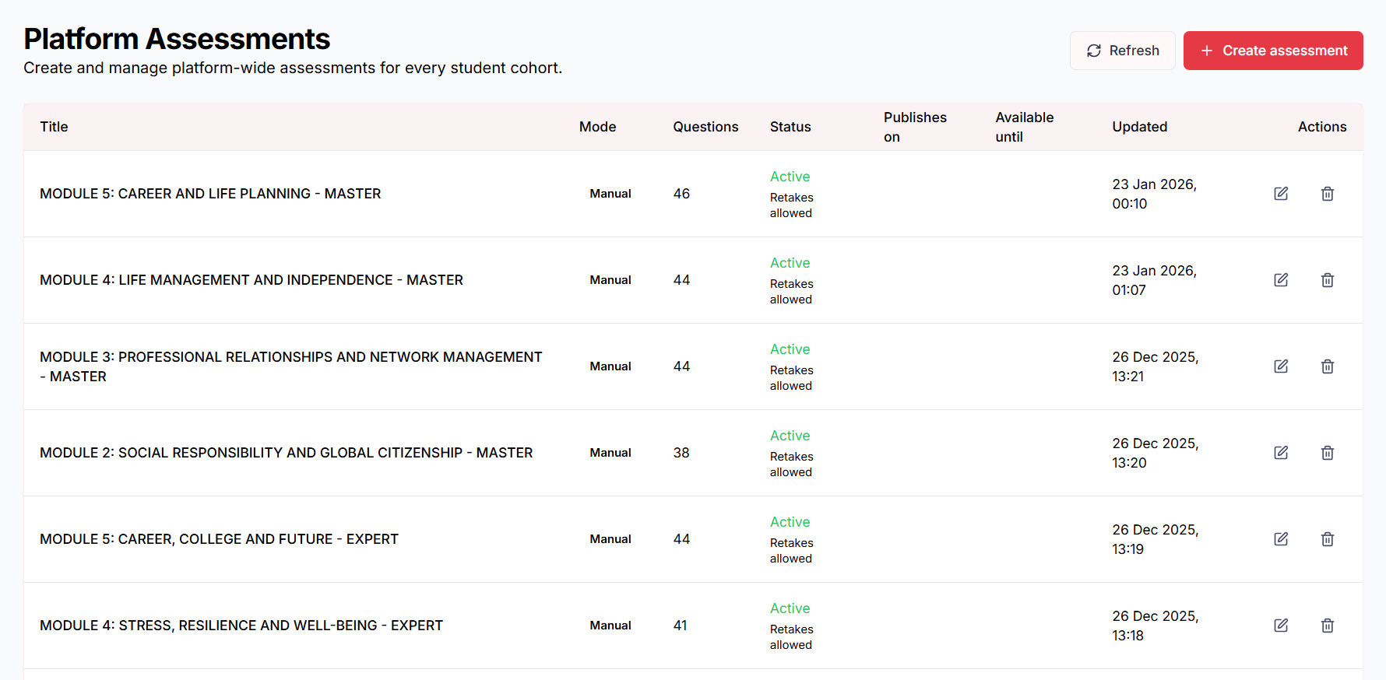

Feature | Description | Expected Behavior | API Endpoint(s)
Assessment Listing | View all platform assessments | Displays title, mode, question count, status, publish dates, and actions | GET /api/assessments
Create Assessment | Create a new platform-wide assessment | Assessment created with configured settings | POST /api/assessments
AI Question Generation | Generate assessment questions using AI | Questions generated based on prompt, locale, and question count | POST /api/assessments/generate-questions
Localization Support | Manage multi-language content | Base locale used when translations are missing | POST /api/assessments
Edit Assessment | Modify an existing assessment | Updates saved and reflected immediately | PUT /api/assessments/{assessmentId}
Delete Assessment | Remove an assessment from the platform | Assessment permanently deleted | DELETE /api/assessments/{assessmentId}
Publish Scheduling | Schedule assessment update time | Assessment becomes available at scheduled time | PUT /api/assessments/{assessmentId}
Availability Control | Set assessment expiration date | Assessment unavailable after “Available until” date | PUT /api/assessments/{assessmentId}
Cover Image Management | Upload or link a cover image | Image displayed on student assessment page | PUT /api/assessments/{assessmentId}

Test Cases

Test Case | Action | Expected Result | Status
TC-PA01 | Open Platform Assessments page | Assessment list loads correctly | Pass
TC-PA02 | Click Create Assessment | Create assessment form opens | Pass
TC-PA03 | Create assessment with AI-generated prompt | Questions generated based on prompt and count | Pass
TC-PA04 | Set base locale and translations | Correct language fallback applied | Pass
TC-PA05 | Upload cover image | Image preview shown and saved | Pass
TC-PA06 | Create assessment with scheduled publish date | Assessment published at specified time | Pass
TC-PA08 | Enable retake option | Students can retake assessment | Pass
TC-PA09 | Edit existing assessment | Changes saved and reflected in list | Pass
TC-PA10 | Delete assessment | Assessment removed from platform | Pass
TC-PA11 | Leave publish date empty | Assessment published immediately | Pass
TC-PA12 | Enter invalid question count | Validation error displayed | Pass

8.Certificates & Badges

The Certificates & Badges module allows administrators to design, manage, and distribute digital certificates and badges to students. Admins can create certificates using a live canvas editor, edit designs in real time, send certificates to students, and delete outdated designs, enabling flexible and professional credential management.

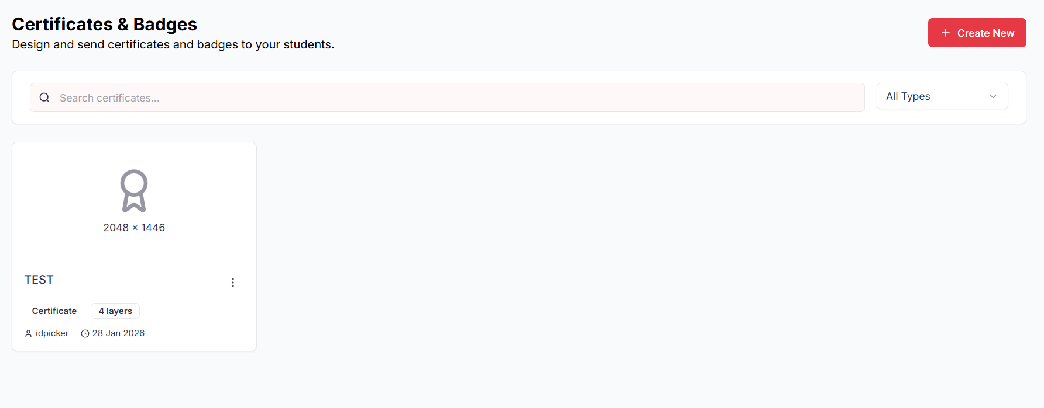

Feature | Description | Expected Behavior | API Endpoint(s)
Certificate Listing | View all certificates and badges | Certificate list displays name, type and actions | GET /api/admin/dashboard/certificates
Create Certificate | Design a new certificate or badge | New certificate created and saved | POST /api/admin/dashboard/certificates/designer
Live Canvas Editor | Edit certificate design in real time | Changes reflected instantly on the canvas | PUT /dashboard/certificates/designer?id=cert_id}
Edit Certificate | Modify existing certificate details and design | Updates saved successfully | PUT /dashboard/certificates/designer?id=cert_id}
Send Certificate | Issue certificate to selected students | Certificate sent to students, organizations by giving their email address | POST /api/certificates/{certificateId}/send
Delete Certificate | Remove a certificate design | Certificate deleted from system | DELETE /api/admin/dashboard/certificate/{id}
Search Certificates | Search certificates by name or type | Matching certificates displayed | GET /api/certificates?search=
Layer Management | Manage certificate design layers | Layers added, edited, or removed correctly

Test Cases

Test Case | Action | Expected Result | Status
TC-CB01 | Open Certificates & Badges page | Certificate list loads correctly | Pass
TC-CB02 | Create a new certificate | Certificate created and appears in list | Pass
TC-CB03 | Edit certificate using live canvas | Design updates reflected in real time | Pass
TC-CB04 | Save edited certificate | Changes persist after refresh | Pass
TC-CB05 | Manage certificate layers | Layers update correctly on canvas | Pass
TC-CB06 | Send certificate to students,organization | Selected students receive certificate | Pass
TC-CB07 | Search certificate by name | Matching certificates displayed | Pass
TC-CB08 | Delete certificate | Certificate removed from list | Pass
TC-CB10 | Refresh certificate list | Latest certificate data displayed | Pass

9. Student Management

The Student Management module enables admins to view, search, sort, and manage all registered students within the system. It provides quick access to student profiles, including subscription and verification status. Admins can also delete students when necessary, ensuring proper account control. Together, these features give administrators full visibility and governance over the student

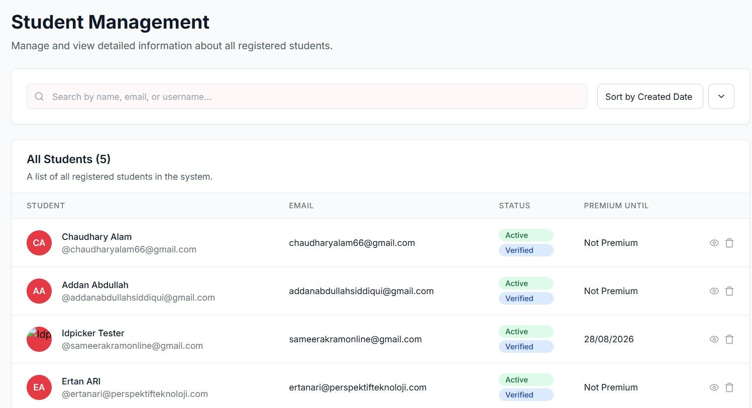

Feature | Description | Expected Behavior | API Endpoint(s)
View All Students | Display a list of all registered students with details (name, email, status, premium status). | Complete student list loads with correct information. | GET /api/students
Search Students | Search by name, email, or username. | Matching students are displayed instantly. | GET  /api/students?sear ch={query}
Sort Students | Sort by created date or other attributes. | Student list updates according to selected sort criteria. | GET  /api/students?sort  ={field}
View Student Details | View detailed profile of a selected student. | Student details page loads with complete information (status, premium, verified). | GET  /api/students/{id}
Delete Student | Remove a student from the system. | Student is deleted and no longer appears in the list. | DELETE  /api/students/{id}
Premium Status | Show premium subscription details (active/expired). | Displays “Premium Until” date or “Not Premium.” | GET  /api/students/{id}
Verification Status | Show whether the student’s account is verified. | Displays “Verified” or “Unverified.” | GET  /api/students/{id}
Invite users | Send invitations to users | It can send link to given email address

Test cases

Test Case ID | Action | Expected Result | Status
TC-SM01 | Open Student Management page | All registered students are displayed | Pass
TC-SM02 | Search by student name/email | Matching student(s) appear in the list | Pass
TC-SM03 | Sort students by created date | List reorders by newest/oldest | Pass
TC-SM04 | View details of a student | Full profile info loads (status, premium, verified) | Pass
TC-SM05 | Delete a student | Student removed from system and list updates | Pass
TC-SM06 | Check premium student | “Premium Until” date is displayed | Pass
TC-SM07 | Check non-premium student | “Not Premium” is displayed | Pass
TC-SM08 | Verify student account | “Verified” status is shown if account is confirmed | Pass
TC-SM09 | Try deleting a verified student | Before deleting system prompts warning about user then this cannot be undo | Pass
TC-SM10 | Send Invitations link on email address | Send link to the emails a invitation link | Pass

10. University Admission Criteria

The University Admission Criteria module allows administrators to manage and publish admission requirements for universities and programs at scale. Using bulk spreadsheet imports, admins can efficiently add or update exam types, minimum scores, rankings, and yearly criteria. The module also provides a searchable and filterable explorer for reviewing detailed program-level admission data.
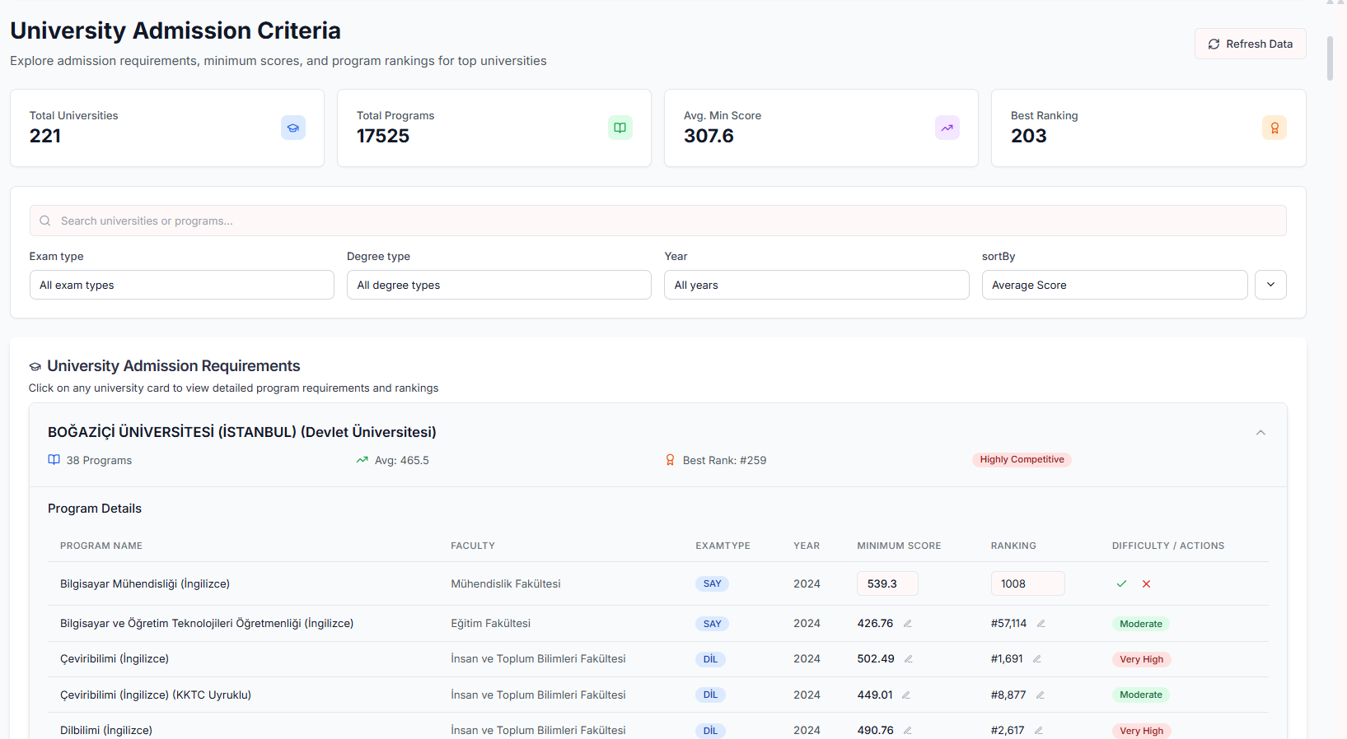

Feature | Description | Expected Behavior
Bulk Admission Criteria Import | Upload admission criteria in bulk using a predefined spreadsheet template | System validates required columns and adds or updates program requirements successfully
Template Download | Download standardized .xlsx template | Template includes all required and optional columns
File Processing | Upload and process filled spreadsheet | Data parsed correctly; errors shown for invalid rows
University & Program Explorer | Browse universities and their programs | Universities displayed with program count, average score, and best ranking
Search | Search by university or program name | Matching universities/programs displayed instantly
Filters | Filter programs by exam type, degree type, and year | Program list updates according to selected filters
Sorting | Sort programs by average score or other criteria | Programs reordered correctly
Metrics Overview | View aggregate statistics | Total universities, programs, average minimum score, and best ranking displayed
Program Details | View detailed admission requirements per program | Shows faculty, exam type, year, minimum score, ranking, and difficulty
Difficulty Indicator | Visualize competitiveness level | Difficulty labels (Moderate, High, Very High) displayed accurately
University Detail View | Expand a university card | Program table loads with full admission data

Test Cases

Test Case | Action | Expected Result | Status
TC-UAC01 | Open University Admission Criteria page | Dashboard loads with metrics and university list | Pass
TC-UAC02 | Download bulk import template | Template downloads with correct required and optional columns | Pass
TC-UAC03 | Upload valid filled .xlsx file | Admission criteria imported successfully | Pass
TC-UAC04 | Upload file with missing required columns | Validation error displayed; import blocked | Pass
TC-UAC06 | Refresh admission data | Metrics and university list update | Pass
TC-UAC07 | Search by university name | Matching universities displayed | Pass
TC-UAC08 | Search by program name | Matching programs displayed | Pass
TC-UAC09 | Filter by exam type | Programs filtered by selected exam type | Pass
TC-UAC10 | Filter by degree type | Programs filtered by selected degree type | Pass
TC-UAC11 | Filter by year | Programs filtered by selected year | Pass
TC-UAC12 | Sort by average score,University ranking,programs counts | Universities/programs reordered correctly | Pass
TC-UAC13 | Click university card | Program details table expands correctly | Pass
TC-UAC14 | Verify program details | Faculty, exam type, score, ranking, and difficulty shown accurately | Pass
TC-UAC15 | Check difficulty label logic | Difficulty level matches score/ranking thresholds | Pass
TC-UAC16 | Import update for existing program | Existing admission criteria updated correctly | Pass
TC-UAC17 | Import new university/program | New university/program added to the list | Pass
TC-UAC18 | Upload unsupported file format | Error message displayed | Pass

11. University Catalog

The University Catalog module allows administrators to manage all academic programs available to students. Admins can create, edit, delete, and promote programs. Promoted programs are highlighted on the user-facing homepage. The catalog also supports searching, filtering by category, degree, language, and keyword, ensuring efficient program management and visibility control.
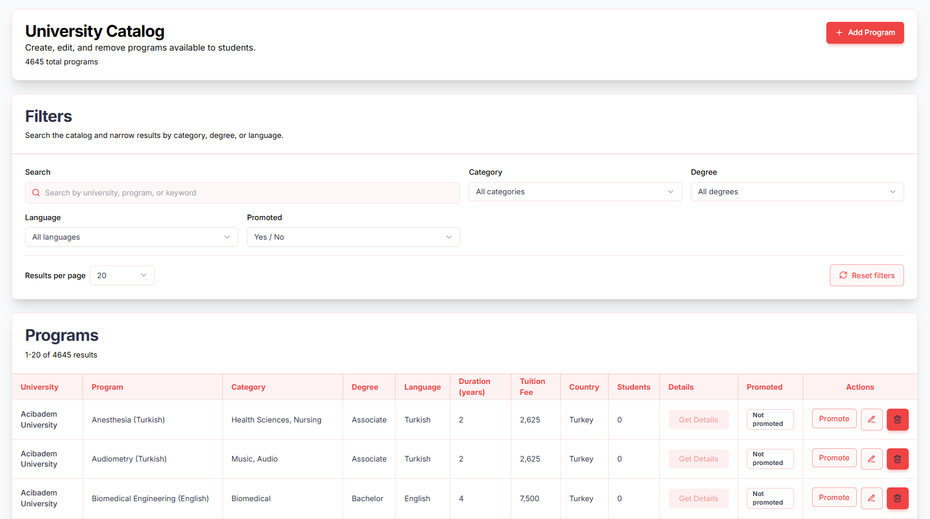

Feature | Description | Expected Behavior | API Endpoint(s)
Program Listing | View all programs in the catalog | Displays university, program, category, degree, language, duration, tuition, country, students, details, promoted status, and actions | GET /api/university-programs
Add Program | Add a new program to the catalog | Program created successfully and listed in the catalog | POST /api/university-programs
Edit Program | Modify program details | Changes saved and reflected immediately | PUT /api/university-programs/{programId}
Delete Program | Remove a program from the catalog | Program deleted permanently | DELETE /api/university-programs/{programId}
Promote Program | Promote a program for user homepage visibility | Program status updated to “Promoted” and displayed on homepage | POST /api/university-programs/{programId}/promote
Search | Search programs by university, program, or keyword | Matching programs displayed | GET /api/university-programs?search=
Filters | Filter programs by category, degree, language, or promotion status | Filtered programs displayed | GET /api/university-programs?category=&degree=&language=&promoted=
Reset Filters | Clear all applied filters | Full program list restored | GET /api/university-programs

Test Cases

Test Case | Action | Expected Result | Status
TC-UC01 | Open University Catalog page | All programs listed with correct details | Pass
TC-UC02 | Add new program | Program appears in catalog with correct data | Pass
TC-UC03 | Edit existing program | Updates saved and reflected immediately | Pass
TC-UC04 | Delete program | Program removed from catalog | Pass
TC-UC05 | Promote program | Program status updated to Promoted; appears on user homepage | Pass
TC-UC06 | Search program by university name | Matching programs displayed | Pass
TC-UC07 | Search program by program name | Matching programs displayed | Pass
TC-UC08 | Search program by keyword | Relevant programs displayed | Pass
TC-UC09 | Filter by category | Programs filtered by selected category | Pass
TC-UC10 | Filter by degree | Programs filtered by selected degree | Pass
TC-UC11 | Filter by language | Programs filtered by selected language | Pass
TC-UC12 | Filter by promoted status | Only promoted/unpromoted programs displayed | Pass
TC-UC13 | Reset filters | All programs displayed again | Pass
TC-UC15 | Promote multiple programs | Selected programs updated and visible on homepage | Pass

12. Forms

The Forms module allows administrators to create, distribute, and manage surveys for students, parents, or advisors. Forms can contain customizable questions, be sent to targeted users, and responses can be tracked, filtered, and exported. This enables efficient data collection and monitoring of engagement.

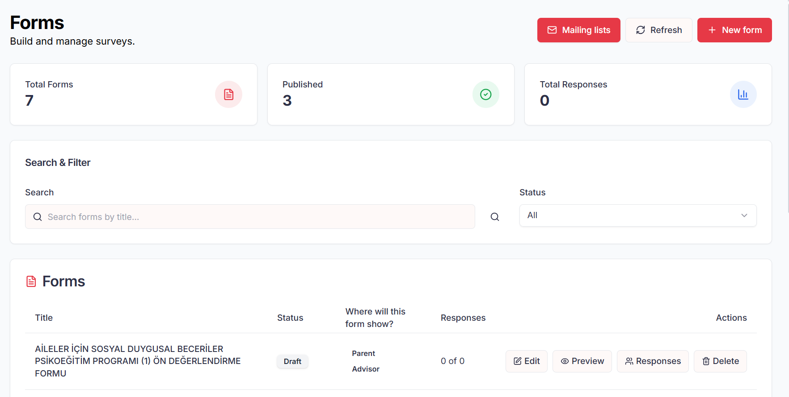

Feature | Description | Expected Behavior | API Endpoint(s)
Form Listing | View all created forms | Displays title, status, target audience, responses, and actions | GET /api/forms
Create Form | Build a new form with questions | Form saved and available for editing and distribution | POST /api/forms
Edit Form | Modify existing form and questions | Changes saved and reflected immediately | PUT /api/forms/{formId}
Preview Form | Preview the form before publishing | Shows form as it will appear to recipients | GET /api/forms/{formId}/preview
Publish Form | Send form to target recipients | Form delivered to selected users (Parent, Advisor, Student) | POST /api/forms/{formId}/publish
Response Tracking | Monitor form responses | Displays total recipients, responded, pending, and response rate | GET /api/forms/{formId}/responses
Filter Responses | Filter responses by email, name, or status | Filtered results displayed accurately | GET /api/forms/{formId}/responses?filter=
Export Responses | Export form responses as CSV | CSV file downloads with all responses | GET /api/forms/{formId}/responses/export
Delete Form | Remove a form permanently | Form deleted and no longer available | DELETE /api/forms/{formId}

Test Cases

Test Case | Action | Expected Result | Status
TC-F01 | Open Forms page | All forms listed with correct details | Pass
TC-F02 | Create new form | Form created and appears in list | Pass
TC-F03 | Add questions to form | Questions saved and displayed correctly | Pass
TC-F04 | Edit existing form | Changes saved and reflected immediately | Pass
TC-F05 | Preview form | Form preview shows correctly for intended audience | Pass
TC-F06 | Publish form to recipients | Form delivered successfully to selected users | Pass
TC-F07 | Track responses | Total recipients, responded, pending, and response rate displayed | Pass
TC-F08 | Filter responses by email | Filtered responses displayed accurately | Pass
TC-F09 | Filter responses by status | Only matching responses displayed | Pass
TC-F10 | Export responses | CSV file downloads with correct data | Pass
TC-F11 | Delete form | Form removed permanently from the system | Pass
TC-F12 | Refresh form list | List updates to reflect latest changes | Pass

13. Mentor Personality Assessment

The Mentor Management module allows administrators to oversee and customize AI mentor personalities that guide students across the platform. It provides full control over creating, editing, and removing mentors, as well as assigning expertise areas and managing visibility status

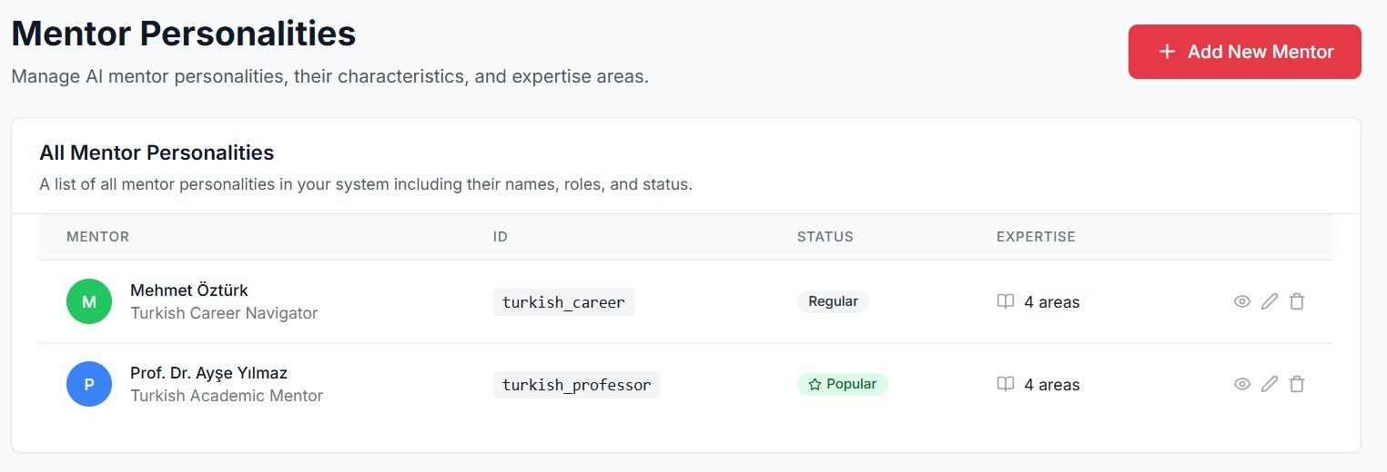

Feature | Description | Expected Behavior | API Endpoint(s)
View Mentor Personalities | Display all AI mentor personalities with details (name, role, expertise, status). | Mentor list load with correct attributes and available actions. | GET /api/mentors
Add New Mentor | Create a new mentor personality with name, role, expertise areas, and status. | Mentor saved in DB and displayed in the list. | POST /api/mentors
Edit Mentor Details | Modify an existing mentor’s name, role, expertise, or status. | Updated details reflected immediately. | PUT /api/mentors/{id}
Delete Mentor | Remove a mentor personality from the system. | Mentor removed and no longer visible in the list. | DELETE  /api/mentors/{id}
Expertise Management | Assign or update expertise areas for a mentor personality. | Mentor profile updates to show new expertise areas. | PUT  /api/mentors/{id}/expertise
Actions Menu | Provides actions for each mentor (view, edit, delete). | Actions execute respective operations.

Test Cases

Test Case ID | Action | Expected Result | Status
TC-MP01 | Open Mentor Management page | All mentor personalities displayed with details | Pass
TC-MP02 | Add a new mentor personality | Mentor created and shown in the list | Pass
TC-MP03 | Edit mentor details (name, role, expertise) | Mentor details updated successfully | Pass
TC-MP04 | Delete a mentor | Mentor removed from the system | Pass
TC-MP05 | Assign new expertise areas | Mentor expertise updates and displays correctly | Pass
TC-MP06 | Change mentor status (Regular→ Popular) | Mentor list reflects updated status | Pass
TC-MP07 | View mentor profile | Full mentor details and expertise areas displayed | Pass

14. Free Usage Management

The Free Use Management module allows administrators to define and control usage limits for free users. Limits can be applied globally across all organizations or overridden with organization-specific settings to control access to assessments and recommendations.

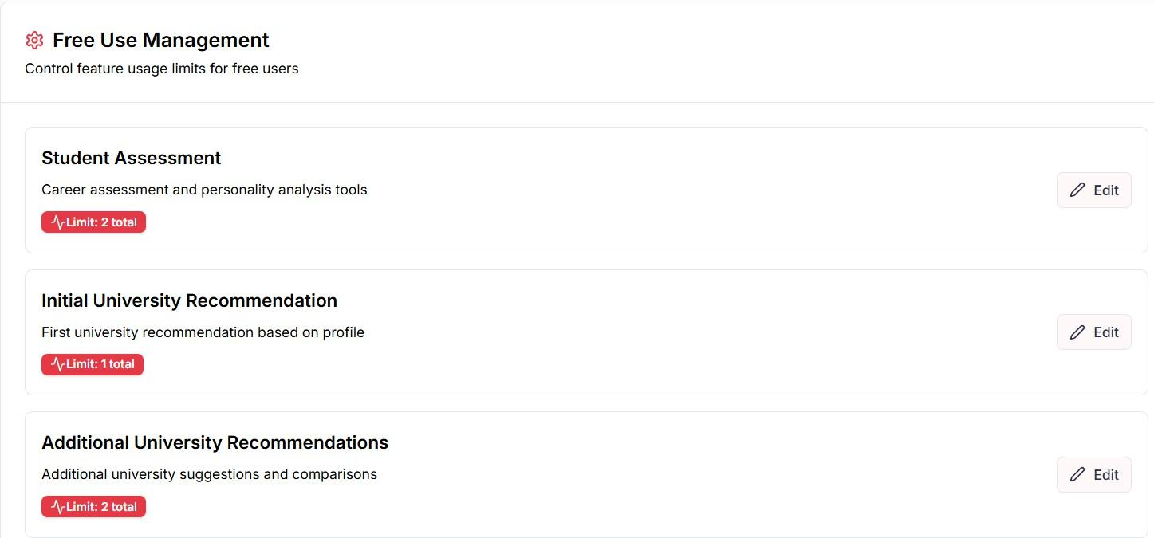

Feature | Description | Expected Behavior
Global Free Limits | Configure default usage limits for all organizations | Limits apply to all free users unless overridden
Organization Selection | Select a specific organization | Displays organization-specific configuration
Organization-Specific Override | Customize limits for a selected organization | Overrides global settings for that organization only
Student Assessment Limit | Set usage count for career and personality assessments | Free users restricted to defined number of attempts
University Recommendation Limit | Set usage count for initial university recommendations | Free users limited to defined recommendation count
Edit Limits | Modify existing limits | Updated limits applied immediately
Refresh Data | Reload latest configuration | Displays most recent saved values

Test Cases

Test Case | Action | Expected Result | Status
TC-FU01 | Open Free Use Management page | Global settings displayed by default | Pass
TC-FU02 | Select an organization | Organization-specific settings displayed | Pass
TC-FU03 | Edit global student assessment limit | Limit updated and saved successfully | Pass
TC-FU04 | Edit global university recommendation limit | Limit updated and saved successfully | Pass
TC-FU05 | Set organization-specific assessment limit | Organization overrides global value | Pass
TC-FU06 | Set organization-specific recommendation limit | Organization override applied correctly | Pass
TC-FU07 | Verify free user assessment usage | User blocked after exceeding limit | Pass
TC-FU08 | Verify free user recommendation usage | User blocked after exceeding limit | Pass
TC-FU09 | Refresh settings | Latest saved limits displayed | Pass
TC-FU10 | Remove organization override | Global settings applied again | Pass

15. Status Page

The Status Page provides real-time visibility into the health of backend services, infrastructure components, and third-party integrations. It enables administrators to quickly detect issues, verify system uptime, and monitor operational readiness across the platform.

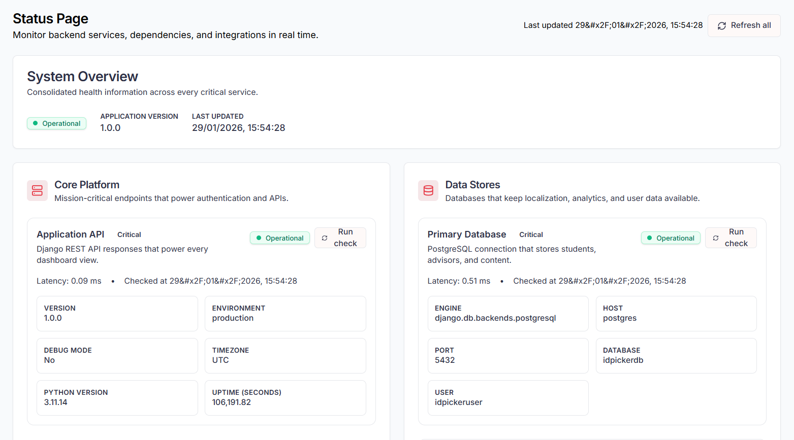

Feature | Description | Expected Behavior
System Overview | Displays consolidated health of all critical services | Overall system status shown as Operational, Advisory, or Critical
Application Metadata | Shows app version, environment, uptime, and last update time | Data reflects current deployed state
Core Platform Monitoring | Monitors main Application API health | API status, latency, and configuration visible
Data Store Monitoring | Tracks database and translation store health | Connection status and latency displayed
Infrastructure Monitoring | Monitors cache and media storage services | Read/write availability and latency shown
Integrations Monitoring | Tracks third-party services like AI providers | Configuration and availability status displayed
Run Check | Manually trigger health checks per service | Service status and latency updated
Refresh All | Reload all system checks | Latest health data displayed

Test Cases

Test Case | Action | Expected Result | Status
TC-ST01 | Open Status Page | System overview loads successfully | Pass
TC-ST02 | Verify system overview status | Correct consolidated status displayed | Pass
TC-ST03 | Check application metadata | Version, environment, and uptime shown accurately | Pass
TC-ST04 | Run check on Application API | API status updates with latency | Pass
TC-ST05 | Run check on Primary Database | Database status and latency displayed | Pass
TC-ST06 | Run check on Translation Store | SQLite store status shown correctly | pass
TC-ST07 | Run check on Cache Layer | Cache status and latency displayed | Pass
TC-ST08 | Run check on Media Storage | Writable state and latency shown | Pass
TC-ST09 | Run check on AI Providers | Provider configuration and status displayed | Pass
TC-ST10 | Click Refresh All | All service statuses refresh with updated timestamps | Pass
TC-ST11 | Simulate service failure | Service marked as Advisory or Critical | Pass
TC-ST12 | Verify last updated timestamp | Timestamp updates after refresh | Pass

16 .Support Tickets

The Support Tickets module allows administrators to manage and resolve support requests submitted by users who are not affiliated with any organization. It provides visibility into ticket status, priority, category, and resolution history to ensure timely issue handling

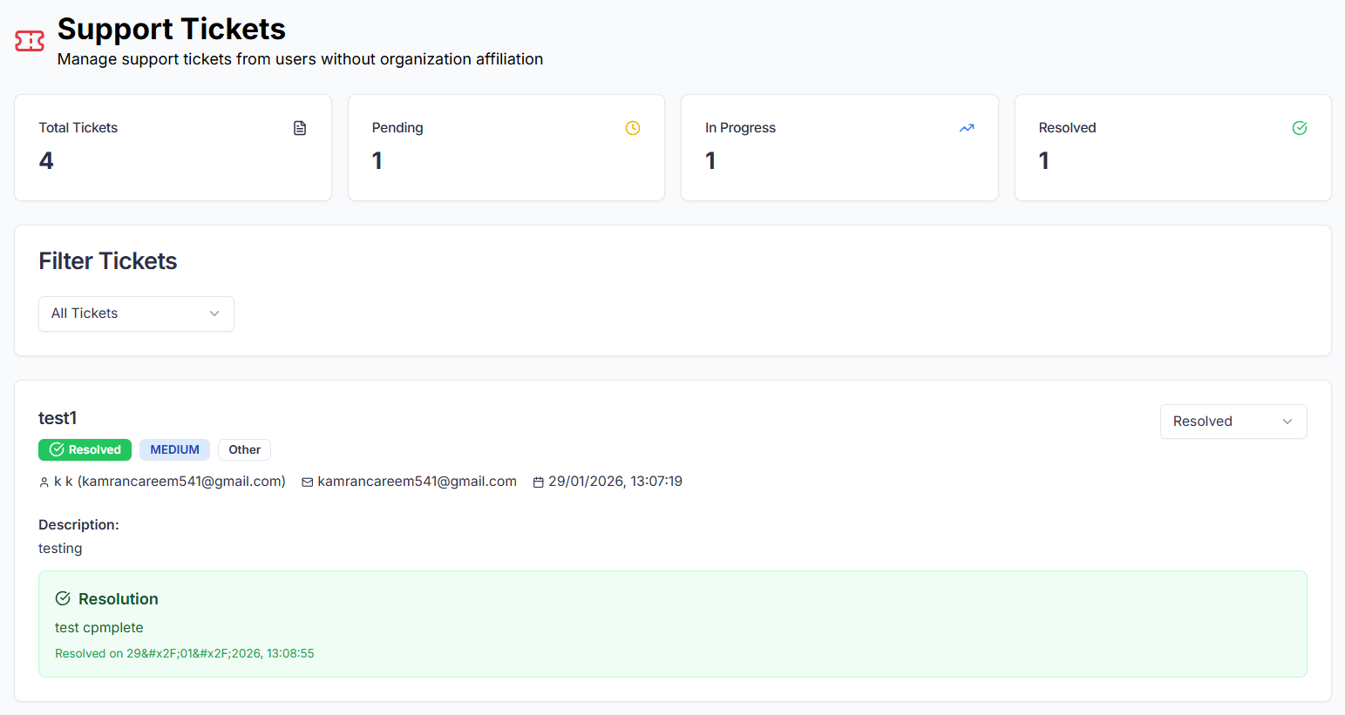

Feature | Description | Expected Behavior
Ticket Overview | Displays total tickets and status breakdown | Counts for Pending, In Progress, and Resolved shown correctly
Ticket List | View all submitted support tickets | Tickets listed with subject, status, priority, and category
Filtering | Filter tickets by status | Only matching tickets displayed
Ticket Details | View full ticket information | Shows description, user details, and timestamps
Status Management | Update ticket status | Ticket can be moved between Pending, In Progress, and Resolved
Resolution Entry | Add resolution notes | Resolution text saved and displayed
Resolve Action | Mark ticket as resolved,pending,progress,  closed | Ticket status updated with mark ticket and timestamp
Sending email | When resolve send email | Email shall be sent about telling the issue was resolved.
User Information | View requester details | Name and email displayed accurately

Test Cases

Test Case | Action | Expected Result | Status
TC-STK01 | Open Support Tickets page | Ticket dashboard loads successfully | Pass
TC-STK02 | Verify ticket counters | Total and status-wise counts are correct | Pass
TC-STK03 | View all tickets | All tickets displayed in the list | Pass
TC-STK04 | Filter by Pending status | Only Pending tickets shown | Pass
TC-STK05 | Open a ticket detail | Full ticket details displayed | Pass
TC-STK06 | Verify user information | Correct name and email shown | Pass
TC-STK07 | Update ticket status to In Progress | Status updates successfully | Pass
TC-STK08 | Add resolution text | Resolution saved correctly | Pass
TC-STK09 | Resolve a ticket | Ticket marked as Resolved with timestamp | Pass
TC-STK10 | Verify resolved ticket view | Resolution details visible in ticket | Pass
TC-STK11 | Resolve issue | Email shall be sent | pass
TC-STK11 | Refresh ticket list | Updated ticket statuses reflected | Pass

17. Notifications

The Notifications module enables administrators to broadcast important announcements and updates to students. Notifications can be sent to all students or targeted to specific individuals, with read and unread tracking for visibility.

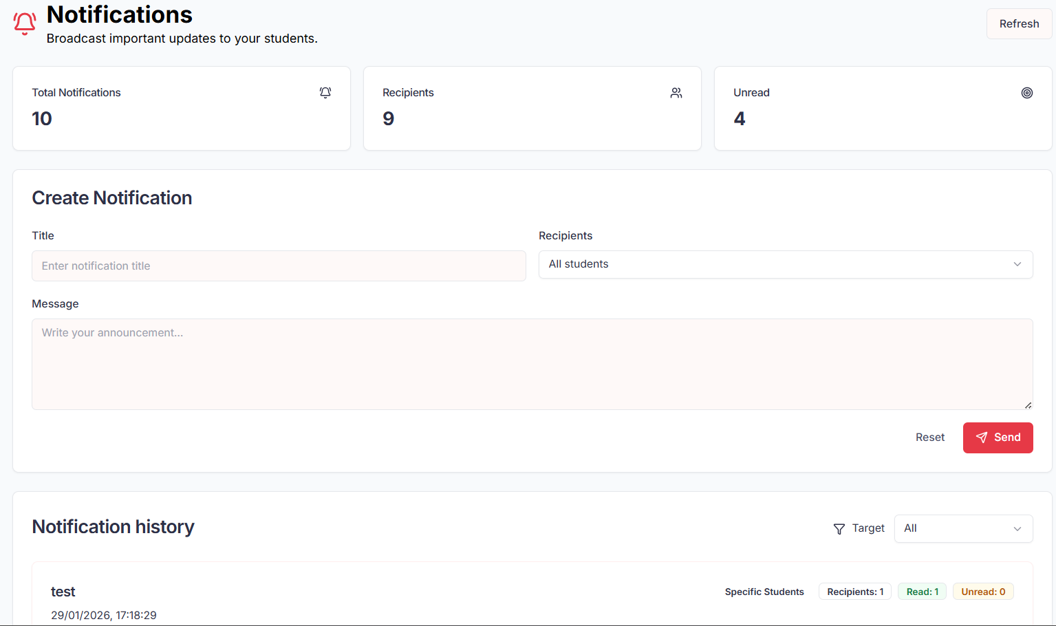

Feature | Description | Expected Behavior
Notification Dashboard | Displays notification statistics | Total notifications, recipients, and unread counts shown
Create Notification | Compose a new notification | Admin can enter title and message
Recipient Selection | Choose notification audience | Notification can be sent to all students or specific students
Send Notification | Dispatch notification | Selected recipients receive the notification
Reset Form | Clear notification fields | Title, message, and recipients reset
Notification History | View sent notifications | History shows target, recipients, and timestamps
Read/Unread Tracking | Track notification status | Read and unread counts updated per notification
Target Filtering | Filter notification history | Notifications filtered by target type

Test case

Test Case | Action | Expected Result | Status
TC-NOT01 | Open Notifications page | Dashboard loads with statistics | Pass
TC-NOT02 | Verify notification counters | Total, recipients, and unread counts correct | Pass
TC-NOT03 | Create notification for all students | Notification sent to all students | Pass
TC-NOT04 | Create notification for specific student | Notification delivered to selected student | Pass
TC-NOT05 | Submit notification without title | Validation error displayed | Pass
TC-NOT06 | Submit notification without message | Validation error displayed | Pass
TC-NOT07 | View notification history | Sent notifications listed correctly | Pass
TC-NOT08 | Verify read/unread counts | Counts update based on student actions | Pass
TC-NOT9 | Filter notification history by target | Only matching notifications shown | Pass
TC-NOT10 | Refresh notifications page | Latest notifications displayed | Pass
TC-NOT11 | Verify timestamp accuracy | Correct sent time shown | Pass

18. Translation Management

The Translation Management module centralizes all static text translations used across the platform. It allows administrators to define, edit, and maintain multilingual content by language and namespace, ensuring consistent localization across all user-facing screens

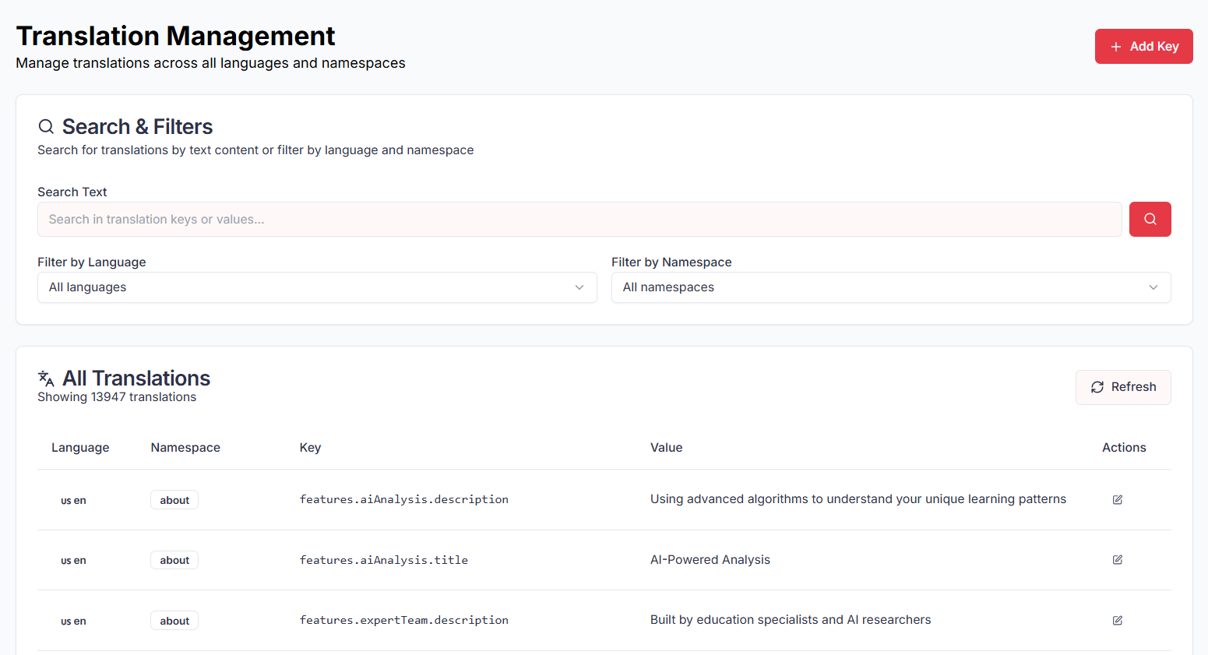

Feature | Description | Expected Behavior
Translation Registry | Central store for all static translations | All UI text keys and values are listed
Add Translation Key | Create new translation entries | New key saved with language, namespace, and value
Language Filtering | Filter translations by language | Only selected language translations displayed
Namespace Filtering | Filter translations by namespace | Only matching namespace keys shown
Text Search | Search keys or values | Results filtered by search text
Edit Translation | Update existing translation value | Changes saved and reflected in UI
Refresh Translations | Reload latest translation data | Updated list loaded without page errors
Multi-language Support | Support multiple locales | Each key can exist in multiple languages

Test Cases

Test Case | Action | Expected Result | Status
TC-TR01 | Open Translation Management page | All translations load successfully | Pass
TC-TR02 | Search by translation key | Matching keys displayed | Pass
TC-TR02 | Search by translation value | Matching value display | Pass
TC-TR04 | Filter by language | Only selected language translation shown | Pass
TC-TR05 | Add new translation key | Key saved and visible in list | Pass
TC-TR06 | Edit existing translation value | Key saved and visible in list | Pass
TC-TR07 | Refresh translation list | Latest translation loaded | pass
TC-TR08 | Verify static ui text | UI display updated translation | pass
TC-TR09 | Add same key for different languages | Translation saved correctly | pass

19. Language

The Language module enables users to interact with the platform in their preferred language. It provides a seamless way to switch between supported languages, ensuring accessibility for a global audience. All key sections of the platform, including navigation, content, and user interactions, adapt instantly when a new language is selected, creating an inclusive and
user-friendly experience

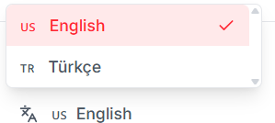

Feature | Description | Expected Behavior | API Endpoint(s)
Language Switcher (EN/TR) | Toggle UI between English and Turkish. | Changing language updates all visible UI instantly without reload. | POST /testapi.idpicker.com/api/set-language-preference/
Language Switcher (TR/EN) | Toggle UI between Turkish and English. | Changing language updates all visible UI instantly without reload. | POST /testapi.idpicker.com/api/set-language-preference/

Test Cases

Test Case | Action | Expected Result | Status
TC-L01 | Switch language EN → TR from header toggle | The entire UI switches to Turkish instantly. | pass
TC-L01 | Switch language TR → EN from header toggle | The entire UI switches to English instantly. | pass

20. Admin Authentication

Admin Authentication ensures secure access to the admin panel through controlled login and logout mechanisms. It restricts administrative features to authorized users and safely terminates sessions on logout

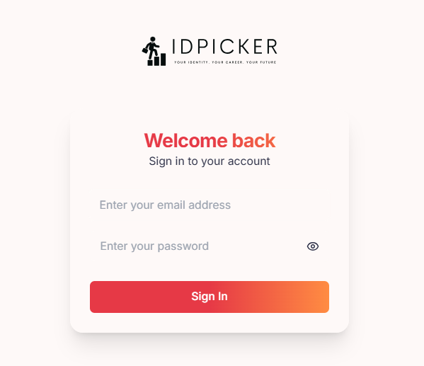

Feature | Description | Expected Behavior
Admin Login | Authenticate admin users | Admin logs in using valid credentials
Credential Validation | Verify login details | Incorrect credentials are rejected
Session Management | Maintain admin session | Session remains active until logout or expiry
Role Authorization | Restrict admin access | Only admin roles can access admin panel
Admin Logout | End admin session | Session terminated and user redirected to login
Session Expiry Handling | Handle inactive sessions | Admin redirected to login on expiry

Test Cases

Test Cases | Action | Expected Result | Status
TC-AUTH-ADM01 | Open admin login page | Login page load correctly | pass
TC-AUTH-ADM02 | Login with valid admin credentials | Admin redirect to dashboard | pass
TC-AUTH-ADM03 | Login with invalid credentials | Error message display | Pass
TC-AUTH-ADM04 | Login with non-admin user | Access denied to admin panel | pass
TC-AUTH-ADM05 | Logout from admin panel | Admin logout and redirect to login | pass

